Supporting Information

Artemisia-Derived Carbon Dots with Excellent Pharmacological Activities and ROS Scavenging for Osteoarthritis Treatment

Sixiang Wang 1, 2 #, Feng Fan 3, 4 #, Shunshun Wang 3, 4 #, Minfu Liu 3, 5, Jiaqing Wu 3, 5, Xiaorong Hu 1, Kun Wei 1, Kang Xu 3, 4 *, Chunli Wang 3, 5 *, Gang Chen 3, 6*

1 Ningbo Rehabilitation Hospital, Wenzhou Medical University, Ningbo, zhejiang 315040, China.
2 Department of Rehabilitation Medicine, The Second Hospital of Wenzhou Medical University, Wenzhou Medical University, Wenzhou, Zhejiang 325027, China.
3 Hubei Shizhen Laboratory, Wuhan 430065, China.
4 School of Pharmacy, Hubei University of Chinese Medicine, Wuhan 430065, China.
5 School of Laboratory Medicine, Hubei University of Chinese Medicine, Wuhan 430065, China.
6 Department of Geriatrics, Hubei Provincial Hospital of Traditional Chinese Medicine, Affiliated Hospital of Hubei University of Chinese Medicine, Wuhan 430061, China.

Corresponding author email address
kangxu05@hbucm.edu.cn (Kang Xu)
lilywang@cqu.edu.cn (Chunli Wang)
chengang@hbucm.edu.cn (Gang Chen)

1. Experimental Section
1.1 Characterization of AA-CDs
The physical morphology of A-CDs and AA-CDs was observed using transmission electron microscopy (TEM, Talos F200S, Thermo Fisher Scientific, USA). The chemical structures of A-CDs and AA-CDs were characterized using ultraviolet-visible spectroscopy (UV-3600, Shimadzu, Japan), Fourier-transform infrared spectroscopy (Nicolet iS50, Thermo Scientific, USA), micro-confocal Raman spectroscopy (LabRAM HR Evolution, Jobin Yvon S.A.S, France), multifunctional high-resolution X-ray diffraction (Empyrean, PANalytical, Netherlands), and X-ray photoelectron spectroscopy (ESCALAB250Xi, Thermo Fisher Scientific, USA).
1.2 Determination of A-CDs and AA-CDs interaction with Fe (II)
A-CDs or AA-CDs were dissolved in H₂O (1 mg/L), 300 μL Fe (II) (1 mM) were added into the A-CDs or AA-CDs solutions (2.7 mL). The emission spectrum and zeta potential of A-CDs or AA-CDs before and after adding iron ion solution were characterized. Meanwhile, different concentrations of Fe²⁺ (0 mM, 0.1 mM, 0.2 mM, 0.3 mM, 0.4 mM, 0.5 mM, 0.6 mM, 0.7 mM, 0.8 mM, 0.9 mM, 1.0 mM) 300 μL were added into A-CDs or AA-CDs solution to study the energy change process of the reaction systemin.¹

Figure S1
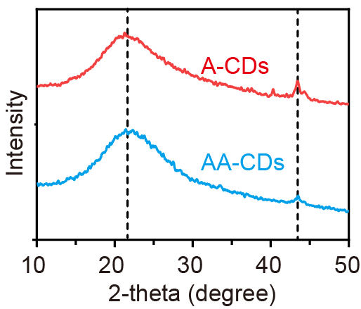
Figure S1. XRD patterns of A-CDs and AA-CDs.

Figure S2
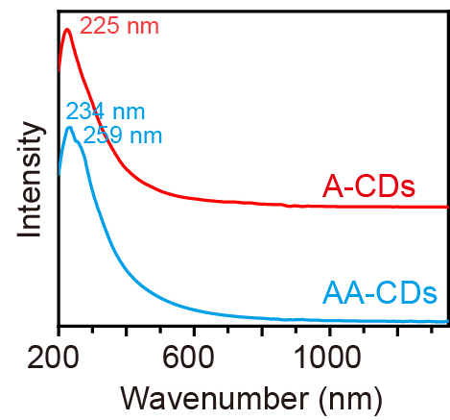
Figure S2. UV-vis absorption spectra of A-CDs and AA-CDs.
Figure S3
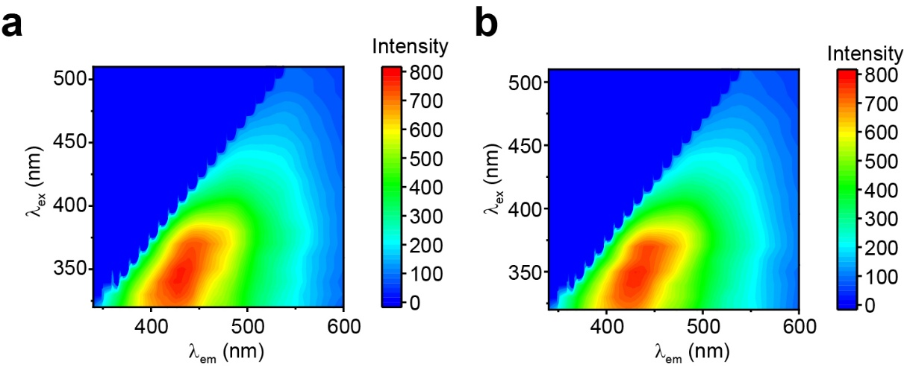
Figure S3. (a) 3D FL spectra of A-CDs (b) 3D FL spectra of AA-CDs.

Figure S4
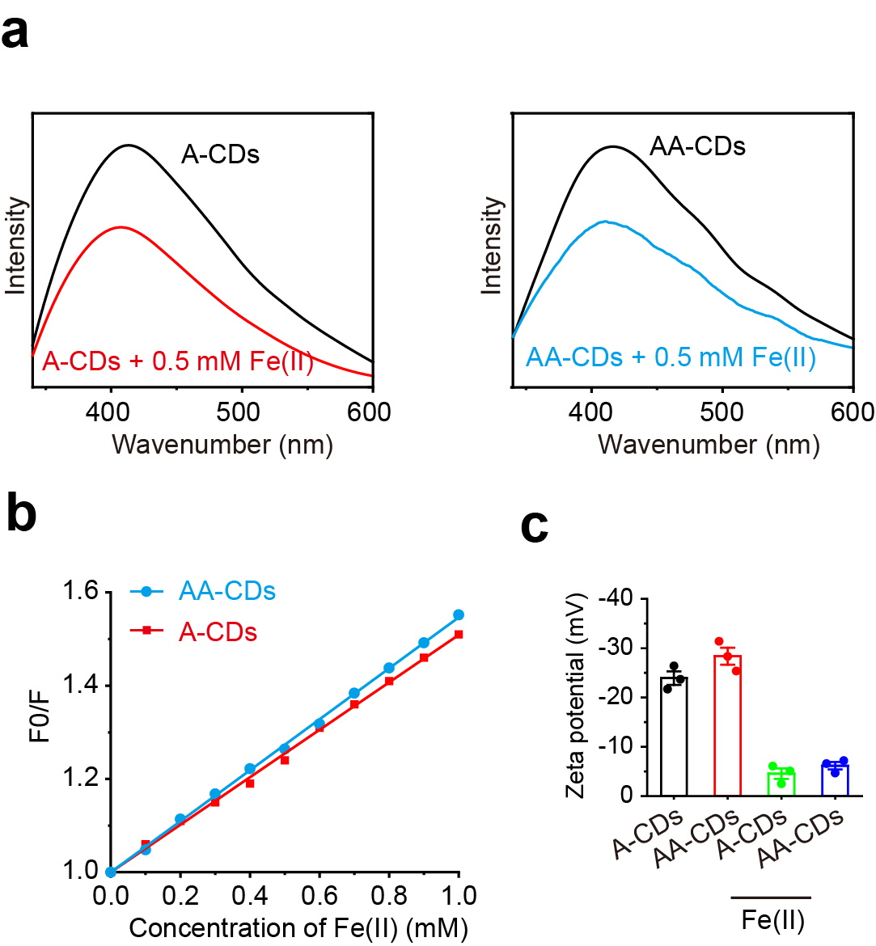
Figure S4. (a) Fluorescence spectra of A-CDs and AA-CDs (100 µg/mL⁻¹) in the presence of Fe²⁺ with +different concentrations. (b). Stern-Volmer values of Fe²⁺ at the emission wavelengths of 416 nm. (c) Zeta potential of A-CDs and AA-CDs with or without Fe²⁺.

Figure S5
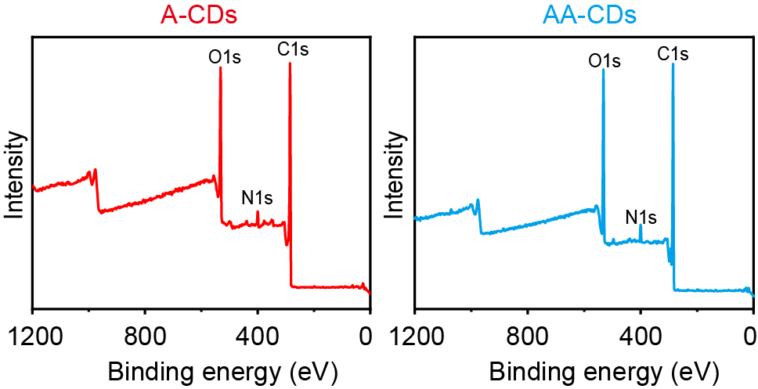
Figure S5. XPS survey spectra of A-CDs and AA-CDs.

Figure S6
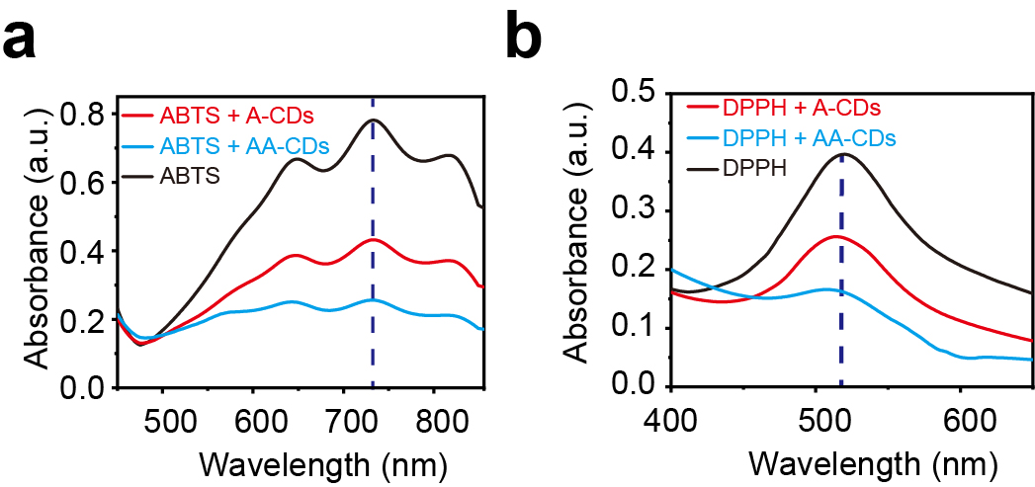
Figure S6. (a) Absorption spectra of ABTS with or without A-CDs and AA-CDs. (b) Absorption spectra of DPPH with or without A-CDs and AA-CDs.

Figure S7
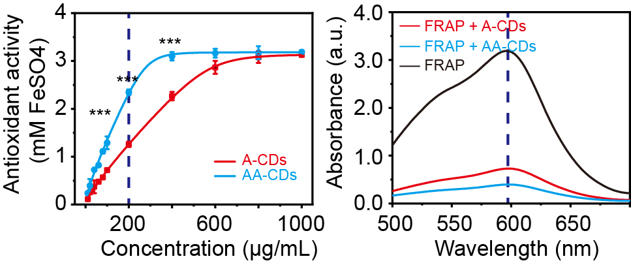
Figure S7. FRAP assay demonstrating the antioxidant capacity of A-CDs and AA-CDs.

Figure S8
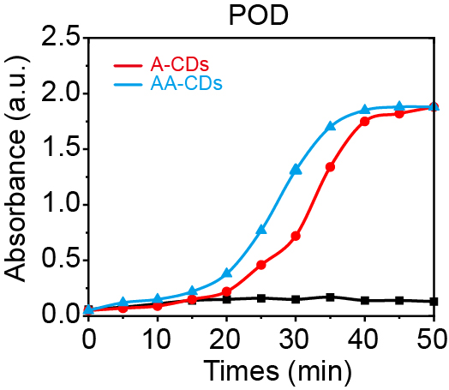
Figure S8. POD-like activity of A-CDs and AA-CDs

Figure S9
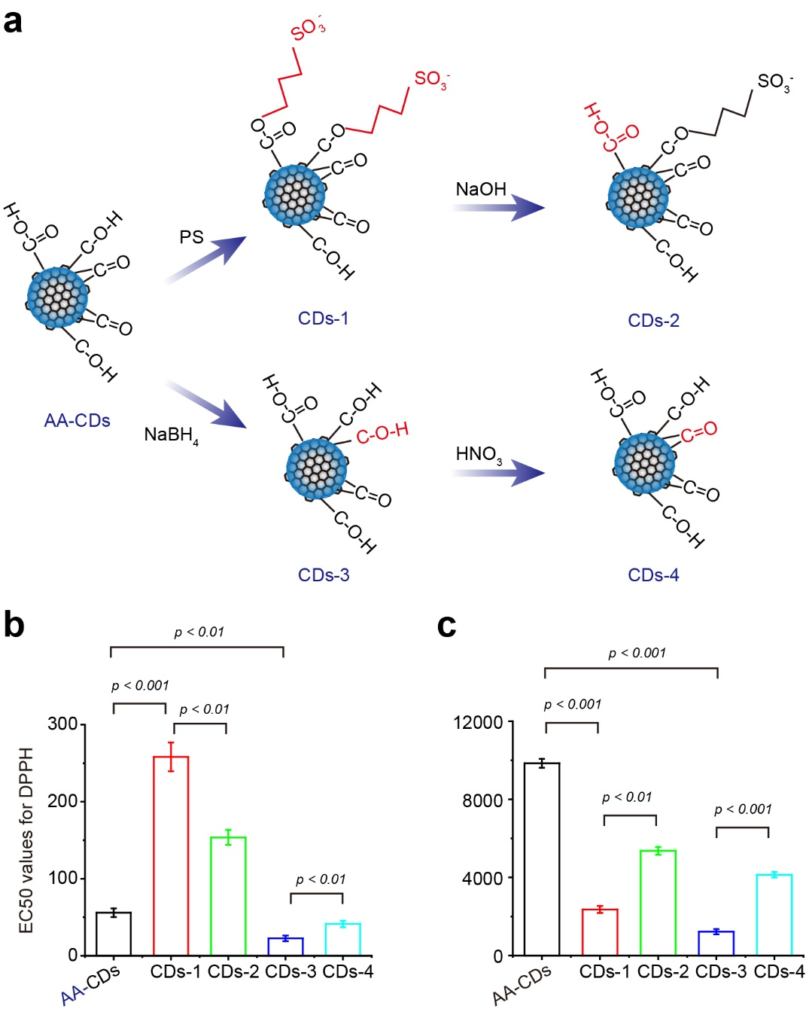
Figure S9. Surface modifications to determine ROS scavenging and the catalytic active site of SOD nanozymes of AA-CDs. (a) Illustration of AA-CDs modification. (b-c) EC50 values for DPPH radical scavenging and SOD-like activity change of AA-CDs before and after passivation, reduction, and re-oxidation.

Figure S10
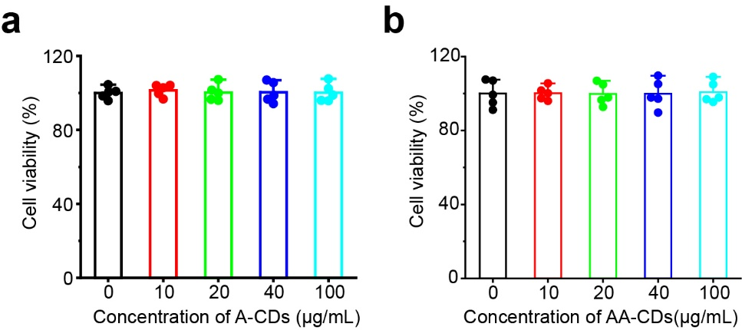
Figure S10. Chondrocyte viability measured by MTT assay after treatment with A-CDs or AA-CDs.

Figure S11
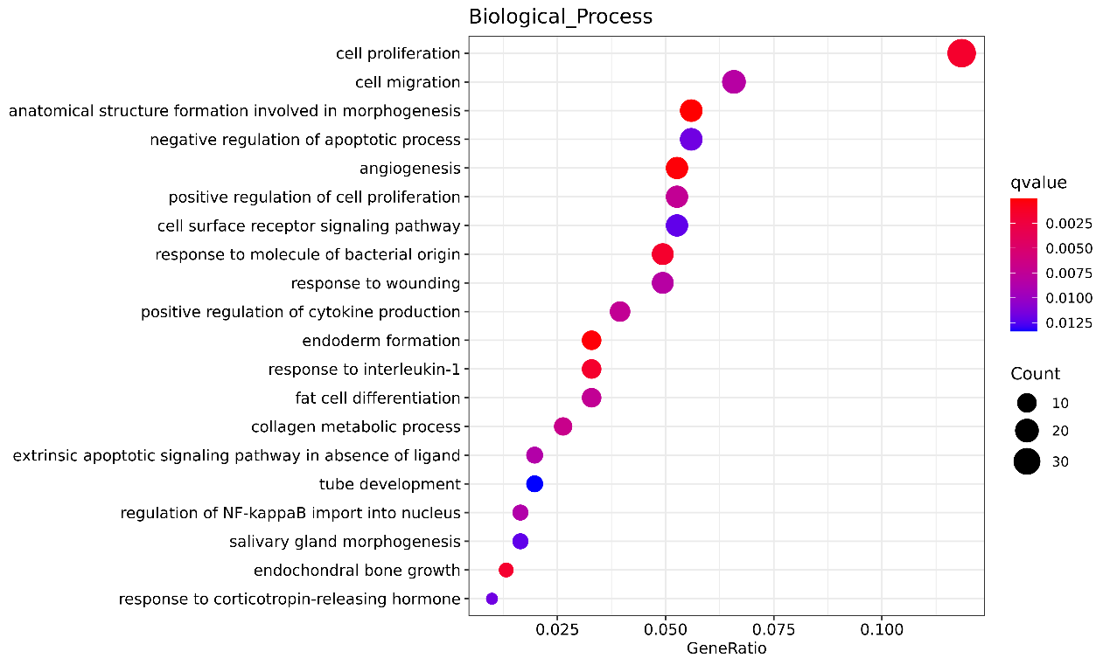
Figure S11. GO enrichment analysis of DEGs
Figure S12
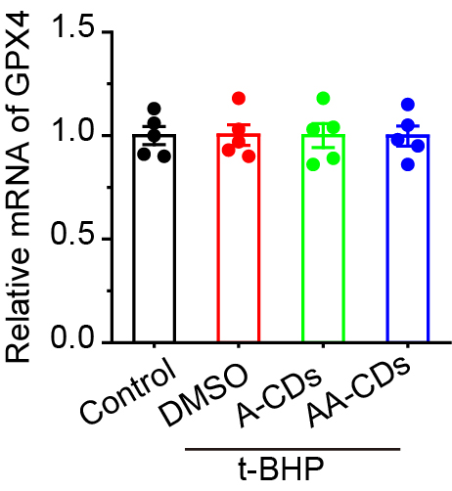
Figure S12. The mRNA expression levels of GPX4 quantified using qRT-PCR analysis

Figure S13
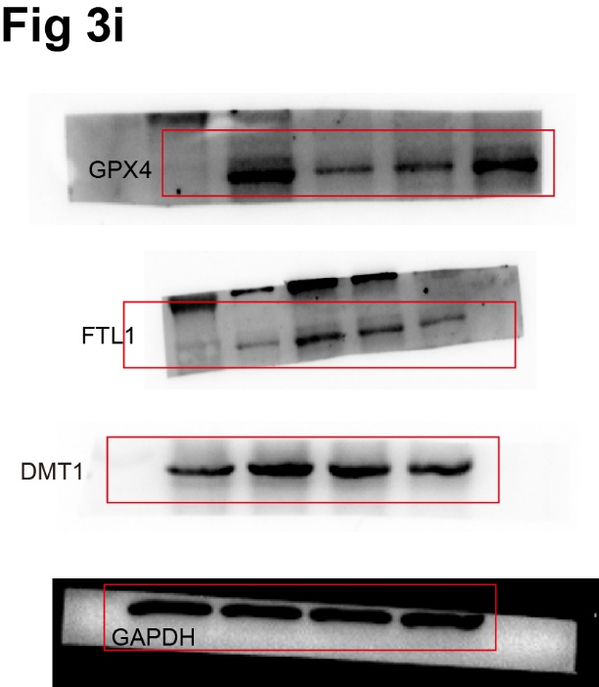

Figure S14
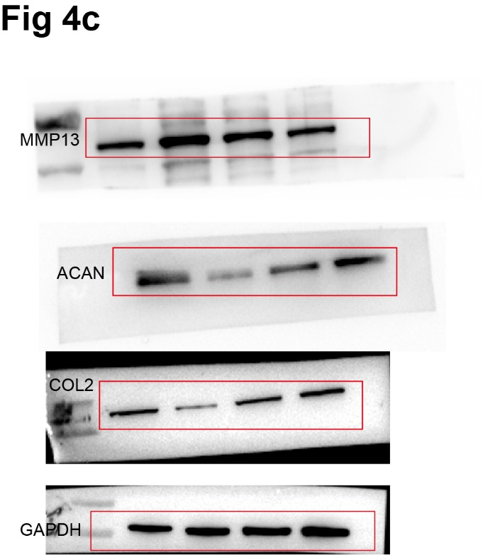

Figure S15

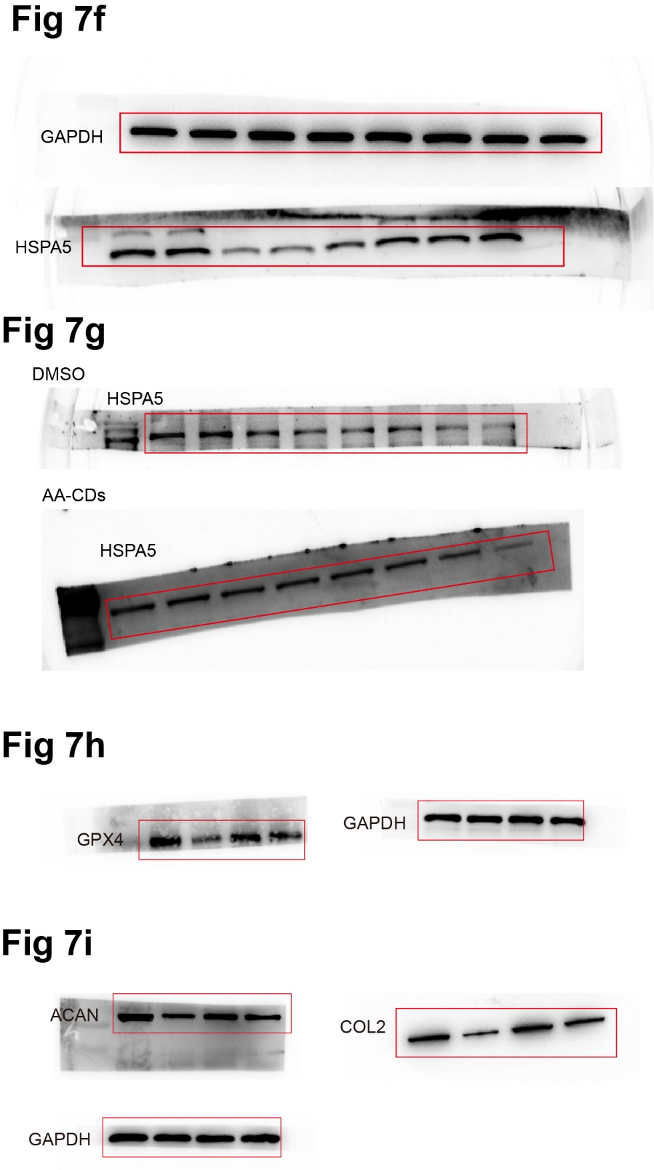

Table S1
Table S1. Detail of primary antibodies for Western blot analysis.
Name | Manufacturers | Product code | Dilution
ACAN | Proteintech | 13880-1-AP | 1/2000
COL2 | ZenBio | 340276 | 1/1000
MMP-13 | Proteintech | 18165-1-AP | 1/2000
GAPDH | ZenBio | R380646 | 1/5000
HSPA5 | ZenBio | 200310-4F11 | 1/1000
GPX4 | ZenBio | R381958 | 1/1000
TFR1 | ZenBio | R25971 | 1/1000
FTL1 | ZenBio | R380999 | 1/1000

Table S2
Table S2. Top10 of GSEA enrichment analysis.
ID | Description | NES | qvalue
ko04657 | IL-17 signaling pathway | 2.406905 | 0.018322
ko04668 | TNF signaling pathway | 2.402058 | 0.018322
ko04060 | Cytokine-cytokine receptor interaction | 2.269899 | 0.018322
ko05323 | Rheumatoid arthritis | 2.217171 | 0.018322
ko04630 | JAK-STAT signaling pathway | 2.125949 | 0.018322
ko04062 | Chemokine signaling pathway | 2.074998 | 0.018322
ko05133 | Pertussis | 2.064692 | 0.018322
ko05134 | Legionellosis | 2.027761 | 0.018322

1. Gan, X.; Liu, S.; Liu, Z.; Hu, X., Determination of Tetracaine Hydrochloride by Fluorescence Quenching Method with Some Aromatic Amino Acids as Probes. Journal of Fluorescence 2011, 22 (1), 129-135.

