Quercetin derived extracellular vesicles combined with ROS responsive hydrogel for diverse damaged tissues repair

Assessment of adhesion scoring method
The scoring criteria were as follows: a score of 0 denoted the absence of adhesion; a score of 1 indicated the presence of a single thin layer of adhesion; a score of 2 represented multiple thin-layer adhesions; a score of 3 signified the existence of thick laminin lesions; and a score of 4 reflected the attachment of thick laminae to the underlying tissue or the presence of multiple foci of thick laminae. These assessments were conducted by independent evaluators in a double-blind fashion to ensure objectivity.
Detection of anti-inflammatory and antioxidant factors in KEVs
The KEVs contain large number of anti-inflammatory and antioxidant factors, which main includs “Hippo signaling pathway”, “TGF-beta signaling pathway”, “TNF signaling pathway”, “FoxO signaling pathway”, “NF-kappa B signaling pathway”, and “NF-kappa B signaling pathway” and so on.

Fig. S1. The synthesis process of Linker.

Fig. S2. Synthesis process of PVA-Linker-CS.

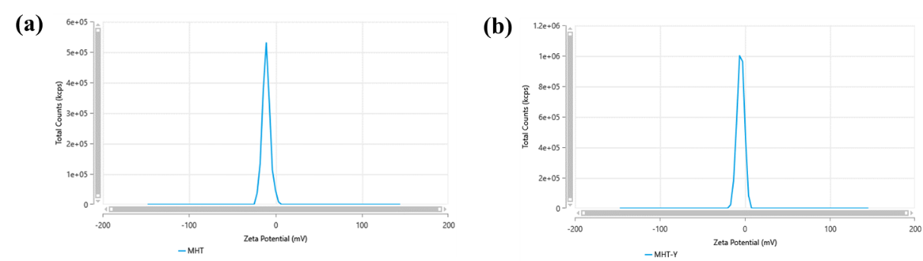
Fig. S3. Zeta distribution of KEVs before (a) and after (b) coating quercetin.

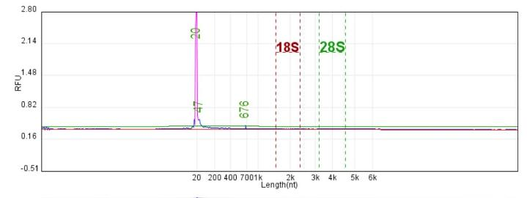
Fig. S4. Concentration of RNA.

Sample name | library concentration(ng/μL) | Total library volume(ng)
kiwi fruit | 0.812 | 11.368
Fig. S5. library concentration.

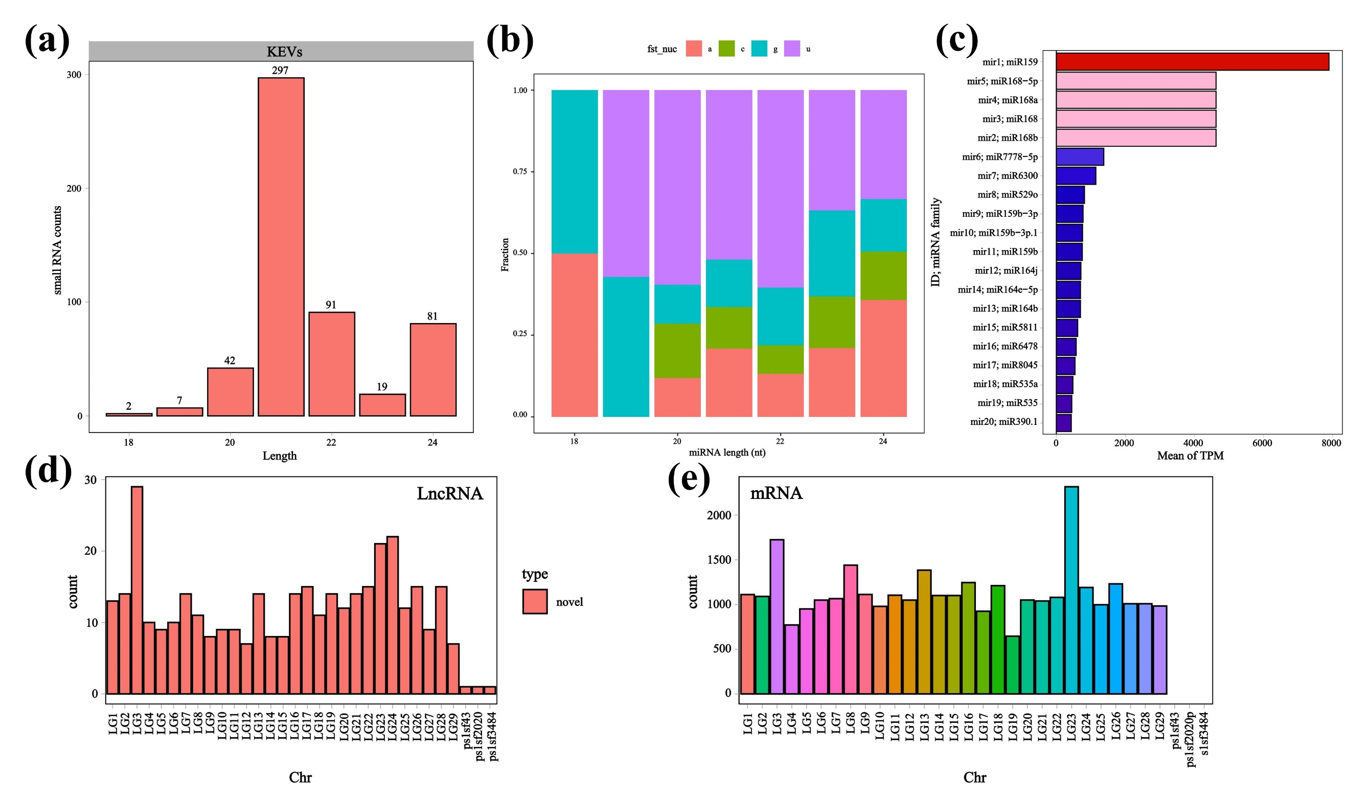
Fig.S6. RNA sequencing analysis of KEVs. (a) The length distribution of small RNAs in KEVs. (b) The proportion of miRNA bases in KEVs. (c) The top 20 of miRNA. (d) The distribution of LncRNA on the chromosome. (e) The distribution of mRNA on the chromosome.

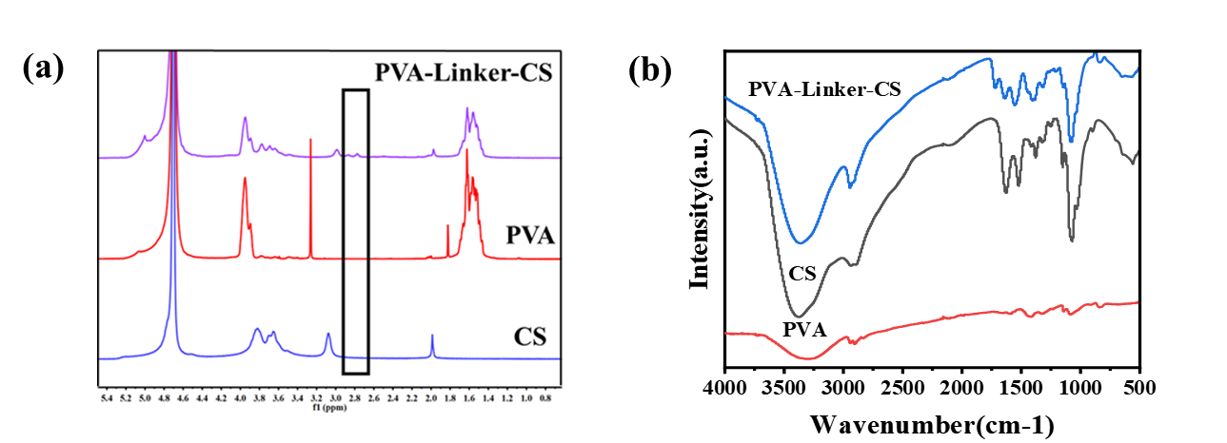
Fig.S7. (a) ¹H NMR of CS, PVA and PVA-Linker-CS. (b) FTIR of CS, PVA and PVA-Linker-CS.

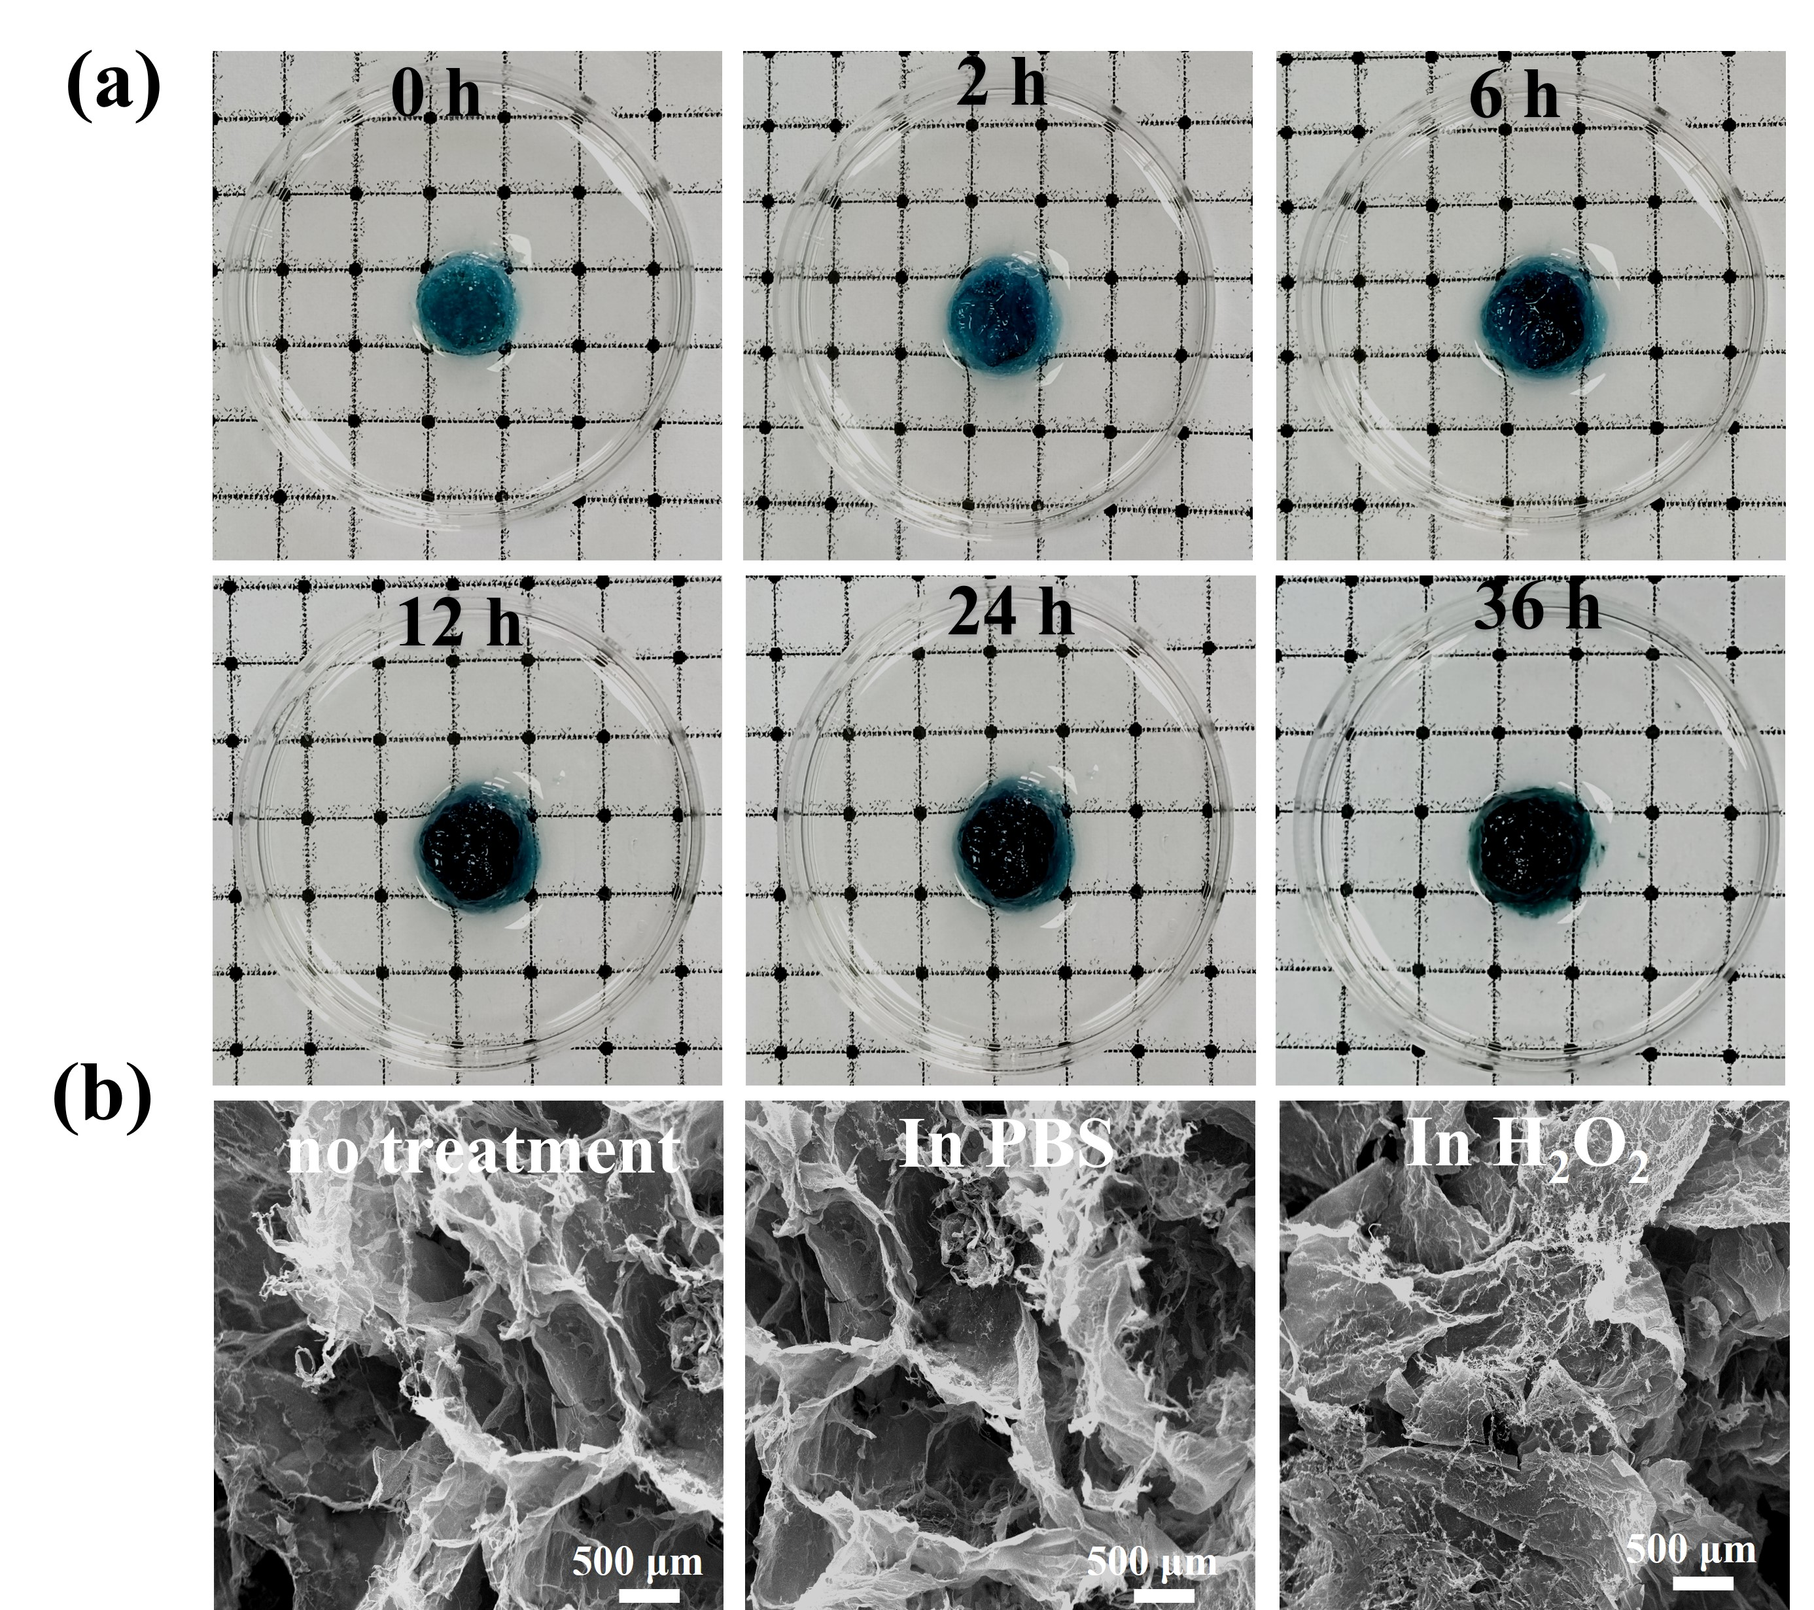
Fig.S8. (a) Swelling diagram of the hydrogel after 36 hours. (b) Electron microscope images of the degradation of hydrogel under PBS and H₂O₂ (500μm).

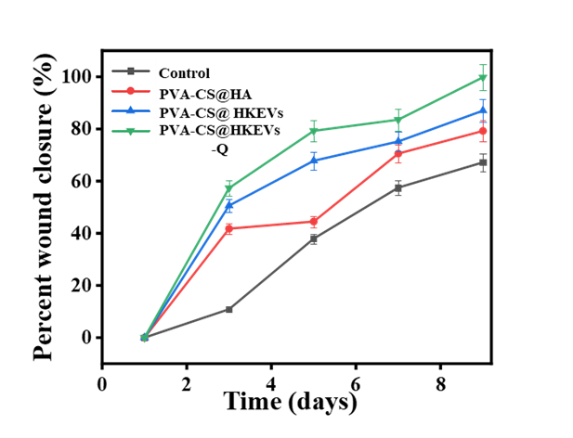
Fig.S9. Wound healing in mice on day 9.

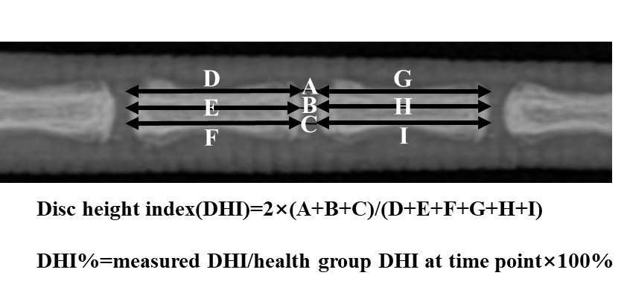
Fig.S10. DHI calculation method.

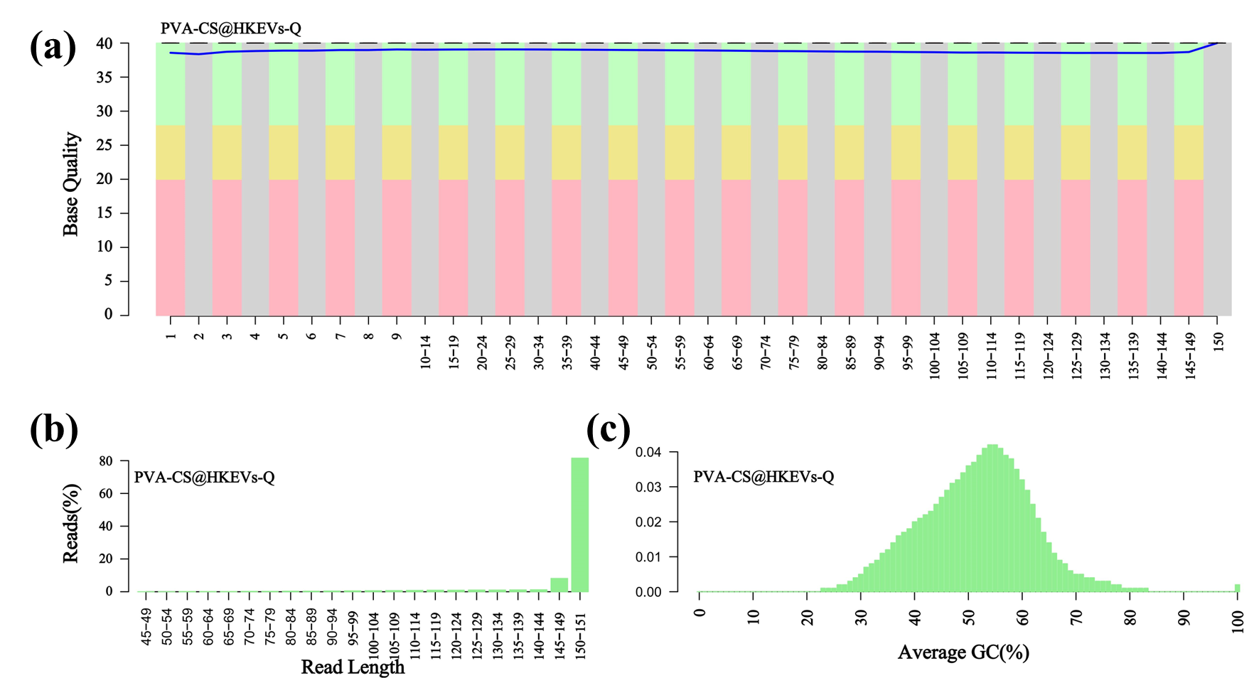
Fig.S11. (a) The mass fraction distribution map of each base position in the sequence. (b) Sequence length distribution map. (c) Percentage sequence number density distribution map.

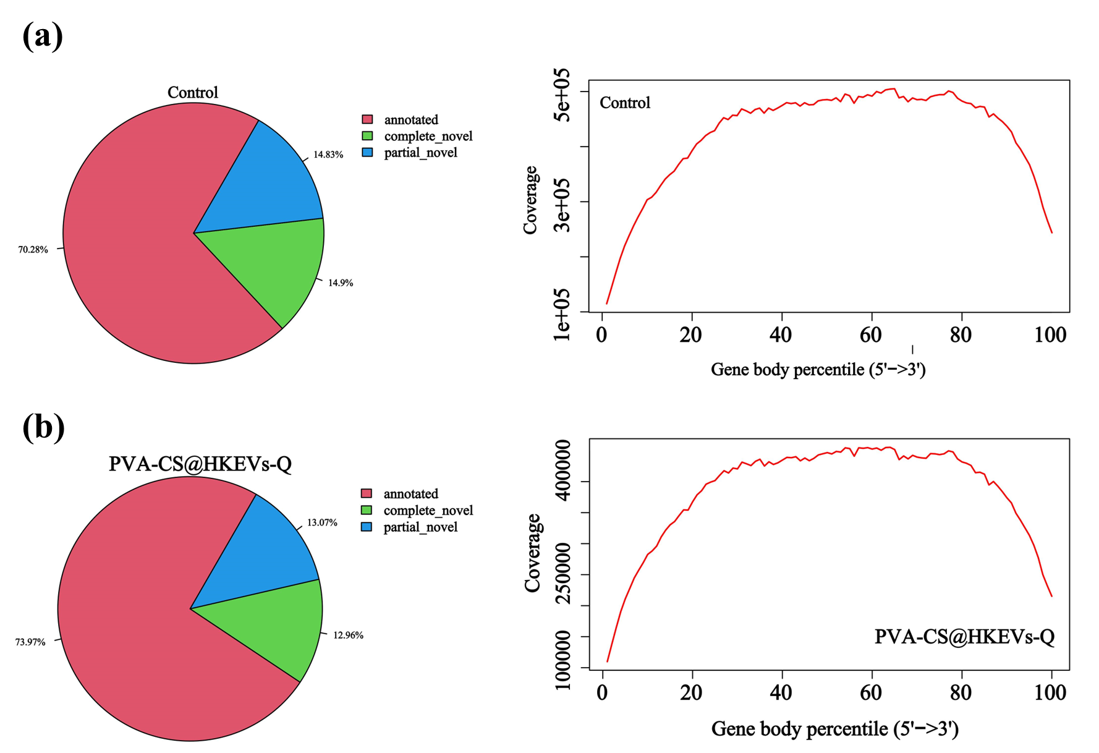
Fig.S12. (a) Pie charts of the distribution of Reads in exons, introns, and intergenomic regions in the control group, as well as the homogeneity distribution of transcript coverage. (b) Pie charts of the distribution of Reads from PVA-CS@HKEVs-Q in exons, introns, and spacer regions, as well as the homogeneity distribution of transcript coverage.

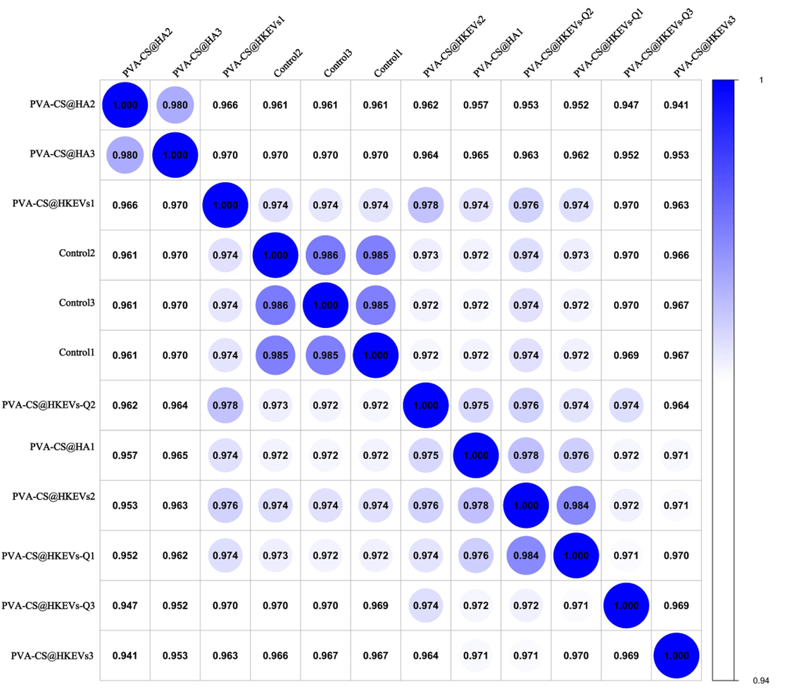
Fig.S13. Correlation coefficient clustering graph.

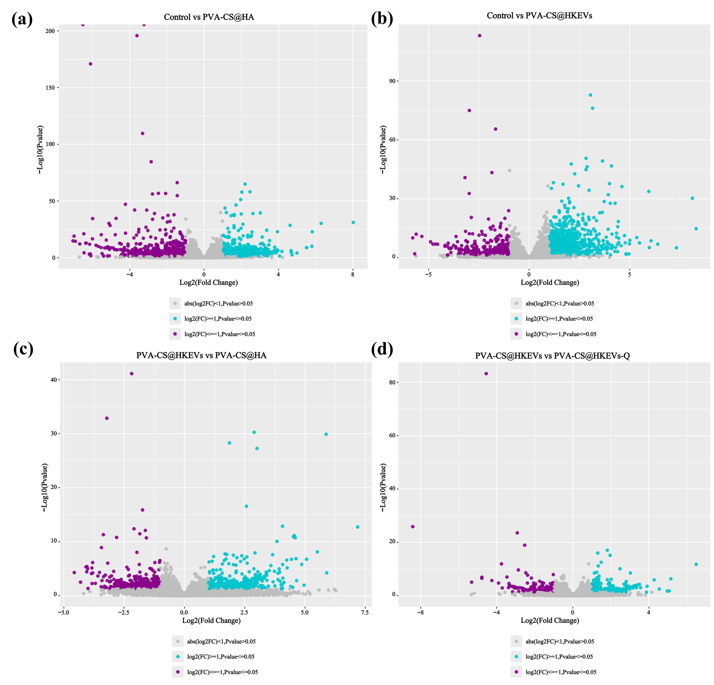
Fig.S14. (a) Volcano map of control vs PVA-CS@HA. (b) Volcano map of control vs PVA-CS@HKEVs. (c) Volcano map of PVA-CS@HKEVs vs PVA-CS@HA. (d) Volcano map of PVA-CS@HKEVs-Q vs PVA-CS@HKEVs.

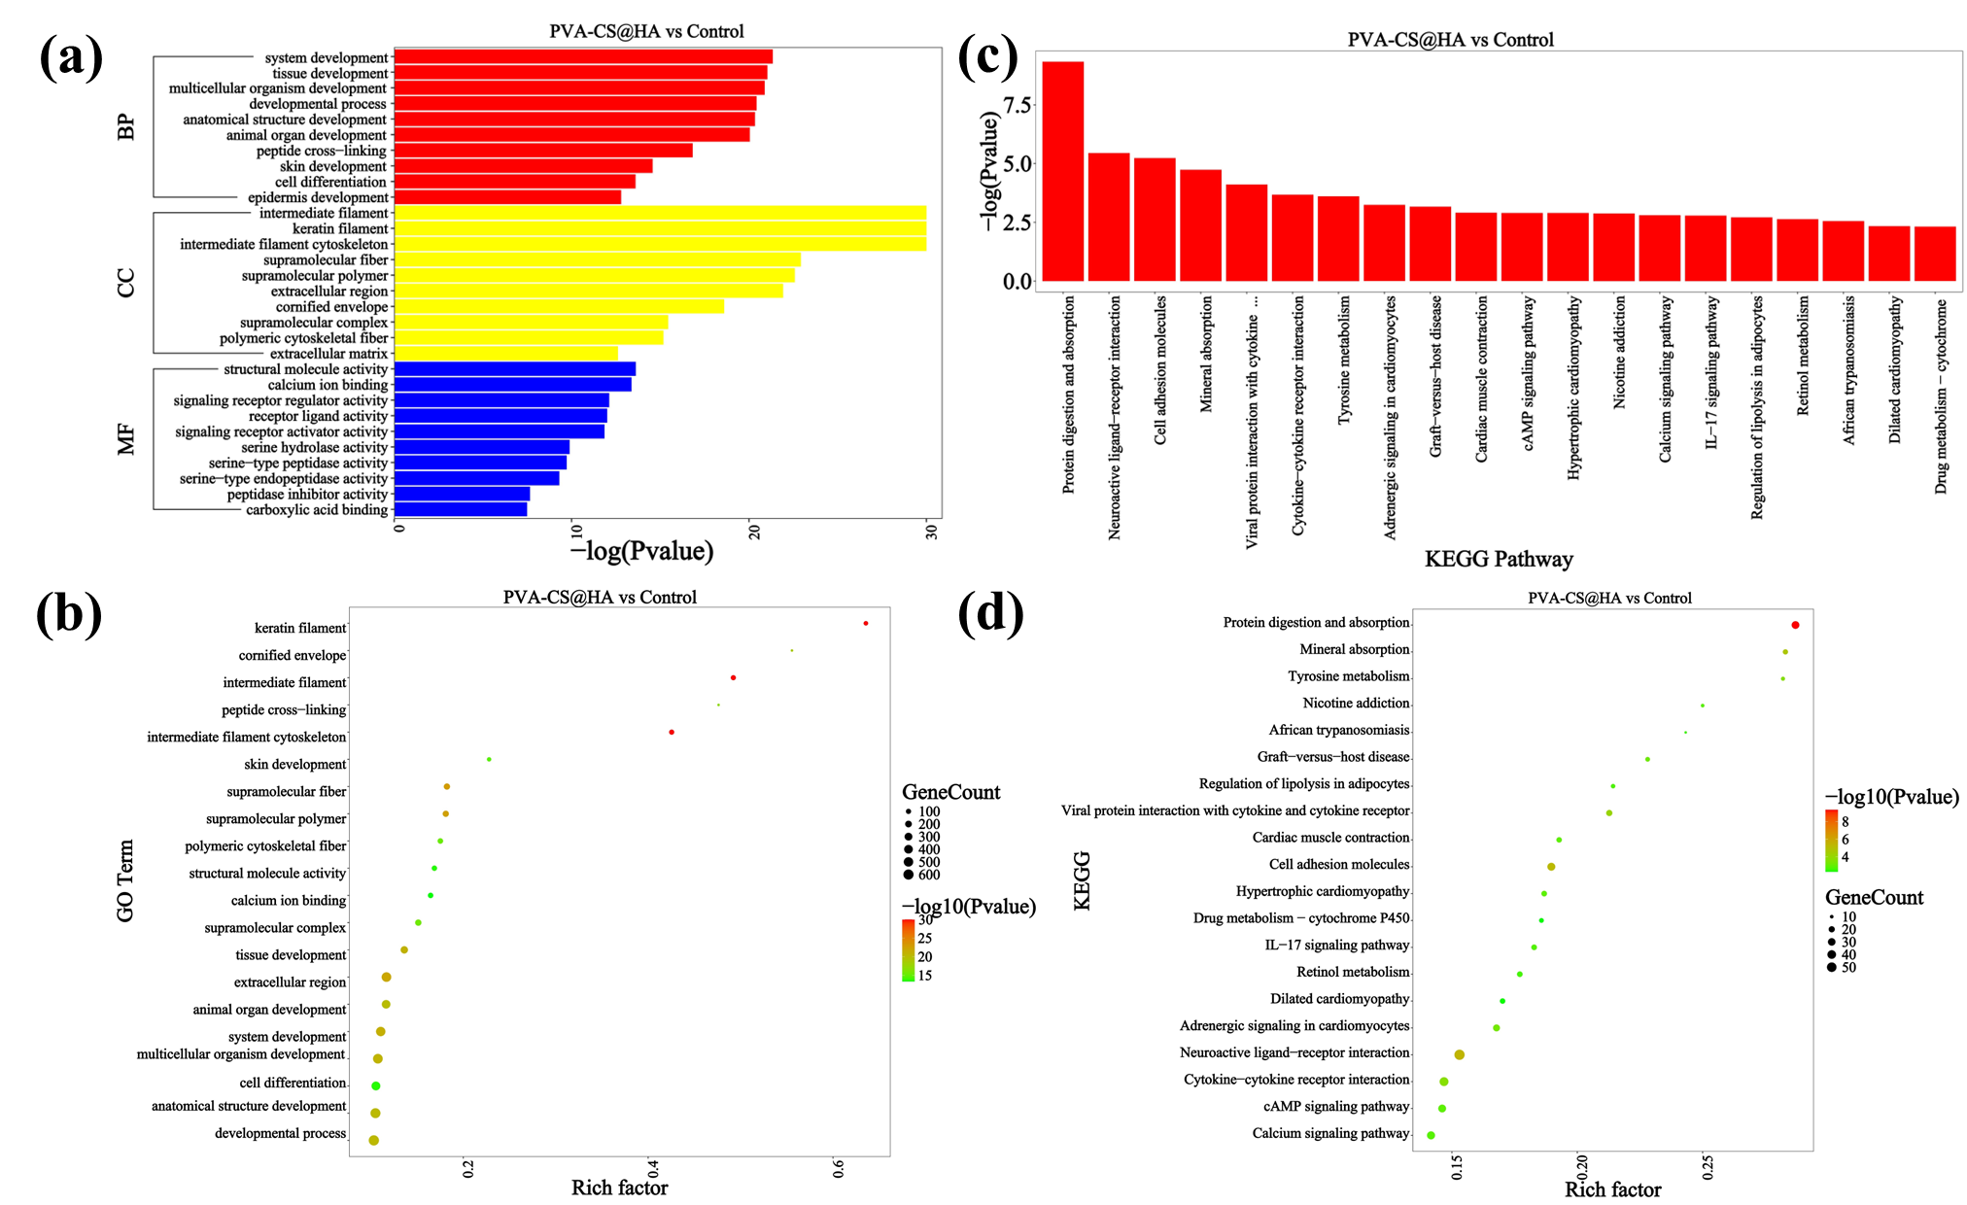
Fig.S15. GO and KEGG enrichment expression of PVA-CS@HA vs control. (a) GO enrichment bar chart. (b) GO top20 enriched bubble chart. (c) KEGG enrichment bar chart. (d) KEGG top20 enriched bubble chart.

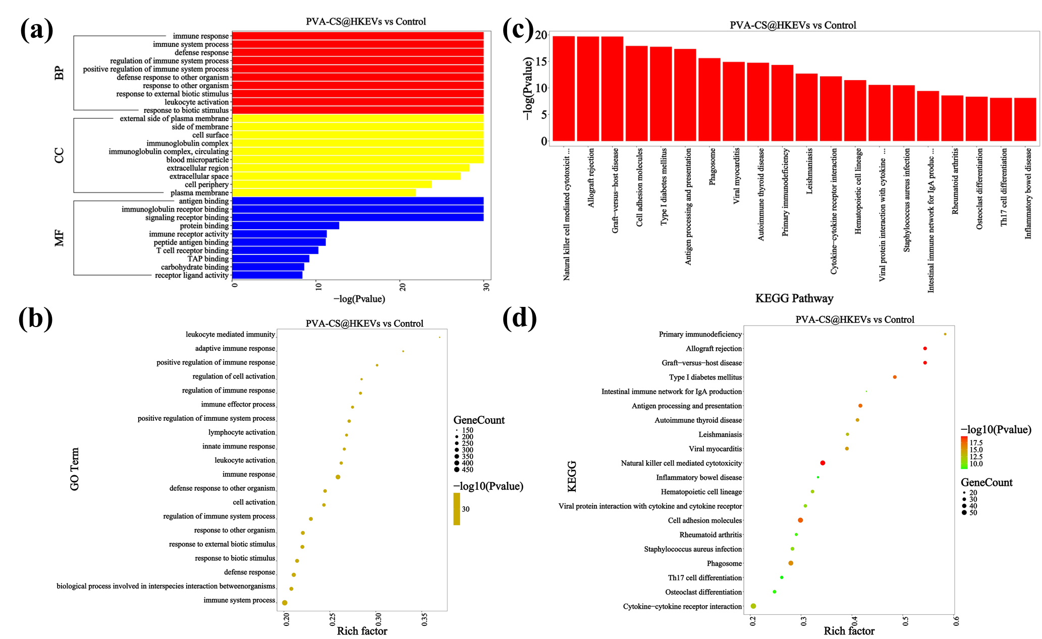
Fig.S16. GO and KEGG enrichment expression of PVA-CS@HKEVs vs control. (a) GO enrichment bar chart. (b) GO top20 enriched bubble chart. (c) KEGG enrichment bar chart. (d) KEGG top20 enriched bubble chart.

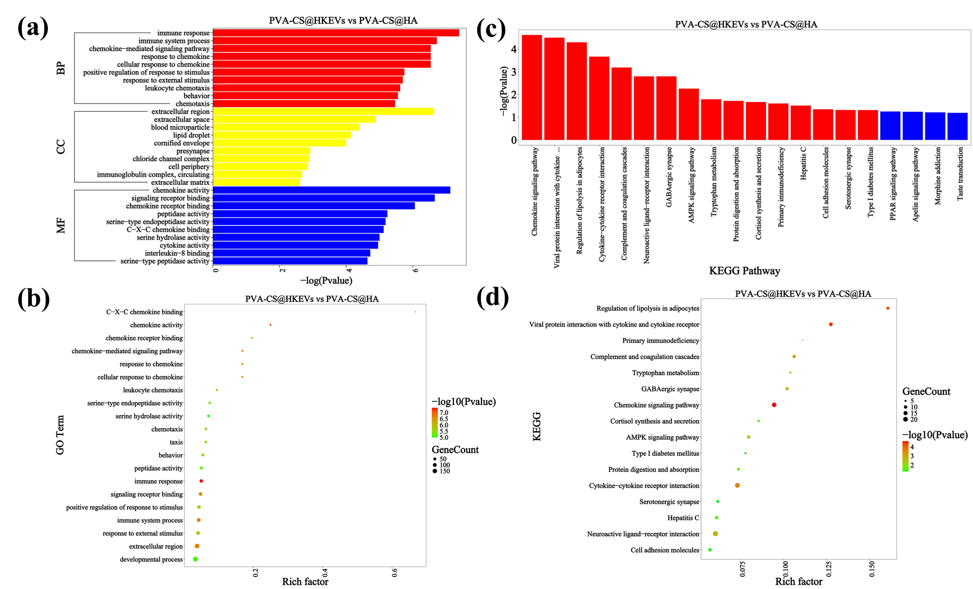
Fig.S17. GO and KEGG enrichment expression of PVA-CS@HKEVs vs PVA-CS@HA. (a) GO enrichment bar chart. (b) GO top20 enriched bubble chart. (c) KEGG enrichment bar chart. (d) KEGG top20 enriched bubble chart.

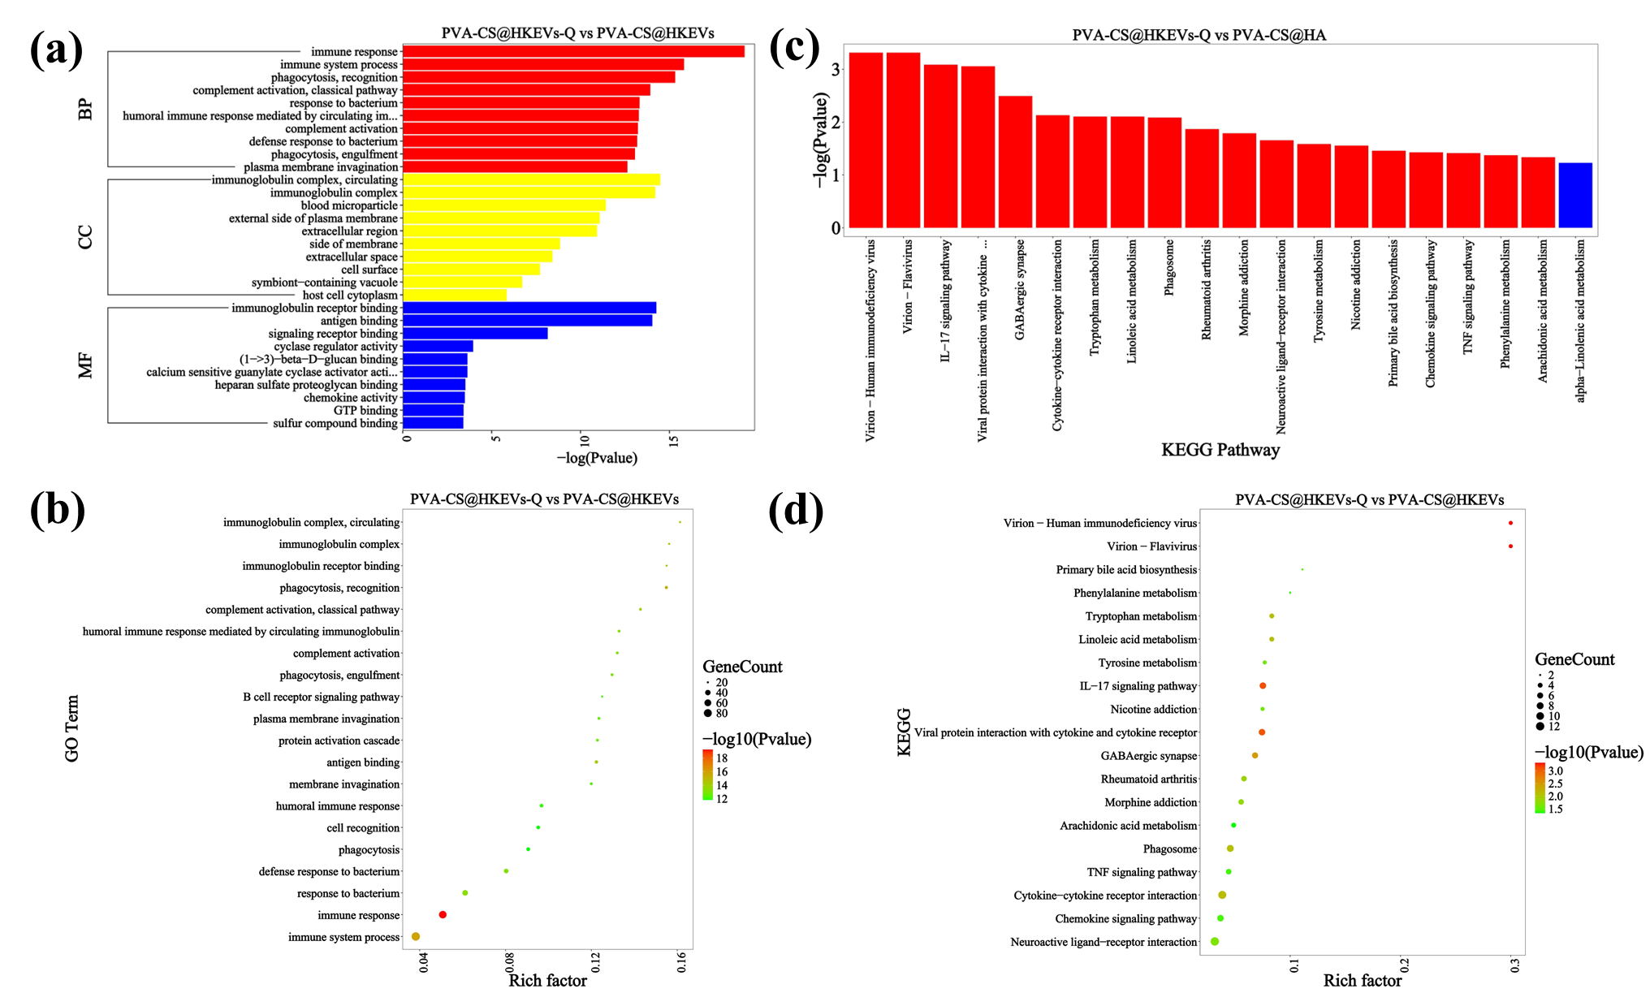
Fig.S18. GO and KEGG enrichment expression of PVA-CS@HKEVs-Q vs PVA-CS@HKEVs. (a) GO enrichment bar chart. (b) GO top20 enriched bubble chart. (c) KEGG enrichment bar chart. (d) KEGG top20 enriched bubble chart.

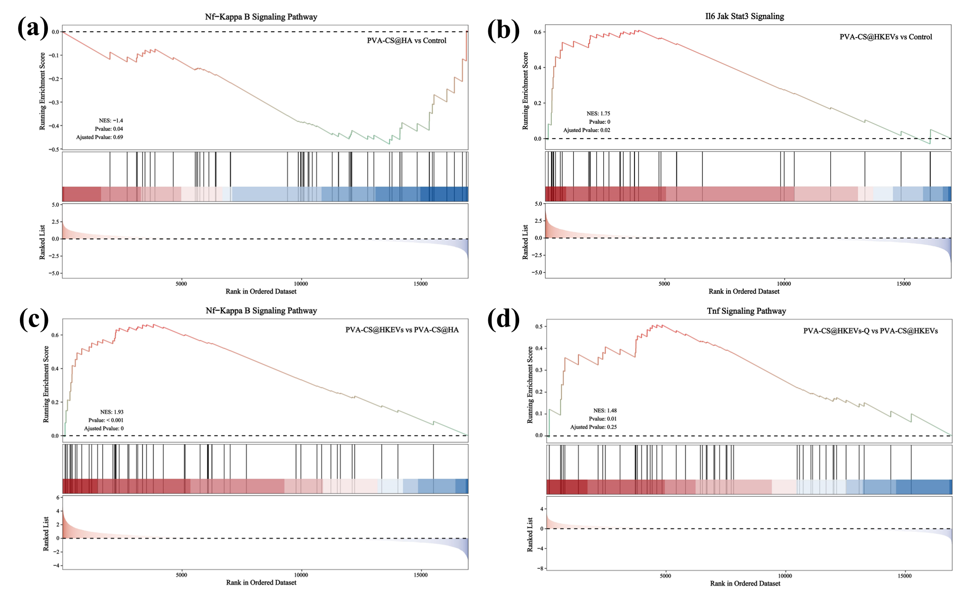
Fig.S19. (a) PVA-CS@HA vs control differentially expressed gene GSEA. (b) PVA-CS@HKEVs vs control differentially expressed gene GSEA. (c) PVA-CS@HKEVs vs PVA-CS@HA differentially expressed gene GSEA. (d) PVA-CS@HKEVs-Q vs PVA-CS@HKEVs differentially expressed gene GSEA.

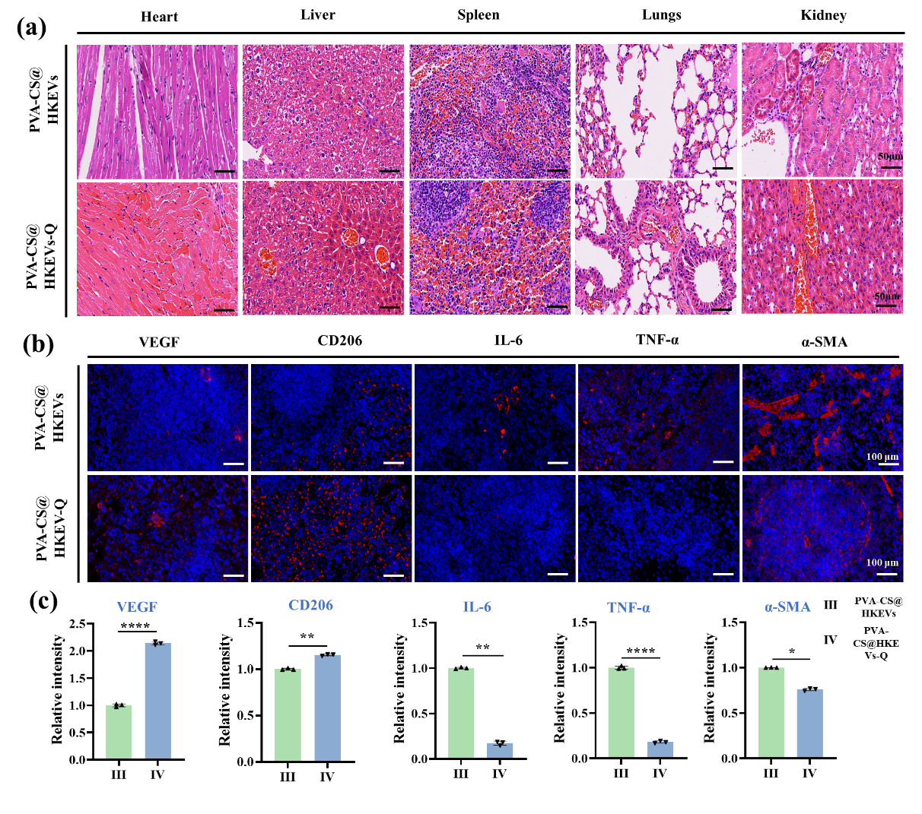
Fig.S20. Safety evaluation of heart, liver, spleen, lungs and kidneys after PVA-CS@HKEVs and PVA-CS@HKEVs treatment, H&E staining and immunofluorescence analysis of spleen were performed. (a) H&E staining of heart, liver, spleen, lungs and kidneys. (b) IL-6, TNF-α, VEGF, α-SMA and CD206 immunostaining images. (c) Qualitative analysis data of related immunostaining images.

