Additional file
Metal-ion-coordinated silk fibroin nanogels for enhanced oral chemotherapy of colorectal cancer

Baoyi Li^{1,2}, Jinhua Liu³, Xiaoyan Li², Yuting Luo², Ga Liu^{2,3}, Menghang Zu^{2,3}, Yajun Wang²*, Xiaoxiao Shi³, Rui L. Reis⁴, Subhas C. Kundu⁴, Bo Xiao^{2*}, and Zhenhua Zhu^{1,5}*

¹Department of Gastroenterology, Jiangxi Provincial Key Laboratory of Digestive Diseases, Jiangxi Clinical Research Center for Gastroenterology, Digestive Disease Hospital, The First Affiliated Hospital, Jiangxi Medical College, Nanchang University, Nanchang 330006, China
²Department of Pharmacy, Personalized Drug Therapy Key Laboratory of Sichuan Province, Sichuan Academy of Medical Sciences & Sichuan Provincial People's Hospital, School of Medicine, University of Electronic Science and Technology of China, Chengdu 610054, China
³College of Sericulture, Textile, and Biomass Sciences, Southwest University, Chongqing 400715, China
⁴3Bs Research Group I3Bs — Research Institute on Biomaterials, Biodegradables, and Biomimetics, University of Minho Headquarters of the European Institute of Excellence on Tissue Engineering and Regenerative Medicine, Barco, Guimarães 4805-017, Portugal
⁵Department of Gastroenterology, Gaoxin Branch of The First Affiliated Hospital, Jiangxi Medical College, Nanchang University, Nanchang 330096, China

*Corresponding authors.
E-mail addresses: zhuzhenhua19820122@163.com (Z.Z); bxiao@uestc.edu.cn (B.X.); yajunw24@uestc.edu.cn (W.Y.)

Supplementary experimental details
Physicochemical characterization of various SFNPs
Hydrodynamic particle sizes, polydispersity index (PDI), and zeta potentials were measured using DLS (Zetasizer Nano ZS, Malvern, UK). Morphology was observed by transmission electron microscopy (TEM, JEM-2100, JEOL, Japan).
For quantification of 5-FU, equal amounts of freeze-dried NPs were dissolved, and the released 5-FU was quantified by HPLC using an external standard calibration curve. The obtained values were expressed as 5-FU content to enable comparison among different NP formulations.
The 5-FU concentration was quantified by HPLC equipped with a C18 reversed-phase column (250 mm × 4.6 mm, 5 μm). The mobile phase consisted of water and methanol (95:5, v/v) containing 0.1% formic acid, delivered at a flow rate of 0.8 mL/min. The detection wavelength was set at 266 nm using a UV detector maintained at 25 °C. Calibration curves constructed from standard solutions were applied for quantification. All samples were filtered through a 0.22 μm membrane prior to injection.
DOX was used solely as a fluorescent tracer and not as a therapeutic agent. DOX loading in SFNPs was quantified based on its intrinsic fluorescence following NP dissolution. Briefly, SFNP samples were dissolved in DMSO to completely release encapsulated DOX. The fluorescence intensity of the resulting solutions was measured with a spectrofluorometer at appropriate excitation and emission wavelengths characteristic of DOX (480 nm excitation and 560 nm emission). A calibration curve was constructed from serial dilutions of free DOX in the same solvent system. The DOX loading content in SFNPs was then calculated by comparing sample fluorescence to the standard curve.
Metal content analysis
Ni and Cu contents in the samples were quantified using ICP-OES. Samples (10 mg) were digested in a Teflon vessel containing 6 mL of concentrated HNO₃ and 1 mL of H₂O₂, diluted to 25 mL, filtered through a 0.22 µm membrane, and analyzed against calibration curves prepared in 2% HNO₃.

Redox-responsiveness assay and DLS measurement
SFNP suspensions (0.5 mg/mL in PBS, pH 7.4) were incubated in PBS, 100 μM H₂O₂, or 10 mM GSH. Samples were incubated at 37 °C under gentle shaking (100 rpm) for 12 h. After equilibration to room temperature, hydrodynamic size was measured by DLS.

In vitro drug release behavior
The in vitro release behavior of 5-FU was investigated using the dialysis diffusion method. SFNP suspensions containing an equivalent dose of 5-FU (200 μg) were sealed in dialysis membranes (MWCO = 3.5 kDa) and immersed in PBS (pH 7.4, 20 mL) under various redox conditions, including 100 μM H₂O₂, 10 mM GSH, or 100 μM H₂O₂ + 10 mM GSH. Samples were incubated at 37 °C with gentle shaking (100 rpm). At predetermined time points, the releasing medium was sampled and replenished with an equivalent volume of fresh releasing medium. Subsequently, the concentration of the released 5-FU was quantified using a multimode microplate reader (Spark-10 M, Tecan, Switzerland) at a wavelength of 266 nm.

Cell lines and animals
Murine CT-26 cells (ATCC: CRL-2638) were obtained from the Shanghai Cell Bank of the Chinese Academy of Sciences (Shanghai, China). Cells were cultured in DMEM supplemented with 100 U/mL penicillin, 0.1 mg/mL streptomycin, and 10% FBS in an incubator supplied 37 °C in a humidified 5% CO₂ incubator.
The animal protocols were approved by the Institutional Animal Care and Use Committee (IACUC-20240520-03) of Southwest University. BALB/c mice (female, 6-8 weeks old) were obtained from Chongqing Ensville Biotechnology Co., Ltd. (Chongqing, China). The CRC mouse model was induced by intraperitoneal injection of AOM (10 mg/kg) on day 0, followed by 3.5% DSS (MW = 36-50 kDa) solution in drinking water during week 2. From week 3, the mice had unrestricted access to drinking water and diet, while in week 4, drinking water was replaced with DSS solution (3.5%, w/v) for one week.

In vitro cellular uptake profiles of SFNPs by colon carcinoma cells
CT-26 cells (2 × 10⁵) were cultured in 12-well plates and incubated overnight. Dox@SFNP (Dox: 1 μg/mL) suspensions were added and cultured for 0, 1, 3, and 5 h, respectively. After being rinsed 3 times with PBS, the cells were ready for flow cytometry (FCM, CYTOFLEX, Beckman Coulter, USA) quantification. For FCM analysis, the cells were harvested, suspended in PBS, and analyzed by FCM using the PE fluorescence channel.

Live/dead staining of SFNP-treated colon carcinoma cells
Live/dead staining using Calcein AM and propidium iodide (PI) dyes was applied for comprehensive anti-tumor assessment. CT-26 cells (2 × 10⁵) were cultured in 12-well plates and incubated overnight. Thereafter, the complete medium was replaced with basic medium containing FU@SFNPs, FU-Ni@SFNPs, or FU-Cu@SFNPs (5-FU: 12 μg/mL). After washing with PBS containing Ca²⁺ and Mg²⁺, cells were stained with Calcein AM and PI, and imaged by confocal laser scanning microscopy (CLSM, FV3000, Olympus, Japan).

Detection of ROS in SFNP-treated colon carcinoma cells
CT-26 cells (2 × 10⁵) were cultured in 12-well plates and incubated overnight. Thereafter, the complete medium was replaced with basic medium containing FU@SFNPs, FU-Ni@SFNPs, or FU-Cu@SFNPs (5-FU: 12 μg/mL). After 5-h incubation, the culture medium was replaced with 500 μL of DCFH-DA solution (10 μM) and further incubated for 30 min. The cells were washed 3 times with PBS, followed by incubation with Hoechst 33342 for 20 min, and imaged using CLSM (FV3000, Olympus, Japan).

Ex vivo biodistribution of NPs
The Dox@SFNPs (Dox: 5 mg/kg) were orally administered to mice to evaluate their tissue biodistribution (Dox was used only for fluorescence tracking). Before oral administration, the SFNPs were incorporated into a hydrogel carrier to enhance their gastrointestinal stability. At predetermined time intervals (6, 12, 24, 48, and 72 h), the mice were euthanized and their entire gastrointestinal tract (including the stomach, small intestine, and colon), as well as the five principal organs (heart, liver, spleen, lung, and kidney) were analyzed for fluorescence profiles using in vivo IVIS fluorescence imaging system (Chemidoc Touch, Bio-Rad, USA).
To further determine the accumulation profiles of NPs in the colorectal tumor tissues, mice with AOM/DSS-induced colon tumors were orally administered with Dox-Ni@SFNPs and Dox-Cu@SFNPs (Dox: 5 mg/kg). Before oral administration, the SFNPs were incorporated into a hydrogel carrier to enhance their gastrointestinal stability. The mice were euthanized 6 h post-administration. The colons were excised, embedded in optimal cutting temperature (OCT) compound, sectioned at a thickness of 5 μm, and stained with DAPI to visualize nuclei (Blue). The colon tumor tissue sections underwent image processing via CLSM (FV3000, Olympus Corporation, Japan).

Preparation of chitosan/alginate hydrogel embedding SFNPs
Chitosan solution was prepared by dissolving chitosan (0.3 g) in 50 mL of 0.5% (v/v) acetic acid under magnetic stirring for 3 h to obtain a 0.6% (w/v) chitosan solution (solution A). Sodium alginate solution was prepared by dissolving sodium alginate (0.7 g) in 50 mL of 0.15 M NaCl solution with continuous stirring for 3 h to obtain a 1.4% (w/v) alginate solution (solution B).
For ionic crosslinking, Ca²⁺/SO₄²⁻ mixed solution (solution C) was prepared by dissolving CaCl₂·2H₂O (0.4116 g) and Na₂SO₄ (0.1704 g) in 40 mL of deionized water.
SFNPs were first homogeneously dispersed in solution B, followed by mixing with solution A at a volume ratio of 7:3 (A:B). The resulting mixture was gently pipetted to ensure uniformity and immediately administered to mice by oral gavage (150 μL per mouse). Subsequently, solution C (50 μL per mouse) was administered as a second gavage to induce in situ ionic crosslinking between polysaccharides, leading to rapid hydrogel formation in the gastrointestinal tract.
This two-step oral administration strategy enables in situ formation of chitosan/alginate hydrogel encapsulating SFNPs, similar to previously reported polysaccharide-based ion-crosslinked oral hydrogel systems.
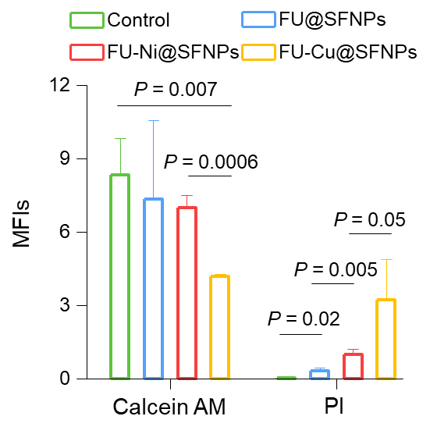
Figure S1. MFIs of live/dead staining CT-26 cells after different treatments. Data are expressed as mean ± s.e.m. (n = 3).

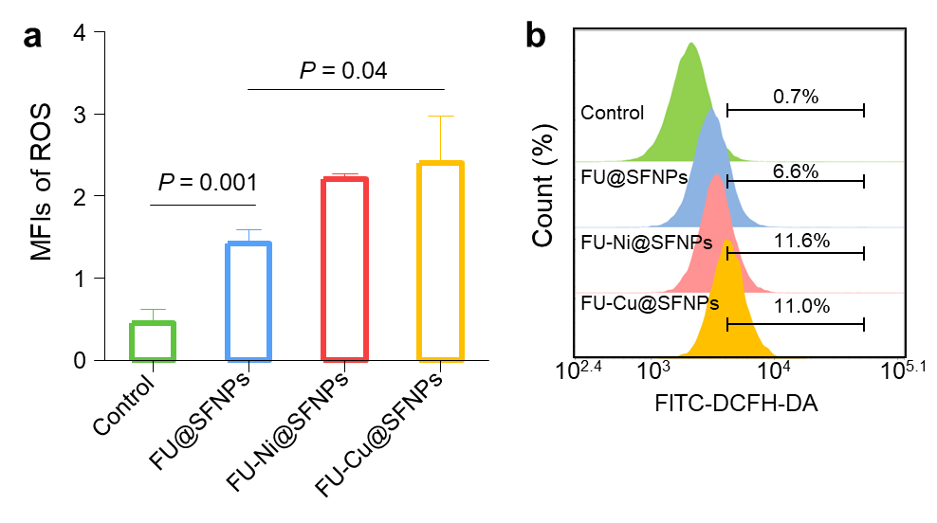
Figure S2. (a) MFIs of ROS staining CT-26 cells after different treatments. (b) Flow cytometric histograms of ROS profiles of SFNPs. Data are expressed as mean ± s.e.m. (n = 3).

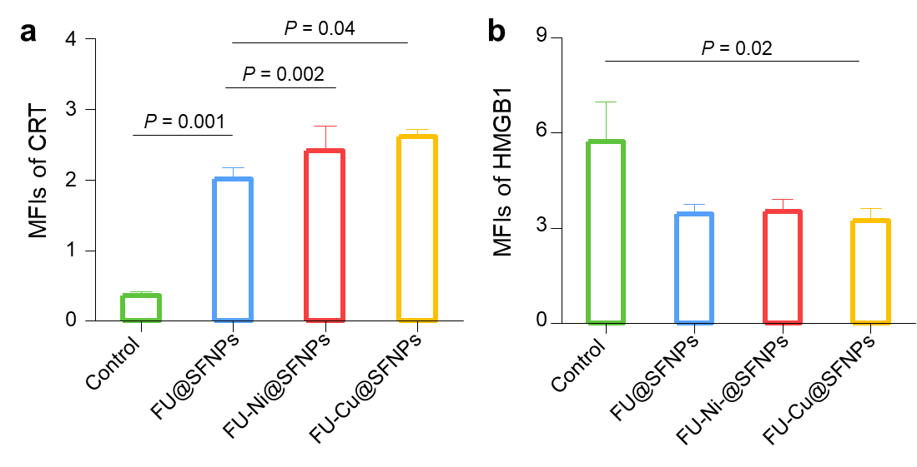
Figure S3. MFIs of (a) CRT and (b) HMGB1 staining CT-26 cells after different treatments. Data are expressed as mean ± s.e.m. (n = 3).

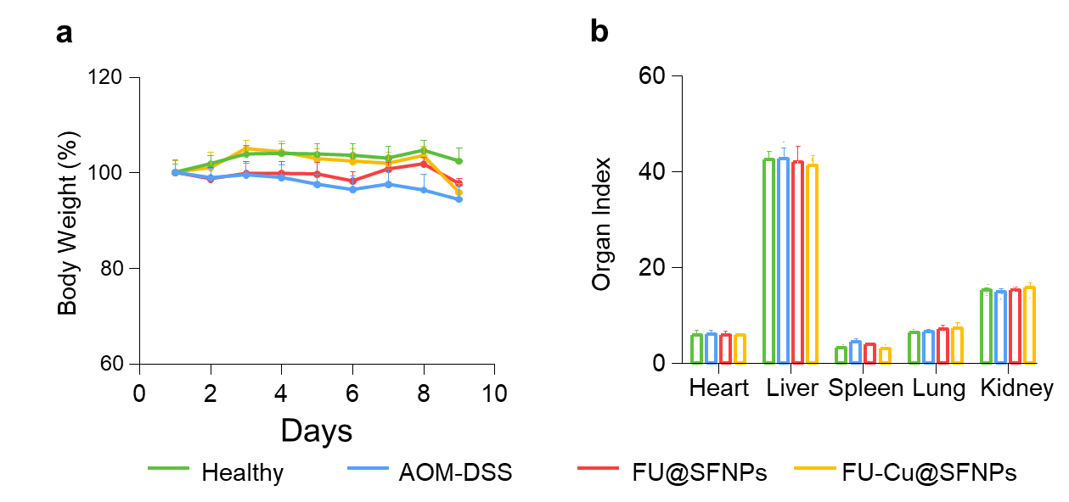
Figure S4. (a) Body weight variations of mice bearing AOM/DSS-induced colorectal tumors during the entire treatment period. (b) Organ indexes of mice with AOM/DSS-induced colorectal tumors at the end of experiments. Data are expressed as mean ± s.e.m. (n = 5).

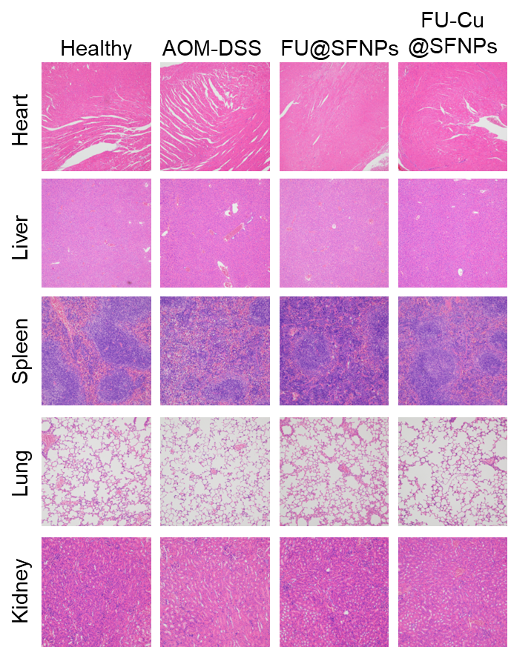
Figure S5. H&E staining of the five principal organs from mice with AOM/DSS-induced colorectal tumors after different treatments. Scale bar = 100 μm.

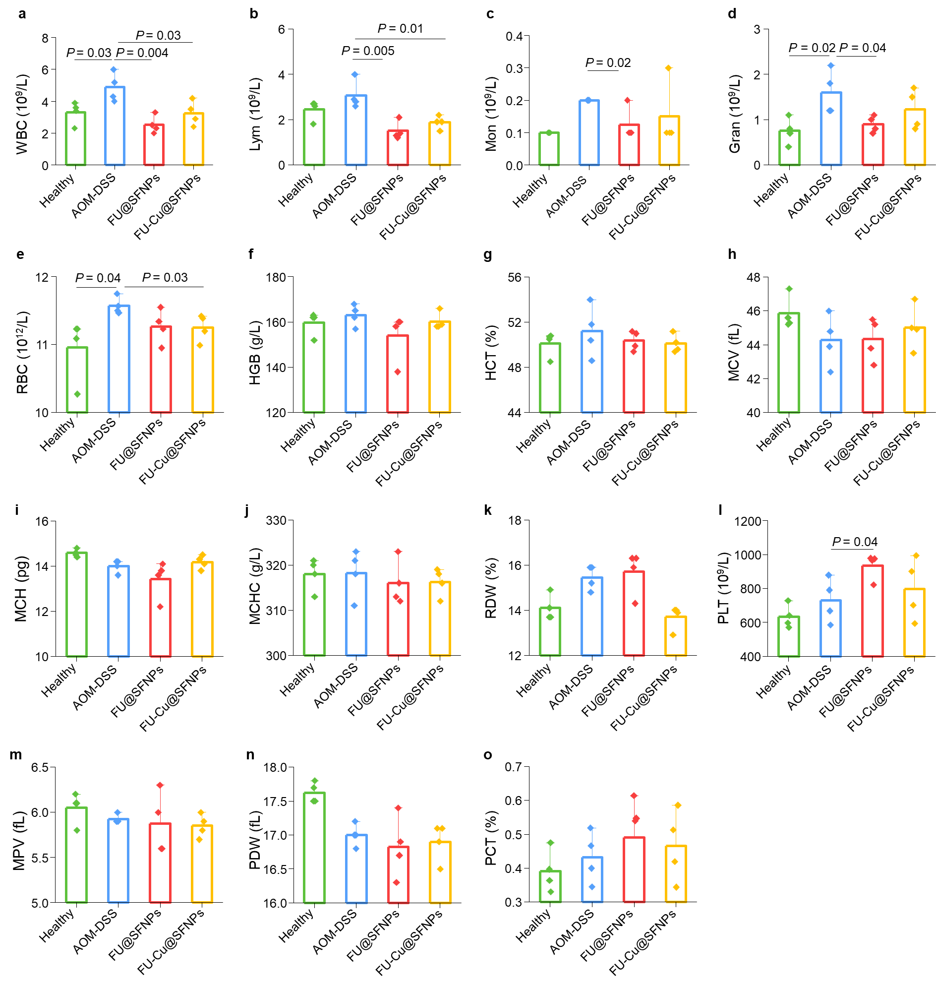
Figure S6. Hematological analysis of mice with AOM/DSS-induced colorectal tumors from mice after different treatments. Data are expressed as mean ± s.e.m. (n = 4).
Table S1. Particle sizes, PDIs, zeta potentials, drug loading efficiencies, and encapsulation efficiencies (EE%) of different NPs. Each value represents the mean ± s.e.m. (n = 3).
 | FU@SFNPs | FU-Ni@SFNPs | FU-Cu@SFNPs
Particle size (nm) | 234.9 | 239.1 | 217.3
PDI | 0.156 | 0.058 | 0.124
Zeta potential (mV) | -38.0 | -21.4 | -22.0
EE% | 77.7% | 53.2% | 58.9%

