Supporting Information

Flos Sophorae Immaturus exosome-like nanovesicles alleviate ulcerative colitis by attenuating intestinal oxidative stress and inflammation through activating aryl hydrocarbon receptor via gut microbiota and tryptophan metabolism regulation

Hao Wu¹, Mi-mi Pang², Yao-lei Li³, Jin-jian Huang⁴, Shi-zhen Geng¹, Jia-hui Hong¹, Pan-miao Liu¹*, and Jian-jun Yang^{1,5}*

¹Department of Anesthesiology, Pain and Perioperative Medicine, The First Affiliated Hospital of Zhengzhou University, Zhengzhou 450000, China
²Henan Key Laboratory of Chronic Disease Prevention and Therapy & Intelligent Health Management, The First Affiliated Hospital of Zhengzhou University, Zhengzhou 450000, China
³National Institutes for Food and Drug Control, Beijing 102629, China
⁴Institute of Information on Traditional Chinese Medicine, China Academy of Chinese Medical Sciences, Beijing 100700, China
⁵Department of Anesthesiology and Perioperative Medicine, The First Affiliated Hospital of Nanjing Medical University, Nanjing 210029, China.

*Corresponding Authors:
Jian-jun Yang, MD, PhD (e-mail: yjyangjj@126.com). Pan-miao Liu, MD, PhD (e-mail: liupan3374@126.com). The First Affiliated Hospital of Zhengzhou University, East Jian-she Road, Er-qi District, Zhengzhou 450000, China.

Figure S1: (A)The main components of the lipids in FSIEVs. (B) The number of lipid categories in the top-ranked FSIEVs. (C) Western blot analysis for the expression of PEN1 in FSIEVs.

Species spectrum analyses of OTU (Operational Taxonomic Unit) number sorting rank, Pan, and Core were conducted for each group of samples. The results indicated that the number of intestinal microbiota species and the sequencing sample size of each group of samples were sufficient to support further analysis.
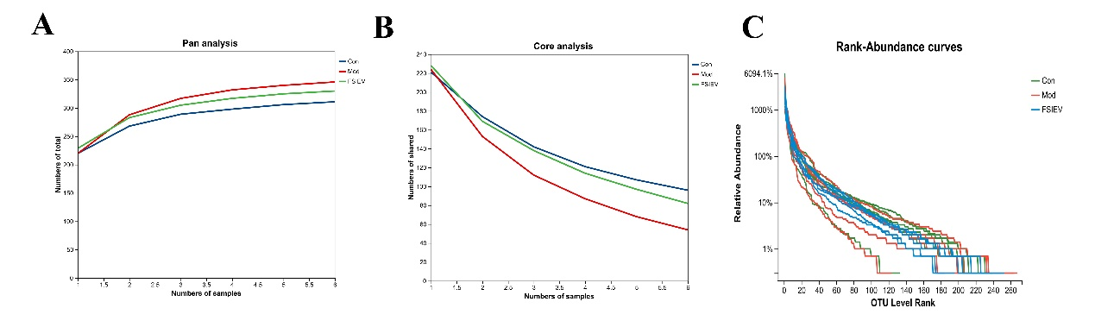
Figure S2: (A) Pan analysis. (B) Core analysis. (C) OUT rank.

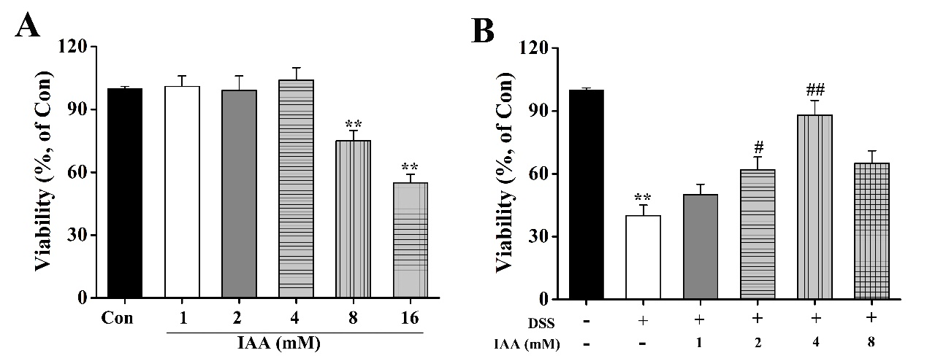
Figure S3: Effect of IAA on viability in intestinal organoids. (A) The viability of organoids was evaluated in IAA administration. (B) The viability of organoids was detected in IAA administration and exposure to DSS (0.01%) stimulation. All data are expressed as mean ±S.E.M. (n=6). **P < 0.01 compared with the control group (Con), #P < 0.05 and ##P < 0.01 compared with the DSS group.

Table S1: Primer sequences used for relative-quantification of Lactobacillus species by qRT-PCR.

Specificity | Primers | Squence (5ʹ-3ʹ)
L. paracasei | L. pa-F | GGATTGGGTTTTGCGTGATGGTCGC
L. paracasei | L. pa-R | TGCATTTCCCCGCTTTCATGACT
L. iners | L.in-F | GTCTGCCTTGAAGATCGG
L. iners | L.in-R | ACAGTTGATAGGCATCATC
L.reuteri | L. re-F | CAGACAATCTTTGATTGTTTAG
L.reuteri | L. re-R | GCTTGTTGGTTTGGGCTCTTC
L. casei | L. ca-F | CAGCGCTGGTGGAAGACTTG
L. casei | L. ca-R | TGCATTTCCCCGCTTTCATGACT
L.helveticus | L.hel-F | GCAGCAGAACCAGCAGATTT
L.helveticus | L.hel-R | GCATCATTGCCTTGGTAAGC
L.curvatus | L.cur-F | GACCCATGCCTTTAATACGCATAGTCAAGC
L.curvatus | L.cur-R | CTGAAATAACCACTATAGCCACCCC

