Supplementary Figures
Figure S1
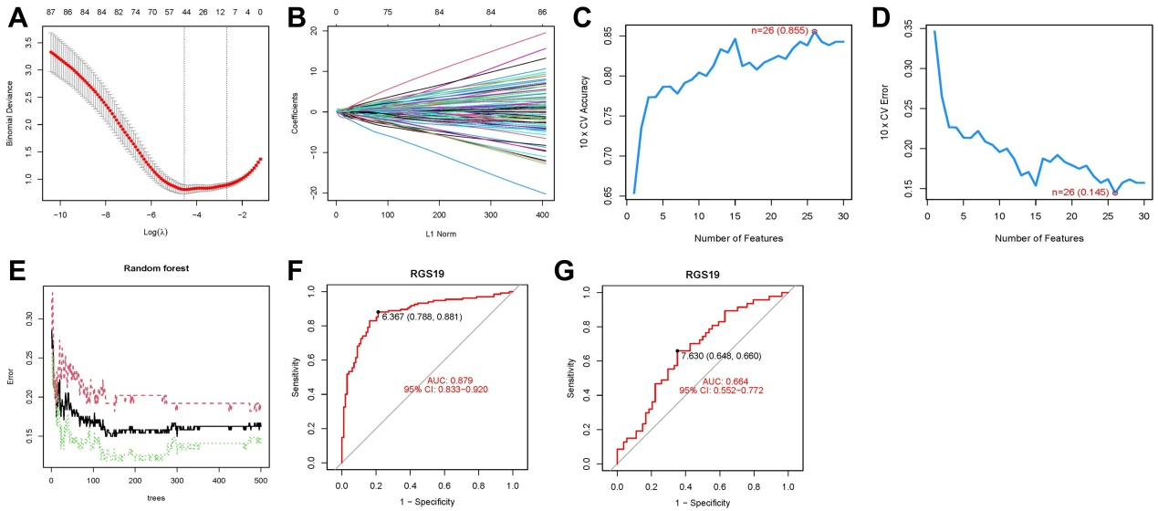
Figure S1. Identification of Candidate Genes Associated with Renal Fibrosis and Autophagy Using Machine Learning Techniques.
Note: (A-B) LASSO regression analysis results for the candidate genes; (C-D) Results of candidate gene selection using the SVM-RFE algorithm; (E) Cross-validation error curve for disease feature gene selection using the RF algorithm, where the x-axis represents the number of trees, and the y-axis represents the cross-validation error; (F-G) ROC curves for RGS19 in the training and validation groups, respectively.

Figure S2
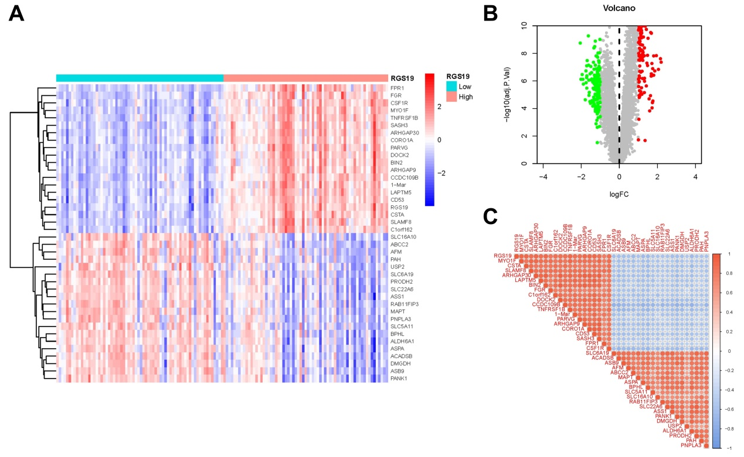
Figure S2. Differential Gene Analysis and Correlation Evaluation of RGS19 High and Low Expression Groups.
Note: (A-B) Display the heatmap and volcano plot of differential gene analysis (Limma) comparing the RGS19 high-expression and low-expression groups in the training cohort; (C) Shows the correlation between DEGs and RGS19 expression in the training cohort.

Figure S3
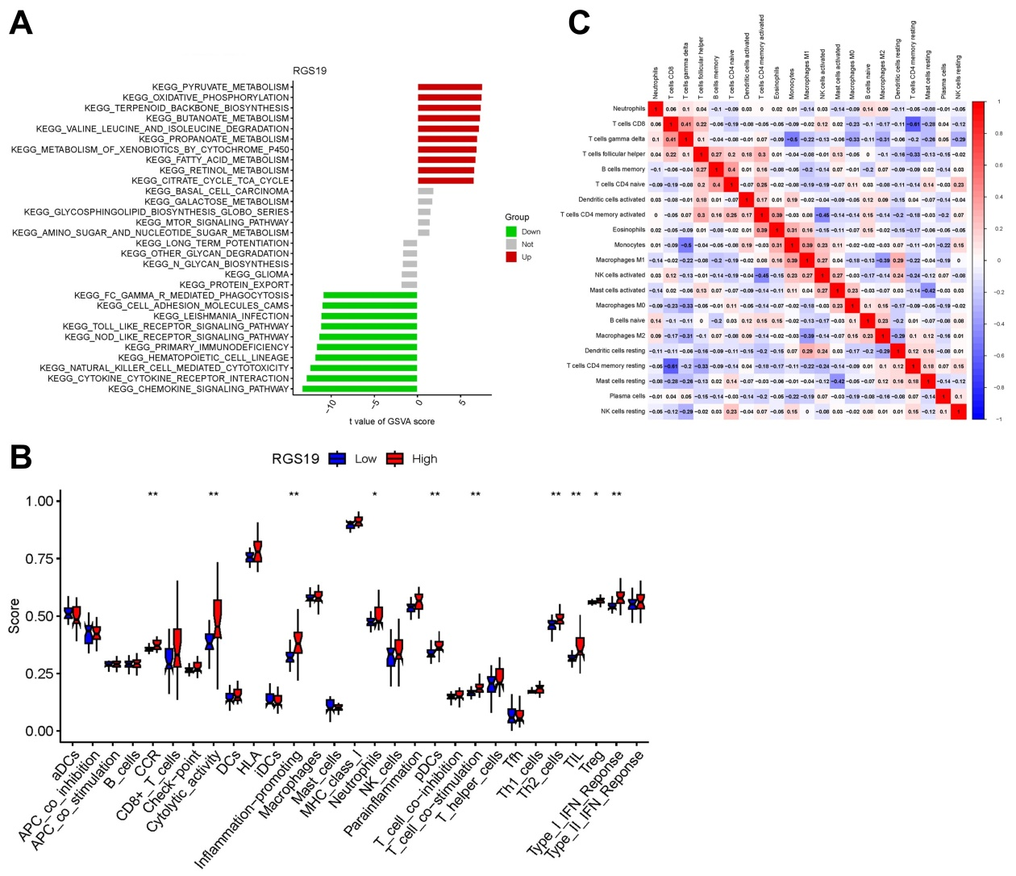
Figure S3. GSVA Enrichment Analysis and Immune Function Assessment in RGS19 High and Low Expression Groups.
Note: (A) Displays the GSVA analysis for the RGS19 high-expression and low-expression groups; (B) Shows the differences in immune function between the RGS19 high-expression and low-expression groups in the validation cohort; (C) Illustrates the heatmap of immune cell infiltration correlation analysis in the training cohort.

Figure S4
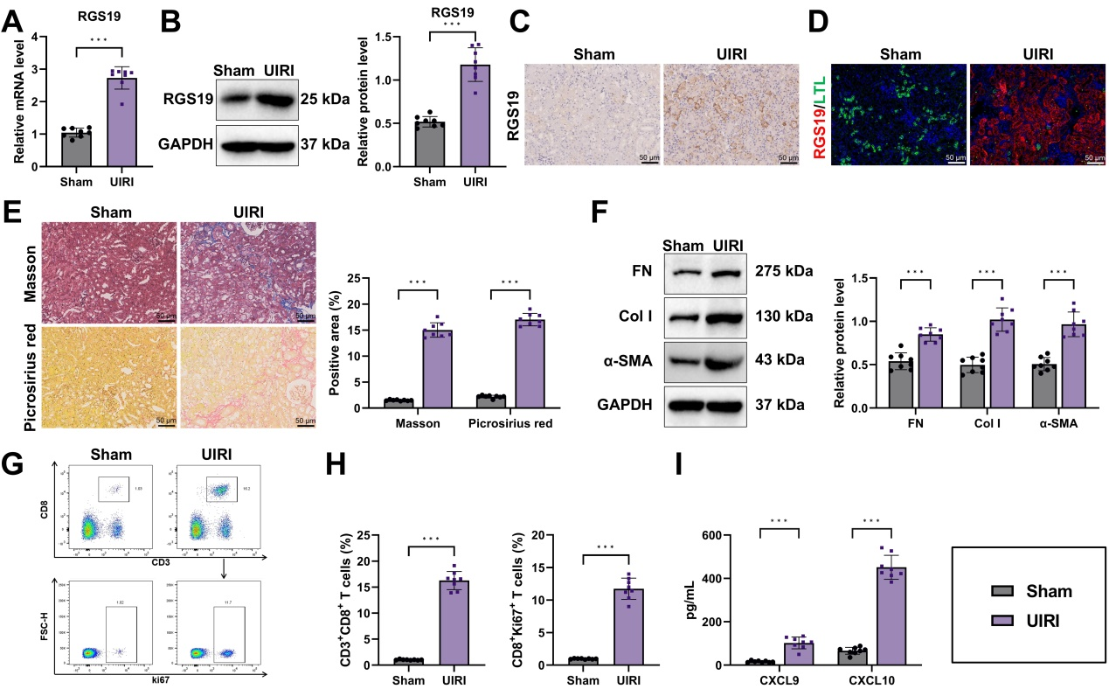
Figure S4. Expression of RGS19 and CD8⁺ T Cell Infiltration in the UIRI Renal Fibrosis Model.
Note: (A) RT-qPCR analysis of RGS19 mRNA expression in the kidneys of UIRI model mice; (B) Western blot analysis of RGS19 protein expression in the kidneys of UIRI model mice; (C) Immunohistochemical analysis showing enhanced RGS19 expression in the kidneys of UIRI model mice (Scale bar = 50 μm); (D) Co-staining of RGS19 with the proximal tubular marker LTL (Scale bar = 50 μm); (E) Masson's trichrome and Picrosirius red staining revealing collagen deposition in the renal interstitium of UIRI model mice (Scale bar = 50 μm), with quantification based on the positive staining area; (F) Western blot analysis of fibrosis markers (FN, Col I, and α-SMA) in the kidneys of UIRI model mice; (G-H) Flow cytometry analysis of CD8⁺ T cell infiltration and proliferation in the kidneys of UUO model mice; (I) ELISA measurement of chemokines CXCL9 and CXCL10 levels in the kidneys of UUO model mice. **p < 0.01, ***p < 0.001, with 8 mice per group.
Figure S5
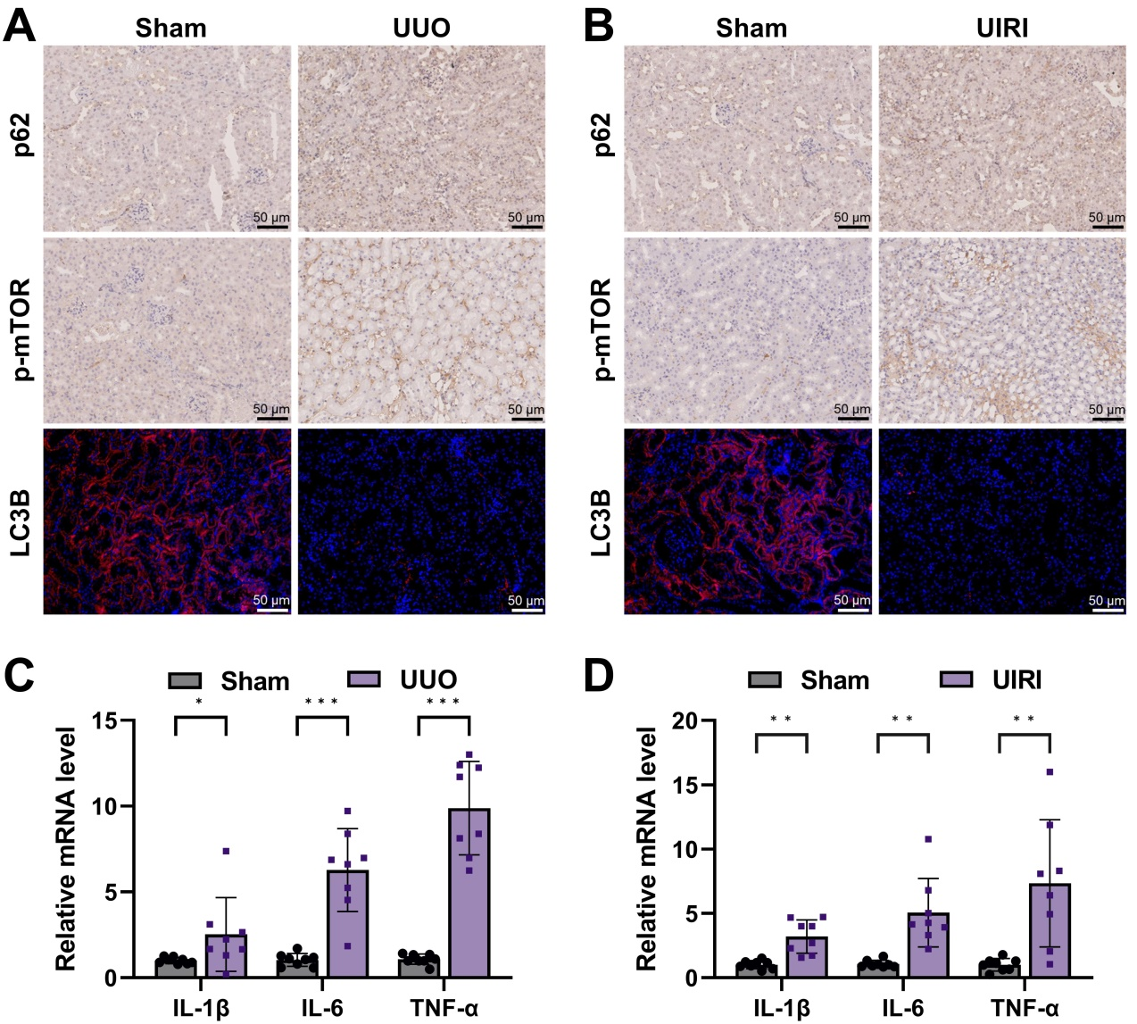
Figure S5. Expression of Autophagy and Inflammatory Factors in UUO and UIRI Renal Fibrosis Models.
Note: (A-B) Immunofluorescence and immunohistochemistry staining were used to detect the expression of autophagy-related factors p62, p-mTOR, and LC3B proteins (Scale bar = 50 μm; yellow arrows indicate positive staining). (C-D) RT-qPCR was used to measure the mRNA expression levels of inflammatory factors IL-1β, IL-6, and TNF-α in kidney tissue from UUO and UIRI models. *p < 0.05, **p < 0.01, ***p < 0.001; n = 8 mice per group.

Figure S6
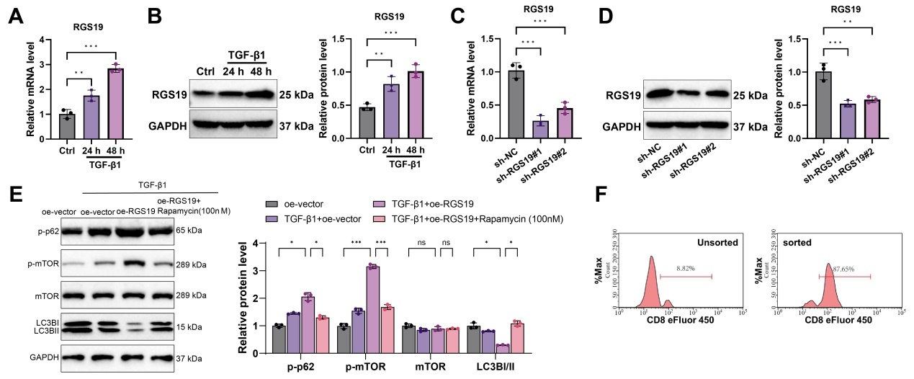
Figure S6. Verification of RGS19 Knockdown Efficiency and CD8⁺ T Cell Purity.
Note: (A-B) mRNA and protein expression of RGS19 in TKPTS cells stimulated with TGF-β1 for 24 and 48 hours; (C-D) Validation of RGS19 knockdown efficiency; (E) Western blot of p62, p-mTOR, mTOR and LC3B (LC3B-I/II), with quantification; (F) Flow cytometry analysis of CD8⁺ T cell purity, showing a purity of approximately 85% for the isolated CD8⁺ T cells. **p < 0.01, ***p < 0.001. Cell experiments were repeated three times.

Figure S7
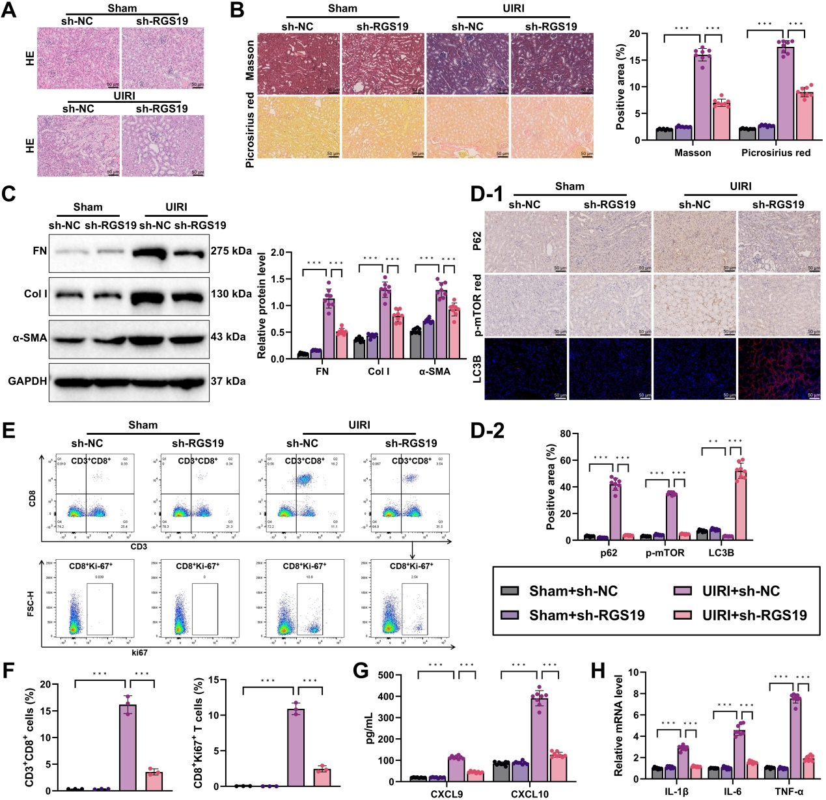
Figure S7. Regulation of Renal Fibrosis Progression in UIRI Model Mice via RGS19 Knockdown.
Note: (A) H&E staining showing pathological changes in the renal tissue of RGS19 knockdown mice (Scale bar = 50 μm); (B) Masson trichrome and Picrosirius red staining assessing collagen deposition in the renal tubulointerstitium of each group (Scale bar = 50 μm), with quantification of the percentage of positive staining areas; (C) Western blot analysis of fibrosis markers (FN, Col I, and α-SMA) in the kidneys of mice from each group; (D) Immunofluorescence and immunohistochemistry staining showing the expression of autophagy-related proteins p62, p-mTOR, and LC3B in the kidney tissue of each group (Scale bar = 50 μm, white arrows indicate positive staining); (E-F) Flow cytometry analysis of CD8⁺ T cell infiltration and proliferation in the kidneys of each group; (G) ELISA measurement of chemokine levels (CXCL9 and CXCL10) in the kidneys of each group; (H) RT-qPCR quantification of mRNA expression of inflammatory cytokines IL-1β, IL-6, and TNF-α in the renal tissue of each group. *p < 0.05, **p < 0.01, ***p < 0.001, n = 8 mice per group.

Figure S8
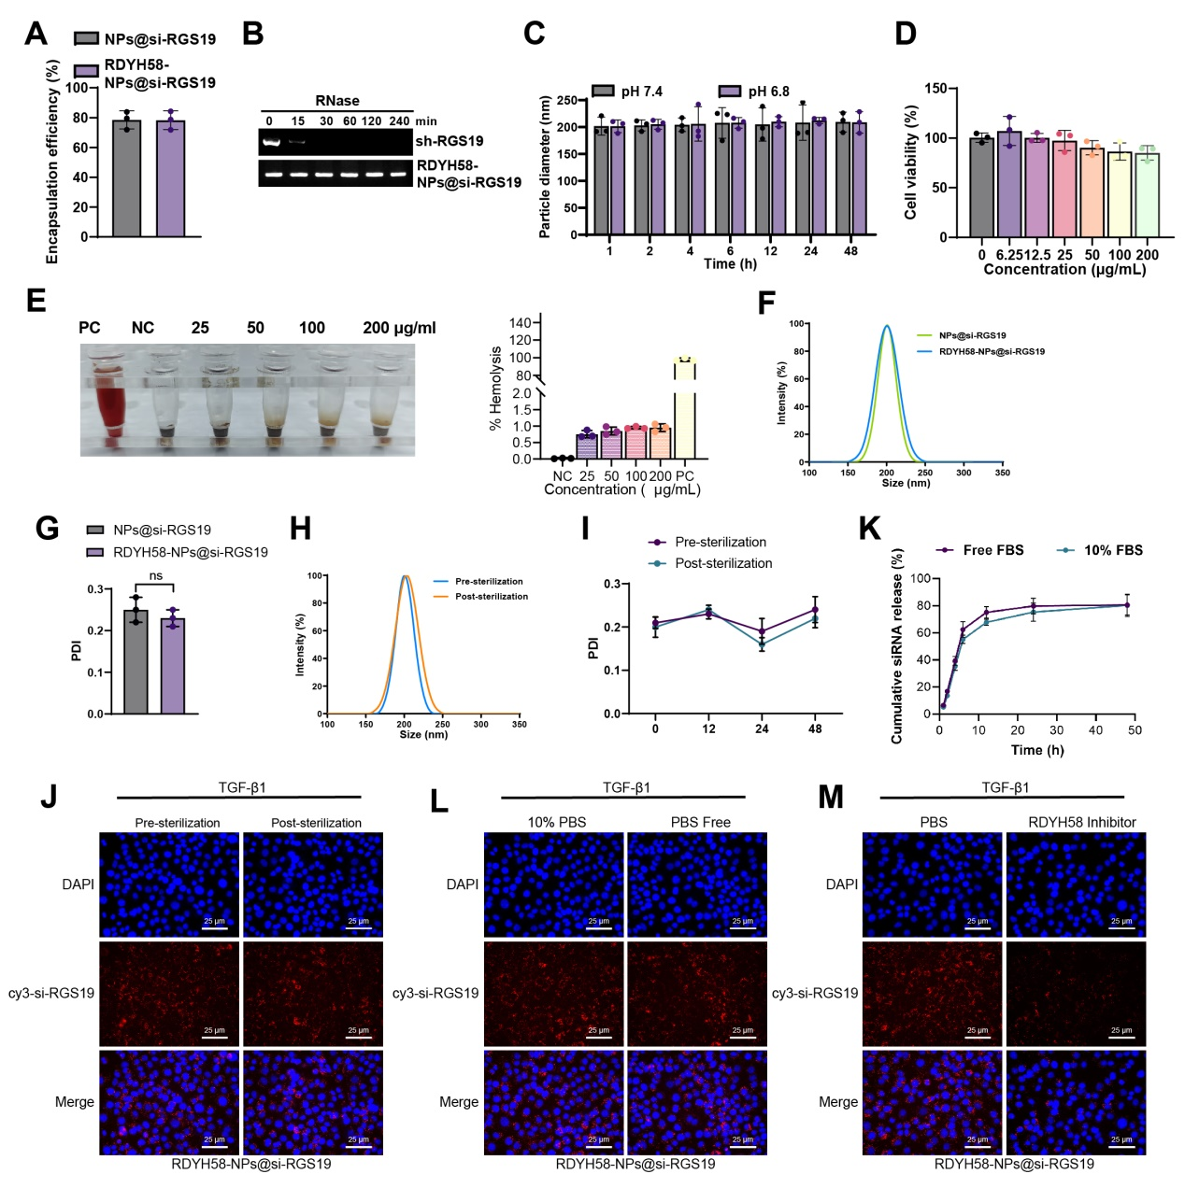
Figure S8. In Vitro Biocompatibility and Stability Assessment of RDYH58-NPs@si-RGS19.
Note: (A) Encapsulation efficiency of siRNA in NPs@si-RGS19 and RDYH58-NPs@si-RGS19; (B) RNase protection assay showing that RDYH58-NPs@si-RGS19 effectively protects siRNA from RNase degradation; (C) Particle size variation of RDYH58-NPs@si-RGS19 measured by DLS after incubation in PBS at pH 7.4 and 6.8 for different time intervals; (D) Cytotoxicity of RDYH58-NPs@si-RGS19 evaluated by CCK-8 assay; (E) Hemolysis assay assessing the hemolytic effect of RDYH58-NPs@si-RGS19 at different concentrations on red blood cells. PC: positive control, NC: negative control. (F-G) Hydrodynamic size distribution (F) and polydispersity index (PDI) (G) of NPs@si-RGS19 and RDYH58-NPs@si-RGS19; (H-J) Effects of sterile filtration on RDYH58-NPs@si-RGS19, including size distribution (H), PDI stability over time (I), and cellular uptake in TKPTS cells (J) (Pre-sterilization vs Post-sterilization); (K-L) Cumulative cy3-siRGS19 release from RDYH58-NPs@si-RGS19 in Free FBS and 10% FBS conditions (K), and cellular uptake under 10% PBS and PBS Free conditions (L); (M) Cellular uptake of RDYH58-NPs@si-RGS19 in the PBS and RDYH58 inhibitor groups (competition assay). All experiments were independently repeated three times.

Figure S9
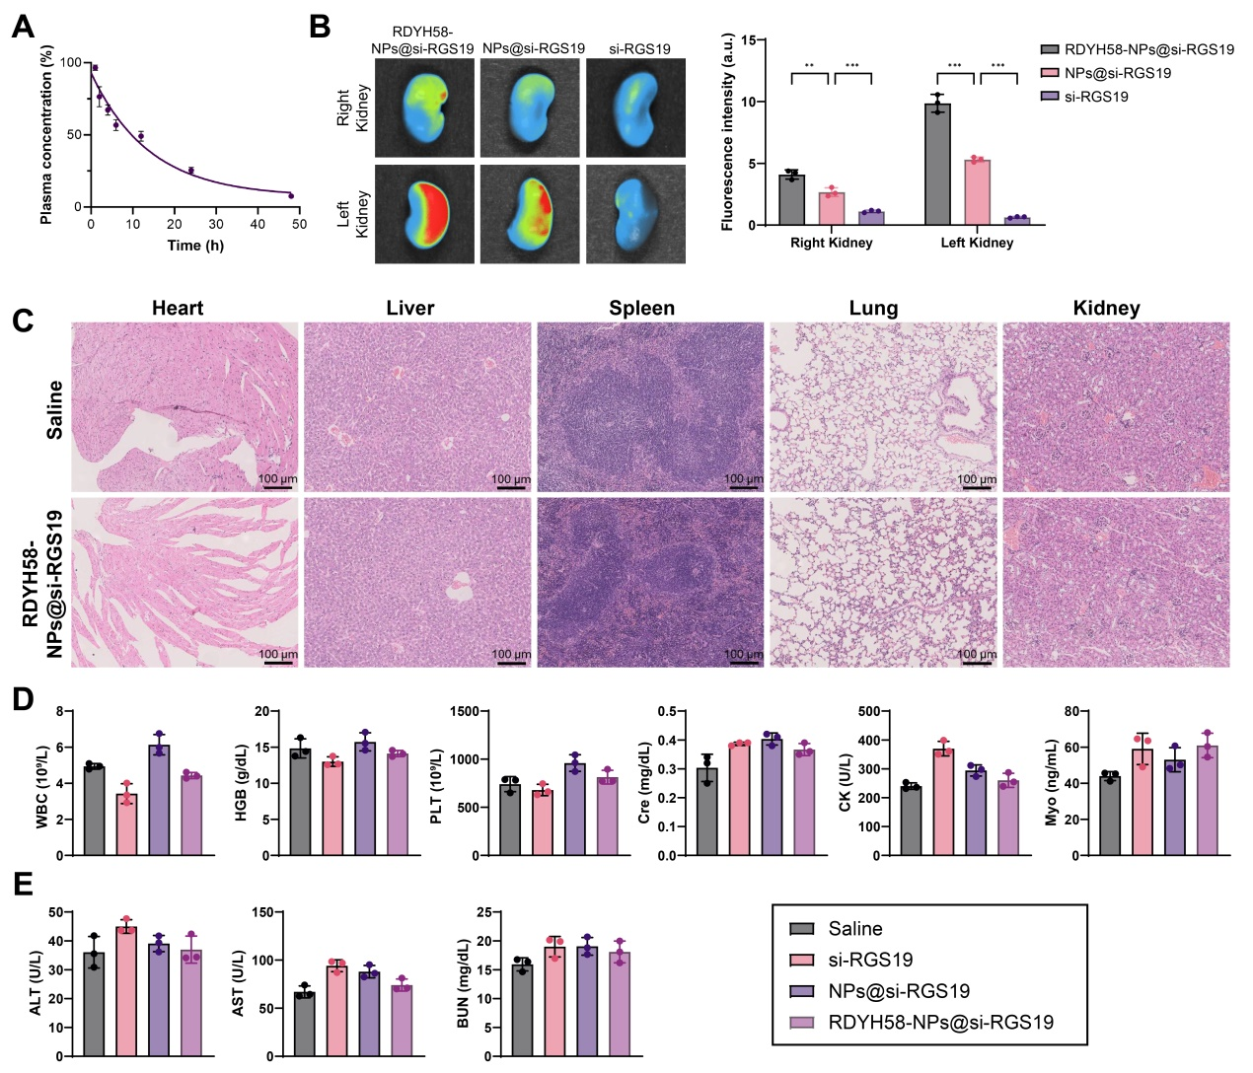
Figure S9. In Vivo Biocompatibility Evaluation of RDYH58-NPs@si-RGS19.
Note: (A) Pharmacokinetic analysis to assess the blood circulation half-life of RDYH58-NPs@si-RGS19. (B) Quantitative biodistribution analysis comparing renal accumulation of RDYH58-NPs@si-RGS19 and NPs@si-RGS19. (C) H&E staining of major organs (heart, liver, spleen, lung and kidney) collected 14 days after injection of RDYH58-NPs@si-RGS19 or saline (scale bar, 100 μm). (D-E) Hematology and serum biochemistry measurements of ALT, AST and BUN. N = 3.

Table S1. RT-qPCR Primer Sequences.
Gene (mouse) | primer sequences (5'-3')
IL-1β | F GAAATGCCACCTTTTGACAGTG
Verified | R TGGATGCTCTCATCAGGACAG
IL-6 | F TAGTCCTTCCTACCCCAATTTCC
Verified | R TTGGTCCTTAGCCACTCCTTC
TNF-α | F GTAGCCCACGTCGTAGCAAA
Verified | R ACAAGGTACAACCCATCGGC
RGS19 | F GGACCTCCCAGTCGCAATC
Verified | R TGCAGCTTGCTTTCCCGAG
β-actin | F GATATCGCTGCGCTGGTCG
Verified | R CATTCCCACCATCACACCCT
Note: F: Forward, R: Reverse.

