Supporting Information
A Biohybrid Platform Integrating Bacterial Propulsion and Photoresponsive Nanomedicine for Adequate Intratumoral Drug Delivery

Zhe Yu ^{a1}, Jingwei Wang^{a,b1}, Youbei Qiaoª, Chaoli Wangª, Tiehong Yangª, Yongan Tang^{c}, Liting Chen^{d}, Huabing Chen^{c,e,f*}, Hong Wu ^{a*}

ª Department of Pharmaceutical Analysis, School of Pharmacy, the Fourth Military Medical University, Xi’an 710032, China
^{b} The First Affiliated Hospital (Shenzhen People’s Hospital), Southern University of Science and Technology, Shenzhen 518055, China
^{c} Jiangsu Key Laboratory of Drug Discovery and Translational Research for Brain Diseases, Jiangsu Province Engineering Research Center of Precision Diagnostics and Therapeutics Development, and College of Pharmaceutical Sciences, Suzhou Medical College, Soochow University, Suzhou 215123, China
^{d} Department of Radiation Oncology, Xijing Hospital, Air Force Medical University, the Fourth Military Medical University, Xi’an 710032, China
^{e} State Key Laboratory of Radiation Medicine and Protection, and School of Radiation Medicine and Protection, Suzhou Medical College, Soochow University, Suzhou 215123, China
^{f} Department of Pharmacy, Institute for Interdisciplinary Drug Research and Translational Sciences, The First Affiliated Hospital, Suzhou Medical College, Soochow University, Suzhou 215006, China

* Corresponding authors. Department of Pharmaceutical Analysis, School of Pharmacy, the Fourth Military Medical University, Xi’an 710032, China
Jiangsu Key Laboratory of Drug Discovery and Translational Research for Brain Diseases, Jiangsu Province Engineering Research Center of Precision Diagnostics and Therapeutics Development, and College of Pharmaceutical Sciences, Suzhou Medical College, Soochow University, Suzhou 215123, China
Email: chenhb@suda.edu.cn (H. Chen); wuhong@fmmu.edu.cn (H. Wu).
¹ These authors contributed equally to this work.

Experimental section
Materials
DBCO-COOH, DBCO-Cy7 and 4-azido-L-phenylalanine were purchased from Ruixi Biological Technology Co., Ltd (Xi’an, China). Tetraethyl orthosilicate (TEOS), PEG2000, ammonium hydroxide, ruthenium trichloride hydrate (RuCl₃‧H₂O), potassium methanol, glycerol, hydrofluoric acid (HF), citric acid, dicyclohexylcarbodiimide (DCC), dimethylaminopyridine (DMAP), rhodamine B (RhB), glycidol and tetradecyl alcohol (PCM) were purchased from Aladdin Chemical Reagent Co., Ltd. (Shanghai, China). DOX was purchased from Sigma-Aldrich (USA). Lysogeny broth (LB) was purchased from Langkang Biotechnology Co., Ltd (Shanghai, China). The LIVE/DEAD BacLight Bacterial Viability Kits and Cell Counting Kit-8 (CCK-8) were purchased from Thermo Fisher Scientific (USA). Enzyme-linked immunosorbent assay (ELISA) kits for TNF-α, IL-6, IL-12p70, and IFN-γ were purchased from MultiSciences Biotech Co., Ltd. (Hangzhou, China). Rabbit anti-CD31 antibody, Goat anti-mouse IgG secondary antibody, CD206, iNOS and CD68 antibodies were obtained from Abcam (UK).

Bacterial strains and cell culture
The attenuated Salmonella typhimurium strain VNP20009 (VNP) was obtained from Baiyi Biotechnology Co., Ltd (Shanghai, China). NRK rat kidney cells, RM-1 mouse prostate cancer cells and Raw264.7-eGFP murine macrophages were acquired from the Cell Resource Center of the Chinese Academy of Sciences (Shanghai, China). NRK and Raw264.7-eGFP cells were cultured in Dulbecco’s Modified Eagle Medium (DMEM; Gibco, USA), while RM-1 cells were maintained in RPMI-1640 medium (Gibco, USA). All culture media were supplemented with 10% (v/v) heat-inactivated fetal bovine serum (FBS; Gibco, USA) and 1% (v/v) penicillin-streptomycin (Gibco, USA). All cells were incubated at 37 °C in a humidified atmosphere containing 5% CO₂.

Synthesis of Azide-functionalized VNP20009
The attenuated Salmonella strain VNP20009 was initially cultured in liquid LB medium (10 mL) inoculated with a little bacterial stock at 37 °C overnight. For strain revival, a single colony from the agar plate was transferred into LB broth using an inoculation loop, vortexed until fully dispersed, and subjected to 24-h shaking at 37 °C. This revival cycle (500-fold dilution in LB broth with subsequent 24-h shaking) was repeated three times. The revived bacteria were finally diluted 500-fold in LB broth containing 50 μg/mL azidophenylalanine and shaken at 37 °C for 24 h to yield azide-modified bacteria (N₃-Bac).

Fabrication and Characterization of VNP-HMRu@DP-PG
HMRu@DP-PG NPs were synthesized following our prior published procedures. Subsequently, DBCO-HMRu@DP-PG was prepared by conjugating carboxyl-DBCO to HMRu@DP-PG via DCC/DMAP-mediated coupling. Specifically, 2 mg of carboxyl-DBCO, DCC, and DMAP were dispersed in 25 mL deionized water under light-protected magnetic stirring at room temperature for 3 h. HMRu@DP-PG (10 mg) was then added and reacted for 6 h. The product was purified by centrifugal washing and lyophilized. The lyophilized DBCO-HMRu@DP-PG was reconstituted in LB broth to generate concentration gradients (10, 20, 50, 100, 200, 500, 1000, 2000 μg/mL). Equal volumes of each gradient were mixed with N₃-Bac suspension (10⁸ CFU/mL) and incubated under magnetic stirring at 200 rpm for 30 minutes at 37 °C. After PBS washing, nanoparticle-loaded bacteria (Bac@HMRu@DP-PG I-VIII) were obtained, with Roman numerals denoting ascending NP loading amounts. Bac@HMRu-PG I-VIII were prepared by functionalizing bacterial surfaces with HMRu-PG nanoparticles via the aforementioned conjugation procedures.
The morphologies of VNP20009 and Bac@HMRu-PG (I-VIII) were characterized using a JEOL-1200 transmission electron microscope (TEM) and a ThermoFisher Quattro S scanning electron microscope (SEM). The number of nanoparticles bound to the bacterial surface was subsequently quantified with ImageJ software. The hydrodynamic diameter and zeta potential of Bac@HMRu@DP-PG were determined using a Malvern Zetasizer Nano ZS analyzer (UK).

Bacterial viability assay
VNP20009 and Bac@HMRu-PG I-VIII cultures were diluted 500-fold in fresh LB medium and incubated at 37 °C with shaking. Bacterial growth was monitored by measuring OD₆₀₀ at specified intervals using a microplate reader (Tecan Infinite M200 Pro, Switzerland), with growth curves generated from 200 μL aliquots sampled periodically.
To directly assess the impact of nanoparticle loading on bacterial viability, VNP20009, azide-modified bacteria (N₃-Bac), and Bac@HMRu@DP-PG complexes were stained with a live/dead viability kit and imaged by Nikon A1R confocal laser scanning microscopy (CLSM, Japan). Specifically, 3 μL of SYTO 9 (1.67 mM) and 1.5 μL of PI (1.67 mM) were added to bacterial suspensions (1 mL, 1×10⁸ CFU/mL) of VNP20009, N₃-Bac and Bac@HMRu@DP-PG. The mixture was shaken at room temperature for 15 min in the dark. After staining, 5 μL of VNP2009, N₃-Bac and Bac@HMRu@DP-PG were mounted on glass slides for CLSM analysis.

Mobility study of Bac@HMRu@DP-PG
Agarose was dissolved in DMEM medium to a concentration of 2 mg/mL and sterilized by autoclaving. Then, 2 mL of the solution was poured into each well of a 6-well plate and allowed to solidify at room temperature to form three-dimensional (3D) gel blocks. The gel blocks were carefully transferred to a bacterial culture dish, followed by the addition of 5 mL of LB broth. Subsequently, 20 μL of Cy7-labeled bacterial suspension was inoculated near the edge of the dish. The setup was incubated at 37 °C in the dark. The overall distribution of bacteria within the gel blocks was visualized and recorded using an IVIS Spectrum (Xenogen, USA).

Long Circulation Performance of Bac@HMRu-PG
In vitro and in vivo immune evasion assay of Bac@HMRu-PG
Bacterial suspensions of Bac and Bac@HMRu-PG (Ⅰ~Ⅷ) in the logarithmic growth phase with a bacterial content of 10⁸ CFU were centrifuged at 3000 rpm for 15 min and washed with PBS. They were then resuspended in 1.5 mL of whole blood from RAW mice and co-incubated at 37 ℃ on a constant temperature shaker for 1.5 h. After incubation, 20 μL of whole blood was taken and spread on LB-agar medium for colony counting. For the in vivo assessment, similarly treated bacteria were resuspended in saline and administered to C57BL/6 mice via tail vein injection. Blood samples (20 μL) were collected from the tail vein at various time points post-injection and plated on LB-agar for colony counting.
Macrophagy phagocytic index of Bac@HMRu-PG
Raw 264.7-eGFP cells (2×10⁵) were seeded into confocal dishes and cultured for 24 h. Cy7-labeled bacteria were resuspended in DMEM medium at a concentration of 10⁸ CFU/mL. Then, 200 μL of the bacterial suspension was added to the Raw 264.7-eGFP cells and co-incubated at 37 °C in the dark for 3 h. After incubation, the medium was removed, and unphagocytosed bacteria were washed away with PBS. Cell nuclei were stained with DAPI, followed by repeated PBS washes and fixation with 4% paraformaldehyde. Images were acquired using CLSM, and the phagocytic index was calculated as follows[1]:
$$\text{Phagocytic }\text{inde}\text{=}\frac{\text{Number of bacteria phagocytosed by macrophages}}{\text{Total number of bacteria}}\text{×}$$
$$\frac{\text{Number of bacteria-containing macrophages}}{\text{Total number of macrophages}}$$
Safety evaluation of Bac@HMRu-PG
The biosafety of Bac@HMRu-PG was evaluated through both in vitro and in vivo studies. For the in vitro assay, NRK cells were seeded in 96-well plates at 1×10⁴ cells/well and incubated for 24 h (37 °C, 5% CO₂). The medium was then replaced with 200 μL fresh medium containing either VNP20009 or Bac@HMRu-PG I-VIII at 10⁸ CFU/mL. After specified incubation periods, cell viability was assessed by CCK-8 assay, while morphological changes were monitored via an EVOS M7000 inverted microscope (Thermo Fisher Scientific, USA). For the in vivo study, a bacterial content of 10⁸ CFU of Bac and Bac@HMRu-PG (I–VIII) were administered to mice via tail vein injection. Changes in body weight and food intake were monitored throughout the experimental period. Major tissues were collected for hematoxylin and eosin (H&E) staining, and blood samples were drawn from the tail vein every other day for white blood cell (WBC) counting using a BC-300VET hematology analyzer (Mindray, China).

Establish of RM-1-bearing mouse model
Male C57BL/6 mice and nude mice (6-8 weeks) were purchased from the Experimental Animal Center of Air Force Medical University. The mice were housed in groups of six under a controlled temperature of 22-25 ℃. All animal experiments were approved by the Ethics Committee of Air Force Medical University (IACUC-20230059). Tumor-bearing mouse models were established by subcutaneously inoculating nude or C57BL/6 mice in the right lumbar region with an RM-1 cell suspension (1 × 10⁶ cells). When the tumors became palpable, their volume was monitored and calculated using the formula: Volume = (length × width²)/2.

Biodistribution and tumor targeting of Bac@HMRu-PG
When tumors in nude mice reached approximately 300 mm³, Cy7-labeled Bac@HMRu-PG (10⁸ CFU) was administered via tail vein injection. The mice were anesthetized with isoflurane and imaged at various time points using a Xenogen IVIS in vivo imaging system (Xenogen, USA) to monitor real-time fluorescence distribution. Fluorescence intensity in the tumor region was quantified using ImageJ software.
To assess the distribution over time, tumor-bearing C57BL/6 mice with tumors of ~300 mm³ received a tail vein injection of Bac or Bac@HMRu@DP-PG (10⁸ CFU per mouse), with saline-injected mice serving as the control. Groups of mice were euthanized at various time points, and the liver and tumor tissues were excised. Then, 0.2 g of each tissue was homogenized, and bacterial colonization was assessed by colony counting to evaluate the time-dependent distribution profiles of the bacteria in major organs and tumors. To specifically evaluate the 24-hour distribution across major organs, a separate cohort of mice was treated identically and euthanized at 24 h post-injection. The heart, liver, spleen, lungs, kidneys, and tumor were harvested, processed, and analyzed as above.

Photothermal Imaging in vivo
Mice were intravenously injected with Bac or Bac@HMRu@DP-PG (10⁸ CFU). At 12 h post-injection, the mice were anesthetized and then subjected to tumor region irradiation at a power density of 1.5 W/cm². During irradiation, the temperature was monitored using a Fluke BT500 thermal camera (Fluke, USA) for image acquisition and recording.

Evaluation of Antitumor effect
The cytotoxicity was first assessed in vitro. RM-1 cells were seeded in a 96-well plate at a density of 10⁵ cells per well and cultured overnight. The medium was then replaced with fresh medium containing DOX, Bac, Bac@HMRu@DP-PG, or Bac@HMRu@DP-PG (which was subsequently exposed to NIR irradiation). After 24 hours of incubation, cell viability was assessed using the CCK-8 assay. The antitumor efficacy was further evaluated in tumor-bearing C57BL/6 mice. When the tumor volume reached approximately 150 mm³, the mice were randomly divided into six groups. The groups received intravenous injections of the following formulations at a DOX-equivalent dose of 3 mg/kg: saline (control), free DOX, Bac, HMRu@DP-PG, Bac@HMRu@DP-PG, and Bac@HMRu@DP-PG + NIR. Administration was performed every other day for a total of nine injections. Mice in the Bac@HMRu@DP-PG + NIR group were anesthetized the day after each injection and subjected to photothermal therapy using laser irradiation (1.5 W/cm²) for 5 minutes. Body weight and tumor volume were measured every other day throughout the treatment period. After the treatment, all mice were euthanized. Major organs, blood, and tumor tissues were collected for subsequent analysis. Tissues were stained with H&E, Ki67, and terminal deoxynucleotidyl transferase mediated dUTP nick-end labeling (TUNEL) for histological examination, and serum was analyzed for hepatic function and myocardial enzyme profiles.

Analysis of Intratumoral Distribution
HMRu-PG labeled with rhodamine was conjugated with SYTO 9-stained bacteria as previously described[2]. Tumor-bearing mice (tumor volume ≈ 500 mm³) were intravenously injected with Bac or Bac@HMRu-PG (10⁸ CFU). After 12 h, mice in the Bac@HMRu@DP-PG + NIR group were anesthetized and irradiated with a laser for 5 min. All mice were sacrificed at 24 h, and tumor tissues were collected for fixation, processing, and sectioning. For nucleus staining, sections were incubated with DAPI at 37 °C for 1 h in the dark. For vascular staining, additional sections were incubated with 50 μL of rabbit anti-CD31 antibody (1:200) at 4 °C for 12 h, followed by Cy5-labeled goat anti-rabbit IgG secondary antibody (1:500) at 37 °C for 1 h in the dark. Images were acquired using CLSM.

Cytokines Analysis and Macrophage Polarization
To comprehensively assess the immunomodulatory effects of the nano-formulations on the tumor microenvironment, both the cytokine secretion profiles and macrophage polarization states were analyzed. The levels of key cytokines (IL-6, TNF-α, IL-10, and TGF-α) in tumor tissues were quantified by ELISA. Briefly, fresh tumor tissues were homogenized, and the supernatants were collected after centrifugation. The cytokine concentrations were determined by measuring the optical density (OD) at 450 nm and calculated based on the respective standard curves.
Simultaneously, the phenotypic polarization of tumor-associated macrophages was evaluated via immunofluorescence (IF) staining. Deparaffinized tumor sections were immunostained with antibodies against the pan-macrophage marker CD68, the M1-like marker iNOS, and the M2-like marker CD206. Following incubation with fluorochrome-conjugated secondary antibodies, the sections were imaged using a confocal microscope. A semi-quantitative analysis of the fluorescence images was performed to determine the populations of total (CD68⁺), M1-like (CD68⁺iNOS⁺), and M2-like (CD68⁺CD206⁺) macrophages, and the M1/M2 ratio was calculated.

Statistical Analysis
Data were presented as mean ± standard deviation. Comparisons between groups were analyzed using the Student's t-test. Repeated-measures analysis was conducted using repeated measures analysis of variance (ANOVA). Statistical analysis was performed using SPSS 20.0 software.

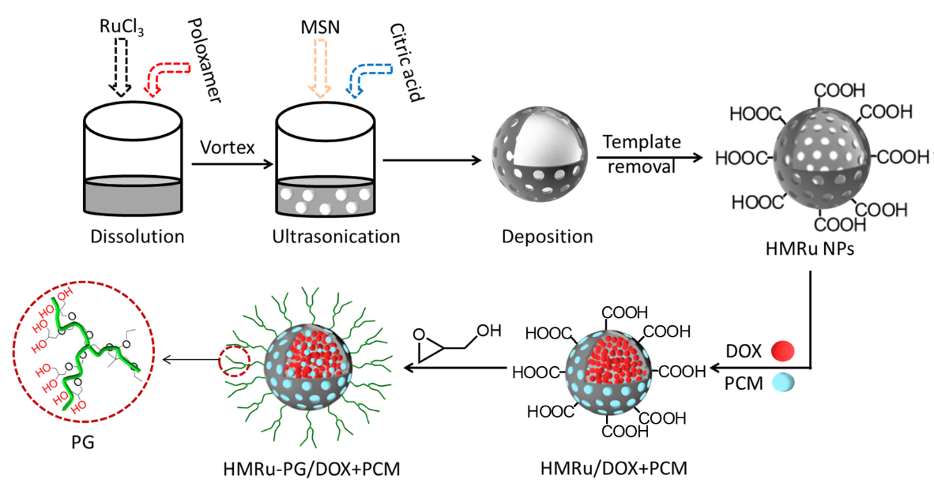
Figure S1. Preparation diagram of HMRu@DP-PG.

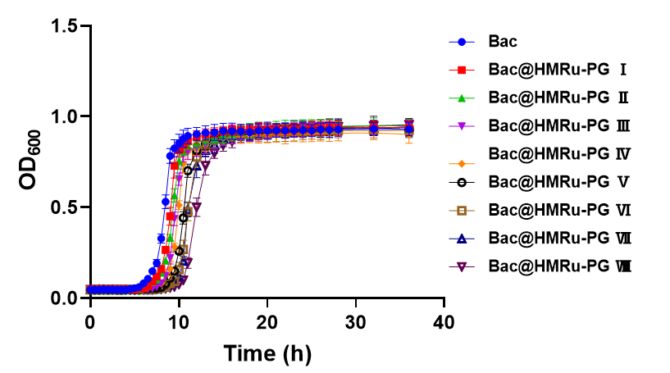
Figure S2. The growth curve of VNP20009 and Bac@HMRu-PG I-VIII, n=3.

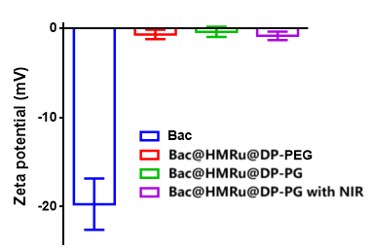
Figure S3. Zeta potential of Bac@HMRu@DP-PG.

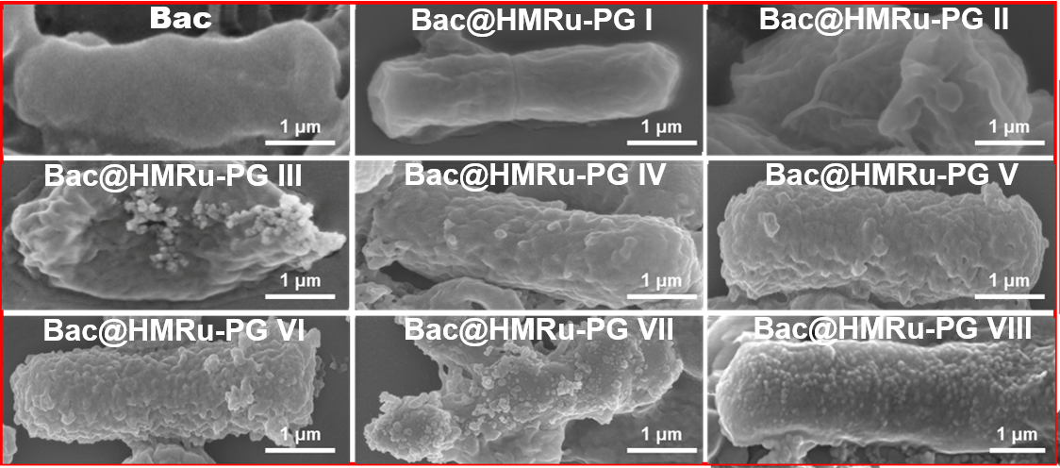
Figure S4. SEM images of VNP20009 and Bac@HMRu-PG. Scale bar, 1 μm.

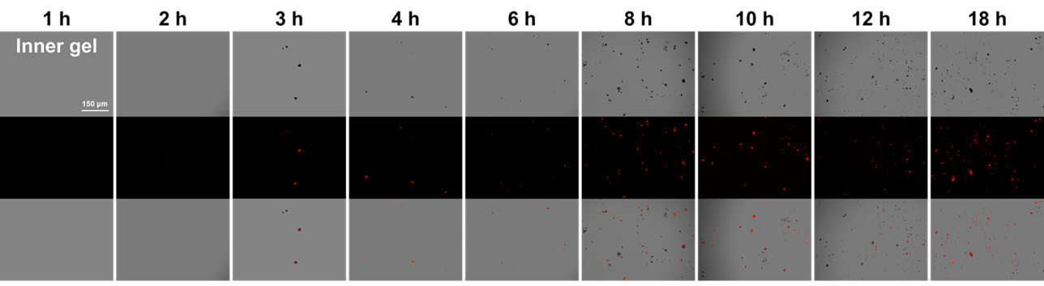
Figure S5. Microscopy images of the gel with Bac added at different time points in transmittance and fluorescence microscopy.

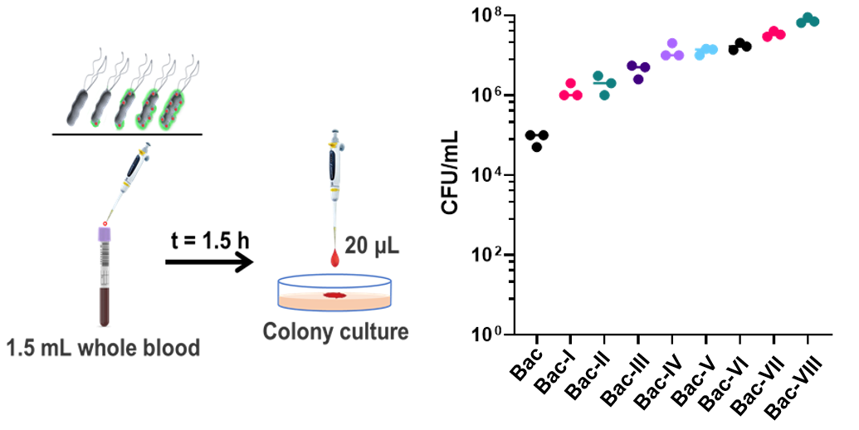
Figure S6. Schematic illustration of the immune escape experiment of Bac@HMRu-PG in whole blood and the corresponding bacterial colony counting after 1.5 h of co-incubation (n=3).

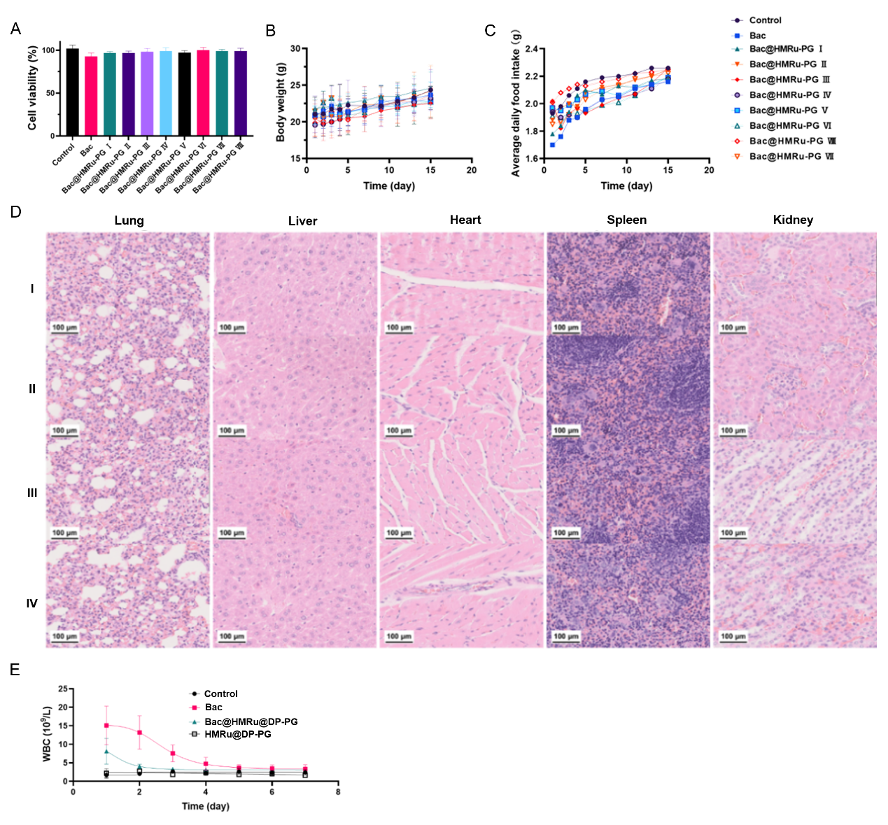
Figure S7. The biosafety evaluation of Bac@HMRu@DP-PG in vitro and in vivo. (A) Viability of NRK cells treated with Bac or Bac@HMRu@DP-PG I-VIII. (B) The body weight (B), and food intake (C) of mice after intravenous injection of Bac and Bac@HMRu-PG Ⅰ-Ⅷ. (D) H&E staining of major organs from mice after 7 days of injection with PBS (I), Bac (II), HMRu@DP-PG (III), and Bac@HMRu@DP-PG (IV). (E) Changes in white blood cell (WBC) counts of mice within 7 days after injection with PBS, Bac, HMRu@DP-PG, and Bac@HMRu@DP-PG. The data were presented as means±SD (n=6).

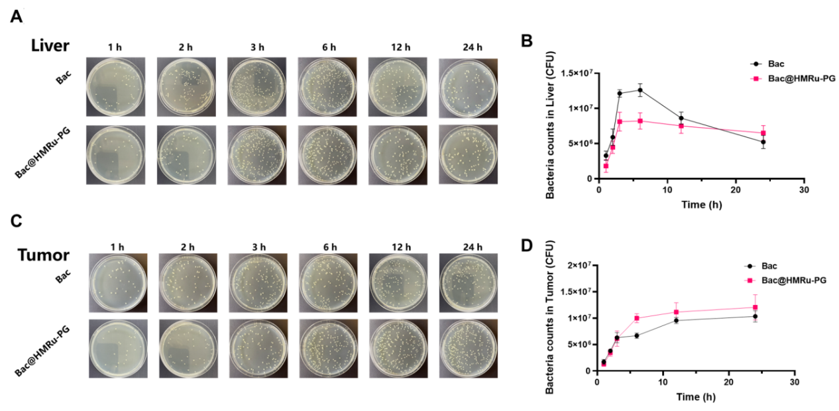
Figure S8. Time-dependent distribution of Bac@HMRu@DP-PG in the liver and tumor of tumor-bearing mice. (A) Representative images of bacterial colonies in the liver at different time points after injection of Bac or Bac@HMRu-PG. (B) Quantification of bacterial colonies in the liver. (C) Representative images of bacterial colonies in the tumor at different time points after injection of Bac or Bac@HMRu-PG. (D) Quantification of bacterial colonies in the tumor.

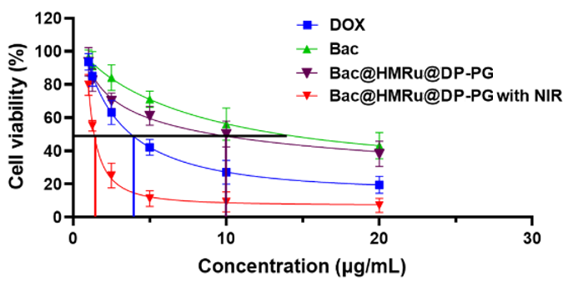
Figure S9. In vitro anti-tumor activity of Bac@HMRu@DP-PG.

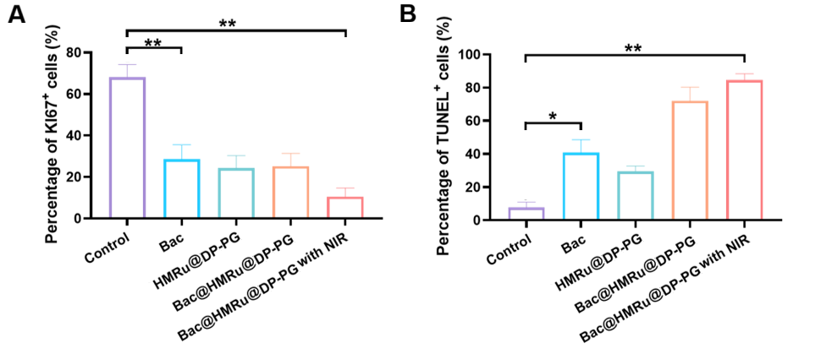
Figure S10. (A) Percentage of Ki67-positive cells and (B) percentage of TUNEL-positive cells in tumor tissues across different treatment groups. n= 3, *P<0.05，**P<0.01.

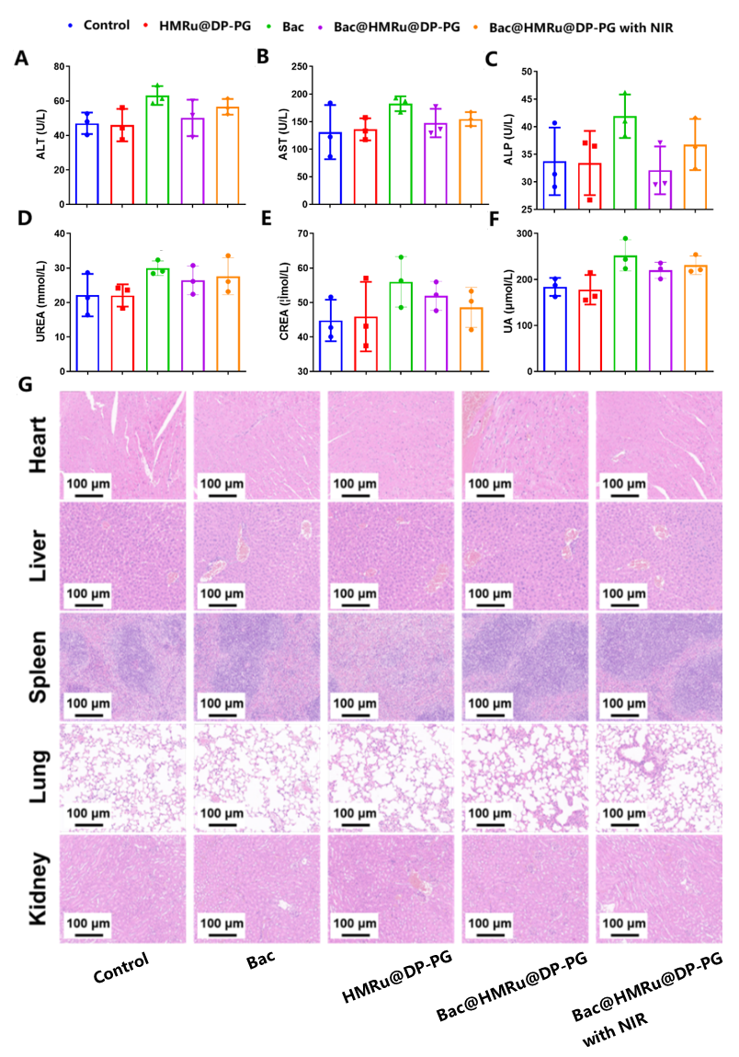
Figure S11. Blood routine examination and histopathological analysis. (A-F) Alterations in blood routine and biochemical parameters of mice following different treatments. (G) H&E staining of major organs (including heart, liver, spleen, lung, and kidney) collected from different treatment groups. Scale bar: 100 μm.

References:
[1] Harimoto T, Hahn J, Chen YY, Im J, Zhang J, et al. A programmable encapsulation system improves delivery of therapeutic bacteria in mice. Nat Biotechnol 2022;40:1259-1269. https://doi.org/10.1038/s41587-022-01244-y.
[2] Wang J, Zhang Z, Yu Z, Qiao Y, Wang C, et al. Polyglycerol-Decorated Hollow Mesoporous Ruthenium Nanoparticles for Long Circulation and Antitumor Effect. ACS Applied Nano Materials. 2023;6:8695-8704. https://doi.org/10.1021/acsanm.3c01052.

