Supplementary information
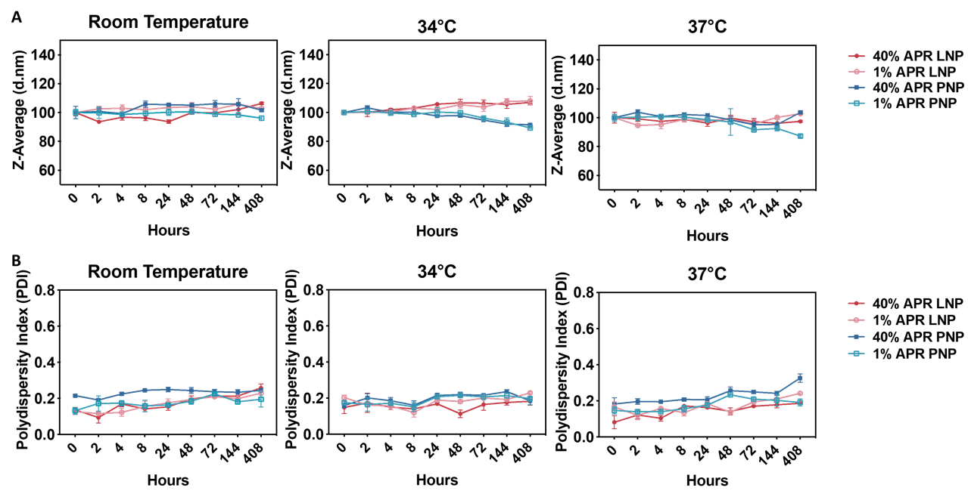
Figure S1. The stability of 40% APR-loading LNPs and 40% APR PNP at room temperature, 34 ℃, and 37 ℃ within 408 hours.
Figure S2. The UV spectrophotometer standard curve of APR.

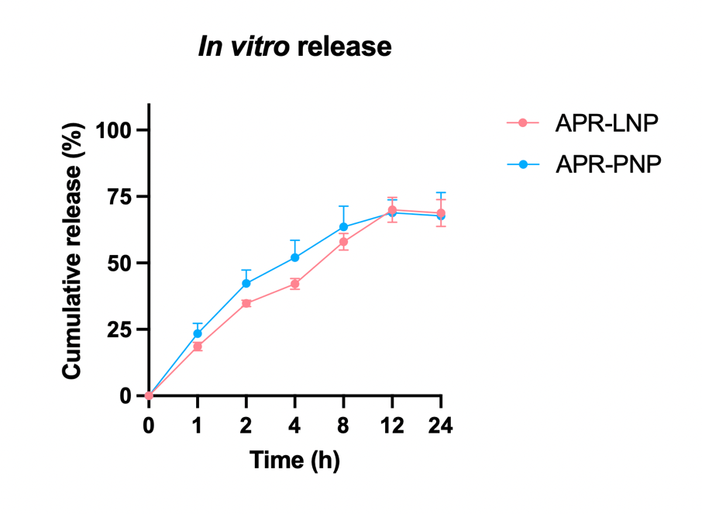
Figure S3. In vitro release profiles of APR LNPs/PNPs. Cumulative release of APR from lipid nanoparticles (APR-LNP) and polymeric nanoparticles (APR-PNP) was evaluated using a dialysis-based method in 30% (v/v) ethanol in phosphate-buffered saline (PBS, pH 7.4) at 32 °C under gentle agitation. At predetermined time points (1, 2, 4, 8, 12, and 24 h), aliquots of the external release medium were collected and replaced with fresh medium. Cumulative release is expressed as a percentage of the total theoretical drug loading. Data are presented as mean ± SD (n = 3).

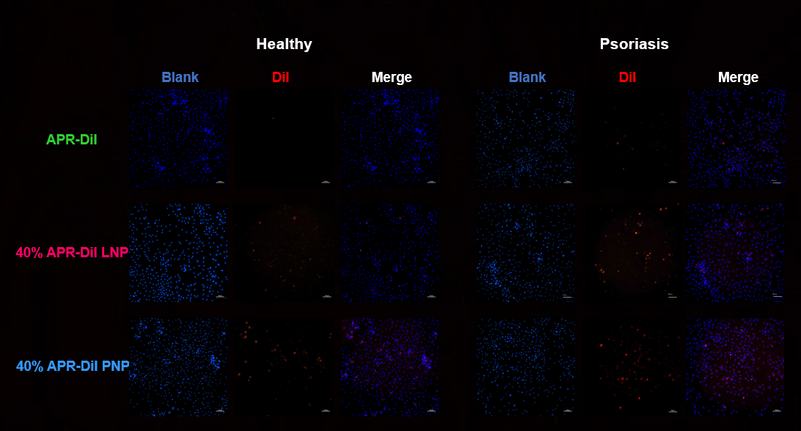
Figure S4 Cellular uptake of APR with or without carriers in in vitro 2D models. DiI was incorporated as a lipophilic fluorescent tracer to enable visualization and quantification of cellular uptake of APR formulations. Freshly prepared 40 wt% APR loading LNP and 40 wt% APR loading PNP labelled with DiI were diluted to an APR concentration of 100 nM. DiI APR premixed with DiI in DMSO was used as the APR-only control, n=3.

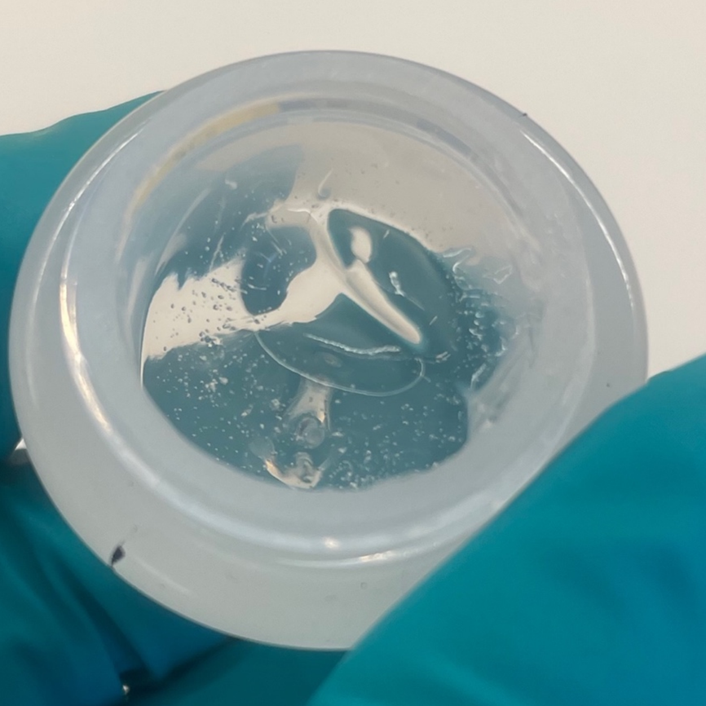
Figure S5. Photograph of APR-loading nanoparticles in 2% _{W/W} Carbopol® 940 gel.
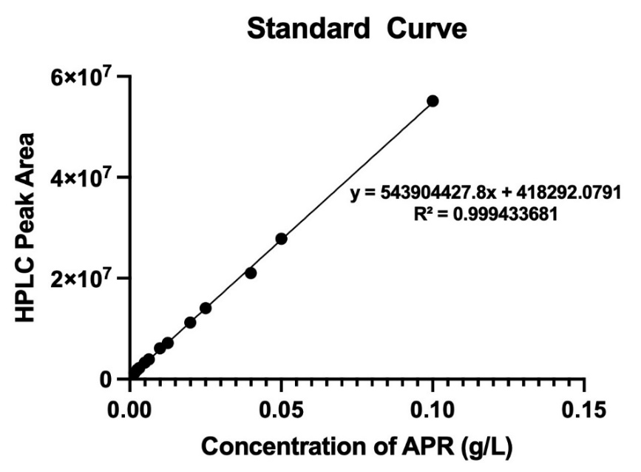
Figure S6. The HPLC standard curve of APR.

Figure S7. The weight of the spleens in the in vivo psoriatic dermatitis mouse model.

Figure S8. The particle size, PDI, and APR concentration of 40% APR-loading LNP and 40% APR-loading PNP after centrifugal concentration.

Table S1. Primer sequences for RT-qPCR analysis

