Supplementary
Core Shell Microneedles with MMP/pH-Triggered Release for Periodontitis Bone Repair
Junhui Liu^{1, 2#}, Zhengrong Gao^{3#}, Minghai Dai⁴, Hui Chen¹, Xiaoyan Xie²*, Lei Yang¹*

¹ Zhejiang Provincial Key Laboratory of Silk and Silk Protein New Materials, Institute of Sericulture and Tea, Zhejiang Academy of Agricultural Sciences, Hangzhou 310021, China
² Department of Stomatology, The Second Xiangya Hospital, Central South University, Changsha, 410011, China
³ NMPA Key Laboratory for Dental Materials National Engineering, Laboratory for Digital and Material Technology of Stomatology, Department of Geriatric Dentistry, Peking University School and Hospital of Stomatology, Beijing, 100081, China.
⁴ Department of Orthopedic, The Third Affiliated Hospital of Wenzhou Medical University, Wenzhou, 325200, China

#Junhui Liu and Zhengrong Gao contributed equally to this work.

*Corresponding authors
E-mail addresses: xyxie@csu.edu.cn (X. Xie), yangleigeili@163.com (L. Yang).

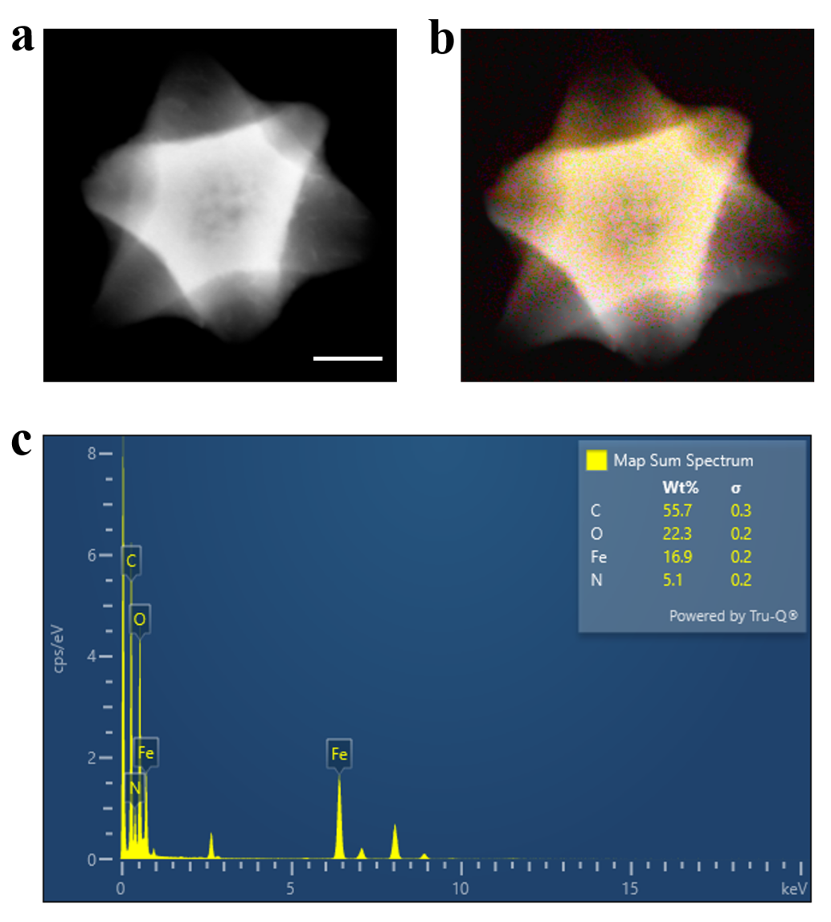
Figure S1. Characterization of physical and chemical properties of GA-MOF. (a) SEM image of GA-MOF nanoparticles. Scale: 200nm. (b) Synthesis image of element distribution of GA-MOF nanoparticles. (c) Energy spectrum point scan (EDS point scan) results of GA-MOF nanoparticles.

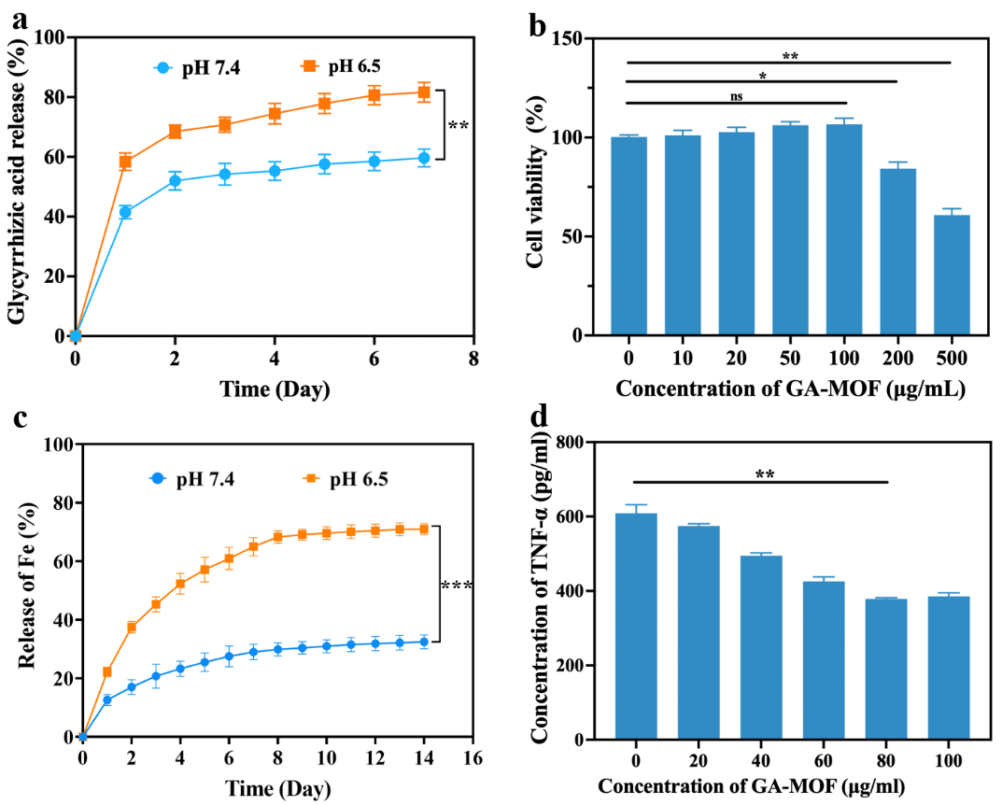
Figure S2. Drug release and biocompatibility testing of GA-MOF. (a) GA-MOF drug release curves under different pH environments. (b) CCK-8 biocompatibility testing of GA-MOF. (c) The release kinetics curve of iron ions under simulated acidic microenvironment (pH 6.5) and physiological neutral conditions (pH 7.4). (d) The inhibitory effect of different concentrations of GA-MOF on the release of pro-inflammatory macrophage cytokine TNF-α.

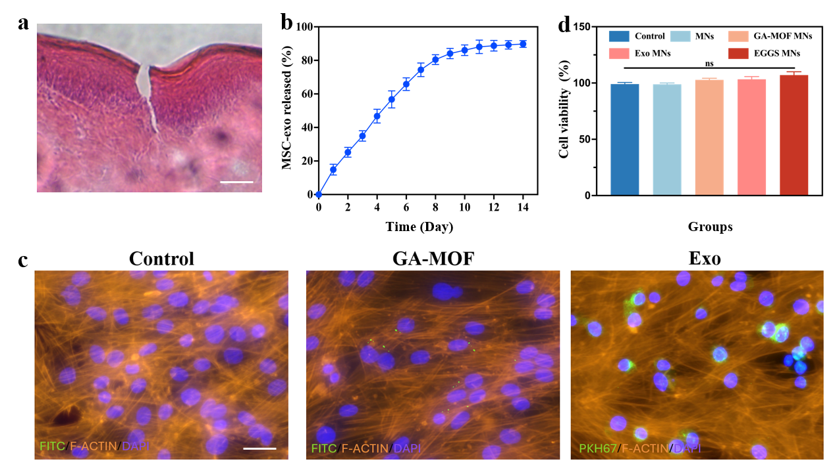
Figure S3. Biological safety testing and exosome release curve of EGGS MNs. (a) Verification of EGGS MNs penetrating epithelial tissue and forming regular microchannels through H&E staining of rat oral mucosal tissue slices. Scale: 500 µm. (b) Exosomal release curve in EGGS MNs. (c) GA-MOF and MSC Exo in vitro cellular uptake experiments. Scale: 20 µm. (d)The cck-8 biosafety testing of MNs in each group.

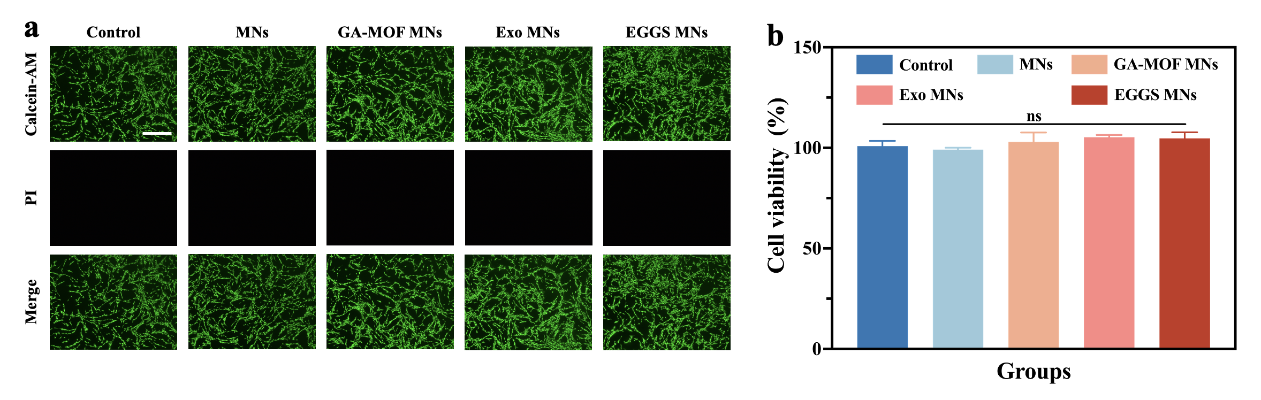
Figure S4. Biological safety testing of MNs. (a) Fluorescent micrograph of living dead cell staining. Scale: 100 µm. (b) Quantitative analysis of living cell dead cell staining.

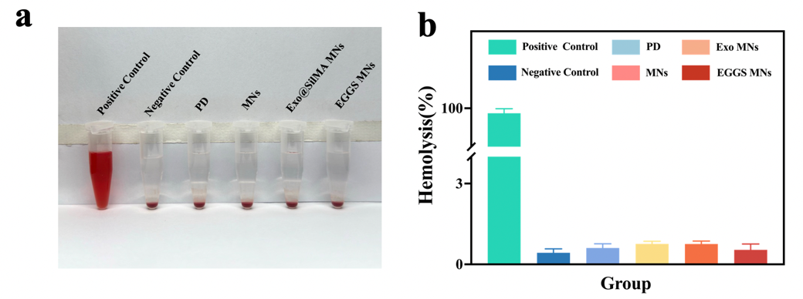
Figure S5. Hemolysis experiment of MNs. (a) Digital photos of hemolysis experiment. (b) Quantitative analysis results of hemolysis experiment.

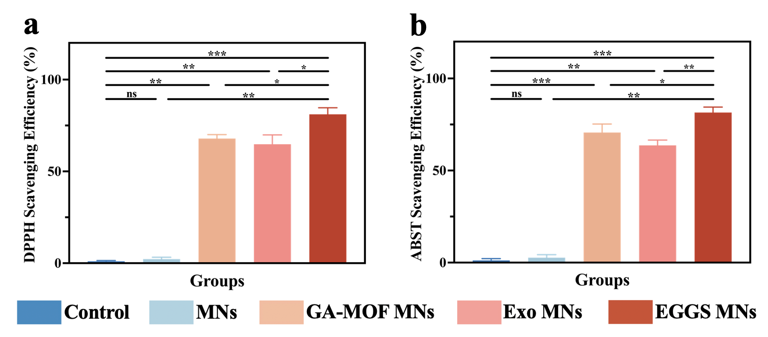
Figure S6. The antioxidant capacity of different MNs. (a) Quantitative analysis of DPPH radical scavenging activity of EGGS MNs. (b) Quantitative analysis of ABTS scavenging activity of EGGS MNs.

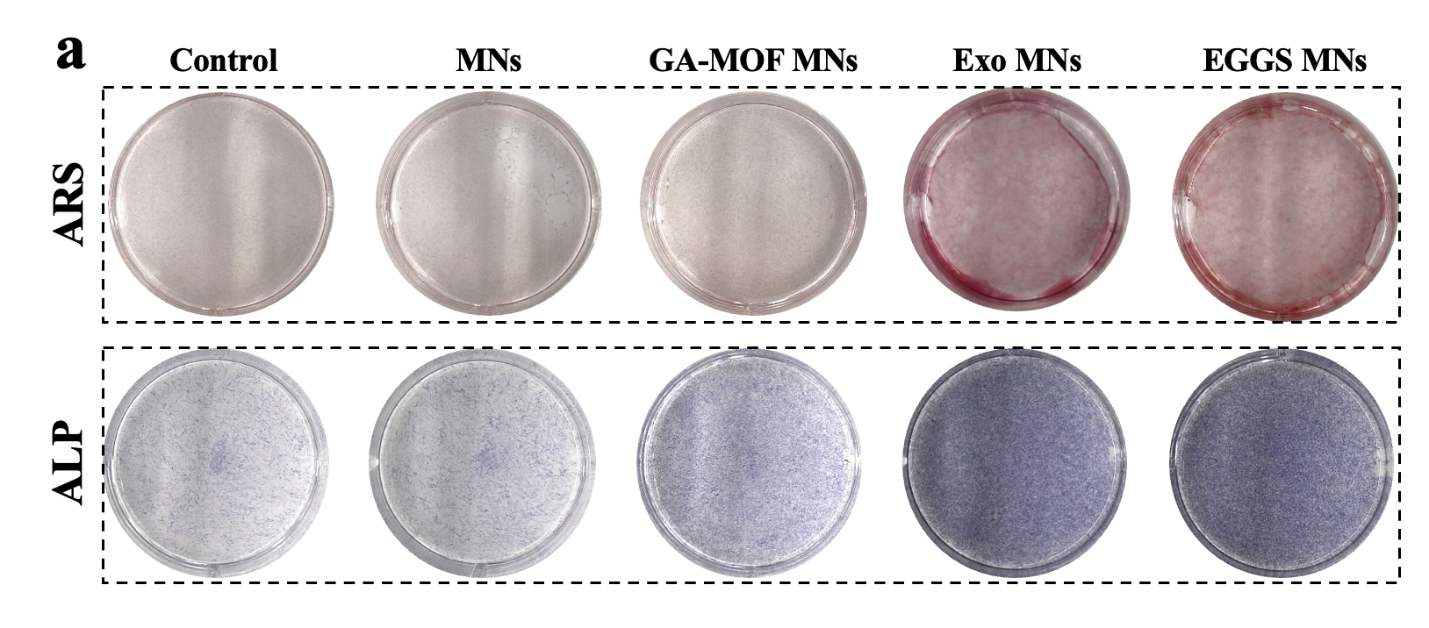
Figure S7. Digital photographs of ARS and ALP staining in MSC osteogenic experiments.

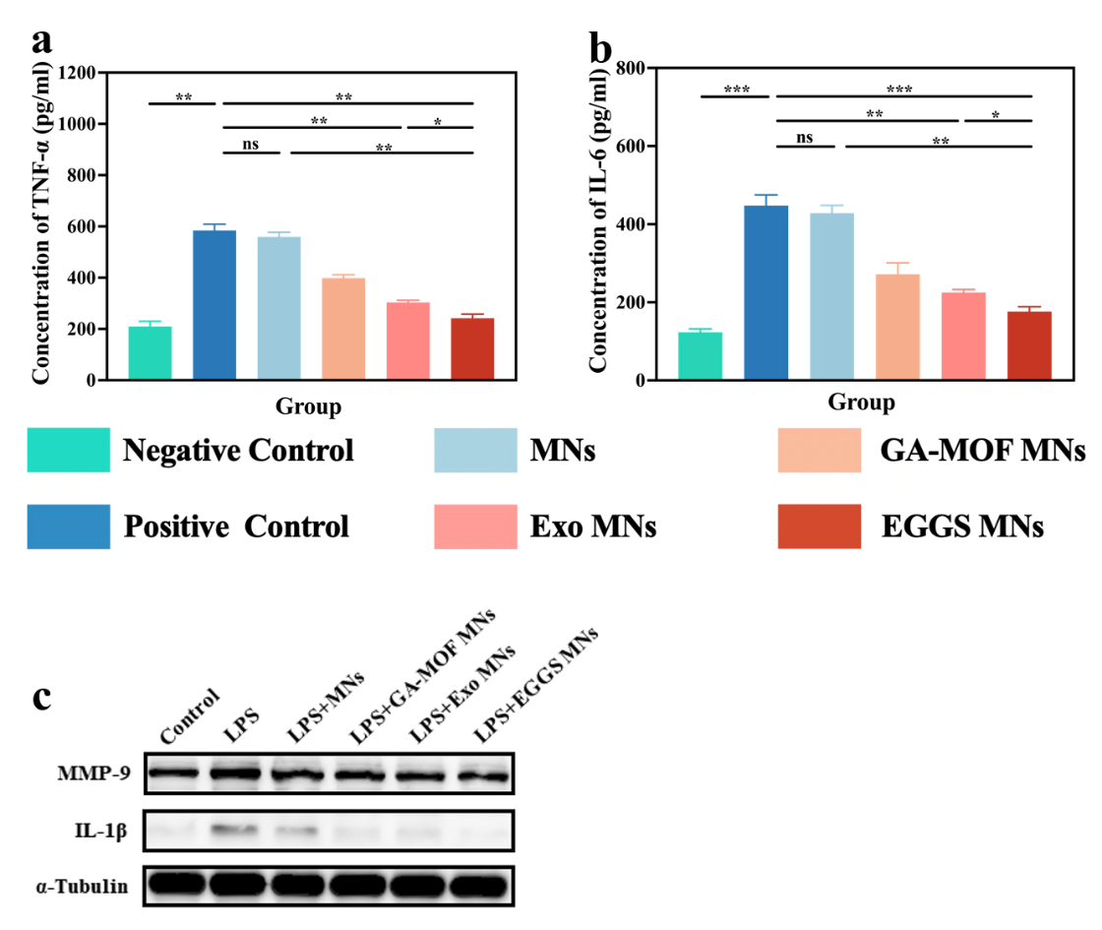
Figure S8. Anti-inflammatory effects of different MNs groups. (a) Elisa detects the concentration of TNF-α in macrophage culture medium treated with LPS and different MNs. (b) Elisa detects the concentration of IL-6 in macrophage culture medium treated with LPS and different MNs. (c) Western blot analysis of MMP-9 and IL-1 β protein expression in macrophages treated with MNs in each group.

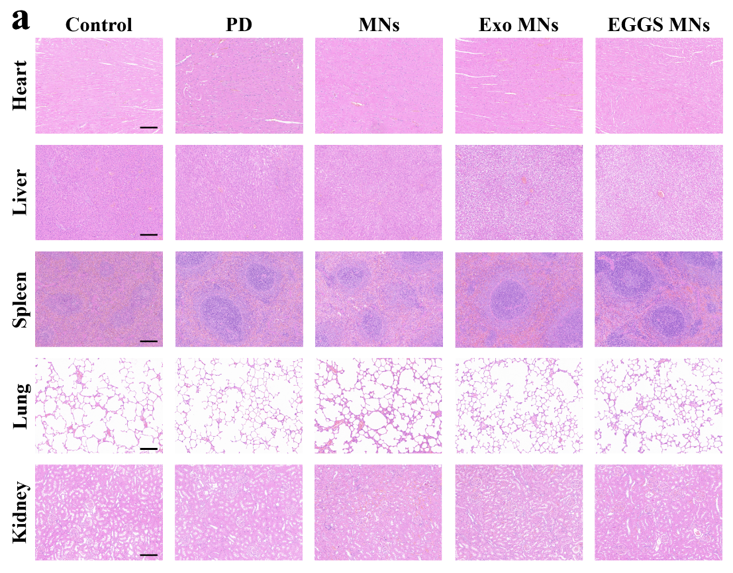
Figure S9. H&E staining of various organs in rats. (a) Using hematoxylin eosin (H&E) staining to observe the pathological changes in the heart, liver, spleen, lungs, and kidneys after MNs treatment for ulcers.

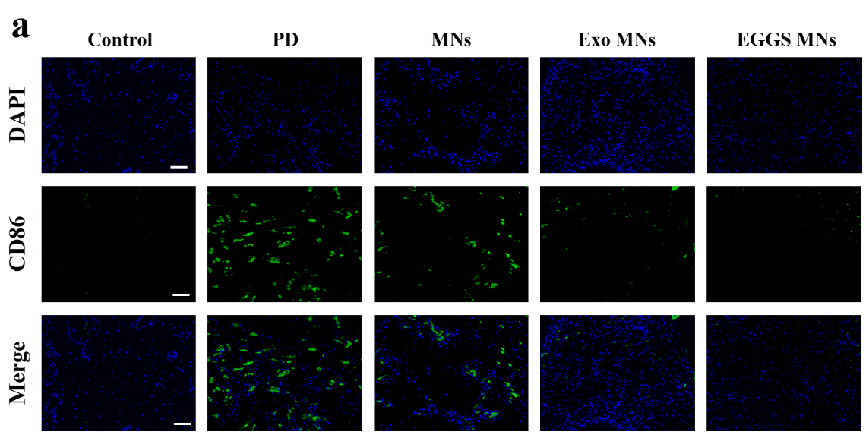
Figure S10. CD86 immunofluorescence staining in periodontal tissue. Representative images show the infiltration of CD86⁺ M1 macrophages (green fluorescence) in the lesion area of each group. Scale: 100 µm.
﻿
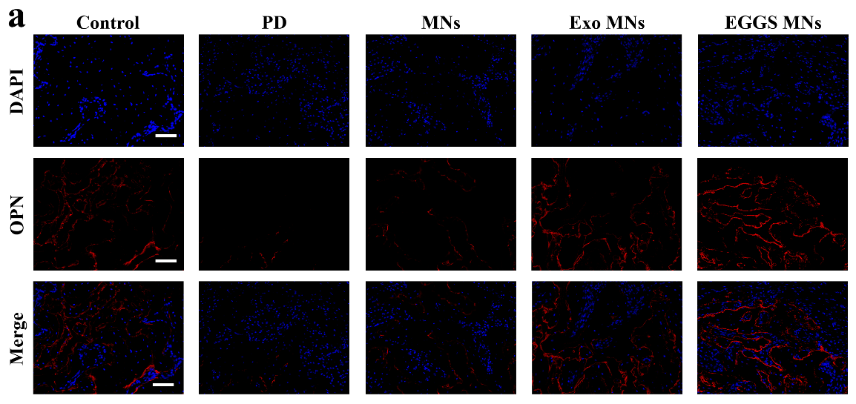
Figure S11. Fluorescence microscopy image of OPN immunofluorescence staining in periodontitis tissue. Scale: 100 µm.

