Supporting Information

Curcumin-loaded copper/iron bimetallic nanoparticle-incorporated hydrogel scaffold: a sequential microenvironment reprogramming platform for accelerated chronic wound healing

Fengyang Hu^{†,1}, Lei Ji^{†,2}, Haixia Chen¹, Xiuling He¹, Huan Huang¹, Ming Wang¹, Wenjie Sun³*, Xiaoya Ding⁴*, Lei Yang¹*

¹ Zhejiang Provincial Key Laboratory of Silk and Silk Protein New Materials, Institute of Sericulture and Tea, Zhejiang Academy of Agricultural Sciences, Hangzhou 310021, China
²Department of Vascular Surgery, The First Affiliated Hospital, School of Medicine, Zhejiang University, Hangzhou 310003, China
³Zhejiang Engineering Research Center for Innovation and Application of Intelligent Radiotherapy Technology, The Second Affiliated Hospital of Wenzhou Medical University, Wenzhou 325000, China
⁴ MOE Innovation Center for Basic Research in Tumor Immunotherapy, Anhui Province Key Laboratory of Tumor Immune Microenvironment and Immunotherapy, The First Affiliated Hospital of Anhui Medical University, Hefei 230022, China

†Fengyang Hu and Lei Ji contributed equally to this work.

*Corresponding authors
E-mail addresses: wenjie@wmu.edu.cn (W. Sun); xyding2021@163.com (X. Ding); yangleigeili@163.com (L. Yang)

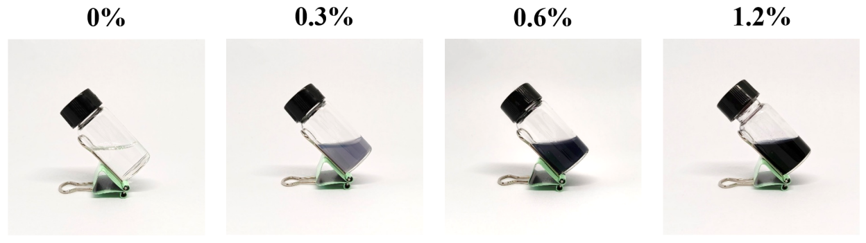
Figure S1. Images of nanoparticles with different Fe³⁺ concentrations.

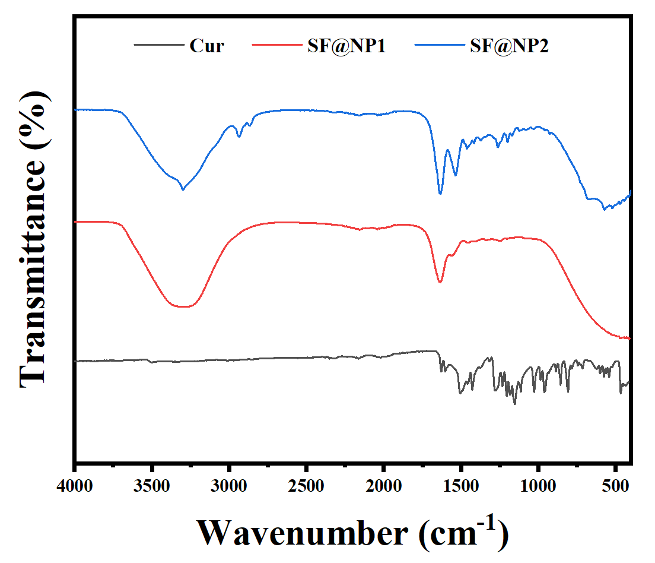
Figure S2. FTIR spectrum of Cur, SF@NP-Cur scaffold (SF@NP2), and SF@NP1 scaffold (SF@NP1).

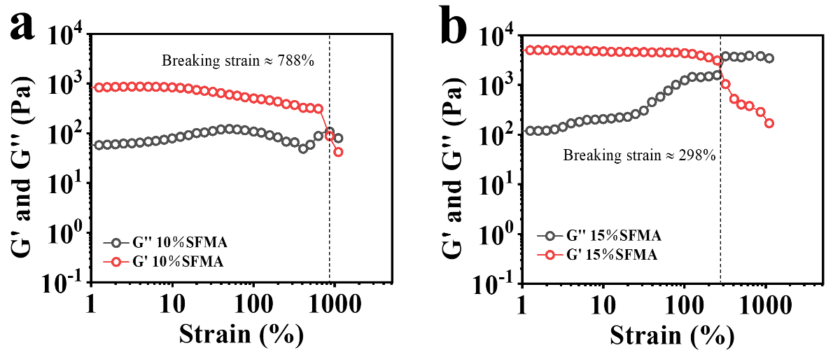
Figure S3. Strain sweep of a) 10% SF hydrogel and b) 15% SF hydrogel.

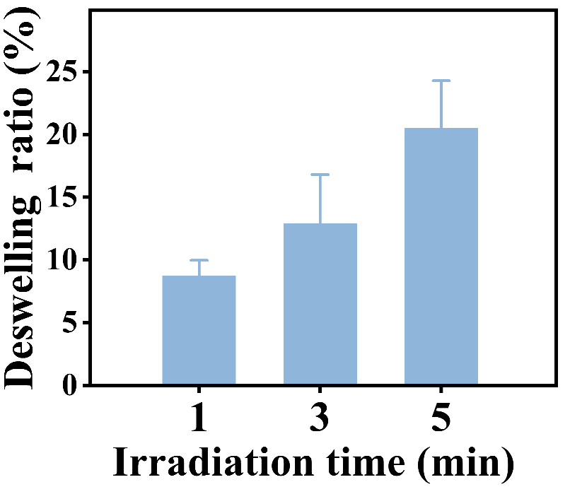
Figure S4. The deswelling behavior of SF@NP-Cur scaffold under NIR irradiation in PBS.

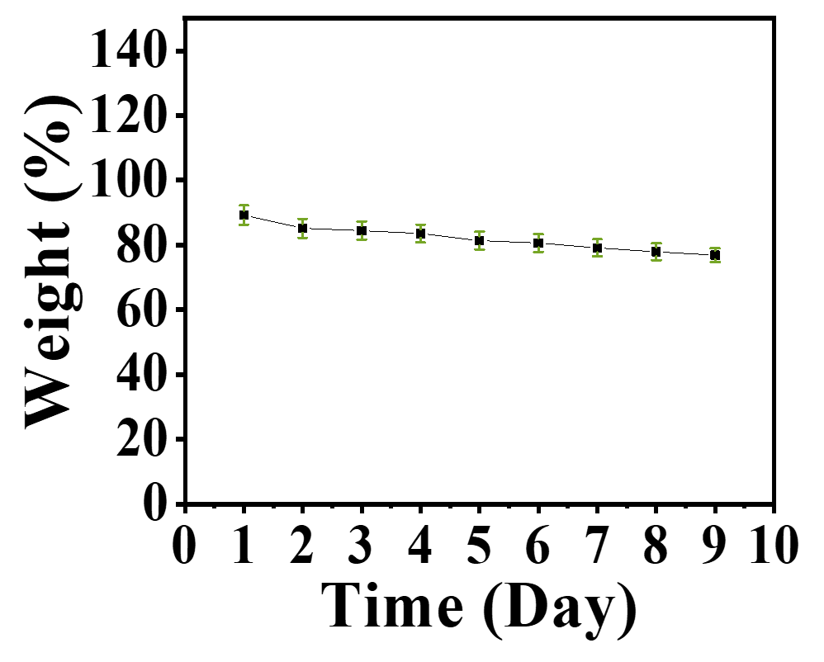
Figure S5. The degradation curve of SF@NP-Cur hydrogel scaffold under physiological conditions.

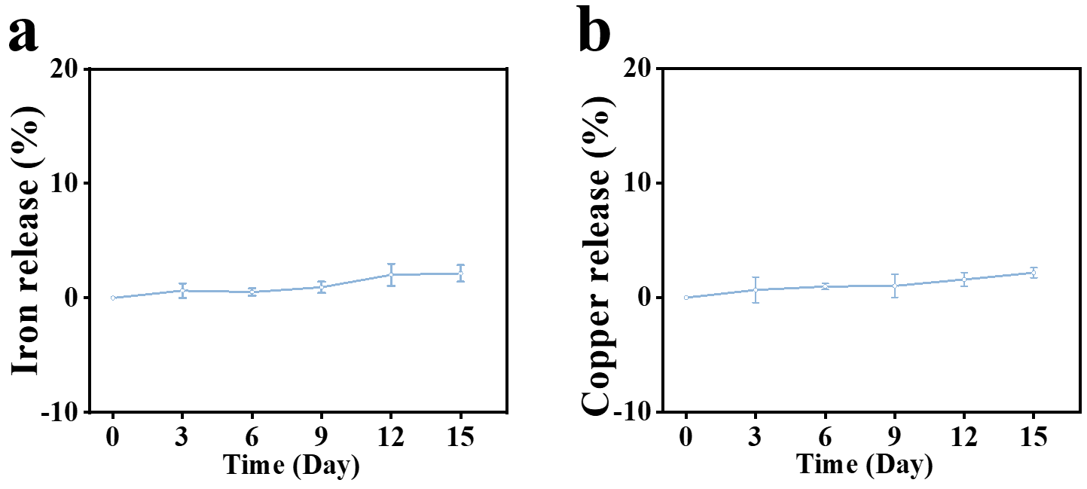
Figure S6. a) Release curves of Fe iron from NP-Cur nanoparticles. b) Release curves of Cu iron from NP-Cur nanoparticles.

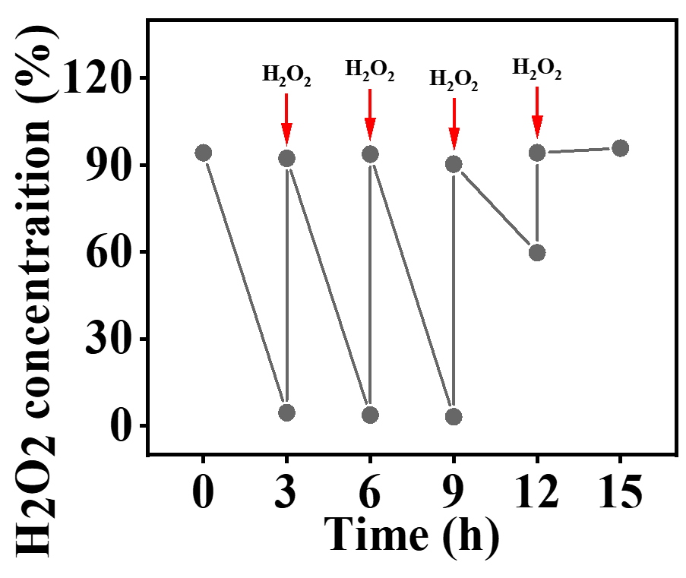
Figure S7. NP-Cur catalyzed the decomposition of hydrogen peroxide.

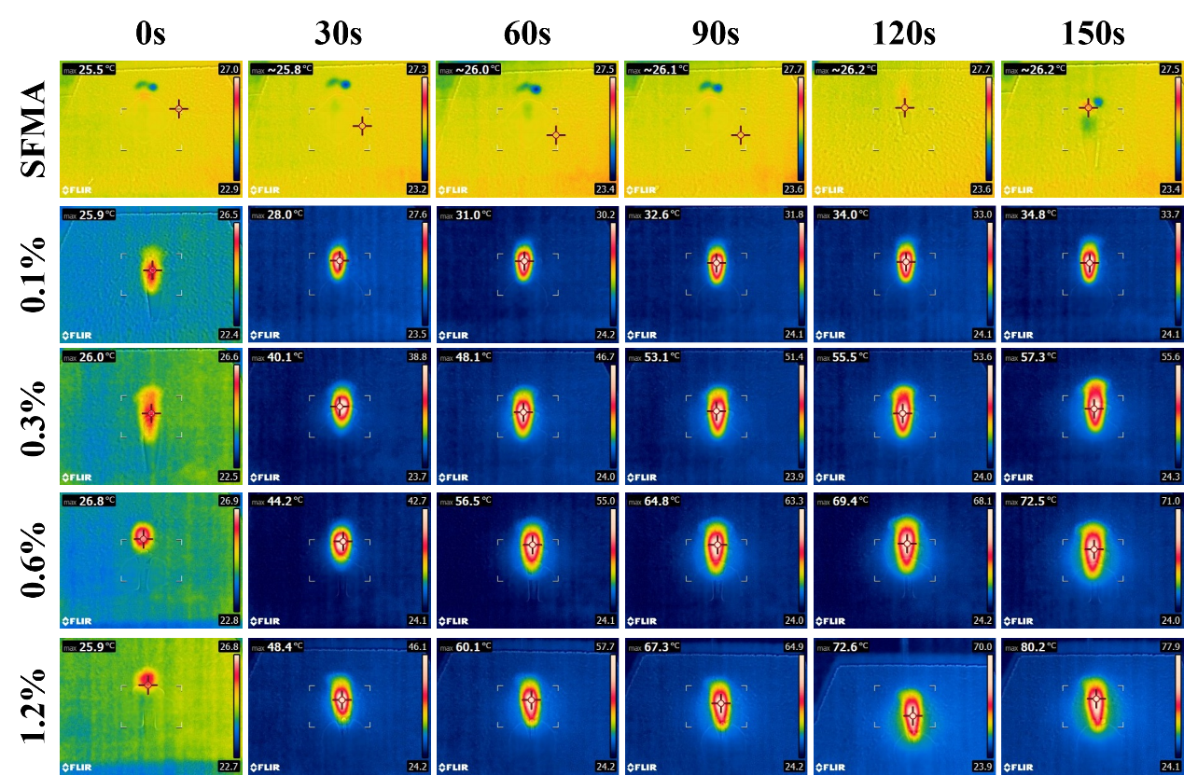
Figure S8. Real-time infrared thermal imaging pictures of NP-Cur with different Fe³⁺ contents.

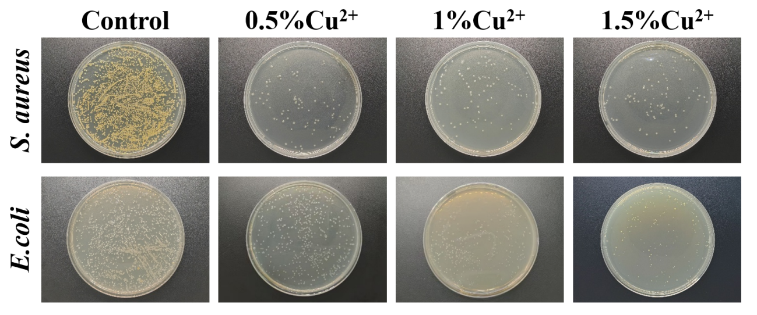
Figure S9. Antibacterial performance of nanoparticles with different Cu²⁺ concentrations.

Figure S10. The effect of NIR on the skin around the treated wound.

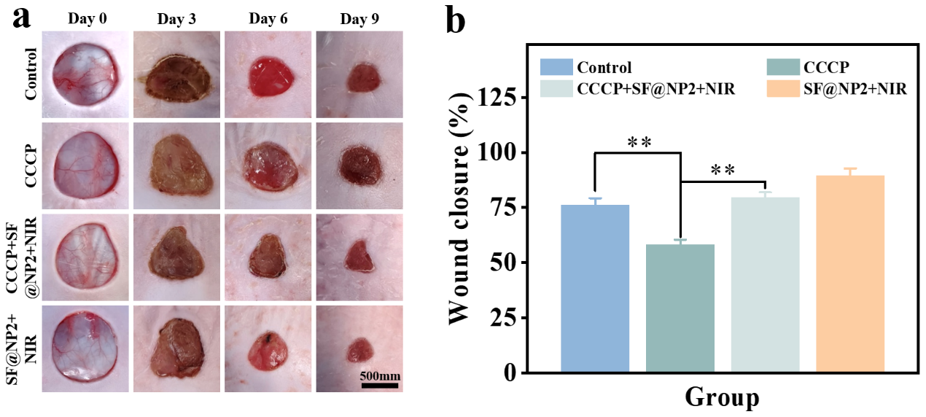
Figure S11. a) Representative macroscopic images of full-thickness wounds in each group at 0, 3, 6, 9 days after CCCP application. b) Quantitative analysis of wound closure rates in each group over 9 days.

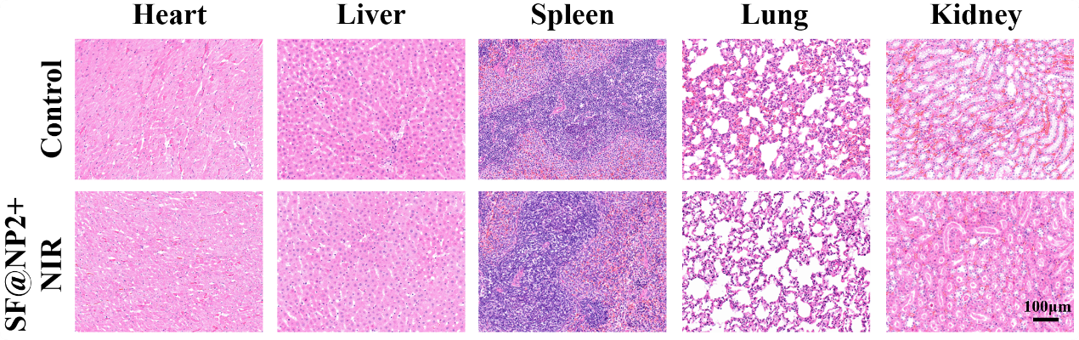
Figure S12. Toxicity assessment of the SF@NP2+NIR treatment on the main organs of SD rats.

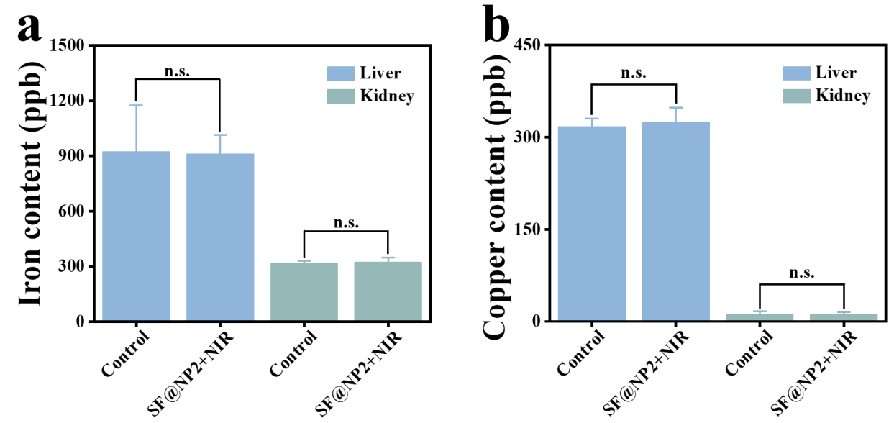
Figure S13. a) Iron contents in the liver and kidneys of rats after treatments. b) Copper contents in the liver and kidneys of rats after treatments.

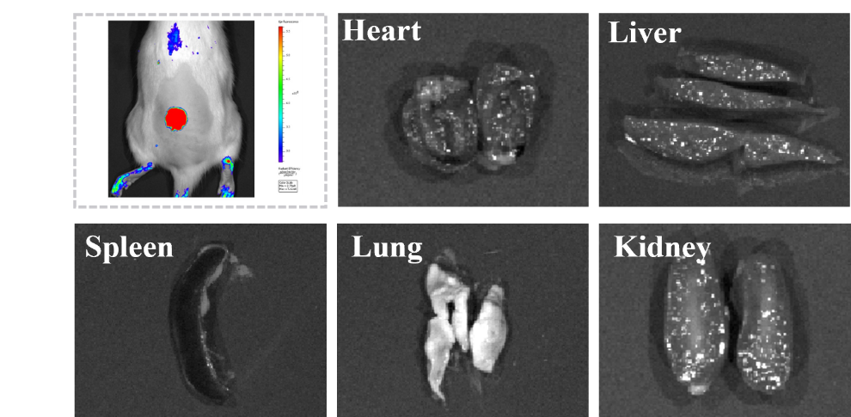
Figure S14. The living imaging result for the wound covered with the hydrogel scaffold, and the isolated organs of heart, liver, spleen, lung, and kidney from rats after different treatments. The harvested organs were sectioned for the better observation.

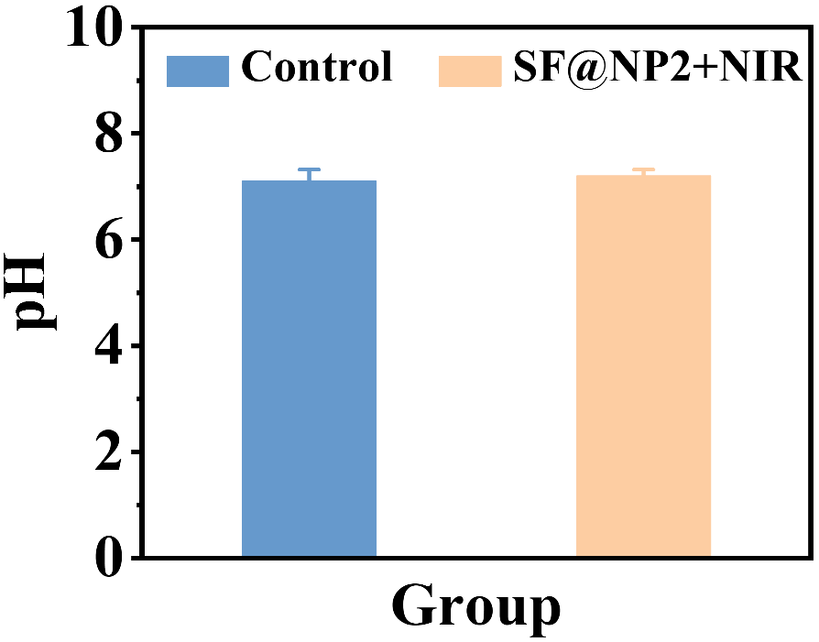
Figure S15. The quantitative analysis of wound exudate pH in Control and SF@NP2+NIR group after 6 days of treatments.

Figure S16. a) Representative immunohistochemical images of CD4 and CD8 after 12 days of different treatments. b, c) Quantitative analysis of CD4 and CD8 levels after 12 days of different treatments. *: compared with the control group.

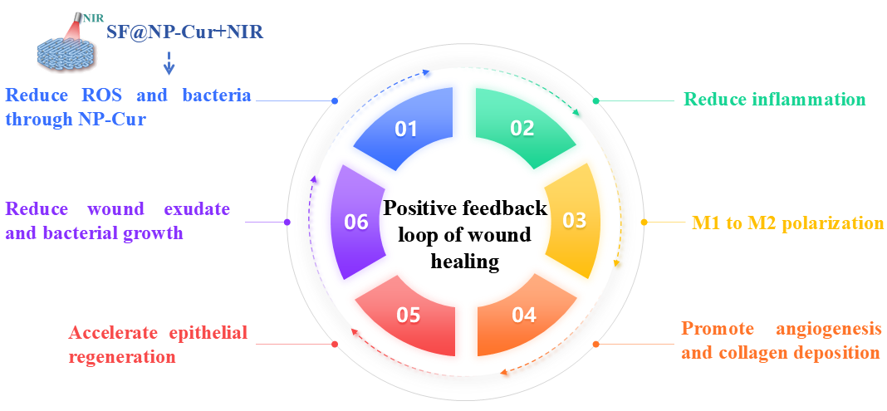
Figure S17. The feedback loop of wound healing mediated by SF@NP-Cur scaffold with NIR.

Table S1 Comparison of different reported hydrogels
Composition | Functions | Applications/  improvements | Reference
SF@NP-Cur (this study) | NIR response, ROS clearance, metabolic reprogramming, immune regulation | Adapting to multiple pathologies,  multi-mechanism synergy,  Drug delivery,  Wound healing | —
CG-Cu²⁺_{0.5}-DG₁₀/MAP | Rapid anti-inflammatory, antibacterial, strong skin adhesion | burns and infected wounds | [1]
FeCl₃/OPD/PEO NH | ROS scavenging, hemostasis, tissue adhesion | burn wounds healing | [2]
ALG-DETA/NO | Antibacterial effect, reduction inflammation, | MRSA-infected wounds | [3]
PAHT | High toughness, anti-swelling mechanical properties, antibacterial, antioxidant | Infect wounds/inhibit scar formation | [4]
Tsg-THA&Fe | antibacterial, anti-inflammatory, hemostatic | Common wounds | [5]
PA-CCB | Self-healing, antibacterial, antioxidant | Infected/diabetic dynamic wounds | [6]
CG: Cationic guar gum; DG: Dipotassium glycyrrhizinate; MAP: Mussel adhesive protein; OPD: Oxidized pectin; PEO NH: Naphthoate hydrazide terminated PEO; ALG-DETA/NO: Diethylenetriamine/N-diazeniumdiolates-doped alginate; Tsg: Tilapia skin gelatin; THA: 2,3,4-trihydroxybenzaldehyde; PA: polydopamine nanoparticles; CCB: Cationic guar gum-chitosan-boric acid;

Reference
[1] Z. Wang, J. Liu, Y. Zheng, B. Zhang, Y. Hu, Y. Wu, Y. Li, L. Liu, H. Zhu, Q. Liu, B. Yang: Copper Ion-Inspired Dual Controllable Drug Release Hydrogels for Wound Management: Driven by Hydrogen Bonds. Small 2024, 20(34): e2401152.
[2] B. Jia, T. Hao, Y. Chen, Y. Deng, X. Qi, C. Zhou, Y. Liu, S. Guo, J. Qin: Mussel-inspired tissue adhesive composite hydrogel with photothermal and antioxidant properties prepared from pectin for burn wound healing. International Journal of Biological Macromolecules 2024, 270(Pt 2): 132436.
[3] N. Hasan, J. Lee, D. Kwak, H. Kim, A. Saparbayeva, H.J. Ahn, I.S. Yoon, M.S. Kim, Y. Jung, J.W. Yoo: Diethylenetriamine/NONOate-doped alginate hydrogel with sustained nitric oxide release and minimal toxicity to accelerate healing of MRSA-infected wounds. Carbohydrate Polymers 2021, 270: 118387.
[4] X. Liu, Y. Sun, J. Wang, Y. Kang, Z. Wang, W. Cao, J. Ye, C. Gao: A tough, antibacterial and antioxidant hydrogel dressing accelerates wound healing and suppresses hypertrophic scar formation in infected wounds. Bioactive Materials 2024, 34: 269-281.
[5] Y. Lu, M. Zhao, Y. Peng, S. He, X. Zhu, C. Hu, G. Xia, T. Zuo, X. Zhang, Y. Yun, W. Zhang, X. Shen: A physicochemical double-cross-linked gelatin hydrogel with enhanced antibacterial and anti-inflammatory capabilities for improving wound healing. Journal of Nanobiotechnology 2022, 20(1): 426.
[6] L. He, S. Xing, W. Zhang, Y. Wang, Y. Li, J. Chen, J. Zhang, S. Wang, Q. Zhao: Multifunctional dynamic chitosan-guar gum nanocomposite hydrogels in infection and diabetic wound healing. Carbohydrate Polymers 2025, 354: 123316.

