Diselenide-Bridged Dual-Action Nanoscavengers Drive Fasting-Boosted BBB Penetration and ROS-Responsive Resveratrol Delivery for Synergistic Ischemic Stroke Therapy

Qing Chen^{1,2,3†}, Qian Zhang^{2,7†}, Jin Wang^{3,4†}, Xiaoxing Xiong^{3,5}, Baiyi Luo¹, Yu Chen^{2,6}, Jinrong Zhang⁷, Min Zhao^{2,7}, Lijuan Gu^{3,4}*, and Jian Tian^{1,2,8}*

¹ Department of Cardiovascular Surgery, Zhongnan Hospital of Wuhan University, School of Pharmaceutical Sciences, Wuhan University, Wuhan 430071, China
² Hubei Shizhen Laboratory, Wuhan 430061, China
³ Central Laboratory, Renmin Hospital of Wuhan University, Wuhan 430060, China
⁴ Department of Anesthesia, Renmin Hospital of Wuhan University, Wuhan 430060, China
⁵ Department of Neurosurgery, Renmin Hospital of Wuhan University, Wuhan 430060, China
⁶ School of Traditional Chinese Medicine, Hubei University of Chinese Medicine, Wuhan 430065, China
⁷ School of Basic Medical Sciences, Hubei University of Chinese Medicine, Wuhan 430065, China
⁸ State Key Laboratory of Metabolism and Regulation in Complex Organisms, College of Life Sciences, Wuhan University, Wuhan 430071, China

* Corresponding email addresses: gulijuan@whu.edu.cn (Lijuan Gu), jian.tian@whu.edu.cn (Jian Tian)
† These authors contributed equally to this work.

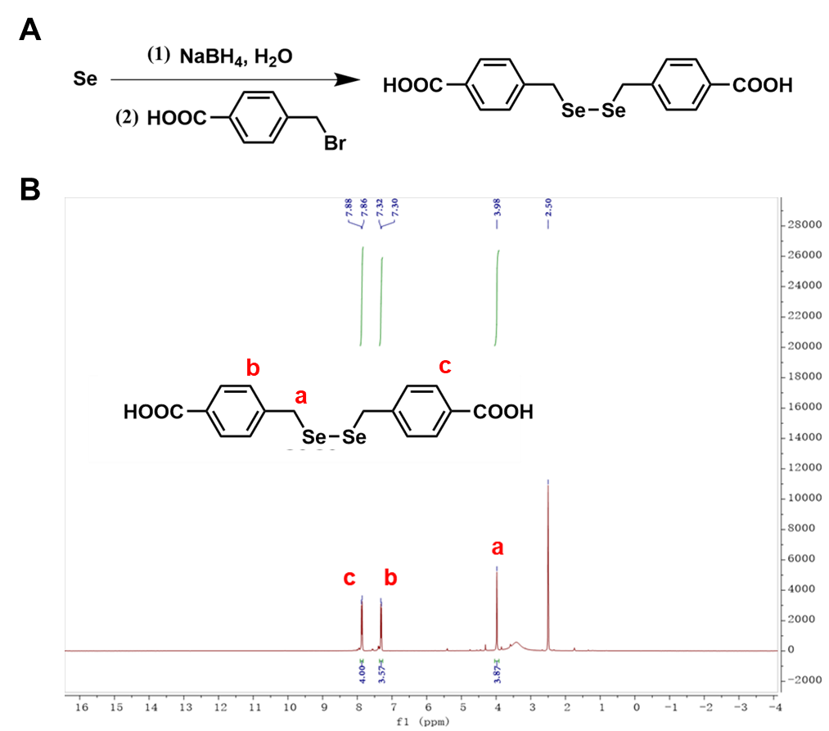

Fig. S1. Synthesis and characterization of diselenide ligand. (A) Synthetic route of diselenide ligand. (B) ¹H NMR spectrum of diselenide ligand in DMSO-d₆.
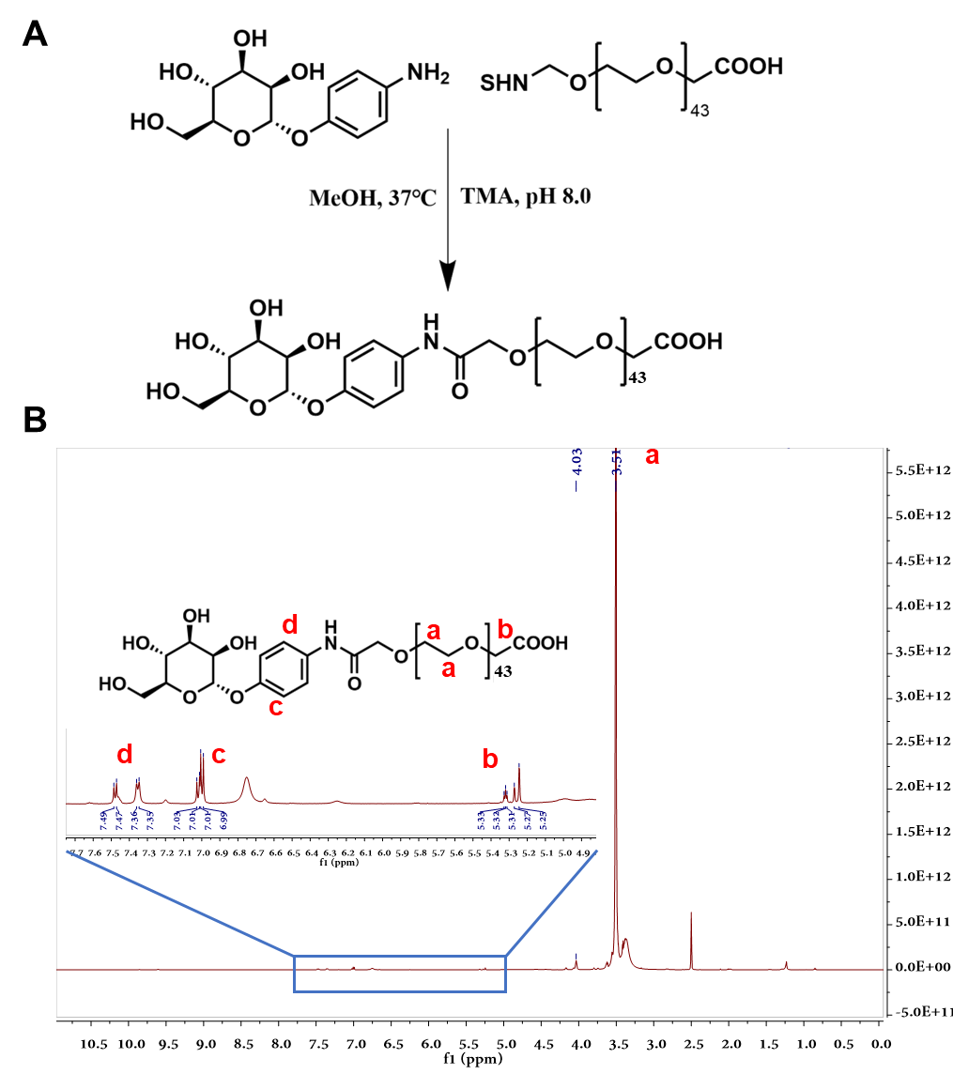

Fig. S2. Synthesis and characterization of Man-PEG2000. (A) Synthetic route of Man-PEG2000. (B) ¹H NMR spectrum of Man-PEG2000 in DMSO-d₆.

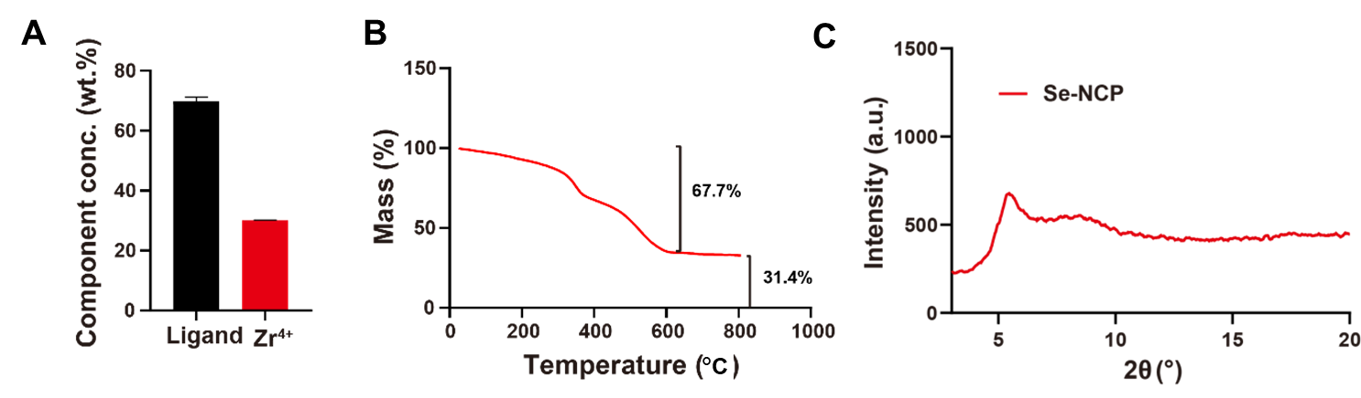

Fig. S3. Characterization of Se-NCP. ICP-MS analysis (A) and TGA curves (B) of Se-NCP. n = 3. (C) XRD pattern of Se-NCP. Data are presented as mean ± SD.

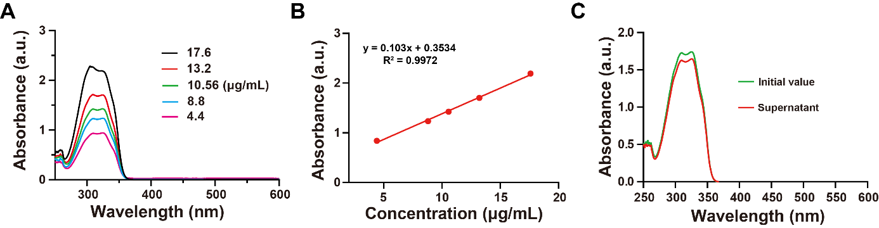

Fig. S4. Characterization of drug loading in preparing R@NCP. (A) UV-Vis absorption spectra of different concentrations of Res. (B) UV-Vis standard curve of Res. (C) UV-Vis spectrum of the Res loading by Se-NCP using the post-synthesis drug loading method.

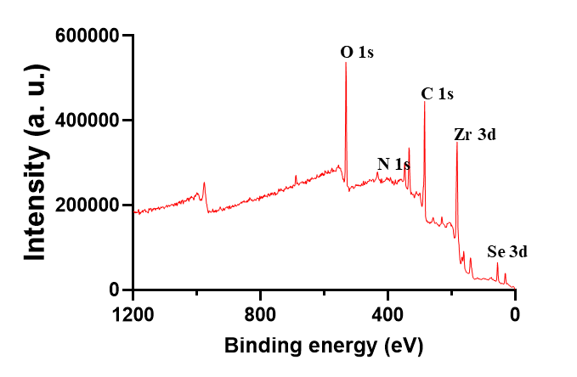

Fig. S5. Qualitative element analysis of M@R@NCP by XPS.

Fig. S6. Particle size stability of M@R@NCP. Size stability of M@R@NCP in various temperature conditions (A) and solvents (B) incubated at 37 °C for 9 days. n = 3. Data are presented as mean ± SD.

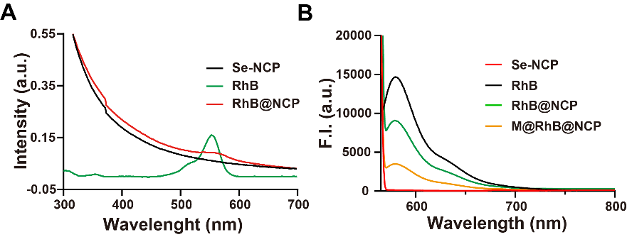

Fig. S7. Characterization of M@RhB@NCP. (A) UV-Vis absorption spectra of RhB, Se-NCP and RhB@NCP. (B) Fluorescence emission spectra of different preparations with excitation at 561 nm.

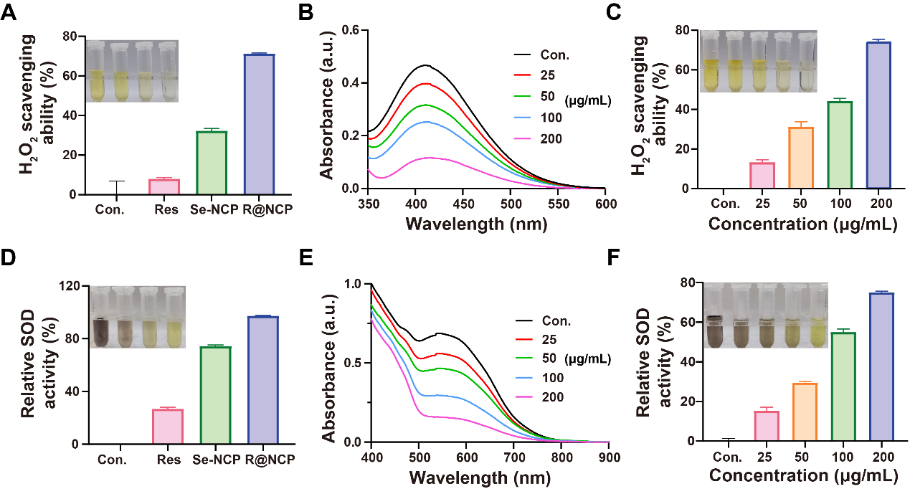

Fig. S8. H₂O₂ consumption and SOD-like activity of Res, Se-NCP and R@NCP. (A) H₂O₂ scavenging effects of Res, Se-NCP and R@NCP. UV-Vis absorption spectra (B) and quantitative analysis (C) of H₂O₂-Ti(SO₄)₂ solution in the presence of different concentrations of R@NCP after 12 h. (D) SOD-like activity of Res, Se-NCP, and R@NCP. (E) Elimination efficiency of ·O₂⁻ with different concentrations of R@NCP. (F) SOD-like activity of different concentrations of R@NCP. n = 3. Data are presented as mean ± SD.
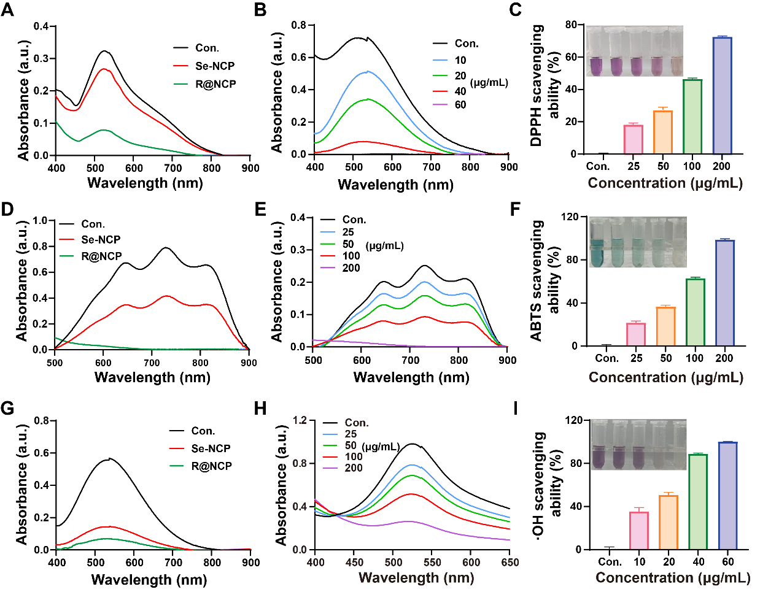
Fig. S9. Free radicals scavenging ability of Se-NCP and R@NCP. (A) DPPH· radicals scavenging ability of Se-NCP and R@NCP. UV-Vis absorption spectra (B) and quantitative analysis (C) of DPPH· radicals scavenging ability of R@NCP at different concentrations. (D) ABTS·⁺ radicals scavenging ability of Se-NCP and R@NCP. UV-Vis absorption spectra (E) and quantitative analysis (F) of ABTS·⁺ radicals scavenging ability of R@NCP at different concentrations. (G) ·OH radicals scavenging ability of Se-NCP and R@NCP. UV-Vis absorption spectra (H) and quantitative analysis (I) of ·OH radicals scavenging ability of R@NCP at different concentrations. n = 3. Data are presented as mean ± SD.

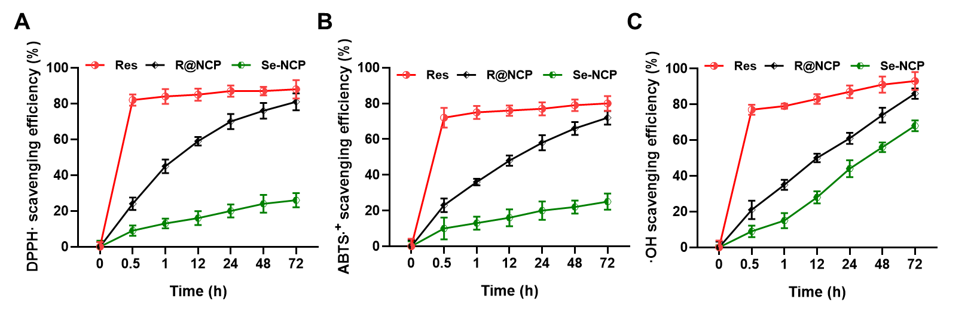
Fig. S10. The kinetic curve of free radical scavenging of Res, Se-NCP, and R@NCP. The kinetic curves of (A) DPPH·, (B) ABTS·⁺, and (C)·OH scavenging.
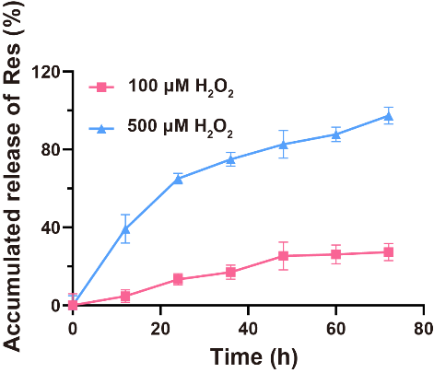
Fig. S11. The drug release profile of M@R@NCP in PBS (pH 7.4) containing different concentrations of H₂O₂ at 37 °C. n = 3. Data are presented as mean ± SD.

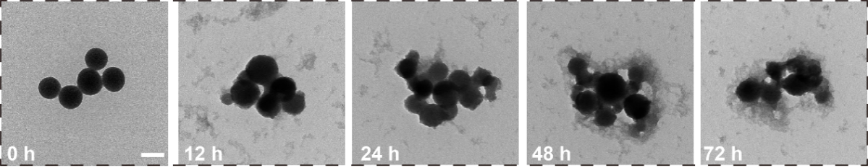

Fig. S12. TEM images of M@R@NCP incubated in the H₂O₂ solution (200 μM) at various time points. Scale bar, 100 nm.

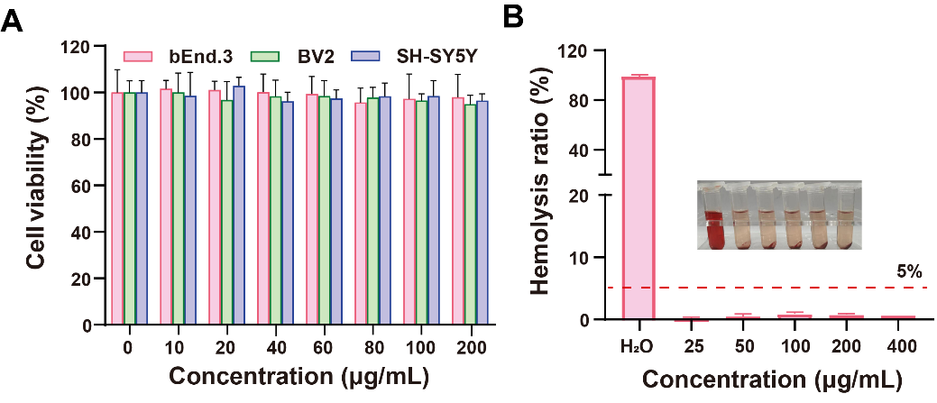
Fig. S13. The biocompatibility analysis of M@R@NCP. (A) Cell viability of M@R@NCP in vitro for bEnd.3 cells, BV2 cells, and SH-SY5Y cells. (B) Hemolysis analysis of M@R@NCP. n = 3. Data are presented as mean ± SD.
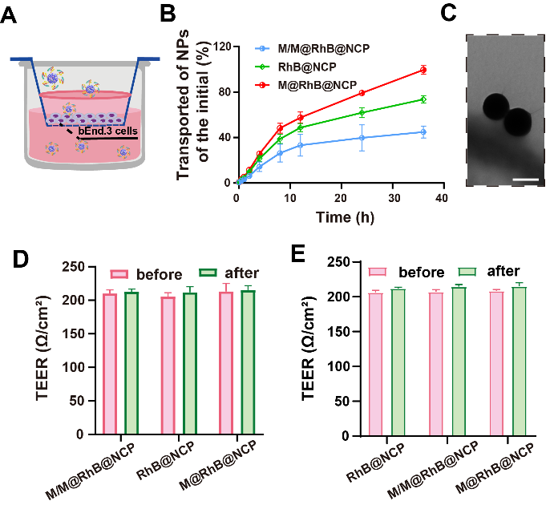
Fig. S14. In vitro permeability of M@R@NCP in a monolayer transwell model. (A) Schematic of a monolayer transwell model. (B) Cumulative transport percentage of different RhB-labeled formulations. (C) TEM images of M@R@NCP in the lower chamber after12 h of incubation. Scale bar, 100 nm. (D) TEER measurement values of the monolayer model before and after the experiment. (E) TEER measurement values of the bilayer model before and after the experiment. n = 3. Data are presented as mean ± SD.

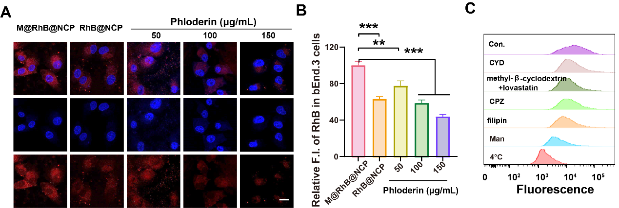

Fig. S15. Internalized behavior of M@RhB@NCP in bEnd.3 cells. CLSM image (A) and quantitative analysis (B) of RhB-labeled NPs after bEnd.3 cells were incubated with different formulations and concentrations of phloretin. Scale bar, 10 µm. (C) Flow cytometry analysis of the endocytosis mechanisms of M@R@NCP in bEnd.3 cell pretreated with different inhibitors. n = 3. Data are presented as mean ± SD. **P < 0.01, ***P < 0.001.

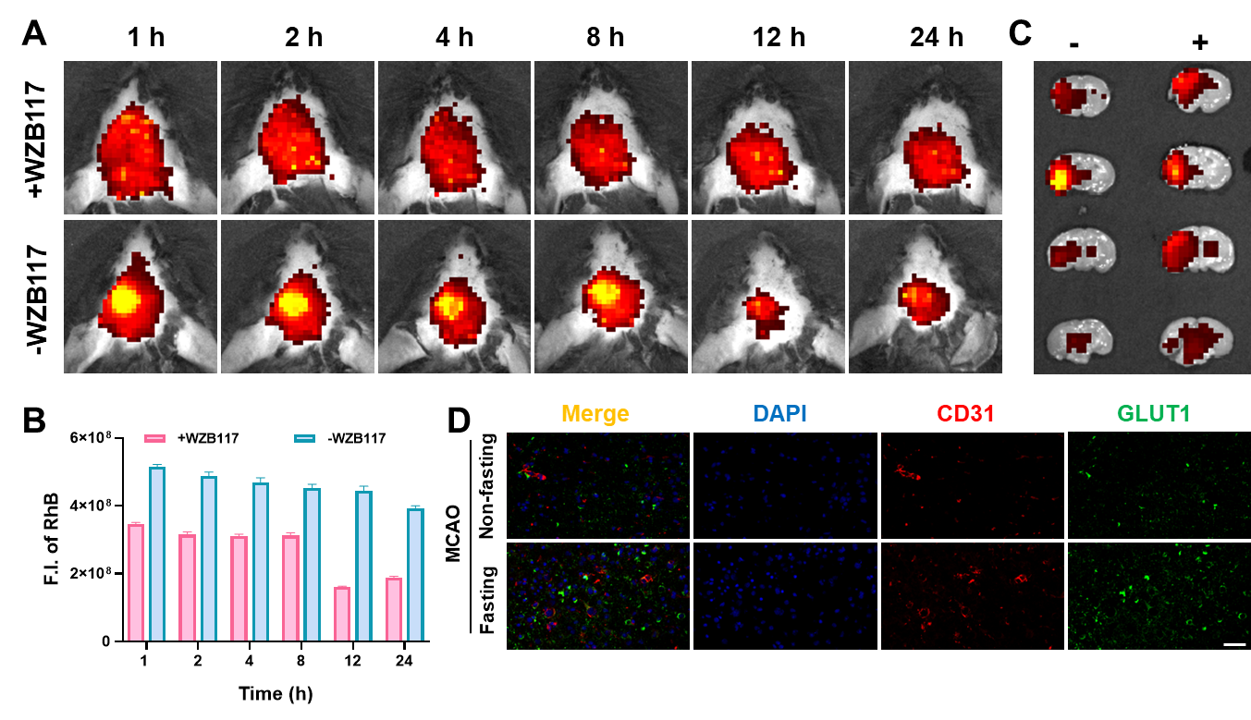
Fig. S16. Specificity analysis of M@RhB@NCP dependence on GLUT1. (A) Fluorescence imaging of mice treated with or without an intravenous GLUT1 inhibitor. (B) Quantitative analysis of fluorescence intensity. (C) Fluorescence imaging of brain tissue sections from mice treated with or without the inhibitor. (D) Immunofluorescence co-localization analysis of GLUT1 with cerebral microvascular marker CD31. Scale bar, 50 µm. n = 3. Data are presented as mean ± SD.

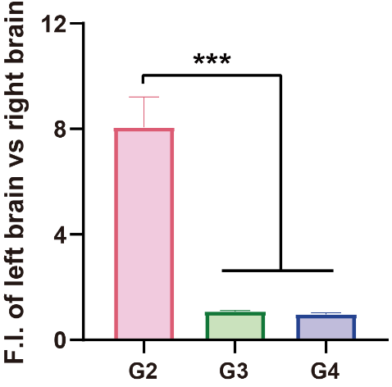

Fig. S17. Fluorescence quantitative analysis of the left brain/right brain after intravenous injection of different formulations (G2: G/M@RhB@NCP, G3: M@RhB@NCP, G4: RhB@NCP). n = 3. Data are presented as mean ± SD. ***P < 0.001.

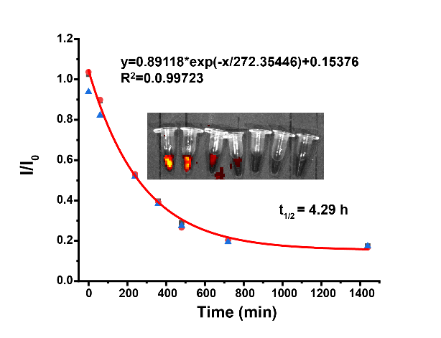
Fig. S18. Pharmacokinetic analysis of M@R@NCP.

Table S1. Pharmacokinetic Parameters

Indicators | Values | Units
AUC | 618.95 | μg·h/mL
Cₘₐₓ | 99.96 | μg/mL
CL | 0.646 | L/h
Vd | 4.0 | L/kg
t_{1/2} | 4.29 | h

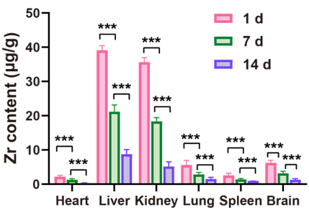

Fig. S19. Biodistribution of M@R@NCP in major organs over time. n = 3. Data are presented as mean ± SD. ***P < 0.001.
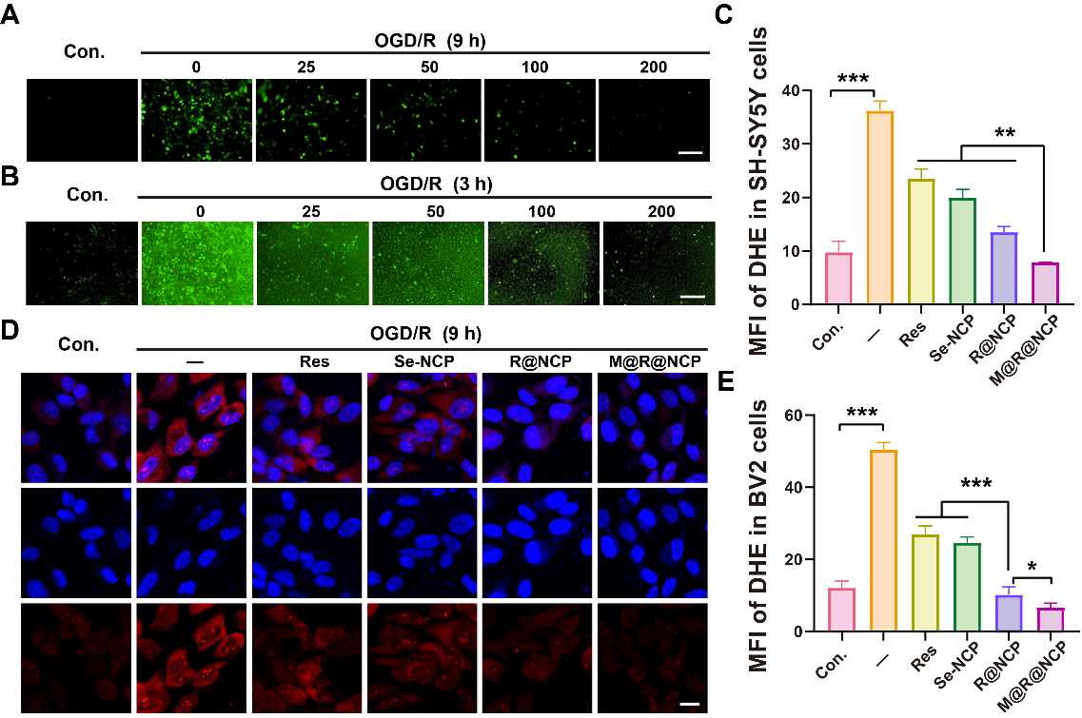

Fig. S20. M@R@NCP protection against OGD/R-induced cell injury. (A) Inverted fluorescence microscope images of intracellular ROS levels in SH-SY5Y cells. Scale bar, 100 μm. (B) Inverted fluorescence microscope images of intracellular ROS levels in BV2 cells. Scale bar, 100 μm. (C) Quantitative analysis of DHE fluorescence staining in BV2 cells. CLSM images (D) and quantitative analysis (E) of DHE fluorescence staining in SH-SY5Y cells. Scale bar, 10 μm. n = 3. Data are presented as mean ± SD. *P < 0.05, **P < 0.01, ***P < 0.001.

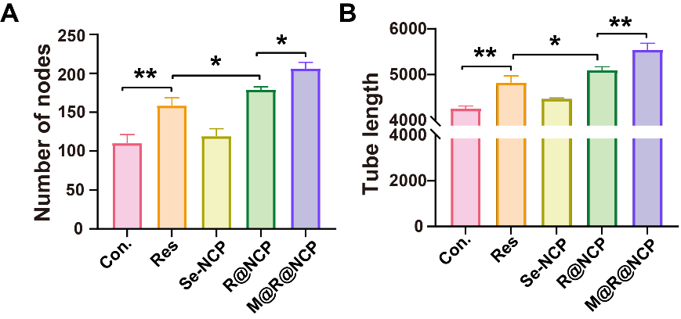

Fig. S21. Tube formation assay of HUVECs after different treatments. Quantitative statistics of the number of nodes (A) and the tube length (B). n = 3. Data are presented as mean ± SD. *P < 0.05, **P < 0.01.
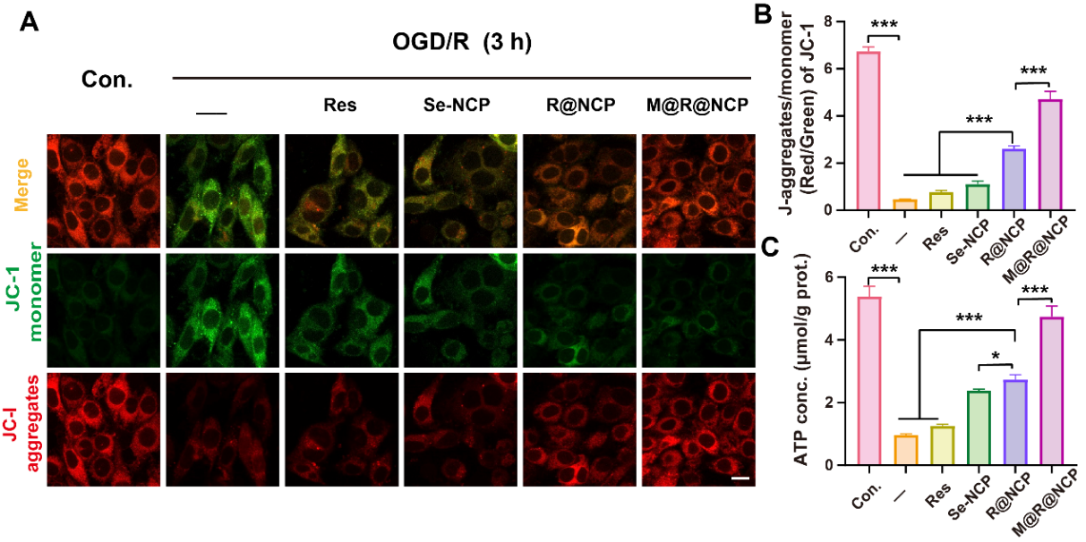

Fig. S22. Mitochondrial protection of M@R@NCP. (A) Representative CLSM images of JC-1 fluorescence staining in BV2 cells. Scale bar, 10 μm. (B) JC-1 aggregates (red)/JC-1 monomer (green) fluorescence ratio. (C) ATP content in BV2 cells. n = 3. Data are presented as mean ± SD. *P < 0.05, ***P < 0.001.

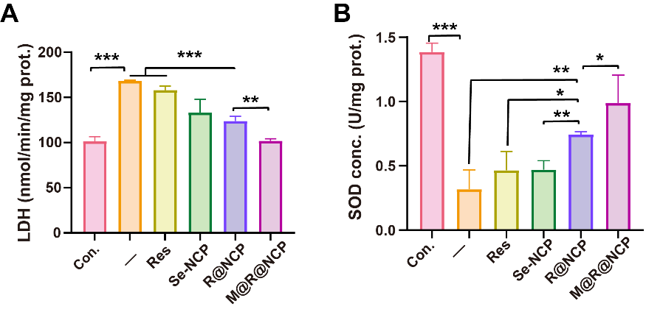

Fig. S23. Regulatory activity of M@R@NCP to oxidative stress. Expression levels of LDH (A) and SOD (B) in SH-SY5Y cells from different treatment groups. n = 3. Data are presented as mean ± SD. *P < 0.05, **P < 0.01, ***P < 0.001.

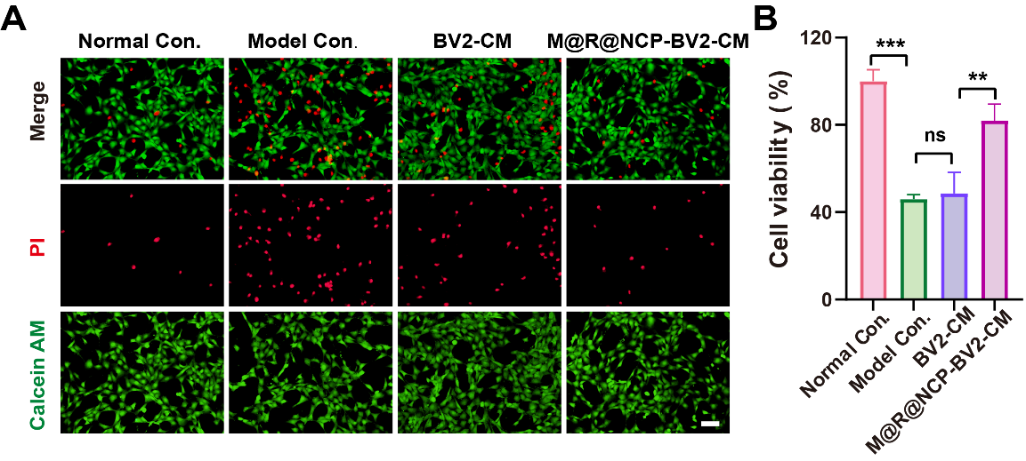

Fig. S24. The impact of conditioned medium from BV2 cells treated with M@R@NCP on the viability of oxidative stress-induced neurons was assessed by (A) MTT assay and (B) Live/Dead staining. Scale bar, 100 μm. n = 3. Data are presented as mean ± SD. **P < 0.01, ***P < 0.001.

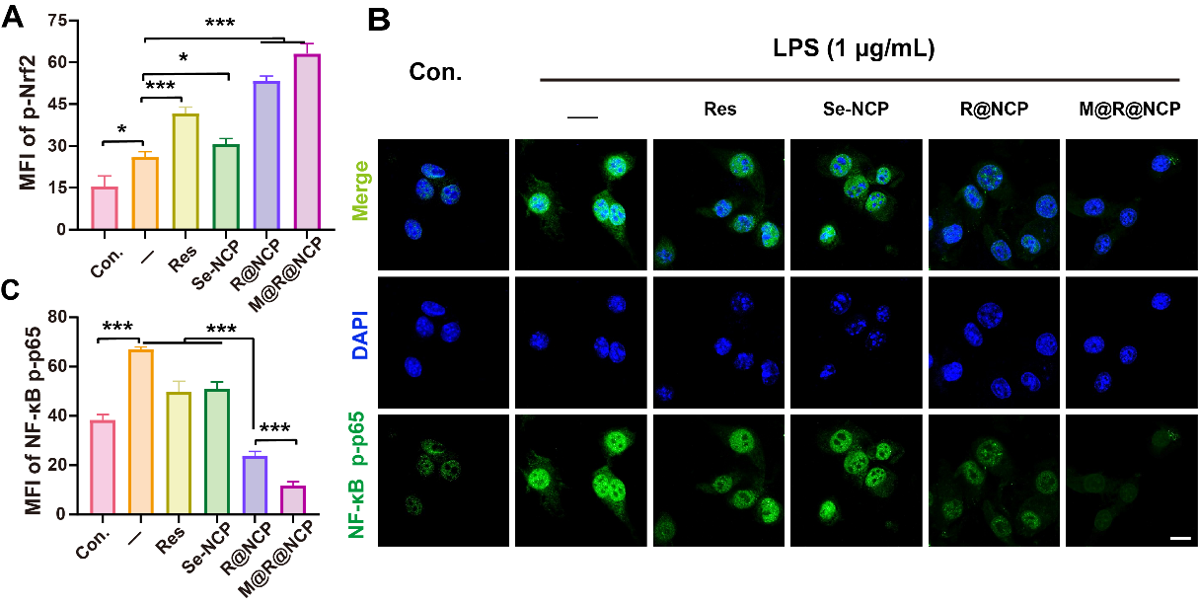

Fig. S25. Regulation of NF-κB signaling pathway by M@R@NCP. (A) Quantitative analysis of p-Nrf2 in BV2 cells. Representative immunofluorescence images (B) and quantitative analysis (C) for NF-κB p-p65 (green) in BV2 cells incubated with different formulations after LPS treatment. Scale bar, 10 μm. n = 3. Data are presented as mean ± SD. *P < 0.05, ***P < 0.001.

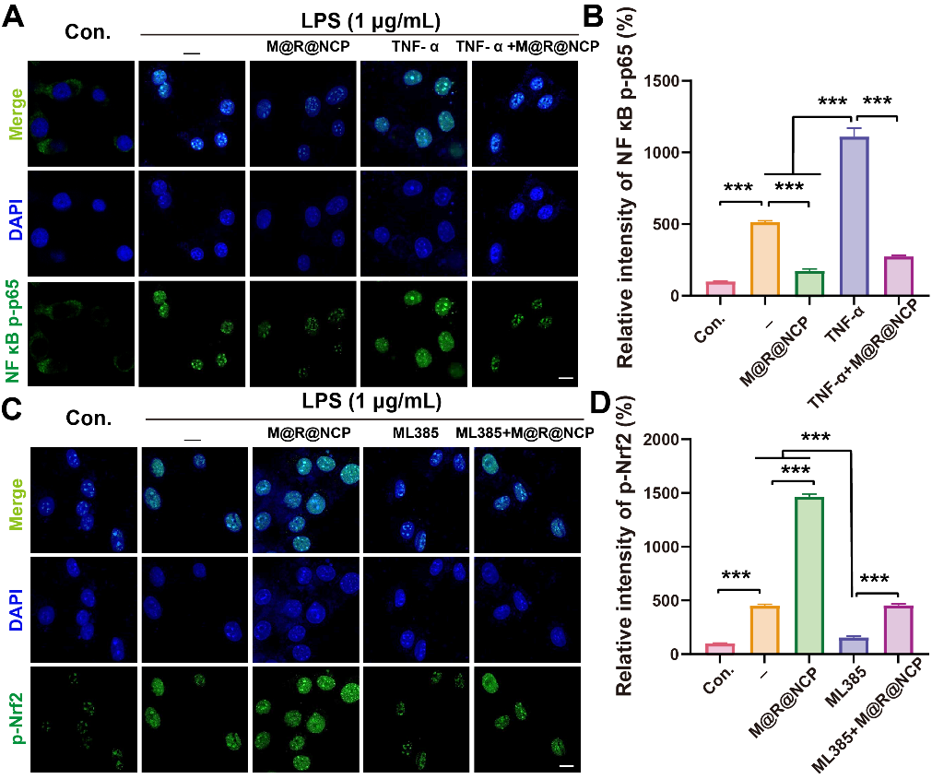

Fig. S26. Specific effects of M@R@NCP on the regulation of the Nrf2/NF-κB signaling pathway. Representative immunofluorescence images (A) and quantitative analysis (B) for NF-κB p-p65 (green) in BV2 cells incubated with different formulations after LPS treatment. Scale bar, 10 μm. Representative immunofluorescence images (C) and quantitative analysis (D) for p-Nrf2 (green) in BV2 cells incubated with different formulations after LPS treatment. Scale bar, 10 μm. n = 3. Data are presented as mean ± SD. ***P < 0.001.

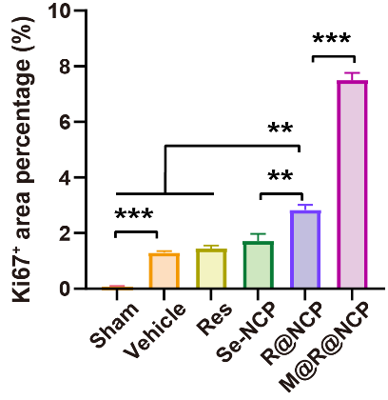

Fig. S27. Quantitative analysis of Ki67-positive area percentage. n = 3. Data are presented as mean ± SD. **P < 0.01, ***P < 0.001.
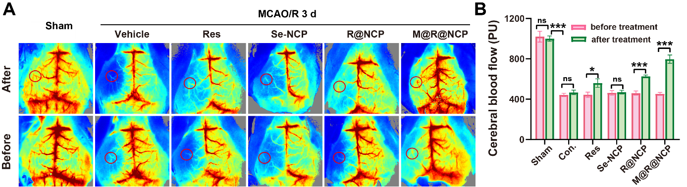

Fig. S28. (A) Laser speckle imaging and (B) quantitative analysis of middle CBF in MCAO/R mice from different groups, measured before and after treatment. n = 3. Data are presented as mean ± SD. *P < 0.05, **P < 0.01, ***P < 0.001.

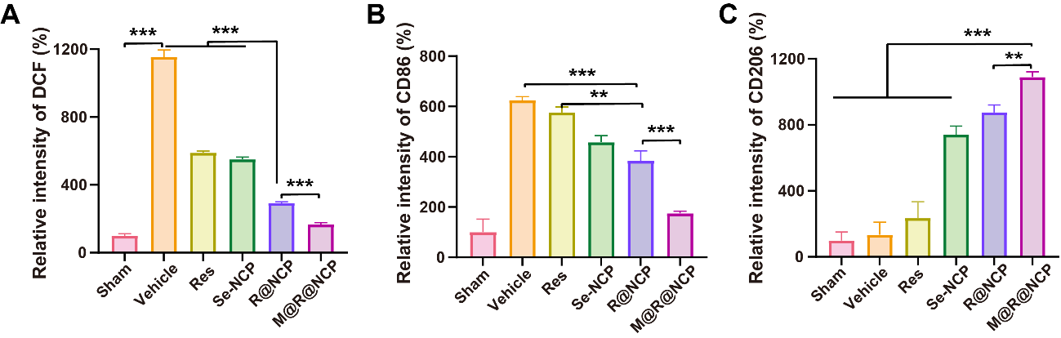

Fig. S29. In vivo therapeutic mechanisms of M@R@NCP in MCAO/R mice. (A) Quantitative analysis of ROS levels in brain tissue sections. Quantitative analysis of CD86 (B) and CD206 (C) levels in brain tissue sections. n = 3. Data are presented as mean ± SD. **P < 0.01, ***P < 0.001.
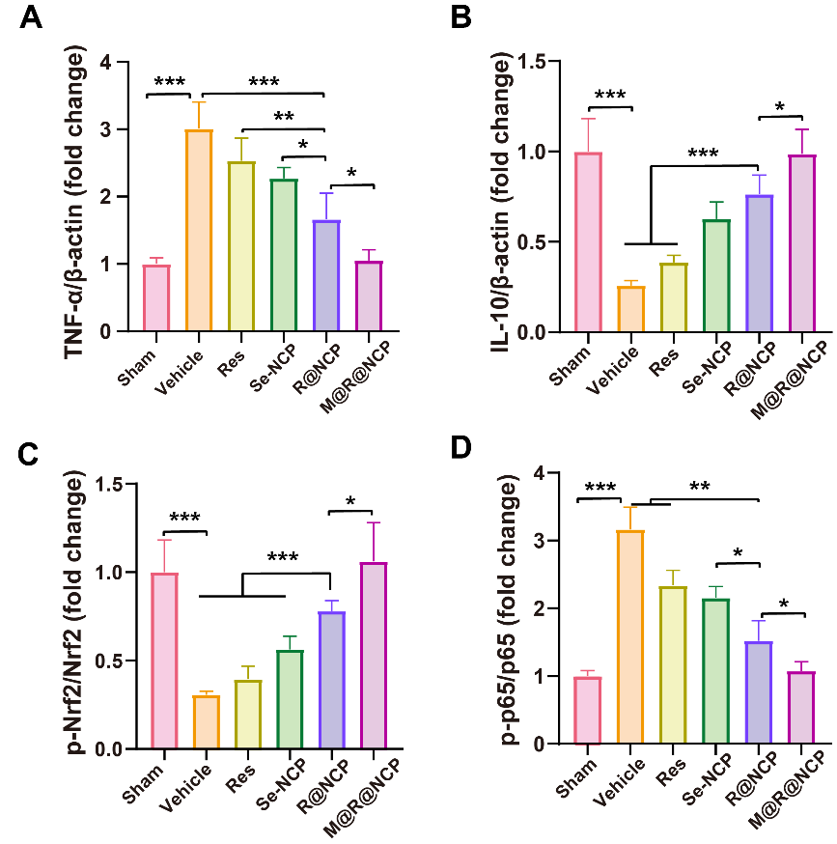

Fig. S30. WB quantitative analysis of the proteins level. Quantitation of the protein levels of TNF-α (A), IL-10 (B) in the ischemic cortical tissues. Quantitative analysis of p-Nrf2/Nrf2 (C) and p-p65/p65 (D) protein expression levels. n = 5. Data are presented as mean ± SD. *P < 0.05, **P < 0.01, ***P < 0.001.

Fig. S31. (A) Representative images of TTC-stained brain sections after 3 days of MCAO/R. (B) Statistical analysis of the infarct volume in different groups. n = 5. Data are presented as mean ± SD. ***P < 0.001.

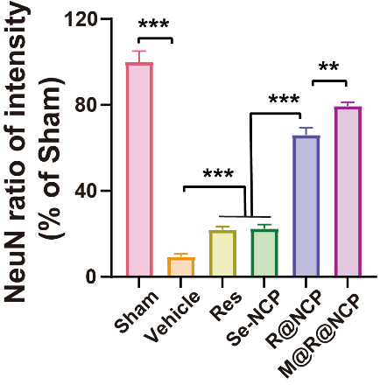
Fig. S32. Statistical analysis of the relative fluorescence intensity of NeuN positive cells. n = 3. Data are presented as mean ± SD. **P < 0.01, ***P < 0.001.

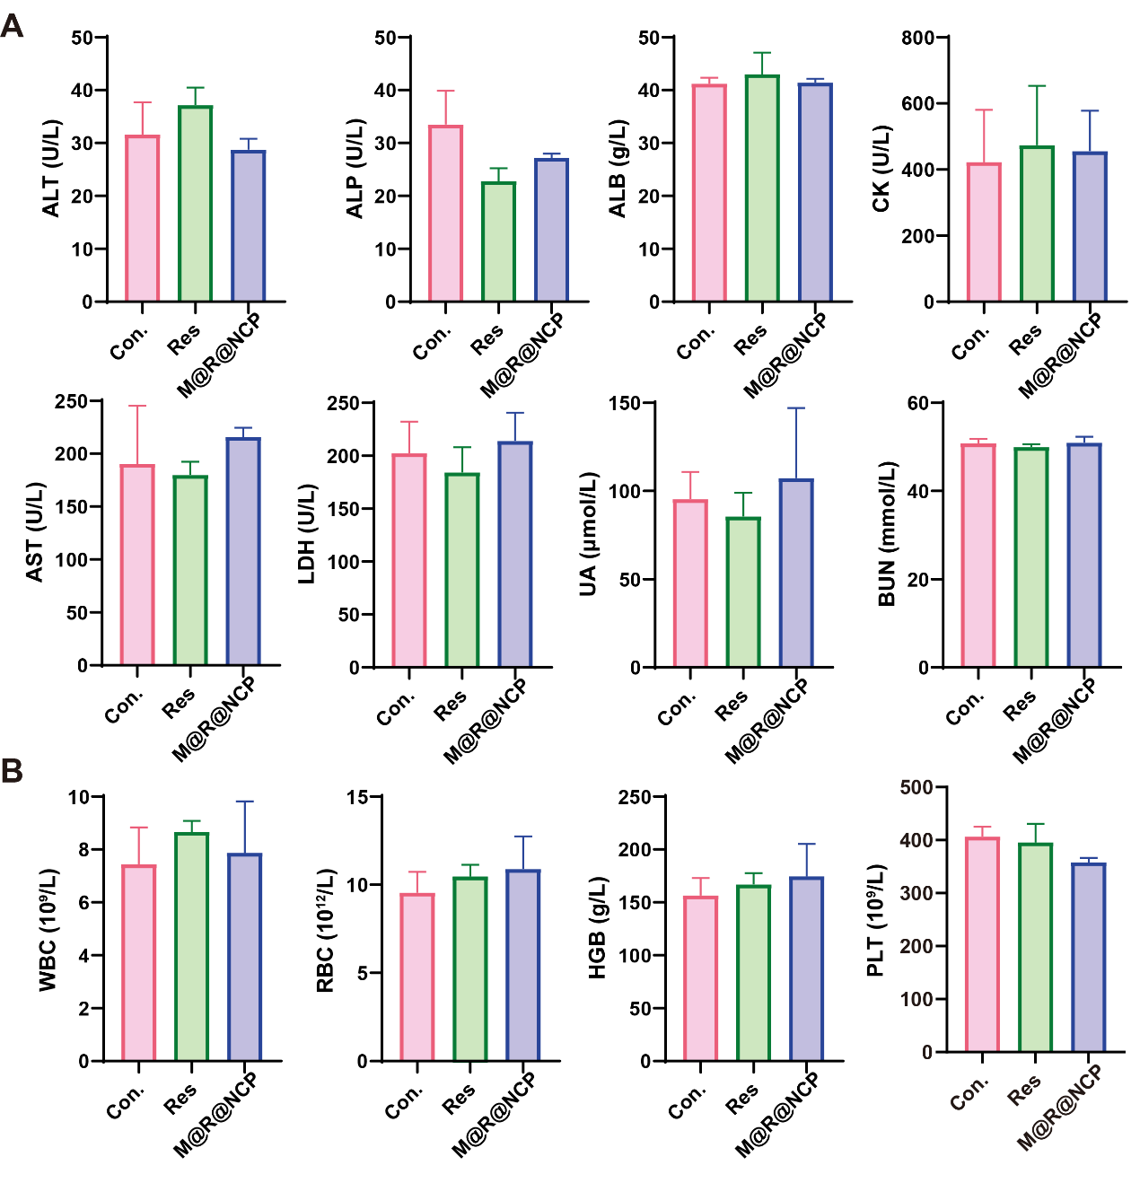

Fig. S33. Comprehensive blood biochemistry panels and complete blood counts (CBC) of treated mice. (A) Blood biochemical parameters of treated mice: Alanine transaminase (ALT), Alkaline phosphatase (ALP), Albumin (ALB), Creatine kinase (CK), Aspartate transaminase (AST), Lactic dehydrogenase (LDH), Uric Acid (UA), Total bilirubin (BUN). (B) Hematological parameters of treated mice: white blood cell (WBC) count, red blood cell (RBC) count, hemoglobin concentration (HGB), and platelet (PLT) count. n = 3. Data are presented as mean ± SD.
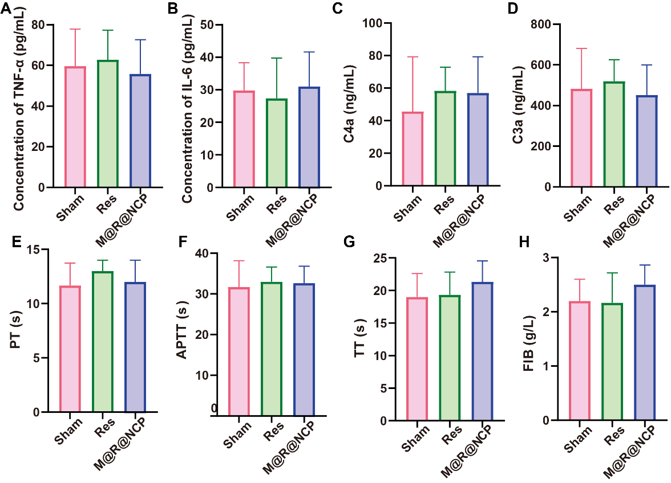
Fig. S34. Long-term biocompatibility analysis. Serum concentrations of the systemic inflammatory cytokines TNF-α (A) and IL-6 (B). Plasma concentrations of the systemic complement anaphylatoxins C4a (C) and C3a (D). Coagulation parameters in treated mice: (E) Prothrombin time (PT), (F) Activated partial thromboplastin time (APTT), (G) Thrombin time (TT), (H) Fibrinogen (FIB). n = 3. Data are presented as mean ± SD.

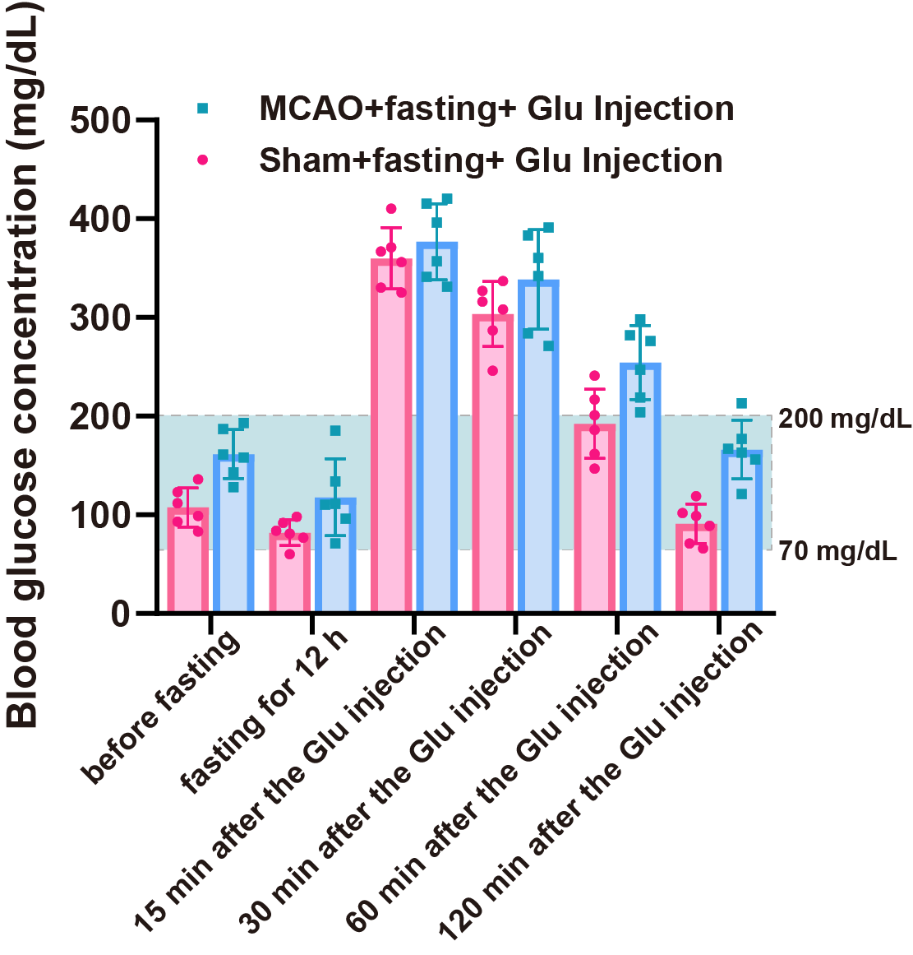

Fig. S35. Changes in blood glucose levels in mice subjected to various interventions. n = 6. Data are presented as mean ± SD.
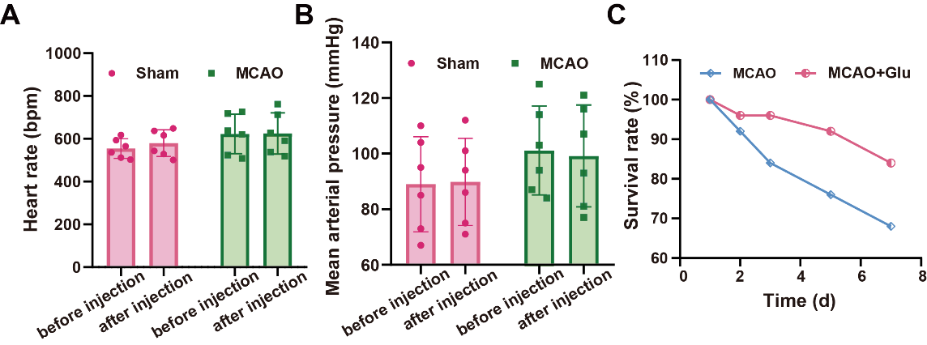

Fig. S36. (A) Heart rate and (B) mean arterial pressure were measured before and after the injection of glucose solutions. n = 6. (C) Survival rates of MCAO mice with or without 20 wt% glucose administration over 7 days. Data are presented as mean ± SD.

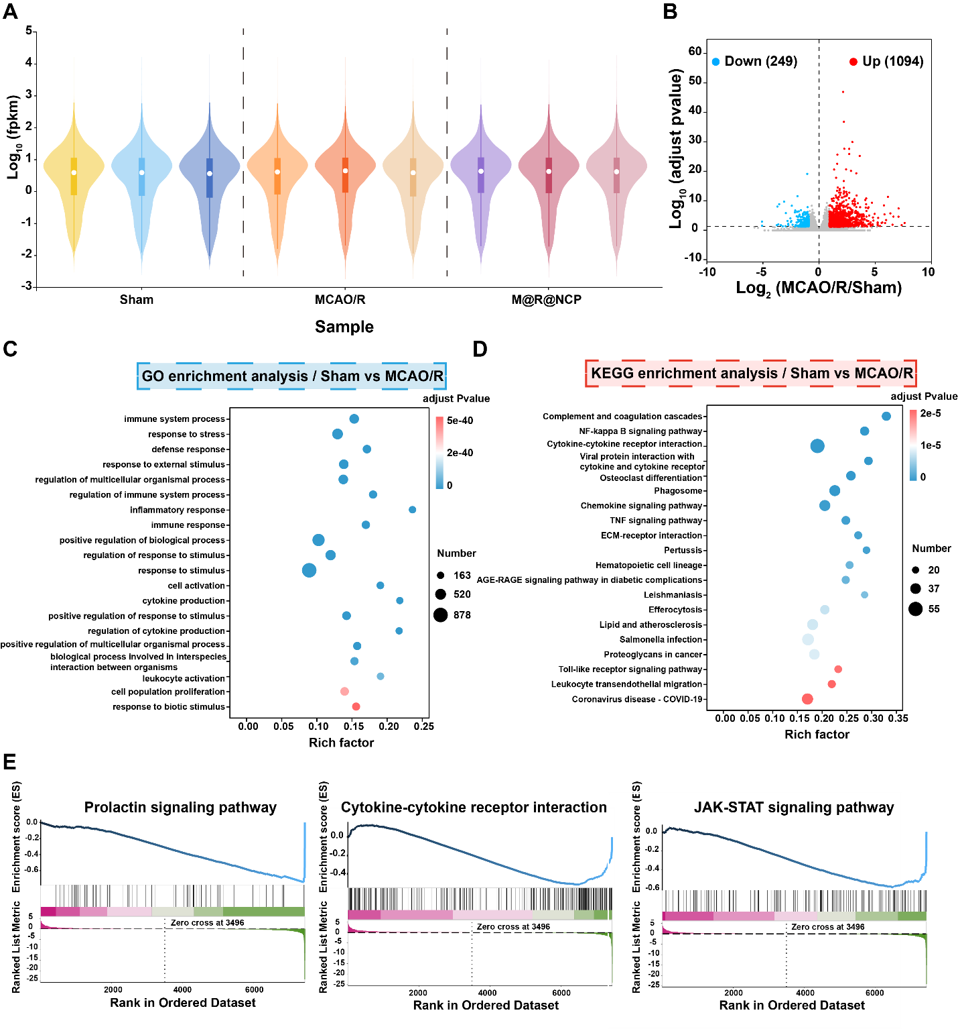

Fig. S37. Transcriptomic analysis of M@R@NCP in MCAO/R mice. (A) Violin plots depicting the distribution of data for different samples. (B) Volcano plots showed the identified upregulated and downregulated genes by MCAO/R treatment. (C) Significantly enriched GO terms for genes in the MCAO/R group compared with the Sham group. (D) KEGG pathway analysis for the identified differentially expressed genes. (E) Gene set enrichment analysis (GSEA) of different pathways in mice brain after M@R@NCP treatment. The ticks below the line represent the rank of each gene. n = 3.

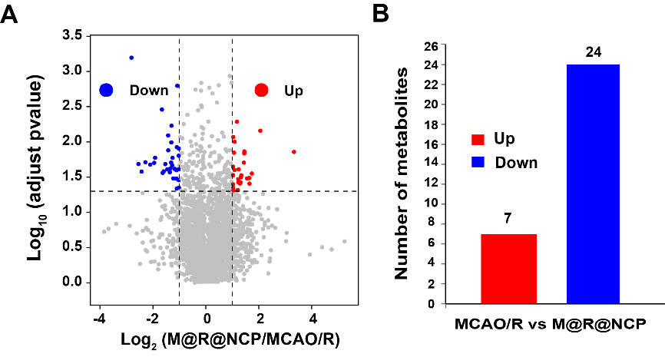

Fig. S38. Metabolomic analysis of M@R@NCP in MCAO/R mice. (A) Volcano plots showed the identified upregulated and downregulated metabolites by M@R@NCP. (B) Differential metabolite analysis demonstrated the up-regulated and down-regulated amounts of metabolites following treatment with M@R@NCP.

