Supporting Information

A Core–Shell Microneedle Platform for the Spatiotemporal Codelivery of Dual-Agent Therapeutics Precisely Orchestrates Diabetic Wound Healing

Yuhang Zhan¹, Zhihan Zhang¹, Zhiyue Zhang¹, Mengru Lin, Hui Liu, Dilihumaer·Abulimiti, Shami·Aihemaiti, Yun Kan, Jinhai Tan*, Xi Chen*, Shengxiang Tao*

A. Yuhang Zhan, Zhihan Zhang, Hui Liu, Dilihumaer·Abulimiti, Shami·Aihemaiti, Yun Kan, Jinhai Tan, Xi Chen, Shengxiang Tao
Department of Orthopedics Trauma and Microsurgery, Zhongnan Hospital, Wuhan University, Wuhan, 430071, China
E-mail: taoshengxiang@whu.edu.cn
B. Zhiyue Zhang
School of Basic Medicine, Peking Union Medical College, Beijing, China
C. Mengru Lin
College of Chemistry and Molecular Sciences, Wuhan University, Wuhan, 430072, China

Fig. S1: SEM images of MN@Ple/Exo^{Q10} patch (Scale bar: 200 μm and 100 μm).
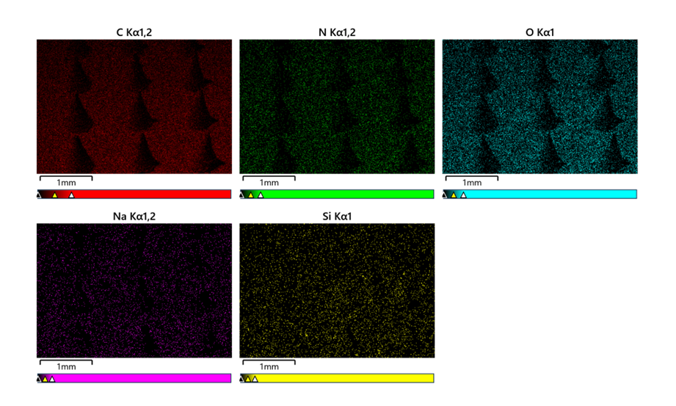
Fig. S2: Surface elemental analysis of MN@Ple/Exo^{Q10} patch (Scale bar: 1 mm).
Fig. S3: Standard curve for Ple release.
Fig. S4: Standard curve for Exo^{Q10} release.
Fig. S5: The adhesion strength of MN patches in various groups.
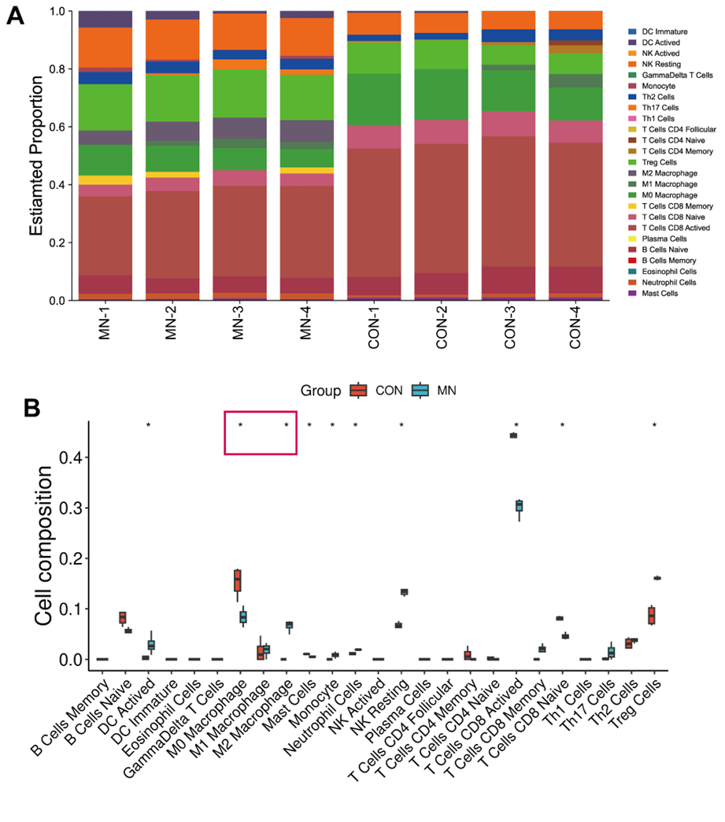
Fig. S6: CIBERSORT quantitative immune infiltration analysis. (A) Sample immune microenvironment composition characteristic stack diagram. (B) Intergroup immune component difference box diagram. (*P< 0.01)
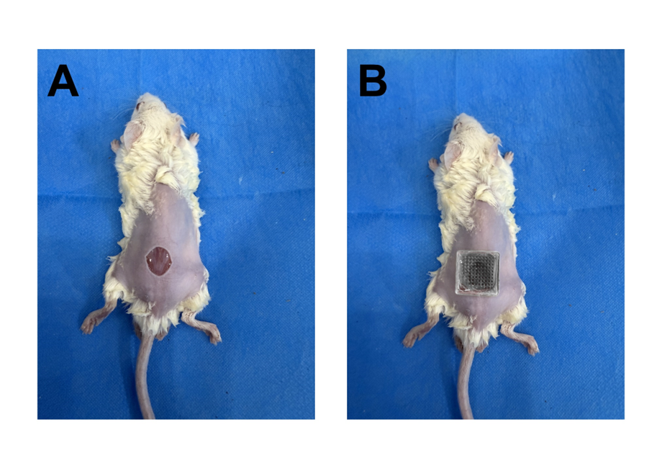
Fig. S7: Schematic illustration of MN patch in treating full-thickness dorsal skin defect in diabetic mouse.
Fig. S8: Representative photographs of bacterial cultures from the skin tissue of diabetic mouse wounds treated with various groups (n = 5).
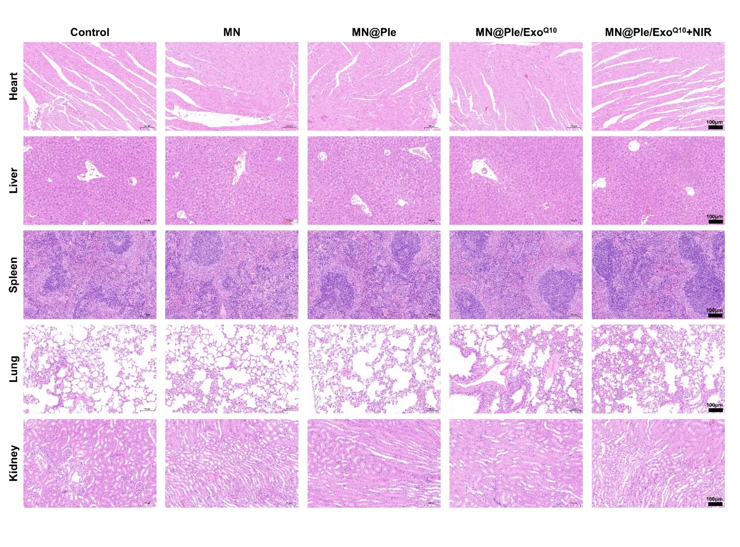
Fig. S9: HE staining results of major organs including heart, liver, spleen, lung and kidney (scale bar: 100 μm).

Fig. S10: EPS concentration of S. aureus and E. coli (n = 3). The results are shown as the mean ± standard deviation (SD). *P < 0.05, **P < 0.01, ***P < 0.001.

Fig. S11: Dissolution images of MN@Ple/Exo^{Q10} patch at different time points in mouse (Scale bar: 200 μm).

Fig. S12: Detection of Exo-specific markers by Western Blotting at day 0 and 18 during in vitro release (n = 3).

Table S1. The forward and reverse primer sequences used for qRT‐PCR.

GPX | Forward: ACGCCAAAGTCCTAGGAAACG
GPX | Reverse: CCCCGGGTTGAAAGGTTCAG
SLC7A11 | Forward: CTGCAGCTAACTGACTGCCC
SLC7A11 | Reverse: ATCACCGACTGGCTCTACAC
ACSL4 | Forward: CTTCCTCTTAAGGCCGGGAC
ACSL4 | Reverse: CTCTTTGCCATAGCGTTTTTAGA
LPCAT3 | Forward: CTACGATGGAGGCAAAGACGG
LPCAT3 | Reverse: CCAGCAATGAAGGGACACCC
TNF-α | Forward: CGCTCTTCTGTCTACTGAACTTCGG
TNF-α | Reverse: GTGGTTTGTGAGTGTGAGGGTCTG
IL6 | Forward: TGGTCTTCTGGAGTACCATAGC
IL6 | Reverse: TGTGACTCCAGCTTATCTCTTGG
Arg-1 | Forward: CTCCAAGCCAAAGTCCTTAGAG
Arg-1 | Reverse: GGAGCTGTCATTAGGGACATCA
IL4 | Forward: CCCCCAGCTAGTTGTCATCC
IL4 | Reverse: TTTGGCACATCCATCTCCGT

