Supporting Information
Self-assembled fluorescent nanosensor for ultrafast and field-deployable monitoring of herbicide fomesafen in multiple matrices

Mei-Hong Ge ª, Shuai Tan ª, Wei Niu ª, Feng Gao ª, Shi-Tao Liu ª, Lin-Lin Yang ^{a, c}, Li-Wei Liu ª, A-Ling Tang ^{a, b,} *, Xiang Zhou ^{a,}* and Song Yang ^{a,}*

ª State Key Laboratory of Green Pesticides, Key Laboratory of Green Pesticide and Agricultural Bioengineering, Ministry of Education, Center for R&D of Fine Chemicals of Guizhou University, Guiyang, 550025, China.
^{b} School of Biological Sciences, Guizhou Education University, Guiyang, 550018, China
^{c} College of Materials Science and Engineering, Guiyang University, Guiyang 550003, PR China.

* Corresponding author.
E-mail: xiangzhou@gzu.edu.cn or zhoux1534@163.com (X. Zhou);
AL1358703140@163.com (A.-L. Tang);
jhzx.msm@gmail.com or syang@gzu.edu.cn (S. Yang)

Contents

1. Materials and Instruments 4
2. Synthesis and characterization of probes 4
3. ¹H NMR, ¹³C NMR, and HRMS spectra of probes 7
4. Self-Assembly Molecular Dynamics Simulation of RBO 21
5. Scanning electron microscope images of RT, RO, RBT, RMBO and RNBO 21
6. Comparison of fluorescence intensity of probes for FSA 22
7. Investigation of the Optimal Excitation Wavelength 22
8. The molecular structure of various herbicides 23
9. Anti-disturbance experiments in the presence of two or more other herbicides 23
10. Detection limit calculation 24
11. Reversibility 25
12. pH-Dependent Fluorescence Response 25
13. Stability of the RBO under different storage conditions 25
15. Response of RBO to the FSA analogues 29
16. Detection of FSA in the soil extract solution 30
17. Linear calibration curve of test paper fluorescence intensity versus FSA concentration 30
18. Smartphone platform test parameters 31
19. The RGB values of the test strips under different concentrations of FSA 31
22. Linear calibration curve of hydrogel fluorescence intensity versus FSA concentration 34
23. The RGB values of the hydrogel under different concentrations of FSA 34
24. Bioluminescence Imaging 35
25. Comparison of different methods for FSA determination 36

- Materials and Instruments
Rhodamine B, 2-aminobenzoxazole, and other chemical reagents/starting materials were purchased from commercial suppliers. Unless otherwise specified, all chemicals were used directly without further purification. All solvents were of HPLC/ACS grade. NMR spectra were recorded on a Bruker Biospin AG-400 or JEOL ECX 500 spectrometer. Crystal structures were determined using a Bruker D8 Venture instrument. Tetramethylsilane (TMS) served as the internal standard. HRMS was performed on a Thermo Scientific Ultimate 3000 system. Fluorescence measurements were conducted on a Horiba PTI QuantaMasterTM 8000 spectrofluorometer, while absorption spectra were acquired with a Shimadzu UV-1900 spectrophotometer. FT-IR spectra were recorded on a Nicolet iS 50 spectrometer. Fluorescent imaging was performed using a ZEISS LSM 900 confocal microscope and an Olympus FVMPE-RS multiphoton laser scanning microscope. The high-performance liquid chromatography (HPLC) system involved was an Agilent Technologies 1260 Infinity II system equipped with a Kinetex® 5 μm EVO C18 100 Å column.
- Synthesis and characterization of probes
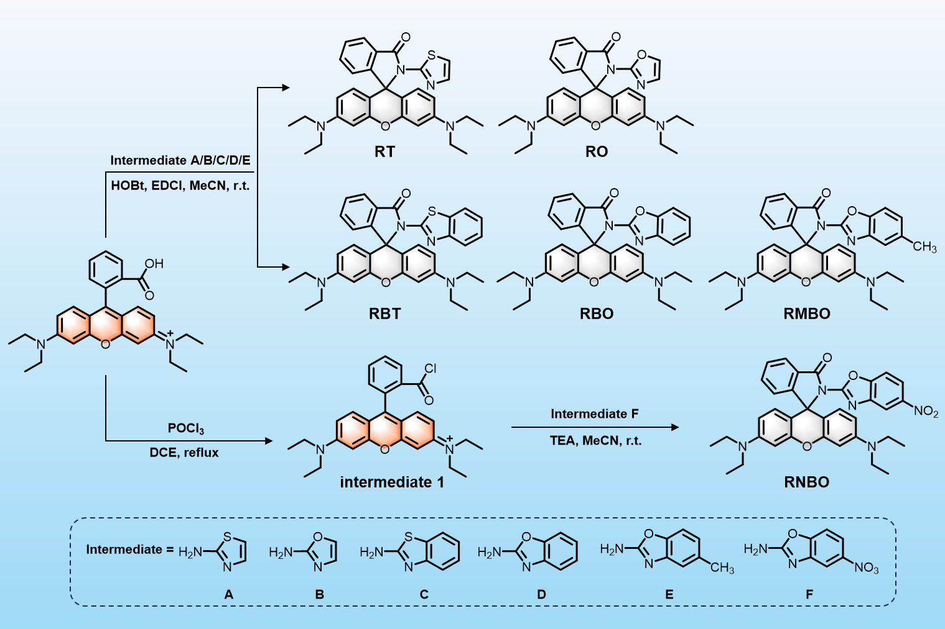
Scheme S1. Synthetic routes of probes.
The synthetic route of probes was depicted in Scheme S1. Probes RT, RO, RBT, RMBO, and RNBO were synthesized according to the reference [1, 2]. Take probe RT and RNBO as examples. The details are as follows:
Synthesis of RT: A mixture of rhodamine B (200 mg, 450.89 μmol), EDCI (103.72 mg, 541.07 μmol), and HOBT (73.11 mg, 541.07 μmol) in anhydrous acetonitrile (8 mL) was magnetically stirred at room temperature for 30 minutes. After the addition of 2-aminothiazole (80.17 mg, 541.07 μmol), the reaction was allowed to proceed with continuous stirring at room temperature for 5 hours. Upon completion, the solvent was removed in vacuo using a rotary evaporator. The resulting crude product was subjected to flash column chromatography (eluent: petroleum ether/ethyl acetate = 2:1, v/v) to afford probe RT (yield: 85%). ¹H NMR (500 MHz, CDCl₃) δ 8.04 (d, J = 7.5 Hz, 1H), 7.54 (dqd, J = 14.5, 7, 1.0 Hz, 2H), 7.27 (d, J = 1 Hz, 1H), 7.19 (d, J = 7.5 Hz, 1H), 6.81 (d, J = 3.5 Hz, 1H), 6.44 (d, J = 2.5 Hz, 2H), 6.40 (d, J = 9 Hz, 2H), 6.17 (dd, J = 9, 2.5 Hz, 2H), 3.37 – 3.25 (m, 8H), 1.14 (d, J = 7.0 Hz, 12H).¹³C NMR (126 MHz, CDCl₃) δ 166.66, 155.26, 153.95, 153.85, 148.85, 138.67, 134.21, 128.96, 128.61, 128.02, 124.76, 123.43, 112.61, 107.39, 106.56, 97.67, 67.66, 44.36, 12.77. HRMS calc. for C₃₁H₃₃O₂N₄S: 525.2300, [M + H]⁺, Found: 525.2300.
Synthesis of RNBO: A solution of rhodamine B (300 mg, 676.34 μmol) in 1,2-dichloroethane (7 mL) was treated with phosphorus oxychloride (0.5 mL) and further refluxed for 4 hours, followed by solvent evaporation under reduced pressure. The resulting crude chloric acid was dissolved in acetonitrile (4 mL) and subsequently added dropwise to a mixture of 5-nitro-2-benzoxazolamide (155.59 mg, 811.60 μmol) and triethylamine (0.5 mL). After the reaction for 5 hours, the solvent was removed, and the crude product was purified via column chromatography using a petroleum ether/ethyl acetate (2:1, v/v) eluent system, affording the target RNBO with a yield of 12%. ¹H NMR (500 MHz, DMSO-d₆) δ 8.16 (d, J = 1.5 Hz), 8.08 (dd, J = 9, 2 Hz), 8.04 (d, J = 7.5 Hz), 7.72 (dd, J = 17, 9 Hz), 7.64 (t, J = 7.5 Hz), 7.14 (d, J = 7.5 Hz), 6.49 (d, J = 9 Hz), 6.43 (d, J = 2 Hz), 6.25 (dd, J = 9, 2 Hz), 3.27 (dd, J = 6.5, 13.5 Hz), 1.03 (t, J = 7 Hz).¹³C NMR (126 MHz, DMSO-d₆) δ 165.12, 155.80, 153.29, 152.98, 151.38, 148.57, 144.90, 140.40, 135.65, 129.39, 127.83, 127.12, 124.58, 123.84, 119.97, 114.16, 110.74, 107.72, 104.95, 97.00, 43.62, 12.42. HRMS calc. for C₃₆H₃₇O₃N₄: 604.2542, [M + H]⁺, Found: 604.2554.
RO: 51% yield. ¹H NMR spectrum, ¹H NMR (400 MHz, CDCl₃) δ 8.03 (d, J = 6.8 Hz, 1H), 7.55 - 7.44 (m, 2H), 7.24 (s, 1H), 7.6 (d, J = 7.3 Hz, 1H), 6.85 (s, 1H), 6.54 (d, J = 8.8 Hz, 2H), 6.38 (d, J = 2.4 Hz, 2H), 6.22 (dd, J = 8.8, 2.4 Hz, 2H), 3.30 (q, J = 7.2 Hz, 8H), 1.14 (t, J = 7.2 Hz, 12H). ¹³C NMR (101 MHz, CDCl₃) δ 166.19, 153.4, 152.52, 148.96, 135.35, 134.28, 128.83, 128.54, 127.06, 124.46, 123.95, 107.80, 106.01, 97.66, 44.39, 12.73. HRMS calc. for C₃₁H₃₃O₃N₄: 509.2523, [M + H]⁺, Found: 509.2547.
RBT: 51% yield. ¹H NMR (400 MHz, DMSO-d₆) δ 8.05 (d, J = 7.6 Hz, 1H), 7.92 (d, J = 7.6 Hz, 1H), 7.69 (dt, J = 25.2, 6.8 Hz, 2H), 7.42 (d, J = 8.0 Hz, 1H), 7.31 (t, J = 7.2 Hz, 1H), 7.26 – 7.16 (m, 2H), 6.43 (d, J = 2.4 Hz, 2H), 6.34 (d, J = 8.8 Hz, 2H), 6.19 (dd, J = 8.8, 2.4 Hz, 2H), 3.27 (dd, J = 6.8, 7.2 Hz, 8H), 1.04 (t, J = 6.8 Hz, 12H).¹³C NMR (101 MHz, DMSO-d₆) δ 166.38, 153.63, 153.58, 153.27, 148.55, 148.40, 135.29, 131.08, 129.28, 127.83, 127.63, 126.05, 124.70, 123.80, 123.46, 121.57, 121.08, 107.29, 105.69, 96.86, 67.50, 43.63, 12.45. HRMS calc. for C₃₅H₃₆O₂N₄S: 575.2462, [M + H]⁺, Found: 575.2475.
RMBO: 45% yield. ¹H NMR (500 MHz, DMSO-d₆) δ 8.00 (d, J = 7.5 Hz), 7.67 (t, J = 8.0 Hz), 7.62 (t, J = 7.4 Hz), 7.38 (d, J = 8.3 Hz), 7.22 (s), 7.10 (d, J = 7.6 Hz), 7.01 (d, J = 8.9 Hz), 6.47 (d, J = 8.9 Hz), 6.39 (d, J = 2.4 Hz), 6.26 (dd, J = 8.9, 2.5 Hz), 3.28 (q, J = 6.9 Hz), 2.29 (s), 1.05 (t, J = 7.0 Hz).¹³C NMR (126 MHz, DMSO-d₆) δ 165.23, 153.42, 152.82, 148.43, 145.92, 140.03, 135.18, 133.99, 129.16, 127.75, 127.45, 124.74, 124.43, 123.59, 118.79, 109.48, 107.65, 105.33, 97.00, 43.62, 20.87, 12.36. HRMS calc. for C₃₆H₃₇O₃N₄: 573.2800, [M + H]⁺, Found: 573.2900.
- ¹H NMR, ¹³C NMR, and HRMS spectra of probes
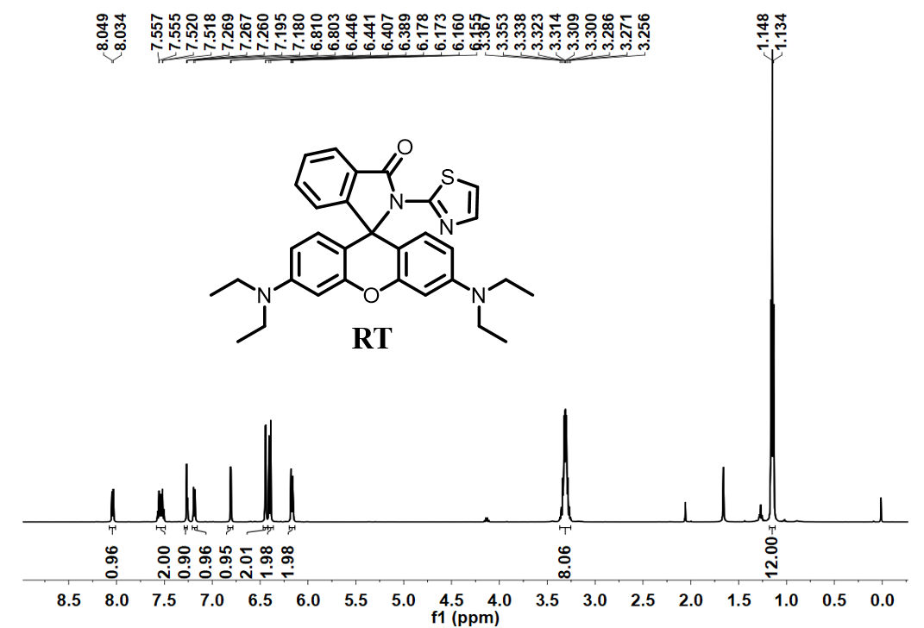
Fig. S1. ¹H NMR (500 MHz) spectrum of RT in CDCl₃.

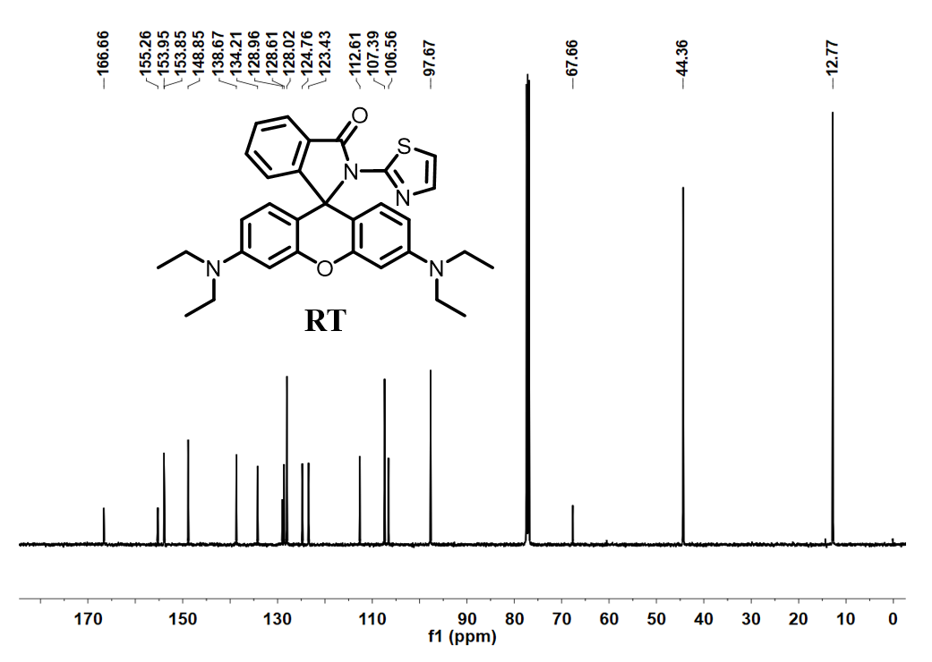
Fig. S2. ¹³C NMR (126 MHz) spectrum of RT in CDCl₃.

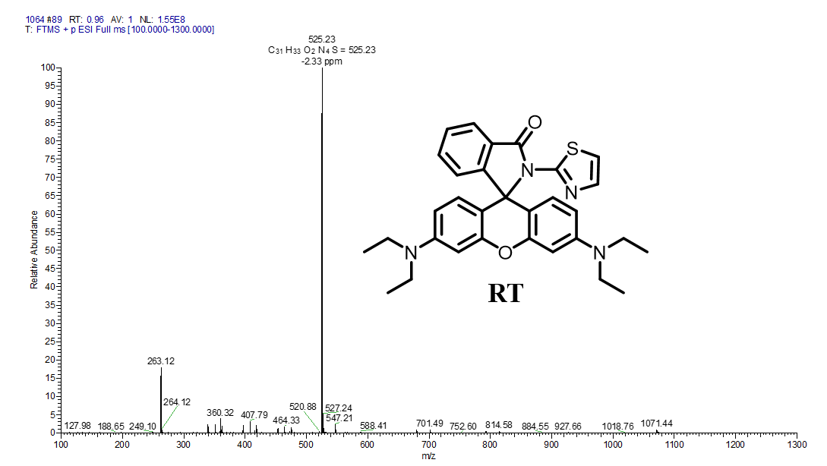
Fig. S3. HRMS spectrum of RT.

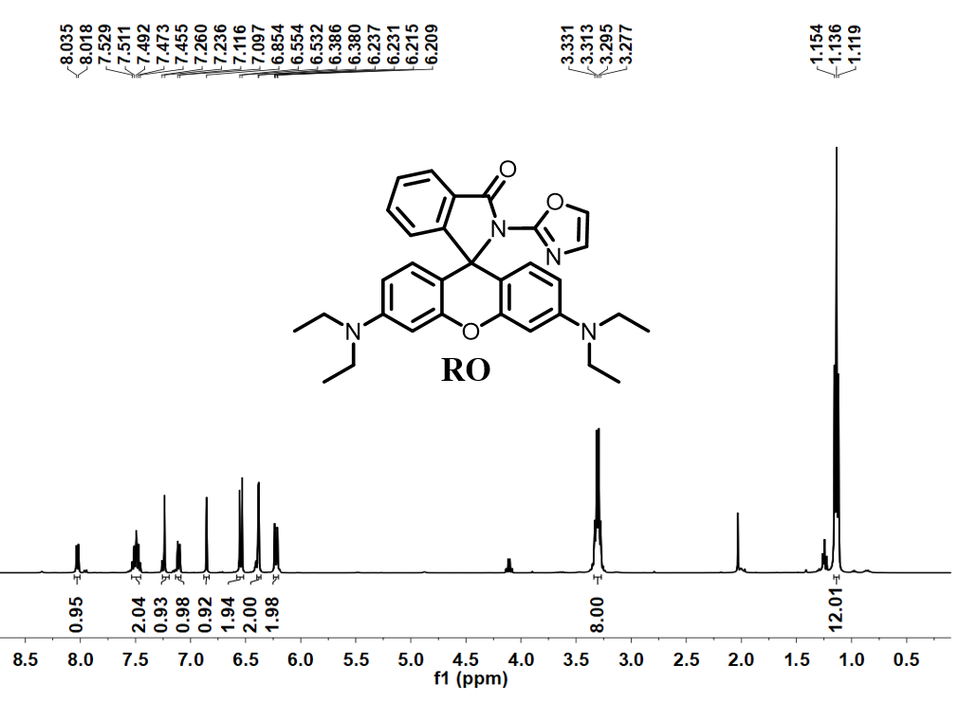
Fig. S4. ¹H NMR (400 MHz) spectrum of RO in CDCl₃.
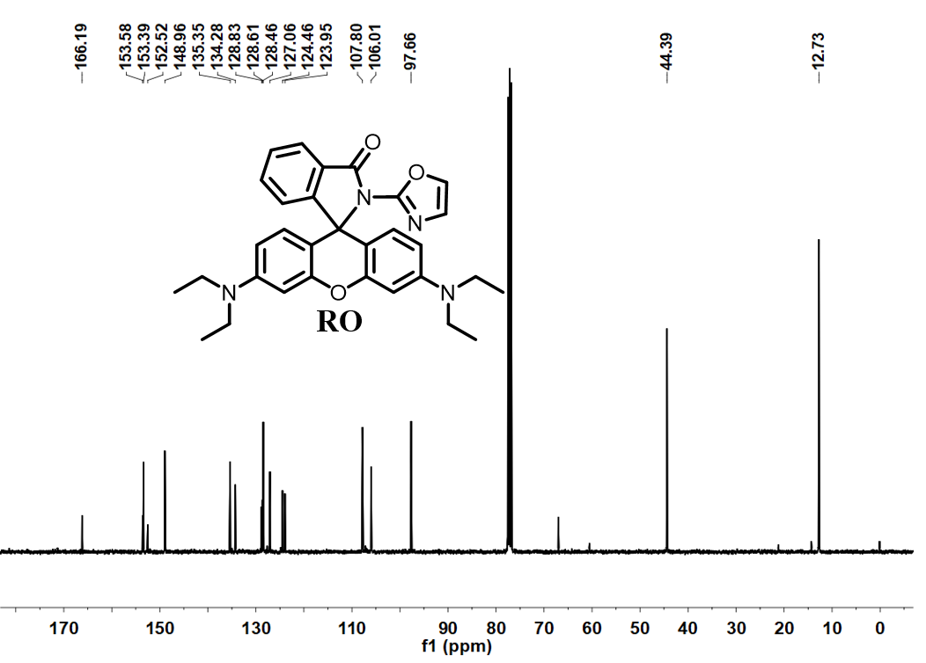
Fig. S5. ¹³C NMR (101 MHz) spectrum of RO in CDCl₃.

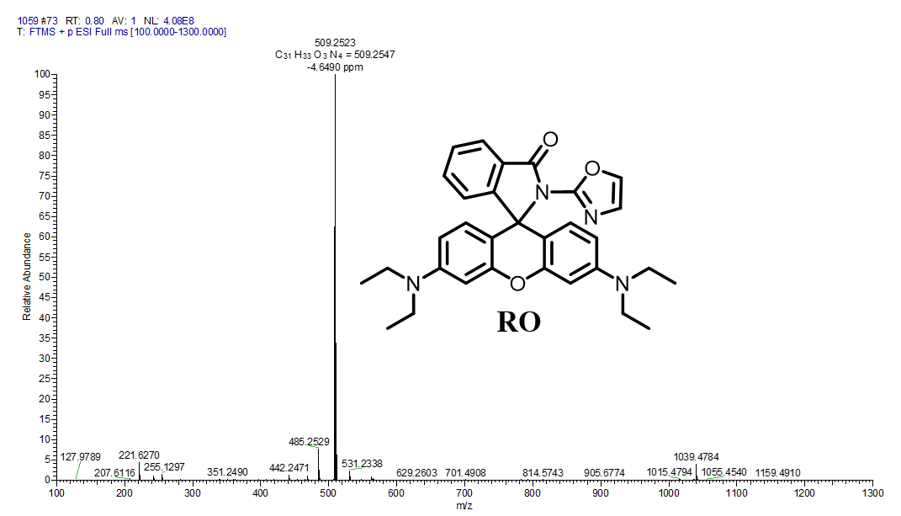
Fig. S6. HRMS spectrum of RO.

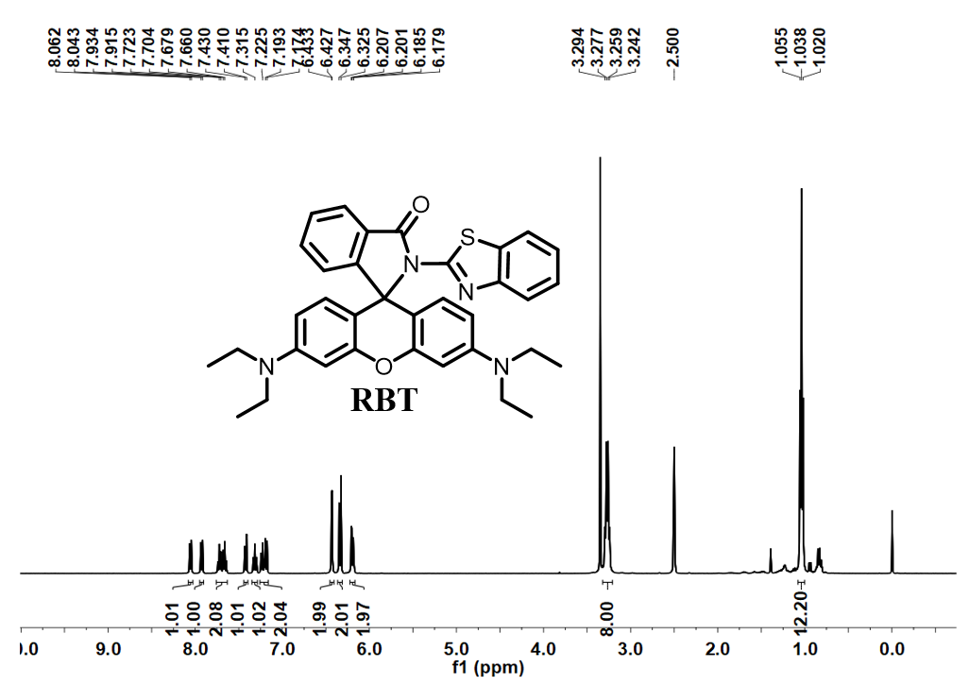
Fig. S7. ¹H NMR (400 MHz) spectrum of RBT in DMSO-d₆.

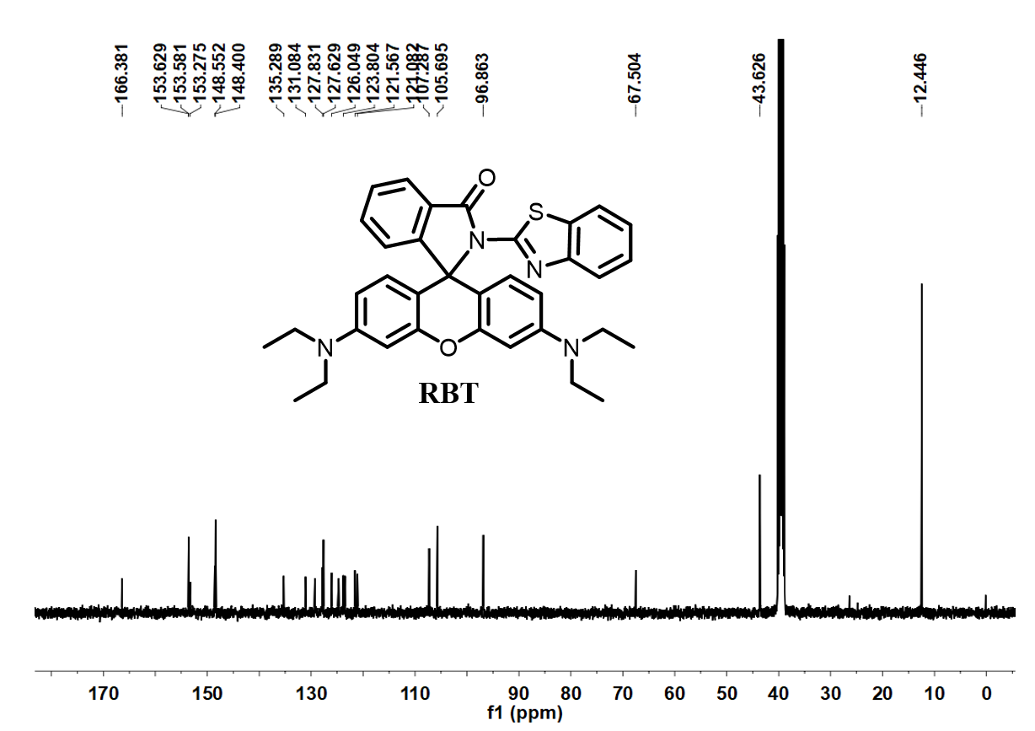
Fig. S8. ¹³C NMR (101 MHz) spectrum of RBT in DMSO-d₆.
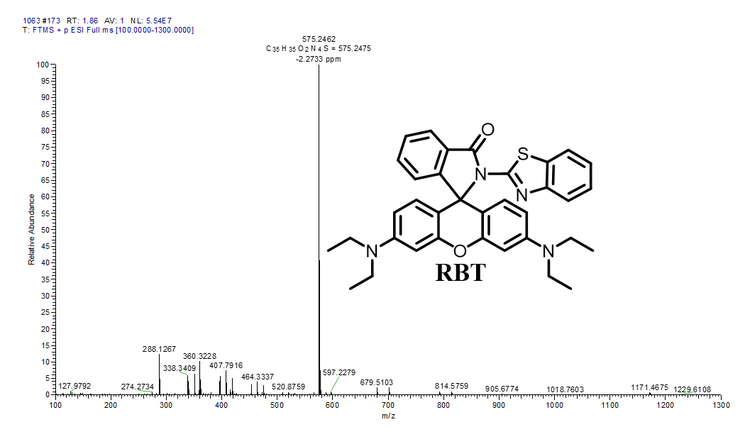
Fig. S9. HRMS spectrum of RBT.

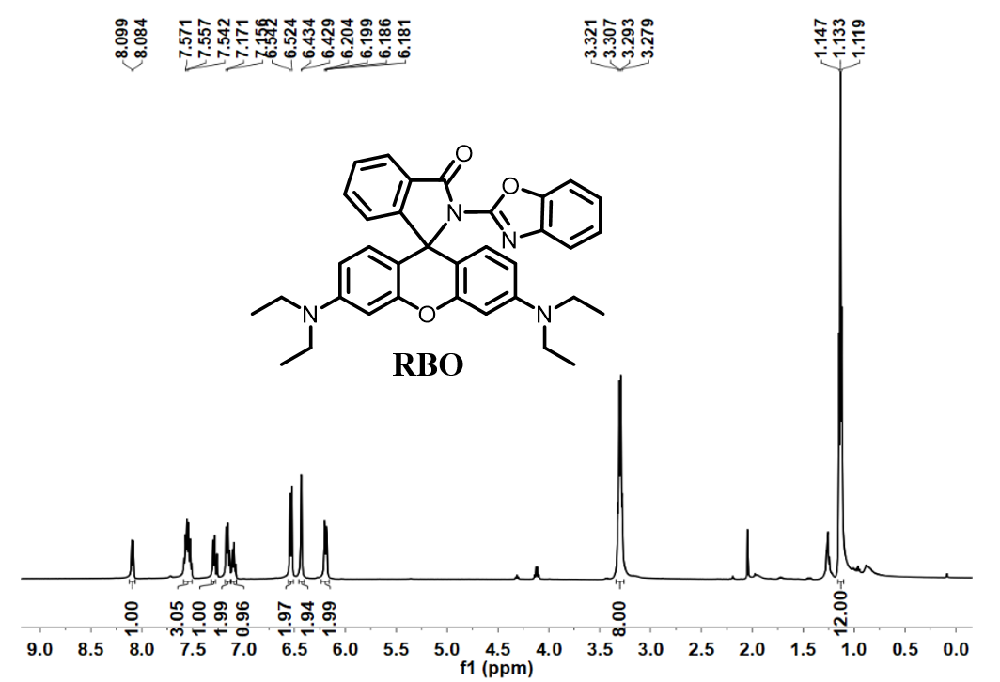
Fig. S10. ¹H NMR (500 MHz) spectrum of RBO in CDCl₃.

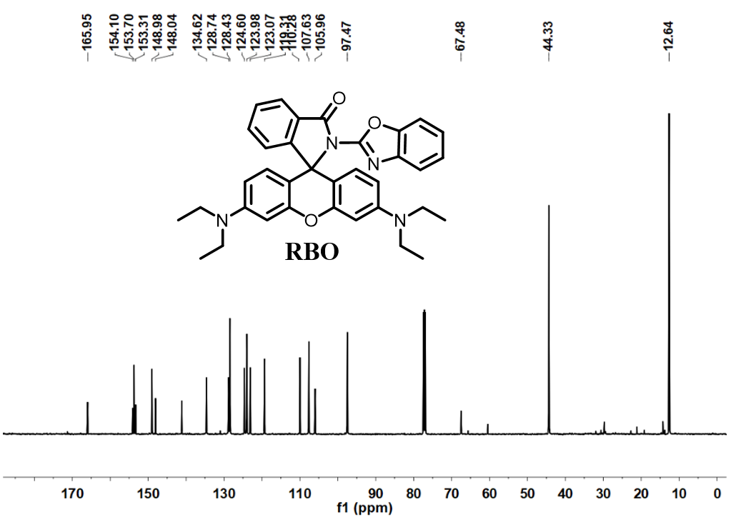
Fig. S11. ¹³C NMR (126 MHz) spectrum of RBO in CDCl₃.

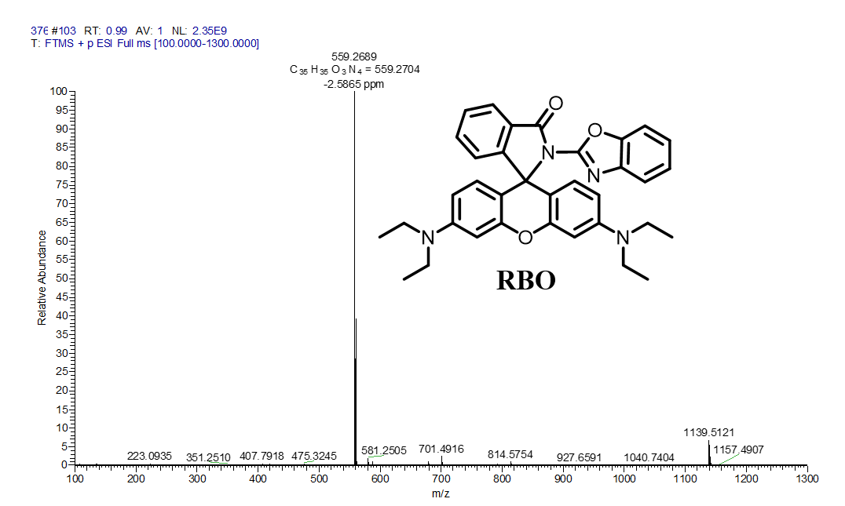
Fig. S12. HRMS spectrum of RBO.

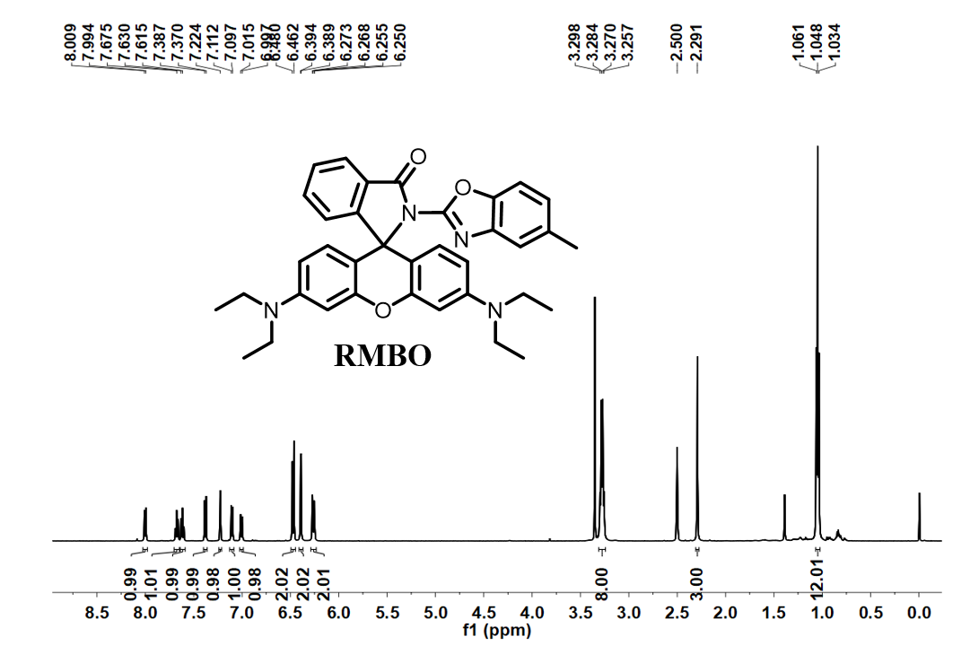
Fig. S13. ¹H NMR (500 MHz) spectrum of RMBO in DMSO-d₆.

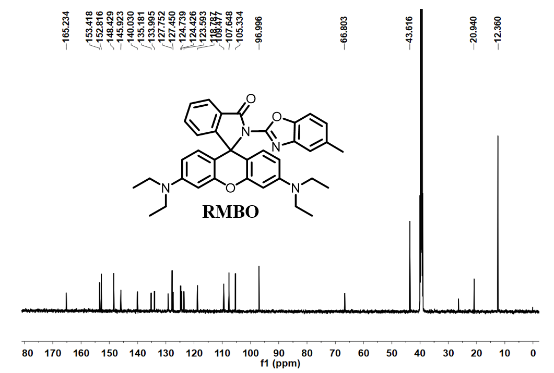
Fig. S14. ¹³C NMR (126 MHz) spectrum of RMBO in DMSO-d₆.
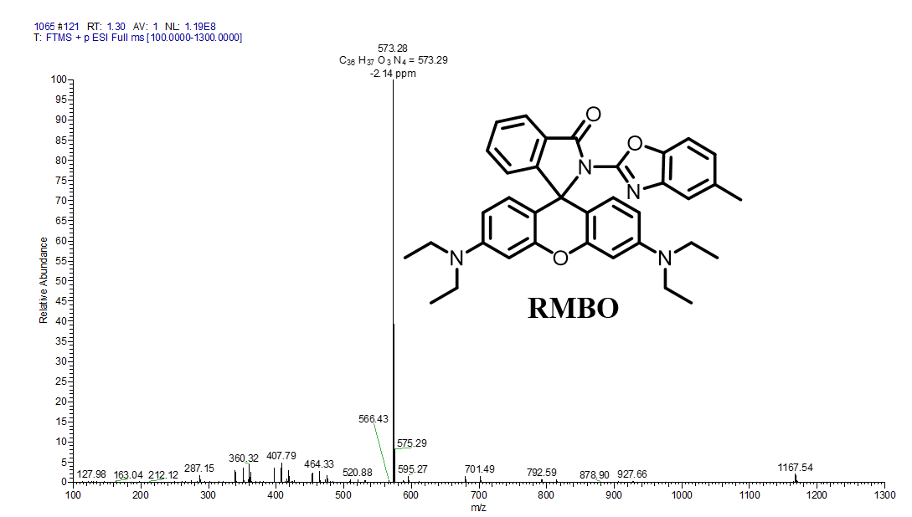
Fig. S15. HRMS spectrum of RMBO.

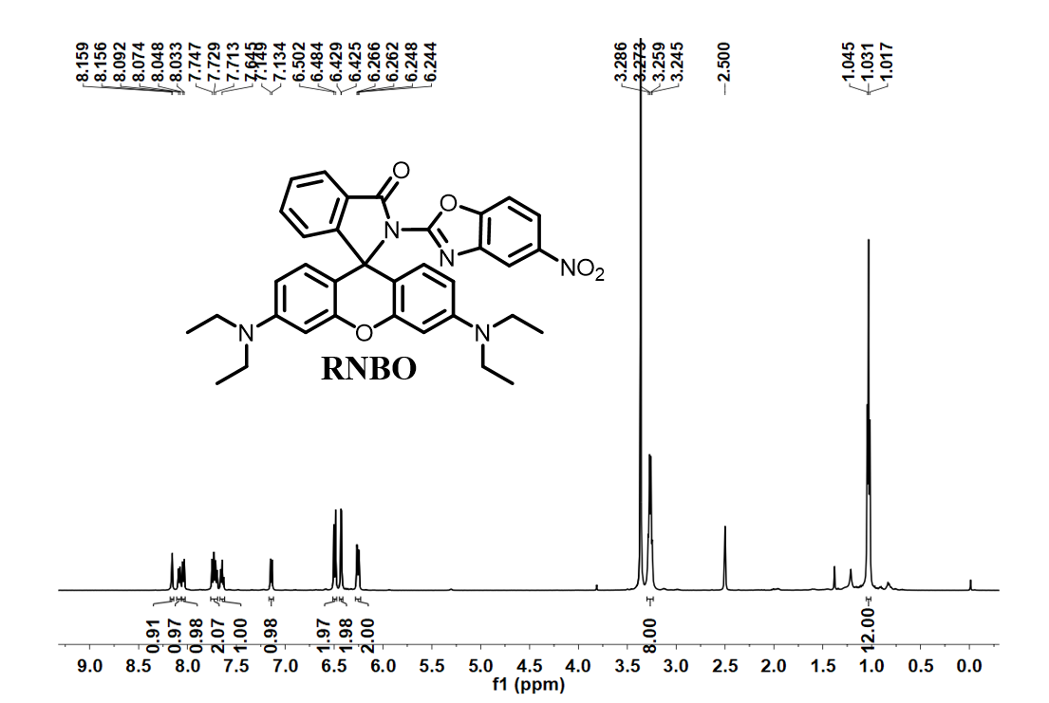
Fig. S16. ¹H NMR (500 MHz) spectrum of RNBO in DMSO-d₆.

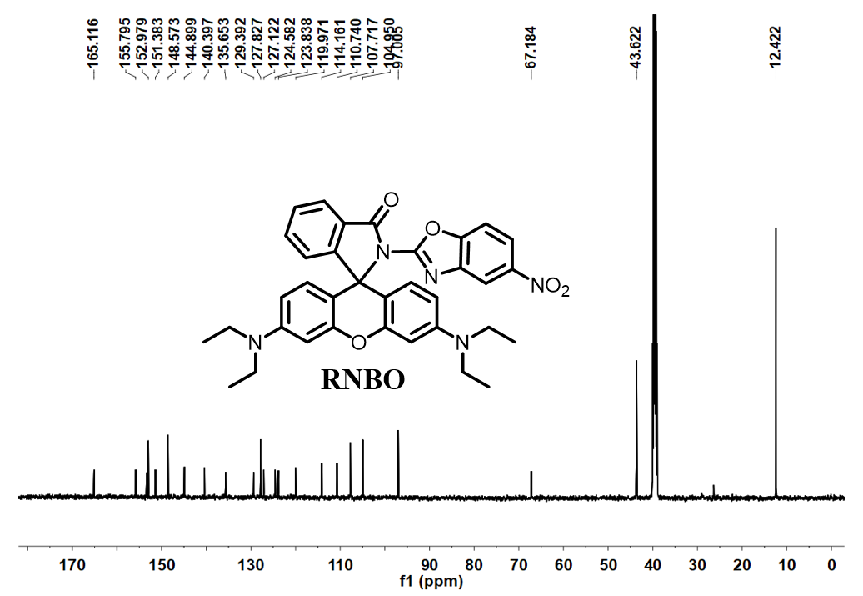
Fig. S17. ¹³C NMR (126 MHz) spectrum of RNBO in DMSO-d₆.

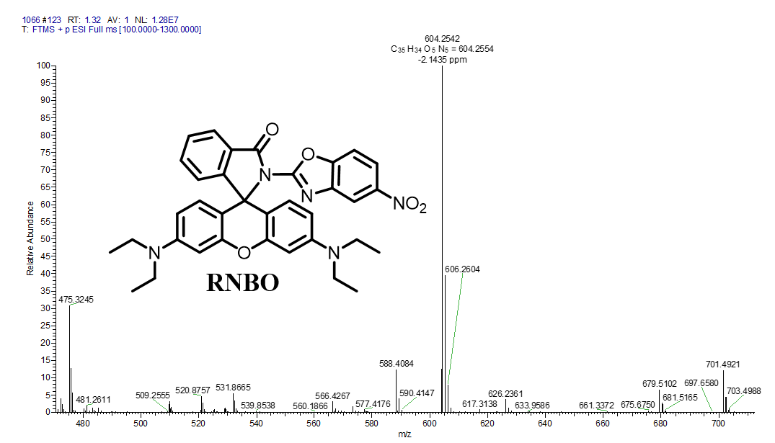
Fig. S18. HRMS spectrum of RNBO.
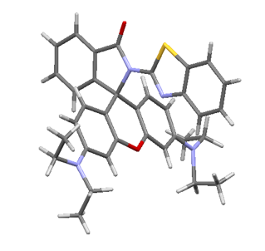
Fig. S19. The crystal structure of RBT and all the hydrogen atoms are omitted for clarity (CCDC: 2403991; grey atoms, C; red atoms, O; blue atoms, N; yellow, S).

Table S1. Crystal data and structural refinement parameters of RBT.
Compound | Molecule RBT
Formula | C₃₅H₃₄N₄O₂S
CCDC numbers | 2403991
Fw | 574.72
Crystal system | orthorhombic
Space group | Pccn
a (Å) | 30.808(2)
b (Å) | 27.2936(15)
c (Å) | 9.8153(5)
α (°) | 90
β (°) | 90
γ (°) | 90
Z | 8
Calculated density (g⋅cm⁻³) | 0.925
F (000) | 2432.0
Reflections | 20527 / 7299
collected/unique | [R(int) = 0.0790]
Goodness-of-fit on F² | 0.979
Final R indices | R₁ = 0.1007
[I >2σ(I)] | wR₂ = 0.2633
R indices (all data) | R₁ = 0.1458, wR₂ = 0.3158

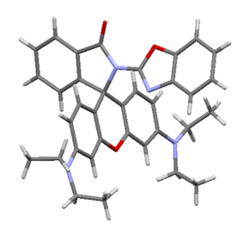
Fig. S20. The crystal structure of RBO and all the hydrogen atoms are omitted for clarity (CCDC: 2385138; grey atoms, C; red atoms, O; blue atoms, N).

Table S2. Crystal data and structural refinement parameters of RBO.
Compound | Molecule RBO
Formula | C₃₅H₃₄N₄O₃
CCDC numbers | 2385138
Fw | 558.66
Crystal system | Monoclinic
Space group | P2(1)/c
a (Å) | 33.506(4)
b (Å) | 12.0476(14)
c (Å) | 15.2625(18)
α (°) | 90
β (°) | 104.219(9)
γ (°) | 90
Z | 8
Calculated density (g⋅cm⁻³) | 1.274
F (000) | 1184
Reflections | 13426 / 5119
collected/unique | [R(int) = 0.0365]
Goodness-of-fit on F² | 1.076
Final R indices | R₁ = 0.0643
[I >2σ(I)] | wR₂ = 0.1223
R indices (all data) | R₁ = 0.1005, wR₂ = 0.1371

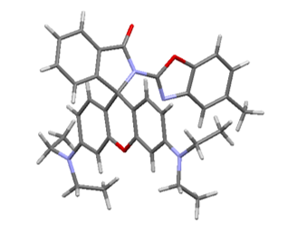
Fig. S21. The crystal structure of RMBO and all the hydrogen atoms are omitted for clarity (CCDC: 2403984; grey atoms, C; red atoms, O; blue atoms, N).

Table S3. Crystal data and structural refinement parameters of RMBO.
Compound | Molecule RMBO
Formula | C₃₆H₃₆N₄O₃
CCDC numbers | 2403984
Fw | 572.69
Crystal system | monoclinic
Space group | P21/c
a (Å) | 9.8527(2)
b (Å) | 26.2592(6)
c (Å) | 11.5347(3)
α (°) | 90
β (°) | 101.867(2)
γ (°) | 90
Z | 2920.52(12)
Calculated density (g⋅cm⁻³) | 1.302
F (000) | 1216.0
Reflections | 11172 / 5759
collected/unique | [R(int) = 0.0402]
Goodness-of-fit on F² | 1.026
Final R indices | R₁ = 0.0488
[I >2σ(I)] | wR₂ = 0.1270
R indices (all data) | R₁ = 0.0561, wR₂ = 0.1357

- Self-Assembly Molecular Dynamics Simulation of RBO
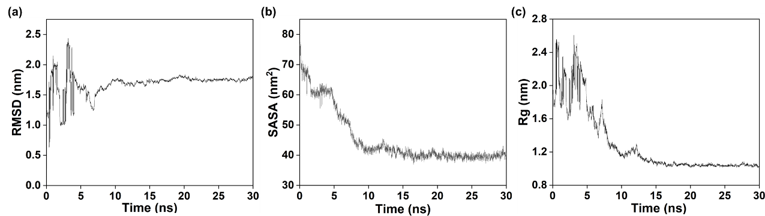
Fig. S22. Molecular dynamics simulation of the RBO self-assembly process. (a) The root mean square deviation of the RBO system during the simulation process. (b) Solvent accessible surface area (SASA) of RBO system during the simulation time. (c) Time evolution of the radius of gyration for the RBO system during the simulation time.

- Scanning electron microscope images of RT, RO, RBT, RMBO and RNBO
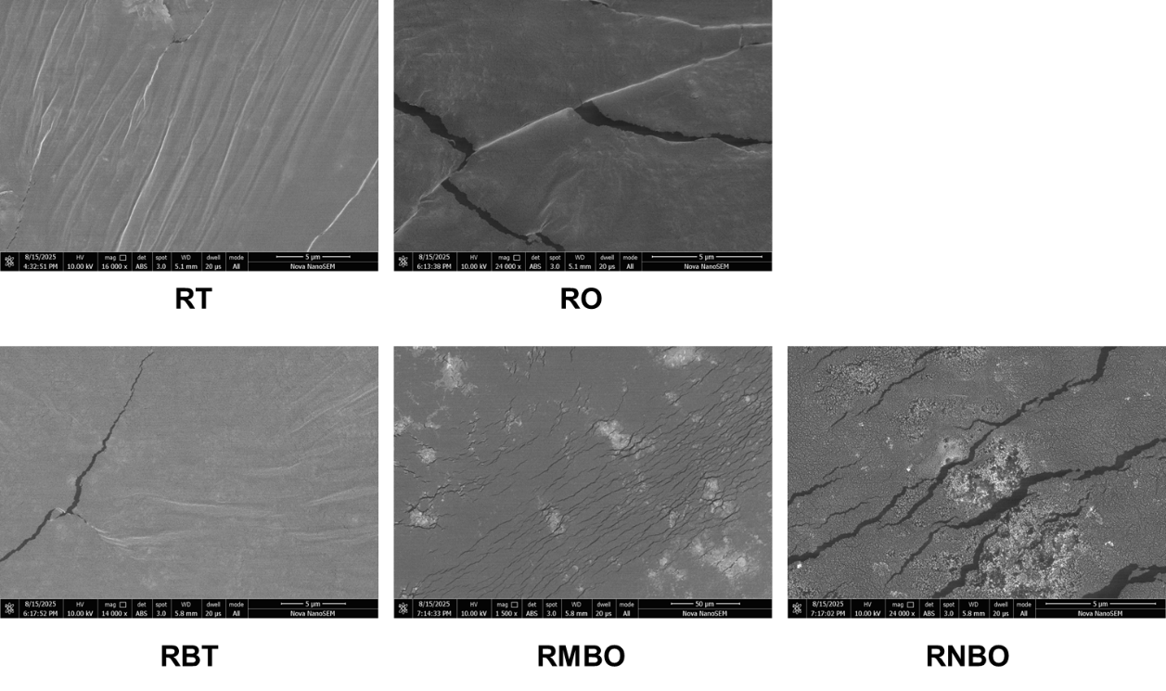
Fig. S23. SEM of RT, RO, RBT, RMBO and RNBO

- Comparison of fluorescence intensity of probes for FSA
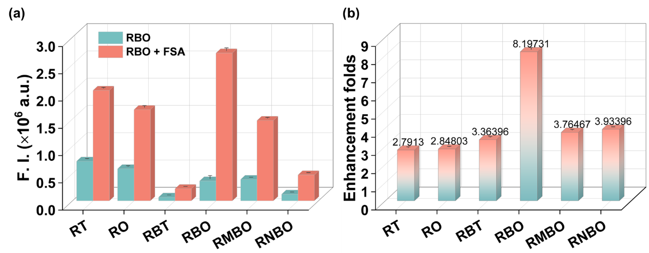
Fig. S24. (a) The fluorescence intensity and (b) enhancement folds of the six probes (10 μM) upon the addition of 10 μM FSA. Error bars indicate the SD calculated from three independent measurements (n=3). Experimental conditions: λ_{ex} = 560 nm; slits, 2/2 nm; and MeOH-H₂O, 2:3 (v/v).

- Investigation of the Optimal Excitation Wavelength
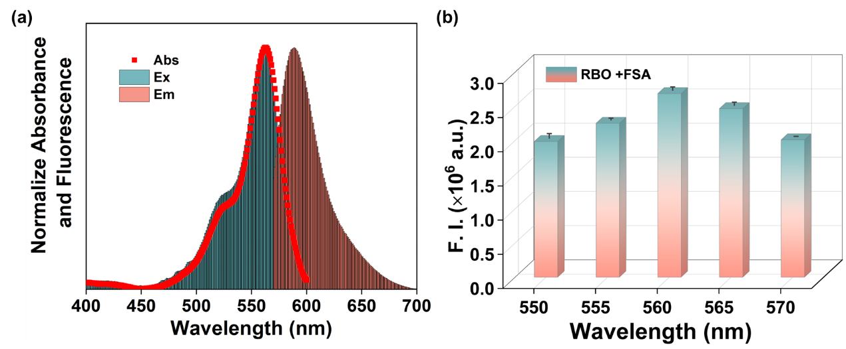
Fig. S25. (a) Normalized absorption, excitation, and emission spectra of the RBO-FSA complex in solution. (b) After adding the FSA, the fluorescence intensities were measured at excitation wavelengths of 550, 555, 560, 565, and 570 nm respectively.

- The molecular structure of various herbicides
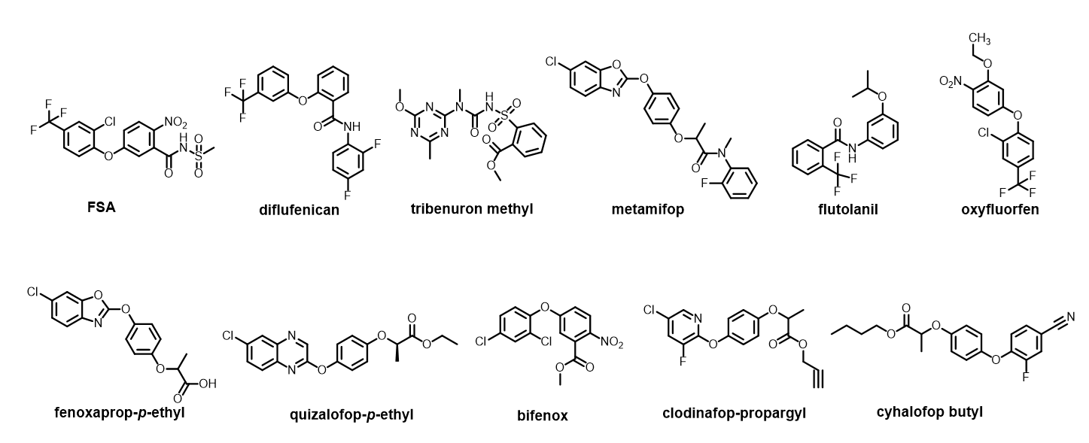
Fig. S26. The molecular structure of various herbicides

- Anti-disturbance experiments in the presence of two or more other herbicides
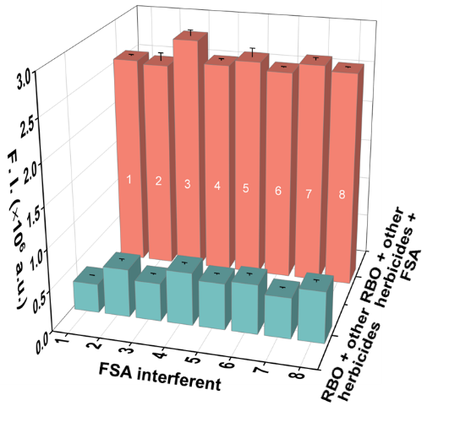
Fig. S27. Anti-interference experiments adding 10 μM FSA into the premixed solution incorporating the probe RBO (10 μM) and two or more other herbicides (10 μM): (1) Blank, (2) clodinafop-propargyl + bifenox, (3) clodinafop-propargyl + bifenox + flutolanil, (4) clodinafop-propargyl + bifenox + flutolanil + fenoxaprop-p-ethyl, (5) clodinafop-propargyl + bifenox + flutolanil + fenoxaprop-p-ethyl + metamifop, (6) clodinafop-propargyl + bifenox + flutolanil + fenoxaprop-p-ethyl + metamifop + oxyfluorfen, (7) clodinafop-propargyl + bifenox + flutolanil + fenoxaprop-p-ethyl + metamifop + oxyfluorfen + cyhalofop-butyl, (8) clodinafop-propargyl + bifenox + flutolanil + fenoxaprop-p-ethyl + metamifop + oxyfluorfen + cyhalofop-butyl + tribenuron methyl.

- Detection limit calculation
To determine the detection limit, we processed the spectrofluorometric titration datasets and established a calibration curve between the concentrations of FSA and the fluorescence titration data at 588 nm. Detection limit is calculated as follows:
LOD = 3σ/k
where σ denotes deviation of the blank measurement (ten blank determinations) and k represents the slope between the fluorescence intensity versus analyte concentration.

- Reversibility
Fig. S28. Fluorescence intensity of RBO recorded after adding FSA and TEA for six continuous cycles (Experimental conditions: λ_{ex} = 561 nm; slits, 2/2 nm; and MeOH/H₂O = 2:3, v/v)

- pH-Dependent Fluorescence Response
Fig. S29. (a) Fluorescence emission spectra of the RBO at different pH values.

- Stability of the RBO under different storage conditions
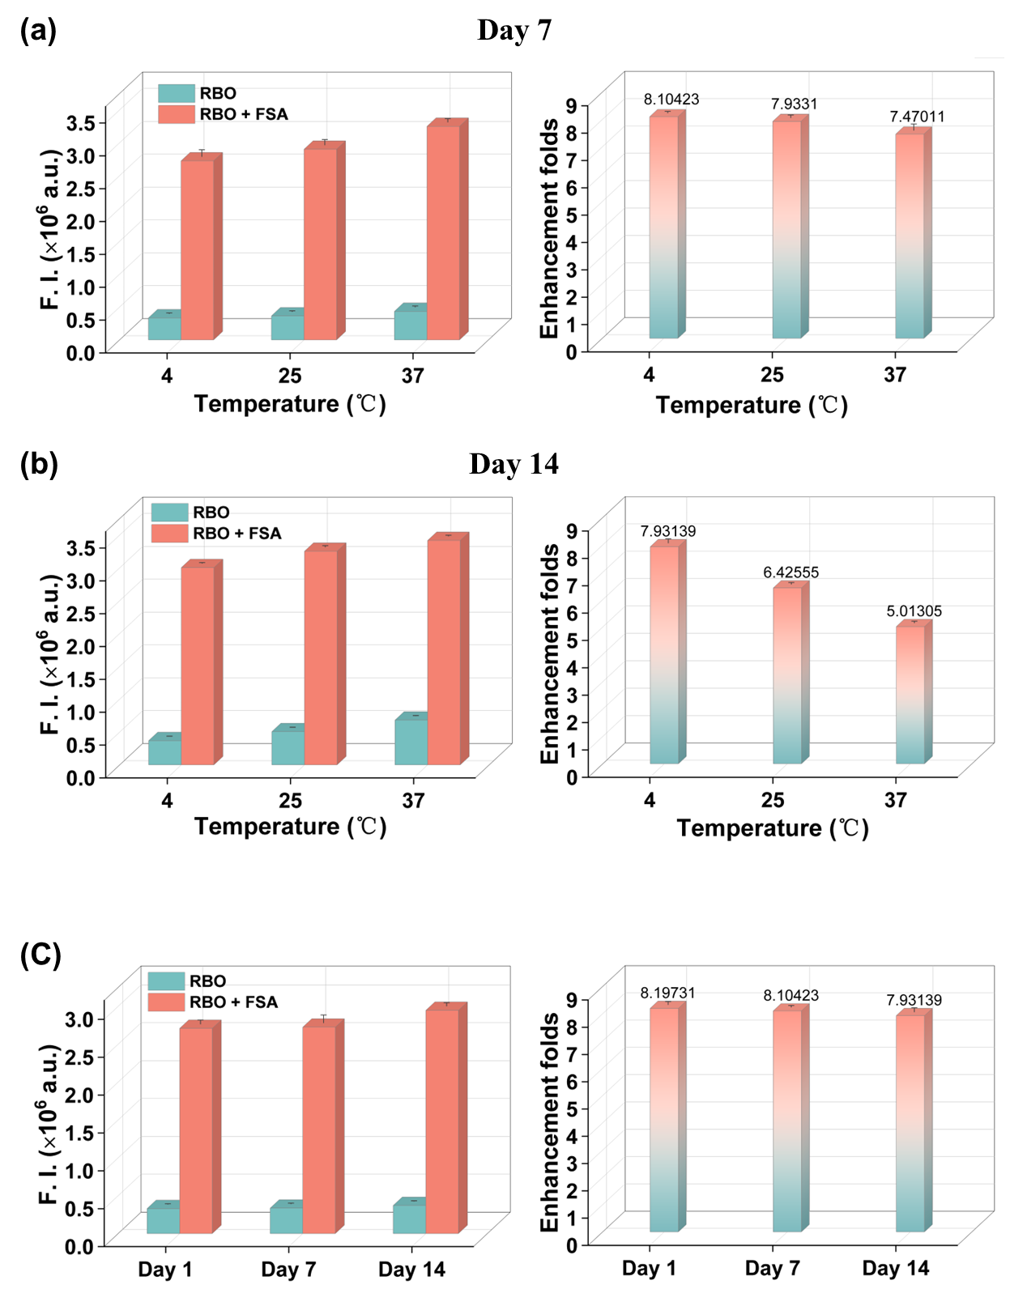
Fig. 30. (a) Fluorescence response of the RBO to FSA after one-week storage at different temperatures (4℃, 25℃, and 37℃). (b) Fluorescence response of the RBO to FSA after two -week storage at different temperatures (4℃, 25℃, and 37℃). (c) Fluorescence intensities of RBO stored at the same temperature (4 ℃) for 1 day, 7 days and 14 days, respectively. Data are presented as mean ± SD (n = 3).

- Chemical shifts of FSA and RBO after complex formation
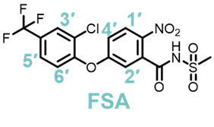
Table S4. The chemical shift of FSA after the formation of the complex RBO-FSA with different molar ratios.
Chemical shift (ppm) | proton
Chemical shift (ppm) | 1' | 2' | 3' | 4' | 5' | 6'
FSA | 8.18 | 7.78 | 7.61 | 7.26 | 7.08 | 6.98
FSA: RBO = 0.5:1 | 8.19 | 7.79 | 7.59 | 7.22 | 7.1 | 6.99
FSA: RBO = 1:1 | 8.19 | 7.78 | 7.60 | 7.25 | 7.09 | 6.98
FSA: RBO = 1.5:1 | 8.18 | 7.78 | 7.60 | 7.24 | 7.08 | 6.98
FSA: RBO = 2:1 | 8.18 | 7.77 | 7.59 | 7.24 | 7.07 | 6.98
FSA: RBO = 3:1 | 8.18 | 7.77 | 7.59 | 7.24 | 7.07 | 6.97
Shift _{FSA:} _{RBO} = 0.5:1 | 0.01 | 0.01 | -0.02 | -0.04 | 0.02 | -0.01
Shift _{FSA:} _{RBO =} 1:1 | 0.01 | 0 | -0.01 | -0.01 | 0.01 | 0
Shift _{FSA:} _{RBO =} 1.5:1 | 0 | 0 | -0.01 | -0.02 | 0 | 0.01
Shift _{FSA:} _{RBO} = 2:1 | 0 | -0.01 | -0.02 | -0.02 | -0.01 | -0.01
Shift _{FSA:} _{RBO} = 3:1 | 0 | -0.01 | -0.02 | -0.02 | -0.01 | -0.02
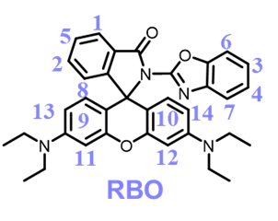
Table S5. The chemical shift of RBO after the formation of the complex RBO-FSA with different molar ratios.
Chemical shift (ppm) | proton
Chemical shift (ppm) | 1 | 2-4 | 5 | 6,7 | 8 | 9,10 | 11,12 | 13,14
RBO | 8.09 | 7.51 | 7.30 | 7.17 | 7.11 | 6.54 | 6.43 | 6.20
FSA: RBO = 0.5:1 | 8.06 | 7.5 | 7.27 | 7.15 | 7.1 | 6.50 | 6.40 | 6.19
FSA: RBO = 1:1 | 8.04 | 7.48 | 7.25 | 7.15 | 7.09 | 6.49 | 6.39 | 6.18
FSA: RBO = 1.5:1 | 8.03 | 7.47 | 7.24 | 7.14 | 7.08 | 6.48 | 6.39 | 6.17
FSA: RBO = 2:1 | 8.02 | 7.46 | 7.24 | 7.13 | 7.07 | 6.47 | 6.38 | 6.16
FSA: RBO = 3:1 | 8.02 | 7.45 | 7.24 | 7.13 | 7.07 | 6.47 | 6.38 | 6.16
Shift _{FSA:} _{RBO} = 0.5:1 | -0.03 | -0.01 | -0.03 | -0.02 | -0.01 | -0.04 | -0.03 | -0.01
Shift _{FSA:} _{RBO} = 1:1 | -0.05 | -0.03 | -0.05 | -0.02 | -0.02 | -0.05 | -0.04 | -0.02
Shift _{FSA:} _{RBO} = 1.5:1 | -0.06 | -0.04 | -0.06 | -0.03 | -0.03 | -0.06 | -0.04 | -0.03
Shift _{FSA:} _{RBO} = 2:1 | -0.04 | -0.05 | -0.06 | -0.04 | -0.04 | -0.07 | -0.05 | -0.04
Shift _{FSA:} _{RBO} = 3:1 | -0.04 | -0.06 | -0.06 | -0.04 | -0.04 | -0.07 | -0.05 | -0.04

- Response of RBO to the FSA analogues
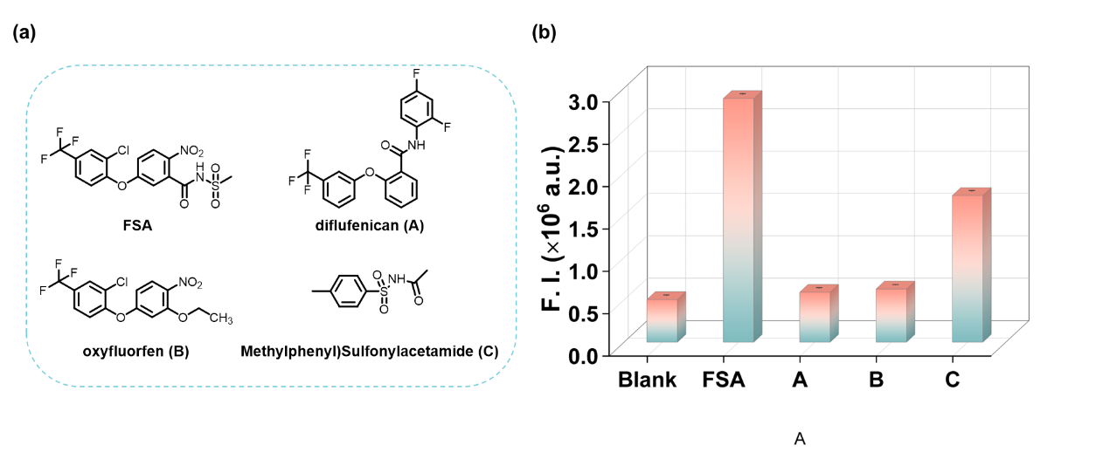
Fig. S31. Fluorescence spectra of RBO after adding 10 μM contrast. Data are presented as mean ± SD (n = 3). (Experimental conditions: MeOH/H₂O = 2/3, v/v, λ_{ex} = 560 nm, slits: 2 nm/2 nm).
- Detection of FSA in the soil extract solution
Fig. S32. The fluorescence intensity of the soil filtrate containing different concentrations of FSA after the addition of RBO. Data are presented as mean ± SD (n = 3).

- Linear calibration curve of test paper fluorescence intensity versus FSA concentration

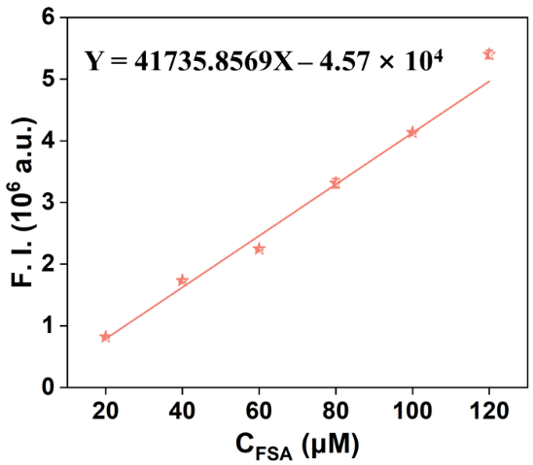
Fig. S33. Linear calibration curve of test strips fluorescence intensity versus FSA concentration.

- Smartphone platform test parameters
Table S6. Smartphone platform test parameters.
Projects | Test condition
Phone model  Camera settings | iphone XR  No special settings
Shooting environment（Fluorescence） | Camera obscura-type UV analyzer
Smartphone software | “Color recognizer” and “Curve fitting” app

- The RGB values of the test strips under different concentrations of FSA
Table S7. The RGB values of the test strips under different concentrations of FSA.
C_{FSA} (μm) | R/B |  |  | Mean | SD
0 | 122/212 | 124/221 | 130/224 | 0.5723 | 0.01002
100 | 149/233 | 155/235 | 155/238 | 0.65011 | 0.01009
200 | 139/205 | 140/207 | 140/203 | 0.68134 | 0.00725
300 | 157/213 | 160/216 | 157/216 | 0.73489 | 0.0072
400 | 147/180 | 143/178 | 143/180 | 0.80483 | 0.01118
500 | 175/194 | 175/196 | 175/194 | 0.88976 | 0.0141
600 | 176/188 | 177/190 | 177/189 | 0.93475 | 0.00275

- The rate of recovery of FSA in real samples
Table S8. The rate of recovery of FSA in real samples (n = 3).
Sample | added (μM) | FSA found (μM) | RSD of RBO (％) | Recovery of RBO (％) | HPLC (μM)
Potatoes | 0 | Not detected
Potatoes | 7 | 7.45 | 1.03 | 106.3 | 7.26
Potatoes | 10 | 10.58 | 2.67 | 105.8 | 11.7
Sweet potato | 0 | Not detected
Sweet potato | 7 | 7.07 | 0.32 | 100.9 | 6.87
Sweet potato | 10 | 9.70 | 0.47 | 97 | 11.1

- HPLC method for determining FSA content
HPLC analysis was performed on an Agilent Technologies 1260 Infinity II system equipped with a Kinetex® 5 μm EVO C18 100 Å column. The mobile phase was composed of 90% acetonitrile (v/v) and 10% water, delivered at a flow rate of 0.50 mL/min. Detection was performed at 290 nm.
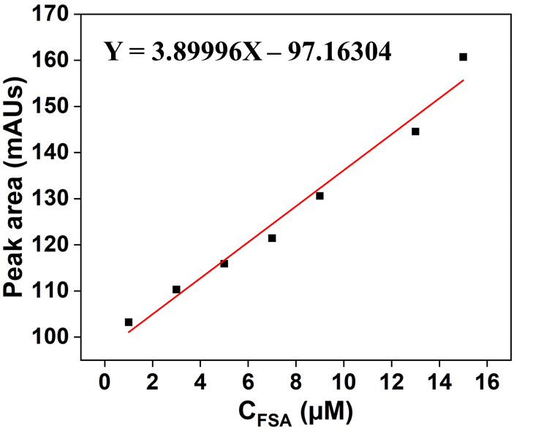
Fig. S34. HPLC calibration curve for FSA quantification.
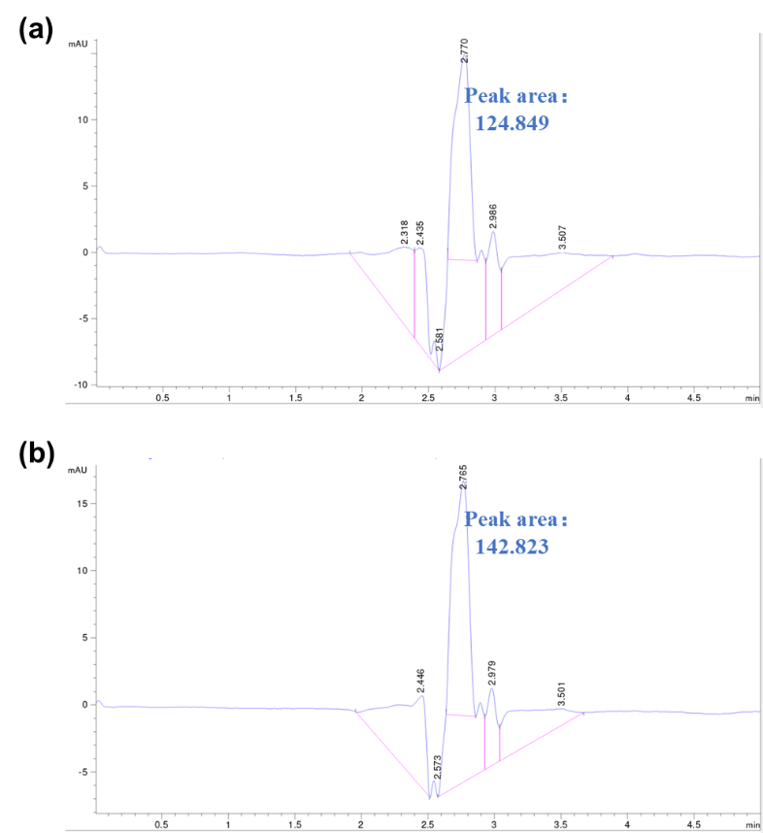
Fig. S35. Representative HPLC chromatograms of potato samples spiked with FSA at concentrations of 7 μM and 10 μM.
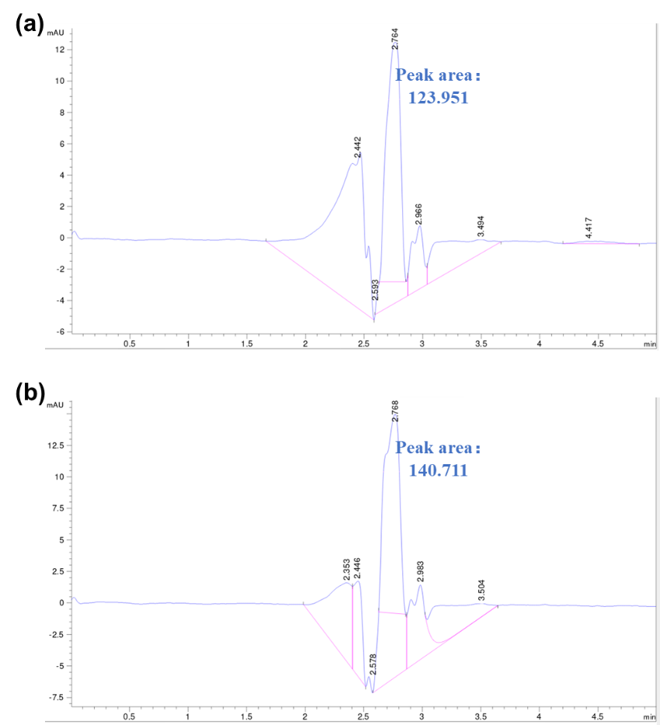
Fig. S36. Representative HPLC chromatograms of sweet potato samples spiked with FSA at concentrations of 7 μM and 10 μM.

- Linear calibration curve of hydrogel fluorescence intensity versus FSA concentration
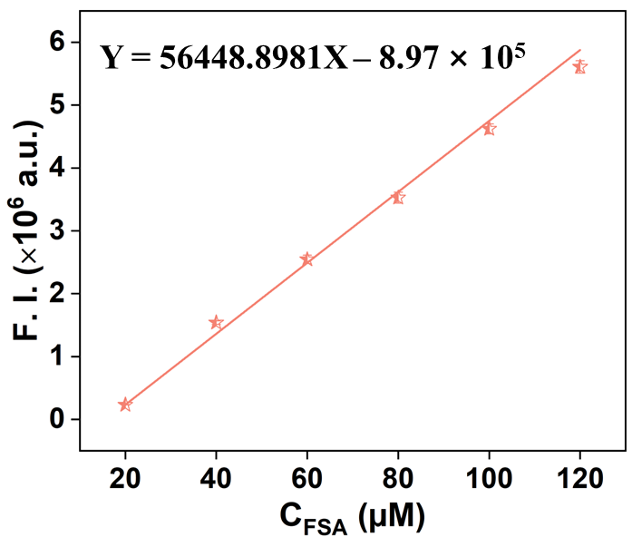
Fig. S37. Linear calibration curve of hydrogel fluorescence intensity versus FSA concentration.

- The RGB values of the hydrogel under different concentrations of FSA
Table S9. The RGB values of the hydrogel under different concentrations of FSA.
C_{FSA} (μm) | R/B |  |  | Mean | SD
0 | 98/212 | 93/203 | 93/191 | 0.4691 | 0.01556
50 | 122/224 | 120/217 | 123/227 | 0.5465 | 0.0058
100 | 109/173 | 124/197 | 122/196 | 0.62732 | 0.00423
200 | 153/210 | 149/192 | 143/194 | 0.74724 | 0.0253
300 | 236/219 | 239/215 | 242/222 | 1.09311 | 0.0172
400 | 247/200 | 246/201 | 243/202 | 1.22062 | 0.01626
500 | 251/166 | 253/164 | 251/166 | 1.52226 | 0.01769

- Bioluminescence Imaging
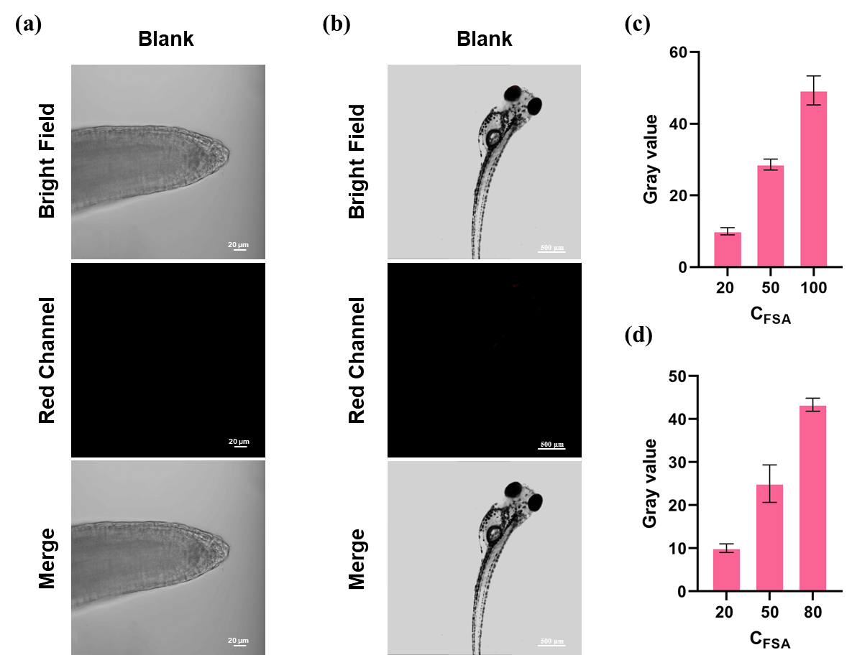
Fig. S38. (a) and (b) Blank group of fluorescence imaging. (c) The relative fluorescence intensity of the Arabidopsis root. (d) The relative fluorescence intensity of zebrafish. Data are presented as mean ± SD (n = 3).

- Comparison of different methods for FSA determination
Table S10. Comparison of different methods for FSA determination.
Methods | LOD | LOQ | Linear range | QY | Application | Portable detection | Fluorescent imaging | Ref.
HPLC-DAD-MS/MS | 0.00935-0.0825 μM | No data | No data | No data | Water | No | No | [3]
MIPs | No data | No data | No data | No data | No | No | No | [4]
SLE/LTP-HPLC/DAD | 0.0166 μM | 0.05039 μM | 0.0570-0.615 μM | No data | Soil | No | No | [5]
LC-MS/MS | 4.10×10⁻⁵-2.85×10⁻⁴ μM | 0.023-0.046 μM | No data | No data | Agricultural products | No | No | [6]
Nanozyme sensor arrays | No data | No data | No data | No data | Soil | No | No | [7]
Colorimetric nanozyme array | 0.071 μM | No data | No data | No data | Water | No | No | [8]
Immunoassay | No data | No data | 4.38×10⁻³ - 1.78 μM | - | Soil | No | No | [9]
Immune sensor | 0.5 fM | No data | 0.5 fM - 500 pM | - | No | No | No | [10]
This work | 0.39 μM |  | 0 – 10 μM | 0.2564 | Soil, agricultural products | Yes | Yes

References:
1. Laganà A, Fago G, Fasciani L, Marino A, Mosso M. Determination of diphenyl-ether herbicides and metabolites in natural waters using high-performance liquid chromatography with diode array tandem mass spectrometric detection. Anal Chim Acta. 2000;414(1):79-94.
2. Jin XY, Wang Y, Bai WY, Zhao D, Song XL, Xu XW. Synthesis and Characterization of Fomesafen Imprinted Polymers. Journal of Macromolecular Science. Part a, Pure Appl Chem. 2015;52(12):316-321.
3. Costa AIG, Queiroz MELR, Neves AA, de Assis RC, Soares CESD, Silva AAD, et al. Mobility and persistence of the herbicide fomesafen in soils cultivated with bean plants using SLE/LTP and HPLC/DAD. Environ Sci Pollut R. 2015;22(5):3457-3466.
4. Pang K, Hu JY. Simultaneous Analysis and Dietary Exposure Risk Assessment of Fomesafen, Clomazone, Clethodim and Its Two Metabolites in Soybean Ecosystem. Int J Env Res Pub He. 2020;17(6):1951.
5. Zhu YY, Wu JJX, Han LJ, Wang XY, Li W, Guo HC, et al. Nanozyme Sensor Arrays Based on Heteroatom-Doped Graphene for Detecting Pesticides. Anal Chem. 2020;92(11):7444-7452.
6. Tai SM, Wang J, Sun FX, Pan QL, Peng CF, Wang ZP. A colorimetric sensor array based on nanoceria crosslinked and heteroatom-doped graphene oxide nanoribbons for the detection and discrimination of multiple pesticides. Anal Chim Acta. 2023;1283:341929.
7. Gao QQ, Chen L, An ZX, Wang YS, Yang DC, Wang ZZ, et al. Development of an immunoassay based on a specific antibody for the detection of diphenyl ether herbicide fomesafen. Sci Total Environ. 2024;914:169858.
8. Xu P, Zhao E. Fomesafen accurate detection by poly (3-hexylthiophene) transistor-based sensor. Journal of Materials Science: Materials in Electronics. 2023;34(36):2279.
9. Wang F, Nam S, Guo Z, Park S, Yoon J. A new rhodamine derivative bearing benzothiazole and thiocarbonyl moieties as a highly selective fluorescent and colorimetric chemodosimeter for Hg²⁺. Sensors and Actuators B: Chemical. 2012;161(1):948-953.
10. Zhang Y, Chen X, Shao J, Zhang J, Yuan Q, Miao J, et al. A Ratiometric Fluorescent Probe for Sensing HOCl Based on Coumarin-rhodamine Dyad. Chem Commun. 2014;50(91): 14241-14244.

