Supplementary Materials
Macrophage-delivered Nifuroxazide reprograms immunosuppressive microenvironment and synergizes with Oxaliplatin for enhanced anti-hepatocellular carcinoma therapy​

Zhentao Yang^{#a}, Hong Tang^{#a}, Ning Wang^{#a},Ruiqi Sunª, Ke Zhou^{e}, Wentao Zhaoª, Zhi Liangª, Haojing Maª, Haoyu Li^{f}, Penghong Song ^{a,b,c,d}, Zhengliang Tu^{g}, Shusen Zheng*^{a,b,c,d}, Haiyang Xie* ^{a,b,c,d}

ª Division of Hepatobiliary and Pancreatic Surgery, Department of Surgery, The First Affiliated Hospital, Zhejiang University School of Medicine, Hangzhou 310003, China
^{b} NHC Key Laboratory of Combined Multi-organ Transplantation, Key Laboratory of Organ Transplantation, Zhejiang Province, Hangzhou 310003, China
^{c} Key Laboratory of the Diagnosis and Treatment of Organ Transplantation, Research Unit of Collaborative Diagnosis and Treatment for Hepatobiliary and Pancreatic Cancer, Chinese Academy of Medical Sciences (2019RU019), Hangzhou 310003, China
^{d} Key Laboratory of Organ Transplantation, Research Center for Diagnosis and Treatment of Hepatobiliary Diseases, Zhejiang Province, Hangzhou 310003,
China
^{e} Department of Lung Transplantation and Thoracic Surgery, The First Affiliated Hospital, Zhejiang University School of Medicine, Hangzhou 310003, China
^{f} Research Project of Jinan Microecological Biomedicine Shandong Laboratory, Jinan 250000, China
^{g} Department of Thoracic Surgery, The First Affiliated Hospital, Zhejiang University School of Medicine, Hangzhou, 310000, China.

#These authors contributed equally to this work.

*Corresponding author: Dr. Haiyang Xie and Professor Shusen Zheng at Division of Hepatobiliary and Pancreatic Surgery, Department of Surgery, First Affiliated Hospital, School of Medicine, Zhejiang University, 79 Qingchun Road, Hangzhou 310003, China. E-mail: xiehy@zju.edu.cn, Email: shusenzheng@zju.edu.cn.

Supplementary Methods
- Anti-tumor experiments in vivo
For subcutaneous HCC mouse models, H22 cell suspension prepared in 100 μL PBS containing about 2×10^6 cells was injected into the right flank of C57BL/6 (male, 6-8 weeks). Once the volume of the subcutaneous tumor reached approximately 100 mm³, the corresponding therapeutic regimen was initiated following random grouping. The corresponding treatments as follows: (1) The administration of NFX was conducted orally at a dosage of 5 mg/kg. (2) The administration of NFX was conducted intravenously at a dosage of 5 mg/kg. (3) Macrophages loaded with NFX were similarly injected intravenously at the same dosage of 5 mg/kg, with approximately 3.0 × 10^6 cells being administered. (4) The quantity of macrophages injected alone was consistent with that of the Mφ-NFX group. (5) Mice of the normal control group were treated with equivalent volume of vehicle. The treatment was administered once daily for seven consecutive days. On day 8, subcutaneous tumor volumes in mice were calculated using the formula: V = 1/2 (length × width²). Subsequently, mice were euthanized, and tumors were excised and weighed. Tumor tissues were then centrifuged to obtain supernatants. Protein concentrations in the supernatants were quantified using the bicinchoninic acid (BCA) assay (Cat# BRK0011, ABclonal, China), with all samples adjusted to a final concentration of 10 mg/mL. Cytokine levels in the tissue lysates and blood were measured using the ABplex Mouse 3-Plex Custom Panel (Cat# RK04383, ABclonal, China).
- Biosafety assessment
Healthy C57BL/6 mice were randomly allocated into five groups: (1) Oral NFX group, receiving NFX at a dosage of 5 mg/kg via oral gavage; (2) Intravenous NFX group, administered NFX intravenously at 5 mg/kg; (3) Mφ-NFX group, where macrophages loaded with NFX (equivalent to 5 mg/kg NFX) were intravenously injected, with approximately 3.0 × 10⁶ cells delivered per mouse; (4) Macrophage-only group, receiving an equivalent quantity of macrophages (3.0 × 10⁶ cells) as the Mφ-NFX group via intravenous injection; (5) Normal control group, treated with an equivalent volume of vehicle. Treatments were administered once daily for seven consecutive days. On days 8, 15, and 30 post-treatment initiation, blood samples were collected for hematological and hepatic/renal function analyses. Additionally, major organs (heart, liver, spleen, lung, kidney) were harvested for histopathological evaluation using hematoxylin and eosin (HE) staining to assess potential treatment-related effects.

Supplementary Figures

Figure S1. Cell cycle distribution of SNU-449 and Huh7 detected by PI staining and corresponding flow cytometric analysis with quantitative results (n = 3).
Figure S2. The inhibitory effect of NFX on Cyclin-B1, Cdc2 and the phosphorylation of STAT3 at the site of Tyr705 examined by western blot in SNU-449 and Huh7 cells.
Figure S3. PICRUSt and Tax4FUN analyses illustrated that orally taken of NFX dramatically affected the flora function. (A and B) Heatmap (A) illustrating the effects of different oral doses of NFX on the functional profiles of gut microbiota in mice, based on PICRUSt analysis, and the statistical representation of gut microbiota abundance for significantly altered functional pathways (B) (n = 6). (C and D) Heatmap (C) depicting the effects of different oral doses of NFX on the functional profiles of gut microbiota in mice, based on Tax4FUN analysis, and the statistical representation of gut microbiota abundance for significantly altered functional pathways (D) (n = 6).NC, normal control. NFX5, oral administration of 5 mg/kg Nifuroxazide. NFX10, oral administration of 10 mg/kg Nifuroxazide.

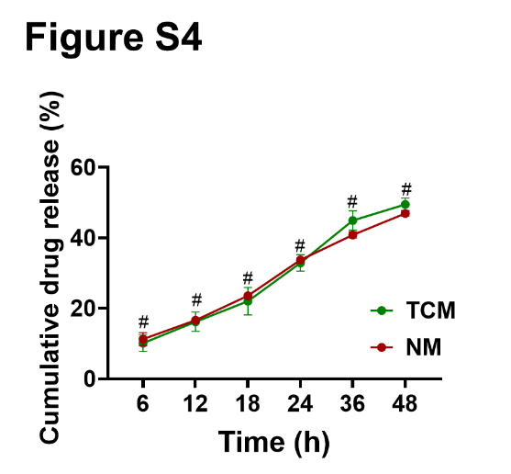
Figure S4. Drug release rate of Mφ-NFX in normal medium (NM) and tumor conditioned medium (TCM) (n = 3), # means no significant difference.

Figure S5. (A) The reaction equation of Nifuroxazide labeled by near-infrared fluorescent dye Cy5. NFX: Nifuroxazide; Cy5-NFX: Cy5-labeled Nifuroxazide. (B) The mass spectra of Cy5-labeled Nifuroxazide.
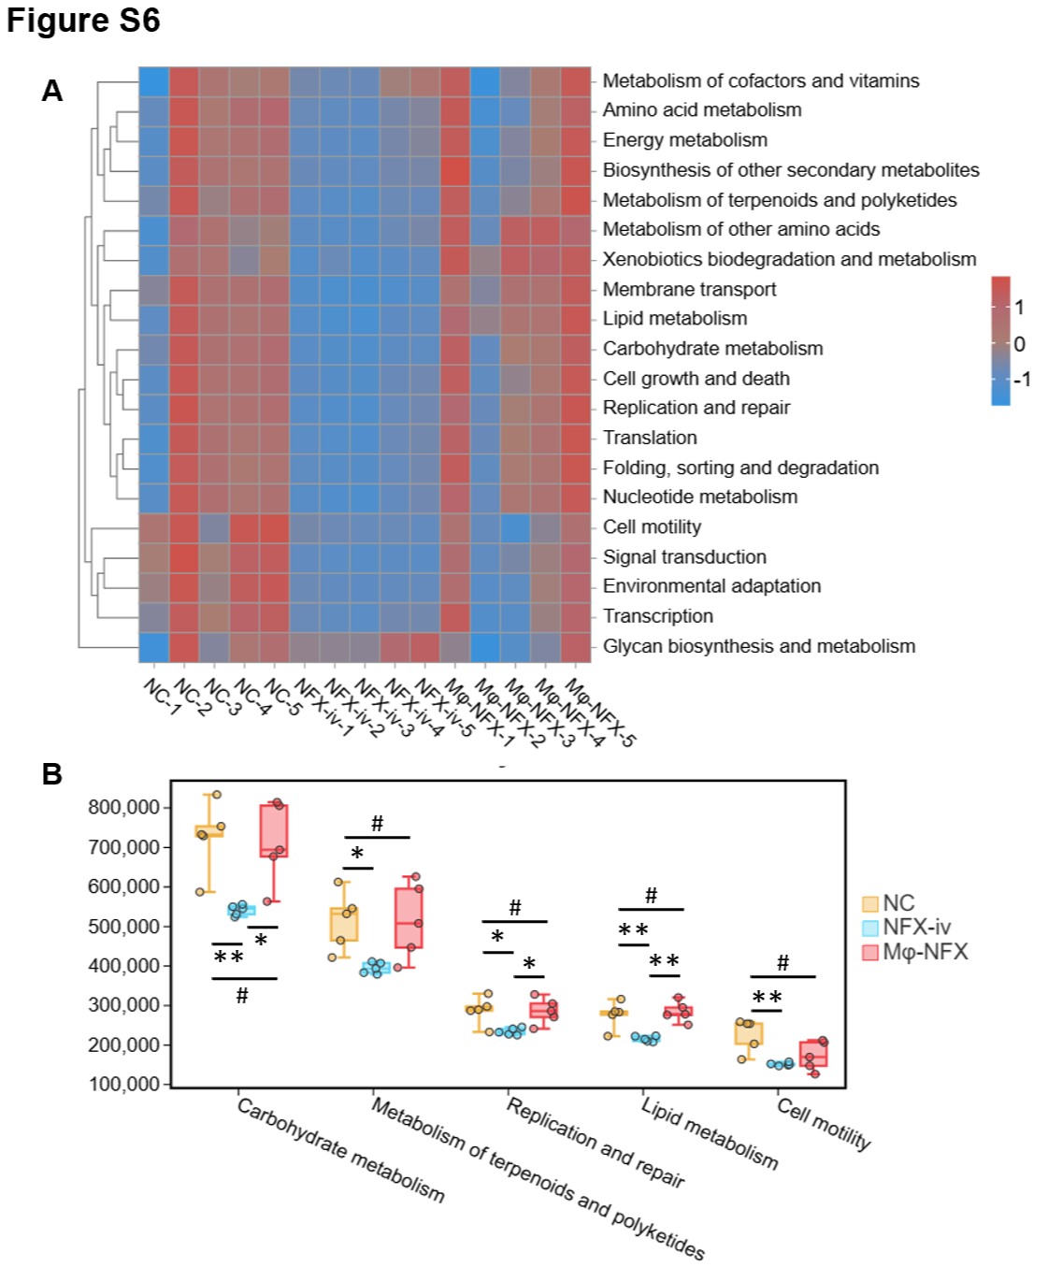
Figure S6. (A and B) Heatmap (A) depicting the effects of intravenous injection of equivalent NFX and NFX loaded by Mφ on the functional profiles of gut microbiota in mice, based on PICRUSt2 analysis, and the statistical representation (B) of gut microbiota abundance for significantly altered (n = 5). NFX-iv, intravenous injection of NFX. Mφ-NFX, intravenous injection of Mφ-NFX.

Figure S7. (A) Images of Hepa1-6 subcutaneous tumors harvested at the experimental endpoint after various treatments. (B) Tumor growth curves of Hepa1-6 subcutaneous tumors in each group (n = 5) of (A). (C) Weights of Hepa1-6 tumors in each group (n = 5) of (A).

Figure S8. (A) Weight changes of H22 subcutaneous tumor-bearing mice in each group (n = 5). (B) Weight changes of Hepa1-6 subcutaneous tumor-bearing mice in each group (n = 5).

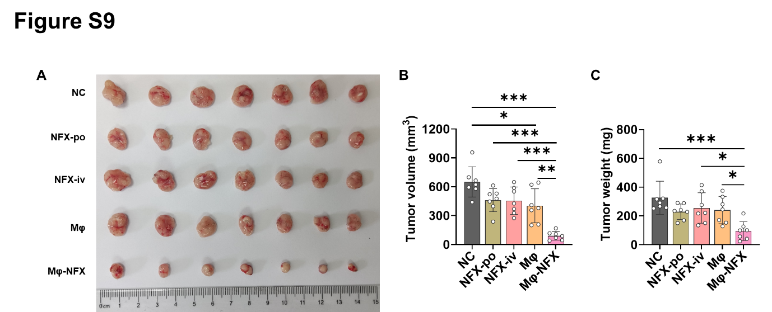
Figure S9. (A) Images of H22 subcutaneous tumors harvested at the experimental endpoint after various treatments. (B) Tumor volume of H22 subcutaneous tumors in each group (n = 7) of (A). (C) Weights of H22 tumors in each group (n = 7) of (A). iv, intravenous injection. po, per oral.

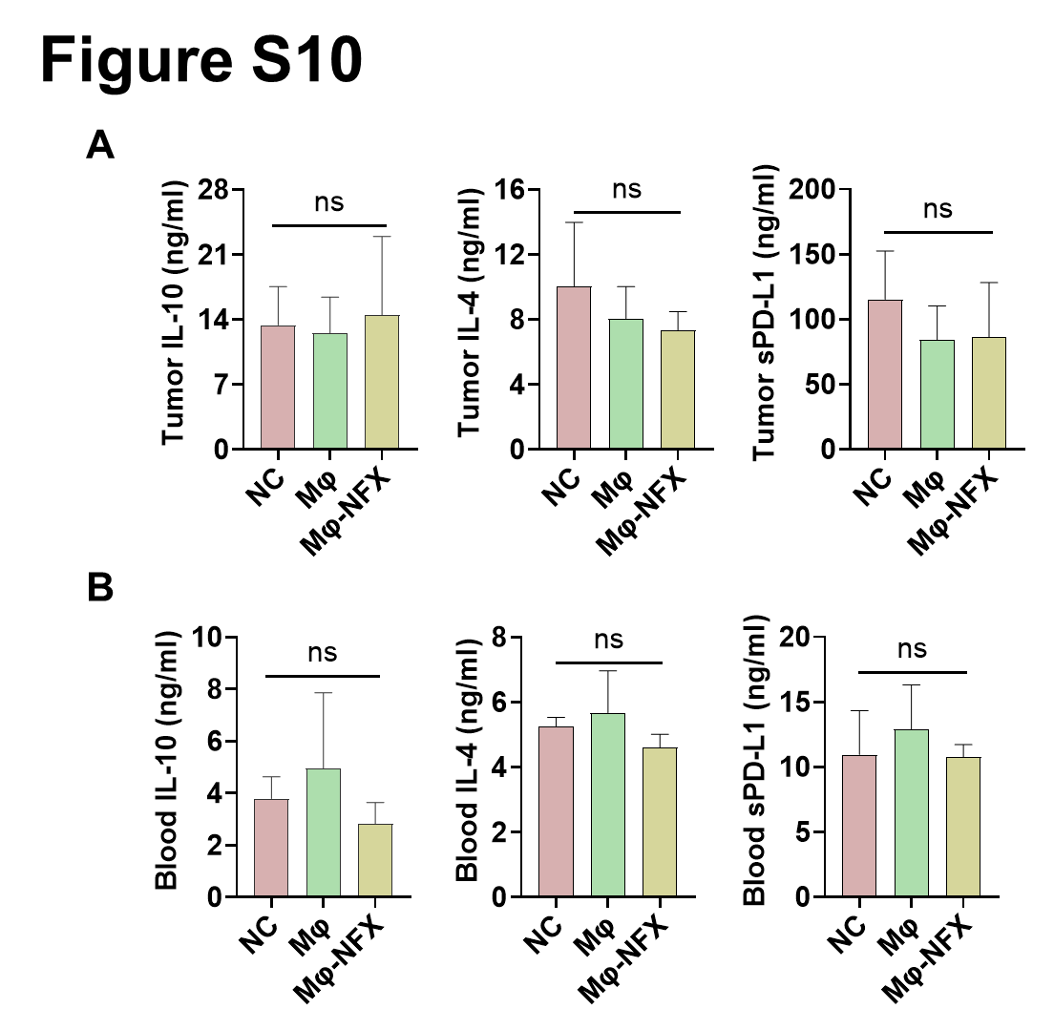
Figure S10. (A) Expression levels of IL-10, IL-4, and sPD-L1 in murine subcutaneous H22 tumors of Figure S9. (B) Expression levels of IL-10, IL-4, and sPD-L1 in the peripheral blood of H22 tumor-bearing mice of Figure S9. sPD-L1, soluble PD-L1.

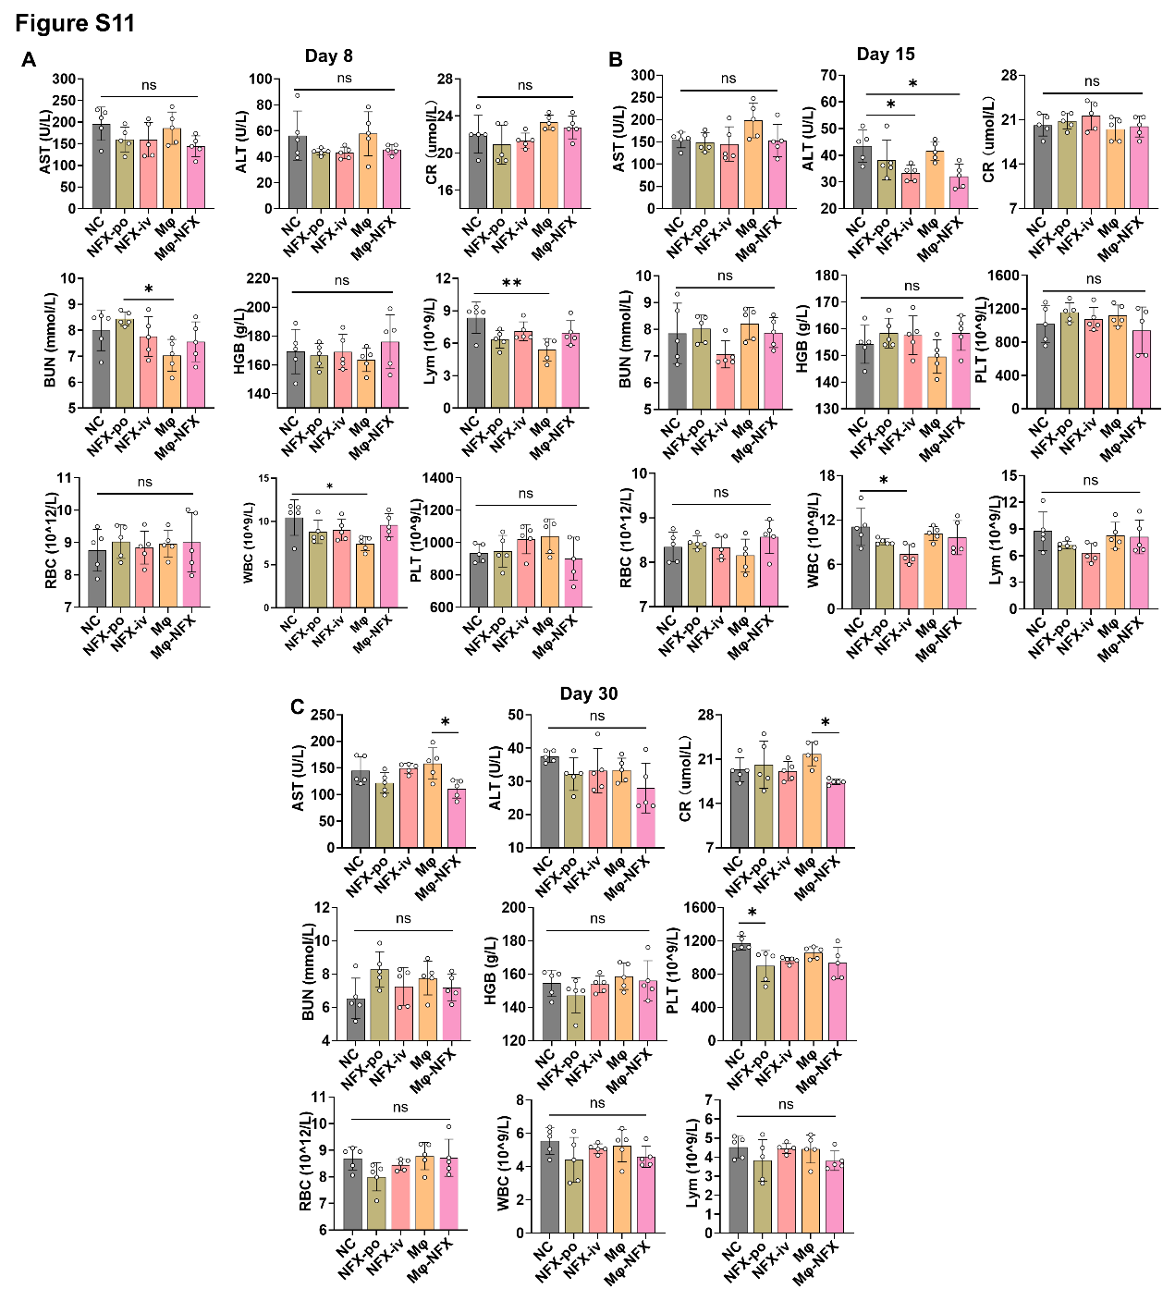
Figure S11. Evaluation of biochemical indicators and hematological parameters, including aspartate aminotransferase (AST), alanine aminotransferase (ALT), creatinine (CR), blood urea nitrogen (BUN), hemoglobin (HGB), lymphocytes (Lym), red blood cells (RBC), white blood cells (WBC), and platelets (PLT) on day 8 (A), 15(B), and 30(C). Data are represented as means ± SD (n = 5).

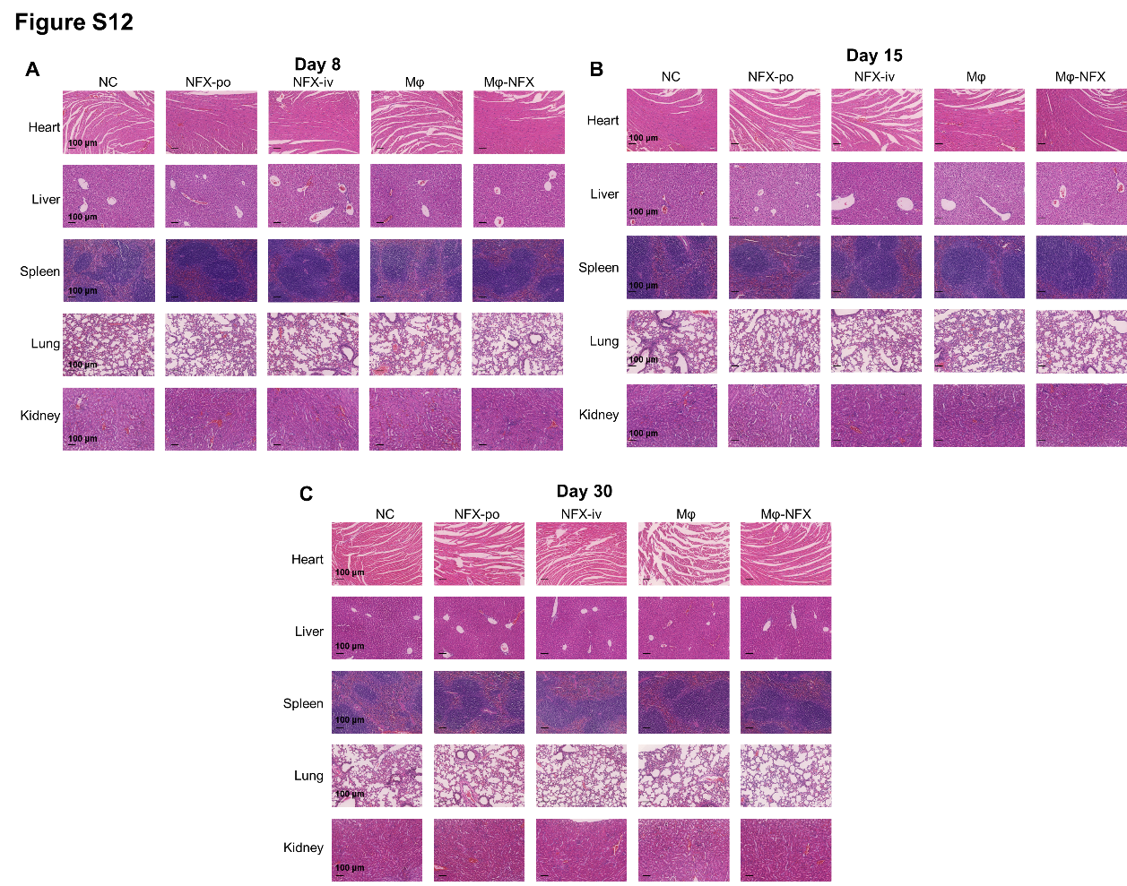
Figure S12. Representative H&E staining images of murine heart, liver, spleen, lung, and kidney on day 8 (A), 15 (B), and 30 (C) (n = 3).

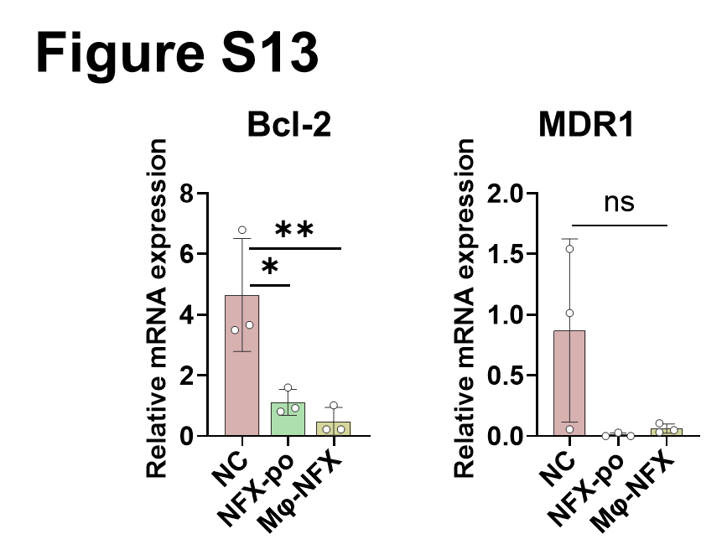
Figure S13. The expression levels of Bcl-2 and MDR1 of H22 subcutaneous tumor tissues in NC, oral NFX, and Mφ-NFX groups quantified by q-PCR (n = 3).

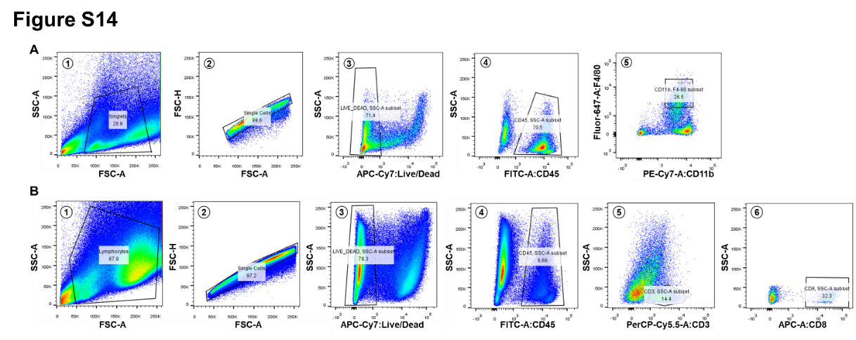
Figure S14. The gating strategy employed for the identification and analysis of tumor-infiltrating macrophages (A) and T cells (B).

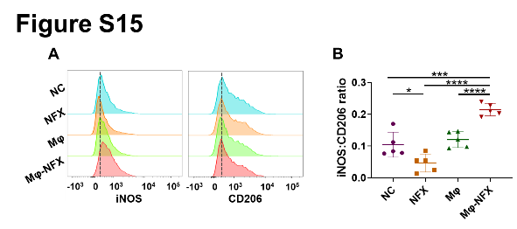
Figure S15. Representative flow cytometry histograms of iNOS⁺ macrophages and CD206⁺ macrophages in Hepa1-6 subcutaneous tumors (A), with statistical representation of the ratio of iNOS⁺ to CD206⁺ macrophages on the right(B) (n = 5).

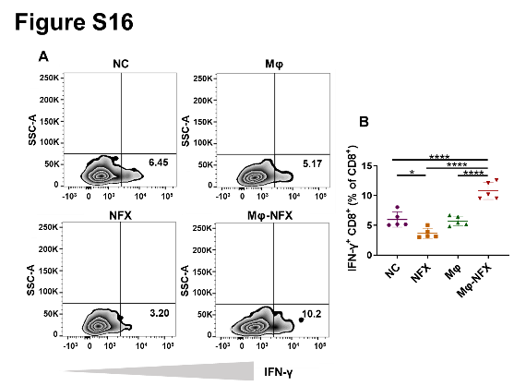
Figure S16. (A) Flow density plots of IFN-γ⁺CD8⁺ T cells in Hepa1-6 subcutaneous tumors, with quantification results on the right (B) (n = 5).

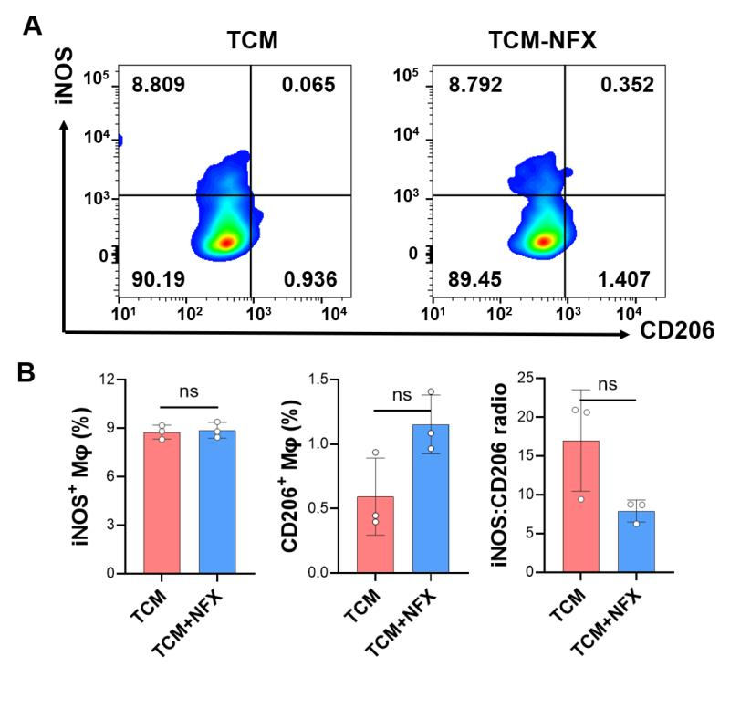

Figure S17. (A) The representative flow cytometry gating plot of iNOS and CD206 in RAW264.7 cells following induction with tumor-conditioned media (TCM) and TCM-NFX for 2 hours. (B) The statistical result of the expression of Inos, CD206，and the ratio of iNOS to CD206 (n = 3).

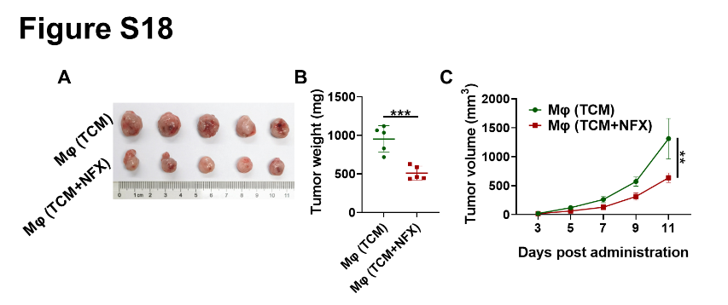
Figure S18. (A) Images of subcutaneous Hepa1-6 tumors harvested from Mφ (TCM) and Mφ (TCM-NFX) groups (n = 5). (B) Tumor weights in the relevant group of (A). (C) Tumor growth curve in the relevant group of (A). Mφ (TCM): macrophage induced by tumor-conditioned media. Mφ (TCM-NFX): macrophage induced by tumor-conditioned media containing Nifuroxazide.

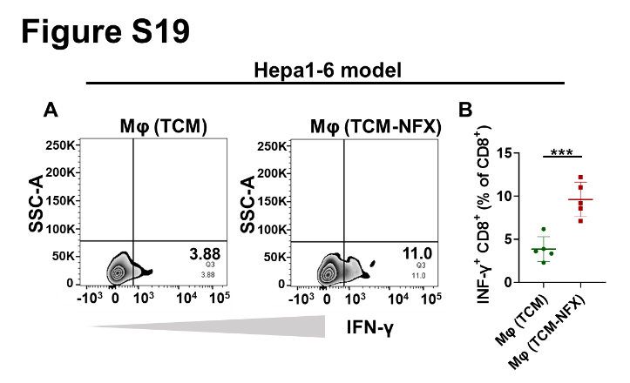
Figure S19. (A) The representative flow cytometry density plots of IFN-γ⁺ in CD8⁺ T cells in the Hepa1-6 subcutaneous tumor following Mφ (TCM) and Mφ (TCM-NFX) treatments, respectively. (B) The infiltration proportion of IFN-γ⁺ CD8⁺ T cells (n = 5). Mφ (TCM): macrophage induced by tumor-conditioned media. Mφ (TCM-NFX): macrophage induced by tumor-conditioned media containing Nifuroxazide.

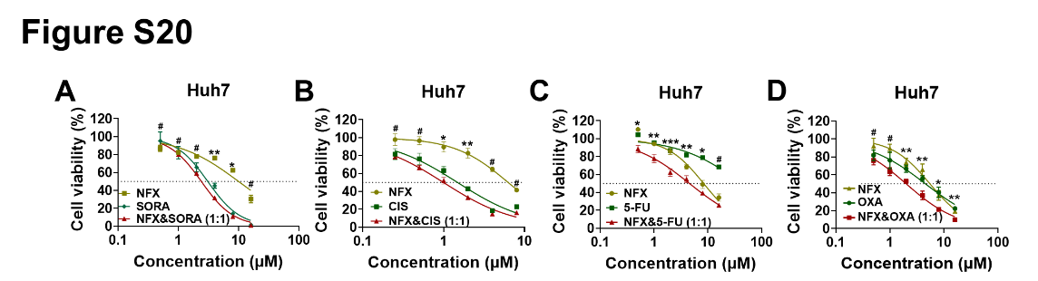
Figure S20. Cell viabilities of Huh7 treated with NFX and/or sorafenib (A), cisplatin (B), 5-fluorouracil (C), and Oxaliplatin (D). SORA, sorafenib. CIS, cisplatin. 5-FU, 5-fluorouracil. OXA, Oxaliplatin (n = 3).

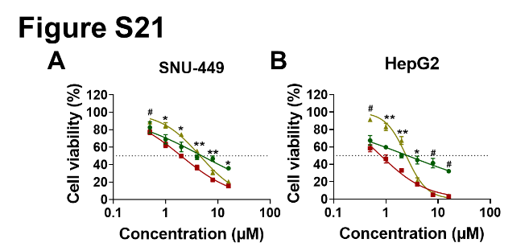
Figure S21. Cell viabilities of SNU-449 (A) and HepG2 (B) administered with NFX and/or Oxaliplatin at multiple concentrations (n = 3).

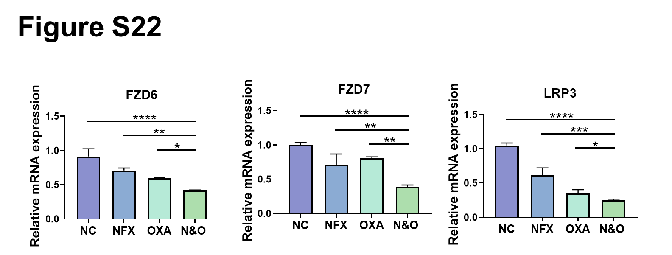
Figure S22. The expression level of FZD6, FZD7, and LRP3 determined by PCR (n = 3). NC: normal control; NFX: Nifuroxazide; OXA: Oxaliplatin; N&O: Nifuroxazide plus Oxaliplatin.

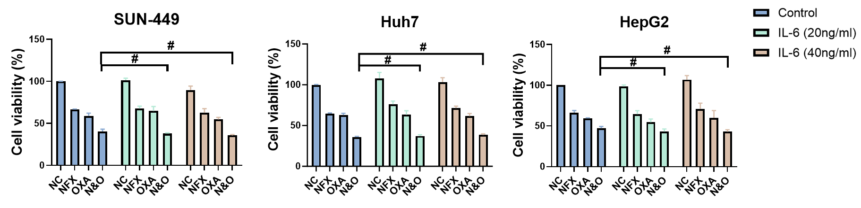
Figure S23. Viabilities of HCC cells administered 4 µM nifuroxazide and 4 µM oxaliplatin single or in combination with or without different concentration of IL6. NC: normal control; NFX: Nifuroxazide; OXA: Oxaliplatin; N&O: Nifuroxazide plus Oxaliplatin. Quantitative data are represented as the means ± SD from three independent experiments. #p > 0.05.

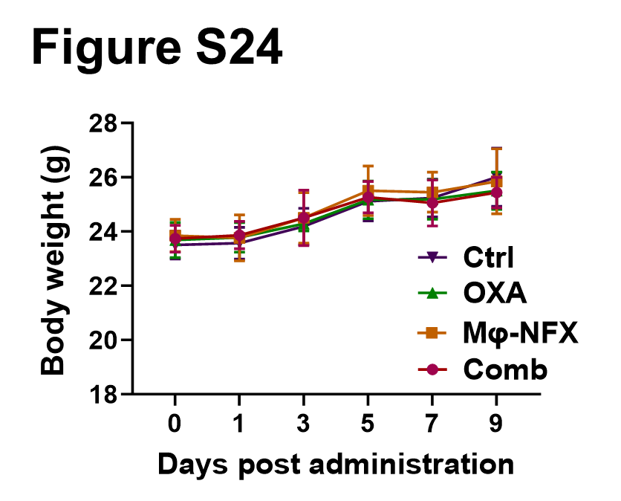
Figure S24. Body wight change of orthotopic H22-tumor bearing mice in various groups (n = 6).
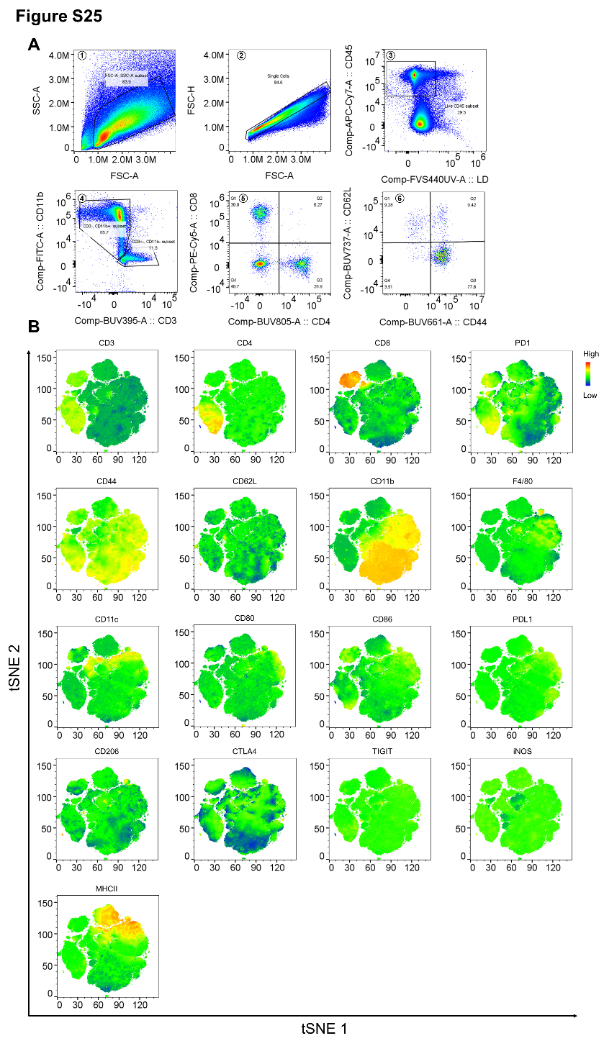
Figure S25. (A) Gating strategy for spectral flow cytometric analysis of tumor-infiltrating immune cells in the murine H22 orthotopic liver tumor model. (B) Incorporated markers of immune cell expression indicated on the tSNE map.

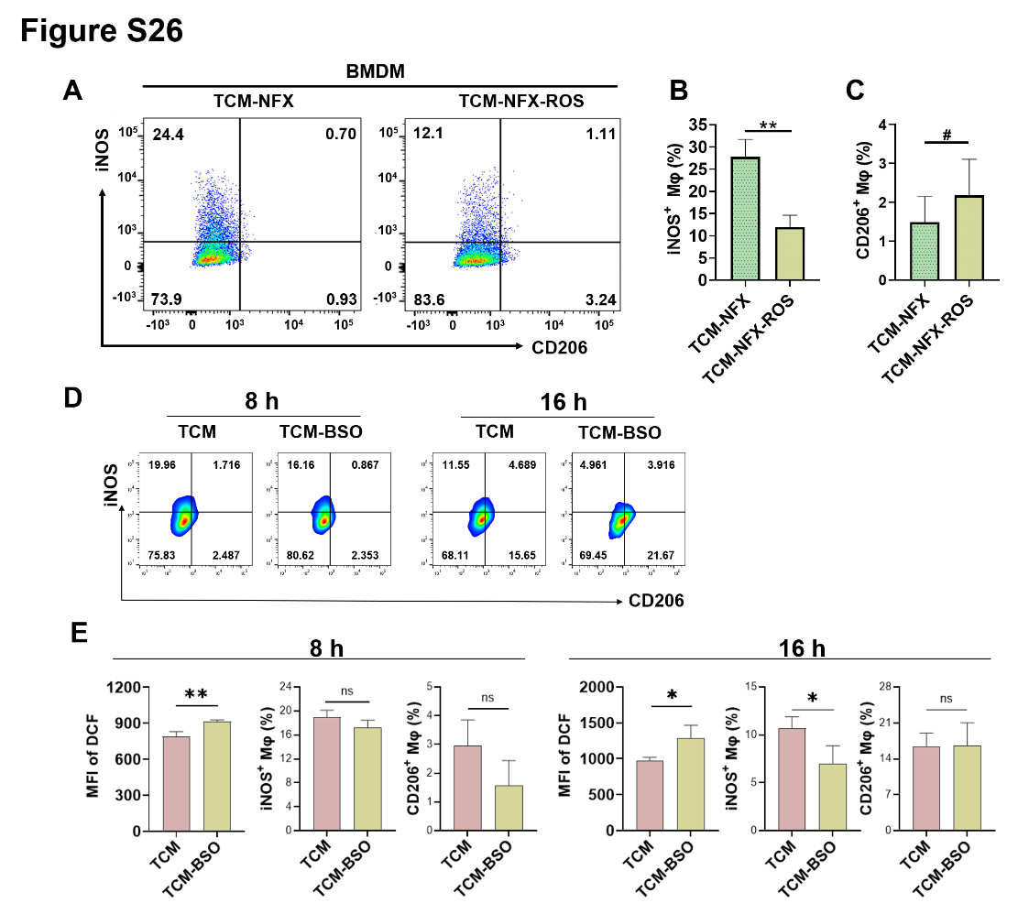
Figure S26. (A) Representative flow cytometry scatter plots of iNOS and CD206 expression of BMDM after 24 hours of treatment with TCM-NFX or TCM-NFX-ROS. (B and C) The proportion of CD206⁺ (F) and iNOS⁺ (G) BMDM after 24 hours of treatment with TCM-NFX or TCM-NFX-ROS (n = 3). (D) Representative flow cytometry scatter plots of iNOS and CD206 expression of RAW264.7 after 8 or 16 hours of treatment with TCM or TCM-BSO. (n = 3). (E) The mean fluorescence intensity of DCF and the proportion of CD206⁺ and iNOS⁺ RAW264.7 cells after 8 or 16 hours of treatment with TCM or TCM-BSO (n = 3). TCM-NFX: tumor-conditioned media containing Nifuroxazide. TCM-NFX-ROS: tumor-conditioned media containing Nifuroxazide and Rosup. BMDM: Bone marrow derived macrophages. TCM-BSO: tumor-conditioned media containing DL-Buthionine-(S,R)-sulfoximine (BSO). Quantitative data are represented as the means ± SD from three independent experiments. *p< 0.05, and **p < 0.01

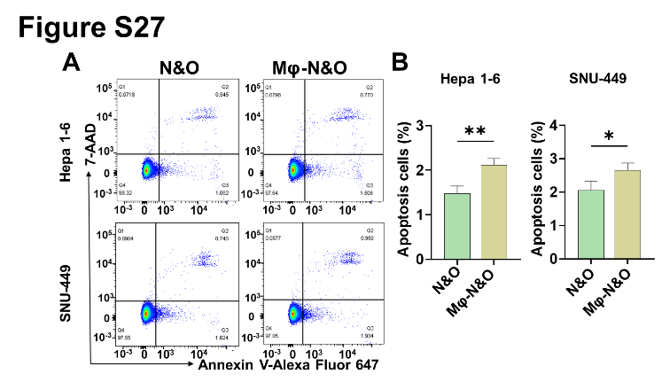
Figure S27. (A and B) Cell apoptosis of Hepa1-6 and SNU-449 measured by flow cytometry after treatment with a combination of 16 µM NFX and 16 µM Oxaliplatin, or a combination of Oxaliplatin and Mφ loaded with NFX (n = 3).

Supplementary Tables

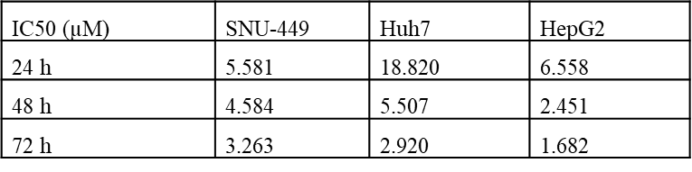
Table S1. IC₅₀ values of NFX treatment for 24, 48, and 72 h in three types of hepatocellular carcinoma cells.

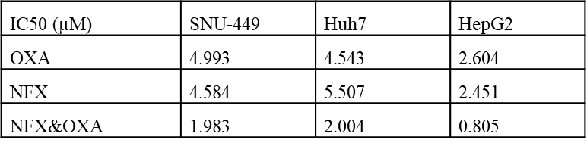
Table S2. IC₅₀ values of NFX combined with OXA treatment for 48 hours in three types of hepatocellular carcinoma cells

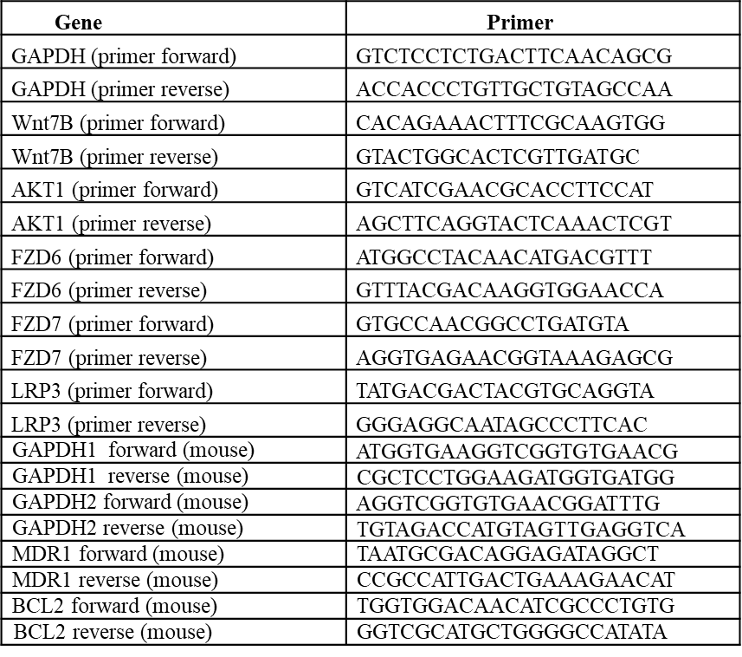
Table S3. Primers used in this study for PCR.

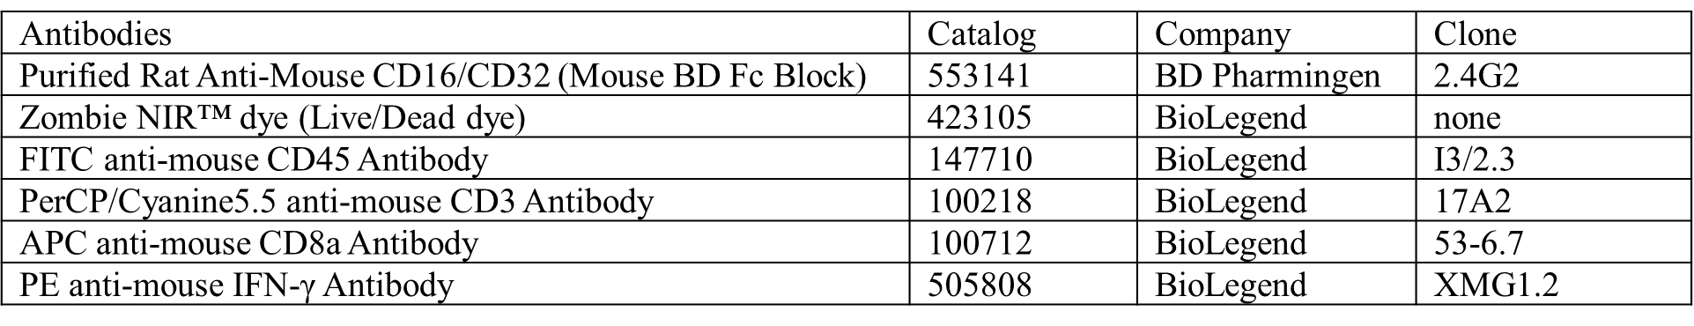
Table S4. The panel of antibodies used for the flow cytometry analysis of intratumoral infiltrating IFN-γ⁺ cytotoxic T cells.

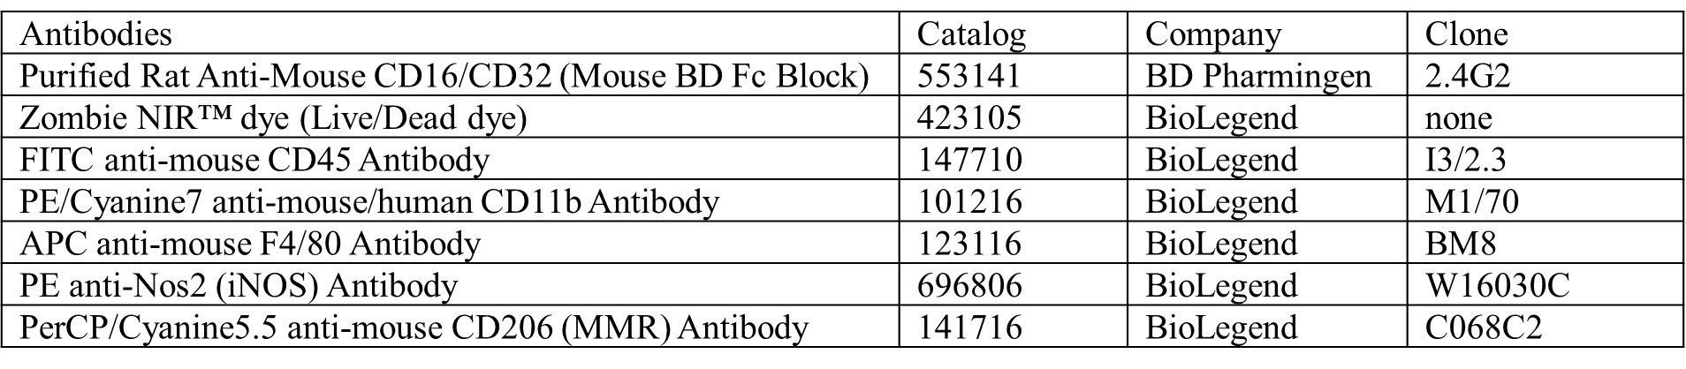
Table S5. The panel of antibodies used for the flow cytometry analysis of macrophage polarization.

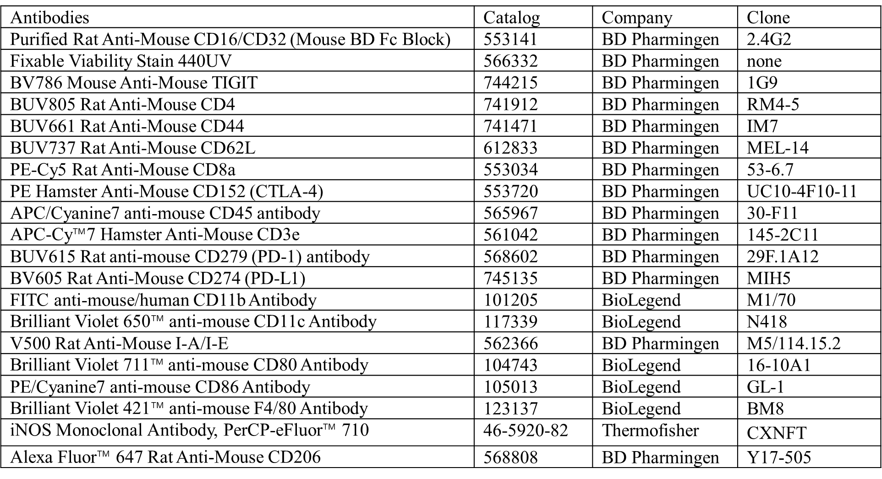
Table S6. The panel of antibodies utilized for multi-parameter spectral flow cytometry analysis.

