Table S1 Primer’s information for mice
Name | Sequence (5'->3')
Col1a1 | Forward primer | GTGGCGGTTATGACTTCAG
Col1a1 | Reverse primer | GCTGCGGATGTTCTCAATC
Col3a1 | Forward primer | CCTGCTCCTGTGCTTCCTGATG
Col3a1 | Reverse primer | GCCACCAGTTGGACATGATTCAC
Mmp2 | Forward primer | CCGAGACCGCTATGTCCACTGT
Mmp2 | Reverse primer | CACACCACACCTTGCCATCGTT
Mmp9 | Forward primer | CGCCACCACAGCCAACTATGAC
Mmp9 | Reverse primer | CCGTCGCTGGTACAGGAAGAGT
Tgfb1 | Forward primer | GCAACAATTCCTGGCGTTACC
Tgfb1 | Reverse primer | CCTGTATTCCGTCTCCTTGGTT
Tgfb2 | Forward primer | AGCAGCGGATTGAACTGTATC
Tgfb2 | Reverse primer | AATTATTAGACGGCACGAAGGT
Tgfbr1 | Forward primer | CATAACCGCACTGTCATTCAC
Tgfbr1 | Reverse primer | TAACACAATGGTCCTGGCAAT
Tgfbr2 | Forward primer | ATCTTCTACTGCTACCGTGTC
Tgfbr2 | Reverse primer | CGTGTTGTGGTTGATGTTGT
Il1a | Forward primer | CTGAAGAAGAGACGGCTGAGT
Il1a | Reverse primer | CTGGTAGGTGTAAGGTGCTGAT
Il1b | Forward primer | ACTACAGGCTCCGAGATGAACA
Il1b | Reverse primer | TTGTCGTTGCTTGGTTCTCCTT
Il6 | Forward primer | GGAGAGGAGACTTCACAGAGGA
Il6 | Reverse primer | GCAAGTGCATCATCGTTGTTCA
Cxcl15 | Forward primer | TGCTGGCTGTCCTTAACCTA
Cxcl15 | Reverse primer | ACTGCTATCACTTCCTTTCTGT
Il10 | Forward primer | GGTTGCCAAGCCTTATCGGAAA
Il10 | Reverse primer | TGCTCCACTGCCTTGCTCTTA
Tnf | Forward primer | CCACCACGCTCTTCTGTCTACT
Tnf | Reverse primer | TGGGCTACAGGCTTGTCACTC
Mmp1a | Forward primer | CCTTGATGAGACGTGGACCAA
Mmp1a | Reverse primer | ATGTGGTGTTGTTGCACCTGT
Mmp3 | Forward primer | GACGATGATGAACGATGGACAG
Mmp3 | Reverse primer | CCTTGGCTGAGTGGTAGAGTC
Gapdh | Forward primer | GTGGCAAAGTGGAGATTGTTG
Gapdh | Reverse primer | CGTTGAATTTGCCGTGAGTG
Table S2 Primer’s information for HFF cell
Name | Sequence (5'->3')
CDH1 | Forward primer | AGACCAAGTGACCACCTTAGAG
CDH1 | Reverse primer | AACAGCAAGAGCAGCAGAATC
CDH2 | Forward primer | AATCAAGTGCCATTAGCCAAGG
CDH2 | Reverse primer | GTCCTGAGCAGTGAATGTTGTC
ACTA2 | Forward primer | GCGTGGCTATTCCTTCGTTA
ACTA2 | Reverse primer | GGCAACTCGTAACTCTTCTCAA
VIM | Forward primer | GCTGCTAACTACCAAGACA
VIM | Reverse primer | CTGTAGGTGGCAATCTCAA
MMP1 | Forward primer | ACATTCACCAAGGTCTCTG
MMP1 | Reverse primer | TTCCTCCAGGTCCATCAA
MMP3 | Forward primer | ACGCCAGCCAACTGTGAT
MMP3 | Reverse primer | CCACGCCTGAAGGAAGAGAT
COL1A1 | Forward primer | GAGGGCCAAGACGAAGACATC
COL1A1 | Reverse primer | CAGATCACGTCATCGCACAAC
COL3A1 | Forward primer | GGATGCTATCAAGGTATTCTG
COL3A1 | Reverse primer | TCAGGAAGTTCAGGATTGC
B2M | Forward primer | ATCCATCCGACATTGAAGT
B2M | Reverse primer | GGCAGGCATACTCATCTT

Table S3. Antibodies for WB
Reagent | Source | Identifier | Batch | Dilution
Anti-COL1A1 Antibody | Huabio | HA722517 | H651517044 | 1:1000
Anti-Collagen III Antibody | Huabio | HA720050 | H651905010 | 1:1000
alpha smooth muscle Actin Rabbit Antibody | Huabio | ET1607-53 | H680612022 | 1:30000
Anti-MMP-3 Antibody | Huabio | ET1705-98 | H650607029 | 1:1000
MMP1 Polyclonal antibody | Proteintech | 10371-2-AP | 00133702 | 1:1000
MMP2 Polyclonal antibody | Proteintech | 10373-2-AP | 00163864 | 1:1000
Vimentin Monoclonal antibody | Proteintech | 60330-1-Ig | 10026732 | 1:30000
E-cadherin Monoclonal antibody | Proteintech | 60902-1-Ig | 10024961 | 1:10000
MMP-9 (N-terminal) Polyclonal antibody | Proteintech | 10375-2-AP | 00140728 | 1:1000
Phospho-NF-κB p65 (Ser468) antibody | Proteintech | 82335-1-RR | 23005077 | 1:5000
NF-κB1 p105/p50 (D4P4D) Rabbit mAb | CST | 13586S | 2 | 1:1000
NF-κB p65 (D14E12) XP Rabbit mAb | CST | 8242T | 16 | 1:1000
N-Cadherin Rabbit mAb | ABclonal | A19083 | 4000000371 | 1:1000
Anti-GAPDH Antibody | Huabio | ET1601-4 | H650617029 | 1:50000
HRP Conjugated Goat anti-Rabbit | Huabio | HA1001 | H641608002 | 1:50000
HRP Conjugated Goat anti-Mouse | Huabio | HA1006 | H650100002 | 1:50000

Table S4. Antibodies for immunofluorescence
Reagent | Source | Identifier | Batch | Dilution
Anti-COL1A1 Antibody | Huabio | HA722517 | H651517044 | 1:200
Anti-Collagen III Antibody | Huabio | HA720050 | H651905010 | 1:200
Anti-MMP-3 Antibody | Huabio | ET1705-98 | H650607029 | 1:200
MMP-9 Recombinant Mouse Antibody | Huabio | EM1801-22 | HL0929 | 1:200
alpha smooth muscle Actin Rabbit Antibody | Huabio | ET1607-53 | H680612022 | 1:2000
Cortactin Rabbit mAb | ABclonal | A9518 | 4000001613 | 1:400
N-Cadherin Rabbit mAb | ABclonal | A19083 | 4000000371 | 1:200
LYVE1 Monoclonal Antibody (ALY7) | Invitrogen | 14-0443-80 | 2801540 | 1:100
MMP1 Polyclonal antibody | Proteintech | 10371-2-AP | 00133702 | 1:200
Rhodamine–conjugated Goat Anti-Rat | Proteintech | SA00007-7 | 20001201 | 1:100
CoraLite® Plus 488-Goat Anti-Mouse | Proteintech | RGAM002 | 20001275 | 1:500
CoraLite® Plus 647-Goat Anti-Rabbit | Proteintech | RGAR005 | 20001140 | 1:500
CoraLite® Plus 488-Goat Anti-Rabbit | Proteintech | RGAR002 | 20001066 | 1:500

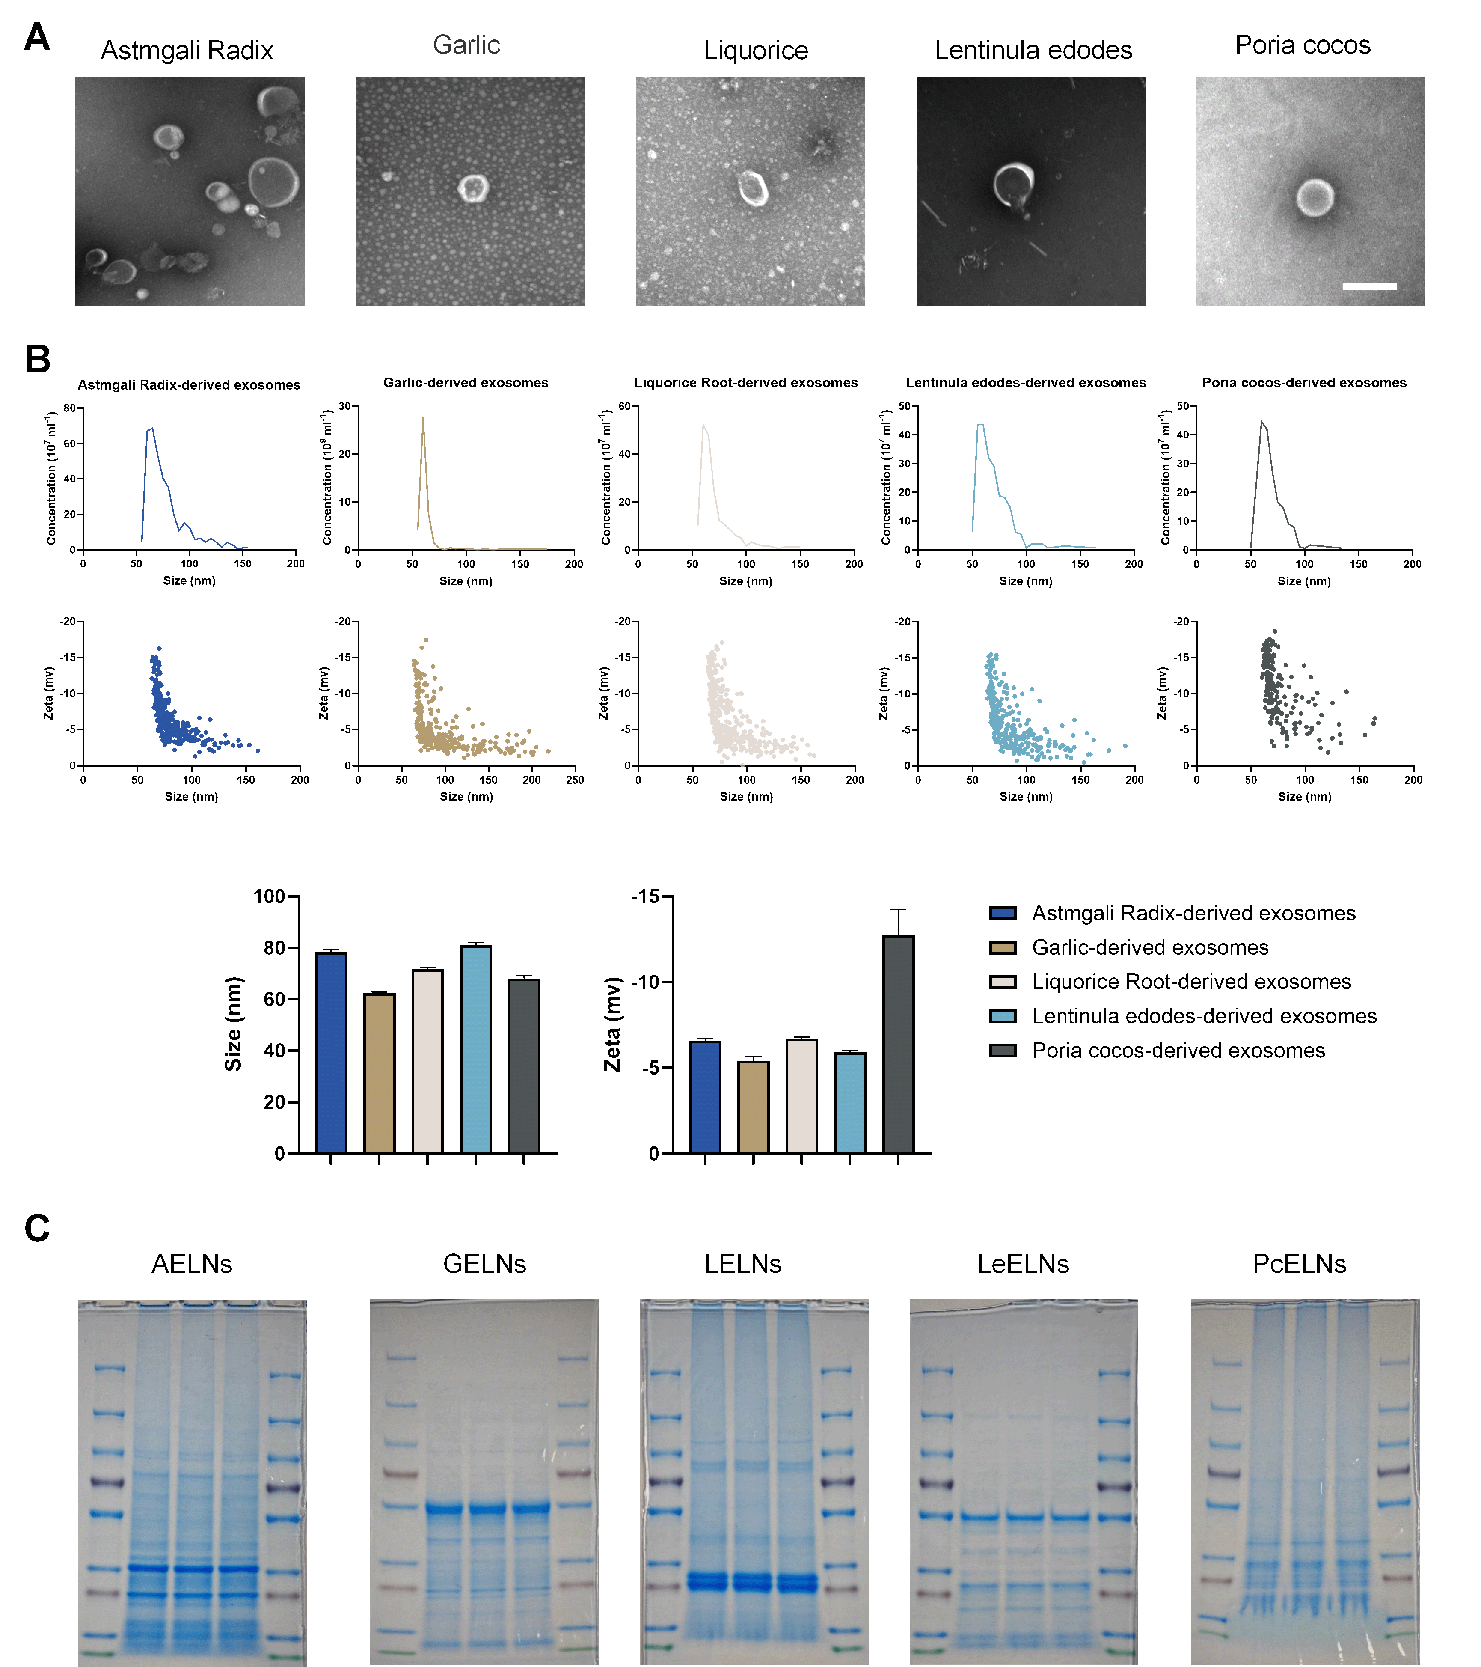
Figure S1. Identification and physicochemical characterization of PELNs. (A) The morphology of Astmgali Radix, Garlic, Liquorice, Lentinula edodes and Poria cocos-Derived Exosome-like Nanoparticles (AELNs, GELNs, LELNs, LeELNs and PcELNs) determined by TEM (scale bar = 200 nm). (B) The particle concentration, size distribution and surface charge of AELNs, GELNs, LELNs, LeELNs and PcELNs were detected by Nanocoulter G (n=3 per each group). (C) Determination of AELNs, GELNs, LELNs, LeELNs and PcELNs proteins by SDS-PAGE. All values are presented as the mean ± SD.

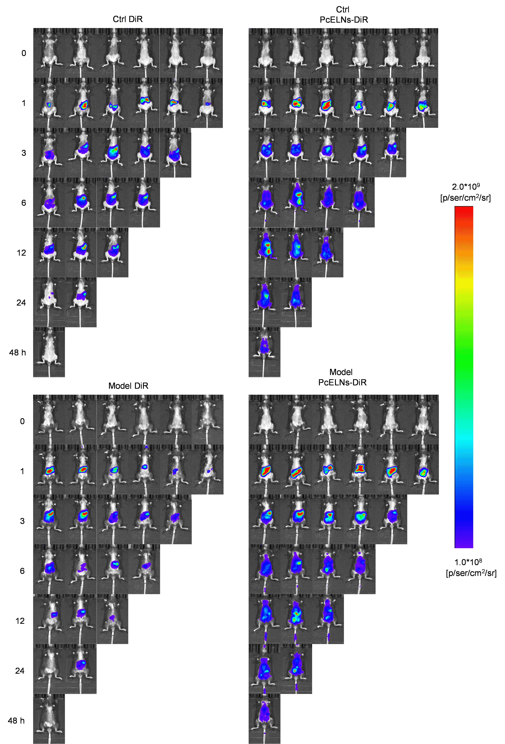
Figure S2. In vivo fluorescence imaging of healthy and lymphedema mice oral gavage with DiR and DiR-loaded PcELNs at different times (0, 1, 3, 6, 12, 24 and 48 h).

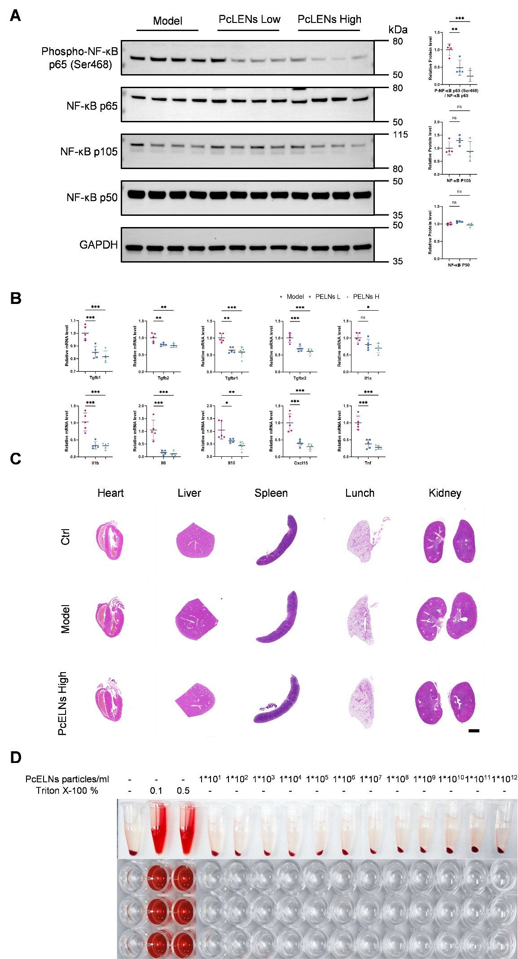
Figure S3. PcELNs anti-inflammatory and safety study (A) Western blot analysis and quantification of key proteins in the NF-κB signaling pathway (n=4 per each group). (B) Quantification of fibrosis and inflammation gene expression in mouse tails 28 days after surgery by qPCR (n=5 per each group). (C) H&E staining of major organs (heart, liver, spleen, lung, kidney) (scale bar = 2000 µm). (D) Haematolysis test of PcELNs. ∗P < 0.05, ∗∗P < 0.01, ∗∗∗P < 0.001. All values are presented as the mean ± SD.

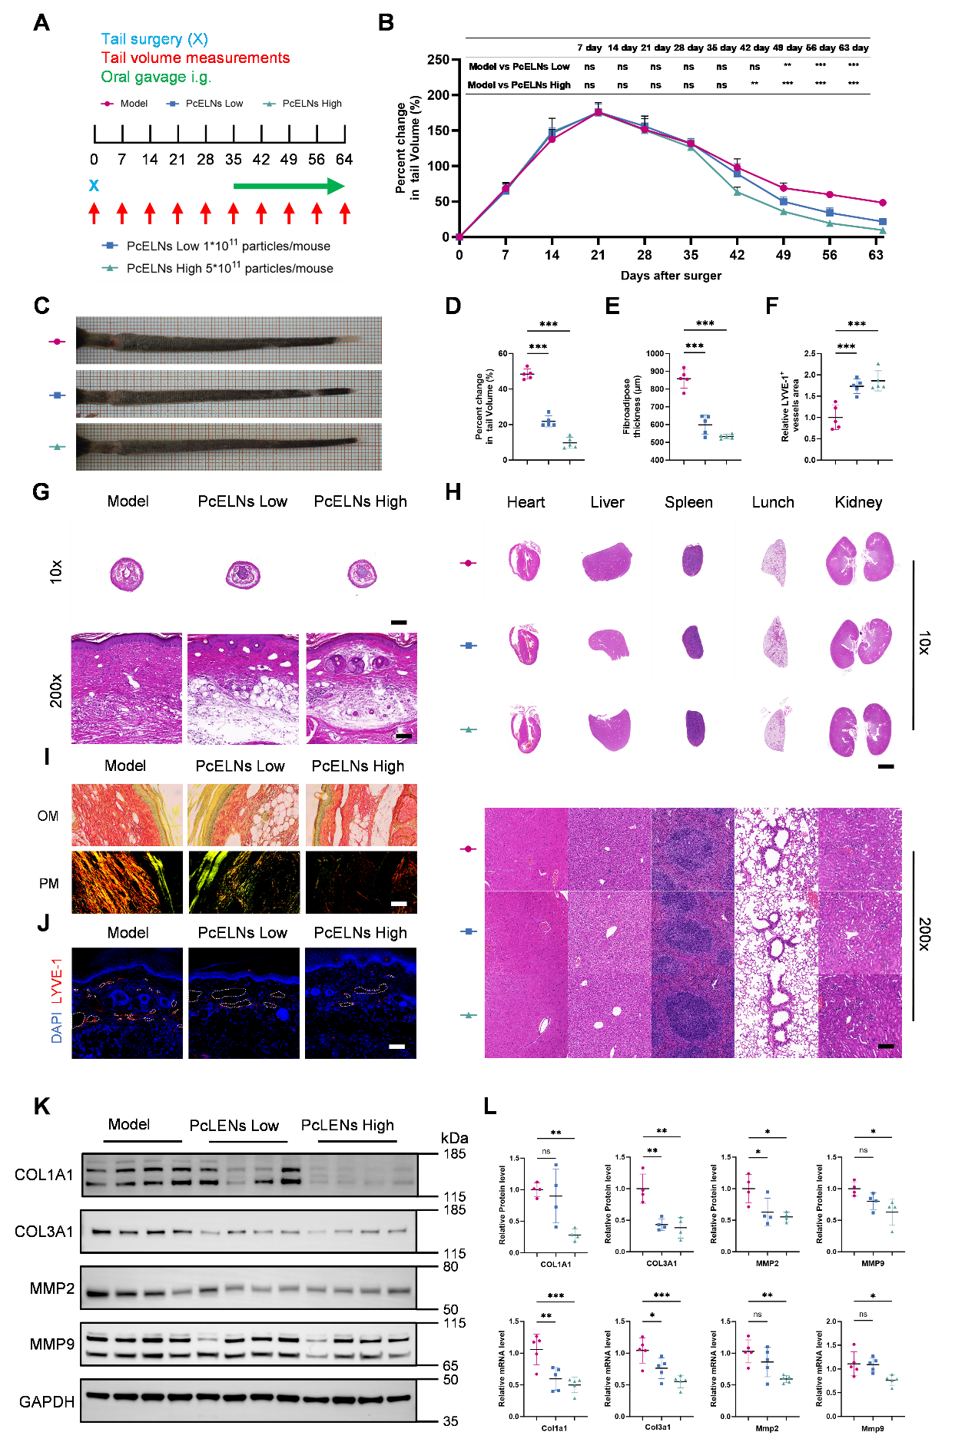
Figure S4. Comparison of the therapeutic effects of different PELNs treatments for chronic lymphedema (A) Schematic diagram of the experimental timeline. (B) Quantitative analysis of percent change in tail volume over time after surgery. Tail volume was measured weekly (n=5 per each group). (C) Representative photographs of tails 63 days after lymphatic surgery. (D) Quantification of tail volume changes over time of each group 63 days after lymphatic surgery (n=5 per each group). (E) Thickness of the subcutaneous tissues measured based on the H&E staining images (n=5 per each group). (F) Quantification of the LYVE1 area data (n=5 per each group). (G) Hematoxylin and eosin staining of tail cross-section 63 days after lymphatic surgery (scale bar: 10x = 2000 µm; 200x = 100 µm). (H) H&E staining of major organs (heart, liver, spleen, lung, kidney) (scale bar: 10x = 2000 µm; 200x = 100 µm). (I) Sirius Red of tail cross-section 63 days after lymphatic surgery (scale bar = 200 nm). (J) Immunofluorescent images of LYVE1 (red) of tail skins 63 days after surgery (scale bar = 100 µm). (K) Detection of lymphedema-related proteins 63 days after mouse tail surgery by Western blot. (L) Quantification of lymphedema-associated protein and gene expression in mouse tails 63 days post-surgery by Western blot and qPCR (for Western blot n=4 per each group, for qPCR n=5 per each group). ∗P < 0.05, ∗∗P < 0.01, ∗∗∗P < 0.001. All values are presented as the mean ± SD.

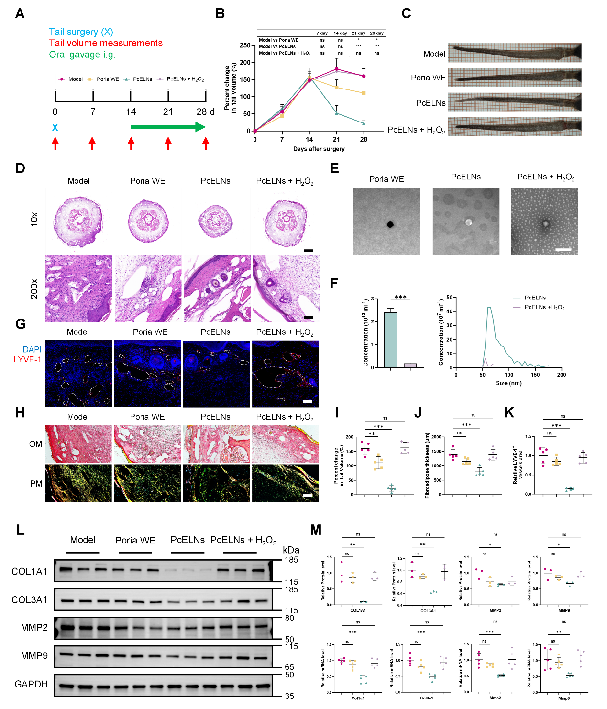
Figure S5. Comparison of the efficacy of Poria Water Extract (Poria WE), PcELNs, and membrane-broken PcELNs products in the treatment of lymphedema (A) Schematic diagram of different group treatments (B) The degree of lymphedema by charting percent changes in the tail volume of each group over 28 days. Tail volume was measured weekly (n=5 per each group). (C) Representative photographs of tails 28 days after lymphatic surgery. (D) Hematoxylin and eosin staining of tail cross-section 28 days after lymphatic surgery (scale bar: 10x = 2000 µm; 200x = 100 µm). (E) The morphology of Poria WE, PcLENs, PcELNs + H₂O₂ determined by TEM (scale bar = 200 nm). (F) The particle concentration and size distribution of PcLENs, PcELNs + H₂O₂ were detected by Nanocoulter G (n=3 per each group). (G) Immunofluorescent images of LYVE1 (red) of tail skins 28 days after surgery (scale bar = 100 µm). (H) Sirius Red of tail cross-section 28 days after lymphatic surgery (scale bar = 200 nm). (I) Quantification of tail volume changes over time of each group 28 days after lymphatic surgery (n=5 per each group). (J) Thickness of the subcutaneous tissues measured based on the H&E staining images (n=5 per each group). (K) Quantification of the LYVE1 area data (n=5 per each group). (L) Detection of lymphedema-related proteins 28 days after mouse tail surgery by Western blot. (M) Quantification of lymphedema-associated protein and gene expression in mouse tails 28 days post-surgery by Western blot (n=3 per each group) and qPCR (n=5 per each group). ∗P < 0.05, ∗∗P < 0.01, ∗∗∗P < 0.001. All values are presented as the mean ± SD.

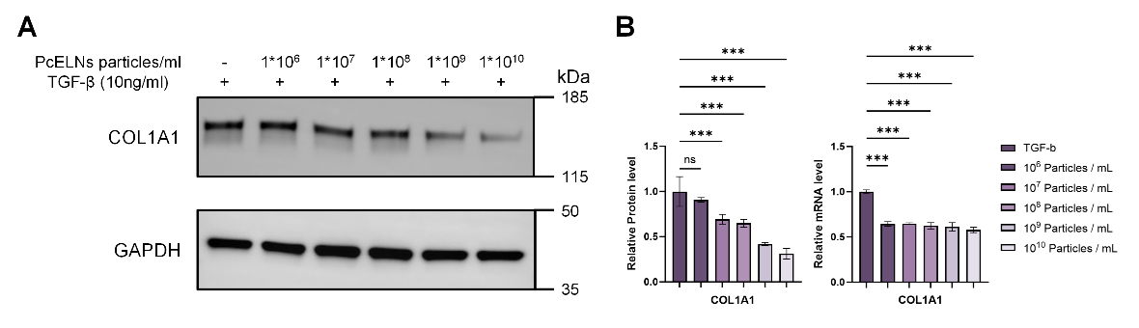
Figure S6. Determination of the dosage of PcELNs for HFF (A) Western blot analysis of COL1A1 protein expression in HFF cells treated with TGF-β (10 ng/ml) for 72 hours, followed by treatment with different concentrations of PcELNs (ranging from 1×10⁶ to 1×10¹⁰ particles/ml) for another 72 hours. (B) Quantification of COL1A1 protein and gene expression in HFF cells treated with TGF-β (10 ng/ml) for 72 hours, followed by treatment with different concentrations of PcELNs (ranging from 1×10⁶ to 1×10¹⁰ particles/ml) for another 72 hours (n=3 per each group). ∗P < 0.05, ∗∗P < 0.01, ∗∗∗P < 0.001. All values are presented as the mean ± SD.

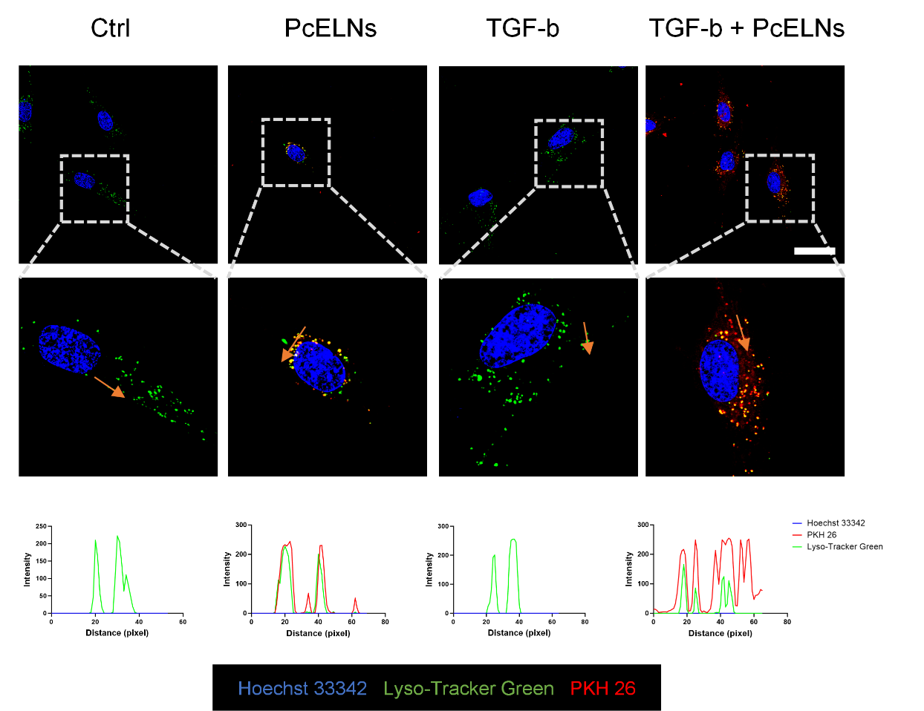
Figure S7. Representative confocal images of PcELNs colocalized with lysosomes 24 hours after uptake in different gropes (red: PKH 26, blue: Hoechst 33342, green: Lyso-Tracker Green, scale bar = 25 μm).

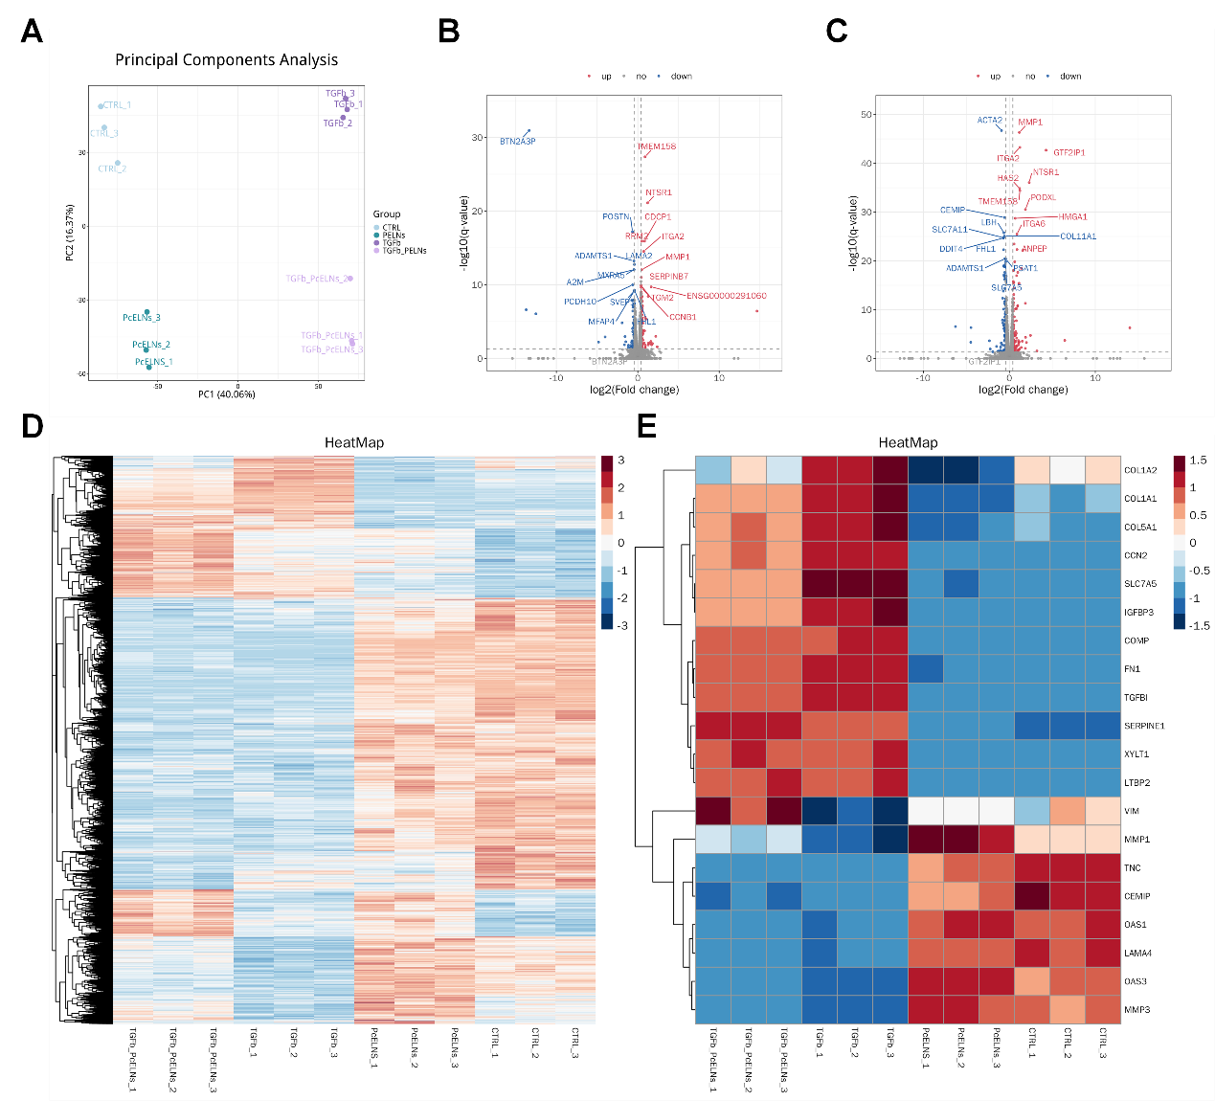
Figure S8. Bioinformatics analysis reveals distinct transcriptomic profiles and identifies differentially expressed genes. (A) Principal component analysis (PCA) plot showing the distribution and clustering of samples based on global gene expression patterns. (B) Volcano plot of differentially expressed genes (DEGs) in PcELNs-treated group versus Control group (PcELNs vs Ctrl). Red dots denote significantly upregulated genes (adjusted P value < 0.05 and log2 fold change > 0.5), blue dots denote significantly downregulated genes. The top 10 most significantly DEGs are labeled. (C) Volcano plot of DEGs in TGF-β + PcELNs co-treated group versus TGF-β alone group (TGF-β vs TGF-β + PcELNs). The top 10 most significantly DEGs are annotated, highlighting key expression changes induced by PcELNs in a pro-fibrotic context (adjusted P value < 0.05 and log2 fold change > 0.5). (D) Heatmap depicting the expression patterns of a broad set of DEGs across all sample groups. Each row represents a gene, each column represents a sample. Color key indicates Z-score of normalized expression. (E) Focused heatmap displaying the expression levels of the top 20 DEGs (enriched) from each of the four comparison groups, providing a consolidated view of key transcriptional changes.

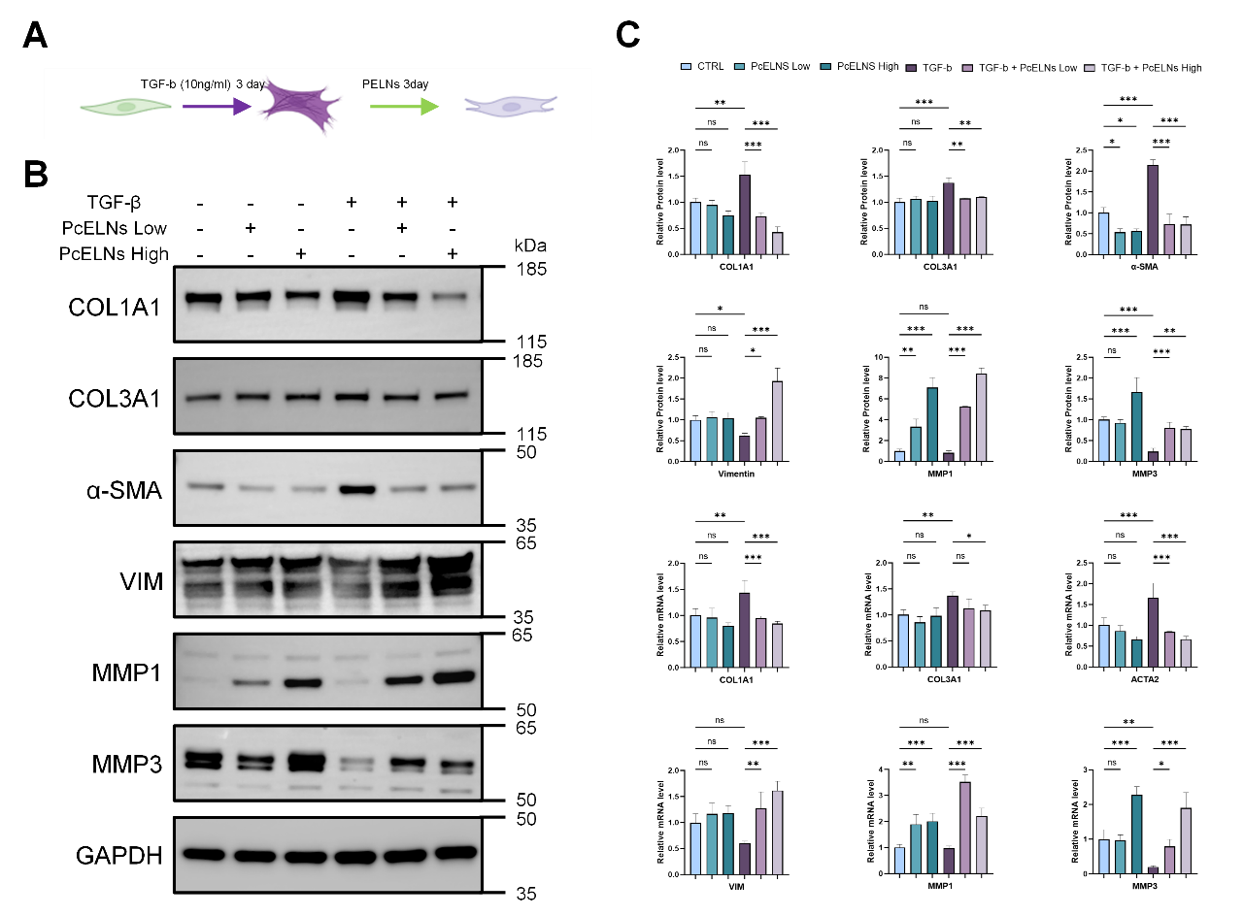
Figure S9. PcELNs inhibit the TGF-β-induced myofibroblast transformation and promote a matrix-remodeling phenotype in HFF cells. (A) Schematic illustration of the experimental timeline. HFF cells were first treated with TGF-β (10 ng/mL) for 3 days to induce myofibroblast transformation, followed by co-treatment with either low or high doses of PcELNs for an additional 3 days. (B) Western blot analysis of myofibroblast markers (α-SMA), EMT markers (VIM), extracellular matrix components (COL1A1, COL3A1) and collagen degradation (MMP1, MMP3). (C) Quantification of myofibroblast markers (α-SMA), EMT markers (VIM), extracellular matrix components (COL1A1, COL3A1) and collagen degradation (MMP1, MMP3) at the protein and transcription levels (n=4 per each group). ∗P < 0.05, ∗∗P < 0.01, ∗∗∗P < 0.001. All values are presented as the mean ± SD.

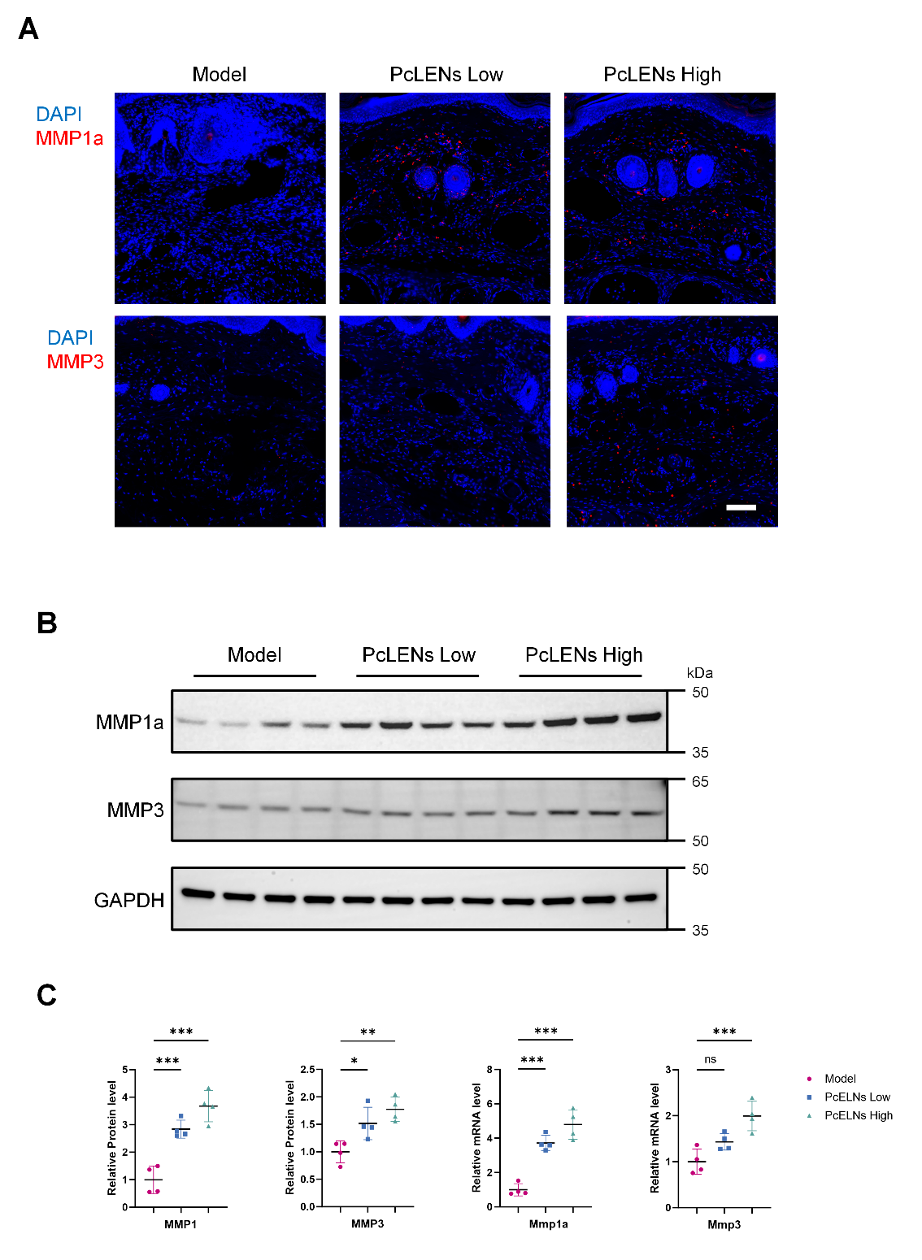
Figure S10. PcELNs ameliorate acute lymphedema by upregulating matrix metalloproteinase expression in mouse model. (A) Representative immunofluorescence images of tissue sections from the Model, PcELNs Low-dose, and PcELNs High-dose groups (blue: DAPI, red: MMP1a or MMP3, Scale bar = 100 µm). (B) Western blot analysis of collagen degradation (MMP1a, MMP3). (C) Quantification of collagen degradation (MMP1a, MMP3) at the protein and transcription levels (n=4 per each group). ∗P < 0.05, ∗∗P < 0.01, ∗∗∗P < 0.001. All values are presented as the mean ± SD.

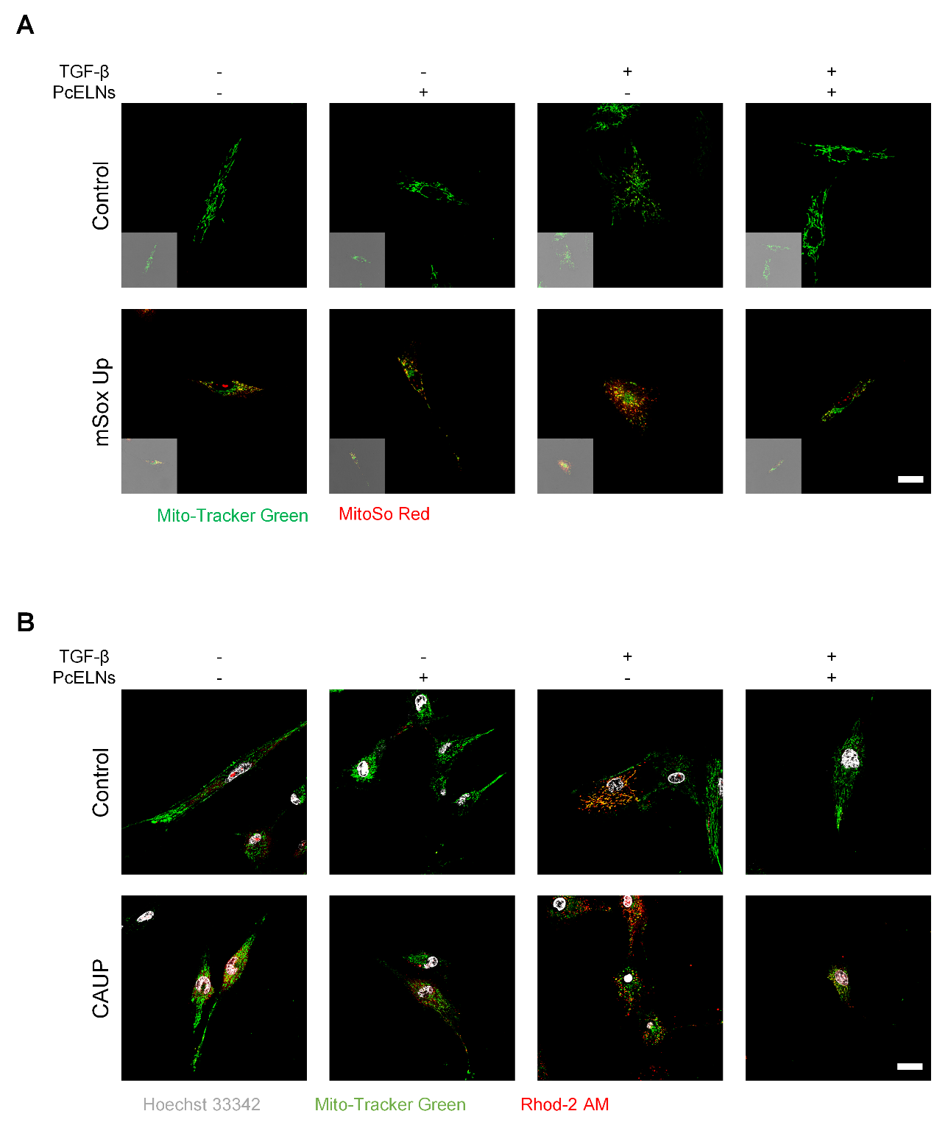
Figure S11. PcELNs induce mitochondrial changes in HFF cells. (A) Representative confocal images of mitochondrial superoxide in HFF cells from each treatment group, with an inset showing the bright-field image (red: MitoSo Red, Green: Mito-Tracker Green, Scale bar = 25 µm). (B) Representative confocal images of mitochondrial calcium in HFF cells of each treatment group (white: Hoechst 33342, red: Rhod-2 AM, Green: Mito-Tracker Green, Scale bar = 25 µm).

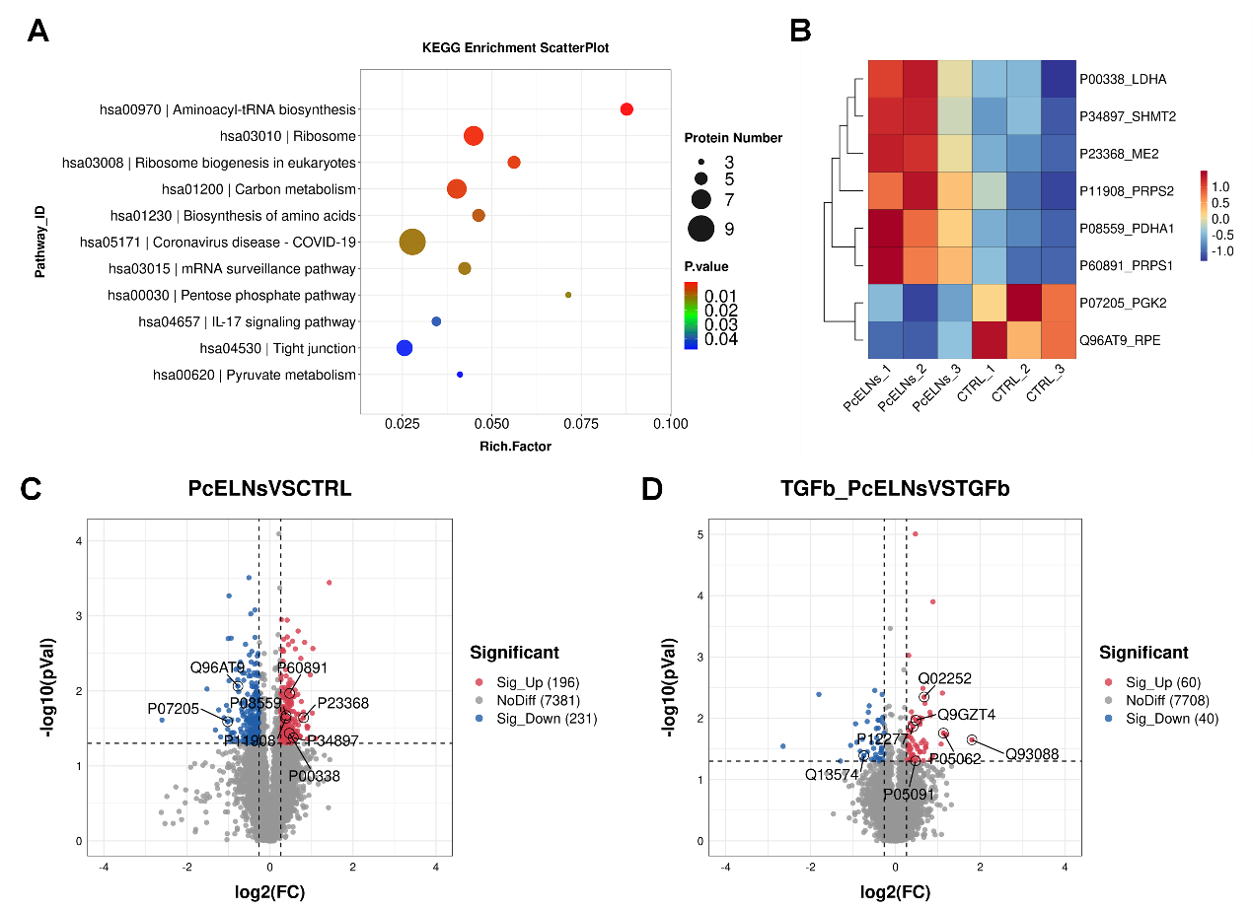
Figure S12. PcELNs induce mitochondrial changes in HFF cells. (A) KEGG pathway enrichment analysis (top 10) of proteomic data from the same comparison (PcELNs vs Ctrl). (B) The heatmap shows the protein expression levels in the metabolic pathways identified in the enriched pathways in (A). (C) Volcano plot of differentially expressed genes/proteins in PcELNs-treated group versus Control group. (D) Volcano plot of differentially expressed genes/proteins in TGF-β + PcELNs co-treated group versus TGF-β alone group.

