<Supporting Information>
Improving Wound Healing Function and Storage Stability of Stem Cell-Derived Extracellular Vesicles via Lyophilized Hyaluronic Acid Formulation

Van Dat Bui ^{1,2†}, Van Hieu Duong ^{1†}, Dong Gil You ^{3†}, Won Ho Jang ¹, Jungmi Lee ¹, Jae Yoon An ¹, Seunglee Kwon ^{1,*}, Jae Hyung Park ^{1,4,5,*}

¹ School of Chemical Engineering, College of Engineering, Sungkyunkwan University (SKKU), Suwon 16419, Republic of Korea
² Vinmec Research Institute of Stem Cell and Gene Technology, College of Health Sciences, VinUniversity, Vinhomes Ocean Park, Gia Lam, Hanoi 1310, Vietnam
³ Department of Chemical Engineering and Biotechnology, Tech University of Korea, Siheung 15073, Republic of Korea
⁴ Department of Health Sciences and Technology, SAIHST, Sungkyunkwan University, Suwon 16419, Republic of Korea
⁵ Biomedical Institute for Convergence at SKKU (BICS), Sungkyunkwan University, Suwon 16419, Republic of Korea

†Van Dat Bui, Hieu Duong Van, and Dong Gil You contributed equally to this study.
* Corresponding author.

CONTACT: Prof. Jae Hyung Park (jhpark1@skku.edu), School of Chemical Engineering, College of Engineering, Sungkyunkwan University (SKKU), Suwon 16419, Republic of Korea

Western Blotting
To evaluate the expression of CD9 and CD44 in ADSC-EV, EV samples were concentrated using a 100 kDa Amicon Ultra-0.5 centrifugal filter unit (Merck, Rahway, NJ, USA), followed by lysis in RIPA buffer. Total protein concentration was quantified using a BCA assay. EV samples were separated by electrophoresis on 6% or 12% SDS-PAGE gels. CD44 (1:1000), CD9, and β-actin (1:1000, Cell Signalling Technology, Danvers, MA, USA) were used as primary antibodies, and HRP-conjugated anti-rabbit IgG and anti-mouse IgG (1:1000) were used as secondary antibodies. The membranes were investigated using ChemiDocTM imaging system (BIORAD Laboratories, CA, USA). The protein’s molecular weights were distinguished using a protein ladder (Precision Plus Protein Dual Color Standards; BIORAD Laboratories, CA, USA).

Cryo-EM
HA-EV and bare EV samples were applied onto freshly glow-discharged holey carbon electron microscopy grids (Lacey Carbon, 200 mesh, copper; Electron Microscopy Sciences, Hatfield, PA, USA). The grids were plunge-frozen using a Vitrobot Mark IV (Thermo Fisher Scientific, Waltham, MA, USA) operated at 4 °C and >95% relative humidity, with a blot force of 3 and a blot time of 4 s. Vitrified samples were subsequently imaged using a Krios Cryo-EM system (Thermo Fisher Scientific).

Single EV imaging
To verify HA deposition onto ADSC-derived EVs, the co-localization of HA and EVs was visualized using confocal laser scanning microscopy. To prepare fluorescently labeled HA, 10 mg of HA was dissolved in 5 mL of DIW with stirring for 30 min. Subsequently, 20 μL of Flamma® 675 dichlorotriazine (5 mg/mL in DMSO; BioAct, Incheon, South Korea) was added, and the reaction mixture was stirred at room temperature for 24 h in the dark. The resulting Flamma® 675-labeled HA was purified by dialysis against DIW using a 3.5 kDa molecular weight cutoff membrane for 3 days, followed by lyophilization. For single-EV co-localization analysis, 1 mL of DiO-labeled EVs (4 × 10⁹ particles/mL) was mixed with 1 mL of Flamma® 675-labeled HA (1 mg/mL) and incubated for 30 min at 25 °C. To evaluate CD44 specificity, EVs were pre-incubated with either an anti-CD44 antibody (3578, 1:1000 dilution, Cell Signaling Technology, Danvers, MA, USA) or an anti-CD9 antibody (13174, 1:1000 dilution, non-CD44 control, Cell Signaling Technology) for 12 h at 4 °C prior to incubation with Flamma® 675-labeled HA. Following incubation, 10 μL of each sample was placed onto a glass slide (Paul Marienfeld GmbH & Co. KG, Lauda-Königshofen, Germany), covered with a coverslip (Electron Microscopy Sciences, Hatfield, PA, USA), and sealed using nail polish. EVs were imaged using a confocal laser scanning microscope (TCS SP8 HyVolution, Leica Microsystems CMS GmbH, Germany).

Confocal Microscopy Imaging
To evaluate the lysosomal escape capability of HA-coated EVs, M1 macrophages or senescent dermal fibroblasts were seeded onto confocal dishes at a density of 1 × 10⁵ cells per dish. Cells were then co-incubated with Flamma® 675–labeled HA-EVs for 6 h. After incubation, cells were washed twice with DPBS and subsequently incubated with 0.1 μM LysoTracker™ Green DND-26 (Thermo Fisher Scientific, Waltham, MA, USA) for 1 h. Cells were then washed twice with DPBS, and nuclei were counterstained with Hoechst. Finally, cells were imaged using a confocal laser scanning microscope (TCS SP8 HyVolution, Leica Microsystems CMS GmbH, Germany).

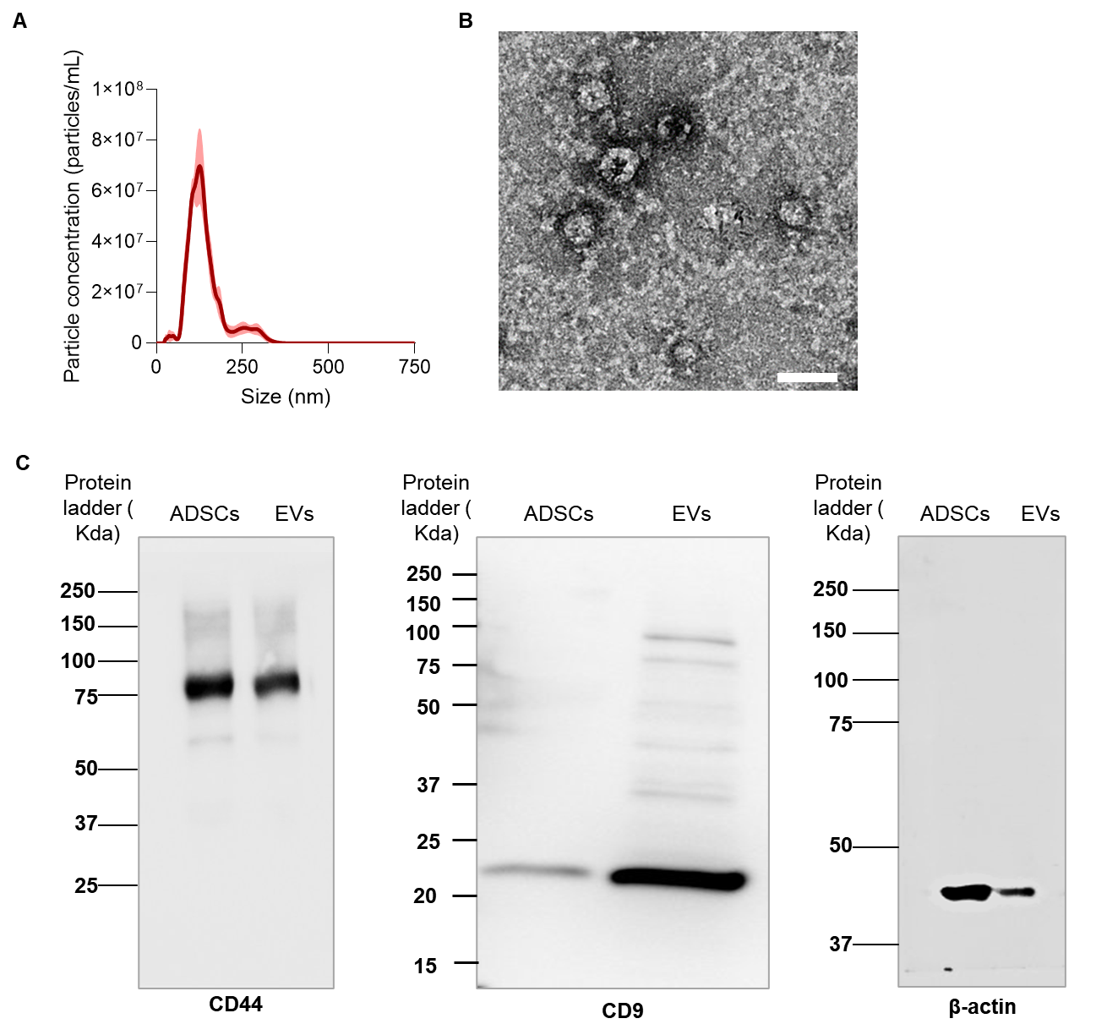

Fig. S1 Characterization of fresh EV. A Size distribution and B TEM image of EVs. The scale bar represents 200 nm. C Western blotting of ADSCs and ADSC-derived EVs.

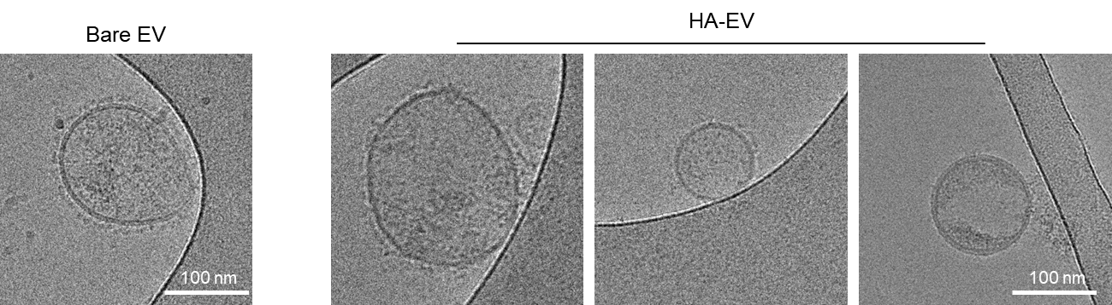
Fig S2 Cryo-EM images of bare EV and HA-EV.

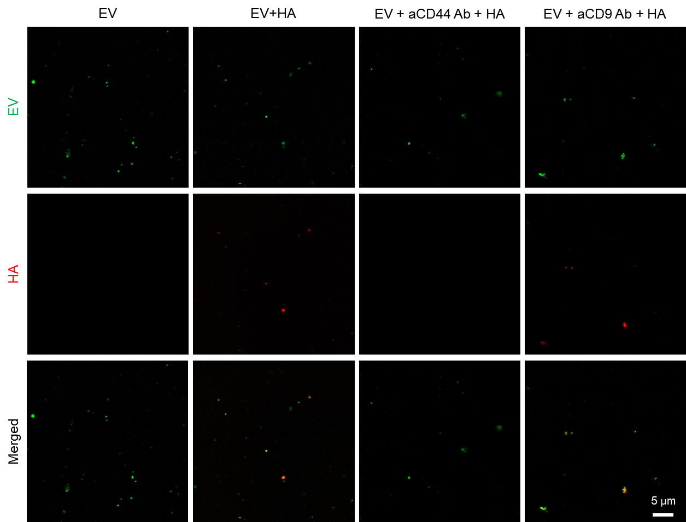
Fig S3 Single–EV–level confocal microscopy analysis of HA binding to EVs.

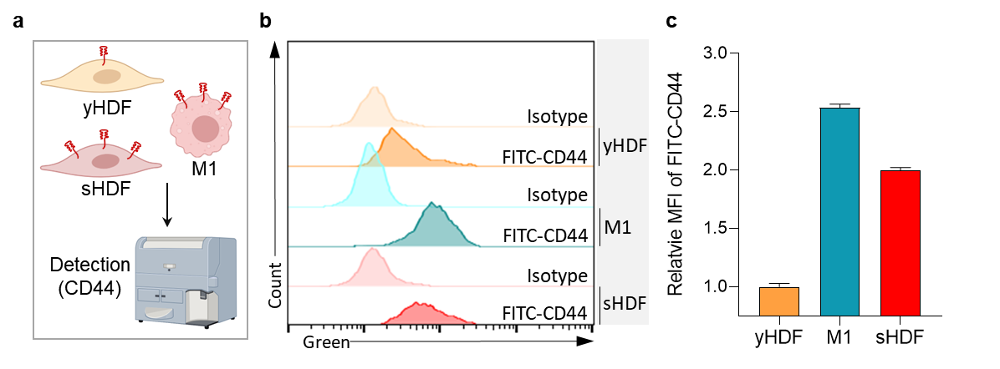
Fig. S4 A Schematics for analyzing CD44-expressing cells. B Flow cytometry of CD44 expression on young HDF (yHDF), M1 macrophage, and senescent HDF (sHDF). C Quantification of CD44 expression from panel B.

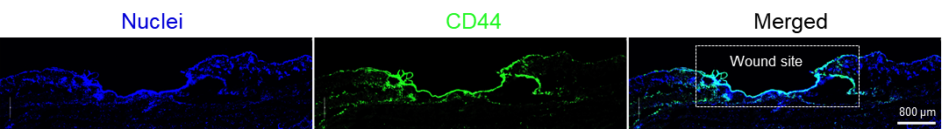
Fig S5 Immunofluorescent staining of CD44 expression in the skin wound.

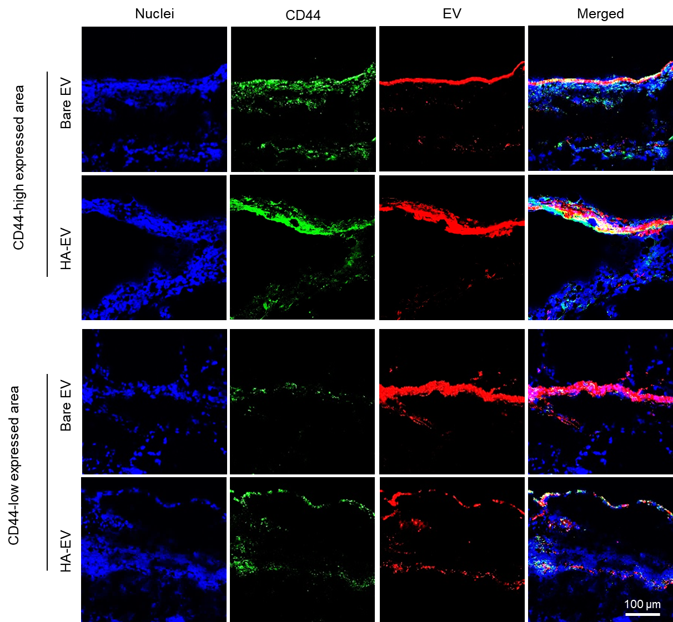
Fig S6 Distribution of CD44 (FITC, green) and EVs (Flamma® 675, red) in the skin of the wound healing mouse models. Cell nuclei were counterstained with DAPI (blue).

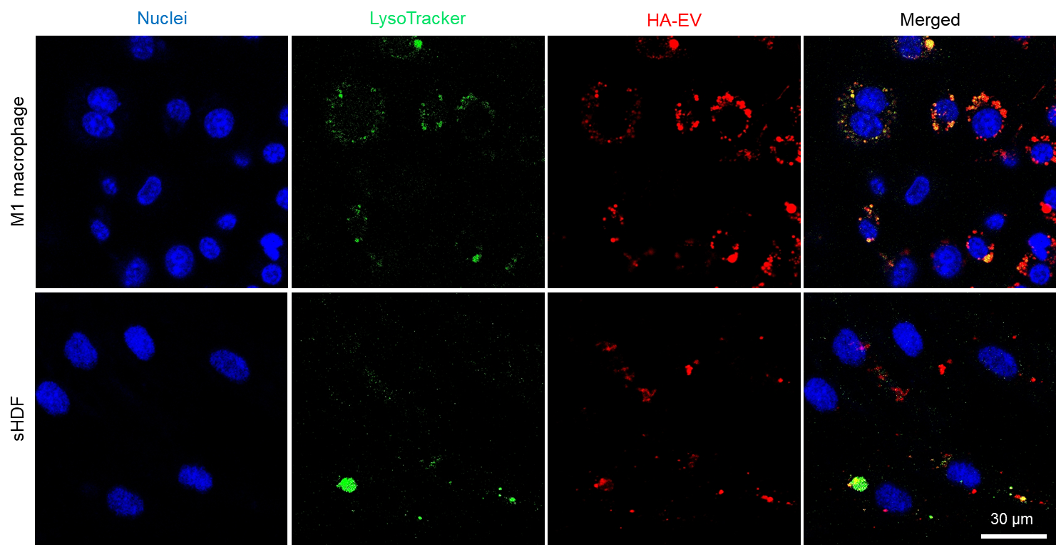
Fig. S7 Confocal microscopy images showing the intracellular localization of Flamma® 675–labeled HA-EVs in M1 macrophages and senescent dermal fibroblasts, co-stained with LysoTracker to visualize lysosomal compartments.

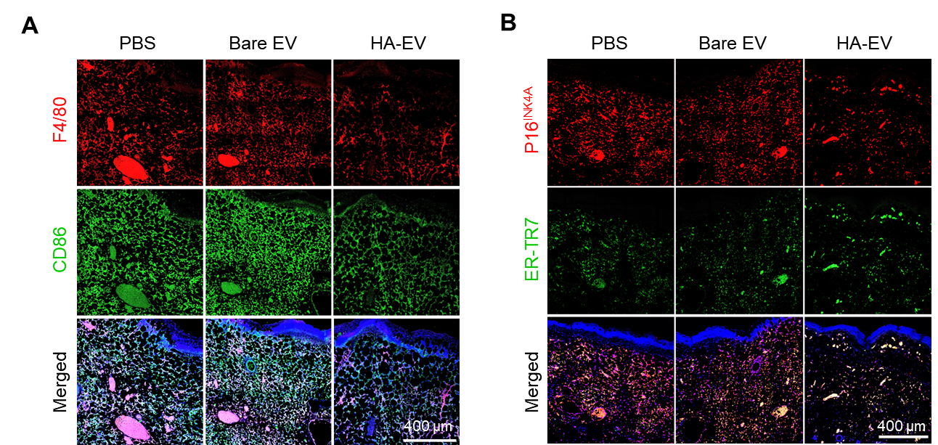
Fig. S8 Confocal microscope images of the wound sites. A For immunohistochemical analysis, the tissue sections were immuno-stained with F4/80 (red) and CD86 (green). B The wound tissues were immuno-stained p16^{INK4A} (red) and ER-TR (green). DAPI (blue) was used as a nuclear counterstain.

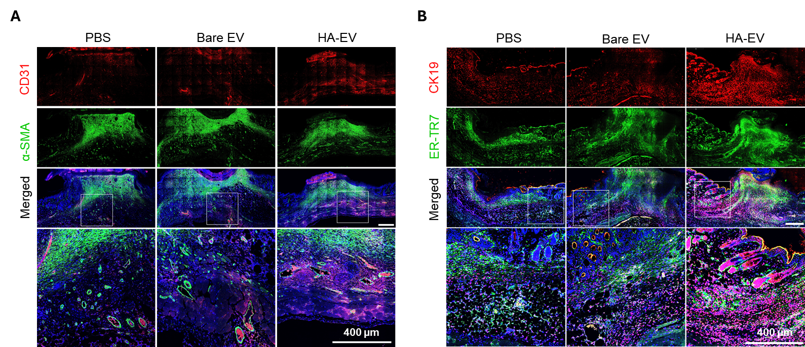
Fig. S9 Immunohistochemical staining of wound sections on day 9 after treatments. A The tissue sections were immuno-stained with CD31 (red) and α-SMA (green). B The wound tissues were immuno-stained with CK19 (red) and ER-TR7 (green). DAPI (blue) was used as a nuclear counterstain.

