Supplementary information

Calcined Lotus leaf-derived carbon dots: enhanced hemostasis, anti-inflammatory, immunomodulatory properties for ulcerative colitis management

Yu Zheng^{a,1}, Jiangcui Liu^{b,1}, Ying Ma ª, Ziting Yang ª, Yunyu Zhang ^{a,c}, Heng Liu ^{b*}, Rui Chen ^{a, c*}
ª School of Pharmacy, Nanjing University of Chinese Medicine, Nanjing 210023, China
^{b} Yunnan Provincial Key Laboratory of Entomological Biopharmaceutical R&D, College of Pharmacy, Dali University, Dali 671000, China
^{c} Jiangsu Province Engineering Research Center of Classical Prescription, Nanjing University of Chinese Medicine, Nanjing 210023, China

¹ These authors contributed equally to this work.
* Corresponding authors.
E-mail addresses: lheng125@dali.edu.cn（Heng Liu）
chenrui@njucm.edu.cn（Rui Chen）

Fig. S1 Powder properties under different conditions of carbon forging, solution images under sunlight and 365 nm ultraviolet light.

450 ℃-1 h
550 ℃-1 h
350 ℃-1 h

450 ℃-2 h
450 ℃-0.5 h

Fig. S2 XPS full spectrum of LLC under different preparation conditions

Fig. S3 UV-Vis spectrum of LLC under different preparation conditions

Fig. S4 FT-IR spectrum of LLC under different preparation conditions
Fig. S5 Analysis of the free radical scavenging ability of LLC under different preparation conditions

Fig. S6 FL spectrum of LLC under different preparation conditions

Fig. S7 Zeta potential of LLC under different preparation conditions

Fig. S8 Carbonization yield (CY) and quantum yield (QY) of LLC under different preparation conditions

Fig. S9 DAI score of day 7,10 and 14

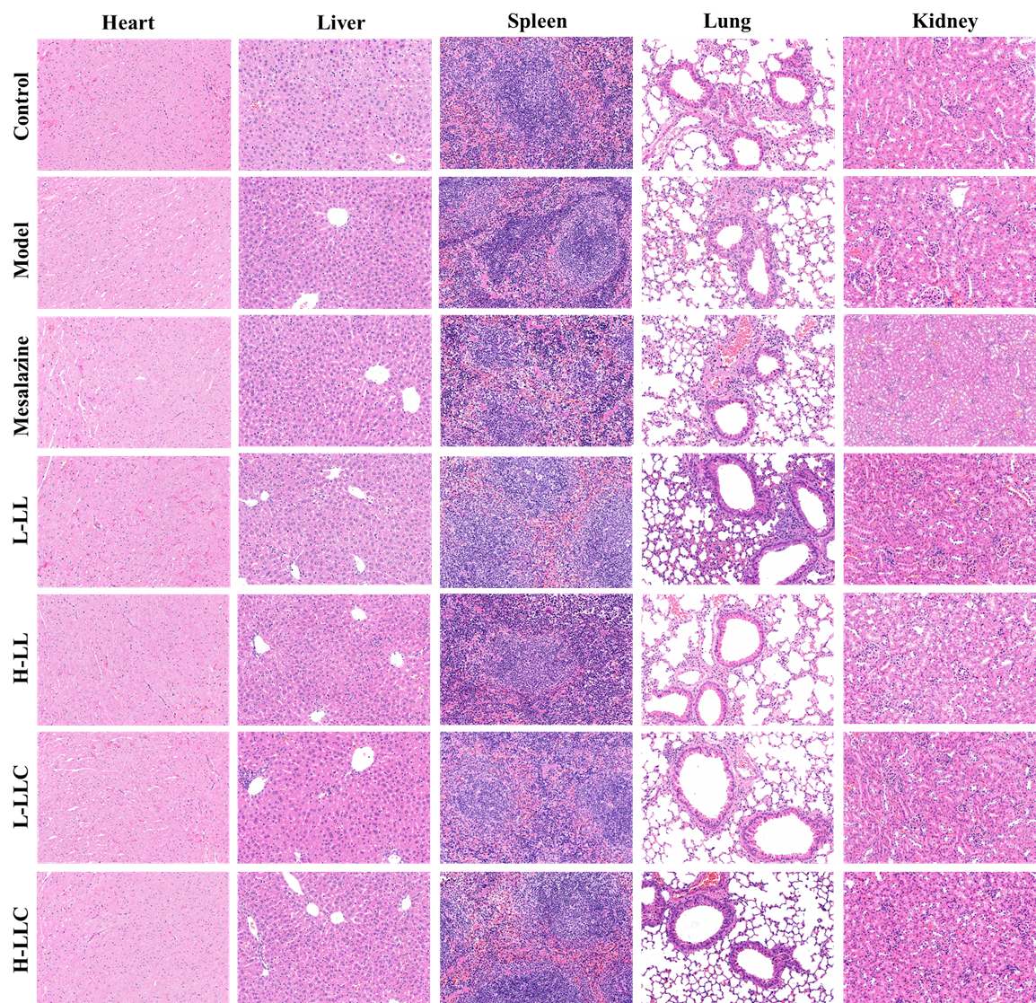
Fig. S10 H&E staining results of heart, liver, spleen, and kidney sections from different administration groups (magnification at 200×).

Fig. S11 Relative abundance of microorganisms in the selected taxon.

Fig. S12 Relative abundance of microorganisms in selected taxonomic genera.

Fig. S13 Relative abundance of microorganisms in selected taxonomic species.

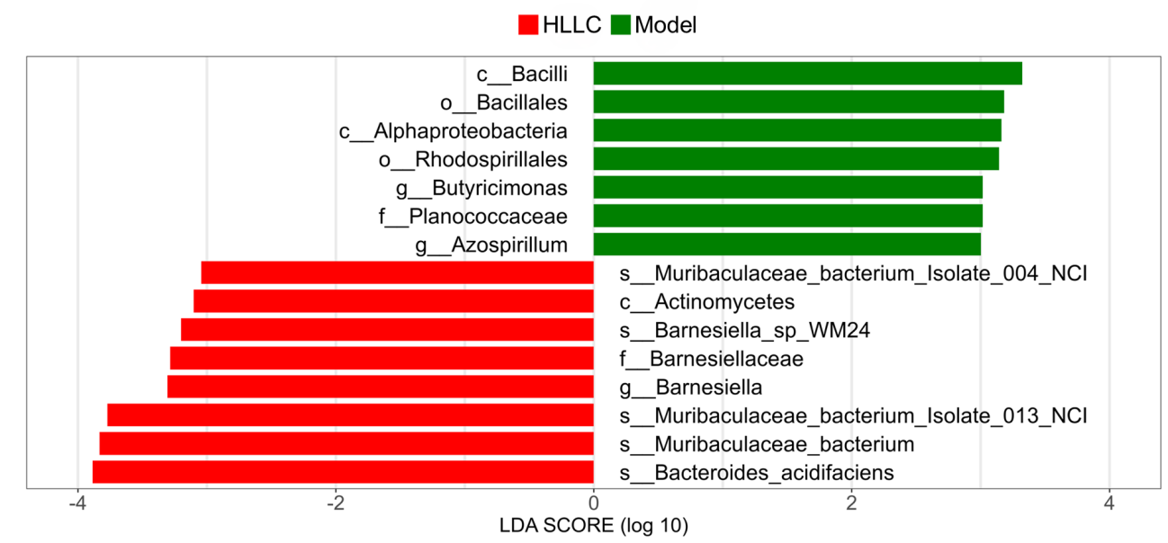
Fig. S14 Difference trend of species in fecal microorganisms of mice in Model group and H-LLC group.

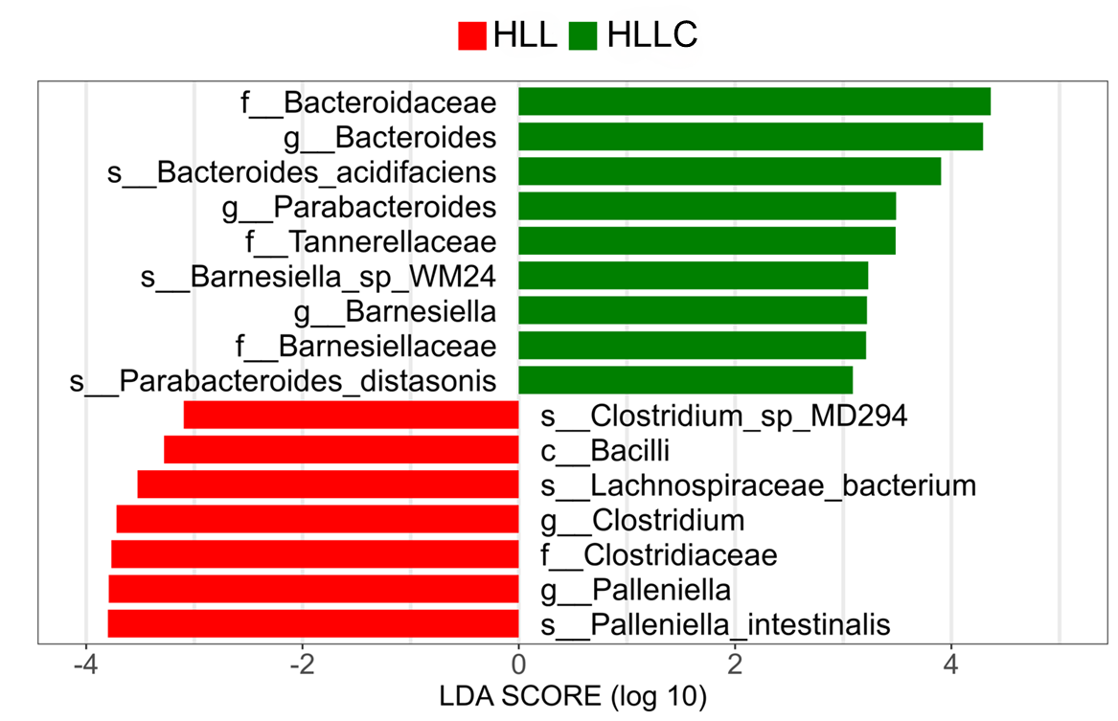
Fig. S15 Difference trend of species in fecal microorganisms of mice in H-LL and H-LLC groups.

Table. S1 Gene primer sequence
PCR primer | Sequence（5' to 3'）
GAPDH F | AGGTCGGTGTGAACGGATTTG
GAPDH R | TGTAGACCATGTAGTTGAGGTCA
NLRP3 F | TCCTCAGCAGCAACCAGAAG
NLRP3 R | TTGTCTCCGAGTGTTGCC
ASC F | AGACATGGGCATACAGGAGC
ASC R | GCAATGAGTGCTTGCCTGTG
Caspase-1 F | GAAAAGCCATGGCCGACAAG
Caspase-1 R | GCTGTCAGAGGTCTTGTGCT
p-NF-κB p65 F | AGACACAGATGATCGCCACC
p-NF-κB p65 R | GGCTTGGGGACAGAAGTTGA

