Supporting Information

Multi-functional self-powered nanofiber conduit for peripheral nerve regeneration and muscle atrophy prevention

Renjie Tan,^{1,2} Ke Zhang,² Yifan Si,⁴ Kaisong Huang,² Weibin Jia,⁵ Min Li,² Saira Iqbal,² Shuai Zhang,² Zhenya Zhai,^{1,3,*} Jinlian Hu^{2,∗}

Supporting Information Includes:
Supplementary note 1. Materials characterization.
Supplementary note 2. NFM biocompatibility assessment.
Supplementary note 3. Absorbance-concentration relationship curve.
Supplementary note 4. Analysis of gait behavior following peripheral nerve repair utilizing PCLG-D nanofiber nerve conduit.
Supplementary note 5. Plasma drug concentration-time curve in mice during daily activity and exercise stimulation.
Supplementary note 6. Hematological analysis of PCLG-D nanofiber nerve conduit in vivo.
Supplementary note 7. The linear correlation among applied external force, self-powering output and drug release rate in PPy/D nanoparticles.
Supplementary note 8. qPCR test of neurodevelopmental-related genes and the anti-superoxide effect of aspirin/lysine.

Figure. S1. The particle size distribution of PPy/D nanoparticles.
Figure. S2. Nanofiber nerve conduit hydrophilic/hydrophobic characterization.
Figure. S3. Nanofiber nerve conduit cytocompatibility.
Figure. S4. The conductivity of PCLG-D nanofiber nerve conduit.
Figure. S5. Absorbance-concentration relationship curve for aspirin/lysine.
Figure. S6. Analysis of gait behavior following peripheral nerve repair utilizing PCLG-D nanofiber nerve conduit.
Figure S7. Plasma drug concentration-time curve in mice during daily activity and exercise stimulation.
Figure. S8. Hematological analysis.
Figure. S9. The linear correlation among applied external force, self-powering output and drug release rate in PPy/D nanoparticles.
Figure. S10. qPCR test of neurodevelopmental-related genes.
Figure. S11. DHE staining for detecting superoxide levels in C2C12 cells.
Figure. S12. Kanehisa laboratories. KEGG Pathway.

Table S1. Primer sequence used for fluorescent quantitative PCR.
Table S2. The quantification data of drug release by time.

Reference
Supplementary note 1. Materials characterization
The particle size of PPy/D nanoparticles was analyzed using ImageJ from SEM images taken
with Thermo Scientific Quattro ESEM (Figure S1a,b) and ARL X’TRA Companion Benchtop
XRD instrument was used to detect the components of PPy/D nanoparticles (Figure S1c-e). The
Hydrophilic/hydrophobic characterization was detected with Dataphysics Contact Angle Tester
(Figure S2), while CH1760e Electrochemical Workstation was used to test the conductivity of
PCLG-D NFM (wet) (Figure S4).
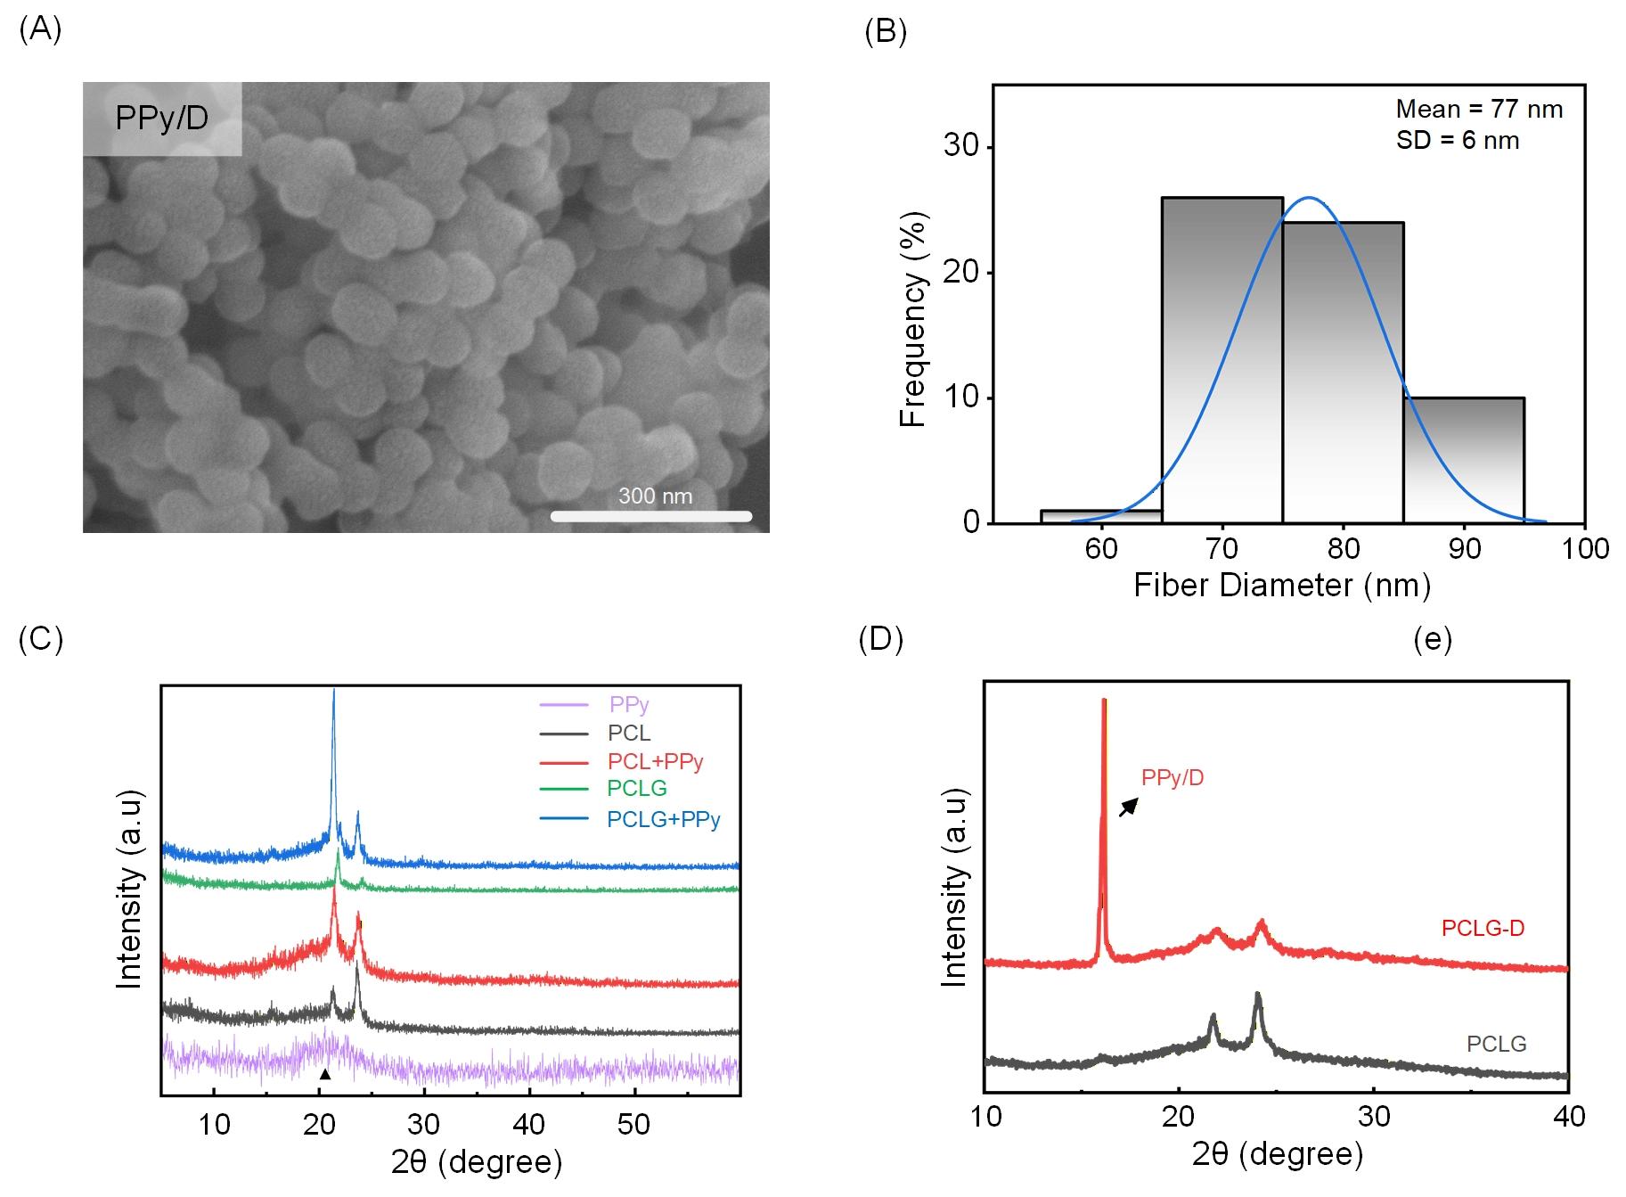
Figure. S1. The particle size distribution and XRD peaks of PPy/D nanoparticles. (a,b) The particle size of PPy/D nanoparticles. (c,d) XRD peaks of PPy and PPy/D nanoparticles.

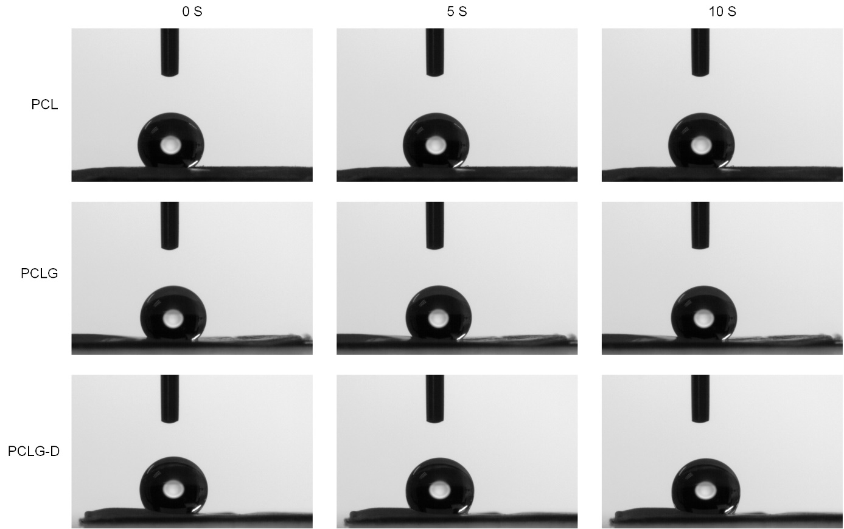
Figure. S2. Nanofiber nerve conduit hydrophilic/hydrophobic characterization.

Supplementary note 2. NFM biocompatibility assessment
The biocompatibility of PCLG-D NFM was evaluated by culturing NIH3T3 cells with its eluate
for seven days. Cell viability was tested using Calcein AM/PI staining (Leica TCS SP8confocal
microscope) and flow cytometry (BD Biosciences benchtop cytometer) (Figure S3a-c) on fifth
day. Cell viability was also tested using CCK-8 method on seventh day (Figure S3g). Moreover,
PCLG-D NFM was implanted into GAS muscles of normal mice for eight weeks, the muscles
were harvested for immunofluorescence detection of inflammatory cytokines (Leica TCS SP8
MP Confocal Micro-scope) (Figure S3d-f).
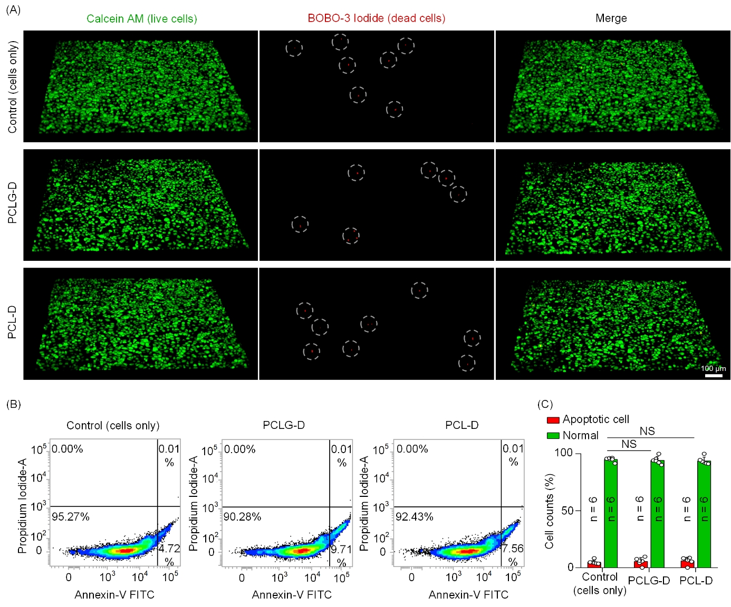
Figure. S3. Nanofiber nerve conduit cytocompatibility. (a) Calcein/PI staining assessment. (b,c) Flow cytometry test. NS represents no significance.

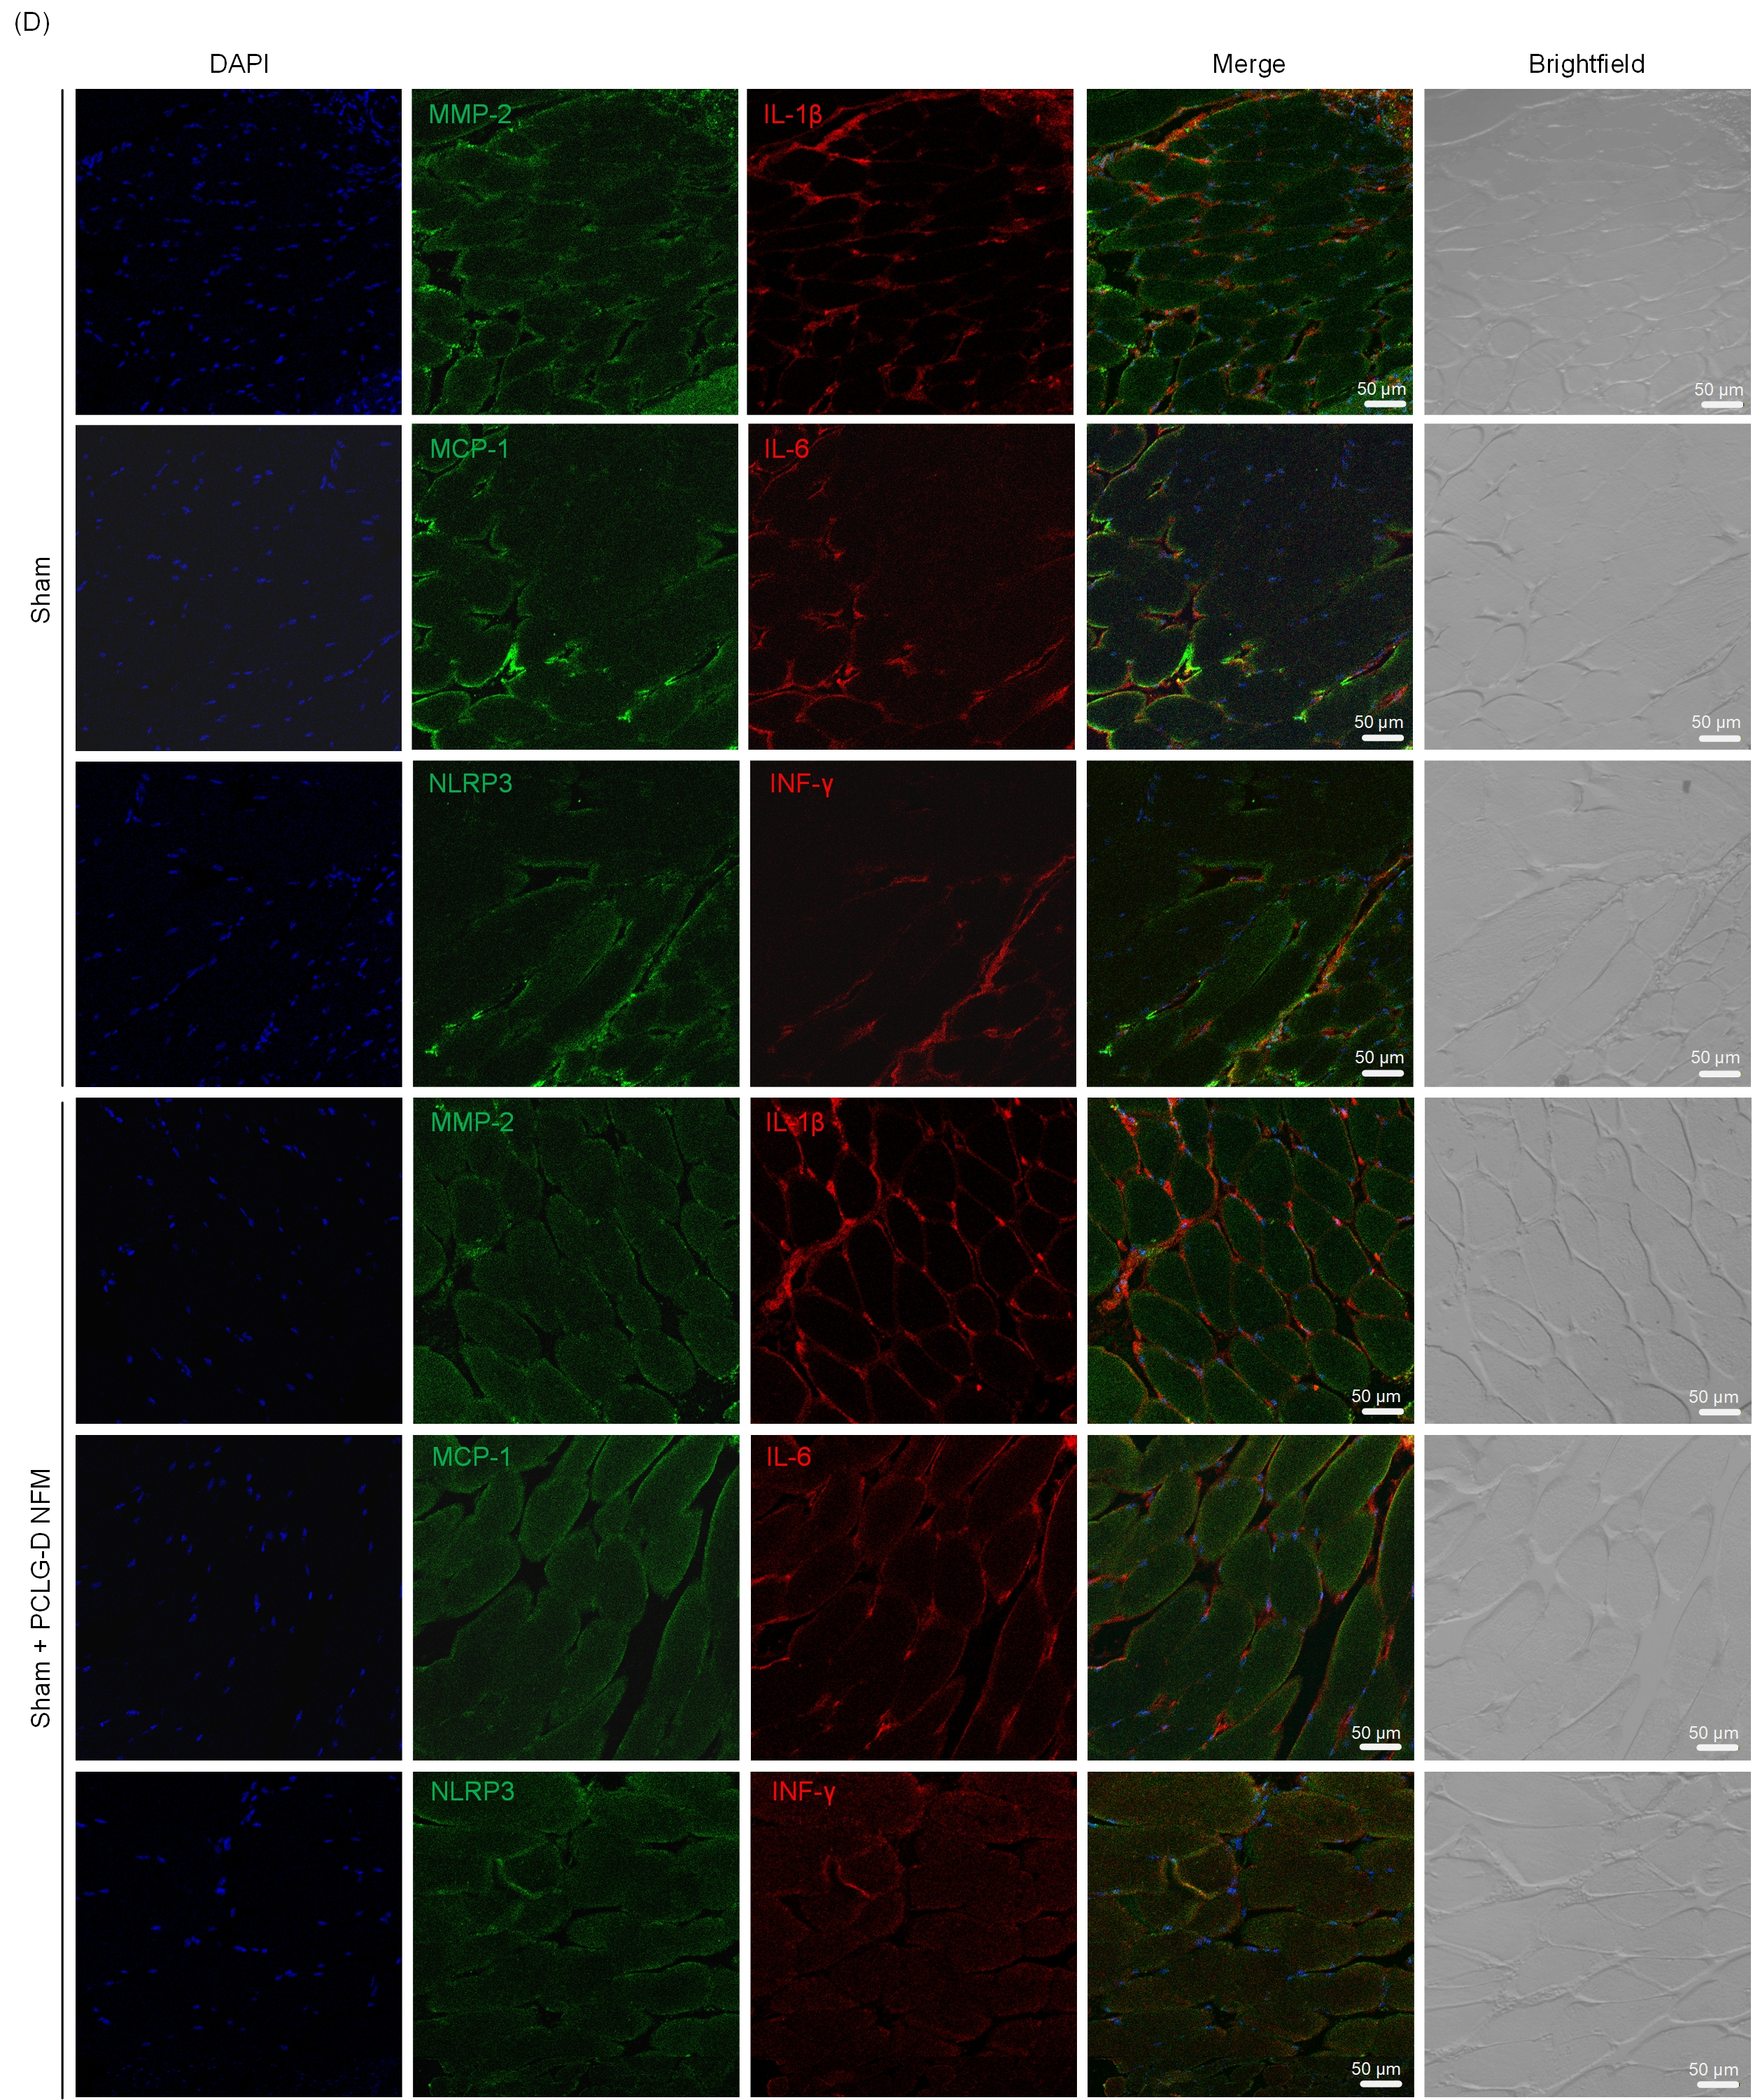
Figure. S3. (d-f) Immunofluorescence detection of inflammatory cytokines.

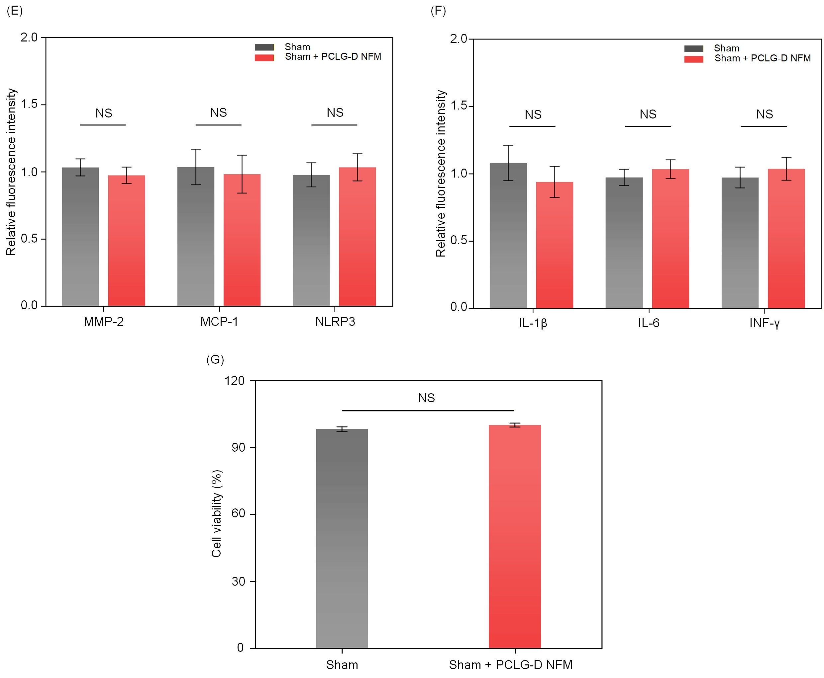
Figure. S3. (g) CCK-8 method for cell viability. Data are presented as mean ± SEM.

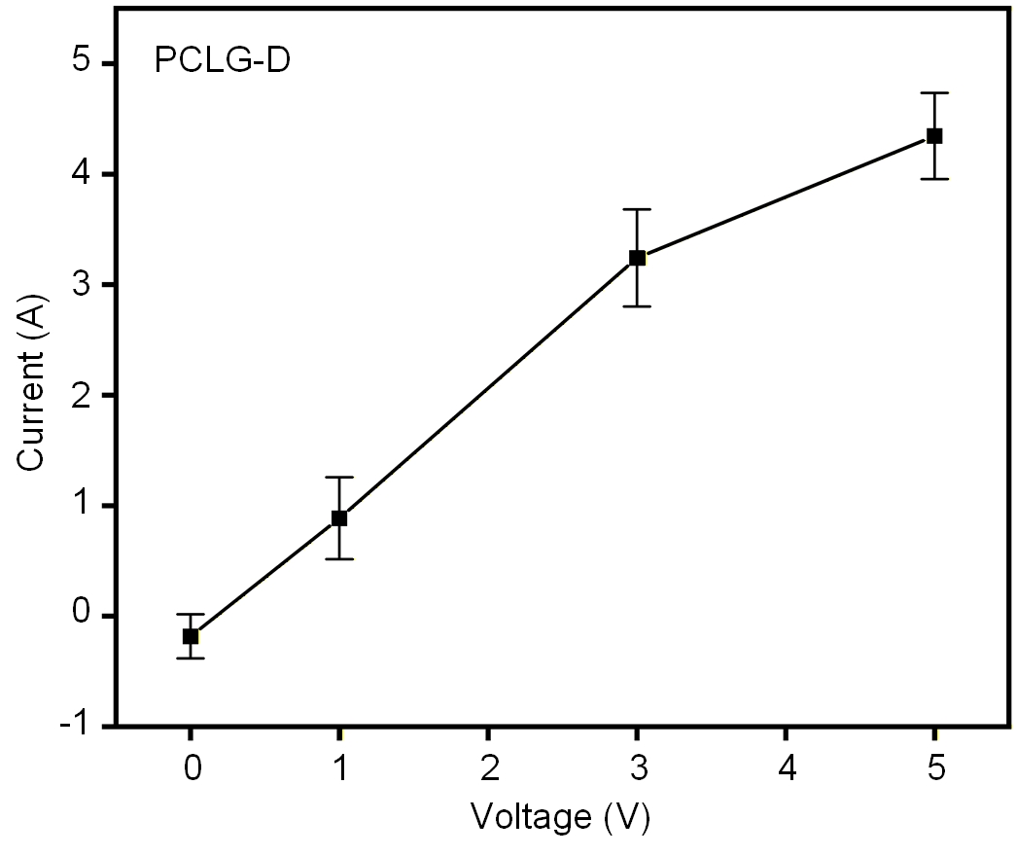
Figure. S4. The conductivity of PCLG-D nanofiber nerve conduit.

Supplementary note 3. Absorbance-concentration relationship curve
The absorbance of aspirin/lysine at six concentrations was measured at 277.5 nm and 320 nm
using SpectraMAX M5e microplate reader. A linear regression established the concentration-
absorbance relationship (Figure S5).
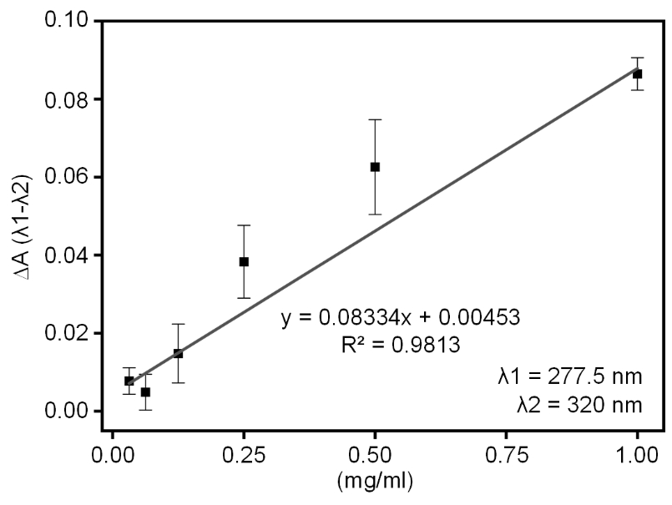
Figure. S5. Absorbance-concentration relationship curve for aspirin/lysine. Data are presented as mean ± SEM.

Supplementary note 4. Analysis of gait behavior following peripheral nerve repair utilizing PCLG-D nanofiber nerve conduit.
To determine the repair effect of the sciatic nerve by PCLG-D nanofiber nerve conduits, mice
were behaviorally analyzed using the DigiGait imaging system (Mouse Specifics, Inc) (Figure
S6).

Supplementary note 5. Plasma drug concentration-time curve in mice during daily activity and exercise stimulation.
Plasma samples were obtained at various time points to measure the aspirin/lysine concentration
by Molecular Devices SpectraMax M5e Microplate Reader. A plasma concentration-time curve
was plotted, where the peak time was determined (Figure S7a-d,f). Meanwhile, the area under
the concentration-time curve (AUC) was calculated using the integration function in Origin
software (Figure S7e) and applied to compare the bioavailability between the PCLG-D nerve
conduit and intramuscular (IM) injection.
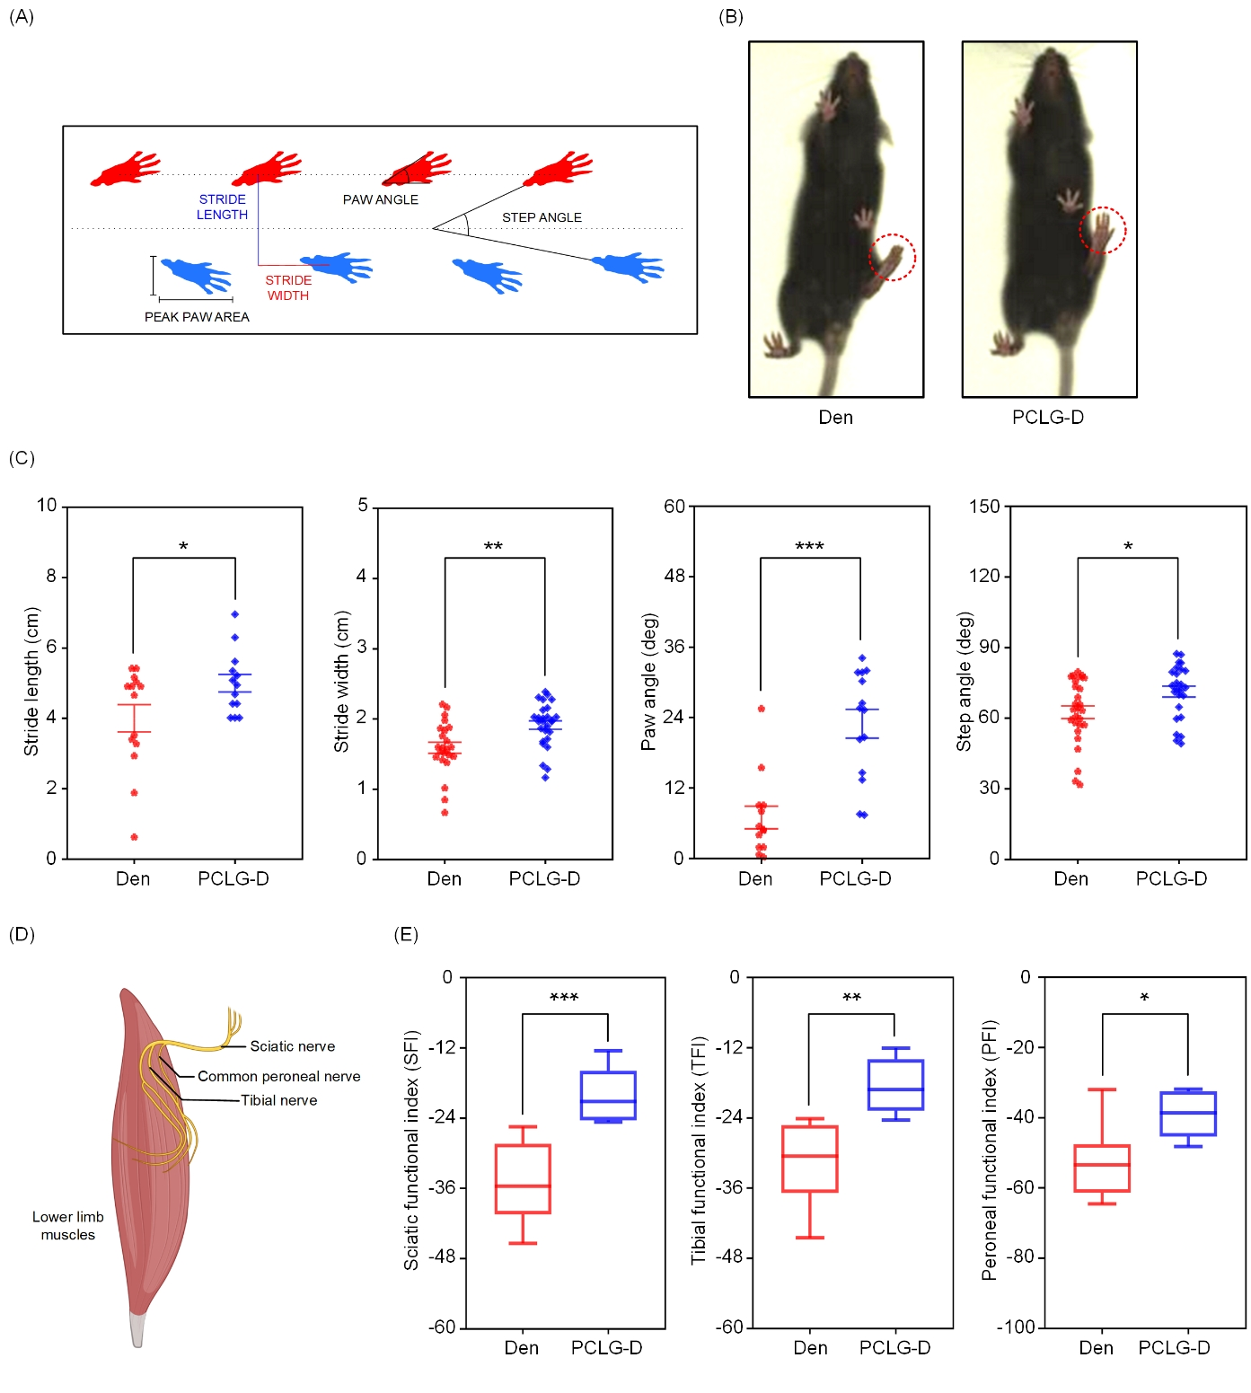
Figure. S6. Analysis of gait behavior following peripheral nerve repair utilizing PCLG-D nerve conduit. (a) Gait analysis mechanism diagram. (b) Foot plantar area. (c) Gait parameters analysis. (d,e) Sciatic nerve function indexes analysis. *P < 0.05, **P < 0.01, ***P < 0.001 vs the Den group. Data are presented as mean ± SEM.

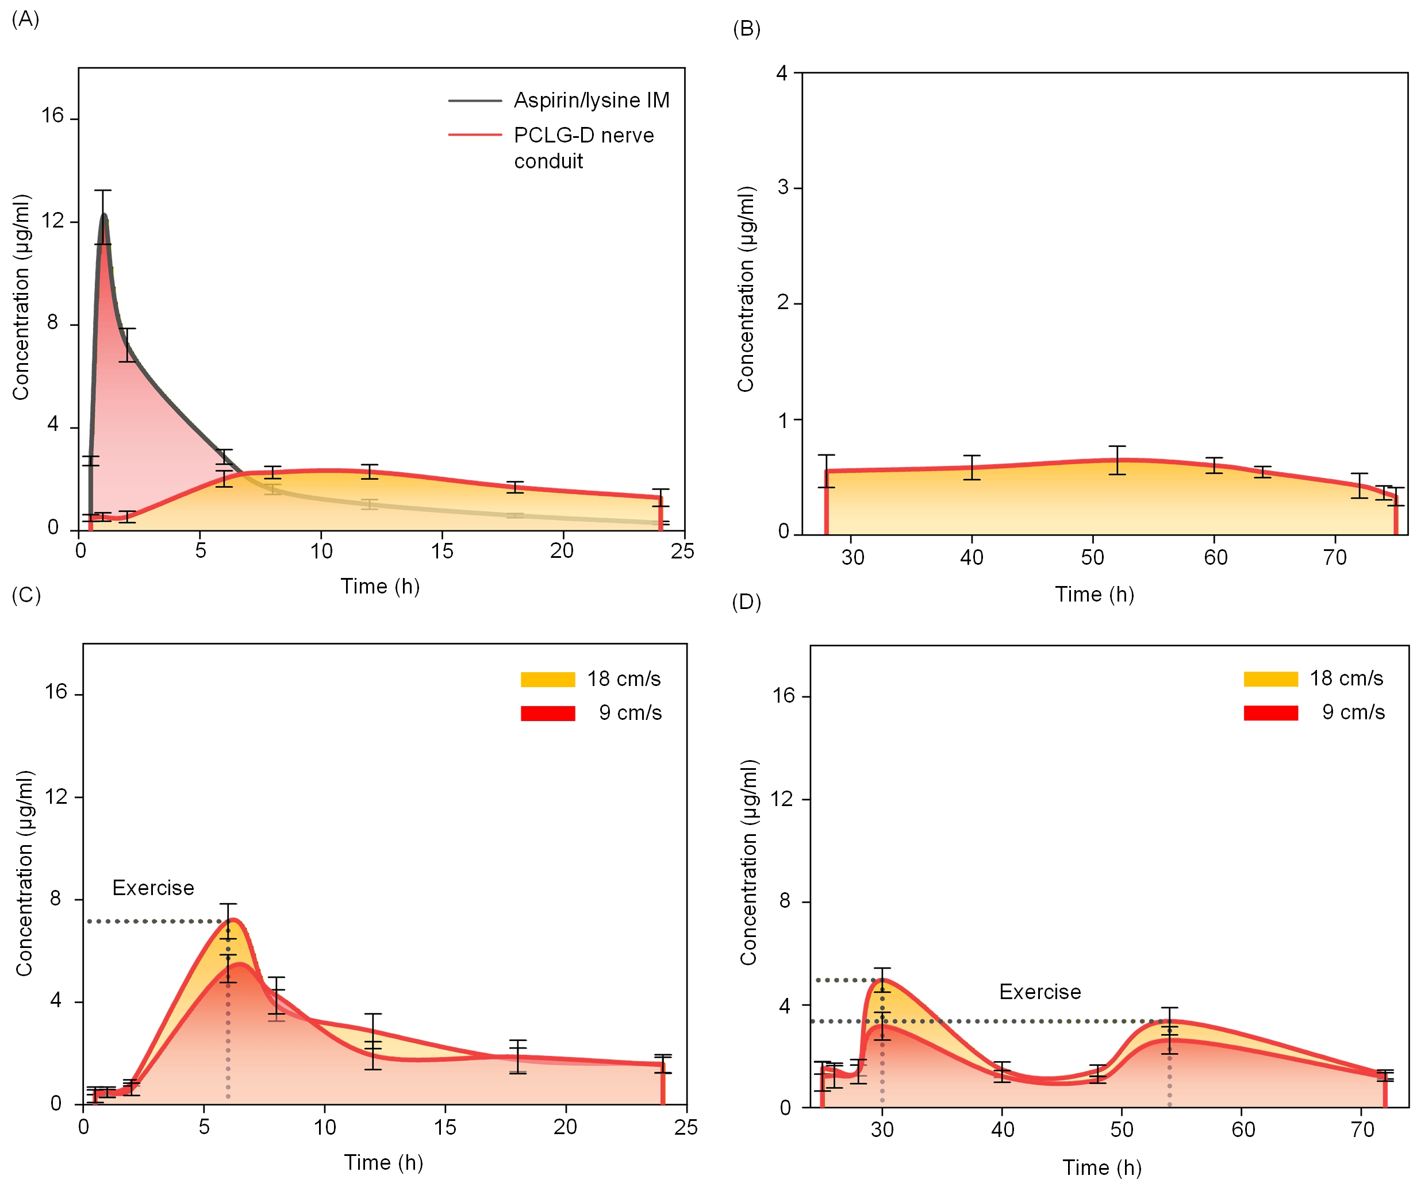
Figure. S7. Plasma drug concentration-time curve in mice during daily activity, and plasma drug concentration-time curve simulating the relationship between treadmill speed and drug release rate. (a) 24-hour plasma concentration-time curve in mice (comparison of PCLG-D nerve conduit and intramuscular injection). (b) Plasma drug concentration-time curve in mice during the 24-72 hour period​ (following PCLG-D nerve conduit implantation). (c,d) PCLG-D nerve conduit implantation in mice subjected to simulated exercise at different speeds, changes
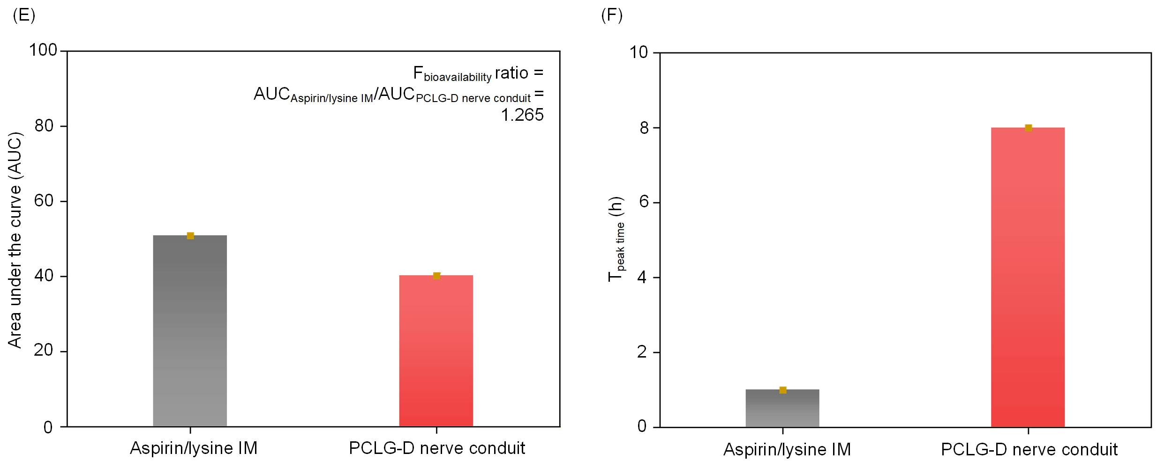
in blood drug concentration within 72 hours. (e) Comparison of bioavailability of drugs administered by mouse intramuscular injection and PCLG-D nerve conduit drug release (within 24 hours). (f) Comparison of peak times within 24 hours between intramuscular injection and PCLG-D nerve conduits implantation. Data are presented as mean ± SEM.

Supplementary note 6. Long-term functional study of PCLG-D nanofiber nerve conduit in vivo.
To investigate whether the PCLG-D nerve conduit enabled full regeneration of sciatic nerve
defects within 8 weeks, three types of nerve conduits (PCL, PCLG, PCLG-D) were implanted
at the site of sciatic nerve defects in mice. Within the 8-week observation window, the PCLG-
D nerve conduit successfully bridged the two stumps of the sciatic nerve defect in mice (Figure
S8a,e). Concomitantly, this conduit promoted effective myelination of the injured nerve fibers
(Figure S8f). Neuro-electrophysiological assessments at week 8 revealed that the peak sciatic
nerve electrical signal amplitude in the PCLG-D group was not significantly different from that
in the sham group (Figure S8b). Moreover, histological analysis demonstrated that the average
muscle fiber area in the PCLG-D group was significantly larger than that in the PCL and PCLG
groups (Figures S8c,d,g). Additionally, gait analysis assays confirmed that the neurological
function index of mice in the PCLG-D group showed no significant difference compared with
the sham group (Figures S8i-m).
To distinguish the individual contributions of PPy conductivity, exercise-induced piezoelectric
output and aspirin/lysine effects, two control groups [PCLG + exercise (18cm/s); PCLG-PPy
(PCLG + PPy-only)] were performed sciatic nerve Tuj1 protein immunofluorescence staining
(to characterize nerve regeneration) and gastrocnemius muscle fiber area measurement within
8 weeks (Figure S8l-q).

Supplementary note 7. The linear correlation among applied external force, self-powering output and drug release rate in PPy/D nanoparticles.
The self-powering output of PCLG-D NFM was measured under forces ranging from 0.5 N to
5 N using a linear motor platform,¹ and the relationship was analyzed by a linear regression
(Figure S9a-c). To study voltage-dependent drug release, PPy/D nanoparticles solution was
stimulated with voltages from 1 V to 5 V for 2 h. Samples (400 µL) were filtered (100 kDa
cutoff, 10,000 rpm, 3 min), and absorbance was measured at 277.5 nm and 320 nm using a
SpectraMAX M5e microplate reader² (Figure S9d-f).
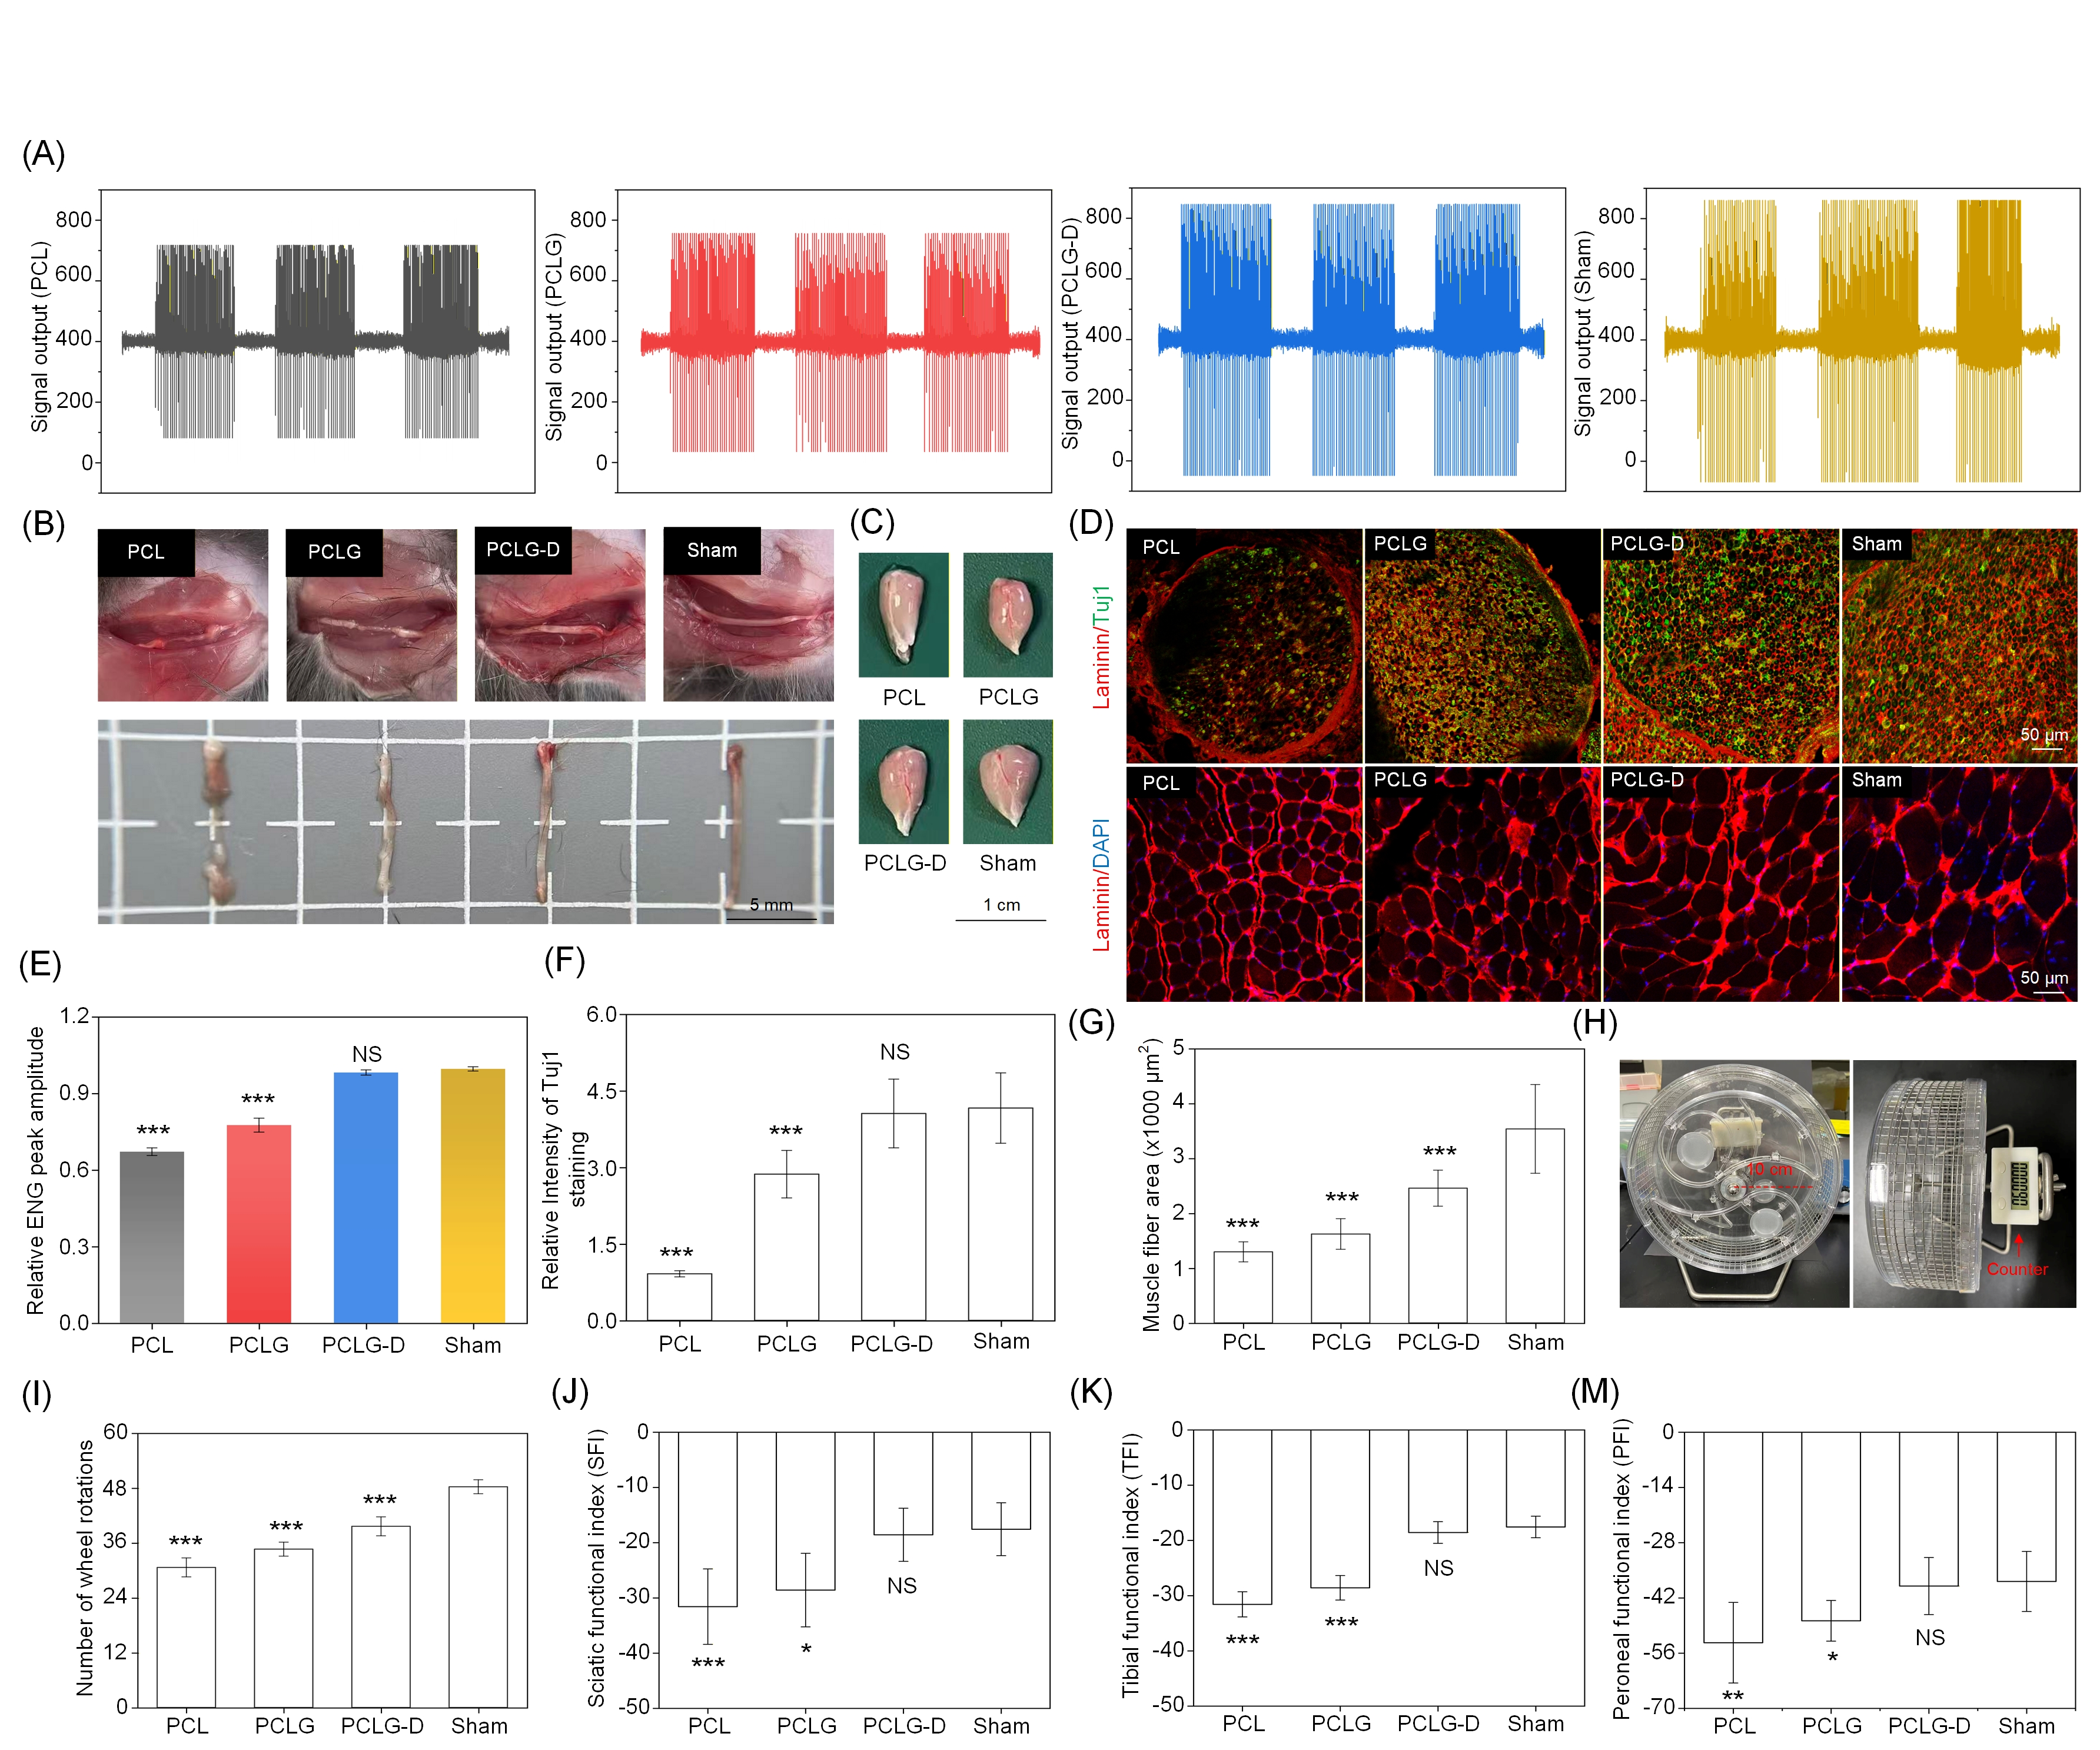
Figure. S8. Long-term functional study of PCLG-D nanofiber nerve conduit in vivo. (a, e) Sciatic nerve electrical signal peaks in each group at 8 weeks, showing no significant difference between the PCLG-D group and the Sham group. (b) Bridging of the two stumps of the sciatic nerve defect by the PCLG-D nerve conduit within 8 weeks. (c, d, g) Average muscle fiber area in each group, demonstrating that the PCLG-D group has a significantly larger average muscle fiber area than the PCL and PCLG groups. (f) Myelination of the injured nerve promoted by the PCLG-D nerve conduit. (i-m) Gait analysis results of mice in each group, indicating no significant difference in the neurological function index between the PCLG-D group and the Sham group. ***P < 0.001 vs the sham group. NS represents no significance vs the sham group. Data are presented as mean ± SEM.
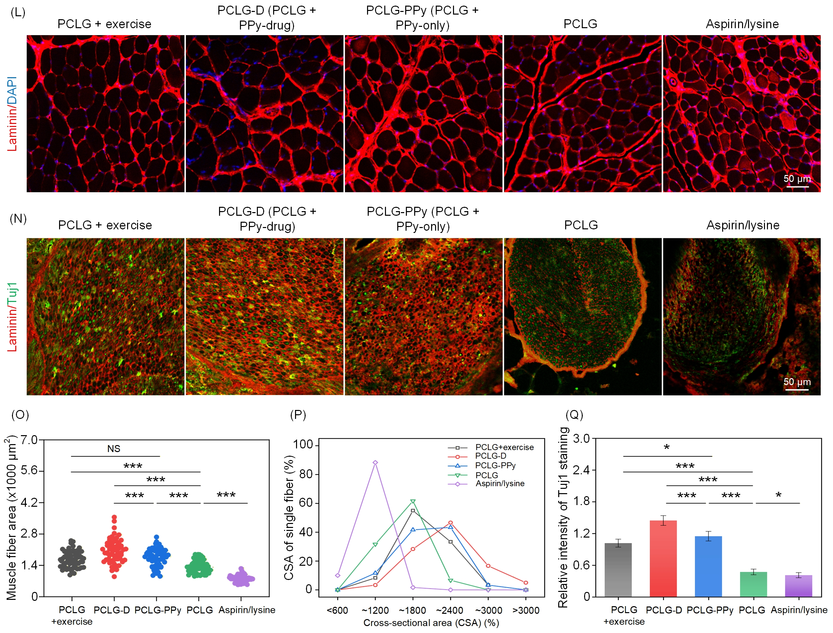
Figure. S8. (l,o,p) Sciatic nerve Tuj1 immunofluorescence staining. (n,q) Gastrocnemius muscle fiber area measurement. Data are presented as mean ± SEM.

Supplementary note 8. qPCR test of neurodevelopmental-related genes and
the anti-superoxide effect of aspirin/lysine.
To illustrate the effect of the spontaneous electrical output of the nanofiber nerve conduit on
sciatic nerve regeneration, the expression levels of nerve development-related genes (Nanog,
Pax3, Egr2, Fgf4) were detected by qPCR (Figure S10a-d). Besides, to illustrate the antioxidant
effect of aspirin/lysine, DHE staining was used to detect the concentration of C2C12 superoxide
anions (Leica TCS SP8 MP Multiphoton/Confocal Microscope) (Figure S11).
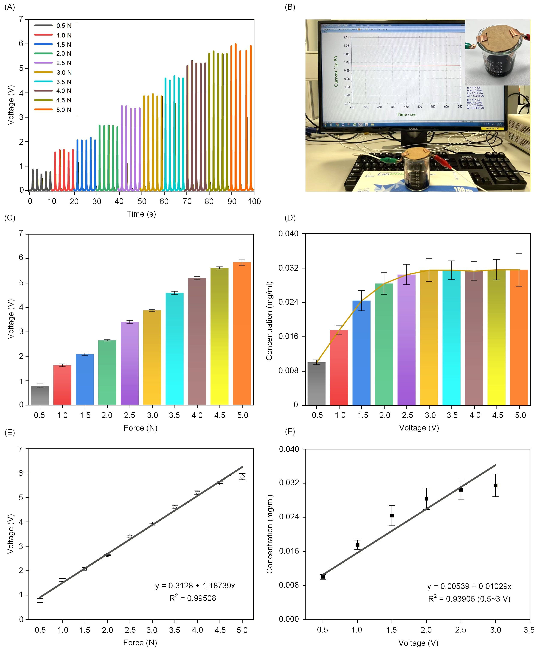
Figure. S9. The linear correlation among applied external force, self-powering output and drug release rate in PPy/D nanoparticles. (a,c,e) The linear correlation between applied external force and self-powering output. (b,d,f) The linear correlation between electrical stimulation and drug release rate in PPy/D nanoparticles. Data are presented as mean ± SEM.

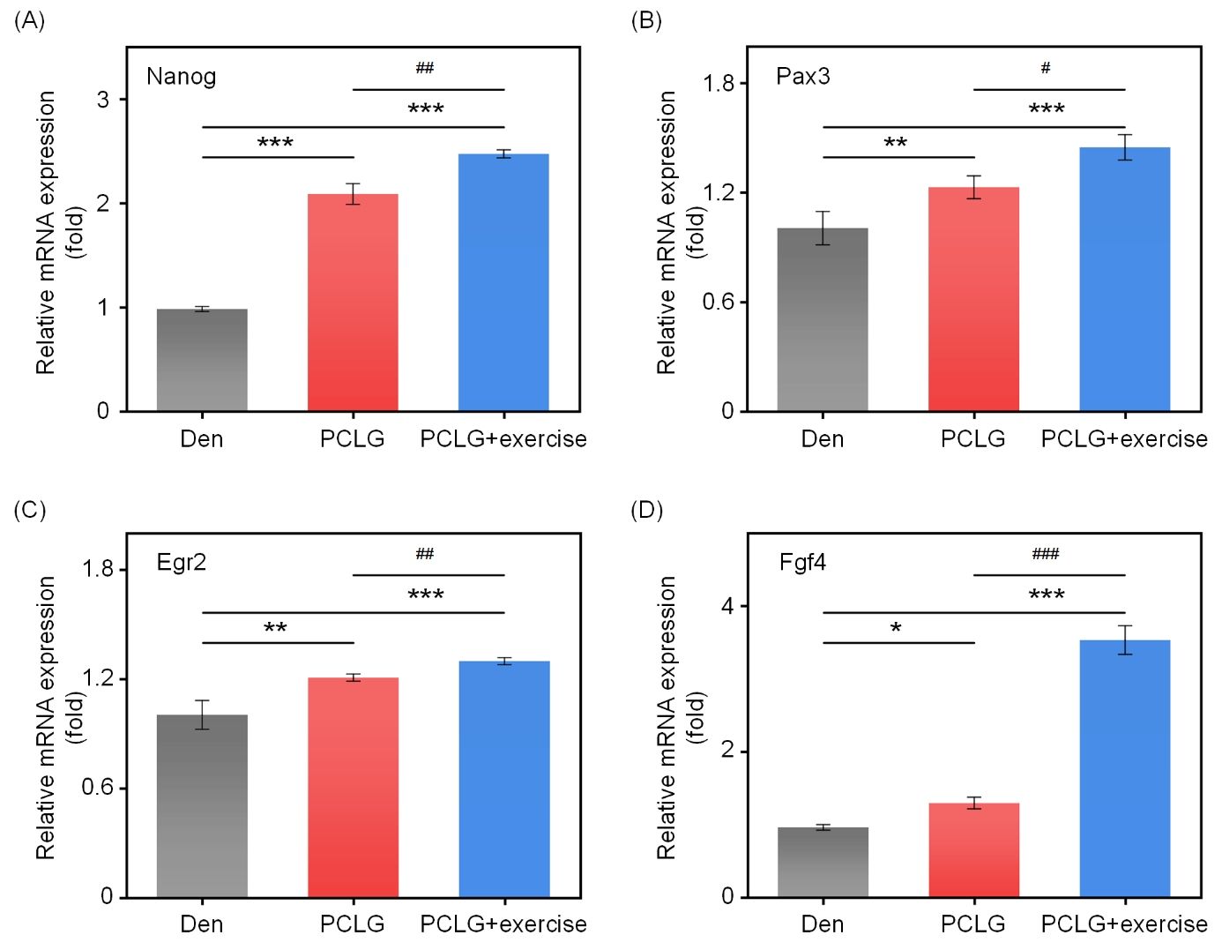
Figure. S10. qPCR analysis of neurodevelopmental-related genes. *P < 0.05, **P < 0.01, ***P < 0.001 vs the Den group; #P < 0.05, ##P < 0.01, ###P < 0.001 vs the PCLG group. Data are presented as mean ± SEM.

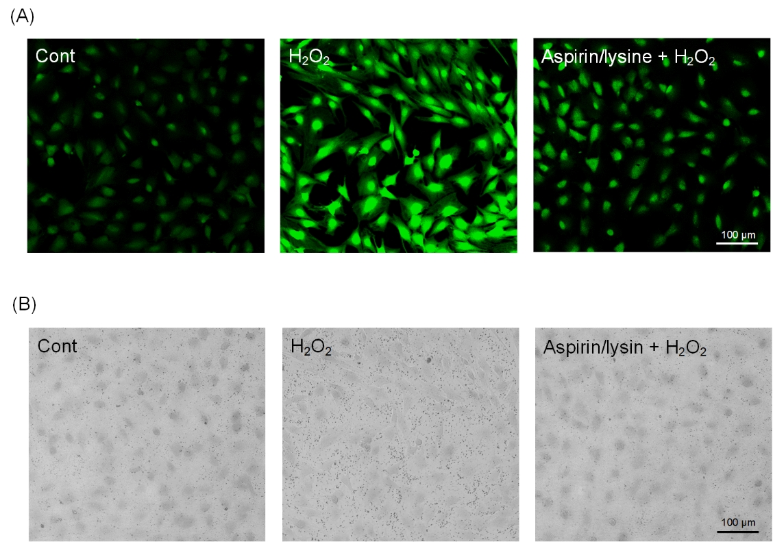
Figure. S11. DHE staining for detecting superoxide levels in C2C12 cells, using 36 μg of aspirin/lysine in 3 ml of medium with 50 µM H₂O₂. (a) Fluorescence and (b) bright field areas.

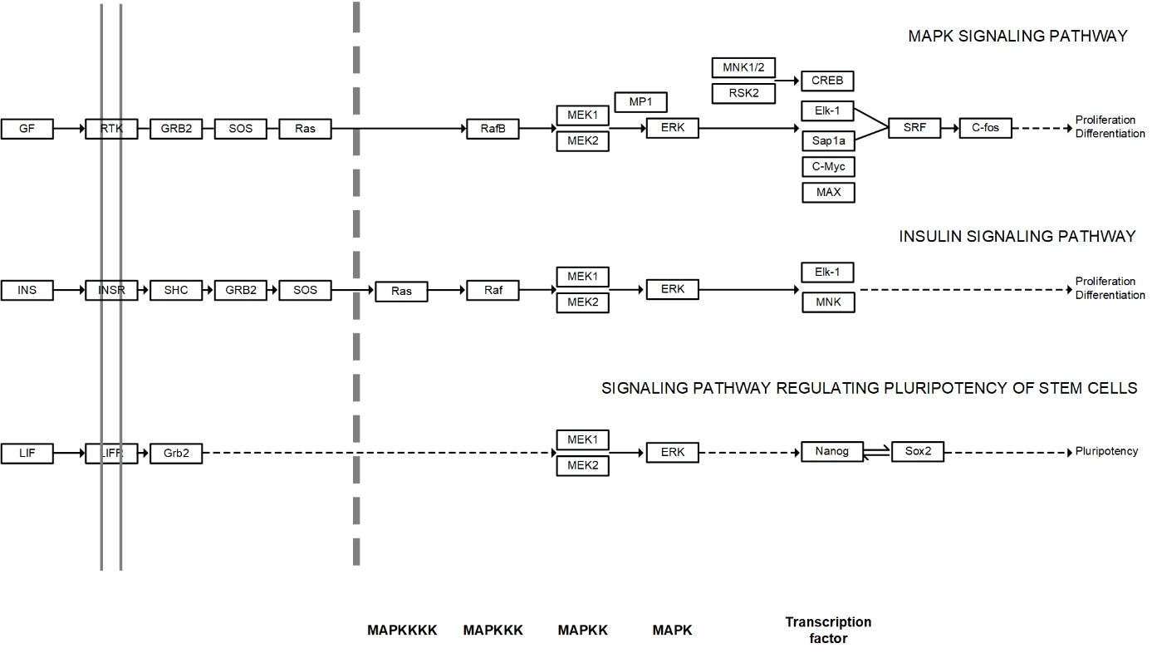
Figure. S12. Kanehisa laboratories. KEGG Pathway: MAPK signaling pathway. Accessed 4/ 11/23. https://www.genome.jp/kegg-bin/show_pathway?map04010; Insulin signaling path-way Accessed 6/16/23. https://www.genome.jp/kegg-bin/show_pathway?map04910; Signaling pathways regulating pluripotency of stem cells. Accessed 7/5/19. https://www.genome.jp/ kegg-bin/show_pathway?map04550.

Table S1. Primer sequence used for fluorescent quantitative PCR.
Primers name | Primer sequence
MuRF1-F  MuRF1-R  MAFbx -F  MAFbx -R  Myostatin-F  Myostatin-R  GAPDH-F  GAPDH-R  Cyclophilin B-F  Cyclophilin B-R  MyHC 1-F  MyHC 1-R  MyHC 2A-F  MyHC 2A-R  MyHC 2X-F  MyHC 2X-R  MyHC 2B-F  MyHC 2B-R  MMP-2-F  MMP-2-R  XIAP-F  XIAP-R  MMP-9-F  MMP-9-R  clAP1/2-F  clAP1/2-R | AGGACTCCTGCAGAGTGACCAA  TTCTCGTCCAGGATGGCGTA  GCAAACACTGCCACATTCTCTC  CTTGAGGGGAAAGTGAGACG  GGCCATGATCTTGCTGTAA  TTGGGTGCGATAATCCAGTC  CCCAGAAGACTGTGGATGG  ACACATTGGGGGTAGGAACA  TGGAGAGCACCAAGACAGACA  TGCCGGAGTCGACAATGAT  CCAAGGGCCTGAATGAGGAG  GCAAAGGCTCCAGGTCTGAG  AAGCGAAGAGTAAGGCTGTC  GTGATTGCTTGCAAAGGAAC  CACCGTCTGGATGAGGCTGA  TGTTTGCGCAGACCCTTGATAG  ACAAGCTGCGGGTGAAGAGC  CAGGACAGTGACAAAGAACG  AGATCTTCTTCTTCAAGGACCGGTT  GGCTCCTCAGTGGCTTGGGGTA  TCACAGCACTCCAACTCTAATC  GACCTTCCGAGTGACCATTT  TGAATCAGCTGGCTTTTGTG  ACCTTCCAGTAGGGGCAACT  ACGCAGCAATCGTGCATTTTG  CCTATAACGAGGTCACTGACGG

Table S2. The quantification data of drug release by time.
Time  (days) | Absorptance: ∆λ (277.5 nm, 320 nm)  PCLG-D Shake |  |  |  |  | y = 0.08463x + 0.00418 (x: drug concentration; y: ∆λ absorptance)
3 | 0.0095 | 0.0104 | 0.00978 | 0.0112 | 0.0106 | 0.05964 | 0.07043 | 0.06323 | 0.08003 | 0.07283
6 | 0.0081 | 0.0079 | 0.0085 | 0.0086 | 0.0088 | 0.04284 | 0.04044 | 0.04764 | 0.04884 | 0.05124
9 | 0.0076 | 0.0071 | 0.0078 | 0.0075 | 0.0075 | 0.03684 | 0.03084 | 0.03924 | 0.03564 | 0.03564
12 | 0.0069 | 0.0066 | 0.0062 | 0.007 | 0.0067 | 0.02844 | 0.02484 | 0.02004 | 0.02964 | 0.02604
14 | 0.0059 | 0.0067 | 0.0065 | 0.0062 | 0.0068 | 0.01644 | 0.02604 | 0.02364 | 0.02004 | 0.02724

References
1. Zhang S, Tan RJ, Zhang K, Meng S, Xu XY, Zhang Q, Zhi CW, Wang Z, Liang XS, Zhu SS, Tai YL, Hu JL. Implantable heterogeneous triboelectric nanogenerator effectively prevents denervation-induced muscle atrophy. Nano Energy. 2024; 125: 109548.
2. Hosseini-Nassab N, Samanta D, Abdolazimi Y, Annes JP, Zare RN. Electrically controlled release of insulin using polypyrrole nanoparticles. Nanoscale. 2017; 9: 143-149.

* Corresponding author. Dr. Zhai Zhenya: zhaizhenyascau@163.com; Prof. Hu Jinlian: jinliahu@cityu.edu.hk 1 Jiangxi Provincial Engineering Research Center for High-Throughput Screening and Evaluation of Small Molecule Compounds, Institute of Medicine and Health, Jiangxi Academy of Sciences, Nanchang, Jiangxi 330096, China. 2 Department of Biomedical Engineering, City University of Hong Kong, Kowloon, Hong Kong SAR 999077, China. 3 Jiangxi Engineering Laboratory for Extraction and Utilization of Functional Components in Medicinal and Edible Plants, Institute of Medicine and Health, Jiangxi Academy of Sciences, Nanchang, Jiangxi 330096, China. 4 College of Biomass Science and Engineering, Sichuan University, Chengdu, 610065 P. R. China. 5 State Key Laboratory of Transvascular Implantation Devices, The Second Affiliated Hospital, Zhejiang University School of Medicine, Hangzhou 310053, China.

