Supporting Information
⁶⁸Ga/¹⁷⁷Lu-Labeled Nectin4-Targeted Covalent Bicyclic Peptide: A Novel Nectin-4-Targeted Radioligands for Theranostic of Urothelial Carcinoma
Li Sun#¹⁻³, Bin Zhu#^{1,4-6}, Ke Zuo⁴, Liyan Bai^{1,4-6}, Jialiang Lei^{1,4-6}, Ye Li^{1,4-6}, Xinyu Liu^{1,4-6}, Xiaoyu Pan^{1,4-6}, Juan Li^{2,3} Aiguo Wu^{2,3}, Yijun Shen^{4,7,8*}, Xiaoping Xu^{1,4-6*}, Shaoli Song^{1,4-6*}

¹ Department of Nuclear Medicine, Fudan University Shanghai Cancer Center, Shanghai 200032, China;
² Ningbo Key Laboratory of Biomedical Imaging Probe Materials and Technology,and Laboratory of Advanced Theranostic Materials and Technology, Ningbo Institute of Materials Technology and Engineering, Chinese Academyof Sciences, Ningbo 315201, China;
³ Zhejiang International Cooperation Base of Biomedical Materials Technology and Application, Zhejiang Engineering Research Center for Biomedical Materials, Ningbo Cixi Institute of Biomedical Engineering, Cixi 315300, China;
⁴ Department of Oncology, Shanghai Medical College, Fudan University, Shanghai 200032, China;
⁵ Shanghai Engineering Research Center of Molecular Imaging Probes, Shanghai 200032, China;
⁶ Center for Biomedical Imaging, Fudan University, Shanghai 200032, China;
⁷ Department of Urology, Fudan University Shanghai Cancer Center, Shanghai 200032, China.
⁸ Shanghai Genitourinary Cancer Institute, Shanghai 200032, China.
Corresponding author(s).
E-mail addresses: Yijunshen79@163.com (Yijun Shen), xxp0012@ustc.edu (Xiaoping Xu), shaoli-song@163.com (Shaoli Song)
#Li Sun and Bin Zhu contributed equally to this work.

Table of contents
Supplementary Methods
S1. Chemicals and instruments
S2. Synthesis,radiolabeling and purification
S3. Surface plasmon resonance binding assays
S4. Stability
S5. Partition coefficient
S6. Cell lines and cell culture
S7. Cell uptake
S8. Western blot
S9. Animal models
S10. In vivo imaging
S11. Biodistribution studies‌ ‌
S12. H&E staining and immunohistochemistry in mice
S13. Immunohistochemistry in patients
S14. PET/CT scans and reconstruction protocols for patients
S15. MicroPET/CT scans and reconstruction protocols
S16. MicroSPECT/CT scans and reconstruction protocols
Supplementary Figure S1. High Performance Liquid Chromatography (HPLC) analysis of FZ-NR-5, FZ-NR-6, and FZ-NR-7
Supplementary Figure S2. Mass spectrum analysis of FZ-NR-5, FZ-NR-6, and FZ-NR-7
Supplementary Figure S3. Binding response between human Nectin-4 protein and different concentrations (0.7812−200 nM) of FZ-NR-5, FZ-NR-6 and FZ-NR-7
Supplementary Figure S4. Radio-high performance liquid chromatography analysis of ⁶⁸Ga/¹⁷⁷Lu-FZ-NRs
Supplementary Figure S5. Stability of (A) ¹⁷⁷Lu-FZ-NR-1, (B) ⁶⁸Ga/¹⁷⁷Lu-FZ-NR-5, (C) ⁶⁸Ga/¹⁷⁷Lu-FZ-NR-6, and (D) ⁶⁸Ga/¹⁷⁷Lu-FZ-NR-7 in fetal bovine serum (FBS) and saline over time.
Supplementary Figure S6. The lipophilicity assessment of ⁶⁸Ga-FZ-NRs. (A) logP and (B) logD_{7.4} for ⁶⁸Ga-FZ-NRs.
Supplementary Figure S7. MicroPET-CT imaging of ⁶⁸Ga-FZ-NRs.
Supplementary Figure S8. MicroPET-CT images of ⁶⁸Ga-FZ-NR-1 in HT1376 and RT112 tumor models at 30-, 60-, 120-, and 180 minutes after injection.
Supplementary Figure S9. MicroPET-CT images of ⁶⁸Ga-FZ-NR-5 in HT1376 and RT112 tumor models at 30-, 60-, 120-, and 180 minutes after injection.
Supplementary Figure S10. MicroPET-CT images of ⁶⁸Ga-FZ-NR-6 in HT1376 and RT112 tumor models at 30-, 60-, 120-, and 180 minutes after injection.
Supplementary Figure S11. MicroPET-CT images of ⁶⁸Ga-FZ-NR-7 in HT1376 and RT112 tumor models at 30-, 60-, 120-, and 180 minutes after injection.
Supplementary Figure S12. Pharmacokinetics of the ⁶⁸Ga-FZ-NRs.
Supplementary Figure S13.The biodistribution of ⁶⁸Ga-FZ-NRs at different time points (30-min, 60-min, 120-min, and 180-min) in HT1376 tumor-bearing mice (n = 3/group).
Supplementary Figure S14. In vivo efficacy and specificity of ⁶⁸Ga-FZ-NRs.
Supplementary Figure S15. Toxicity test of ⁶⁸Ga-FZ-NRs.
Supplementary Figure S16. The biodistribution of ¹⁷⁷Lu-FZ-NRs at different time points (1-hour, 6-hours, 24-hours, 48-hours, 96-hours, and 168-hours) in HT1376 tumor-bearing BALB/c nude mice (n = 3/group).
Supplementary Figure S17. Corresponding tumor-to-muscle (T/NT) ratio from the biodistribution of ¹⁷⁷Lu-FZ-NRs in the HT1376 tumor model.
Supplementary Figure S18. Tumor volume curves for individual mice (n = 5).
Supplementary Figure S19. The change in tumor volume for individual mice (n = 5).
Supplementary Figure S20. The change in body weight for individual mice was analyzed (n = 5).
Supplementary Figure S21. Toxicity test of ¹⁷⁷Lu-FZ-NRs.
Supplementary Figure S22. PET/CT images of ⁶⁸Ga-FZ-NRs and ¹⁸F-FDG in representative Nectin-4-positive UC patients.
Supplementary Table S1. The biodistribution of ⁶⁸Ga-FZ-NR-1 at different time points (30-min, 60-min, 120-min, and 180-min) in HT1376 tumor-bearing mice (n = 3/group).
Supplementary Table S2. The biodistribution of ⁶⁸Ga-FZ-NR-5 at different time points (30-min, 60-min, 120-min, and 180- min) in HT1376 tumor-bearing mice (n = 3/group).
Supplementary Table S3. The biodistribution of ⁶⁸Ga-FZ-NR-6 at different time points (30-min, 60-min, 120-min, and 180- min) in HT1376 tumor-bearing mice (n = 3/group).
Supplementary Table S4. The biodistribution of ⁶⁸Ga-FZ-NR-7 at different time points (30-min, 60-min, 120-min, and 180- min) in HT1376 tumor-bearing mice (n = 3/group).
Supplementary Table S5. The biodistribution of ⁶⁸Ga-FZ-NR-1 at different time points (30-min, 60-min, 120-min, and 180- min) in RT112 tumor-bearing mice (n = 3/group).
Supplementary Table S6. The biodistribution of ⁶⁸Ga-FZ-NR-5 at different time points (30-min, 60-min, 120-min, and 180- min) in RT112 tumor-bearing mice (n = 3/group).
Supplementary Table S7. The biodistribution of ⁶⁸Ga-FZ-NR-6 at different time points (30-min, 60-min, 120-min, and 180- min) in RT112 tumor-bearing mice (n = 3/group).
Supplementary Table S8. The biodistribution of ⁶⁸Ga-FZ-NR-7 at different time points (30-min, 60-min, 120-min, and 180- min) in RT112 tumor-bearing mice (n = 3/group).
Supplementary Table S9. The biodistribution of ¹⁷⁷Lu-FZ-NR-1 at different time points (1-h, 6-h, 24-h, and 48-h) in HT1376 tumor-bearing mice (n = 3/group).
Supplementary Table S10. The biodistribution of ¹⁷⁷Lu-FZ-NR-5 at different time points (1-h, 6-h, 24-h, 48-h, 96-h and168-h ) in HT1376 tumor-bearing mice (n = 3/group).
Supplementary Table S11. The biodistribution of ¹⁷⁷Lu-FZ-NR-6 at different time points (1-h, 6-h, 24-h, 48-h, 96-h and 168-h ) in HT1376 tumor-bearing mice (n = 3/group).
Supplementary Table S12. The biodistribution of ¹⁷⁷Lu-FZ-NR-7 at different time points (1-h, 6-h, 24-h, 48-h, 96-h and 168-h ) in HT1376 tumor-bearing mice (n = 3/group).
Supplementary Table S13. Information of representative Nectin-4-positive UC patients enrolled in PET/CT imaging studies using ⁶⁸Ga-FZ-NRs and ¹⁸F-FDG.
Supplementary Table S14. ⁶⁸Ga-FZ-NRs and ¹⁸F-FDG uptake of 17 UC participants.

S1. Chemicals and instruments
Chemicals: NH₄OAc, CH₃CN, CH₃COH and HCl (37%) were purchase from China National Medicines Corporation Ltd., NaOH (Bide Medical Company, China), Sodium Chloride injection (China Otsuka Pharmaceutical Co., Ltd.), 2-Ethyl Hexanol (Shanghai Macklin Biochemical Technology Co., Ltd., China), Nectin-4 antibody (MedChemExpress, USA), Fetal bovine serum (FBS, moregate bitech, Australian), Phosphate buffer saline (PBS, Gibco, USA), Bovine Serum Albumin (BSA, sigma, USA), protease inhibitors（P8340，Sigma Life Sciences, USA）
¹⁸F-FDG was produced automatically using Explora FDG4 module with cyclotron (Siemens CTI RDS Eclips ST, Knoxville, Tennessee, USA) in our center. FZ-NRs (Chinese Peptide Company, China) was radiolabeled with ⁶⁸Ga-solution (elution from the ⁶⁸Ge generator IGG100, Eckert & Ziegler, Berlin, Germany). Radiochemical purity of ⁶⁸Ga-FZ-NRs was over 95%.
Instruments: Inveon microPET/CT (Siemens AG, Germany),PET-CT (United Imaging Healthcare, Shanghai, China) SPECT/CT (MOLECUBES, Belgium), γ-counter (Shanghai Hesuo Rihuan Photoelectric Instrument Ltd., China), Cell Culture Incubator (Thermo Fisher, USA)

S2. Synthesis, radiolabeling and purification
Synthesis: The precursors DOTA-Sar10(SF)-Nectin-4 (FZ-NR-5), DOTA-Sar10(pFS)-Nectin-4 (FZ-NR-6), and DOTA-Sar10(mFS)-Nectin-4 (FZ-NR-7), were obtained from a peptide manufacturing company (Chinese Peptide, China). The radiolabeling procedure was completed in a single step within 20 minutes, and the radiochemical purity was evaluated using radio-HPLC and radio-iTLC. The radiolabeling of FZ-NR-5 ligand with the radionuclide ⁶⁸Ga³⁺ was conducted employing the subsequent protocol: Briefly, a volume of 400 μL of ⁶⁸GaCl³, which was eluted from a ⁶⁸Ge/⁶⁸Ga generator, was brought into reaction with 10 μg of FZ-NR-5 (1 μg/μL) in 40 μL volume of 1.5 M sodium acetate buffer. This reaction was carried out under thermocycling conditions at 75°C for a duration of 20 minutes. The radiolabeling of FZ-NR-6 and FZ-NR-7 ligands with ⁶⁸Ga³⁺ was performed adhering to an analogous protocol.
Radiolabeling: The radiolabeling of FZ-NR-5 ligand with the radionuclide ¹⁷⁷Lu³⁺ was conducted employing the subsequent protocol: Briefly, a volume of 5 μL of ¹⁷⁷LuCl³, which was obtained from Chengdu New Radiomedicine Technology Co., LTD in China, was brought into reaction with 10 μg of FZ-NR-5 (1 μg/μL) in 4 μL of 0.5 M ammonium acetate buffer, 25 μL of 0.5 M gentisic Acid solution and 180 μL of 0.9% sodium chloride solution. This reaction was carried out under thermocycling conditions at 75°C for a duration of 40 minutes. The radiolabeling of FZ-NR-1 (1), FZ-NR-6 and FZ-NR-7 ligands with ¹⁷⁷Lu³⁺ was performed adhering to an analogous protocol.
Purification: Subsequent to the radiolabeling reaction, the conjugate was subjected to a purification process prior to utilization. Then the final product was eluted from the Sep-pak C18 column (waters, USA, Light Cartridge C18) by injecting 1.0 mL of aqueous ethanol (V_{ethanol}: V_{water}=70%:30%). The radiochemical purity (>95%) was evaluated by radio-thin-layer chromatography (radio-TLC) (depolymerizing agent, V_{H2O}:V_{MeOH}:V_{NH3•H2O}=2:2:0.1) and radio-high performance liquid chromatography (radio-HPLC). The Rf values under the radio-TLC conditions are 0-0.1 for ⁶⁸Ga/¹⁷⁷Lu and 0.8-1.0 for ⁶⁸Ga/¹⁷⁷Lu-FZ-NRs.

S3. Surface plasmon resonance binding assays
To assess the affinity of the ⁶⁸Ga-FZ-NRs for the Nectin-4 protein, we selected their respective precursors (FZ-NR-5, FZ-NR-6, and FZ-NR-7) for surface plasmon resonance (SPR) binding experiments. Additionally, lead compound was utilized as a reference compound for comparison of affinity. The SPR binding assays were conducted in accordance with established protocol(1). The nectin-4 protein, derived from human HEK293 cells and tagged with a histidine label, was sourced from MedChemExpress.
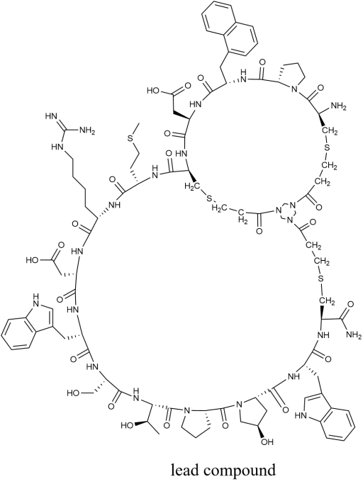
Lead compound

S4. Stability
To evaluate the in vitro stability of the Nectin4-targeted covalent bicyclic peptide ⁶⁸Ga/¹⁷⁷Lu-FZ-NRs, the experimental design is as follows: Approximately 74 kBq of the radiotracers (¹⁷⁷Lu-FZ-NR-1, ⁶⁸Ga/¹⁷⁷Lu-FZ-NR-5, ⁶⁸Ga/¹⁷⁷Lu-FZ-NR-6, and ⁶⁸Ga/¹⁷⁷Lu-FZ-NR-7) is mixed with fetal bovine serum (FBS) and phosphate-buffered saline, respectively and incubated at 37°C for 3 hours for the ⁶⁸Ga-labelled radiotracers, and for 24 and 48 hours for the ¹⁷⁷Lu-labelled radiotracers. After incubation, 100 μL of the mixture is taken from each group. In the FBS group, the mixture is treated with trifluoroacetic acid, followed by centrifugation at 12,000×g for 10 minutes at room temperature to precipitate serum proteins. The supernatant is then collected and analyzed by radio-HPLC. In the saline group, the mixture is directly analyzed using radio-HPLC. The chromatographic characteristics at different time points and in different media are compared to systematically investigate the stability differences of the tracer in physiological buffer versus biological fluids, providing data support for subsequent applications.

S5. Partition coefficient
To evaluate the lipophilicity characteristics of the Nectin4-targeting covalent bicyclic peptide radiotracers-⁶⁸Ga-FZ-NRs, we conducted LogP and LogD_{7.4} experiments. In the LogP experiment, 74-185 kBq of the radiotracer was added to a n-octanol-water mixed system (1:1, v/v, total volume of 2 mL) and oscillated at room temperature for 5 minutes before centrifugation at 15,000×g for 10 minutes to achieve phase separation. Then, 100 μL of both the n-octanol phase and the aqueous phase was taken, and the radioactivity of each phase was measured using a γ-counter. The logarithm of the radioactive activity ratio between the n-octanol and water phases (logP ) was calculated, with the experiment repeated in parallel five times.
In the LogD_{7.4} experiment, the same amount of 74-185 kBq of the radiotracer was introduced into an n-octanol-phosphate-buffered saline mixed system (1:1, v/v, total volume of 2 mL), followed by the same oscillation and centrifugation conditions. From the n-octanol phase and PBS phase, 100 μL of each was taken to measure their radioactive activity. The logarithm of the radioactive activity ratio between the n-octanol phase and the phosphate-buffered saline phase (logD_{7.4}) was calculated to quantitatively characterize the ⁶⁸Ga-FZ-NRs’ lipophilicity under pH 7.4 conditions, with the experiment also repeated in parallel five times.

S6. Cell lines and cell culture
In this study, we selected human bladder cancer cell lines HT1376 and RT112 as models representing high and low expression levels of Nectin-4, respectively. All cells were cultured in RPMI-1640 medium supplemented with 10% fetal bovine serum (FBS) and 1% penicillin-streptomycin, and maintained in a humidified incubator at 37°C with 5% CO₂. The cell growth was monitored daily until the cells reached the desired density for the experiments.

S7. Cell uptake
HT1376 cells (which express high levels of Nectin-4) and RT112 cells (which express low levels of Nectin-4) were seeded in 24-well plates at a density of 1 × 10^5 cells/well and incubated overnight at 37°C in a 5% CO₂ atmosphere until fully adherent. The medium was then replaced with serum-free culture medium, and approximately 40 kBq of each radioligand (⁶⁸Ga/¹⁷⁷Lu-FZ-NR-5, ⁶⁸Ga/¹⁷⁷Lu-FZ-NR-6, ⁶⁸Ga/¹⁷⁷Lu-FZ-NR-7) was added to the respective wells. After incubation at 37°C for 60 minutes, the reaction was terminated, and the supernatant was collected. The cells were washed three times with pre-cold phosphate buffered saline (PBS), and then lysed with 0.2 M NaOH lysis solution, from which the lysate was collected. In blocking experiments, a 400-fold molar excess of the Nectin-4-targeted lead compound was added to each well and co-incubated with the corresponding radioligand (approximately 40 kBq) for 60 minutes to verify the targeting specificity of the radioligands. Finally, the radioactivity of the lysate (representing cellular uptake) and the supernatant (representing free radioligands) was measured using a γ-counter (SN-697, China), and the proportion (%) of cell-associated radioactivity relative to the total radioactivity was calculated. Each experimental group was independently repeated six times.

S8. Western blot
Once the growth density of HT1376 and RT112 cells reached approximately 80%, the cells were harvested for protein extraction. For Western blot analysis, cell lysates from HT1376 and RT112 were prepared by lysing the cells in RIPA buffer supplemented with protease inhibitors (P8340, Sigma Life Sciences) and phosphatase inhibitor cocktails 2 and 3 (P5726, P0044, Sigma Life Sciences). Following established protocols, the lysates were centrifuged at 12,000 g for 15 minutes at 4 ºC to obtain supernatants, which were then used for Western blotting.
Prior to incubation with the primary antibody specific for Nectin-4 (rabbit monoclonal, obtained from Abcam Plc), the membranes were blocked with a 3% bovine serum albumin (BSA) solution. The immunoreactive signals were detected using a LiCor Odyssey CLx Imager based in Lincoln, Nebraska. For quantitative analysis of the Western blots, densitometric analysis was conducted using ImageJ software (developed by the National Institutes of Health, USA). A total of 20 mg of protein from the cell lysate was loaded in each lane, and glyceraldehyde-3-phosphate dehydrogenase (GAPDH) served as the loading control. Molecular weight markers are indicated on the right side of the blot.

S9. Animal models
Female BALB/c nude mice (6 weeks old, purchased from GemPharmatech, Shanghai, China) were used to establish a subcutaneous tumor model. A mixed suspension of 1×10^6 HT1376 or RT112 cells (1:1 ratio of Matrigel to PBS, 100 μL) was injected subcutaneously in the right shoulder region. Tumor growth was monitored three times a week using calipers to measure the longest diameter (L) and shortest diameter (W), with tumor volume calculated using the formula V = 0.5 × L × W², until the tumor volume reached 800 ± 50 mm³. Tumor-bearing mice underwent microPET/CT imaging (⁶⁸Ga-FZ-NRs) and microSPECT/CT imaging (¹⁷⁷Lu-FZ-NRs) to assess the in vivo targeting capability of the probes and the metabolic activity of the tumors. All experiments were approved by the Animal Ethics Committee of Fudan University Shanghai Cancer Center (FUSCC-IACUC-S2025-0441), and followed the ARRIVE guidelines. Animals were provided with standardized feed, analgesia, and controlled temperature and humidity.
S10. In vivo imaging
For microPET/CT imaging experiments, HT1376 and RT112 tumor-bearing mice were administered with radioligands (⁶⁸Ga-FZ-NR-5, ⁶⁸Ga-FZ-NR-6, or ⁶⁸Ga-FZ-NR-7) via tail vein injection at doses of 5.55 to 7.40 MBq, diluted to 200 μL with 0.9% sodium chloride solution (n=3/group). Inveon microPET/CT scans were performed at 30-, 60-, 120-, and 180-minutes post-injection. Mice were anesthetized using isoflurane during imaging. Based on reconstructed images, regions of interest (ROIs) were delineated for the tumors and non-target organs, and the radioactivity uptake values (%ID/g) were calculated. To verify the targeting specificity of the radioligands in vivo, 5.55 to 7.40 MBq of ⁶⁸Ga-FZ-NR-5, ⁶⁸Ga-FZ-NR-6, or ⁶⁸Ga-FZ-NR-7 was mixed with a 400-fold molar excess of the lead compound (diluted to 200 μL with 0.9% sodium chloride solution, n=3/group), and injected into tumor-bearing mice via the tail vein. MicroPET/CT imaging was conducted at 30-, 60-, 120-, and 180-minutes post-injection, and %ID/g values for tumors and normal tissues were analyzed using the same method.
During the micro single-photon emission computed tomography/computed tomography (microSPECT/CT) imaging experiment, HT1376 tumor-bearing mice were injected via the tail vein with approximately 15 MBq of radioligands (¹⁷⁷Lu-FZ-NR-5, ¹⁷⁷Lu-FZ-NR-6, or ¹⁷⁷Lu-FZ-NR-7) diluted to 200 μL with 0.9% sodium chloride solution (n=3/group). MicroSPECT-CT (MOLECUBES, Belgium) scans were conducted at various time points post-injection, including 1-, 6-, 24-, 48-, 96-, and 168-hours, with each scan lasting approximately 20-min for data acquisition. Mice were induced with isoflurane anesthesia prior to imaging and maintained under isoflurane throughout the imaging session. All SPECT data were subjected to attenuation and scatter correction and were reconstructed using the three-dimensional ordered subset expectation maximization (OSEM) algorithm. This imaging experiment utilized a subcutaneous transplantation model in BALB/c-nu mice, and all procedures were approved by the animal ethics committee of Fudan University Shanghai Cancer Center (Approval No.: FUSCC-IACUC-S2025-0441).

S11. Biodistribution studies‌ ‌
HT1376 and RT112 tumor-bearing mice (n=3/group) were injected via the tail vein with either ⁶⁸Ga-FZ-NR-5, ⁶⁸Ga-FZ-NR-6, or ⁶⁸Ga-FZ-NR-7 (approximately 1.5 MBq, diluted to 200 μL with 0.9% sodium chloride solution). Tumor-bearing mice were then euthanized at 30-, 60-, 120-, and 180-min post-injection, and various organs were harvested, including the heart, liver, spleen, lungs, kidneys, bladder, stomach, intestine, brain, muscle, bone, blood, and tumor tissue. The excised organs were washed three times with saline to remove any residual surface radioactivity, after which the sample weights were recorded. The radioactivity of each sample was then measured using a γ-counter. Raw data were decay-corrected based on the physical half-life of ⁶⁸Ga (t_{1/2} = 68 min), and the %ID/g values for each tissue were calculated.
HT1376 tumor-bearing mice were injected via the tail vein with either ¹⁷⁷Lu-FZ-NR-1, ¹⁷⁷Lu-FZ-NR-5, ¹⁷⁷Lu-FZ-NR-6, or ¹⁷⁷Lu-FZ-NR-7 (approximately 1 MBq, diluted to 200 μL with saline). The mice were then euthanized at 1-, 6-, 24-, 48-, 96-, and 168-hours post-injection (n = 3/group), and tissue samples were obtained and processed as described earlier. After correcting radioactive counts based on the physical half-life of ¹⁷⁷Lu (t_{1/2} = 6.65 days), a quantitative analysis of the biodistribution characteristics at each time point was performed.
The calculation of tumor absorbed dose is performed using the spherical model in IDAC-Dose2.1. The input parameters are the tumor volume, the radiopharmaceutical nuclide, and the cumulated activity, from which the tumor absorbed dose is computed. The cumulated activity is obtained by fitting the time-ID% curve and integrating over time, after which the resulting cumulated activity is used as input to the spherical model to determine the tumor absorbed dose.

S12. H&E staining and immunohistochemistry in mice
In the in vitro biodistribution study, tumor tissues were harvested, promptly frozen at -80ºC, and sectioned into thin slices. Hematoxylin and eosin staining, along with immunohistochemistry, was performed on consecutive sections to examine the distribution of the radiotracer and assess the tissue architecture. For the immunohistochemical analysis of Nectin-4 protein, sections from HT1376 and RT112 tumors were processed according to a previously established protocol. The slides were incubated with a recombinant anti-Nectin-4 antibody (1:500 dilution, ab191217, Abcam) to facilitate the detection of the protein.

S13. Immunohistochemistry in patients
Immunohistochemical staining for Nectin-4 (clone: EPR15613-68, Abcam, applied at 1:500 dilution) was performed with a Ventana BenchMark Ultra autostainer (Ventana Medical System Inc, Roche, Tucson, Arizona) according to the BenchMark ULTRA advanced staining system operator guide(2). Specific Nectin-4 immunoreactivity was found and localized in the cell membrane of tumor cells.

S14. PET/CT scans and reconstruction protocols for patients
¹⁸F-FDG and ⁶⁸Ga-FZ-NRs (⁶⁸Ga-FZ-NR-1,⁶⁸Ga-FZ-NR-5,⁶⁸Ga-FZ-NR-6 and ⁶⁸Ga-FZ-NR-7) PET-CT (uMI780 digital PET-CT scanner, United Imaging Healthcare, Shanghi, China) were performed within one week. For ¹⁸F-FDG PET-CT scanning, patients were fasted at least 6 hours, maintaining venous blood glucose levels under 10 mmol/L prior to ¹⁸F-FDG administration. But this was not necessary for ⁶⁸Ga-FZ-NRs PET-CT scanning. For quantitative analysis, SUVmax was used to measure uptake by tumor tissues. After injecting with a certain amount of ¹⁸F-FDG or a certain amount of ⁶⁸Ga-FZ-NRs (Table S13), patients were kept in a quiet environment for approximately 60 mins prior to examination. All images were obtained on a Biograph mCT Flow scanner (Siemens Medical Solutions). The CT scans were performed fist (120 kV, 0.33 s per rotation, with CareDOSE 4D) using a slice thickness of 3.0 mm and reconstructed to a 512 x 512 matrix (voxel size 0.98 x 0.98 x 3.0 mm³). Then, PET scans were performed with 2mm/s bed speed, and a TrueX+TOF algorithm (2 iteration, 21 subsets and 5 mm full width at half maximum) with Gaussian filtering was used to reconstruct the PET images. For all PET reconstructions, the matrix size was 200 x 200, resulting in anisotropic voxel of 4.07 x 4.07 x 3.0 mm³.

S15. MicroPET/CT scans and reconstruction protocols
Animal-PET/CT scans and image analyses were performed 30 min, 60 min,120 min and 180 min after an injection of radiotracer (5.55–7.40 MBq of ⁶⁸Ga-FZ-NRs in 0.2 mL saline) using an Inveon MicroPET/CT (Siemens Preclinical Solution, iterations, Target resolution 1.5 mm and matrix size: 128 ×128) without filtering and smoothing was used to reconstruct the PET images. The PET images were converted into %ID/g units by normalizing the activity concentration to the dosage of injected ⁶⁸Ga-FZ-NRs and mouse body weight. The animal-PET and animal-CT images were generated separately and then fused using Inveon Research Workplace (Siemens PreclinicalSolution, Knoxville, TN). The region of interest (ROI) was manually drawn covering the whole tumor on the fused images for further analysis. The highest uptake point of the entire tumor was included in ROI and no necrosis area was allowed.

S16. MicroSPECT/CT scans and reconstruction protocols
The imaging process of ¹⁷⁷Lu-FZ-NRs and parameter settings for microSPECT/CT (MOLECUBES, Belgium) are as follows: During imaging, mice were anesthetized with 1.5-2% isoflurane in oxygen, while SPECT and CT images were acquired simultaneously. The SPECT acquisition parameters were as follows: seven-head parallel multi-pinhole collimator, energy peak at 210 keV (± 10% peak width), with a whole-body image acquisition time of 20 minutes. The CT acquisition parameters were set to a voltage of 50 kVp, a current of 500 µA, and an exposure time of 4 minutes. After imaging, the data collected from the CT acquisition were reconstructed using an iterative reconstruction algorithm, with a voxel size of 200 µm. The data acquired from SPECT were reconstructed using the Maximum Likelihood Expectation Maximization (MLEM) algorithm, with a voxel size of 500 µm and an iteration count of 50. The images were analyzed using Vivo-Quant software, and 3D imaging of the mice was obtained by fusing the SPECT and CT images into a Maximum Intensity Projection (MIP) image.

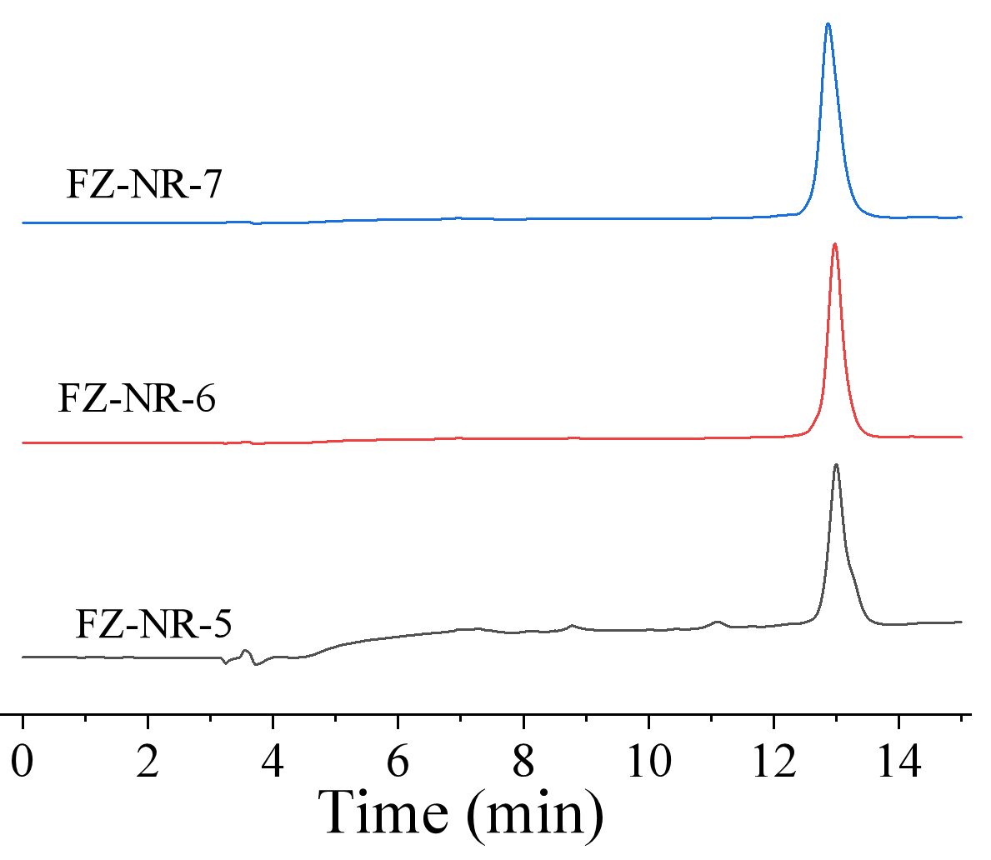
Supplementary Figure S1. High Performance Liquid Chromatography (HPLC) analysis of FZ-NR-5, FZ-NR-6, and FZ-NR-7

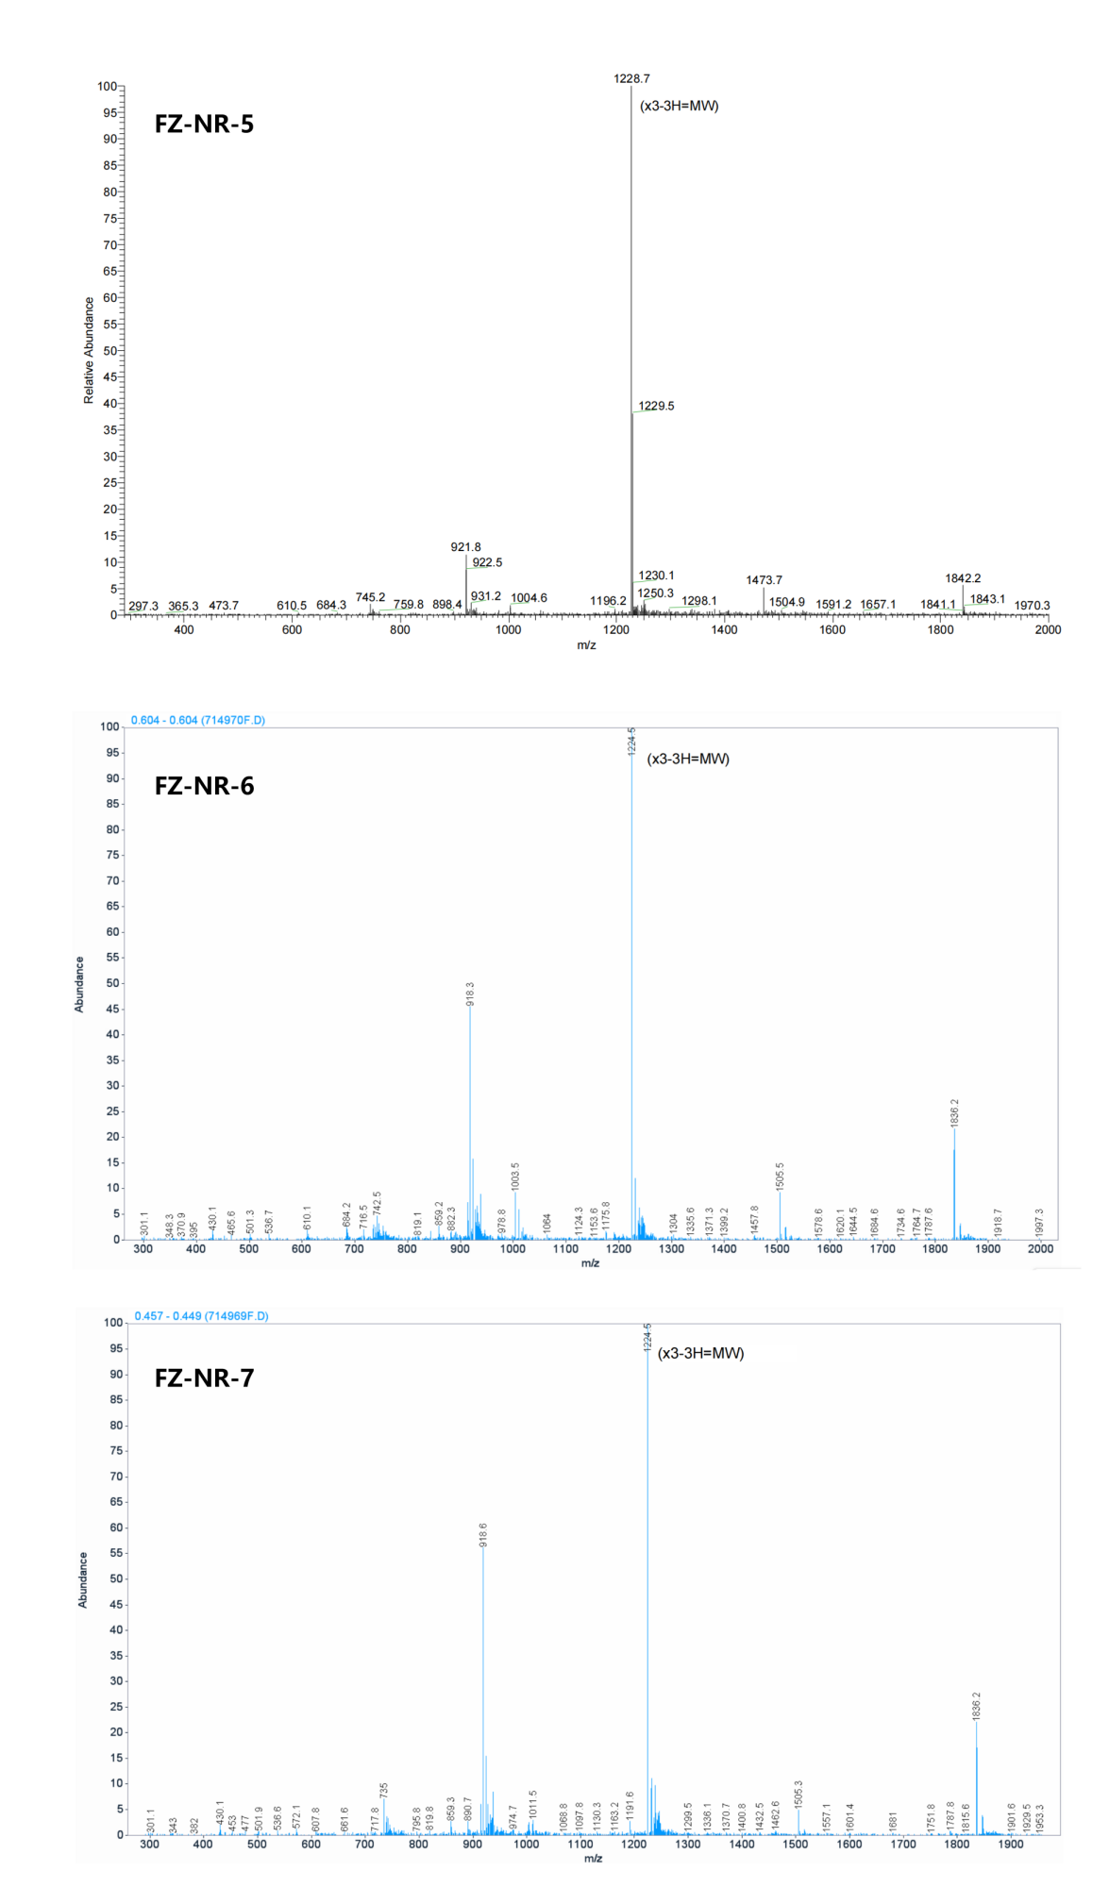
Supplementary Figure S2. Mass spectrum analysis of FZ-NR-5, FZ-NR-6, and FZ-NR-7

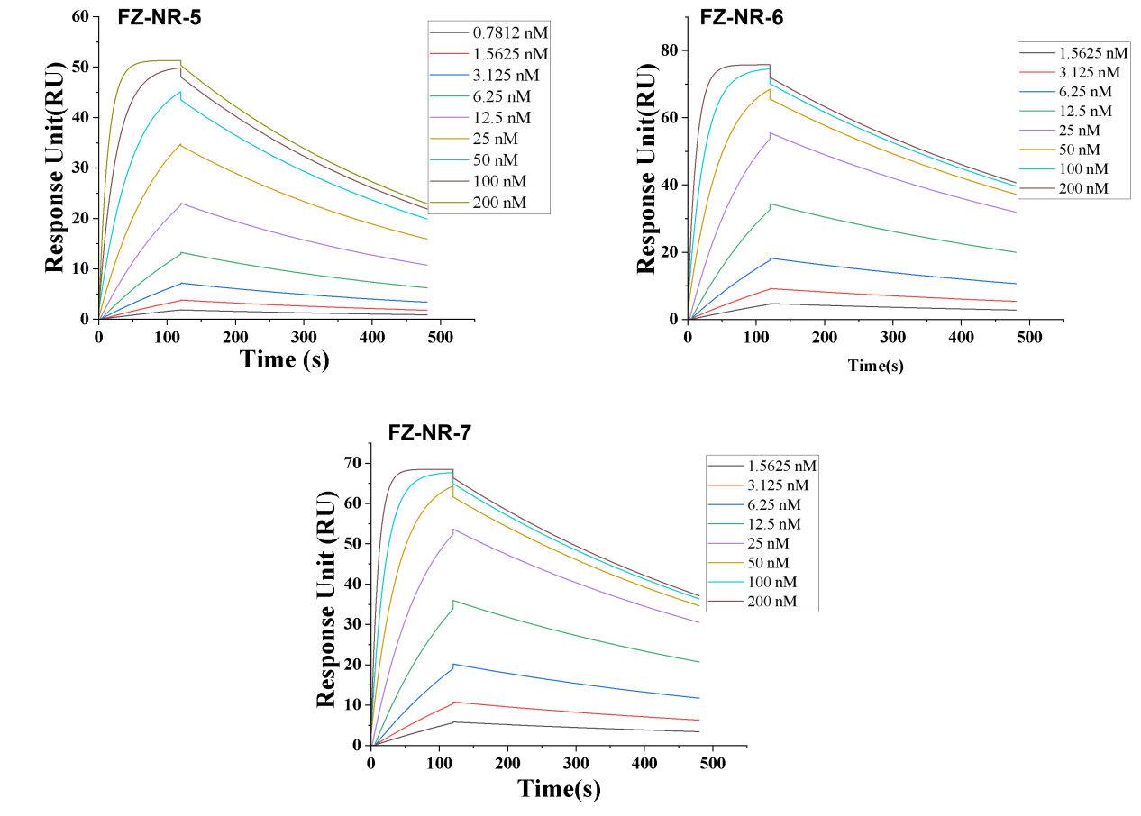
Supplementary Figure S3. Binding response between human Nectin-4 protein and different concentrations (0.7812−200 nM) of FZ-NR-5, FZ-NR-6 and FZ-NR-7

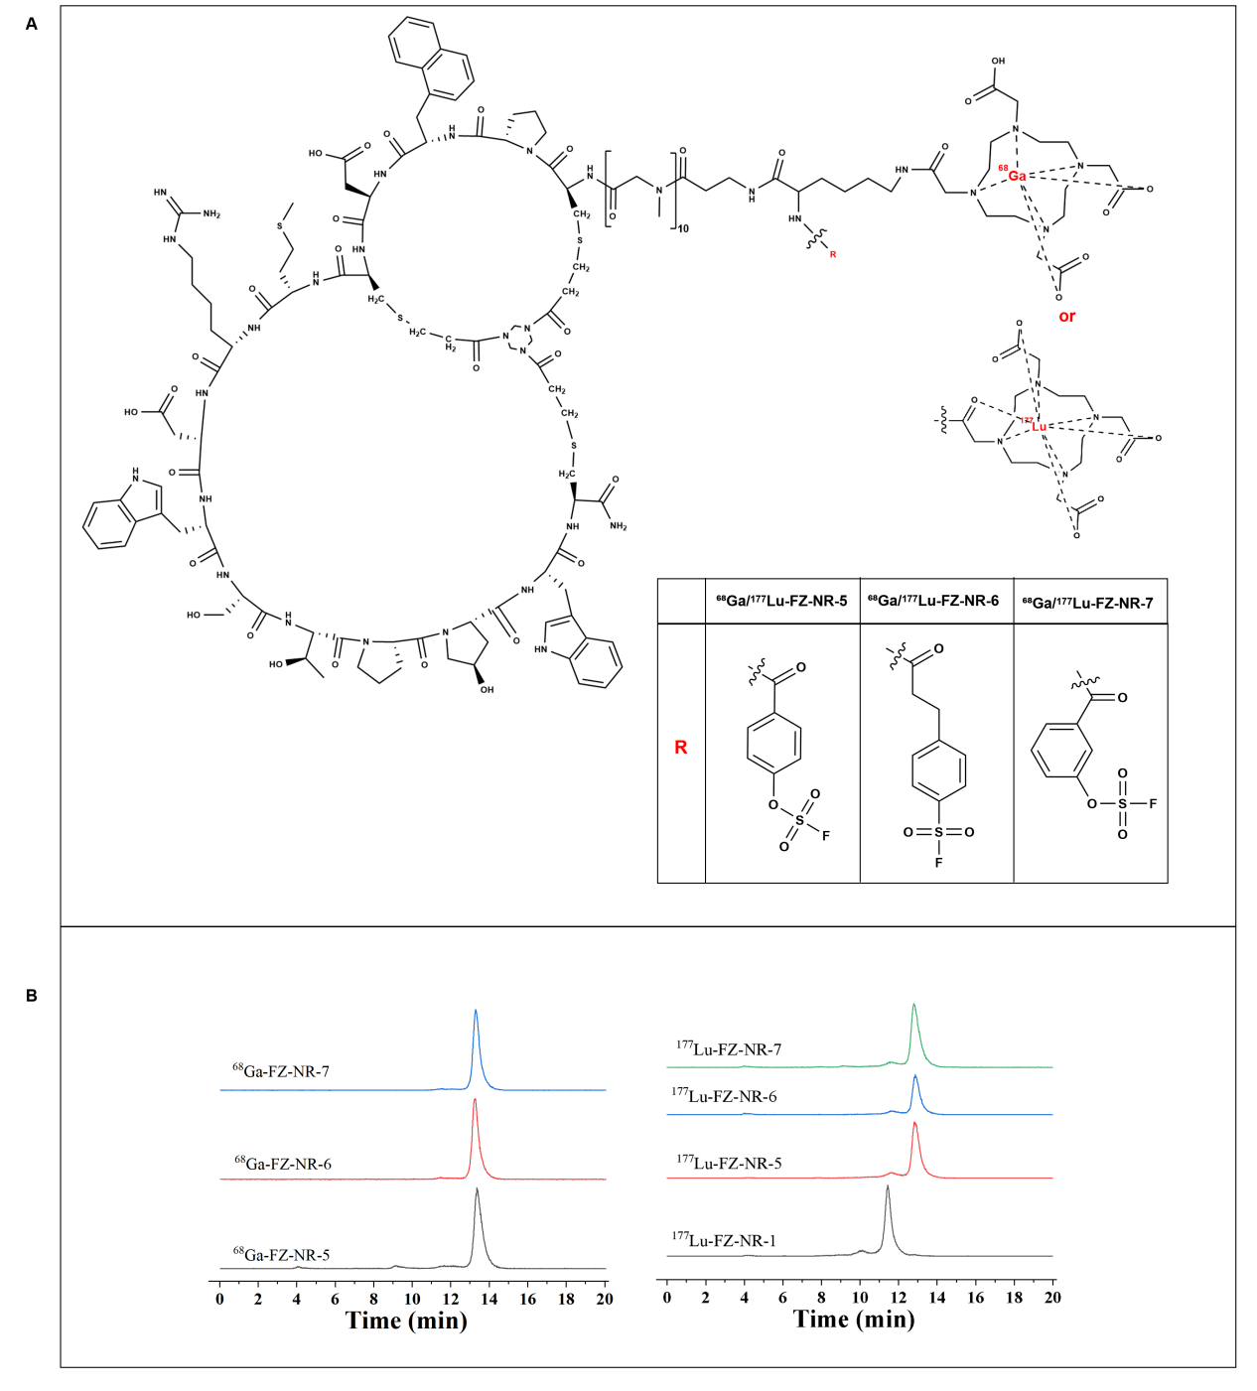
Supplementary Figure S4. (A) Radiochemical structure of the Nectin-4-targeted covalent bicyclic peptide radioligands ⁶⁸Ga/¹⁷⁷Lu-FZ-NRs, (B)Radio-high performance liquid chromatography analysis of ⁶⁸Ga/¹⁷⁷Lu-FZ-NRs

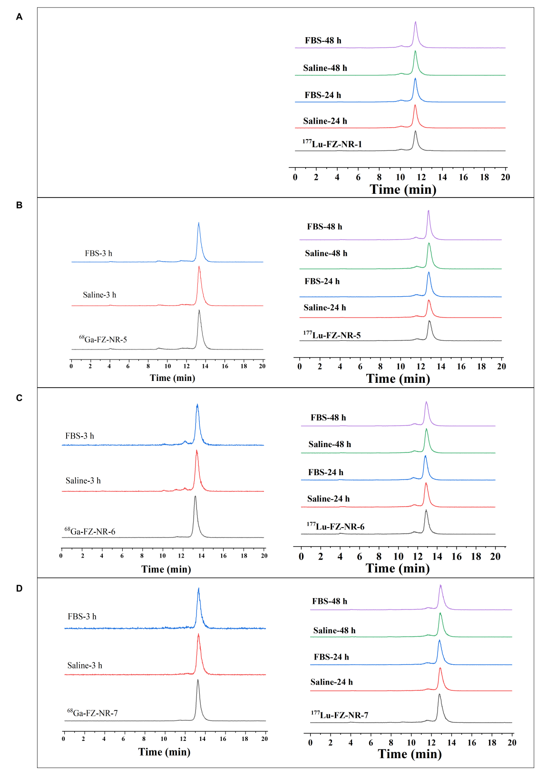
Supplementary Figure S5. Stability of (A) ¹⁷⁷Lu-FZ-NR-1, (B) ⁶⁸Ga/¹⁷⁷Lu-FZ-NR-5, (C) ⁶⁸Ga/¹⁷⁷Lu-FZ-NR-6, and (D) ⁶⁸Ga/¹⁷⁷Lu-FZ-NR-7 in fetal bovine serum (FBS) and saline over time.

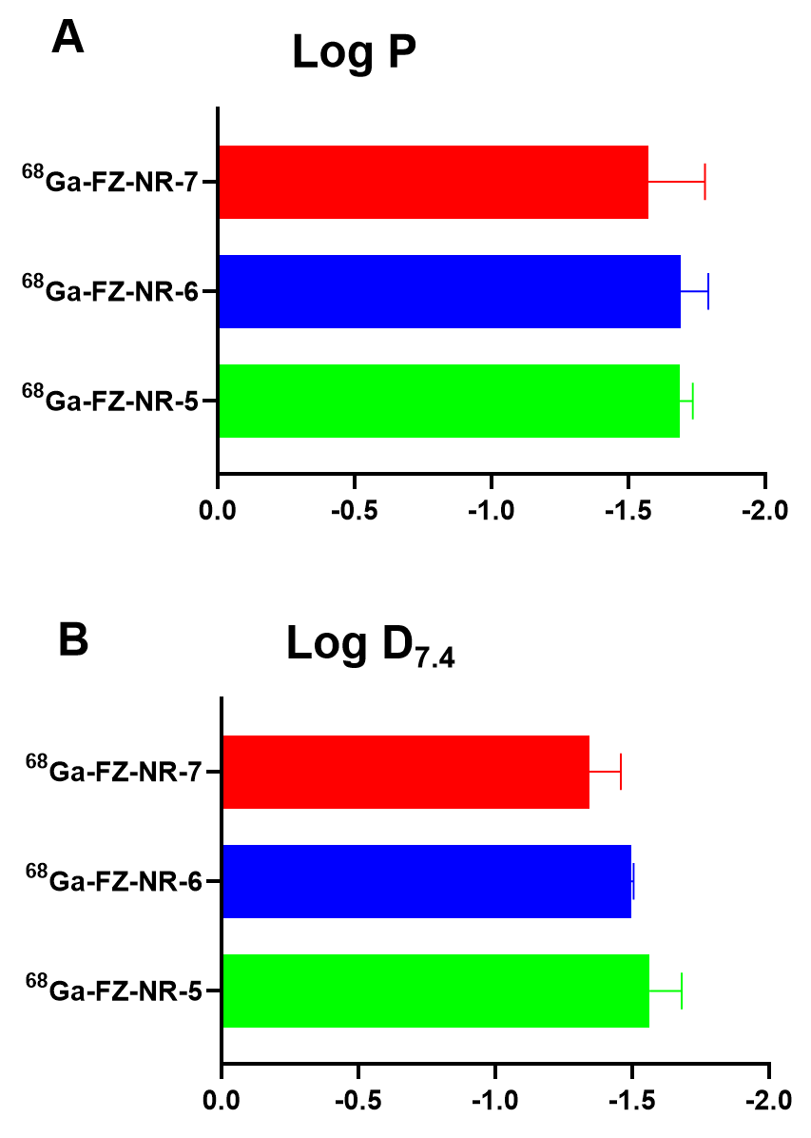
Supplementary Figure S6. The lipophilicity assessment of ⁶⁸Ga-FZ-NRs. (A) logP and (B) logD_{7.4} for ⁶⁸Ga-FZ-NRs.

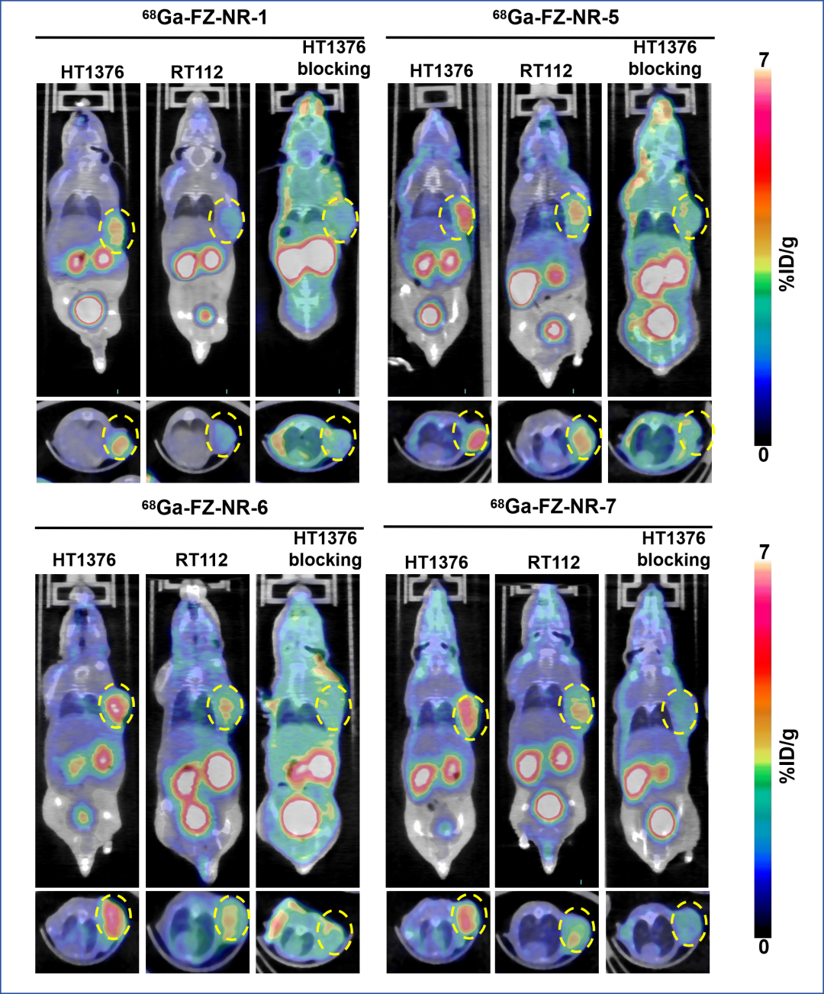
Supplementary Figure S7. MicroPET/CT imaging of ⁶⁸Ga-FZ-NRs. MicroPET/CT images of ⁶⁸Ga-FZ-NR-1, ⁶⁸Ga-FZ-NR-5, ⁶⁸Ga-FZ-NR-6, and ⁶⁸Ga-FZ-NR-7 in HT1376 and RT112 tumor models at 60 minutes (60-minute blocking for HT1376 tumor model) after injection.The yellow dashed circles indicate the tumor positions.

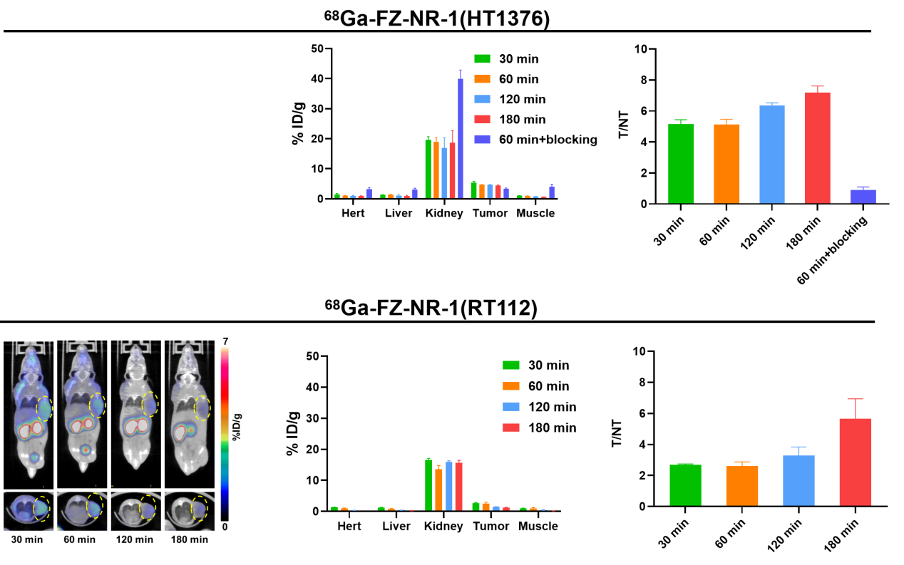
Supplementary Figure S8. MicroPET/CT images of ⁶⁸Ga-FZ-NR-1 in HT1376 and RT112 tumor models at 30-, 60-, 120-, and 180 minutes after injection. The quantification of the regions of interest (ROIs) in HT1376 and RT112 tumor models is expressed as %ID/g of ⁶⁸Ga-FZ-NR-1, and the T/NT (tumor to muscle) ratios in HT1376 and RT112 tumor models for ⁶⁸Ga-FZ-NR-1.

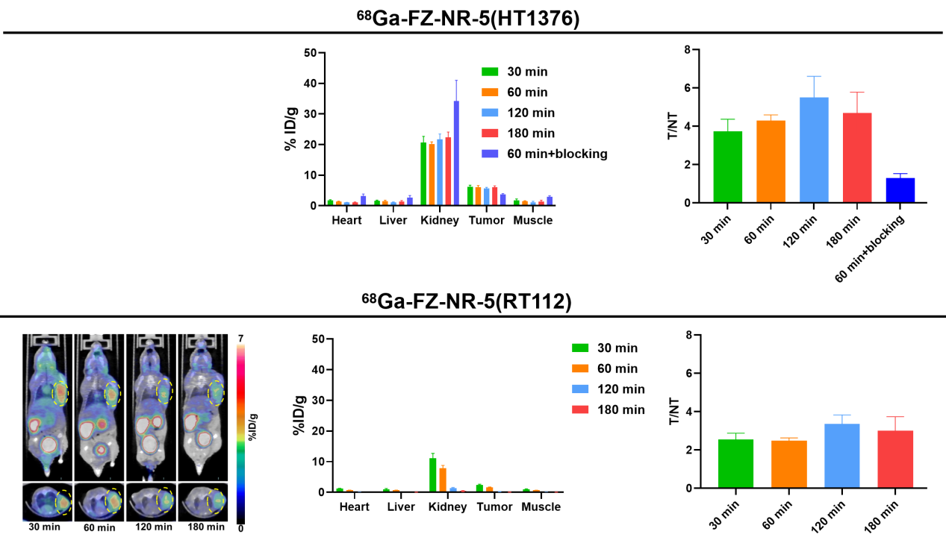
Supplementary Figure S9. MicroPET/CT images of ⁶⁸Ga-FZ-NR-5 in HT1376 and RT112 tumor models at 30-, 60-, 120-, and 180 minutes after injection. The quantification of the regions of interest (ROIs) in HT1376 and RT112 tumor models is expressed as %ID/g of ⁶⁸Ga-FZ-NR-5, and the T/NT (tumor to muscle) ratios in HT1376 and RT112 tumor models for ⁶⁸Ga-FZ-NR-5.

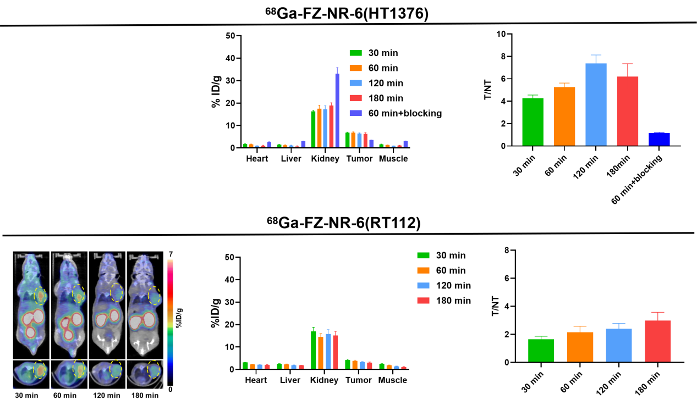
Supplementary Figure S10. MicroPET/CT images of ⁶⁸Ga-FZ-NR-6 in HT1376 and RT112 tumor models at 30-, 60-, 120-, and 180 minutes after injection. The quantification of the regions of interest (ROIs) in HT1376 and RT112 tumor models is expressed as %ID/g of ⁶⁸Ga-FZ-NR-6, and the T/NT (tumor to muscle) ratios in HT1376 and RT112 tumor models for ⁶⁸Ga-FZ-NR-6.

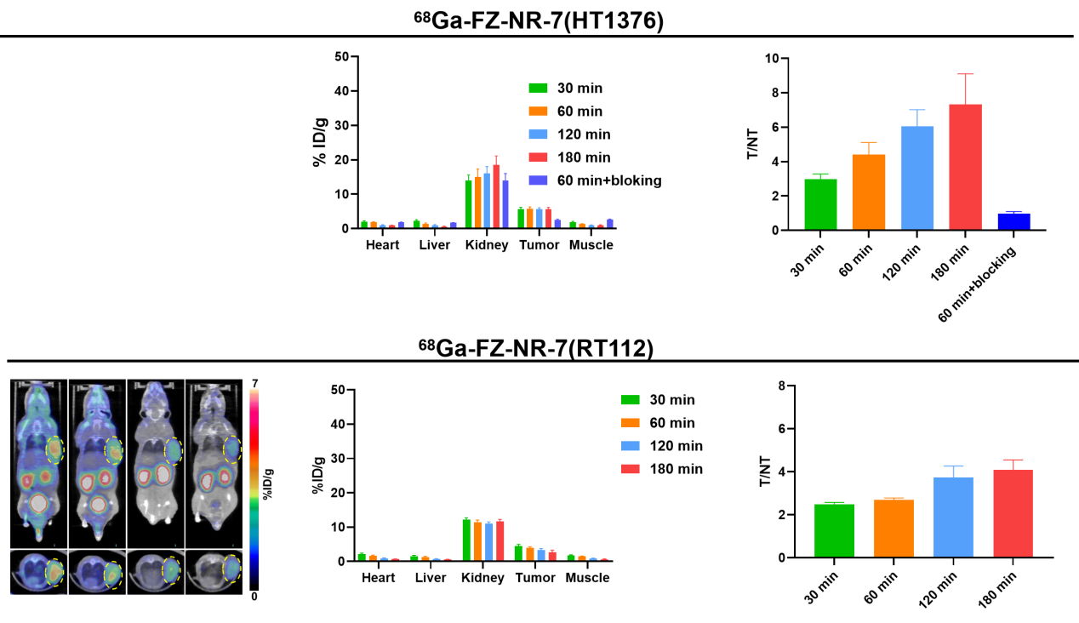
Supplementary Figure S11. MicroPET/CT images of ⁶⁸Ga-FZ-NR-7 in HT1376 and RT112 tumor models at 30-, 60-, 120-, and 180 minutes after injection. The quantification of the regions of interest (ROIs) in HT1376 and RT112 tumor models is expressed as %ID/g of ⁶⁸Ga-FZ-NR-7, and the T/NT (tumor to muscle) ratios in HT1376 and RT112 tumor models for ⁶⁸Ga-FZ-NR-7.

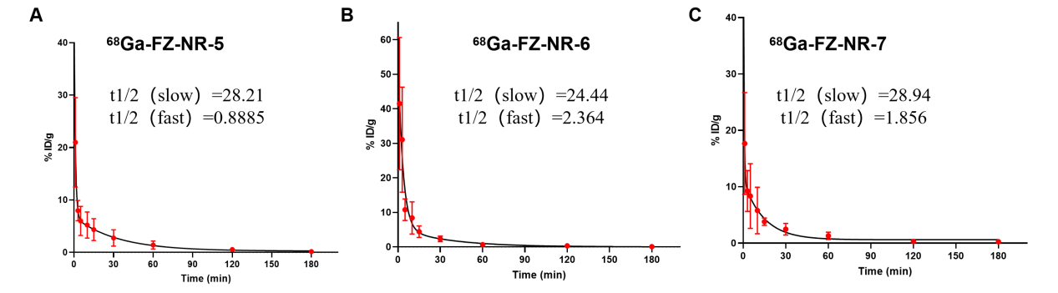
Supplementary Figure S12. Pharmacokinetics of the ⁶⁸Ga-FZ-NRs. Blood clearance of the three ⁶⁸Ga-FZ-NRs radioligands in vivo (A) ⁶⁸Ga-FZ-NR-5, (B) ⁶⁸Ga-FZ-NR-6, and (C) ⁶⁸Ga-FZ-NR-7.

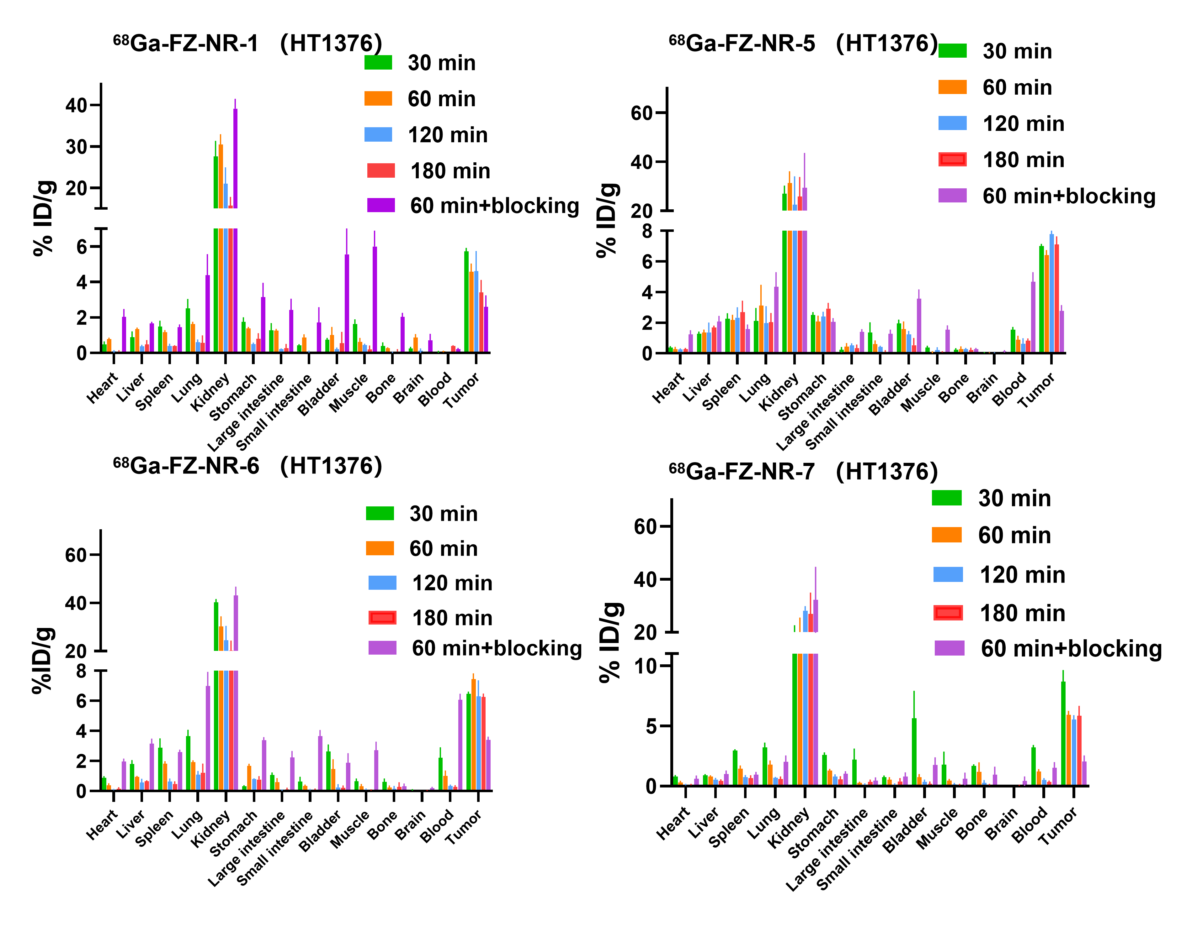
Supplementary Figure S13.The biodistribution of ⁶⁸Ga-FZ-NRs at different time points (30-min, 60-min, 120-min, and 180-min) in HT1376 tumor-bearing mice (n = 3/group).

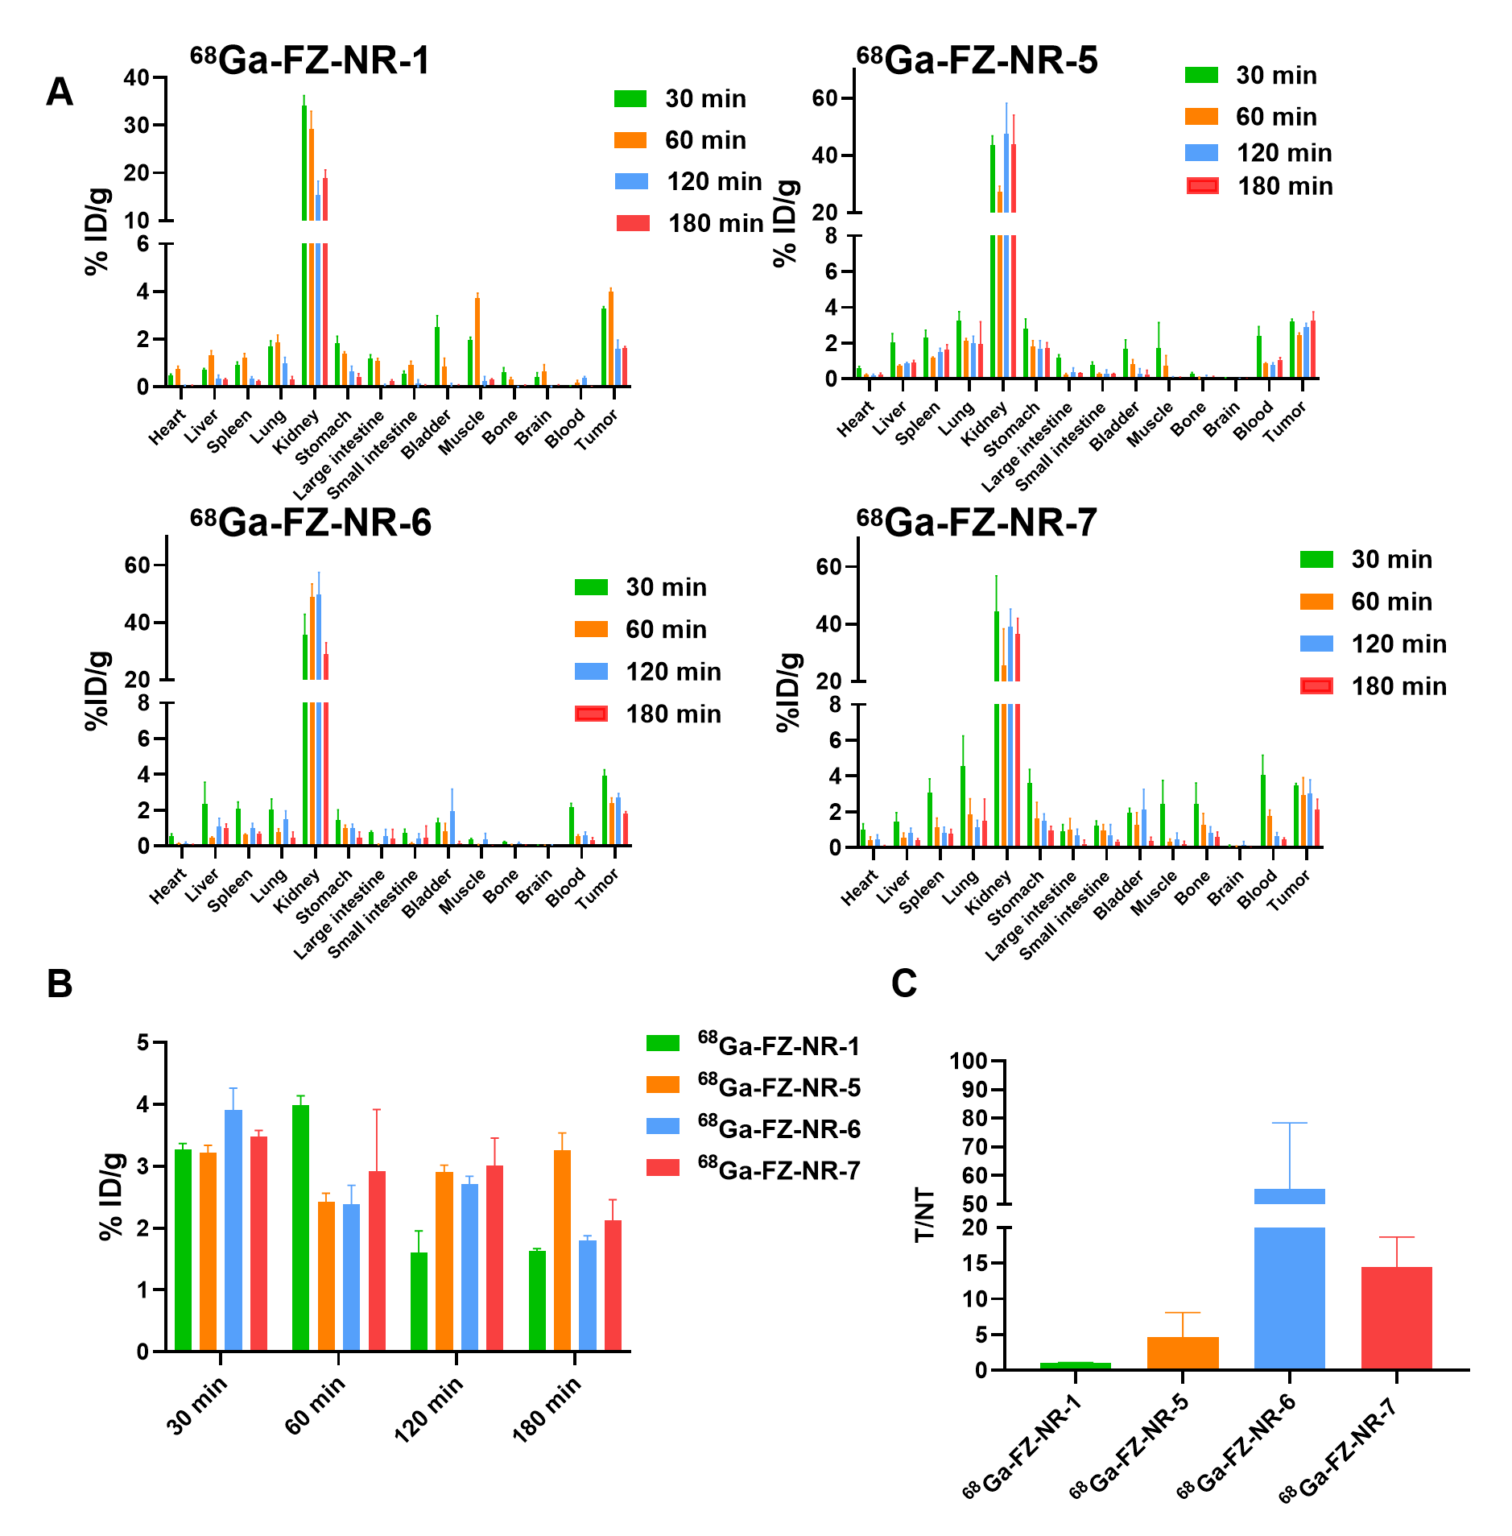
Supplementary Figure S14. In vivo efficacy and specificity of ⁶⁸Ga-FZ-NRs. (A) Biodistribution of ⁶⁸Ga-FZ-NRs in RT112 (%ID/g); (B) Tumor uptake of ⁶⁸Ga-FZ-NRs from biodistribution; (C) Corresponding tumor-to-muscle (T/NT) ratio from biodistribution (n = 3)

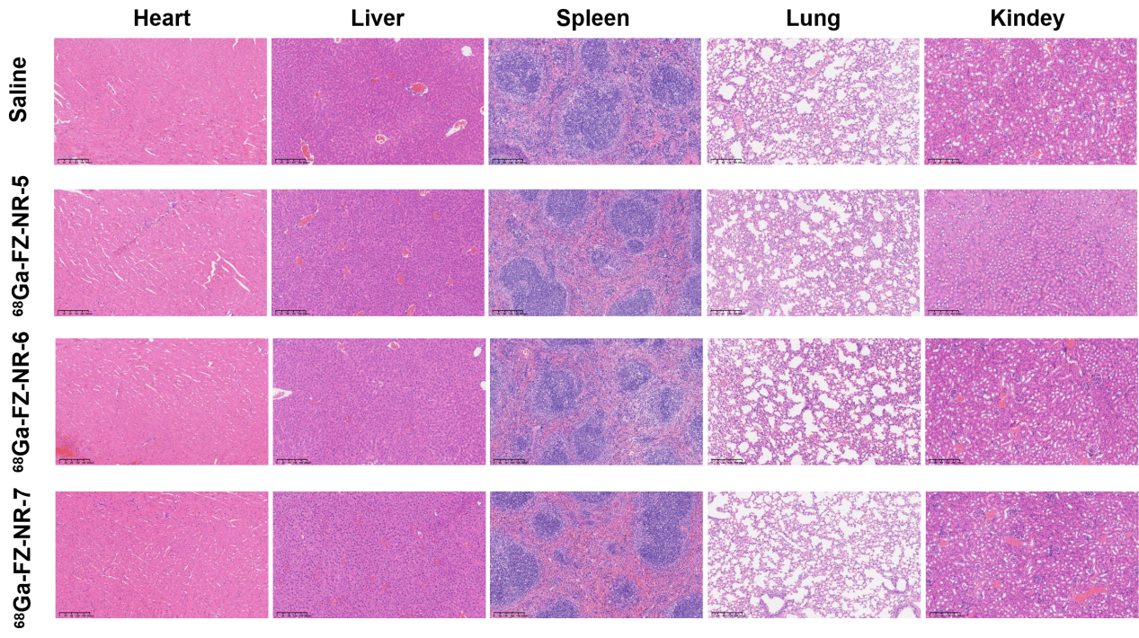
Supplementary Figure S15. Toxicity test of ⁶⁸Ga-FZ-NRs. H&E staining of main organs from the test group and control group (n = 3 for the ⁶⁸Ga-FZ-NRs treatment group and n = 3 for the saline treatment group).

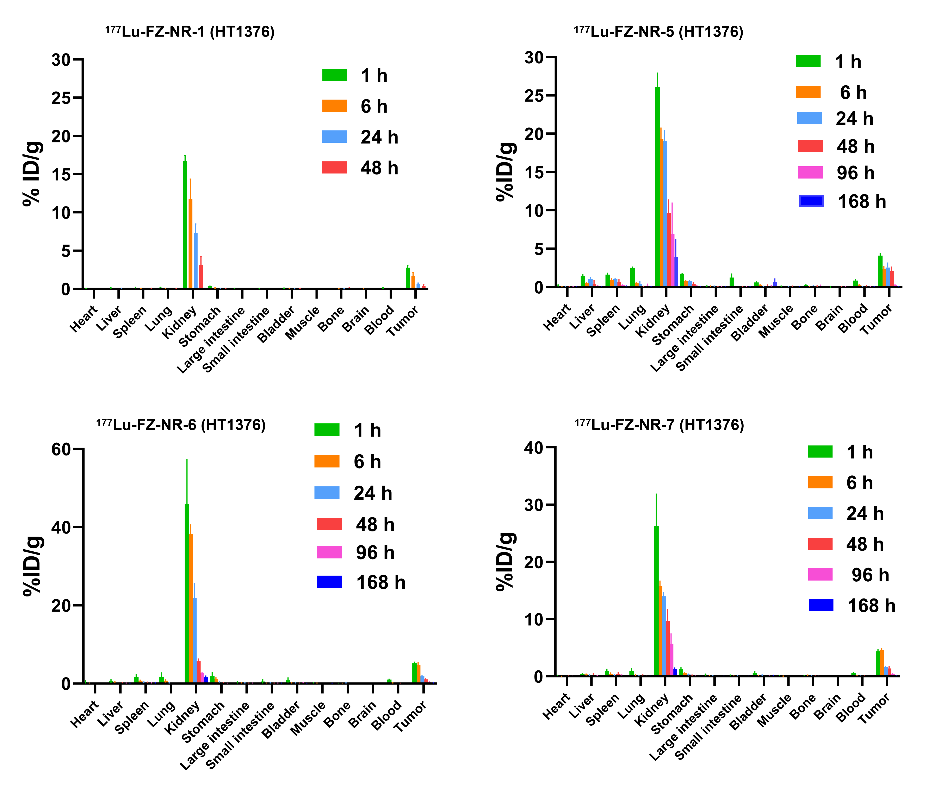
Supplementary Figure S16. The biodistribution of ¹⁷⁷Lu-FZ-NRs at different time points (1-hour, 6-hours, 24-hours, 48-hours, 96-hours, and 168-hours) in HT1376 tumor-bearing BALB/c nude mice (n = 3/group).

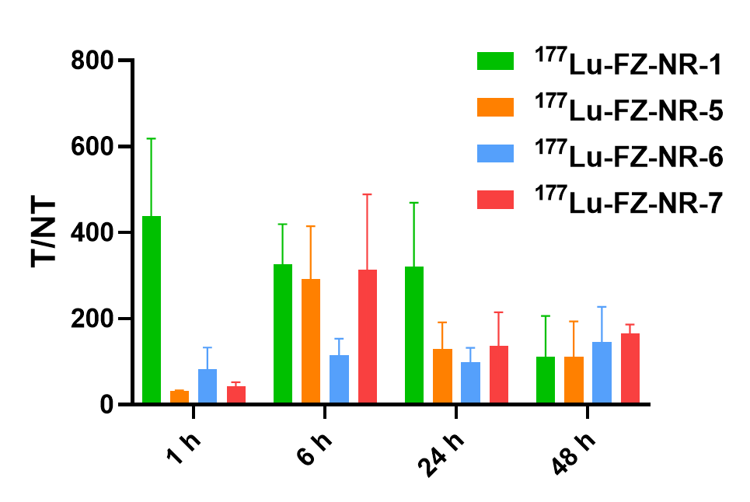
Supplementary Figure S17. Corresponding tumor-to-muscle (T/NT) ratio from the biodistribution of ¹⁷⁷Lu-FZ-NRs in the HT1376 tumor model.

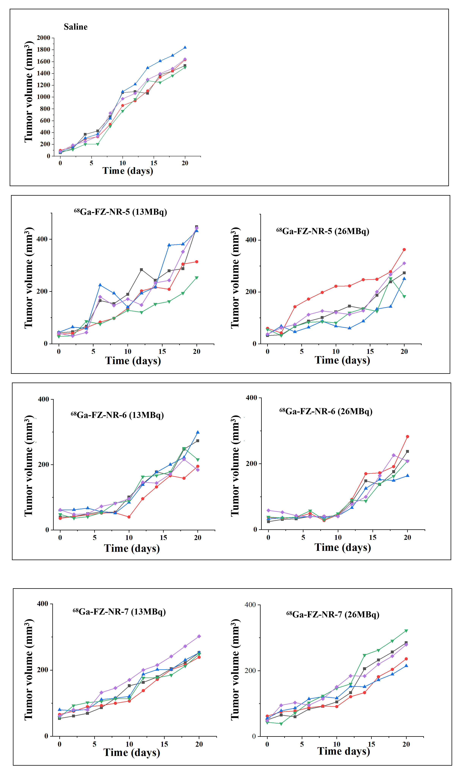
Supplementary Figure S18. Tumor volume curves for individual mice (n = 5).

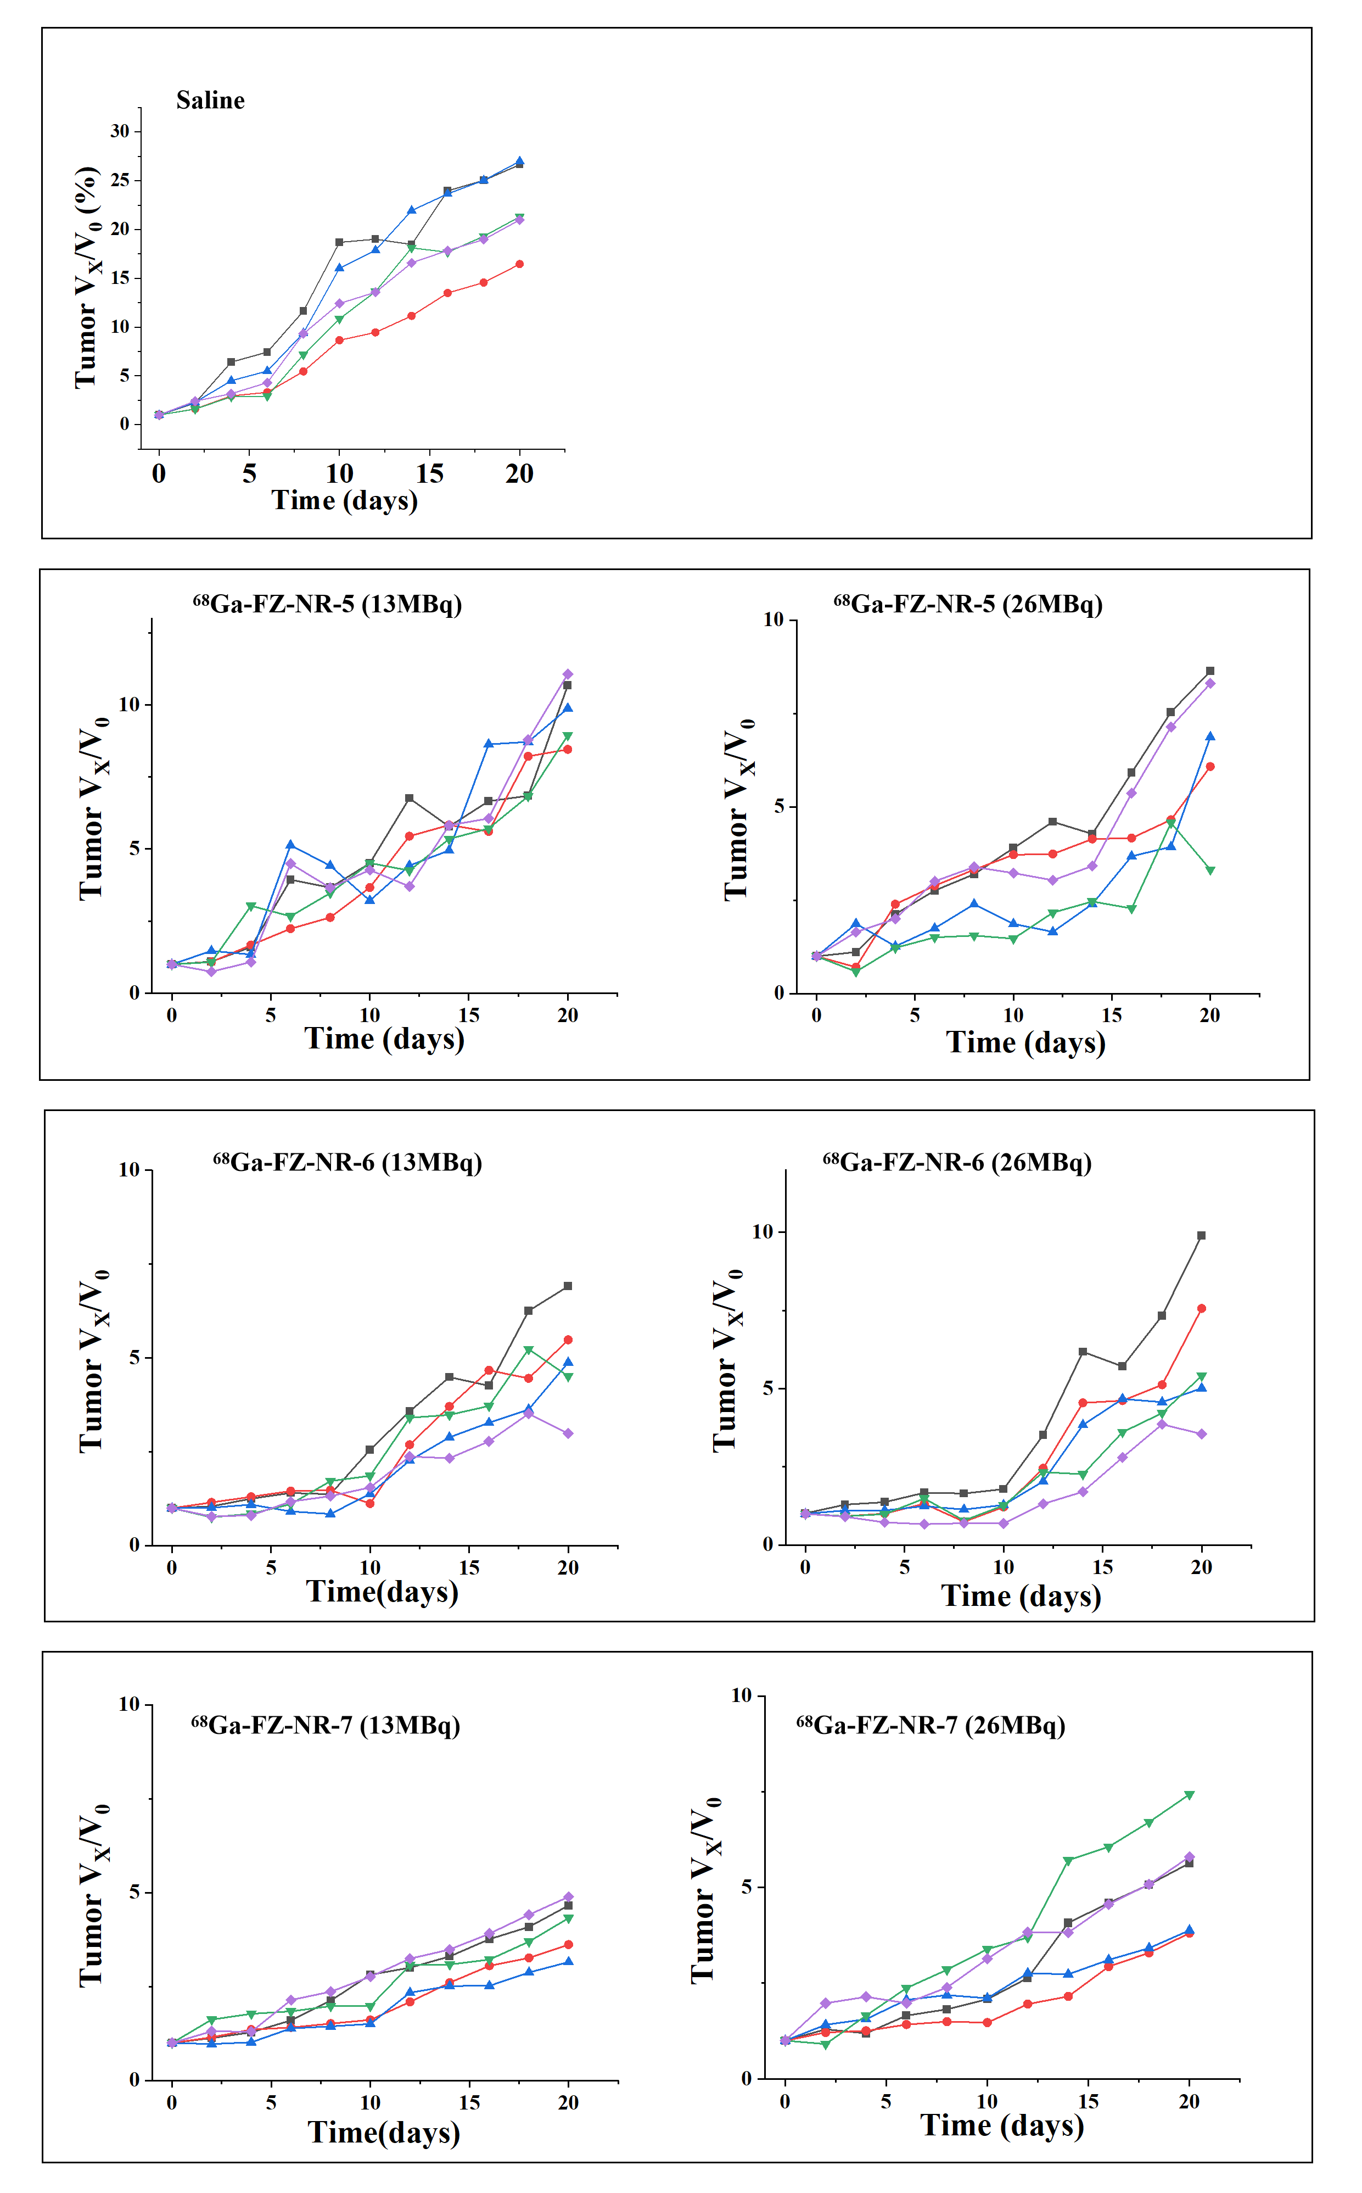
Supplementary Figure S19. The change in tumor volume for individual mice (n = 5).

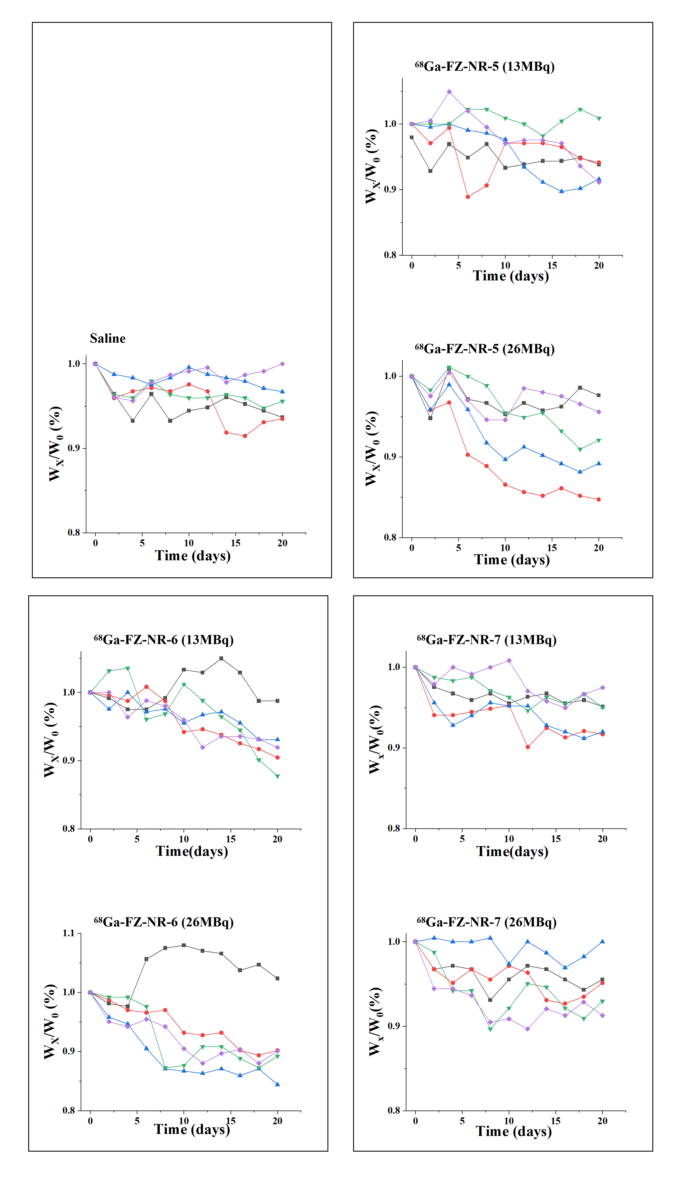
Supplementary Figure S20. The change in body weight for individual mice was analyzed (n = 5).

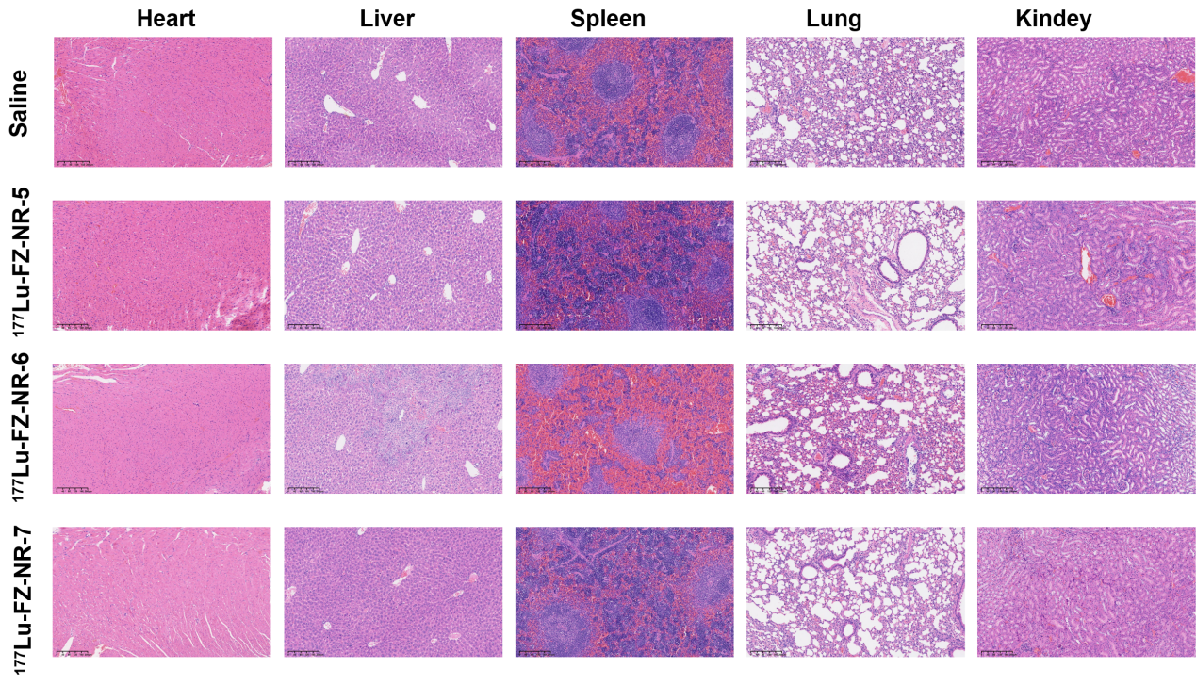
Supplementary Figure S21. Toxicity test of ¹⁷⁷Lu-FZ-NRs. Hematoxylin and Eosin staining of main organs from the test group and control group (n = 3 for the ¹⁷⁷Lu-FZ-NRs treatment group and n = 3 for the saline treatment group).

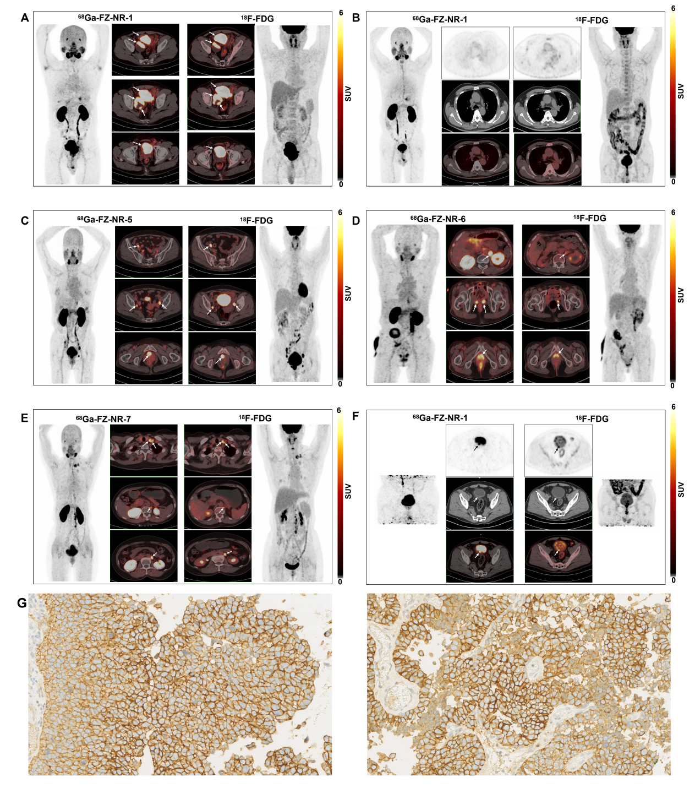
Supplementary Figure S22. PET/CT images of ⁶⁸Ga-FZ-NRs and ¹⁸F-FDG in representative Nectin-4-positive UC patients. (A) Patient 06, (B) Patient 07, (C) Patient 09, (D) Patient 12, and (E) Patient 15 at static time points (50-70 minutes). (F) Patient 07 underwent delayed imaging after multiple urinations during the static time points. (G) Immunohistochemical staining of UC patient 06 (left) and patient 07 (right), scale 40 x.

Supplementary Table S1. The biodistribution of ⁶⁸Ga-FZ-NR-1 at different time points (30-min, 60-min, 120-min, and 180- min) in HT1376 tumor-bearing mice (n = 3/group).
Tissue | 30 min  (%ID/g) | 60 min  (%ID/g) | 120 min  (%ID/g) | 180 min  (%ID/g) | 60 min+blocking  (%ID/g)
Heart | 0.484±0.21 | 0.80±0.07 | 0.09±0.06 | 0.07±0.05 | 2.04±0.40
Liver | 0.89±0.50 | 1.35±0.07 | 0.38±0.07 | 0.49±0.20 | 1.66±0.06
Spleen | 1.48±0.54 | 1.17±0.15 | 0.39±0.17 | 0.39±0.01 | 1.44±0.12
Lung | 2.51±0.86 | 1.64±0.14 | 0.62±0.20 | 0.56±0.39 | 4.38±1.15
Kidney | 27.56±6.26 | 30.51±3.97 | 21.04±6.50 | 15.72±1.95 | 39.12±2.25
Stomach | 1.76±0.39 | 1.38±0.10 | 0.50±0.09 | 0.80±0.28 | 3.15±0.76
Large intestine | 1.27±0.66 | 1.26±0.09 | 0.21±0.03 | 0.28±0.20 | 2.42±0.60
Small intestine | 0.44±0.04 | 0.87±0.24 | 0.07±0.03 | 0.01±0.01 | 1.70±0.83
Bladder | 0.75±0.11 | 1.00±0.76 | 0.21±0.11 | 0.55±0.61 | 5.55±1.99
Muscle | 1.62±0.41 | 0.62±0.34 | 0.45±0.07 | 0.19±0.20 | 6.00±0.86
Bone | 0.38±0.31 | 0.27±0.02 | 0.03±0.02 | 0.08±0.11 | 2.04±0.19
Brain | 0.26±0.07 | 0.87±0.26 | 0.13±0.15 | 0.01±0.01 | 0.72±0.32
Blood | 0.05±0.05 | 0.09±0.01 | 0.10±0.01 | 0.39±0.01 | 0.21±0.04
Tumor | 5.73±0.26 | 4.57±0.73 | 4.61±1.90 | 3.41±0.67 | 2.60±0.63

Supplementary Table S2. The biodistribution of ⁶⁸Ga-FZ-NR-5 at different time points (30-min, 60-min, 120-min, and 180- min) in HT1376 tumor-bearing mice (n = 3/group).
Tissue | 30 min  (%ID/g) | 60 min  (%ID/g) | 120 min  (%ID/g) | 180 min  (%ID/g) | 60 min+blocking  (%ID/g)
Heart | 0.38±0.08 | 0.29±0.16 | 0.25±0.03 | 0.27±0.04 | 1.23±0.38
Liver | 1.27±0.18 | 1.35±0.27 | 1.37±0.60 | 1.68±0.09 | 2.07±0.57
Spleen | 2.26±0.54 | 2.17±0.51 | 2.33±0.63 | 2.69±0.70 | 1.58±0.46
Lung | 2.11±1.42 | 3.10±2.31 | 1.96±1.07 | 2.03±0.56 | 4.34±1.57
Kidney | 27.03±5.18 | 31.33±7.86 | 22.59±11.26 | 25.85±7.68 | 29.53±24.03
Stomach | 2.50±0.24 | 2.08±0.58 | 2.41±0.26 | 2.93±0.32 | 2.06±0.34
Large intestine | 0.23±0.24 | 0.43±0.34 | 0.50±0.11 | 0.34±0.19 | 1.39±0.24
Small intestine | 1.35±1.09 | 0.60±0.35 | 0.41±0.05 | 0.08±0.09 | 1.28±0.39
Bladder | 1.95±0.35 | 1.57±0.80 | 1.23±0.19 | 0.52±0.43 | 3.57±0.98
Muscle | 0.37±0.16 | 0.07±0.04 | 0.20±0.15 | 0.06±0.02 | 1.55±0.40
Bone | 0.24±0.10 | 0.26±0.26 | 0.26±0.04 | 0.20±0.12 | 0.27±0.08
Brain | 0.02±0.01 | 0.01±0.01 | 0.02±0.01 | 0.01±0.01 | 0.13±0.06
Blood | 1.53±0.26 | 0.89±0.37 | 0.61±0.33 | 0.83±0.10 | 4.66±1.04
Tumor | 7.01±0.15 | 6.41±0.51 | 7.78±0.45 | 7.10±0.50 | 2.75±0.60

Supplementary Table S3. The biodistribution of ⁶⁸Ga-FZ-NR-6 at different time points (30-min, 60-min, 120-min, and 180- min) in HT1376 tumor-bearing mice (n = 3/group).
Tissue | 30 min  (%ID/g) | 60 min  (%ID/g) | 120 min  (%ID/g) | 180 min  (%ID/g) | 60 min+blocking  (%ID/g)
Heart | 0.87±0.11 | 0.38±0.16 | 0.06±0.04 | 0.15±0.05 | 1.97±0.26
Liver | 1.79±0.37 | 0.95±0.02 | 0.56±0.21 | 0.63±0.03 | 3.15±0.51
Spleen | 2.87±1.00 | 1.82±0.20 | 0.64±0.14 | 0.46±0.13 | 2.59±0.20
Lung | 3.65±0.66 | 1.91±0.14 | 1.08±0.20 | 1.22±0.56 | 6.97±1.58
Kidney | 40.21±2.12 | 30.18±6.95 | 24.57±5.61 | 20.23±3.90 | 43.10±6.00
Stomach | 0.31±0.07 | 1.66±0.19 | 0.79±0.02 | 0.76±0.19 | 3.38±0.27
Large intestine | 1.05±0.24 | 0.59±0.39 | 0.05±0.02 | 0.10±0.08 | 2.23±0.67
Small intestine | 0.63±0.47 | 0.34±0.08 | 0.06±0.04 | 0.09±0.04 | 2.66±0.61
Bladder | 2.64±0.72 | 1.46±1.05 | 0.24±0.17 | 0.20±0.13 | 1.89±1.01
Muscle | 0.66±0.23 | 0.30±0.22 | 0.07±0.06 | 0.03±0.03 | 2.72±0.90
Bone | 0.61±0.31 | 0.23±0.16 | 0.14±0.15 | 0.26±0.28 | 0.31±0.24
Brain | 0.07±0.01 | 0.03±0.01 | 0.01±0.01 | 0.01±0.01 | 0.20±0.06
Blood | 2.22±1.12 | 1.00±0.57 | 0.33±0.05 | 0.28±0.06 | 6.07±0.62
Tumor | 6.47±0.18 | 7.43±0.60 | 6.29±1.02 | 6.25±0.19 | 3.39±0.32

Supplementary Table S4. The biodistribution of ⁶⁸Ga-FZ-NR-7 at different time points (30-min, 60-min, 120-min, and 180- min) in HT1376 tumor-bearing mice (n = 3/group).
Tissue | 30 min  (%ID/g) | 60 min  (%ID/g) | 120 min  (%ID/g) | 180 min  (%ID/g) | 60 min+blocking  (%ID/g)
Heart | 0.78±0.14 | 0.31±0.13 | 0.11±0.03 | 0.08±0.05 | 0.61±0.39
Liver | 0.90±0.08 | 0.78±0.12 | 0.54±0.09 | 0.43±0.08 | 1.00±0.40
Spleen | 2.94±0.11 | 1.46±0.35 | 0.74±0.12 | 0.66±0.18 | 0.94±0.31
Lung | 3.23±0.57 | 1.77±0.53 | 0.69±0.02 | 0.59±0.16 | 2.02±0.80
Kidney | 19.36±5.22 | 19.27±10.37 | 28.13±1.45 | 26.87±7.86 | 32.24±21.19
Stomach | 2.58±0.27 | 1.29±0.16 | 0.78±0.15 | 0.57±0.19 | 1.04±0.25
Large intestine | 2.18±1.53 | 0.27±0.07 | 0.14±0.04 | 0.34±0.16 | 0.44±0.38
Small intestine | 0.74±0.16 | 0.52±0.27 | 0.11±0.05 | 0.39±0.21 | 0.78±0.51
Bladder | 5.65±3.83 | 0.75±0.33 | 0.35±0.14 | 0.19±0.13 | 1.76±1.00
Muscle | 1.77±1.80 | 0.45±0.17 | 0.15±0.06 | 0.08±0.06 | 0.60±0.81
Bone | 1.68±0.14 | 1.18±1.26 | 0.27±0.18 | 0.06±0.06 | 0.95±1.04
Brain | 0.05±0.02 | 0.01±0.01 | 0.01±0.01 | 0.03±0.02 | 0.42±0.56
Blood | 3.21±0.25 | 1.20±0.29 | 0.51±0.10 | 0.34±0.07 | 1.51±0.75
Tumor | 8.69±1.57 | 5.91±0.49 | 5.52±0.32 | 5.84±0.77 | 2.05±0.76

Supplementary Table S5. The biodistribution of ⁶⁸Ga-FZ-NR-1 at different time points (30-min, 60-min, 120-min, and 180-min) in RT112 tumor-bearing mice (n = 3/group).
Tissue | 30 min(%ID/g) | 60 min(%ID/g) | 120 min(%ID/g) | 180 min(%ID/g)
Heart | 0.49±0.06 | 0.74±0.23 | 0.06±0.02 | 0.06±0.02
Liver | 0.72±0.08 | 1.33±0.32 | 0.33±0.27 | 0.29±0.06
Spleen | 0.93±0.18 | 1.22±0.32 | 0.33±0.17 | 0.25±0.03
Lung | 1.70±0.39 | 1.85±0.56 | 0.98±0.45 | 0.31±0.12
Kidney | 34.21±3.48 | 29.19±6.49 | 15.46±4.88 | 18.89±1.75
Stomach | 1.83±0.50 | 1.39±0.15 | 0.66±0.37 | 0.43±0.13
Large intestine | 1.21±0.24 | 1.09±0.17 | 0.09±0.05 | 0.24±0.06
Small intestine | 0.56±0.19 | 0.91±0.29 | 0.15±0.25 | 0.05±0.04
Bladder | 2.52±0.81 | 0.83±0.64 | 0.08±0.12 | 0.06±0.04
Muscle | 1.96±0.21 | 3.72±0.37 | 0.24±0.33 | 0.32±0.02
Bone | 0.60±0.36 | 0.31±0.13 | 0.01±0.01 | 0.04±0.05
Brain | 0.40±0.34 | 0.64±0.50 | 0.02±0.01 | 0.07±0.03
Blood | 0.04±0.01 | 0.19±0.15 | 0.40±0.07 | 0.01±0.01
Tumor | 3.27±0.18 | 3.98±0.27 | 1.61±0.60 | 1.64±0.05

Supplementary Table S6. The biodistribution of ⁶⁸Ga-FZ-NR-5 at different time points (30-min, 60-min, 120-min, and 180-min) in RT112 tumor-bearing mice (n = 3/group).
Tissue | 30 min(%ID/g) | 60 min(%ID/g) | 120 min(%ID/g) | 180 min(%ID/g)
Heart | 0.59±0.18 | 0.24±0.03 | 0.21±0.04 | 0.23±0.09
Liver | 2.04±0.85 | 0.74±0.08 | 0.88±0.03 | 0.90±0.14
Spleen | 2.32±0.68 | 1.16±0.12 | 1.50±0.21 | 1.63±0.29
Lung | 3.26±0.84 | 2.12±0.22 | 1.98±0.40 | 1.94±1.25
Kidney | 43.46±5.85 | 27.14±3.62 | 47.64±10.63 | 43.86±10.20
Stomach | 2.80±0.94 | 1.81±0.55 | 1.69±0.46 | 1.72±0.30
Large intestine | 1.18±0.31 | 0.26±0.07 | 0.38±0.22 | 0.31±0.03
Small intestine | 0.77±0.29 | 0.27±0.09 | 0.30±0.20 | 0.26±0.03
Bladder | 1.66±0.91 | 0.85±0.39 | 0.30±0.27 | 0.25±0.24
Muscle | 1.73±2.47 | 0.73±1.00 | 0.08±0.03 | 0.05±0.05
Bone | 0.27±0.16 | 0.05±0.07 | 0.12±0.08 | 0.09±0.05
Brain | 0.05±0.02 | 0.11±0.01 | 0.01±0.01 | 0.02±0.01
Blood | 2.41±0.88 | 0.87±0.05 | 0.77±0.14 | 1.06±0.14
Tumor | 3.22±0.21 | 2.42±0.25 | 2.91±0.19 | 3.26±0.48

Supplementary Table S7. The biodistribution of ⁶⁸Ga-FZ-NR-6 at different time points (30-min, 60-min, 120-min, and 180- min) in RT112 tumor-bearing mice (n = 3/group).
Tissue | 30 min(%ID/g) | 60 min(%ID/g) | 120 min(%ID/g) | 180 min(%ID/g)
Heart | 0.56±0.22 | 0.14±0.05 | 0.15±0.07 | 0.05±0.05
Liver | 0.35±2.10 | 0.46±0.09 | 1.08±0.47 | 1.02±0.22
Spleen | 2.10±0.62 | 0.63±0.07 | 0.99±0.27 | 0.70±0.07
Lung | 2.03±1.04 | 0.77±0.31 | 1.50±0.47 | 0.47±0.31
Kidney | 35.64±12.43 | 48.95±7.89 | 49.67±7.89 | 28.86±4.04
Stomach | 1.44±1.02 | 1.02±0.23 | 1.00±0.22 | 0.44±0.34
Large intestine | 0.76±0.13 | 0.09±0.03 | 0.54±0.39 | 0.43±0.49
Small intestine | 0.73±0.36 | 0.16±0.04 | 0.41±0.27 | 0.45±0.67
Bladder | 1.34±0.34 | 0.79±0.81 | 1.94±1.23 | 0.17±0.08
Muscle | 0.37±0.10 | 0.05±0.05 | 0.35±0.35 | 0.01±0.01
Bone | 0.22±0.05 | 0.07±0.02 | 0.14±0.07 | 0.03±0.01
Brain | 0.04±0.01 | 0.02±0.04 | 0.03±0.03 | 0.01±0.01
Blood | 2.19±0.34 | 0.58±0.08 | 0.59±0.19 | 0.34±0.13
Tumor | 3.91±0.62 | 2.38±0.54 | 2.71±0.22 | 1.81±0.12

Supplementary Table S8. The biodistribution of ⁶⁸Ga-FZ-NR-7 at different time points (30-min, 60-min, 120-min, and 180- min) in RT112 tumor-bearing mice (n = 3/group).
Tissue | 30 min(%ID/g) | 60 min(%ID/g) | 120 min(%ID/g) | 180 min(%ID/g)
Heart | 0.98±0.62 | 0.41±0.31 | 0.46±0.26 | 0.10±0.02
Liver | 1.44±0.90 | 0.56±0.45 | 0.81±0.28 | 0.41±0.09
Spleen | 3.10±1.28 | 1.12±0.93 | 0.80±0.35 | 0.76±0.26
Lung | 4.57±2.90 | 1.84±1.54 | 1.13±0.39 | 1.49±1.23
Kidney | 44.40±21.63 | 25.47±22.27 | 39.04±6.24 | 36.44±5.63
Stomach | 3.61±1.31 | 1.65±1.52 | 1.49±0.40 | 0.94±0.25
Large intestine | 0.93±0.63 | 0.99±1.11 | 0.67±0.36 | 0.21±0.22
Small intestine | 1.25±0.41 | 0.97±0.55 | 0.70±0.59 | 0.34±0.07
Bladder | 1.94±0.43 | 1.29±1.15 | 2.13±1.13 | 0.36±0.23
Muscle | 2.45±2.24 | 0.34±0.24 | 0.46±0.35 | 0.19±0.15
Bone | 2.43±2.03 | 1.27±1.11 | 0.80±0.36 | 0.59±0.28
Brain | 0.11±0.04 | 0.06±0.03 | 0.14±0.20 | 0.01±0.01
Blood | 4.04±1.96 | 1.75±0.60 | 0.65±0.19 | 0.44±0.09
Tumor | 3.48±1.83 | 2.93±1.71 | 3.01±0.77 | 2.13±0.57

Supplementary Table S9. The biodistribution of ¹⁷⁷Lu-FZ-NR-1 at different time points (1-h, 6-h, 24-h, and 48-h) in HT1376 tumor-bearing mice (n = 3/group).
Tissue | 1 h(%ID/g) | 6 h(%ID/g) | 24 h(%ID/g) | 48 h(%ID/g)
Heart | 0.05±0.02 | 0.01±0.01 | 0.01±0.01 | 0.02±0.01
Liver | 0.13±0.02 | 0.14±0.02 | 0.07±0.02 | 0.04±0.01
Spleen | 0.17±0.05 | 0.05±0.02 | 0.04±0.02 | 0.04±0.04
Lung | 0.19±0.04 | 0.05±0.01 | 0.03±0.01 | 0.02±0.01
Kidney | 16.71±1.30 | 11.76±4.53 | 7.27±2.11 | 3.12±1.08
Stomach | 0.34±0.02 | 0.14±0.06 | 0.06±0.02 | 0.02±0.01
Large intestine | 0.06±0.04 | 0.03±0.01 | 0.01±0.01 | 0.01±0.01
Small intestine | 0.03±0.02 | 0.01±0.01 | 0.01±0.01 | 0.02±0.01
Bladder | 0.10±0.03 | 0.07±0.02 | 0.03±0.02 | 0.04±0.02
Muscle | 0.01±0.01 | 0.01±0.01 | 0.01±0.01 | 0.01±0.01
Bone | 0.01±0.01 | 0.02±0.02 | 0.03±0.02 | 0.08±0.08
Brain | 0.01±0.01 | 0.02±0.04 | 0.01±0.01 | 0.01±0.01
Blood | 0.15±0.04 | 0.04±0.01 | 0.01±0.01 | 0.01±0.01
Tumor | 2.79±0.51 | 1.69±0.76 | 0.65±0.19 | 0.34±0.24

Supplementary Table S10. The biodistribution of ¹⁷⁷Lu-FZ-NR-5 at different time points (1-h, 6-h, 24-h, 48-h, 96-h and168-h ) in HT1376 tumor-bearing mice (n = 3/group).
Tissue | 1 h(%ID/g) | 6 h(%ID/g) | 24 h(%ID/g) | 48 h(%ID/g) | 96 h(%ID/g) | 168 h(%ID/g)
Heart | 0.22±0.09 | 0.08±0.03 | 0.06±0.04 | 0.04±0.03 | 0.05±0.01 | 0.03±0.02
Liver | 1.48±0.27 | 0.52±0.19 | 1.08±0.15 | 0.43±0.37 | 0.15±0.07 | 0.04±0.02
Spleen | 1.63±0.34 | 0.91±0.32 | 1.02±0.07 | 0.71±0.28 | 0.26±0.03 | 0.13±0.04
Lung | 2.55±0.11 | 0.53±0.15 | 0.44±0.26 | 0.09±0.03 | 0.20±0.18 | 0.03±0.03
Kidney | 26.07±3.19 | 19.28±2.54 | 19.09±1.31 | 9.69±1.67 | 6.93±4.03 | 3.96±2.27
Stomach | 1.73±0.03 | 0.82±0.03 | 0.73±0.13 | 0.38±0.18 | 0.15±0.07 | 0.06±0.02
Large intestine | 0.13±0.08 | 0.12±0.05 | 0.09±0.03 | 0.05±0.04 | 0.09±0.03 | 0.02±0.02
Small intestine | 1.24±0.82 | 0.13±0.01 | 0.04±0.01 | 0.05±0.03 | 0.05±0.04 | 0.05±0.03
Bladder | 0.60±0.19 | 0.29±0.12 | 0.05±0.07 | 0.16±0.12 | 0.10±0.11 | 0.63±0.43
Muscle | 0.13±0.02 | 0.01±0.01 | 0.03±0.02 | 0.06±0.07 | 0.01±0.04 | 0.01±0.02
Bone | 0.32±0.06 | 0.07±0.06 | 0.11±0.09 | 0.06±0.09 | 0.17±0.08 | 0.01±0.01
Brain | 0.04±0.02 | 0.01±0.01 | 0.01±0.01 | 0.03±0.04 | 0.03±0.05 | 0.01±0.01
Blood | 0.87±0.16 | 0.29±0.03 | 0.06±0.02 | 0.09±0.10 | 0.02±0.01 | 0.02±0.01
Tumor | 4.12±0.44 | 2.39±0.50 | 2.56±0.59 | 2.08±0.53 | 0.27±0.02 | 0.07±0.01

Supplementary Table S11. The biodistribution of ¹⁷⁷Lu-FZ-NR-6 at different time points (1-h, 6-h, 24-h, 48-h, 96-h and 168-h ) in HT1376 tumor-bearing mice (n = 3/group).
Tissue | 1 h(%ID/g) | 6 h(%ID/g) | 24 h(%ID/g) | 48 h(%ID/g) | 96 h(%ID/g) | 168 h(%ID/g)
Heart | 0.48±0.53 | 0.10±0.06 | 0.04±0.01 | 0.03±0.01 | 0.02±0.01 | 0.04±0.01
Liver | 0.65±0.58 | 0.41±0.09 | 0.24±0.12 | 0.19±0.02 | 0.08±0.02 | 0.05±0.01
Spleen | 1.64±1.22 | 0.78±0.14 | 0.37±0.13 | 0.27±0.12 | 0.14±0.03 | 0.11±0.08
Lung | 1.78±1.60 | 0.73±0.50 | 0.25±0.11 | 0.07±0.02 | 0.03±0.02 | 0.02±0.01
Kidney | 46.00±19.44 | 38.17±4.15 | 21.85±6.45 | 5.66±0.62 | 2.69±0.21 | 1.55±0.38
Stomach | 1.89±1.72 | 1.18±0.55 | 0.50±0.09 | 0.19±0.08 | 0.05±0.01 | 0.01±0.01
Large intestine | 0.33±0.34 | 0.22±0.17 | 0.14±0.09 | 0.06±0.05 | 0.09±0.04 | 0.01±0.01
Small intestine | 0.54±0.83 | 0.10±0.02 | 0.18±0.12 | 0.07±0.03 | 0.08±0.06 | 0.04±0.06
Bladder | 0.93±0.85 | 0.19±0.12 | 0.20±0.22 | 0.06±0.09 | 0.11±0.09 | 0.05±0.04
Muscle | 0.11±0.07 | 0.07±0.08 | 0.02±0.02 | 0.01±0.01 | 0.03±0.01 | 0.04±0.05
Bone | 0.05±0.03 | 0.05±0.03 | 0.24±0.13 | 0.02±0.02 | 0.01±0.02 | 0.03±0.02
Brain | 0.01±0.01 | 0.01±0.01 | 0.01±0.01 | 0.01±0.01 | 0.01±0.01 | 0.01±0.01
Blood | 1.02±0.20 | 0.25±0.12 | 0.07±0.01 | 0.05±0.02 | 0.01±0.01 | 0.01±0.01
Tumor | 5.16±0.57 | 4.82±0.95 | 1.85±0.40 | 1.07±0.18 | 0.42±0.08 | 0.09±0.06

Supplementary Table S12. The biodistribution of ¹⁷⁷Lu-FZ-NR-7 at different time points (1-h, 6-h, 24-h, 48-h, 96-h and 168-h ) in HT1376 tumor-bearing mice (n = 3/group).
Tissue | 1 h(%ID/g) | 6 h(%ID/g) | 24 h(%ID/g) | 48 h(%ID/g) | 96 h(%ID/g) | 168 h(%ID/g)
Heart | 0.19±0.07 | 0.04±0.04 | 0.06±0.01 | 0.05±0.02 | 0.03±0.01 | 0.01±0.01
Liver | 0.41±0.15 | 0.34±0.12 | 0.26±0.08 | 0.29±0.19 | 0.11±0.03 | 0.02±0.01
Spleen | 0.97±0.48 | 0.47±0.27 | 0.31±0.09 | 0.42±0.22 | 0.21±0.08 | 0.06±0.01
Lung | 0.90±0.75 | 0.27±0.14 | 0.14±0.03 | 0.17±0.12 | 0.03±0.03 | 0.02±0.02
Kidney | 26.33±9.57 | 15.75±1.56 | 14.01±1.10 | 9.72±1.98 | 5.70±1.73 | 1.25±0.23
Stomach | 1.28±0.56 | 0.63±0.05 | 0.35±0.10 | 0.20±0.04 | 0.06±0.03 | 0.02±0.02
Large intestine | 0.32±0.15 | 0.11±0.10 | 0.14±0.02 | 0.02±0.01 | 0.02±0.01 | 0.03±0.02
Small intestine | 0.19±0.11 | 0.06±0.03 | 0.14±0.08 | 0.05±0.01 | 0.01±0.01 | 0.02±0.03
Bladder | 0.63±0.33 | 0.20±0.04 | 0.19±0.16 | 0.05±0.01 | 0.04±0.03 | 0.13±0.09
Muscle | 0.12±0.05 | 0.04±0.05 | 0.02±0.02 | 0.01±0.01 | 0.01±0.01 | 0.01±0.01
Bone | 0.12±0.12 | 0.19±0.10 | 0.10±0.09 | 0.05±0.03 | 0.03±0.02 | 0.05±0.01
Brain | 0.01±0.01 | 0.01±0.01 | 0.01±0.01 | 0.01±0.01 | 0.01±0.01 | 0.01±0.01
Blood | 0.62±0.16 | 0.13±0.04 | 0.06±0.01 | 0.04±0.04 | 0.01±0.01 | 0.01±0.01
Tumor | 4.38±0.53 | 4.54±0.60 | 1.60±0.15 | 1.42±0.32 | 0.46±0.08 | 0.07±0.01

Supplementary Table S13. Information of representative Nectin-4-positive UC patients enrolled in PET/CT imaging studies using ⁶⁸Ga-FZ-NRs and ¹⁸F-FDG.
⁶⁸Ga-FZ-NRs | Patient No. | Sex | Age (Year old) | Weight (Kg) | ⁶⁸Ga-FZ-NRs  Dose (MBq) | ¹⁸F-FDG  Dose (MBq) | ⁶⁸Ga-FZ-NRs PET-CT protocal | ¹⁸F-FDG  PET-CT protocal
⁶⁸Ga-FZ-NR-1 | 1 | Male | 71 | 63 | 156.51 | 231.99 | Static(50-70min) | Static(50-70min)
⁶⁸Ga-FZ-NR-1 | 6 | Male | 40 | 82 | 166.5 | 302.29 | Static(50-70min) | Static(50-70min)
⁶⁸Ga-FZ-NR-1 | 7 | Male | 55 | 77 | 122.84 | 284.9 | Static(50-70min) | Static(50-70min)
⁶⁸Ga-FZ-NR-1 | 8 | Male | 76 | 80 | 167.98 | 279.646 | Static(50-70min) | Static(50-70min)
⁶⁸Ga-FZ-NR-5 | 2 | Male | 43 | 75 | 211.011 | 274.91 | Static(50-70min) | Static(50-70min)
⁶⁸Ga-FZ-NR-5 | 9 | Female | 63 | 60 | 178.192 | 221.63 | Static(50-70min) | Static(50-70min)
⁶⁸Ga-FZ-NR-5 | 10 | Male | 33 | 58 | 109.483 | 214.6 | Static(50-70min) | Static(50-70min)
⁶⁸Ga-FZ-NR-5 | 11 | Male | 75 | 61 | 181.67 | 224.59 | Static(50-70min) | Static(50-70min)
⁶⁸Ga-FZ-NR-6 | 3 | Male | 67 | 105 | 270.174 | 385.17 | Static(50-70min) | Static(50-70min)
⁶⁸Ga-FZ-NR-6 | 5 | Male | 71 | 62 | 166.796 |  | Static(50-70min) | Static(50-70min)
⁶⁸Ga-FZ-NR-6 | 12 | Female | 74 | 41 | 140.267 | 149.591 | Static(50-70min) | Static(50-70min)
⁶⁸Ga-FZ-NR-6 | 13 | Male | 71 | 55 | 201.28 | 190.106 | Static(50-70min) | Static(50-70min)
 | 14 | Male | 53 | 65 | 169.46 | 245.976 | Static(50-70min) | Static(50-70min)
⁶⁸Ga-FZ-NR-7 | 04 | Male | 69 | 63 | 171.051 | 254.301 | Static(50-70min) | Static(50-70min)
⁶⁸Ga-FZ-NR-7 | 15 | Female | 59 | 63 | 158.989 | 233.174 | Static(50-70min) | Static(50-70min)
⁶⁸Ga-FZ-NR-7 | 16 | Male | 70 | 42 | 141.71 | 168.72 | Static(50-70min) | Static(50-70min)
⁶⁸Ga-FZ-NR-7 | 17 | Male | 76 | 73 | 182.077 | 254.227 | Static(50-70min) | Static(50-70min)
⁶⁸Ga-FZ-NR-7 | 2 | Male | 43 | 75 | 172.42 | 266.03 | Static(50-70min) | Static(50-70min)
*For patient 05, ¹⁸F-PSMA-3Q imaging was performed (226.699 MBq), and no ¹⁸F-FDG PET/CT imaging was conducted.

For further comparative analysis of the ⁶⁸Ga-FZ-NRs and ¹⁸F-FDG uptake of the UC lesions, 17 participants with UC are analyzed in Supplementary Table S14). All 17 participants underwent PET scanning on PET/CT (uMI780).

Supplementary Table S14.⁶⁸Ga-FZ-NRs and ¹⁸F-FDG uptake of 17 UC participants.
⁶⁸Ga-FZ-NRs | Patient No. | ⁶⁸Ga-FZ-NRs-SUVmax | ⁶⁸Ga-FZ-NRs-Background-SUVmax | ⁶⁸Ga-FZ-NRs-TBR | ¹⁸F-FDG-SUVmax | ¹⁸F-FDG-Background-SUVmax | ¹⁸F-FDG-TBR
⁶⁸Ga-FZ-NR-1 | 1 | 15.1 | 1.4 | 10.78 | 22.2 | 2.4 | 9.25
⁶⁸Ga-FZ-NR-1 | 1 | 17.8 | 1.4 | 12.71 | 21.8 | 2.4 | 9.08
⁶⁸Ga-FZ-NR-1 | 1 | 17.4 | 1.4 | 12.43 | 25.9 | 2.4 | 10.79
⁶⁸Ga-FZ-NR-1 | 1 | 20.4 | 1.4 | 14.57 | 25.4 | 2.4 | 10.58
⁶⁸Ga-FZ-NR-1 | 1 | 21.8 | 1.4 | 15.57 | 27.7 | 2.4 | 11.54
⁶⁸Ga-FZ-NR-1 | 1 | 23.7 | 1.4 | 16.93 | 24.1 | 2.4 | 10.04
⁶⁸Ga-FZ-NR-1 | 6 | 25.1 | 1.2 | 20.92 | 22.3 | 3 | 7.43
⁶⁸Ga-FZ-NR-1 | 6 | 17.5 | 1.2 | 14.58 | 22.7 | 3 | 7.57
⁶⁸Ga-FZ-NR-1 | 7 | 7.6 | 1.5 | 5.07 | 6 | 2.6 | 2.31
⁶⁸Ga-FZ-NR-1 | 7 | 21.6 | 1.5 | 14.4 | 14.3 | 2.6 | 3.5
⁶⁸Ga-FZ-NR-1 | 8 | 14.8 | 1.9 | 7.79 | 14 | 2.9 | 4.83
⁶⁸Ga-FZ-NR-1 | 8 | 8.6 | 1.9 | 4.53 | 3.7 | 2.9 | 1.28
⁶⁸Ga-FZ-NR-1 | 8 | 5.3 | 1.9 | 2.79 | 3.6 | 2.9 | 1.24
⁶⁸Ga-FZ-NR-1 | 8 | 8.3 | 1.9 | 4.37 | 4.2 | 2.9 | 1.45
⁶⁸Ga-FZ-NR-1 | 8 | 7.4 | 1.9 | 3.89 | 4.5 | 2.9 | 1.55
⁶⁸Ga-FZ-NR-1 | 8 | 9.4 | 1.9 | 4.95 | 6 | 2.9 | 2.07
⁶⁸Ga-FZ-NR-1 | 8 | 5.4 | 1.9 | 2.84 | 5 | 2.9 | 1.72
⁶⁸Ga-FZ-NR-5 | 2 | 12.4 | 1.5 | 8.27 | 12.6 | 3.1 | 4.06
⁶⁸Ga-FZ-NR-5 | 2 | 11.4 | 1.5 | 7.6 | 8.3 | 3.1 | 2.68
⁶⁸Ga-FZ-NR-5 | 2 | 10.8 | 1.5 | 7.2 | 11.0 | 3.1 | 3.55
⁶⁸Ga-FZ-NR-5 | 2 | 7.7 | 1.5 | 5.13 | 5.7 | 3.1 | 1.84
⁶⁸Ga-FZ-NR-5 | 2 | 7.2 | 1.5 | 4.8 | 5.8 | 3.1 | 1.87
⁶⁸Ga-FZ-NR-5 | 9 | 20.8 | 1.8 | 11.56 | 21.9 | 2.6 | 8.42
⁶⁸Ga-FZ-NR-5 | 9 | 11.9 | 1.8 | 6.61 | 11.7 | 2.6 | 4.5
⁶⁸Ga-FZ-NR-5 | 9 | 4.5 | 1.8 | 2.5 | 5.4 | 2.6 | 2.08
⁶⁸Ga-FZ-NR-5 | 9 | 5.5 | 1.8 | 3.06 | 15 | 2.6 | 5.77
⁶⁸Ga-FZ-NR-5 | 9 | 3.8 | 1.8 | 2.11 | 7.7 | 2.6 | 2.96
⁶⁸Ga-FZ-NR-5 | 10 | 26.9 | 1.4 | 19.21 | 28.3 | 1.9 | 14.89
⁶⁸Ga-FZ-NR-5 | 10 | 6.3 | 1.4 | 4.5 | 5 | 1.9 | 2.63
⁶⁸Ga-FZ-NR-5 | 10 | 10.1 | 1.4 | 7.21 | 12.6 | 1.9 | 6.63
⁶⁸Ga-FZ-NR-5 | 11 | 11.6 | 1.6 | 7.25 | 5.2 | 3 | 1.73
⁶⁸Ga-FZ-NR-5 | 11 | 12.4 | 1.6 | 7.75 | 3.9 | 3 | 1.3
⁶⁸Ga-FZ-NR-5 | 11 | 4.2 | 1.6 | 2.63 | 2.6 | 3 | 0.87
⁶⁸Ga-FZ-NR-5 | 11 | 7.9 | 1.6 | 4.94 | 5.7 | 3 | 1.9
⁶⁸Ga-FZ-NR-6 | 3 | 8 | 2.4 | 3.33 | 5.5 | 3.3 | 1.67
⁶⁸Ga-FZ-NR-6 | 12 | 7.9 | 1.9 | 4.16 | 6.4 | 2.6 | 2.46
⁶⁸Ga-FZ-NR-6 | 12 | 9.7 | 1.9 | 5.11 | 6.2 | 2.6 | 2.38
⁶⁸Ga-FZ-NR-6 | 12 | 22 | 1.9 | 11.58 | 6.6 | 2.6 | 2.54
⁶⁸Ga-FZ-NR-6 | 12 | 13.1 | 1.9 | 6.89 | 3.8 | 2.6 | 1.46
⁶⁸Ga-FZ-NR-6 | 12 | 4.7 | 1.9 | 2.47 | 3.8 | 2.6 | 1.46
⁶⁸Ga-FZ-NR-6 | 13 | 10.8 | 1.2 | 9 | 13.8 | 2.3 | 6
⁶⁸Ga-FZ-NR-6 | 13 | 6.3 | 1.2 | 5.25 | 6.5 | 2.3 | 2.83
⁶⁸Ga-FZ-NR-6 | 13 | 6.5 | 1.2 | 5.42 | 10.4 | 2.3 | 4.52
⁶⁸Ga-FZ-NR-6 | 13 | 8.5 | 1.2 | 7.08 | 10.9 | 2.3 | 4.74
⁶⁸Ga-FZ-NR-6 | 13 | 4 | 1.2 | 3.33 | 5.8 | 2.3 | 2.52
⁶⁸Ga-FZ-NR-6 | 14 | 8.7 | 1.2 | 7.25 | 12.2 | 2.9 | 4.21
⁶⁸Ga-FZ-NR-6 | 14 | 12.3 | 1.2 | 10.25 | 8.7 | 2.9 | 3
⁶⁸Ga-FZ-NR-6 | 14 | 15.2 | 1.2 | 12.67 | 12.6 | 2.9 | 4.34
⁶⁸Ga-FZ-NR-6 | 14 | 15 | 1.2 | 12.5 | 14 | 2.9 | 4.83
⁶⁸Ga-FZ-NR-6 | 14 | 17.6 | 1.2 | 14.67 | 9 | 2.9 | 3.10
⁶⁸Ga-FZ-NR-7 | 4 | 4.9 | 1.3 | 3.77 | 1.6 | 2.7 | 0.59
⁶⁸Ga-FZ-NR-7 | 4 | 4.7 | 1.3 | 3.62 | 1.7 | 2.7 | 0.63
⁶⁸Ga-FZ-NR-7 | 4 | 3.4 | 1.3 | 2.62 | 1.6 | 2.7 | 0.59
⁶⁸Ga-FZ-NR-7 | 4 | 4.9 | 1.3 | 3.77 | 2.1 | 2.7 | 0.78
⁶⁸Ga-FZ-NR-7 | 4 | 4.3 | 1.3 | 3.31 | 1.3 | 2.7 | 0.48
⁶⁸Ga-FZ-NR-7 | 15 | 8.3 | 1.4 | 5.93 | 7 | 2.9 | 2.41
⁶⁸Ga-FZ-NR-7 | 15 | 5.7 | 1.4 | 4.07 | 5 | 2.9 | 1.72
⁶⁸Ga-FZ-NR-7 | 15 | 9.8 | 1.4 | 7 | 7.1 | 2.9 | 2.45
⁶⁸Ga-FZ-NR-7 | 15 | 9.7 | 1.4 | 6.93 | 7.8 | 2.9 | 2.69
⁶⁸Ga-FZ-NR-7 | 15 | 7.6 | 1.4 | 5.43 | 6.2 | 2.9 | 2.14
⁶⁸Ga-FZ-NR-7 | 16 | 13.2 | 1.4 | 9.43 | 13.6 | 2.1 | 6.48
⁶⁸Ga-FZ-NR-7 | 17 | 11.9 | 1.8 | 6.61 | 20.1 | 3.1 | 6.48
* SUVmax = maximum standardized uptake value, TBR = tumor-to-background (Liver) ratio.
*Patient 05 has a high number of bone metastases; please refer to Figure 7B in the manuscript.

Reference
- Li Sun, Yuyun Sun, Ke Zuo, et al. Pilot Study of Nectin-4-Targeted PET Imaging Agent 68Ga-FZ-NR-1 in Triple-Negative Breast Cancer from Bench to First-in-Human, Journal of Nuclear Medicine, 2025,66,473-479.
- Challita-Eid PM, Satpayev D, Yang P, et al. Enfortumab vedotin antibody–drug conjugate targeting Nectin-4 is a highly potent therapeutic agent in multiple preclinical cancer models. Cancer Res 2016;76, 3003-3013

