Ultrasound-activated Nanoregulator Enables Cu²⁺ Directional Enrichment and Enhances Cuproptosis via Energy-gated Feedback Loop
Haiyan Huang^{#1}, Rui Zhang^{#1}, Yu Luo^{*1}, Kexin Zhang¹, Bingbing Duan¹, Gulizhaer Ainiwa¹, Yiting Ma¹, Yamei Miao¹, Lingxiao Zhang², Xiaofeng Zhu^{*1}, Xiang Li^{*3}, Kaiyang Wang^{*1}
# H. Huang and R. Zhang contributed equally to this work.
¹ Shanghai Engineering Research Center of Pharmaceutical Intelligent Equipment, Shanghai Frontiers Science Research Center for Druggability of Cardiovascular Non-coding RNA, Institute for Frontier Medical Technology, School of Chemistry and Chemical Engineering, Shanghai University of Engineering Science, Shanghai 201620, P. R. China
Email: yuluo@sues.edu.cn (Y. Luo); zhuxf@sues.edu.cn (X. Zhu); kaiyang.wang@sues.edu.cn (K. Wang)
² Interdisciplinary Nanoscience Center (INANO) Aarhus University, Aarhus 8000, Denmark
³ Department of Thyroid-Breast Surgery, The Fourth Affiliated Hospital of Nanjing Medical University, 298 Nanpu Road, Nanjing, 210032, Jiangsu Province, P. R. China.
Email: lixiang0805211@163.com (X. Li)
Keywords: Copper homeostasis regulation, Mitochondrial dysfunction, Cuproptosis, Immunotherapy, Energy-gated feedback loop.
Experimental Methods
In vitro detection of •OH production. 100 μg mL⁻¹ of HCMO and 10 μg mL⁻¹ of TMB were used. US was applied (1 W cm⁻², 50% duty cycle) for 3 min.
ESR measurement of •OH and •O₂⁻. 10 μL of DMPO stock solution was added individually to 90 μL of an HCMO aqueous solution at a concentration of 100 μg mL⁻¹. US was applied (1 W cm⁻², 50% duty cycle) for 3 min.
Cellular endocytosis study. MB49 cells were seeded in 24-well plates and cultured overnight. The culture medium was then replaced with a medium containing Cy2-labeled HCMO. At 0, 4, 8, and 12 h intervals, Hoechst staining was performed to label the cell nuclei.
In vitro cytotoxicity. L929 and MB49 cells were seeded in 96-well plates and cultured overnight. Then, 100 µL of DMEM containing HCMO at concentrations of 0, 12, 25, 50, 100, and 200 µg mL⁻¹ was co-cultured for 24 h. Subsequently, the media was replaced with a fresh medium containing 100 µL of CCK-8 solution and incubated for 1 h.
In vitro treatment. MB49 cells were seeded in 96-well plates and cultured overnight. The medium was then replaced with a complete medium containing 100 µg mL⁻¹ HCMO. After 12 h of co-culture, US treatment (1 W cm⁻², 50%, 5 min) were applied. The cells were cultured overnight. Subsequently, the medium was replaced with fresh medium containing 100 µL of CCK-8 solution and incubated for 1 h.
Detection of intracellular ROS production. MB49 cells were seeded in 24-well plates and cultured overnight. The medium was then replaced with a complete medium containing 100 µg mL⁻¹ HCMO, and the cells were co-cultured for 12 h. Afterward, a DCFH probe was added according to the kit instructions and incubated at 37°C for 30 min. As in the previous experiment, various treatments were applied under the same conditions.
Calcein/PI Cell Viability/Cytotoxicity Assay. MB49 cells were seeded in 96-well plates and cultured overnight. The medium was then replaced with a complete medium containing 100 µg mL⁻¹ HCMO, and the cells were co-cultured for 12 h. As in the previous experiment, various treatments were applied under the same conditions, followed by overnight culture. Cell viability and cytotoxicity were then assessed using a Calcein/PI Cell Viability and Cytotoxicity Detection Kit.
FITC/PI Flow Cytometry Apoptosis Assay. MB49 cells were seeded in 24-well plates and cultured overnight. The medium was then replaced with a complete medium containing 100 µg mL⁻¹ HCMO, and the cells were co-cultured for 12 h. As in the previous experiment, various treatments were applied under the same conditions, followed by overnight culture. The cells were then trypsinized, and the cell suspension was treated with an Annexin V-FITC Apoptosis Detection Kit and analyzed using a flow cytometer.
DLAT expression. MB49 cells were seeded in 96-well plates and cultured overnight. The medium was then replaced with a complete medium containing HCMO (100 µg mL⁻¹), and the cells were co-cultured for 12 h. As in the previous experiment, various treatments were applied under the same conditions, followed by overnight culture. Subsequently, the cells were washed with PBS and fixed with 4% paraformaldehyde. They were then blocked with an immunofluorescence-blocking solution and incubated with a primary antibody against DLAT at room temperature for 2 h. After washing with PBS, the cells were incubated with a secondary antibody (Alexa Fluor 488) for 1 h, and then stained with Hoechst 33342 for 10 min. Finally, DLAT was detected using a fluorescence microscope.
FDX-1 expression. Similar to the DLAT experiment, treated cells were blocked with an immunofluorescence-blocking solution and incubated with a primary antibody against FDX-1 at room temperature for 2 h. After washing with PBS, the cells were incubated with a secondary antibody (Alexa Fluor 594) for 1 h, and then stained with Hoechst 33342 for 10 min. Finally, FDX-1 was detected using a fluorescence microscope.
c-Cas-3 expression. Treated cells were blocked with an immunofluorescence-blocking solution and incubated with a primary antibody against c-Cas-3 at room temperature for 2 h. After washing with PBS, the cells were incubated with a secondary antibody (Alexa Fluor 488) for 1 h, and then stained with Hoechst 33342 for 10 min. Finally, c-Cas-3 was detected using a fluorescence microscope.
Cyt-c expression. Treated cells were blocked with an immunofluorescence-blocking solution and incubated with a primary antibody against Cyt-c room temperature for 2 h. After washing with PBS, the cells were incubated with a secondary antibody (Alexa Fluor 488) for 1 h, and then stained with Hoechst 33342 for 10 min. Finally, Cyt-c was detected using a fluorescence microscope.
RIPK 3 expression. Treated cells were blocked with an immunofluorescence- blocking solution and incubated with a primary antibody against RIPK 3 at room temperature for 2 h. After washing with PBS, the cells were incubated with a secondary antibody (Alexa Fluor 488) for 1 h, and then stained with Hoechst 33342 for 10 min. Finally, RIPK 3 was detected using a fluorescence microscope.
CRT expression. Treated cells were blocked with an immunofluorescence-blocking solution and incubated with a primary antibody against CRT at room temperature for 2 h. After another PBS wash, the cells were incubated with a secondary antibody (Alexa Fluor 488) for 1 h, and then stained with Hoechst 33342 for 10 min. CRT exposure was observed under a fluorescence microscope.
HMGB1 release detection. Treated cells were blocked with an immunofluorescence blocking solution. The cells were incubated with a primary antibody against HMGB1 at room temperature for 2 h. After washing with PBS, the cells were incubated with a secondary antibody (Alexa Fluor 594) for 1 h, and stained with Hoechst 33342 for 10 min. HMGB1 release was then observed using a fluorescence microscope.
Detection of mitochondrial membrane potential at a cellular level. MB49 cells were seeded in 96-well plates and cultured overnight. The medium was replaced with a complete medium containing 100 µg mL⁻¹ HCMO, and the cells were co-cultured for 12 h. As in the previous experiment, various treatments were applied under the same conditions, followed by an additional 1 h of culture. Changes in mitochondrial membrane potential were observed using JC-1.
Intracellular ATP and released ATP detection. MB49 cells were seeded in 24-well plates and cultured overnight. The medium was replaced with a complete medium containing 100 µg mL⁻¹ HCMO, and the cells were co-cultured for 12 h. As in the previous experiment, various treatments were applied under the same conditions, followed by overnight culture. Cells and supernatant were collected. The cells were lysed, and intracellular ATP levels were measured using an ATP assay kit. The supernatant was centrifuged, and ATP content was also measured using the kit.
Bio-TEM. MB49 cells were seeded in 96-well plates and cultured overnight. The medium was then replaced with a complete medium containing HCMO (100 µg mL⁻¹), and the cells were co-cultured for 12 h. As in the previous experiment, various treatments were applied under the same conditions. After an additional 1 h of culture, the medium was removed, and the cells were fixed with glutaraldehyde fixative before being collected for bio-TEM imaging.
Detection of intracellular Cu²⁺ concentration: MB 49 cells treated with different treatments: Control, US (1 W/cm², 50%, 4 min), HCMO, and HCMO + US (1 W/cm², 50%, 4 min). Following treatment, the cells were washed three times with PBS and then further co-incubated with the Cu²⁺ probe Rhodamine B hydrazide (10 μM) and Hoechst (1 μg/mL) for 30 minutes. Finally, the medium was removed, and the cells were washed with PBS. Fluorescence signals were measured using a fluorescence microscope.
Western blot. MB49 cells were seeded into 6-well plates and cultured overnight. After removal of the medium, cells were incubated with a complete medium containing HCMO (100 µg mL⁻¹) for 12 h. Subsequently, cells were subjected to various treatments as described previously and further incubated overnight. Cells were then collected and lysed with RIPA buffer, and the extracted proteins were analyzed by WB to detect the expression of and GSDMD-N. ATP7A, DLAT, FDX-1, LIAS, Cyt-c, and RIPK 3.
DCs maturation assay. MB49 cells were seeded in 24-well plates and cultured overnight. After removing the medium, cells were incubated with a complete medium containing HCMO (100 µg mL⁻¹) for 12 h. As in the previous experiment, various treatments were applied under the same conditions, and the cells were cultured overnight. The supernatant was then collected. Meanwhile, the differentiated DCs were harvested and seeded in 24-well plates. The collected supernatant from treated MB49 cells was added to the cultures. After 48 h of co-culture, the DCs were harvested and prepared as a single-cell suspension. The cells were stained with antibodies: CD45-FITC, CD11c-Violet 450, CD80-APC, and CD86-PE-Cy7. Finally, the cells were washed three times with PBS and analyzed by flow cytometry.
Hemolysis assay. The red blood cells were collected from BALB/c mice to evaluate the hematotoxicity of HCMO in vitro. First, the red blood cells were collected by centrifugation and washed with PBS about 3 times to remove the white cells. Subsequently, the HCMO was dispersed into the red blood cells with a series of concentrations (0, 6.25, 12.5, 25, 50, and 100 μg mL⁻¹). The mixture was kept standing at room temperature for 2 h and collected by centrifugation at 3000 rpm for 5 min. The water and 10 mM PBS (pH = 7.4) were used as positive and negative groups, respectively. The supernatant was collected, and the absorbance was measured at 540 nm. The hemolysis ratio was calculated by following the formula: hemolysis rate (%) = (sample absorption − negative control absorption) / (positive control absorption − negative control absorption) × 100%.
Tumor pathological sections. For H&E, TUNEL, and Ki67 staining, tumors were harvested from each group of mice after 12 days of various treatments. For ROS staining, tumors were collected after 3 days of treatment. The harvested tumors were fixed in paraformaldehyde (10%), embedded in paraffin, and sectioned to approximately 4 mm thickness. Major organs (heart, liver, spleen, lung, and kidney) were also collected after the treatments for H&E staining to observe any pathological changes.
In vivo immune response detection. MB49 tumor-bearing C57BL/6 mice with tumor sizes of approximately 120 mm³ were randomly divided into six groups (n=3): (1) Control, (2) US, (3) HCMO, (4)HCMO+US. The mice received intravenous administration of HCMO as appropriate for each group. After 3 days of treatment, tumors, and inguinal lymph nodes were collected and processed into single-cell suspensions. These cells were stained with fluorescence-labeled antibodies specific for DCs (CD45-FITC, CD11c-Violet 450, CD80-APC, and CD86-PE-Cy7) and T-cells (CD45-FITC, CD3-Violet 450, CD4-PerCP/Cy5.5, and CD8a-APC).

Supporting Figures
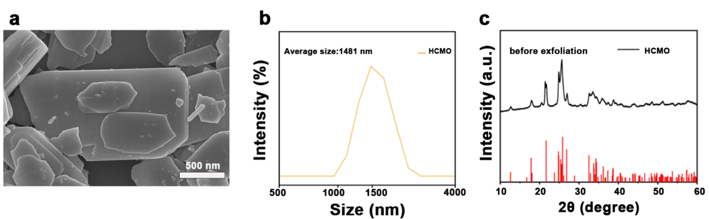
Figure S1 Characterization of the bulk HCMO before ultrasonic exfoliation. (a) SEM image of the bulk HCMO (scale bar: 500 nm). (b) DLS size distribution of the bulk HCMO. (c) XRD of the bulk HCMO.

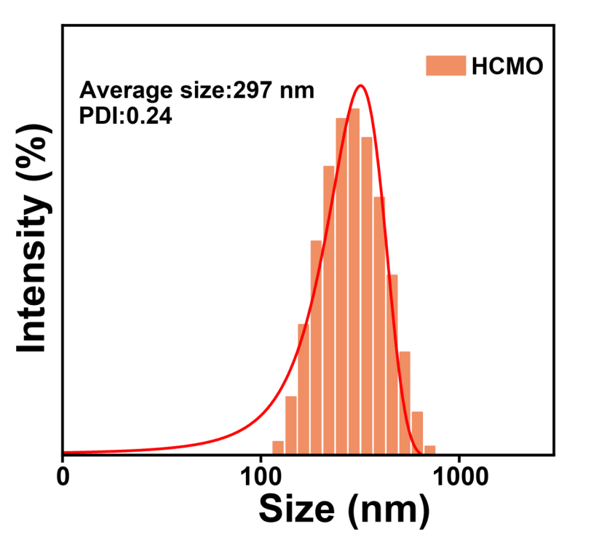
Figure S2 Hydrodynamic diameter of the HCMO dispersed solutions by DLS measurements.

Figure S3 Zeta potential of HCMO (n = 3, mean ± SD).

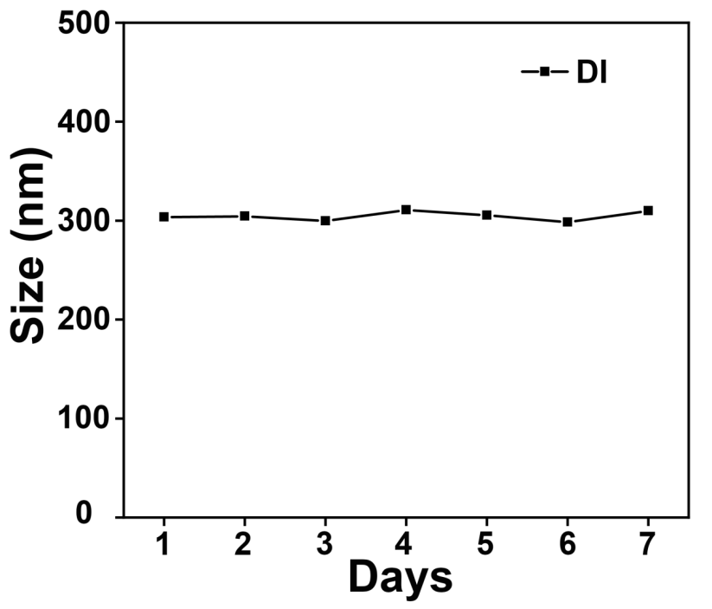
Figure S4 Hydrodynamic diameter of HCMO after incubation in H₂O for 7 days.

Figure S5 Hydrodynamic diameter of HCMO after incubation in PBS and DMEM for7 days.

Figure S6 XPS spectra of wide-scan of the HCMO.

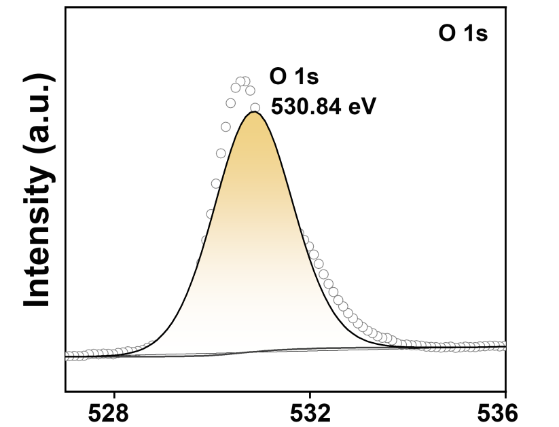
Figure S7 High-resolution XPS spectra of O 1s.

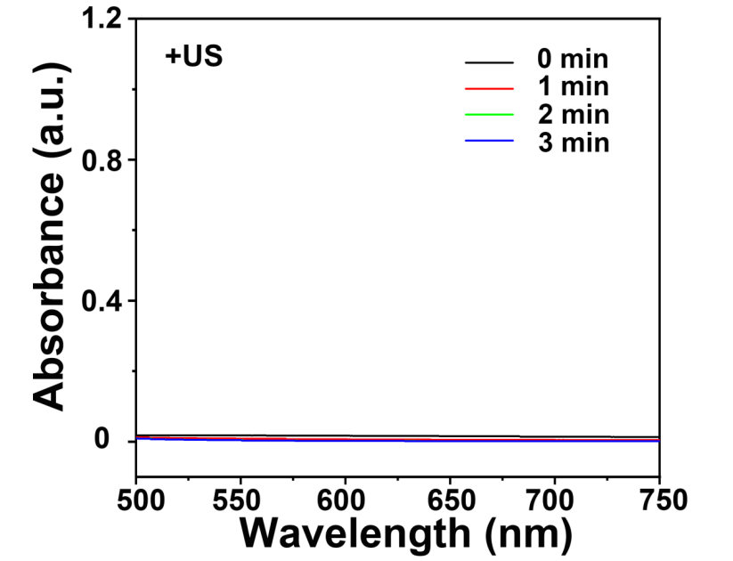
Figure S8 UV-vis absorption spectra of TMB without HCMO after different US time.

Figure S9 UV-vis absorption spectra of TMB with different HCMO concentration and US irradiation.

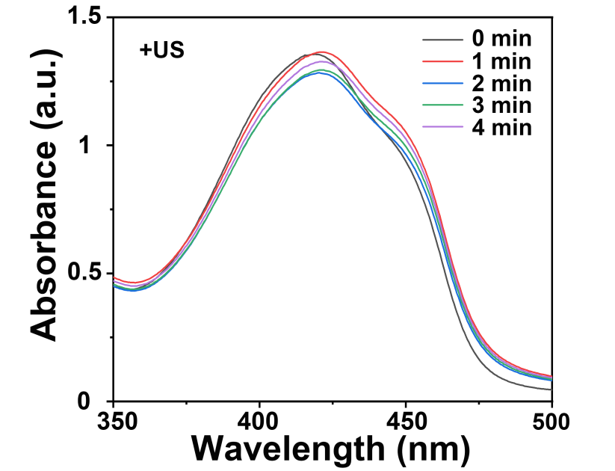
Figure S10 UV-vis absorption spectra of DPBF without HCMO after different US time.

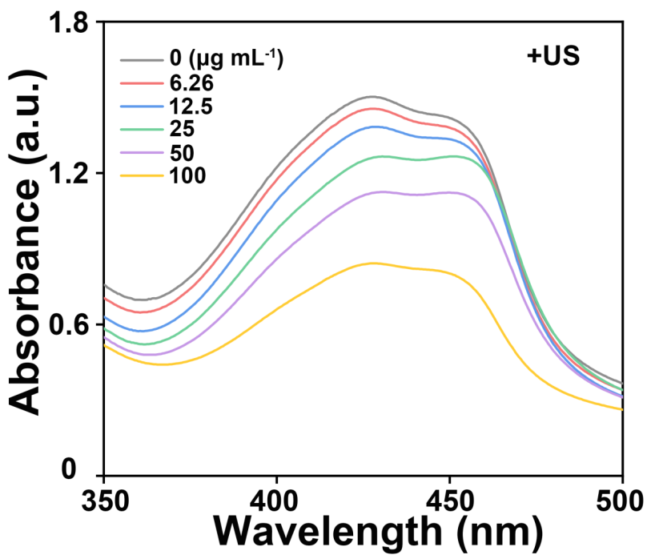
Figure S11 UV-vis absorption spectra of DPBF after different HCMO concentration.

Figure S12 Release of Cu²⁺ from HCMO at varying pH and with or without US.

Figure S13 (a) Fluorescence images of MB49 cells treated with HCMO@Cy2. and (b) the relative fluorescence intensity at different times. Statistical analysis was performed by one-way ANOVA. ***P < 0.001.

Figure S14 Cytotoxicity of HCMO towards MB49 and L929 Cells after 12 h co-culture.

Figure S15 Cytotoxicity of HCMO towards MB49 and L929 Cells after 36 h co-culture.

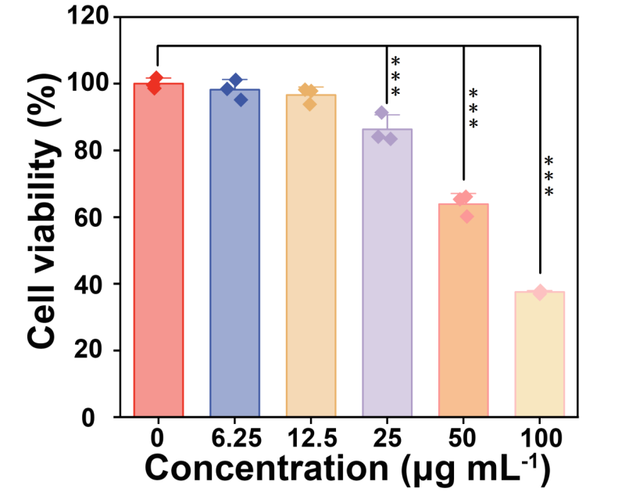
Figure S16 Therapeutic efficiency of HCMO at different concentrations under US in MB49 cells. Statistical analysis was performed by one-way ANOVA. ***P < 0.001.

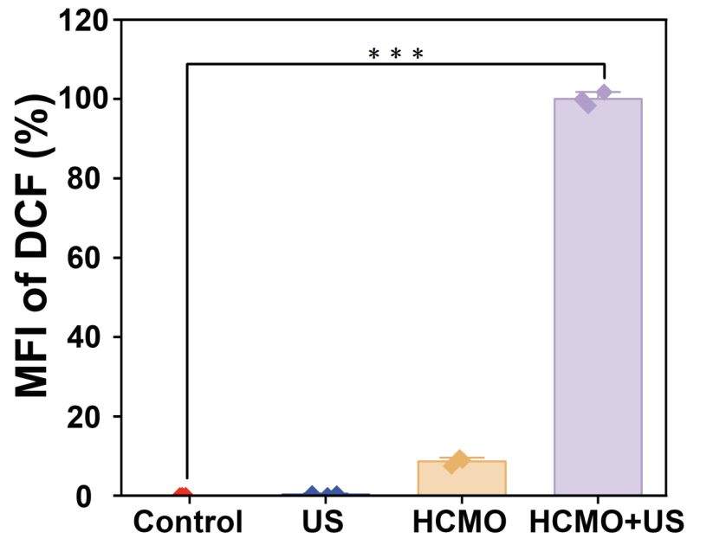
Figure S17 Corresponding quantification of MFI of DCF inside cells (n=3). Statistical analysis was performed by one-way ANOVA. ***P < 0.001.

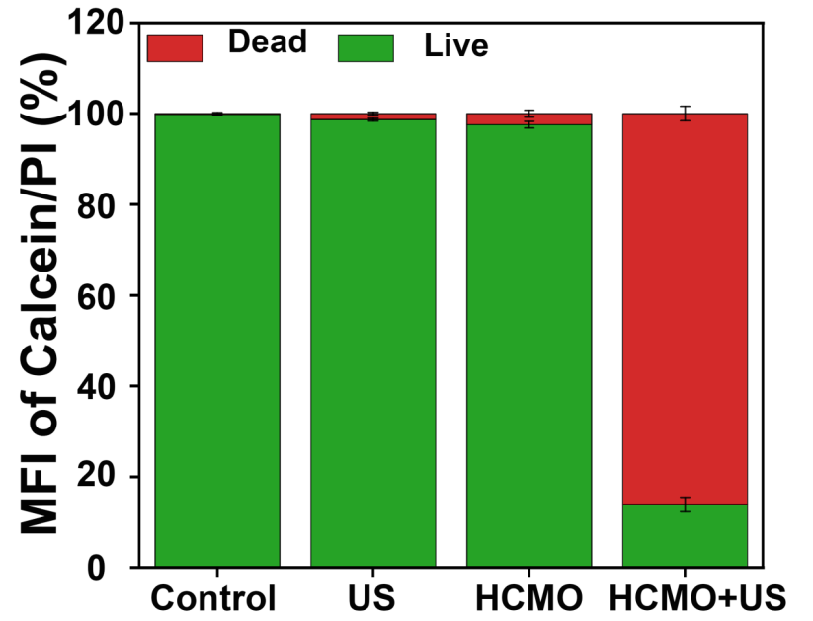
Figure S18 MFI of Calcein/PI inside cells (n=3).

Figure S19 Corresponding quantification of apoptosis rate from the flow cytometry results (n=3). Statistical analysis was performed by one-way ANOVA. ***P < 0.001.

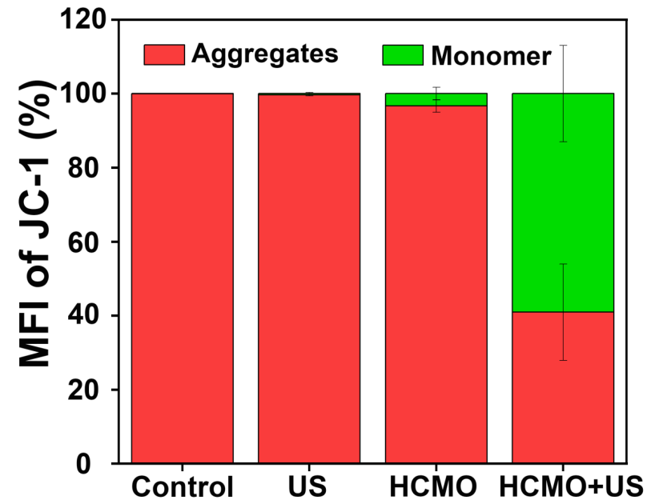
Figure S20 MFI of JC-1 inside cells (n=3).

Figure S21 Uncropped Western blot of ATP7A, DLAT, FDX-1, and LIAS after various treatments.

Figure S22 Relative protein levels of ATP7A, DLAT and FDX1 as determined by quantitative Western blot analysis

Figure S23 Fluorescence imaging with RBH (Cu²⁺) probe after different treatments ( scale bar: 100 μm).

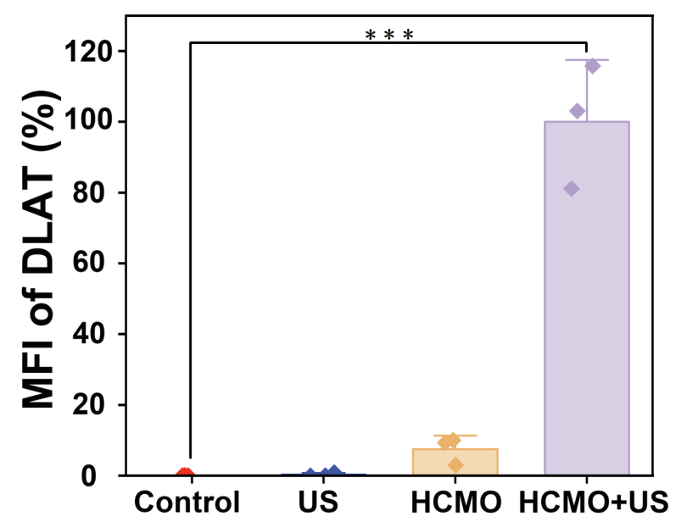
Figure S24 MFI of DLAT inside cells (n=3). Statistical analysis was performed by one-way ANOVA. ***P < 0.001.

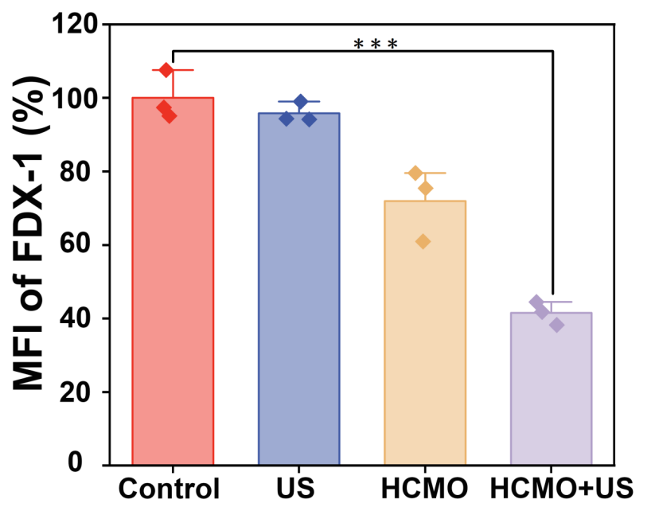
Figure S25 MFI of FDX-1 inside cells (n=3). Statistical analysis was performed by one-way ANOVA. ***P < 0.001.

Figure S26 Uncropped Western blot of Cyt-c and RIPK3 after various treatments.

Figure S27 Relative protein levels of Cyt-c and RIPK3 as determined by quantitative Western blot analysis

Figure S28 MFI of Cyt-c inside cells (n=3). Statistical analysis was performed by one-way ANOVA. ***P < 0.001.

Figure S29 (a) Immunofluorescence of c-Cas-3 (scale bar: 100 μm) after various treatments. and (b) MFI of c-Caspase-3 inside cells (n=3). Statistical analysis was performed by one-way ANOVA. ***P < 0.001.

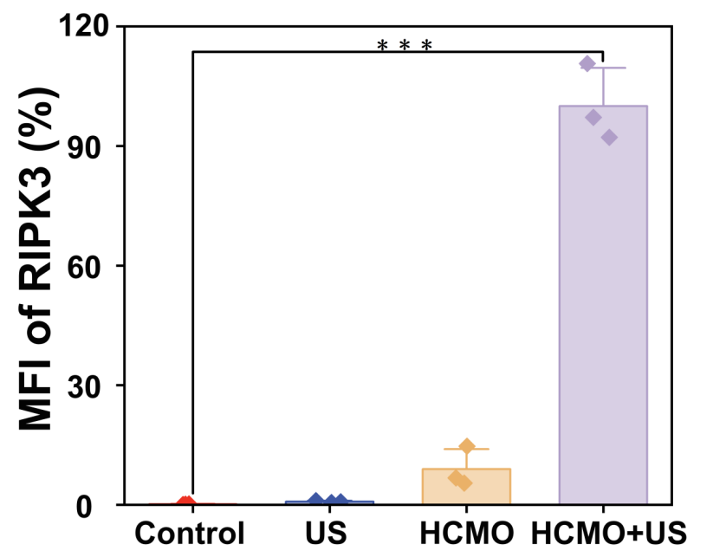
Figure S30 MFI of RIPK3 inside cells (n=3). Statistical analysis was performed by one-way ANOVA. ***P < 0.001.

Figure S31 The Level of TNF-α in MB 49 cells after different treatments (n = 3). Statistical analysis was performed by one-way ANOVA. ***P < 0.001.

Figure S32 The Level of IL-1β in MB 49 cells after different treatments (n = 3). Statistical analysis was performed by one-way ANOVA. ***P < 0.001.

Figure S33 Hemolysis ratio of HCMO with different concentrations.

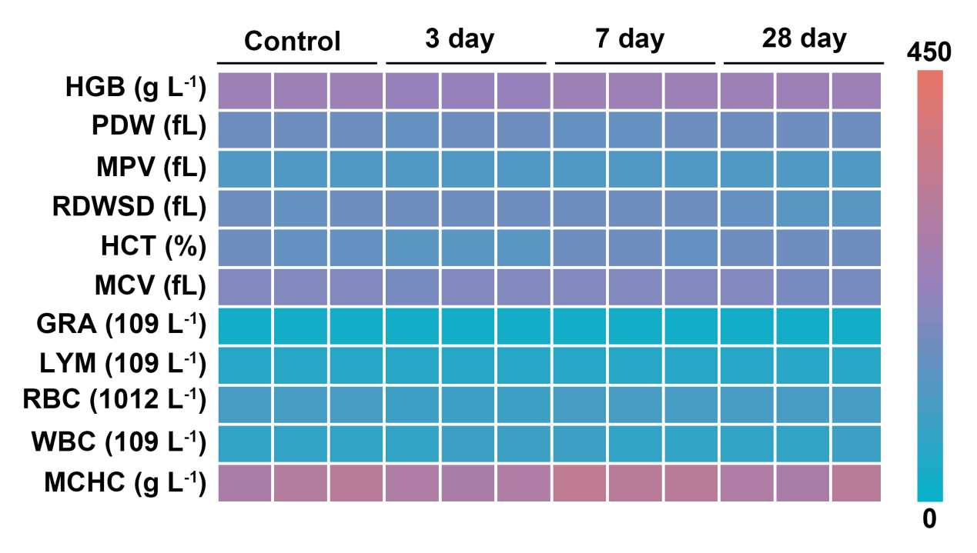
Figure S34 The hematology indexes of C57BL/6 mice treated with HCMO (15 mg kg^{–1}) at different times (0, 7, and 28 days).

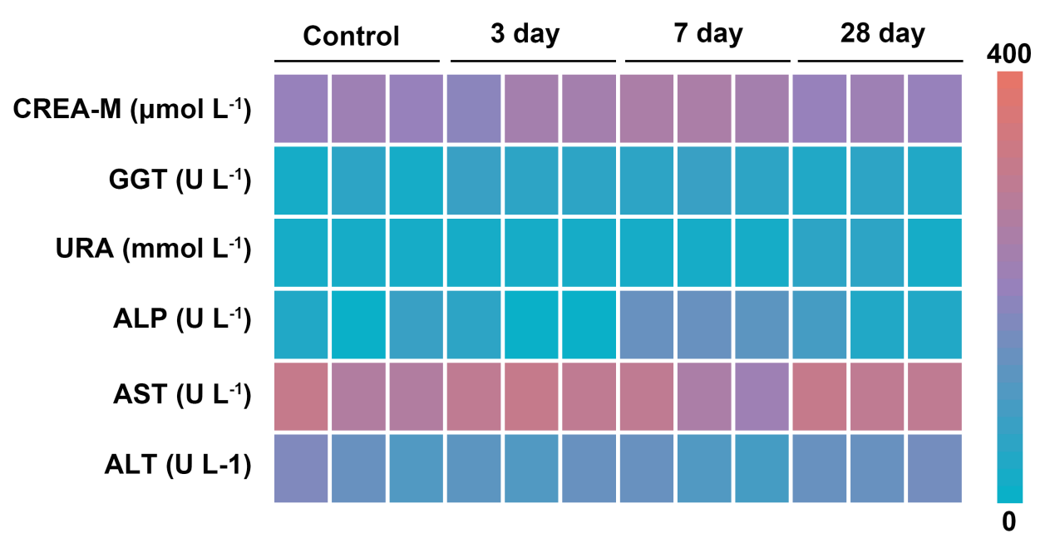
Figure S35 The blood biochemistry indexes of C57BL/6 mice treated with HCMO (15 mg kg^{–1}) at different times (0, 7, and 28 days).

Figure S36 H&E staining of heart, liver, spleen, lung, and kidney after different treatments. Scale bar: 100 µm.

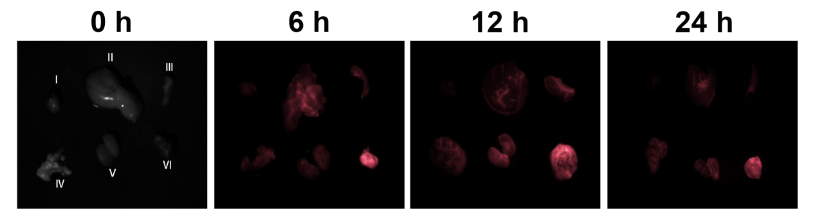
Figure S37 The ex vivo fluorescence image of tumor and major organs with intravenous injection of HCMO@Cy5.5 recorded at 0, 6, 12 and 24 h. I: heart; II: liver; III: spleen; IV: lung; V: kidney; VI: tumor.

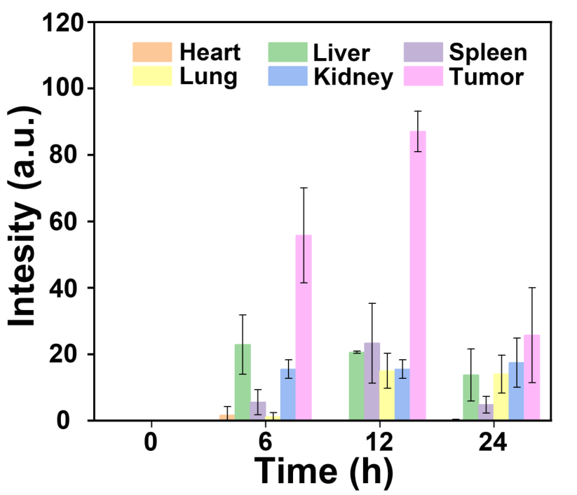
Figure S38 MFI of ex vivo fluorescence image of tumor and major organs. Values are expressed as mean ± SD (n = 3).

Figure S39 DLAT-stained tumor slices in different groups. Scale bar: 100 µm.

Figure S40 FDX-1-stained tumor slices in different groups. Scale bar: 100 µm.

Figure S41 Gating strategy for determining the percentage of matured DC cells.

Figure S42 Gating strategy for determining the percentage of T cells.

