A photothermal immune hydrogel dressing for enhanced post-melanoma resection treatment
Dehong Tan^{1, 6,#}, Wenxiang Zhu^{2,#}, Shilei Liu^{1, 6} Fengchu Liao³, Xuesheng Xu³, Jianlan Luo³, Sai Zhang^{1, 6},Qingming Xie^{1, 6},Yuan Liang^{4*}, Zhiqiang Yu^{5*},Pengfei Zhang^{1, 6*}

¹NHC Key Laboratory of Cancer Proteomics, Department of Oncology, Xiangya Hospital, Central South University, Changsha, Hunan 410008, P.R. China.
²Aier Academy of Opthamology, Central South University, Changsha, Hunan 410015, P.R.China.
³Hunan Provincial Key Laboratory of Geochemical Processes and Resource Environmental Effects, Geophysical and Geochemical Survey institute of Hunan,Changsha, Hunan 410114, P.R. China.
⁴Department of Orthopedics, Northern Jiangsu People’s Hospital Affiliated to Yangzhou University, Yangzhou, Jiangsu 225000, P.R. China.
⁵Department of Laboratory Medicine, Dongguan Institute of Clinical Cancer Research, The Tenth Affiliated Hospital Southern Medical University (Dongguan People's Hospital), Dongguan, Guangdong, 523018, P.R. China
⁶National Clinical Research Center for Geriatric Disorders, Xiangya Hospital, Central South University, Changsha, Hunan 410008, P.R. China.
#These authors contributed equally to this work.
Corresponding Authors: *Yuan Liang: liangyuan996@126.com, *Zhiqiang Yu: yuzq@smu.edu.cn, *Pengfei Zhang: zhangpf690421@csu.edu.cn

Supplementary Figures
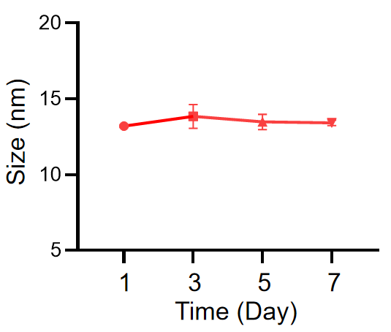
Fig. S1. Changes in the hydrodynamic diameter of Pd nanosheets in PBS on days 1, 3, 5, and 7.
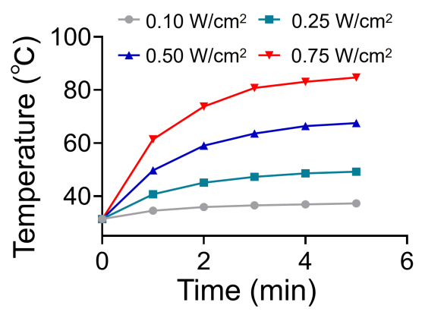
Fig. S2. Photothermal temperature profiles under varying NIR laser power densities (0.1–0.75 W/cm²).
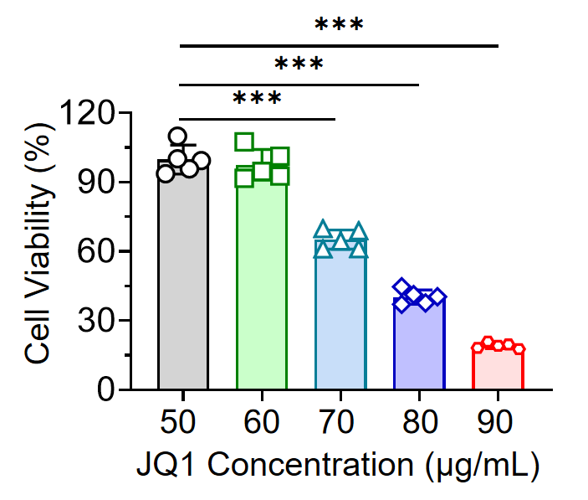
Fig. S3. Cell viability of B16F10 cells assessed using the CCK-8 assay following different treatments.
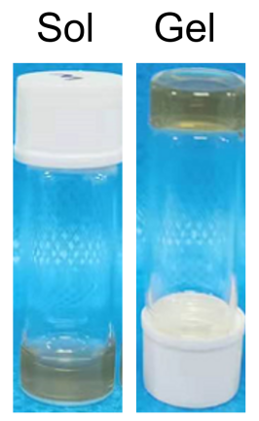
Fig. S4. Images depicting Pd/JQ1@SerMA hydrogel in both sol and gel states.
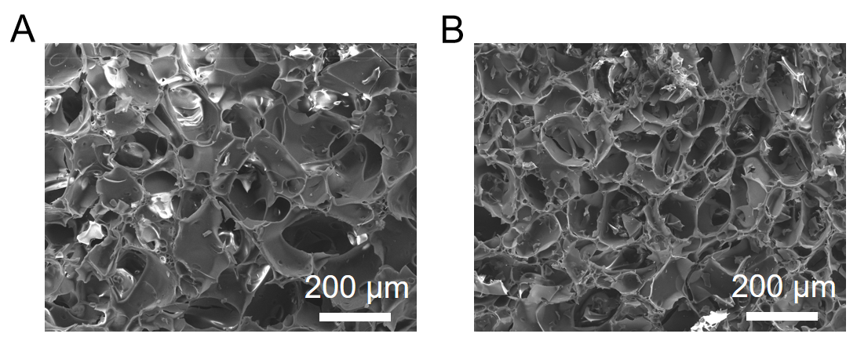
Fig. S5. SEM images of hydrogels. (a) SEM image of Pd@SerMA; (b) SEM image of Pd/JQ1@SerMA.

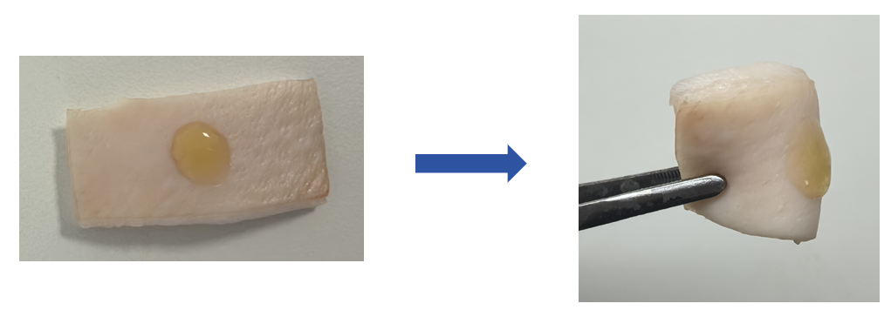
Fig. S6. Characterization of the adhesive property of Pd/JQ1@SerMA hydrogel on the porcine skin surface.

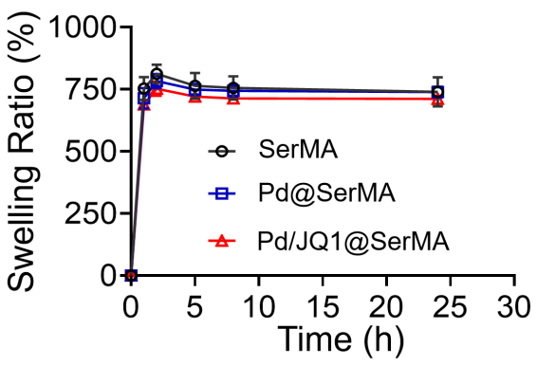
Fig. S7. The swelling ratios of SerMA、Pd@SerMA and Pd/JQ1@SerMA.
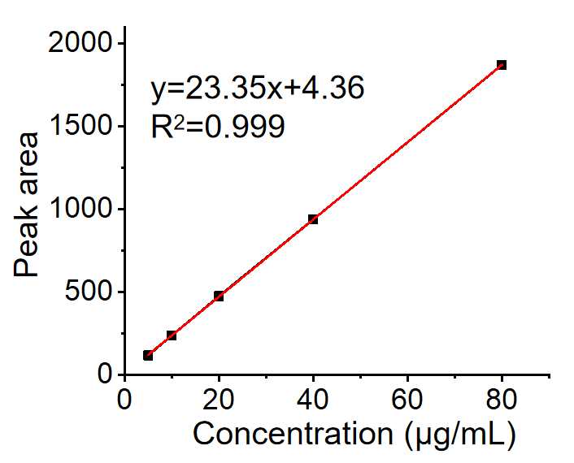
Fig. S8. The standard curves for JQ1 was established using HPLC.

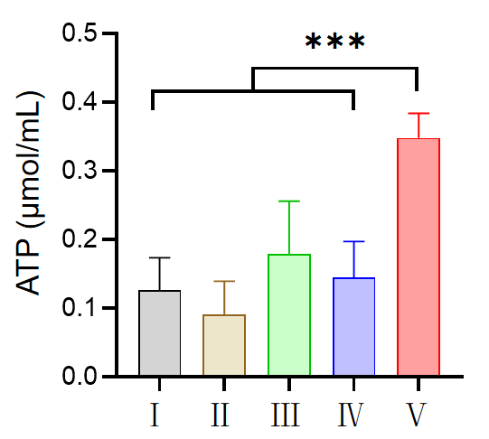
Fig. S9. Release of ATP from B16F10 cells in different treatment groups. Ⅰ: PBS, Ⅱ: SerMA, Ⅲ: Pd/SerMA, Ⅳ: Pd/JQ1@SerMA, Ⅴ: Pd/JQ1@SerMA (+).

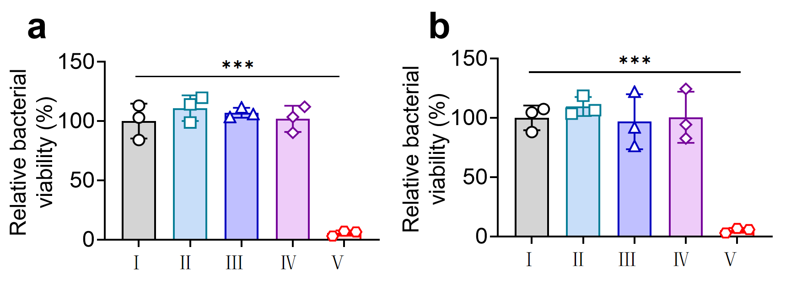
Fig. S10. Bacterial survival rate of S. aureus (a) and E. coli (b).

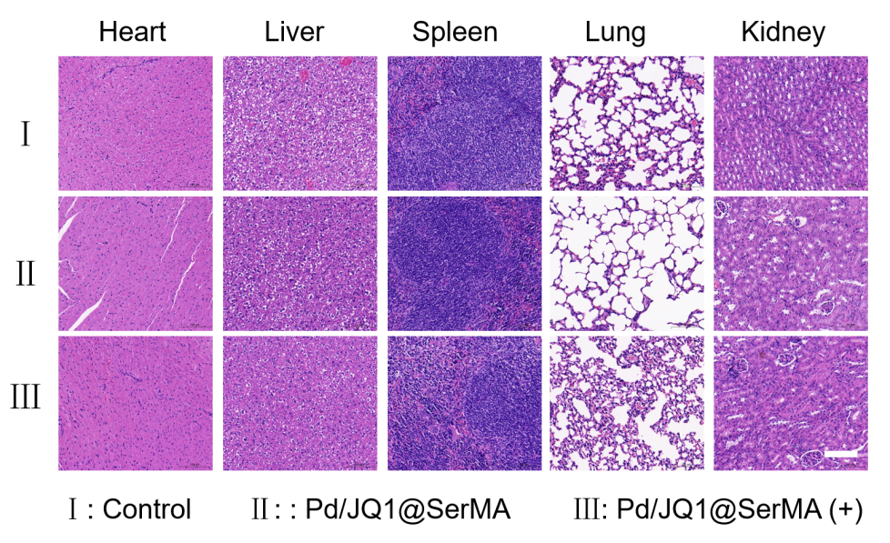
Fig. S11. The H&E stained of heart, liver, spleen, lung, and kidney after treatment by different formulations. Scale bar: 200 μm.
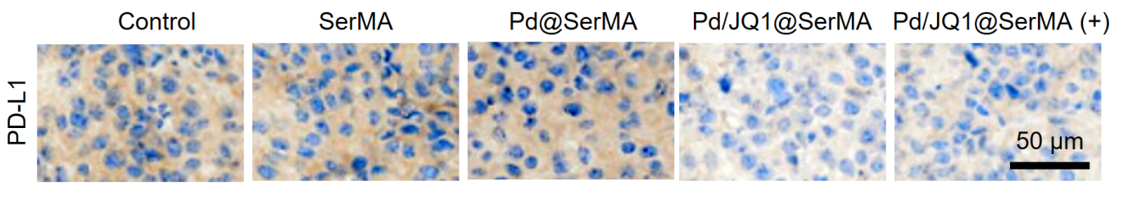
Fig. S12. The PD-L1 immunohistochemistry staining of tumor tissues after different treatments. Scale bar: 50 μm.

