Supporting Information for

Porphyrin Oriented Bimetallic Sonodynamic MOF for Enhanced Ferroptosis and cGAS-STING Pathway Mediated Antitumor Immunotherapy
Huan-Hui Wang¹, Long-Yi Nan¹, Yan Zheng^{1, *}, Jian-Peng Guo^{1, *}
¹ College of Pharmacy, Yanbian University, 977 Gongyuan Road, Yanji 133002, PR China
*Corresponding author. E-mail: zhengyan_0308@163.com (Y. Zheng); gjp807@ybu.edu.cn (J. P. Guo)

Supplementary Figures and Tables
Fig. S1. Three-dimensional reciprocal lattice of Mn–Fe(TCPP) MOF reconstructed from cRED data. (a) Reconstructed three-dimensional reciprocal lattice showing the overall reflection distribution. (b–d) Selected reciprocal lattice sections viewed along the a*, b*, and c* directions, respectively.
Fig. S2. Crystal structure of Mn–Fe(TCPP) MOF. (a-c) The crystal structure models of Mn–Fe(TCPP) MOF viewed along the a, b, and c crystallographic axes, respectively.
Fig. S3. PXRD patterns of simulated Mn–Fe(TCPP) MOF (blue) and as-synthesized Mn–Fe(TCPP) MOF (red).
Fig. S4. Metal ion release behavior of Mn–Fe(TCPP) MOF under (a) physiological conditions and (b) tumor-mimicking microenvironment.

Fig. S5. FT-IR spectra of FeTCPP, Fe(TCPP)-MOF, and FMP.

Fig. S6. PXRD patterns of TCPP, FeCl₃, and Fe(TCPP)-MOF.

Fig. S7. RGD@Mn-Fe(TCPP) MOF exhibited excellent stability, maintaining its structural integrity for up to 7 days under simulated physiological conditions. Data are presented as mean ± SD (n = 3).

Fig. S8. PL spectra of (a) FeTCPP and (b) MFMP in DMF with different water fractions (f_{w} = 0% and 90%).

Fig. S9. Optimization of ultrasound irradiation parameters for intracellular ROS generation.
(a) Time-dependent intracellular ROS levels under ultrasound irradiation (1.5 W·cm⁻²) for 1, 5, 10, and 15 min. (b) Power-dependent intracellular ROS levels under US irradiation for 5 min at different power densities (0.5, 1.0, 1.5, and 2.0 W·cm⁻²). Data are presented as mean ± SD (n = 3). ***P < 0.001.
Fig. S10. Representative CLSM images of 4T1 cells after 12 h incubation with FITC@FeTCPP, FITC@FMP, and FITC@MFMP.

Fig. S11. (a) Flow cytometry analysis of 4T1 cells after 12 h incubation with FITC@FeTCPP, FITC@FMP, and FITC@MFMP. (b) Quantification of fluorescence intensity in 4T1 cells treated with FITC@FeTCPP, FITC@FMP, and FITC@MFMP. Data are expressed as mean ± SD (n = 3). ***P < 0.001.

Fig. S12. Cell viability of 4T1 cells under different treatment conditions. Data are expressed as mean ± SD (n = 5). ns, P > 0.05; *P < 0.05; **P < 0.01; ***P < 0.001.

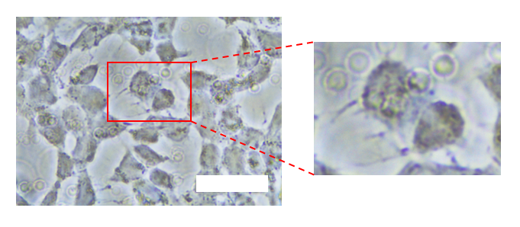
Fig. S13. Representative high-magnification bright-field images of 4T1 cells treated with MFMP + US. Scale bar = 20 μm.

Fig. S14. Analysis of (a) IL-1β release, (b) LDH activity, and (c) IL-1β expression levels. Data are presented as mean ± SD (n = 5). ns, P > 0.05; **P < 0.01; *P < 0.001.

Fig. S15. (a) Quantification of GSH immunofluorescence intensity in 4T1 cells after different treatments. (b) Flow cytometric analysis of GSH expression in 4T1 cells after different treatments. Data are presented as mean ± SD (n = 3). ns, P > 0.05; **P < 0.01; *P < 0.001.

Fig. S16. Relative grey values of GPX4 protein blots normalized to the internal reference. Data are presented as mean ± SD (n = 6). *P < 0.05, ***P < 0.001.

Fig. S17. (a) Quantification of GPX4 immunofluorescence intensity in 4T1 cells after different treatments. (b) Flow cytometric analysis of GPX4 expression in 4T1 cells after different treatments. Data are expressed as mean ± SD (n = 5). ns, P > 0.05; *P < 0.05; **P < 0.01; ***P < 0.001.

Fig. S18. Relative grey values of HMGB1 protein blots normalized to the internal reference. Data are presented as mean ± SD (n = 6). *P < 0.05.

Fig. S19. Quantification of cytosolic dsDNA levels in 4T1 cells after different treatments. Data are presented as mean ± SD (n = 6); ***p < 0.001.
Fig. S20. Western blot analysis of cGAS–STING pathway–related proteins (a). p-IRF-3, (b). p-TBK-1, (c) p-STING, (d) p-NF-Κb, (e) IKK, (f) cGAS. Data are expressed as mean ± SD (n = 3). *P < 0.05; **P < 0.01; ***P < 0.001.

Fig. S21. Hemolysis test of MFMP nanoparticles. (a) Representative images of red blood cells treated with MFMP nanoparticles (25–400 μg mL⁻¹), water (positive control), and PBS (negative control). (b) UV–vis spectra of the corresponding supernatants, indicating negligible hemolysis in the MFMP groups.

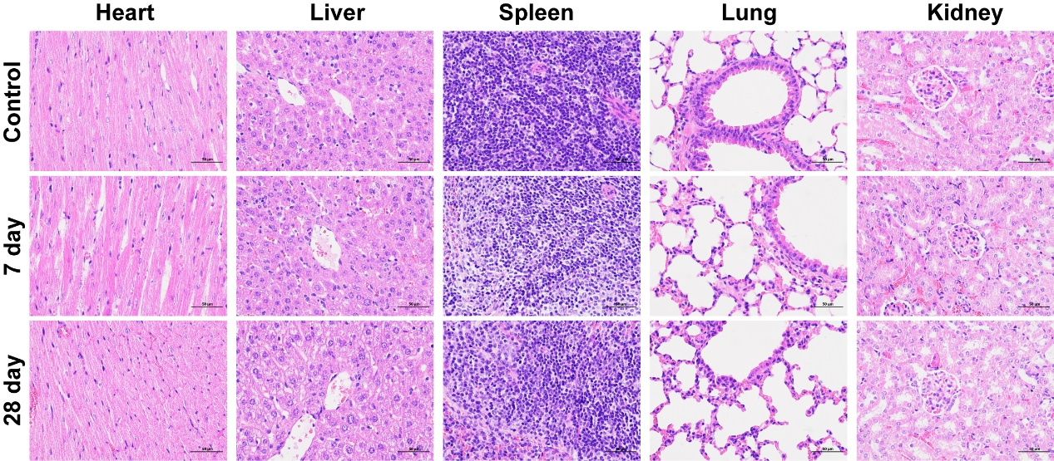
Fig. S22. H&E staining of major organs after MFMP treatment. Representative images of heart, liver, spleen, lung, and kidney on day 7 and day 28 post-treatment, showing no evident tissue damage.

Fig. S23. Body-weight profiles during treatment.

Fig. S24. Hematological and serum biochemical parameters after MFMP treatment. Blood analyses of mice (n = 3) sacrificed at day 3 post-MMP treatment. Serum biochemical indicators: (a) alanine aminotransferase (ALT) and (b) aspartate aminotransferase (AST) for liver function; (c) urea (UREA) and (d) creatinine (CREA) for kidney function. Hematological counts: (e) red blood cells (RBC), (f) white blood cells (WBC), (g) hematocrit (HCT), (h) hemoglobin (HGB), and (i) mean corpuscular hemoglobin (MCH).

Fig. S25. In vivo biodistribution of MFMP nanoparticles in tumor-bearing mice.

Fig. S26. Ex vivo fluorescence imaging of major organs after MFMP administration.

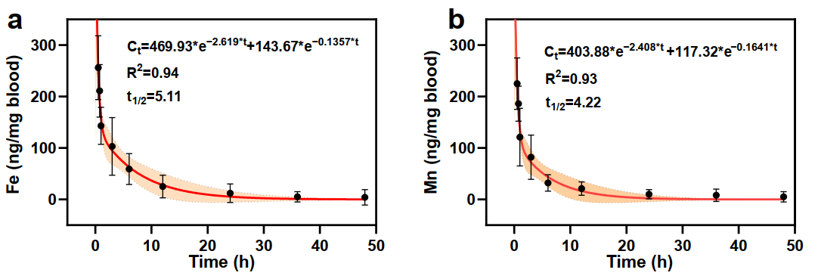
Fig. S27. Pharmacokinetic curves of Fe and Mn ions released after intravenous injection of MFMP.
Fig. S28. Tumor growth curves under different treatments with/without ultrasound. (***p < 0.001)
Fig. S29. Immunofluorescence of STING and GPX4 in tumor sections under different treatments. (a) STING immunofluorescence (green) with nuclear counterstain DAPI (blue). (b) GPX4 immunofluorescence (red) with DAPI (blue).
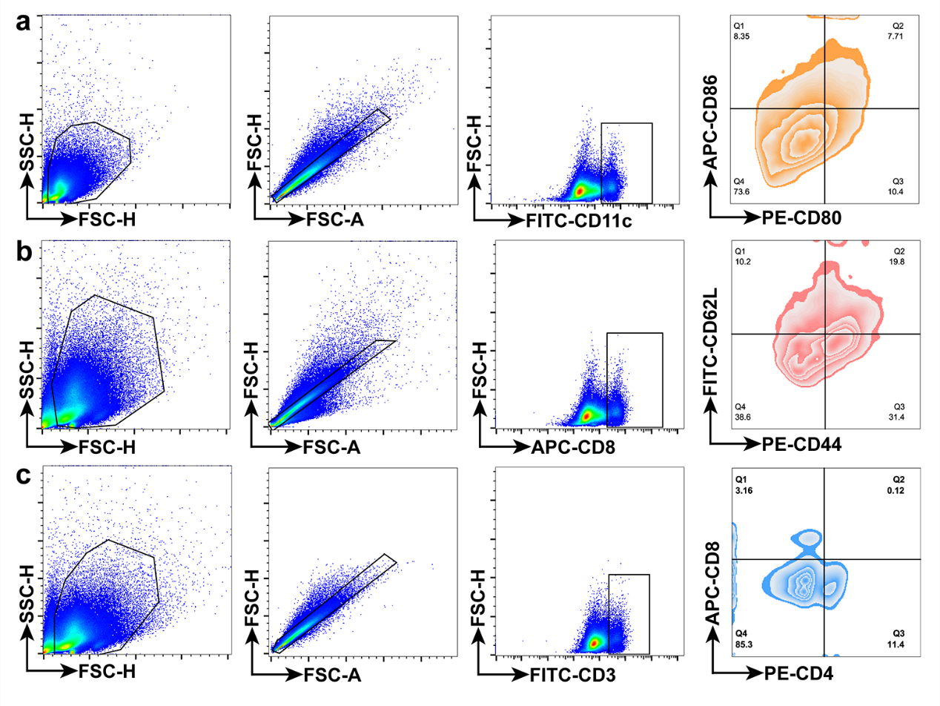
Fig. S30. Schematic workflow for immune-cell gating. (a) Dendritic cells (DCs) in tumor-draining lymph nodes (TDLNs), (b) CD8⁺ T cells in tumors, (c) memory T cells in tumors.

Fig. S31. Growth curves of distant tumors under different treatments with/without ultrasound. (***p < 0.001).

Fig. S32. Distant tumor weights across treatment groups. Data are expressed as mean ± SD (n = 5). *P < 0.05; ***P < 0.001.

Tab. S1. Crystal data, data collection, and structure refinement parameters for Mn-Fe(TCPP) MOF
Identification code | Mn-Fe(TCPP) MOF
Empirical formula | C₂₄H₁₅FeMnN₂O₅
CCDC Code | 2449005
Formula weight | 521.17
Temperature/K | 77(2)
Crystal system | orthorhombic
Space group | Cmmm
α/° | 90
β/° | 90
γ/° | 90
Z | 4
ρ_{calc}g/cm³ | 0.700
Radiation | MoKα (λ = 0.71073)
2θ range for data collection/° | 4.136 to 49.998
Index ranges | -17 ≤ h ≤ 17, -20 ≤ k ≤ 20, -25 ≤ l ≤ 25
Reflections collected | 119625
Independent reflections | 36593 [Rint = 0.1318, R_{sigma} = 0.0726]
Data/restraints/parameters | 36,593/0/1526
Goodness-of-fit on F² | 1.046
Final R indexes [I>=2σ (I)] | R₁ = 0.0456, wR₂ = 0.1345
Final R indexes [all data] | R₁ = 0.0681, wR₂ = 0.1607

Tab. S2. Comparison of unit-cell parameters between Mn–Fe(TCPP) MOF and Fe(TCPP) MOF
Unit-cell parameters | Mn-Fe(TCPP) MOF | Fe(TCPP) MOF
a/Å | 14.13(9) | 6.8400(14)
b/Å | 16.86(12) | 32.080(7)
c/Å | 20.75(6) | 16.920(3)
Volume/ Å³ | 4943.31(49) | 3712.7(13)

