Supplementary Information

Endothelialized human umbilical cord mesenchymal stem cell-derived exosomes enhances angiogenesis and stabilizes the blood-spinal cord barrier after spinal cord injury
Quanbo Liu^{1#}, Wentao Zhang^{2,3#}, Jingbo Xue¹, Xuelin Li¹, Jinghua Tan¹, Zhun Xu¹, Ming Wang¹, Yunlong Li¹, Zhihua Ouyang¹, Cheng Wang¹, Yiguo Yan¹, Liyuan Jiang^{4,5,6}*, Yong Xie¹*

1 Department of Spine Surgery, The First Affiliated Hospital, Hengyang Medical School, University of South China, Hengyang, Hunan, China
2 Department of Cardiology, The First Affiliated Hospital, Hengyang Medical School, University of South China, Hengyang, Hunan, China
3 Institute of Cardiovascular Disease, The First Affiliated Hospital, Hengyang Medical School, University of South China, Hengyang, Hunan, China
4 Department of Spine Surgery and Orthopaedics, Xiangya Hospital, Central South University, Changsha, Hunan, China
5 Key Laboratory of Organ Injury, Aging and Regenerative Medicine of Hunan Province, Changsha, Hunan, China
6 National Clinical Research Center for Geriatric Disorders, Xiangya Hospital, Central South University, Changsha, Hunan, China

Figure S1 GFP Validation of UCMSCs Lentivirus Transfection. Representative fluorescence images of GFP-UCMSCs, Scale bar: 50 μm.

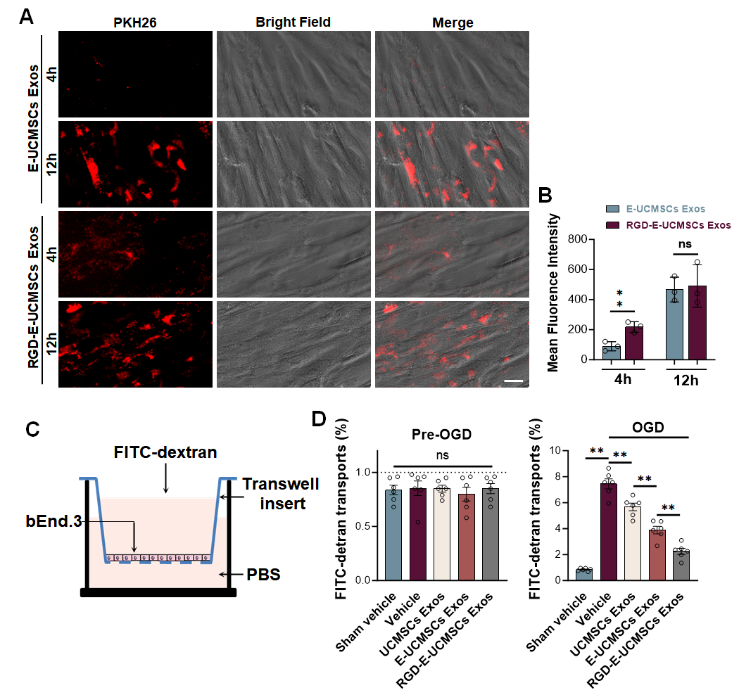
Figure S2 Exosome Uptake and FITC Leakage Experiment. A. Representative fluorescence images of exosome uptake, Scale bar: 50 μm. B. Quantitative analysis of exosome uptake, n = 3 per group. C. Schematic diagram of FITC leakage experiment. D. FITC-dextran leakage experiment to detect permeability before and after OGD treatment, n = 6 per group. Data are presented as mean ± SD, ns > 0.05, ** P < 0.01.

Figure S3 Gross Image of Spinal Cord EB Leakage. Representative images of EB.

Figure S4 Behavioral Analysis of SCI Mice. A. Gait analysis of SCI mice treated with Sham, Vehicle, UCMSCs Exos, E-UCMSCs Exos, and RGD-E-UCMSCs Exos. B. Quantitative analysis of stride length, n = 12 per group. C. Quantitative analysis of stride width, n = 12 per group. Data are presented as mean ± SD, * P < 0.05, ** P < 0.01.

Table S1 Antibody Catalog
IF Antibody | Company | Catalog Number | Dilution
rabbit anti- CD90 | Abcam | ab307736 | 1:200
rabbit anti- CD73 | Abcam | ab317462 | 1:200
goat anti- CD31 | R&D | FAB3628G-100 | 1:400
rabbit anti- CD105 | Abcam | ab221675 | 1:100
mouse anti- Integrin | Santa | sc-7312 | 1:200
goat anti- GFAP | Abcam | ab302644 | 1:400
rabbit anti- Neun | Milliopre | 3551434 | 1:400
rat anti- F4/80 | Abcam | ab6640 | 1:100
rabbit anti- Occludin | Abcam | Ab216327 | 1:100
rabbit anti- Claudin5 | Abcam | ab15106 | 1:100
rabbit anti- ZO-1 | Invitrogen | 40-2200 | 1:200
rabbit anti- Tuj-1 | CST | 5568 | 1:400
rabbit anti- GAS6 | Proteintech | 13795-1-AP | 1:200
rabbit anti- FLT-1 | Abcam | ab2350 | 1:200
rabbit anti- CTHRC1 | Proteintech | 16534-1-AP | 1:200
mouse anti- MMP2 | Abcam | ab92356 | 1:200
rabbit anti- NEO1 | Affinity | DF13183 | 1:400
rabbit anti- TIMP1 | Affinity | AF7007 | 1:400
WB Antibody | Company | Catalog Number | Dilution
rabbit anti-CD9 | Abcam | ab217345 | 1:1000
rabbit anti-CD63 | Abcam | ab134045 | 1:1000
rabbit anti-TSG101 | Abcam | ab125011 | 1:1000
rabbit anti-Calnexin | Proteintech | 10427-2-AP | 1:1000
rabbit anti-DYKDDDDK tag (FLAG-tag) | Proteintech | 20543-1-AP | 1:1000
rabbit anti- GAS6 | Proteintech | 13795-1-AP | 1:1000
rabbit anti- FLT-1 | Abcam | ab2350 | 1:1000
rabbit anti- CTHRC1 | Proteintech | 16534-1-AP | 1:1000
rabbit anti- MMP2 | Abcam | ab92356 | 1:1000
rabbit anti- NEO1 | Affinity | DF13183 | 1:1000
rabbit anti- TIMP1 | Affinity | AF7007 | 1:1000
rabbit anti- TFPI2 | Affinity | DF14781 | 1:1000
rabbit anti- FN1 | Proteintech | 15613-1-AP | 1:1000
rabbit anti- Serpine1 | Abcam | ab317604 | 1:1000
rabbit anti- Serpine2 | Abcam | ab134905 | 1:1000
rabbit anti- PLAU | Proteintech | 17968-1-AP | 1:1000
rabbit anti- GAPDH | Proteintech | 10494-1-AP | 1:1000
Flow Cytometry Antibody | Company | Catalog Number | Dilution
anti-CD31-PE | Biolegend | 303106 | 1:100
anti-CD45-PE | Biolegend | 304008 | 1:100
anti-CD235-PE | Biolegend | 306604 | 1:100
anti-CD90-APC/Cy7 | Biolegend | 344020 | 1:100
anti-CD73-PE/CF594 | Biolegend | 155306 | 1:100
Zombie Aqua | Biolegend | 77143 | 1:500

Table S2 All primer sequences used for qRT-PCR.
Claudin5 | Forward primer | GCAAGGTGTATGAATCTGTGCT
Claudin5 | Reverse primer | GTCAAGGTAACAAAGAGTGCCA
Occludin | Forward primer | TGGGCAGTCGGGTTGACT
Occludin | Reverse primer | GGGCATCATGGTGTTCATTG
ZO-1 | Forward primer | GCCGCTAAGAGCACAGCAA
ZO-1 | Reverse primer | TCCCCACTCTGAAAATGAGGA
GAPDH | Forward primer | AGCAAGGACACTGAGCAAGA
GAPDH | Reverse primer | GGGGTCTGGGATGGAAATTGT

