Supplemental Figures

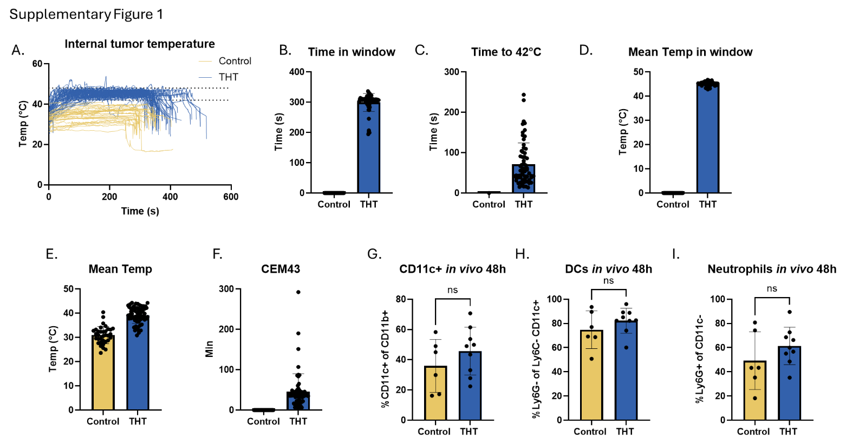

Figure S1. Thermal kinetics of THT treated tumors. A, Intratumoral temperature profiles over time for control (n = 35) and THT (n = 58) tumors. B, Mean time in hyperthermic temperature window (42-48 °C) for control and THT-treated tumors. C, Time tumors took to reach 42 °C (control tumors did not reach 42 °C). D, Mean temperature of tumors while in hyperthermic temperature window (control tumors did not enter therapeutic temperature range). E, Mean temperatures of control and THT tumors after laser-induced heat. F, Thermal dose (CEM43) measurements of tumors. Frequency of CD11c+ of CD11b+ (G), Ly6G- of Ly6C- CD11c+ (H), and Ly6G+ of CD11c- (I) in CT26 tumors 48 h post THT. (mean ± SD)

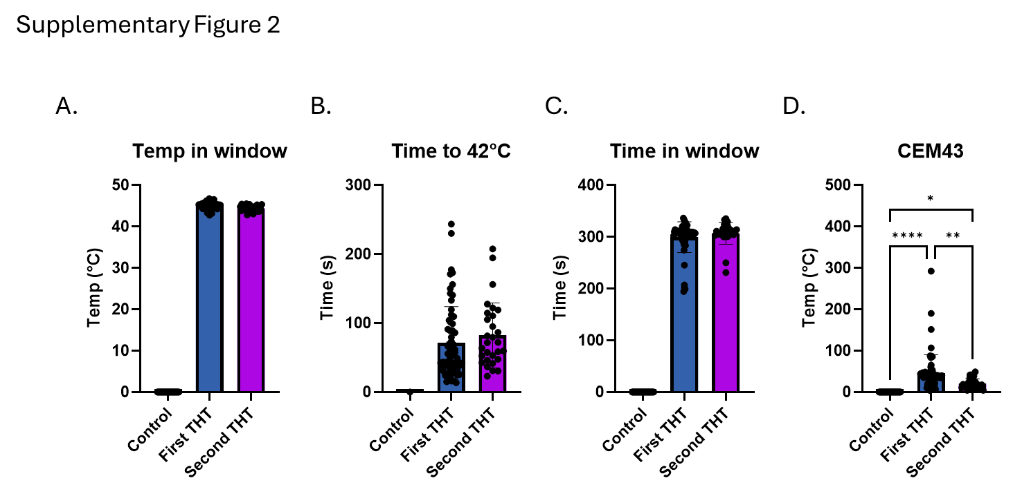

Figure S2. Heat profiles of tumors treated once or twice with THT. A, Mean temperature achieved in therapeutic window after PBS control (n = 35), ^First THT (n = 58) or Second THT (n = 28) treated tumors. B, Time to reach 42 °C after First THT or Second THT. C, Time spent in hyperthermic temperature window (42-48 °C) following First THT or Second THT laser exposure. D, CEM43 after First THT or Second THT treatments. ^First THT counts all samples, including first THT for those treated a second time. (mean ± SD; *p<0.05, **p<0.01, ****p<0.0001)

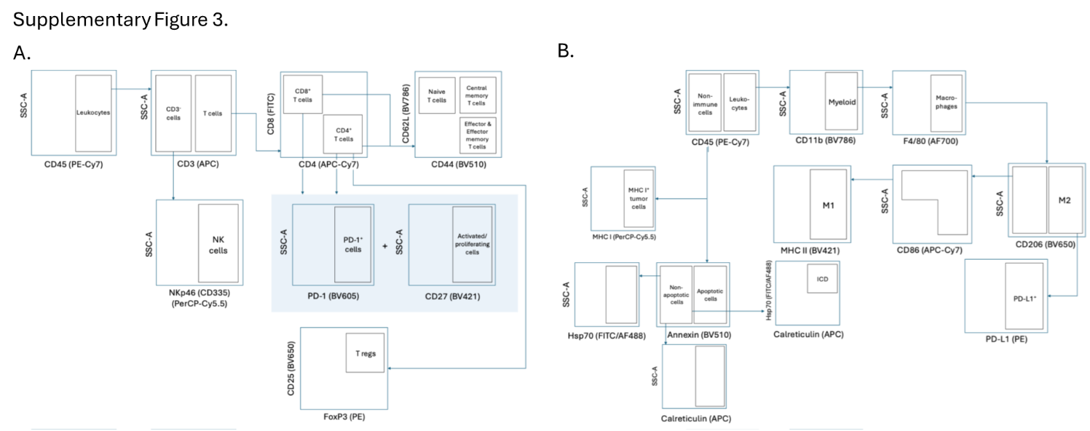

Figure S3. Flow cytometry gating strategy. A, Leukocyte populations (NK cells, T cells, and T cell subsets, including PD-1⁺ populations). B, Non-immune and myeloid populations (apoptotic/non-apoptotic cells, ICD marker-expressing cells, M1/M2/PD-L1⁺ macrophages).

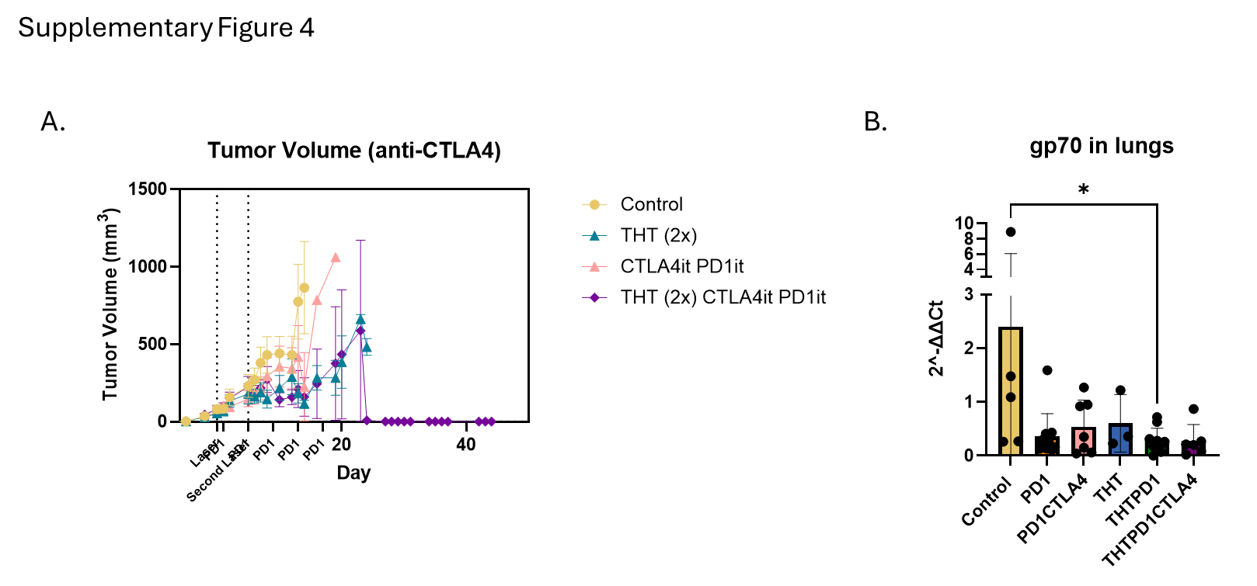

Figure S4. Impact of THT with checkpoint blockade on metastasis to the lungs. A, Tumor volume of control vs. THT (2x), THT (2x) PD1it with i.t. anti-CTLA-4 (THT (2x) CTLA4it PD1it; n = 8) or CTLA4it PD1it alone (n = 7). B, gp70 levels in the lungs of control (n = 5), THT (n = 3), anti-PD-1 (PD1; n = 11), THT with anti-PD-1 (THTPD1; n = 10), THTPD1with anti-CTLA-4 (THTPD1CTLA4; n = 6), or anti-PD-1 plus anti-CTLA4 without THT (PD1CTLA4; n = 7) treated tumors. (mean ± SD; *p<0.05)

