Oral Colon Targeted Curcumin-based Nanocomposite Inulin Hydrogel for alleviating Intestinal Inflammation and Dysbiosis
Qiangyuan Fan¹, Chen Kan¹, Kesheng Wang¹, Huanhuan Zhu¹, Yue Zhang¹, Meiling Lu¹, Shaobo Xue¹, Lin Han¹, Zhongmin Geng^{4,*}, Weiliang Hou^{3,*}, Zunzhen Ming^{2,*}

¹Central Laboratory, Shanghai Tenth People’s Hospital, School of Medicine, Tongji University, Shanghai 200092, China
² School of Life Sciences, Shanghai University, Shanghai 200444, China.
³Department of Gastroenterology, Shanghai Institute of Pancreatic Diseases, National Key Laboratory of Immunity and Inflammation, Changhai Clinical Research Unit, Changhai Hospital, Naval Medical University, Shanghai, 200433, China
⁴Cancer Institute, The Affiliated Hospital of Qingdao University, Qingdao University, Qingdao 266071, China

Fig. S1 Strain-sweep oscillatory tests.
Fig. S2 Dynamic step-strain measurements of CUR-PLGA-CS Inulin gel with the deformation of 10% for 60 s and 100% for 60 s.

Fig. S3 Digital photos of inulin gel at different stages of action of inulin exo-enzyme at 37℃ for 12 hours and the scanned image of the final freeze-dried product; scale bar: 20 μm.
Fig. S4 Total antioxidant capacity of CUR-PLGA-CS Inulin gel with different concentrations at 734 nm.

Fig. S5 The absorption spectra of CUR-PLGA-CS Inulin gel with different concentrations in the range of 500 nm to 800 nm; Inset: digital photograph of the total antioxidant capacity test.
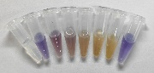
Fig. S6 The absorption spectra of CUR-PLGA-CS Inulin gel with different concentrations in the range of 300nm to 800nm; Inset: digital photograph of the SOD-like activity test.

Fig. S7 SOD-like activity of CUR-PLGA-CS Inulin gel with different concentrations at 560 nm.
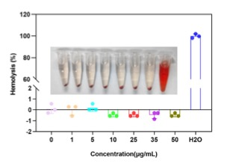
Fig. S8 Hemolytic rate of CUR-PLGA-CS Inulin gel with different concentrations, and H₂O; Inset: digital photograph of the hemolytic test.

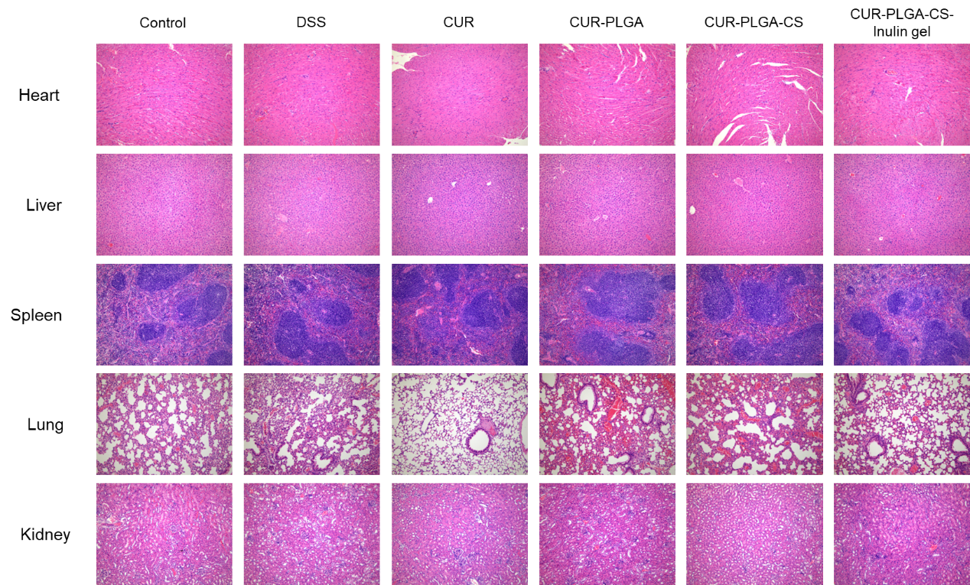
Fig. S9 H&E staining of major organs (heart, liver, spleen, lung and kidney) of PBS, DSS, CUR, CUR-PLGA, CUR-PLGA-CS, CUR-PLGA-CS Inulin gel groups.

Fig. S10 Immunohistochemical analysis of myeloperoxidase (MPO) expression in the colon tissue sections, and tight junction proteins occludin and ZO-1 in the colonic mucosa; scale bar: 50 μm.

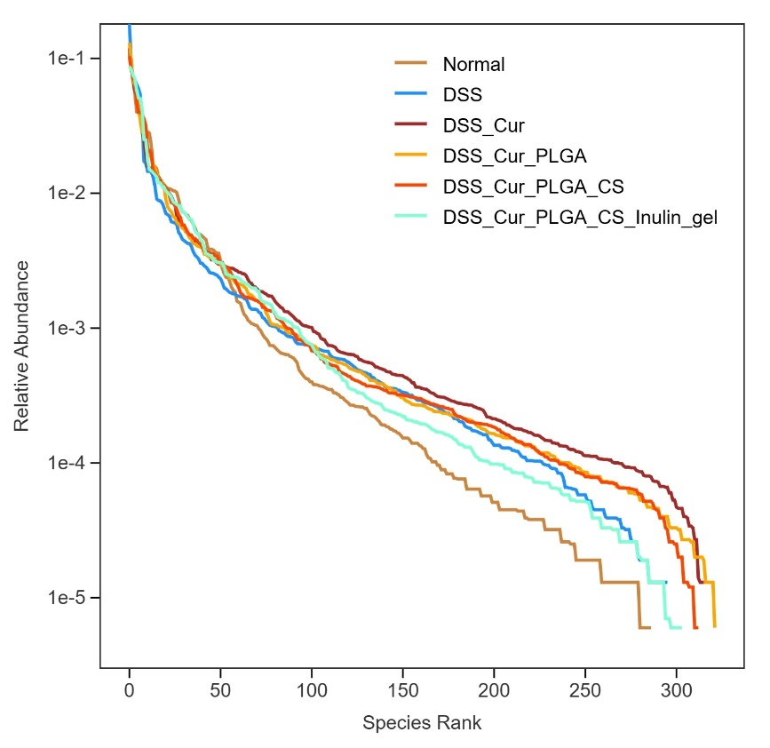
Fig. S11. Grouped Rank Abundance Curve of Normal, DSS, DSS_CUR, DSS_CUR-PLGA, DSS_CUR-PLGA-CS, DSS_CUR-PLGA-CS Inulin gel groups.

