GSH-Responsive Triple-Action Photosensitizer Nanoplatforms Orchestrate Cuproptosis-Ferroptosis Synergy to Potentiate Antitumor PDT Efficacy

Luyao Xu ª‡, Jing Feng ª‡, Shihao Xu ª, Mingli Jin ª, Xianyue Bai ª, Hui Zhang ª, Minghui Zhu ^{b}, Shengmin Lin ª, Jiaxing Song ^{b}, and Cuixia Lu ª*
ª Guangxi Key Laboratory of Special Biomedicine; School of Medicine, Guangxi University, Nanning, 530004, China,
^{b} Cell and Immunology Laboratory, Medical Research Centre, School of Life Sciences and Medical Engineering, Guangxi Medical University, Nanning, 530021, China
‡ These authors contributed equally to this work.
* Corresponding author
E-mail addresses: lucuixia@gxu.edu.cn (Cuixia Lu)

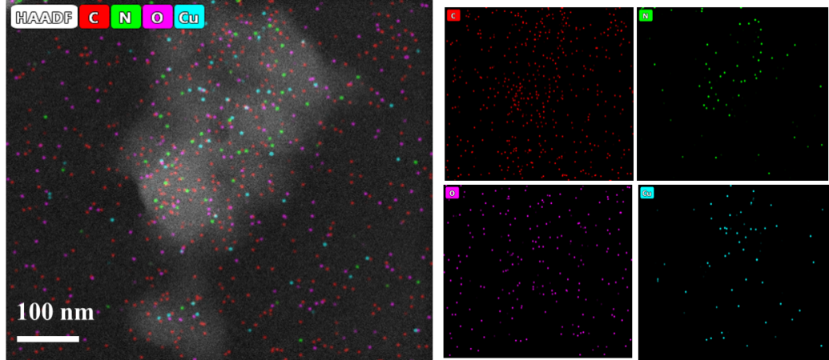

Fig. S1. EDS Mapping of CCD NPs.

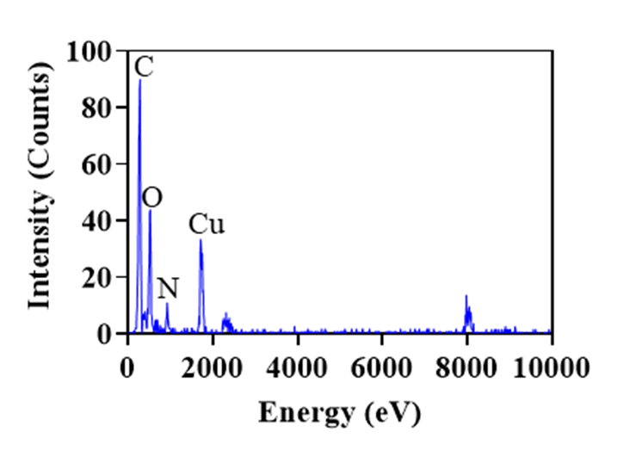

Fig. S2. Element analysis diagram of CCD NPs.

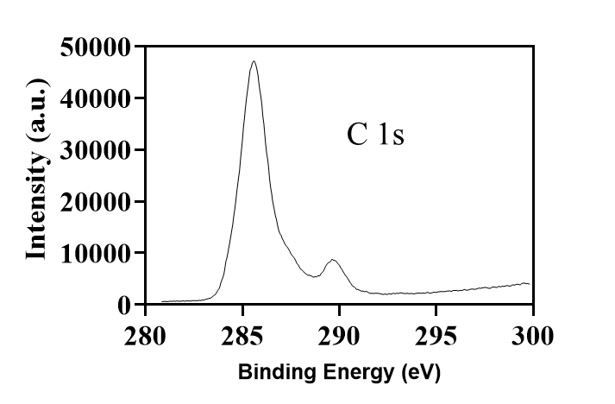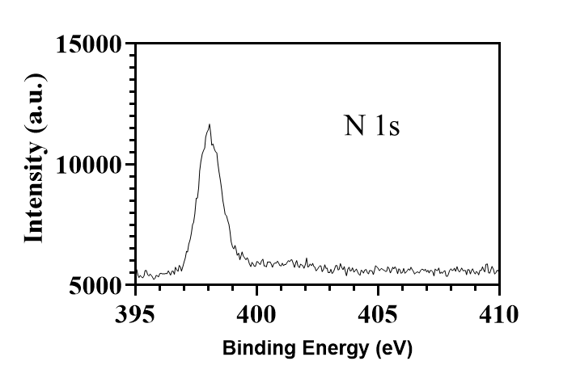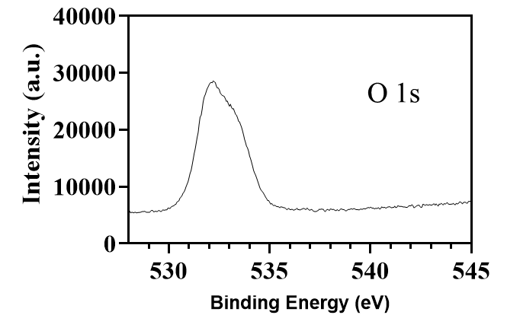
Fig. S3. XPS spectra of CCD NPs. C 1s, N 1s, and O 1s.

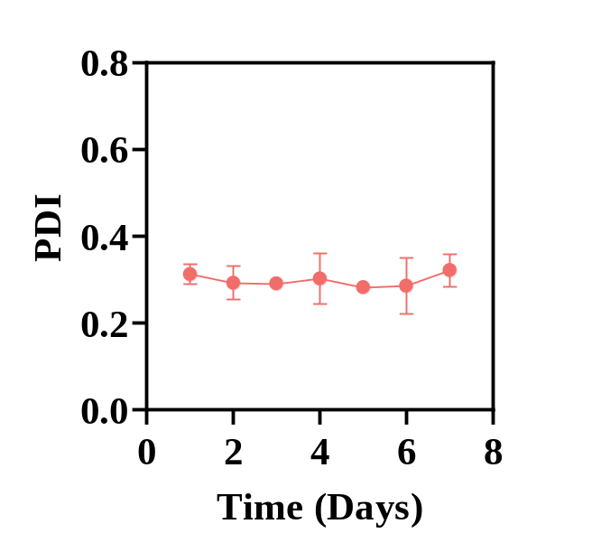
Fig. S4. DLS measured PDI of CCD NPs in aqueous solution for 7 days.

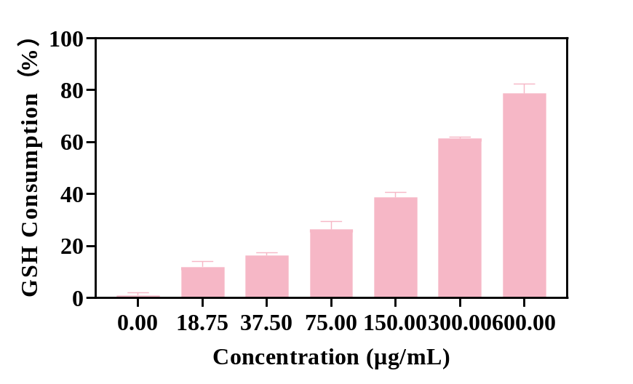

Fig. S5. Efficiency of GSH consumption by CCD NPs at different concentrations.

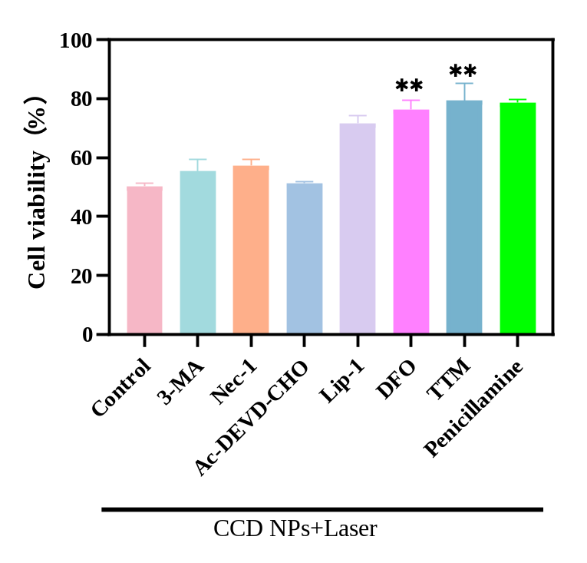
Fig. S6. Cell viability changes after co-incubation with CCD NPs and receiving light after addition of inhibitors of different cell death types.

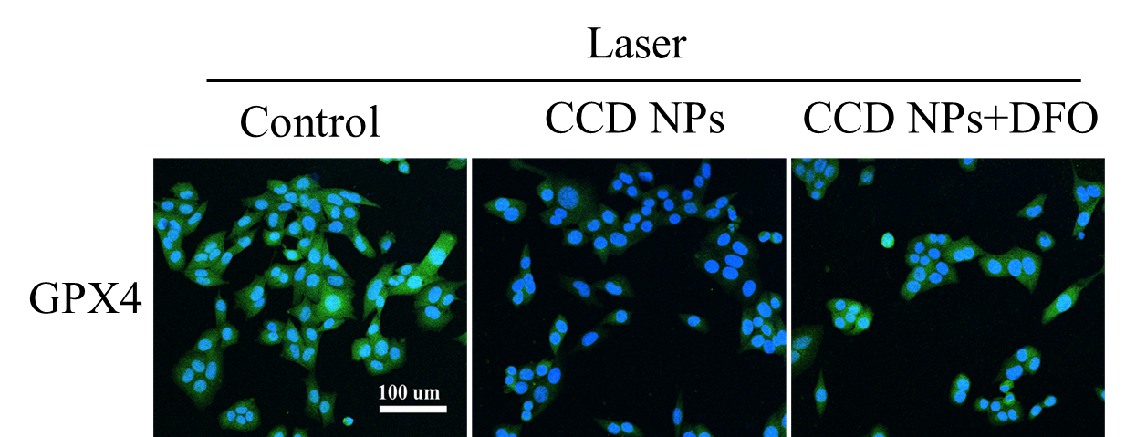
Fig. S7. CLSM images of GPX4 in 4T1 cells treated with CCD NPs and ferroptosis inhibitor.

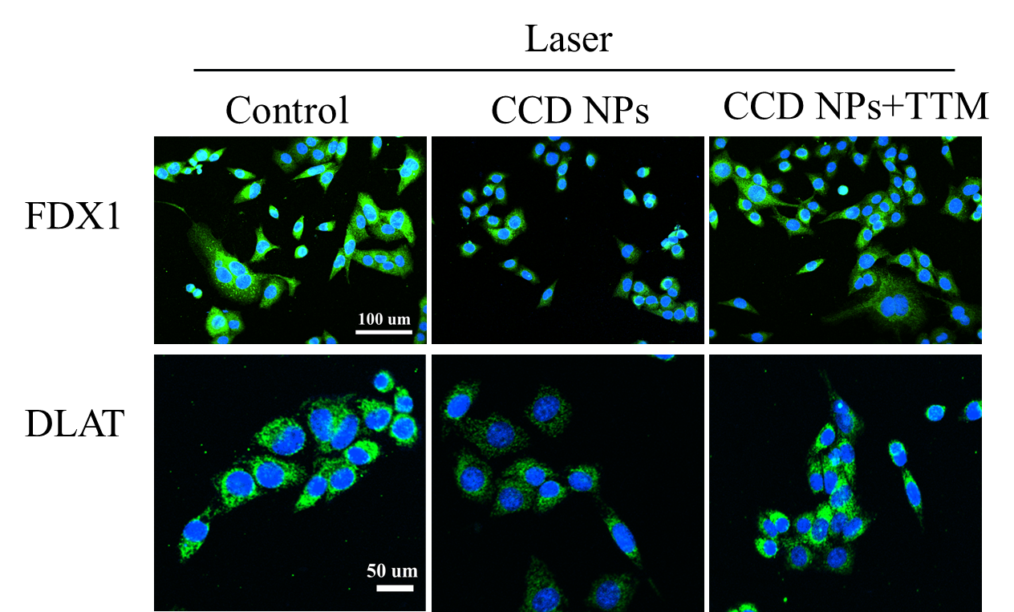

Fig. S8. CLSM images of FDX1 and DLAT in 4T1 cells treated with CCD NPs and cuproptosis inhibitor.

Liver
Tumor
Heart
Spleen
Lung
Kidney
Liver
Tumor
Heart
Spleen
Lung
Kidney

Fig. S9. Fluorescence images of mouse tumors and major organ tissues after treatment with Ce6 and CCD NPs.
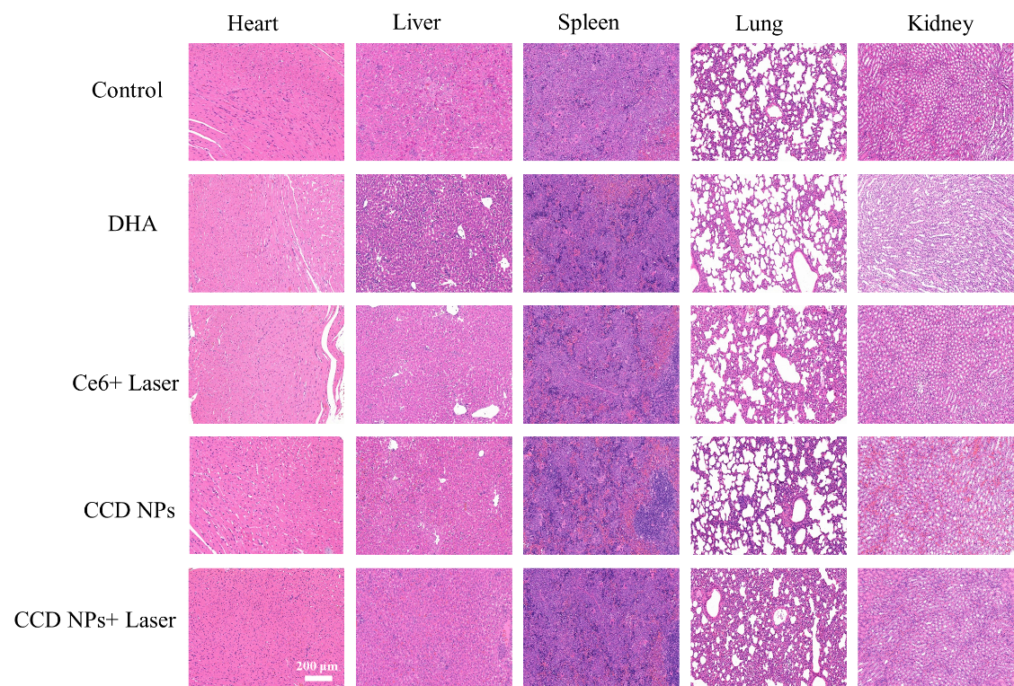

Fig. S10. Histological imaging of heart, Liver, spleen, Lung and kidney.

Table S1. Different synthesis parameters and resultant particle metrics in CCD NPs fabrication.

