Supporting information
Mesenchymal stem cell-derived extracellular vesicles attenuate liver transplantation-induced ischemia/reperfusion injury by suppressing hepatocellular complement C5 expression
Yasong Liu^{1, #}, Jiaqi Xiao^{1, #}, Zhengqi Wu^{1, #}, Feng Zhang^{2, #}, Qiang You¹, Haitian Chen¹, Jiebin Zhang¹, Yang Yang¹, Tingting Wang^{1, *}, Shuhong Yi^{1, *}, Rong Li^{3, *}, Jun Zheng ^{1, *}

Supplement figure legend
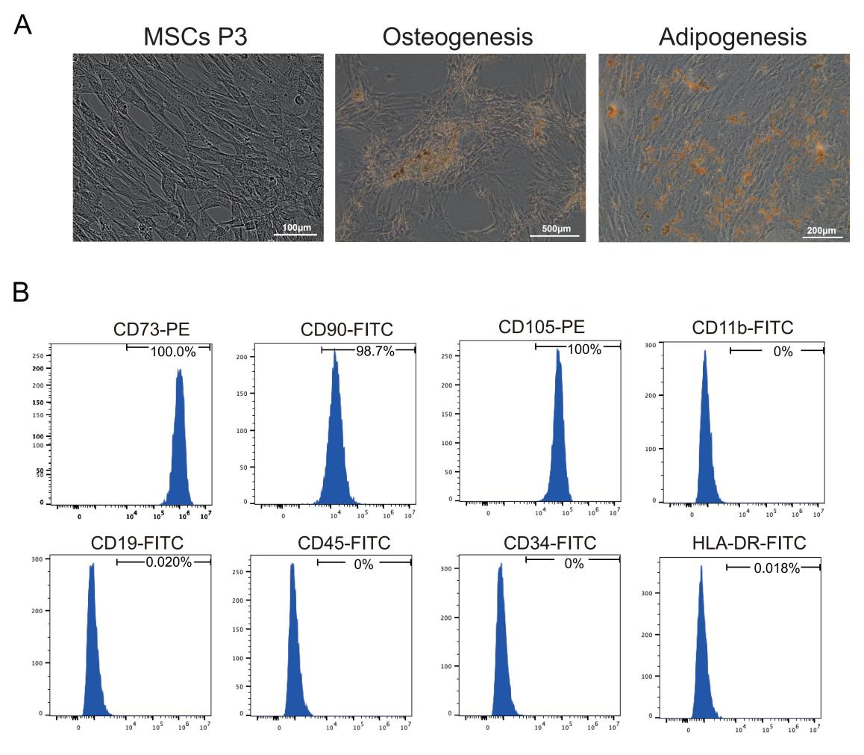
Supplement Figure1. Morphology, differentiation potential, and immunophenotype of UC-MSCs
- The fibroblast-like morphology of UC-MSCs was examined under a light microscope and representative images depict UC-MSCs differentiated into osteogenic and adipogenic lineages. (B) Expression of specific surface markers on UC-MSCs，including CD73, CD90, CD105, CD11b, CD19, CD45, CD34, and HLA-DR，was analyzed by flow cytometry.

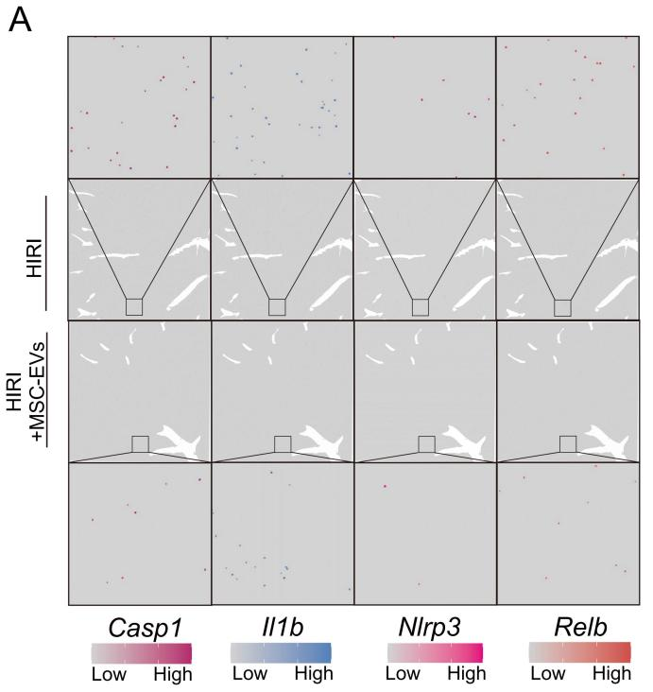
Supplement Figure2. Spatial mapping of inflammatory programs in HIRI and MSC-EVs treated mouse livers
- Spatial transcriptomic mapping of inflammatory gene expression in HIRI and MSC-EVs treated mouse livers.

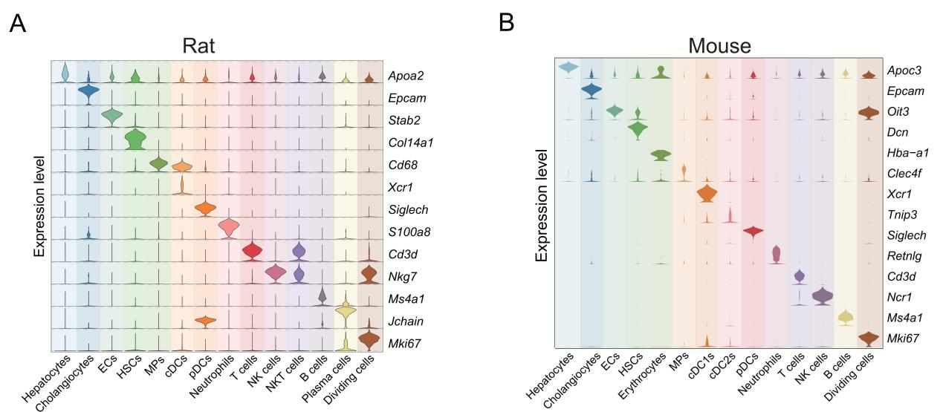
Supplement Figure3. Marker-based validation of cell identities in rat and mouse liver single-cell datasets
- Violin plots showing the expression levels of representative cell type-specific marker genes for the corresponding cell types in rat livers. (B) Violin plots showing the expression levels of representative cell type-specific marker genes for the corresponding cell types in mouse livers.

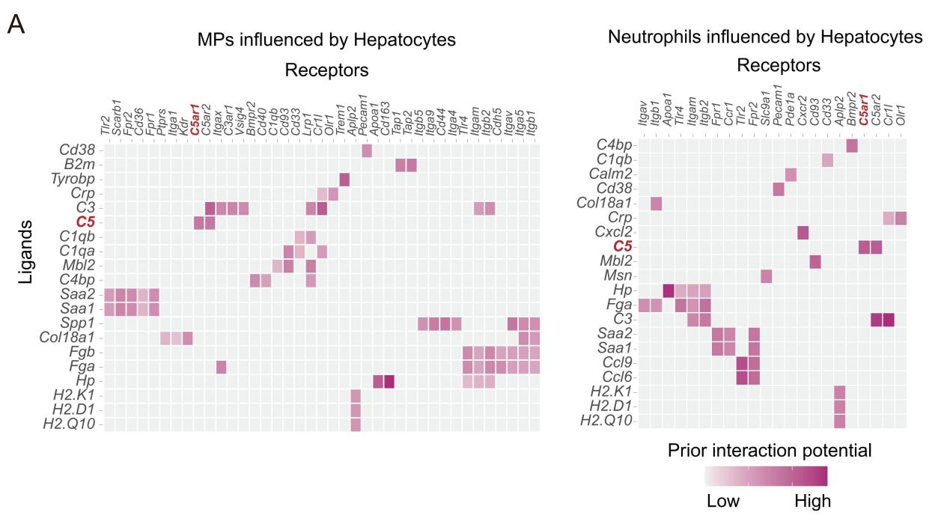
Supplement Figure4. Intercellular ligand–receptor networks between hepatocytes and MPs and neutrophils
- Hepatocyte-derived ligands and their cognate receptors identified in MPs (left) and neutrophils (right).

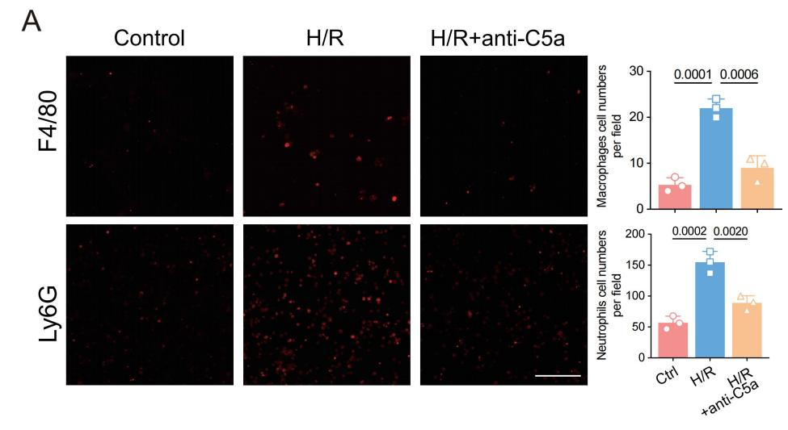
Supplement Figure5. Transwell migration of macrophages and neutrophils
- Macrophages and neutrophils migrating from the upper to the lower chamber were analyzed using fluorescence microscopy. Three independent cell experiments. Scale bar: 100 μm.

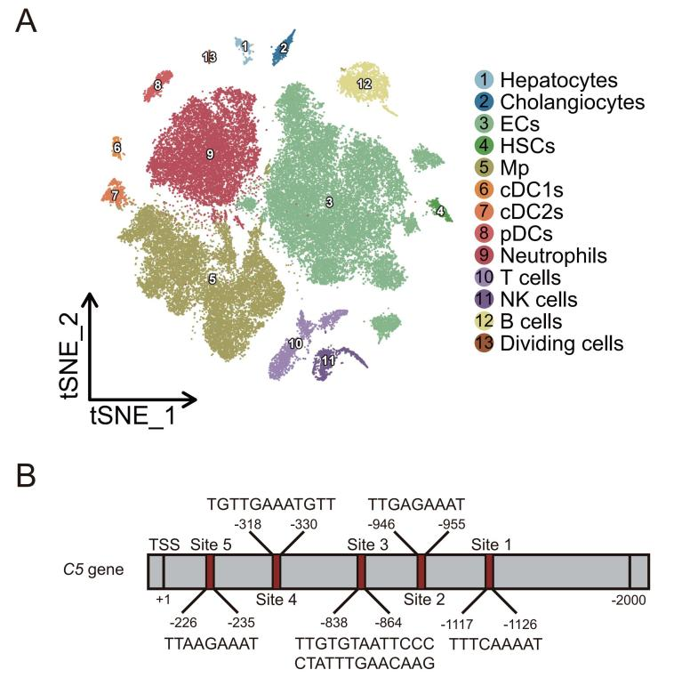
Supplement Figure6. snATAC-seq clustering and predicted C/EBPα binding at the C5 promoter
- t-SNE map of snATAC-seq profiles from mouse livers under HIRI and MSC-EV–treated HIRI, annotated into 14 hepatic cell clusters. (B) The potential C/EBPα binding sites on mouse C5 promotor were predicted by the JASPAR database.

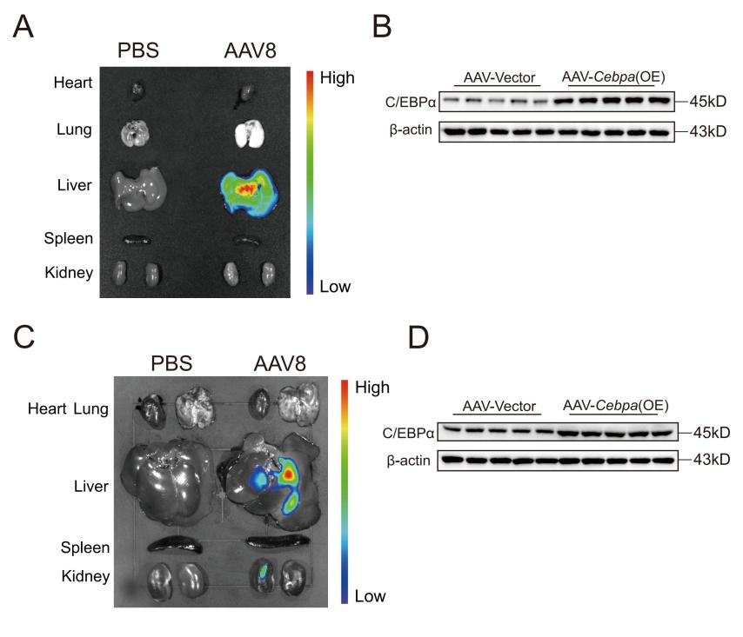
Supplement Figure7. AAV8 biodistribution and hepatocyte transduction in mice and rats
- Representative IVIS images of heart, lung, liver, spleen, and kidneys harvested from mice following injection with AAV8. (B) Cell lysates from mouse primary hepatocytes were assessed by western blotting in each group( n=5 animals per group). (C) Representative IVIS images of heart, lung, liver, spleen, and kidneys harvested from rats following injection with AAV8. (D) Cell lysates from rat primary hepatocytes were assessed by western blotting in each group( n=5 animals per group).

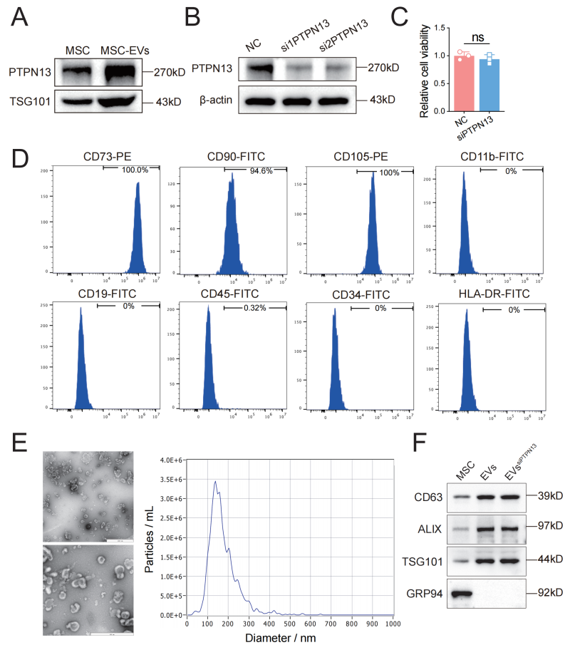
Supplement Figure8. Characterization of PTPN13 knockdown in MSCs and derived MSC-EVs^{siPTPN13}
- The expression of PTPN13 and TSG101 was measured in MSCs and MSC-EVs. (B) The efficiency of PTPN13 knockdown in MSCs was assessed by Western blotting. (C) The cell viability was detected in MSCs. (D) The expressions of the MSC-specific markers in MSCs^{siPTPN13}. (E) TEM and Nanoparticle tracking analysis for detecting the diameter of MSC-EVs^{siPTPN13} revealed the size and spheroid morphology of MSC-EVs^{siPTPN13}. (F) The expression of specific vesicle-related markers in MSC-EVs^{siPTPN13}.

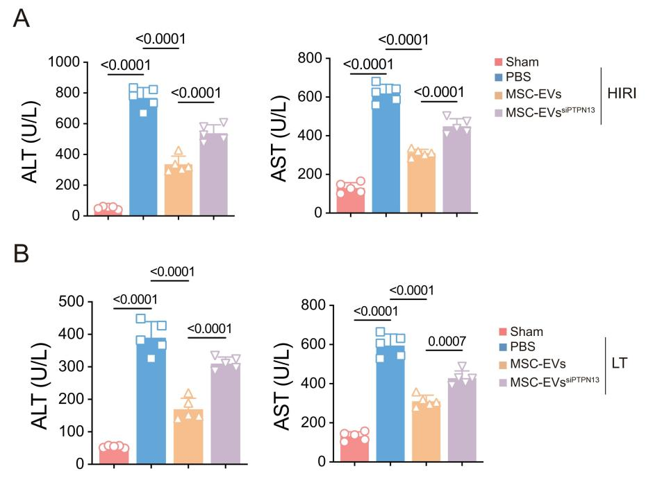
Supplement Figure9. Serum transaminases across experimental groups in mice and rats
- Serum levels of ALT and AST in each mouse group. (B) Serum levels of ALT and AST in each rat group( n=5 animals per group).

