Supporting Information
NIR-II Photothermal-Amplified Triple Catalysis of a Spherical Mesoporous Iron Single-atom Nanozyme for Potentiating Ferroptosis-Based Tumor Therapy
Jingting Li ª, Sihan Wang ª, Fan Yang ª, Yang Guo ª, Xinyu Gao ª, Mingyu Nie ª, Zihan Zhou ª, Hao Xin ª, Fei Song ª, Changsong Dai ^{b}, Zhaohui Wen ^{a＊}
ª Department of Neurology, Brain Ultrasound, The First Affiliated Hospital of Harbin Medical University, Harbin 150001, China.
^{b} MIIT Key Laboratory of Critical Materials Technology for New Energy Conversion and Storage, School of Chemistry and Chemical Engineering, Harbin Institute of Technology, Harbin 150001, China.
＊Corresponding author: wenzhaohui1968@163.com (Z. Wen).

Supplementary figures and tables
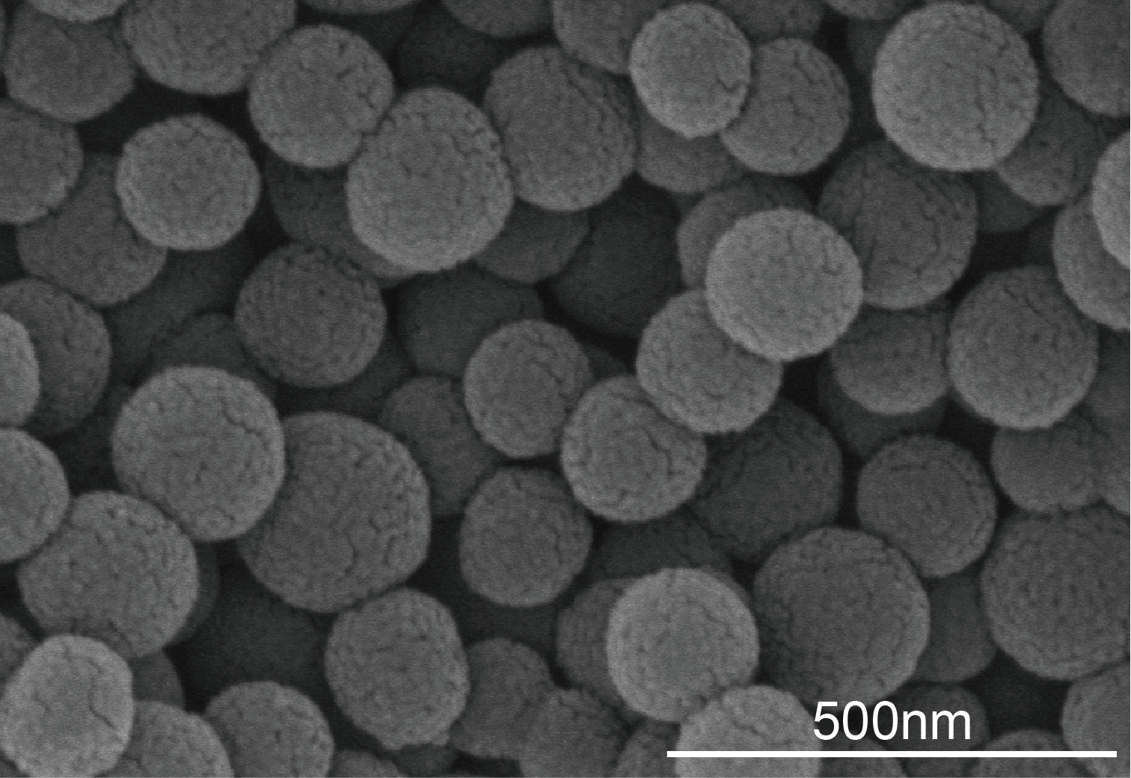
Fig. S1. SEM image of Fe-SAzyme-TPP.
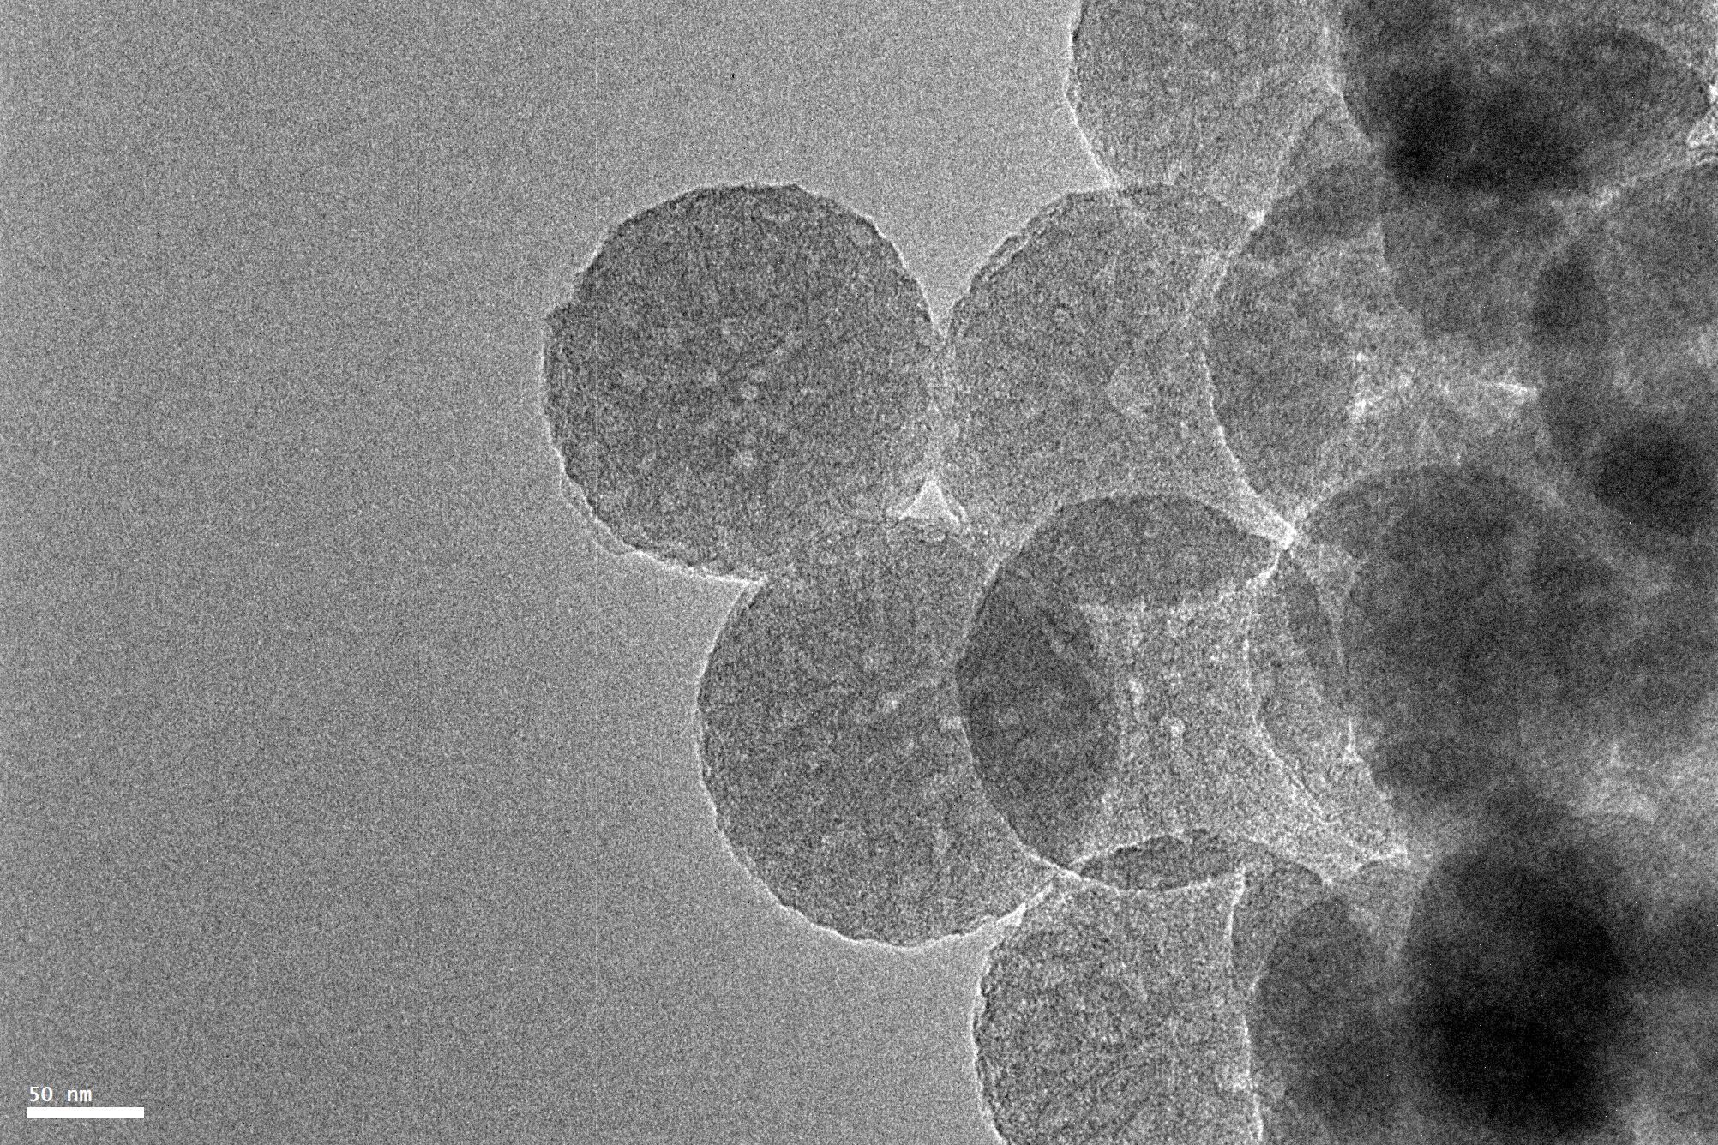
Fig. S2. TEM image of Fe-SAzyme-TPP
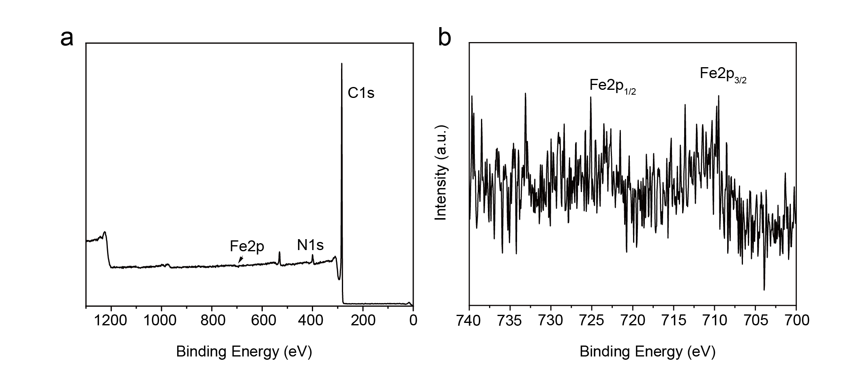
Fig. S3. Survey XPS spectra of (a) Fe-SAzyme and (b) high-resolution Fe2p spectra of Fe-SAzyme.
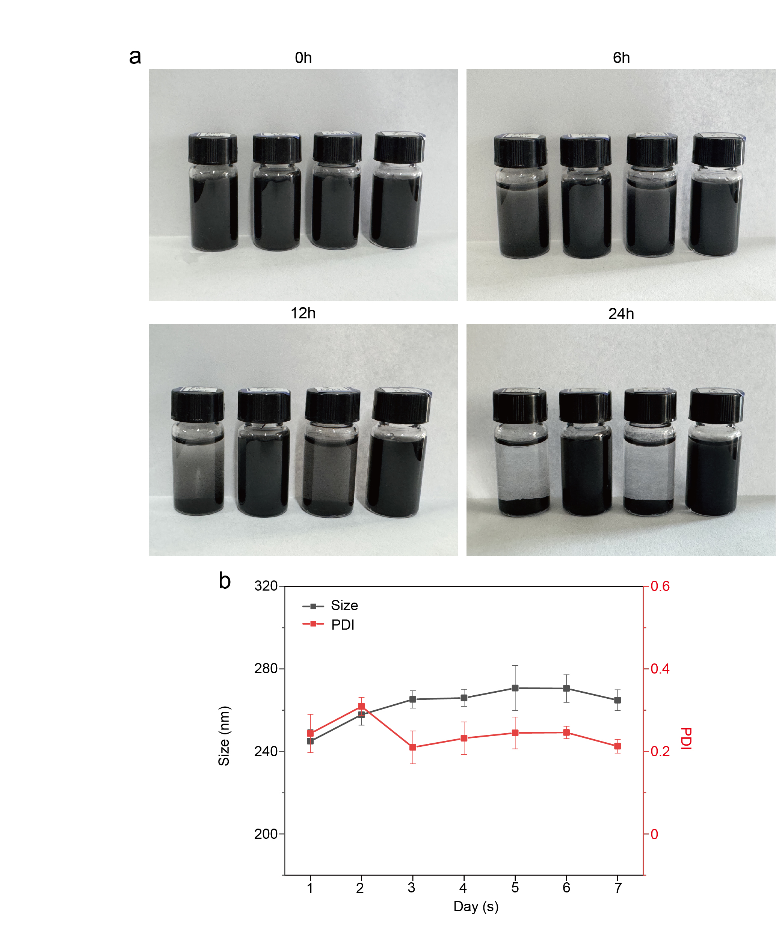
Fig. S4. Stability analysis of Fe-SAzyme and Fe-SAzyme-TPP. (a) Stability of Fe-SAzyme and Fe-SAzyme-TPP in PBS and saline after a 24 h incubation period. Photographs showing (from left to right): Fe-SAzyme in PBS, Fe-SAzyme in saline, Fe-SAzyme-TPP in PBS, and Fe-SAzyme-TPP in saline, (b) Time-dependent changes in the hydrodynamic diameter and polydispersity index (PDI) of Fe-SAzyme-TPP in saline over 7 days.

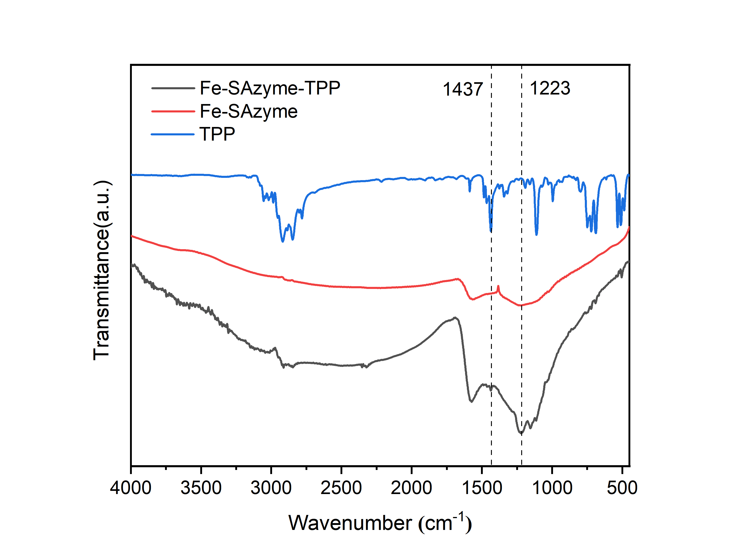
Fig. S5. FT-IR patterns of Fe-SAzyme, TPP, and Fe-SAzyme-TPP.

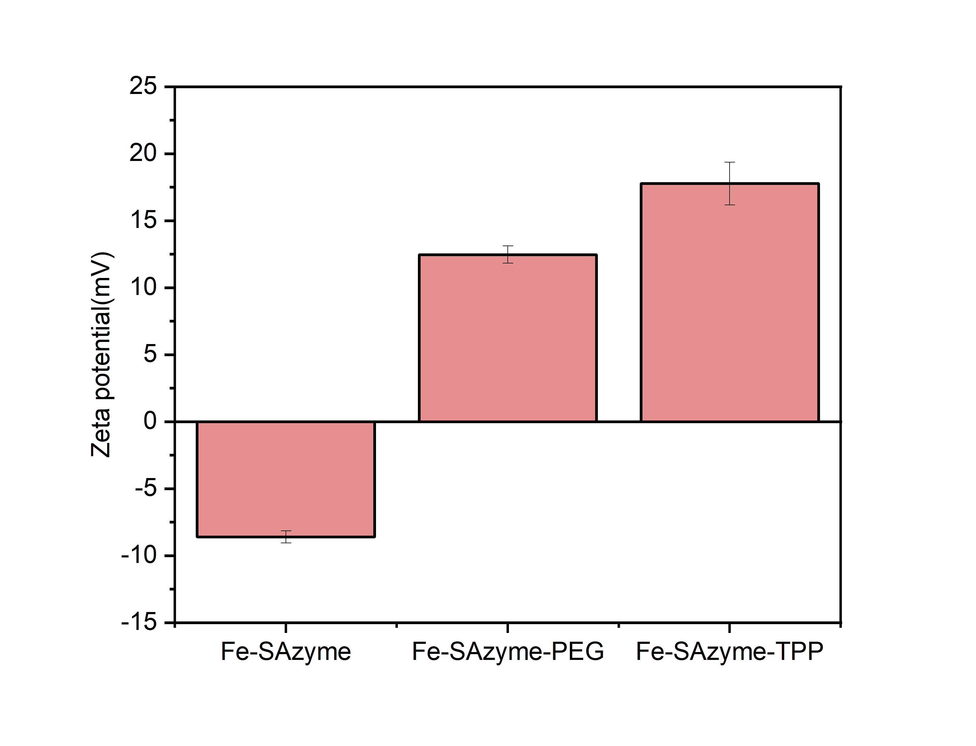
Fig. S6. Zeta potential of Fe-SAzyme, Fe-SAzyme-PEG, and Fe-SAzyme-TPP.

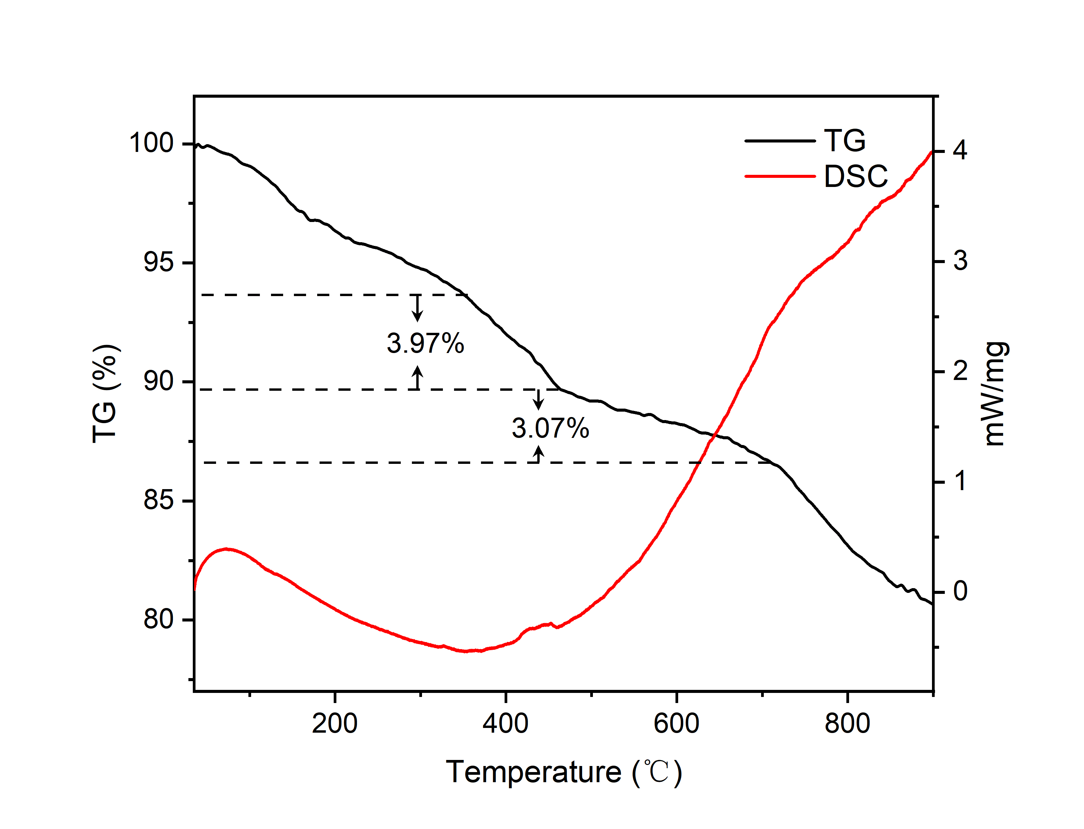
Fig. S7. Thermogravimetric analysis of Fe-SAzyme-TPP.
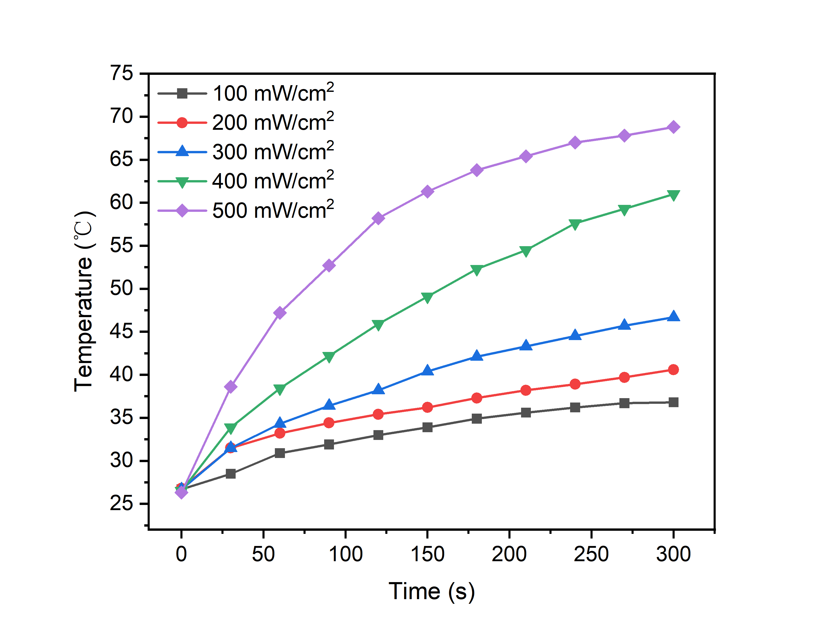
Fig. S8. Temperature changes of the Fe-SAzyme aqueous solutions at different laser power densities (1064 nm).
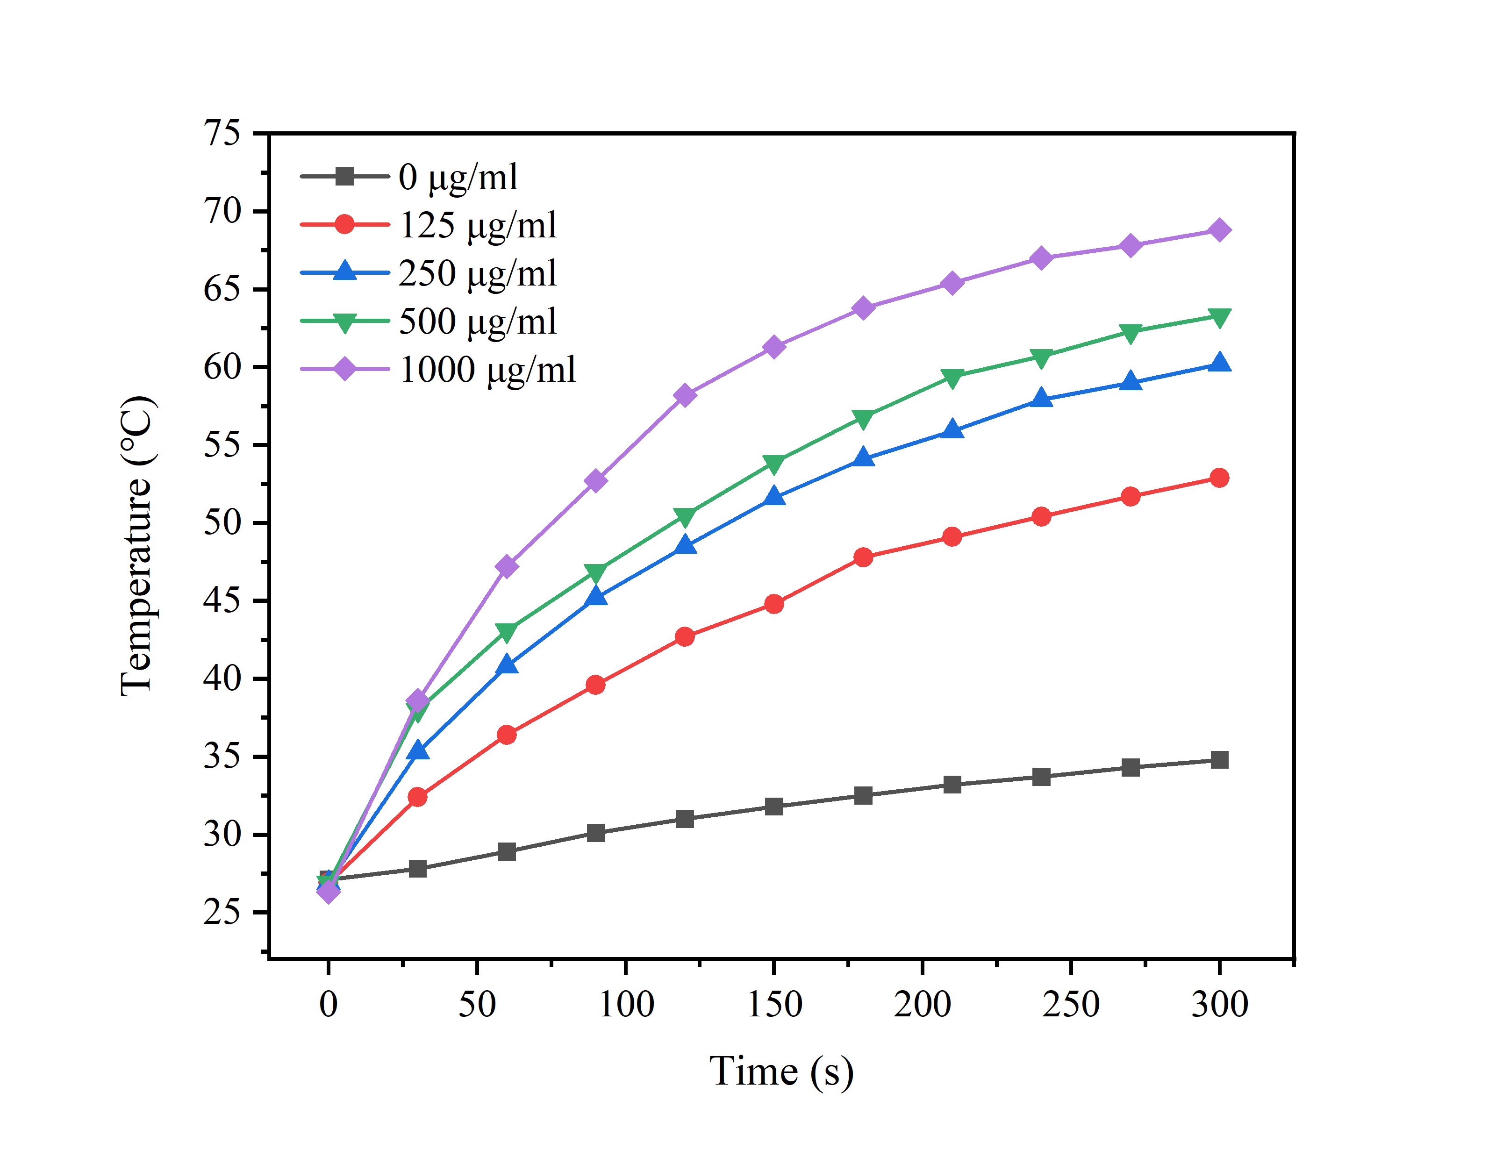
Fig. S9. Temperature changes of Fe-SAzyme aqueous solutions at different concentrations after 5 min of irradiation (1064 nm, 500 mW/cm²).

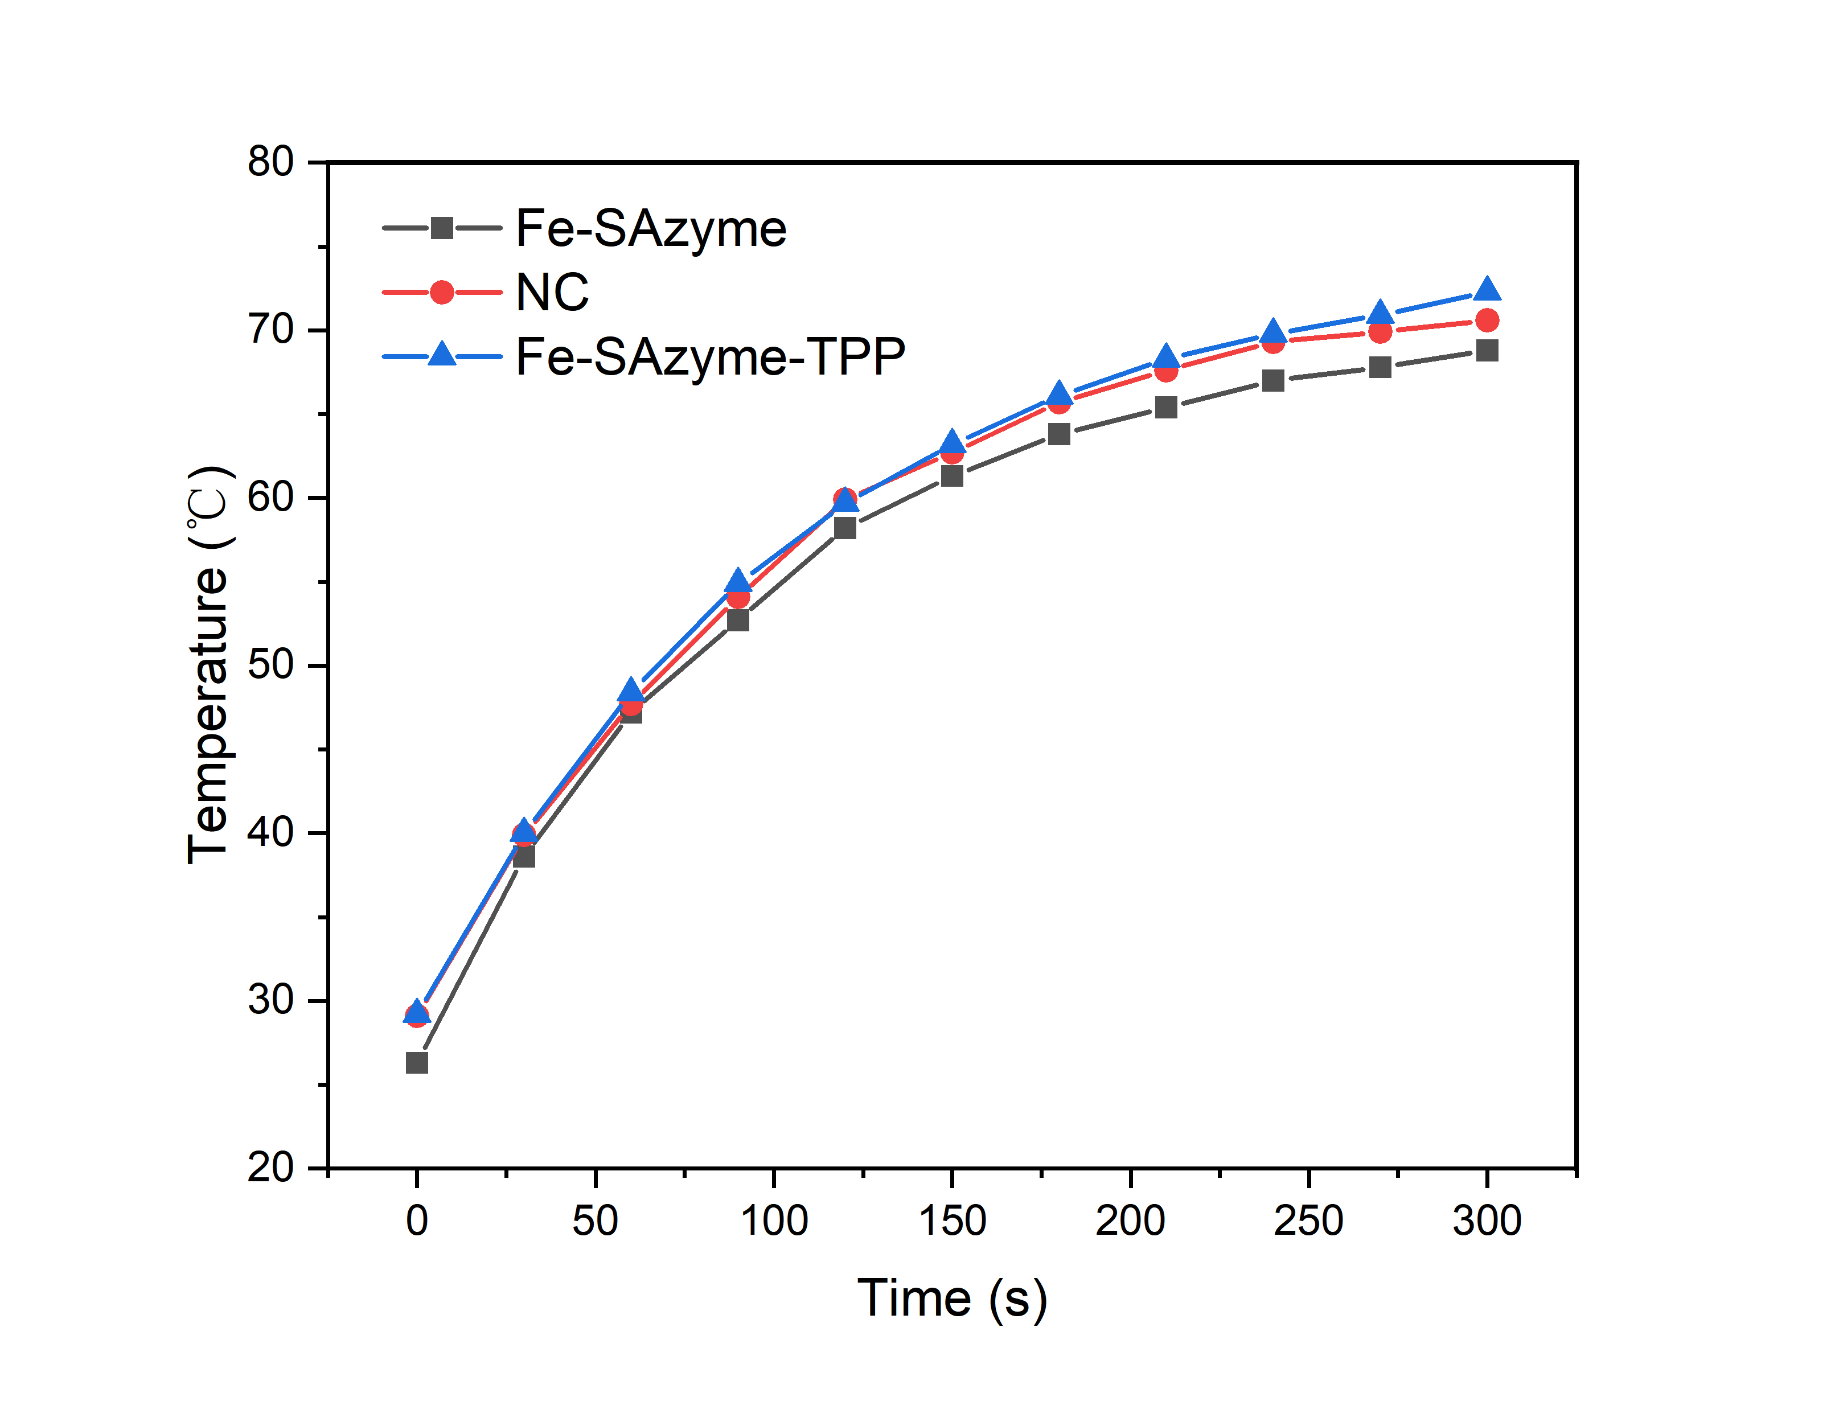
Fig. S10. Temperature changes of NC, Fe-SAzyme, and Fe-SAzyme-TPP aqueous solutions (1 mg/ml) after 5 min of irradiation (1064 nm, 500 mW/cm²).

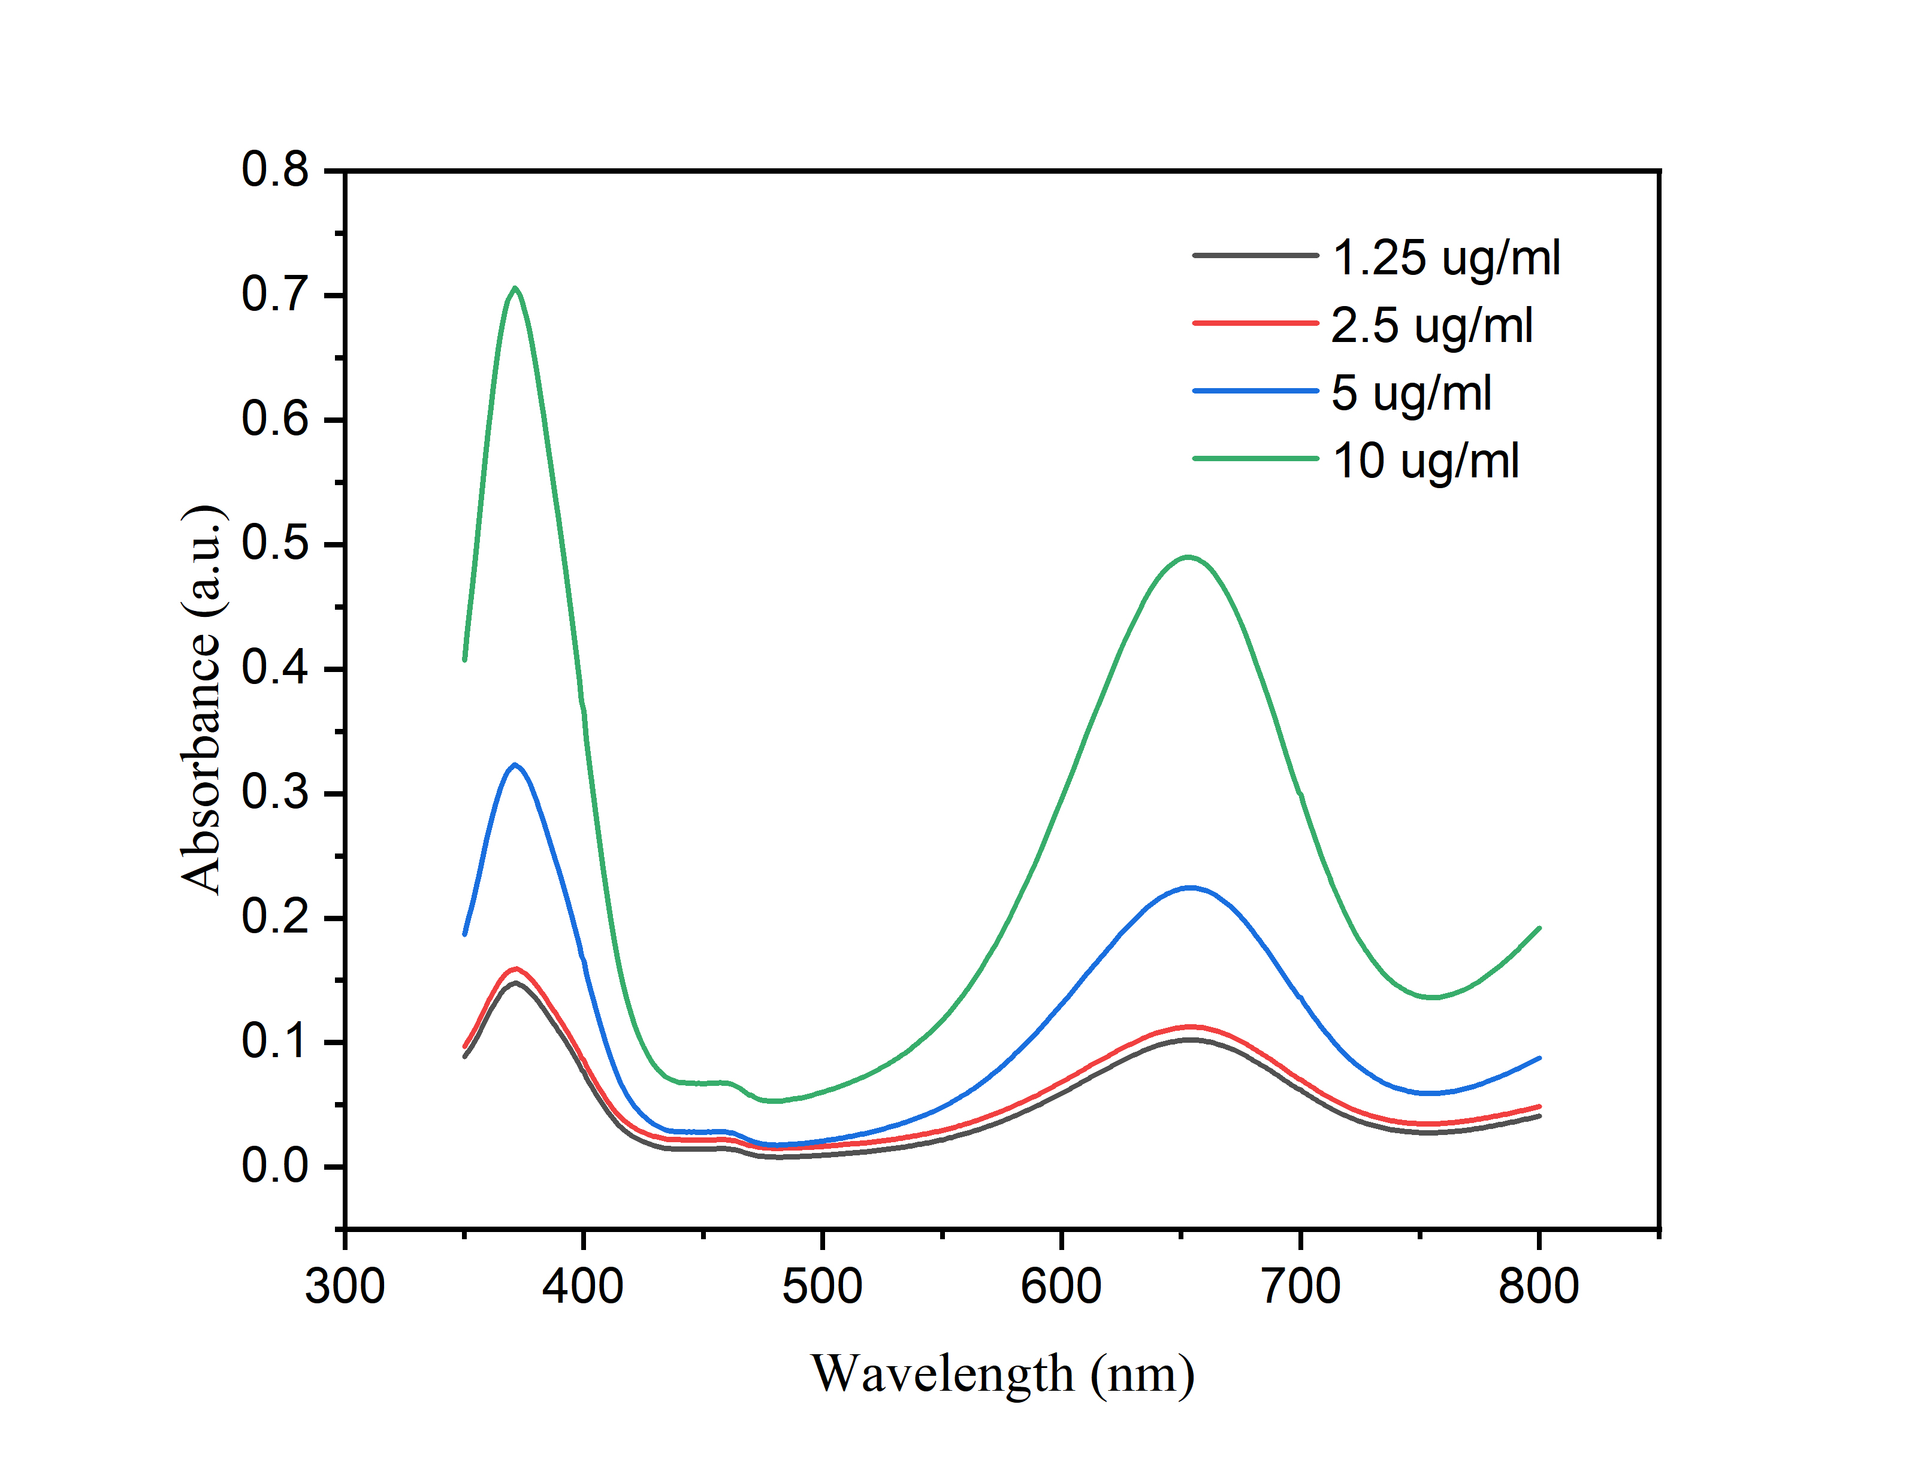
Fig. S11. Absorbance changes of the TMB solution containing 1 mM H₂O₂ with the addition of different Fe-SAzyme concentrations.
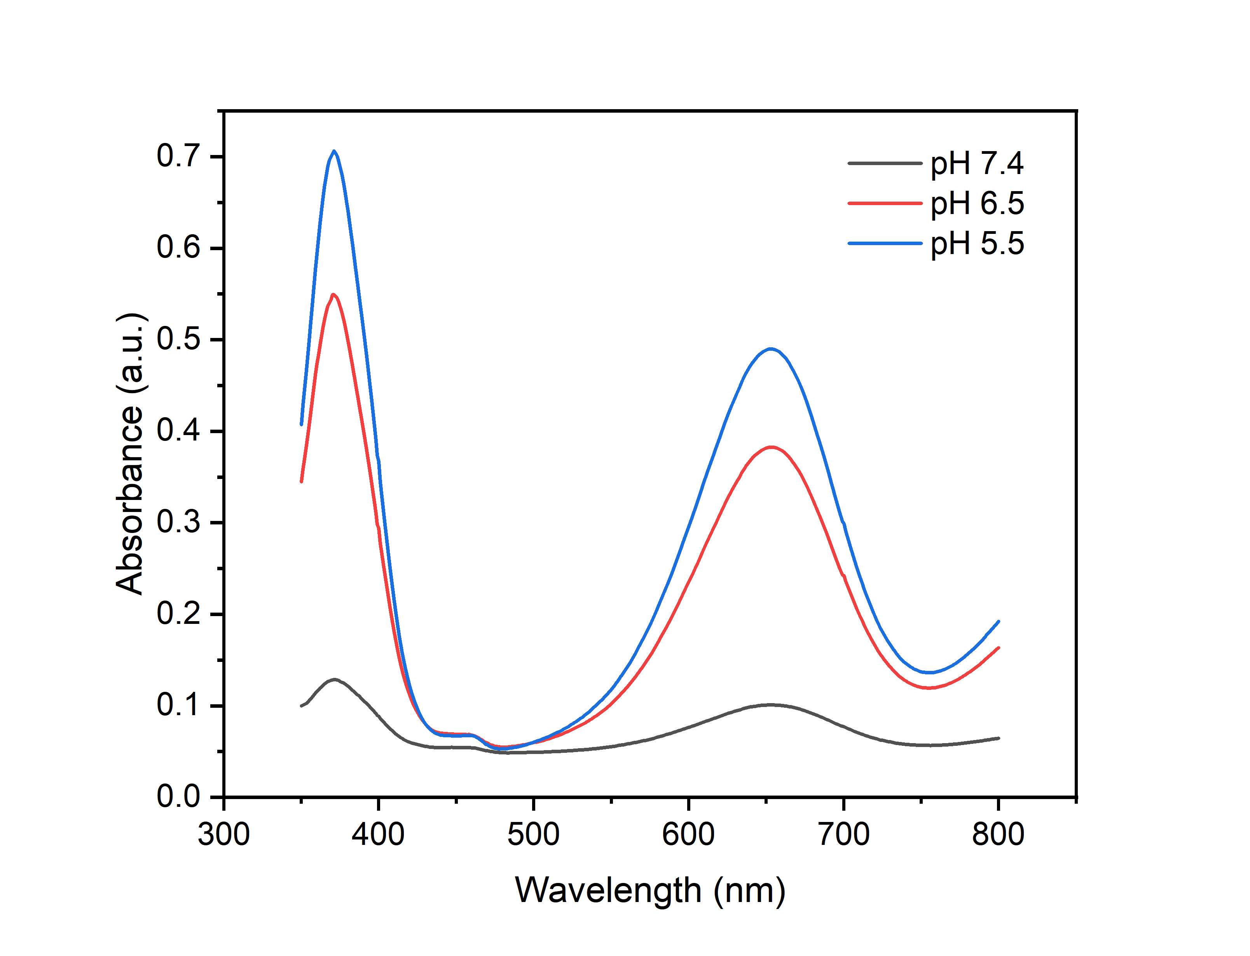
Fig. S12. Absorbance changes of TMB solution containing 10 μg/mL Fe-SAzyme at different pH levels with 1mM H₂O₂ as a substrate.
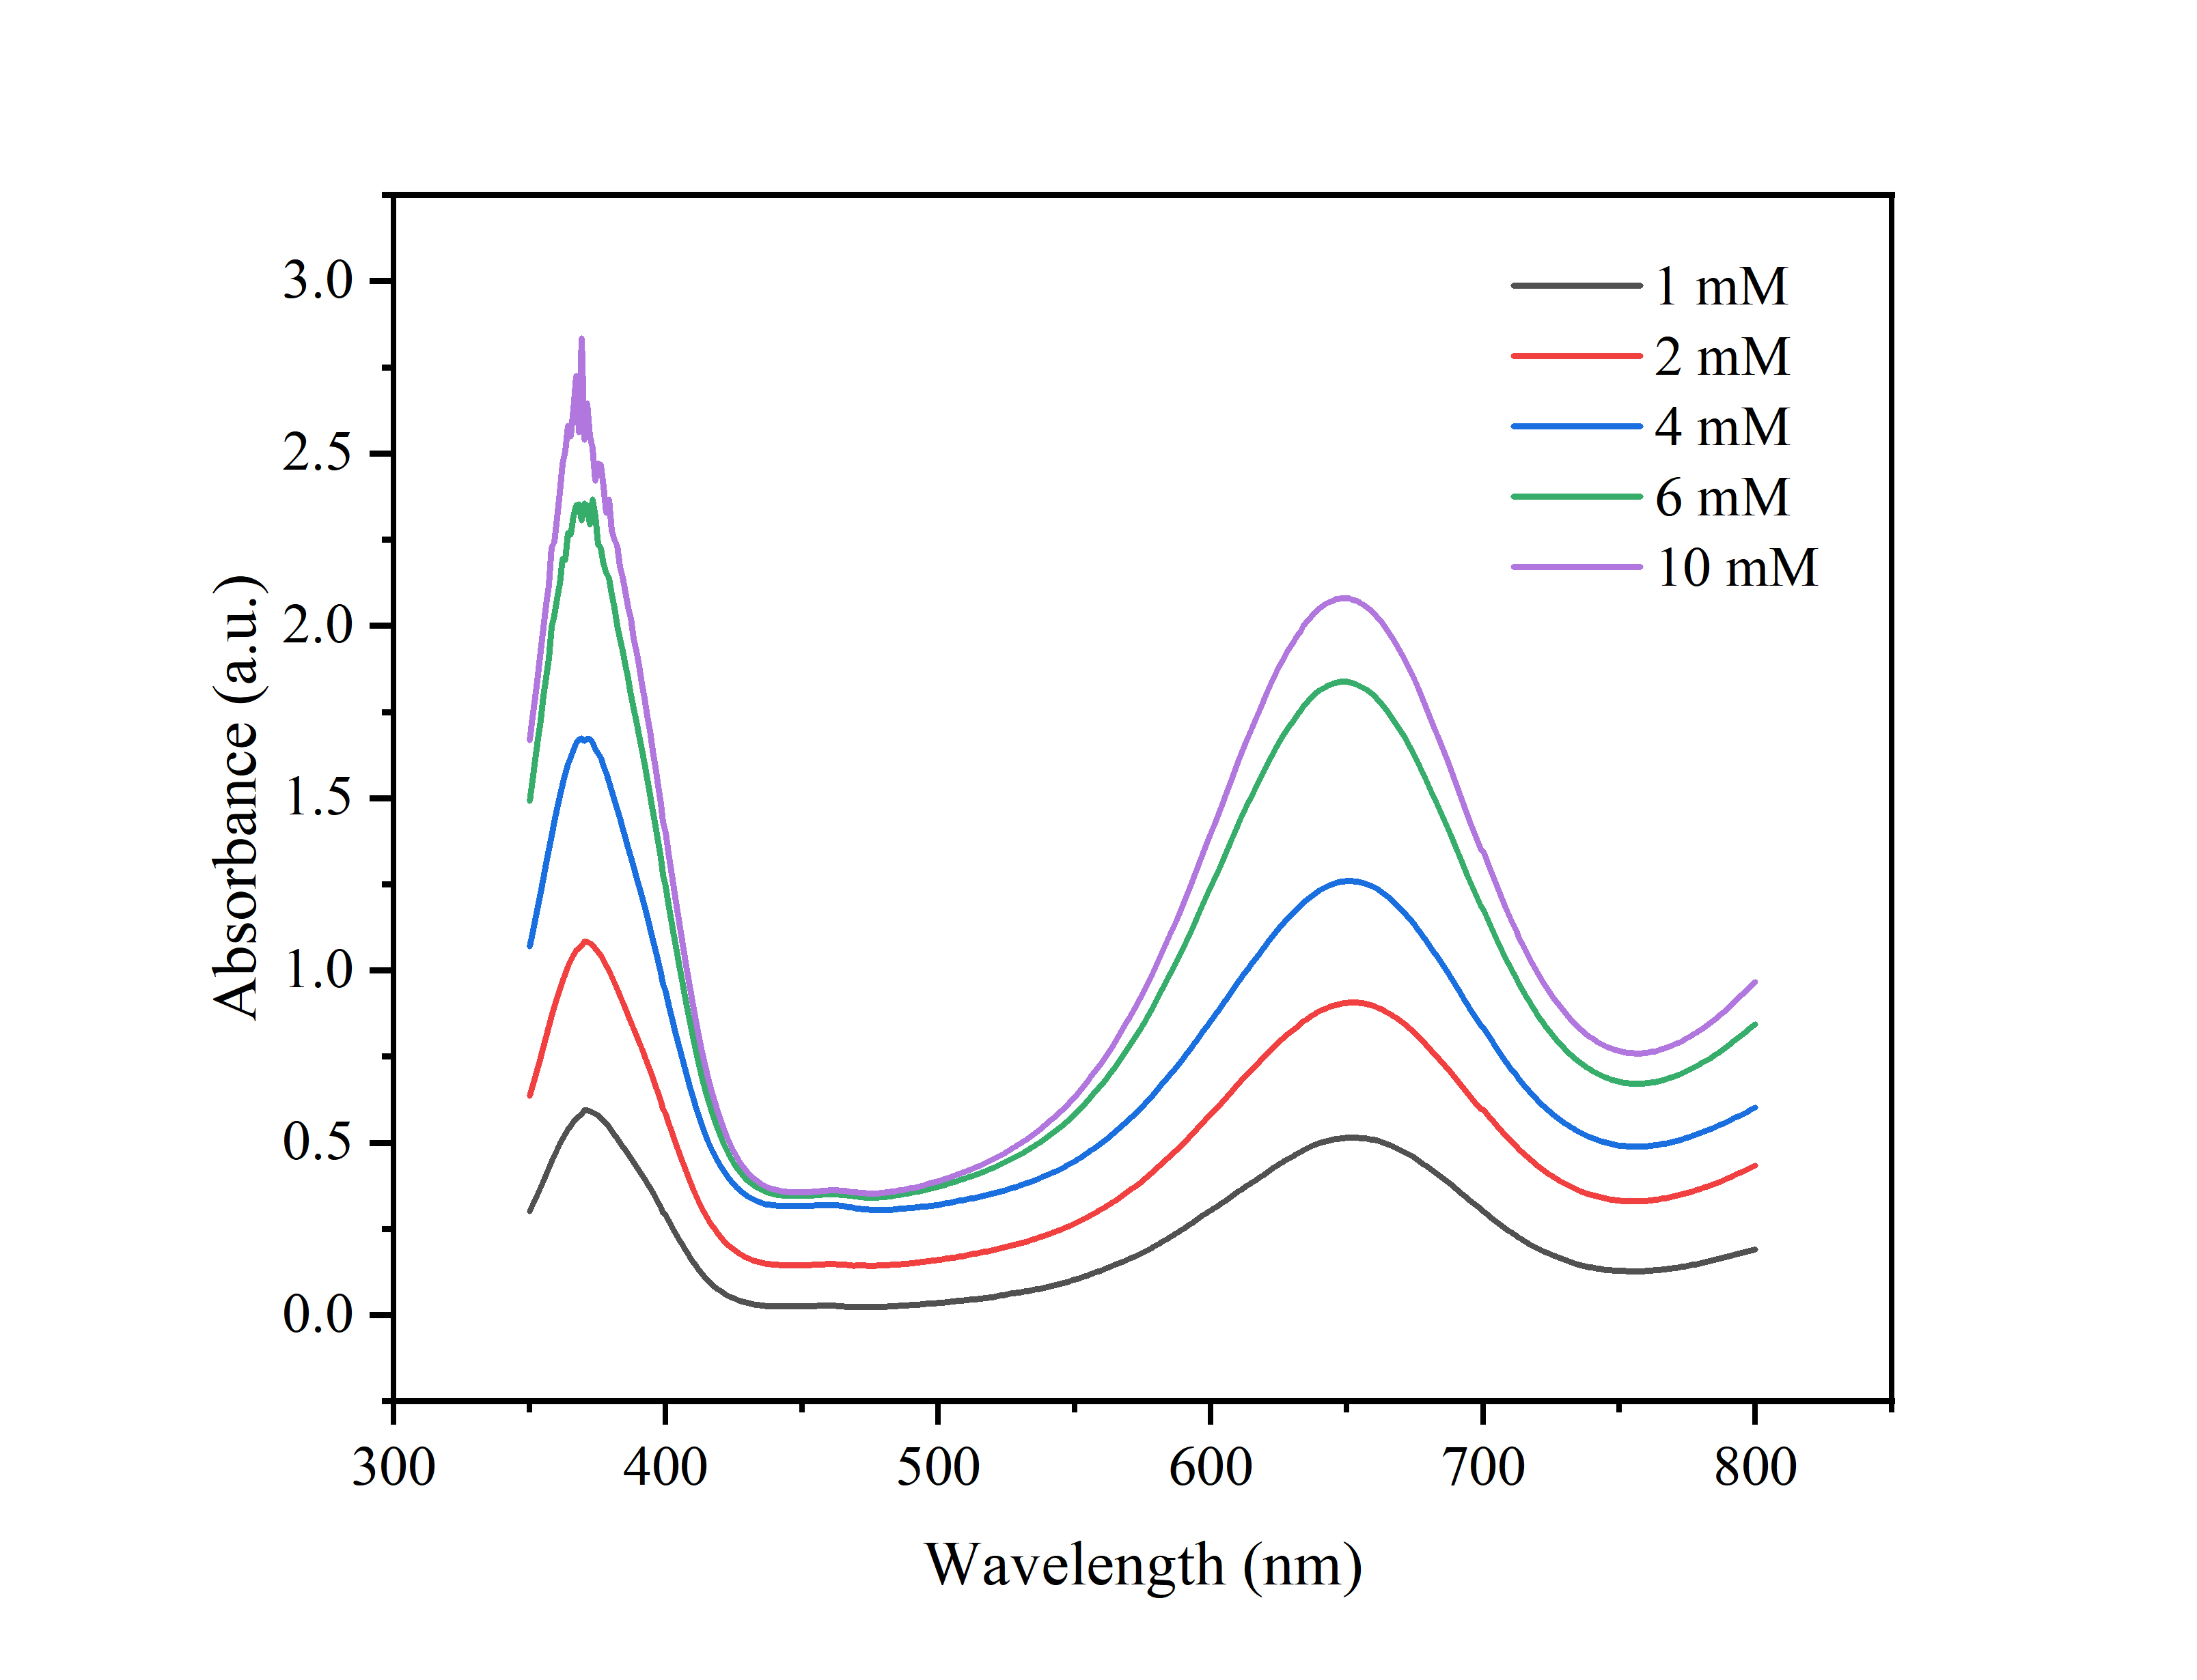
Fig. S13. Absorbance changes of TMB solution containing 10 μg/mL Fe-SAzyme with the addition of different H₂O₂ concentrations.

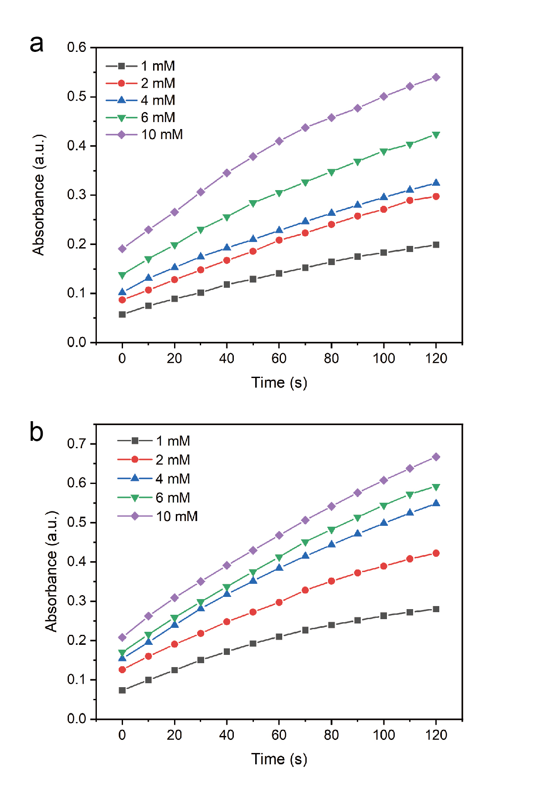
Fig. S14. Absorbance changes of TMB solution containing 10 μg/mL Fe-SAzyme with the addition of different H₂O₂ concentrations (a) without or (b) with mild NIR-II laser treatments.
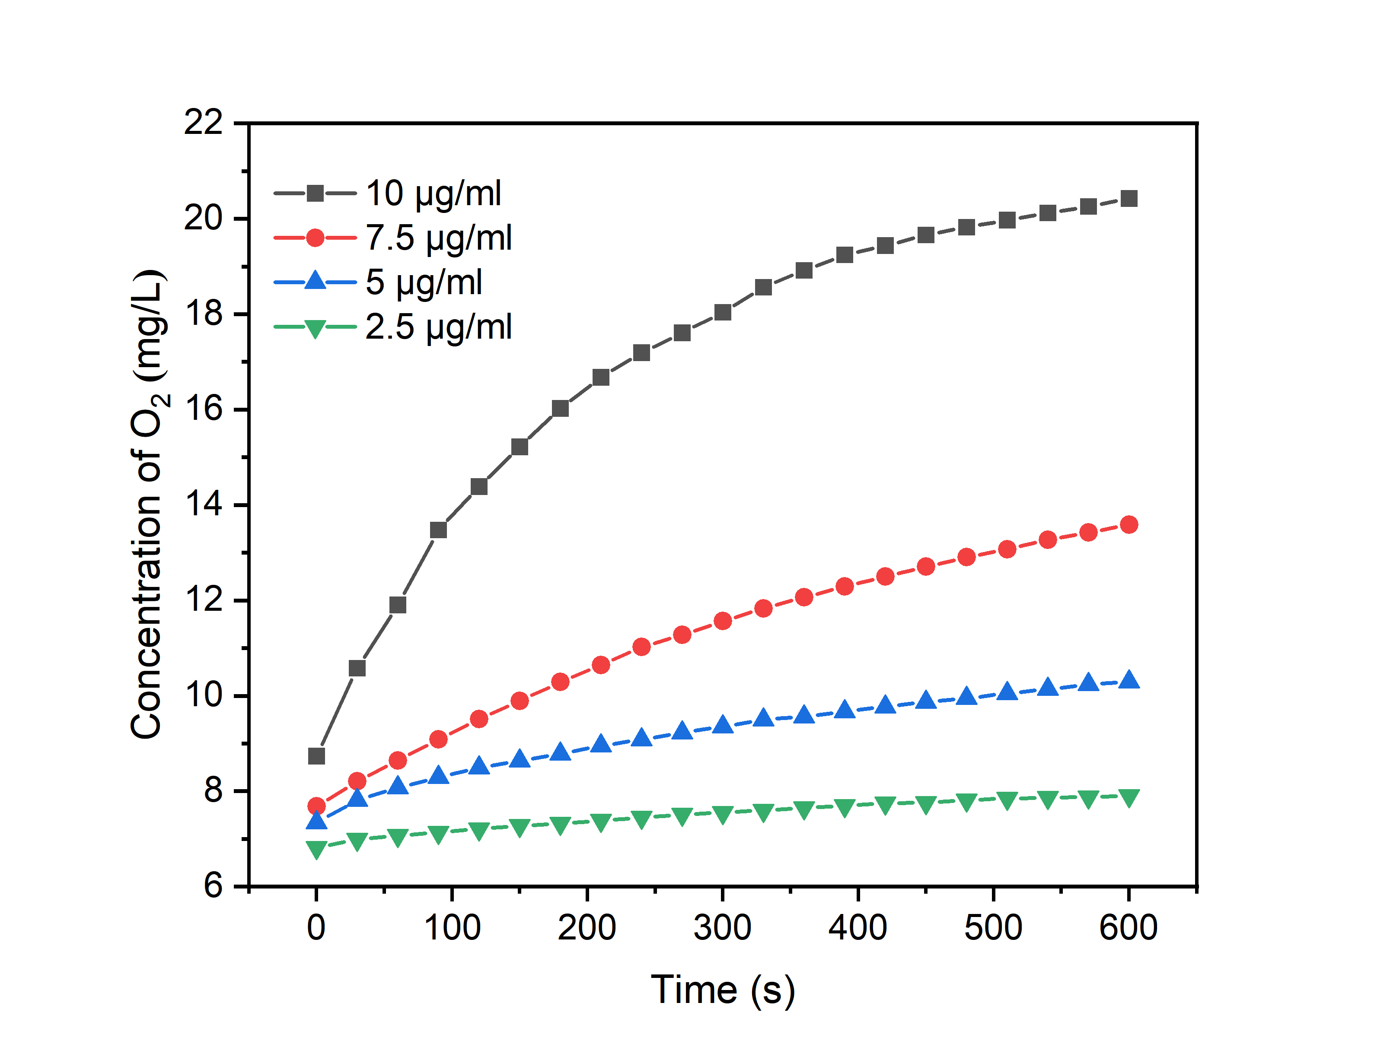
Fig. S15. Dissolved O₂ concentrations of different concentrations of Fe-SAzyme
in H₂O₂ solution.
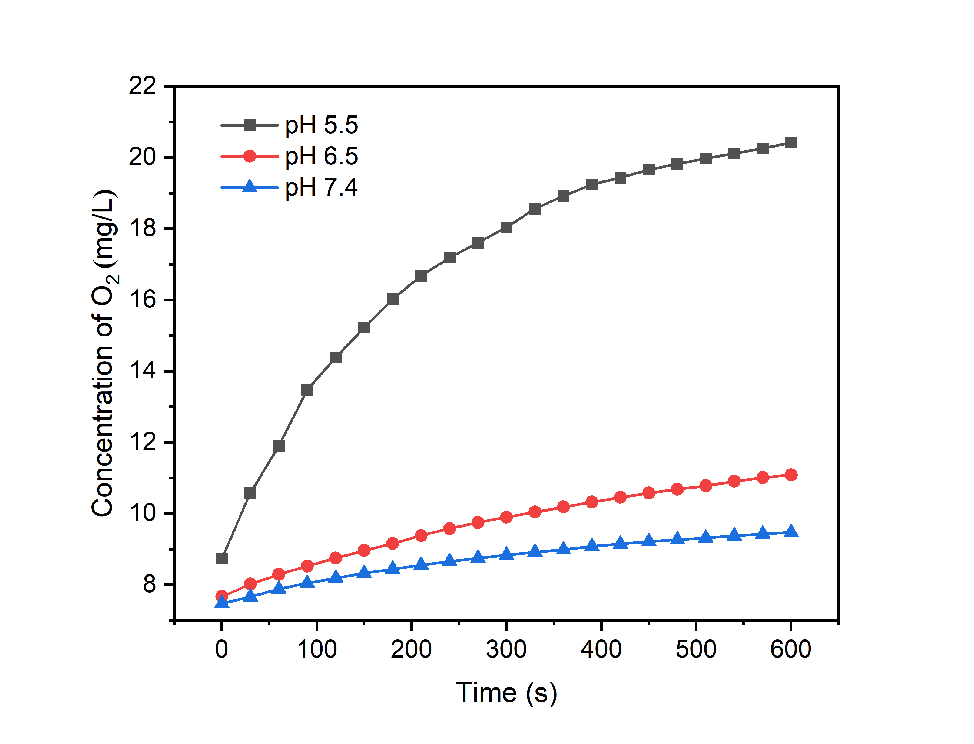
Fig. S16. Dissolved O₂ concentrations of Fe-SAzyme at different pH levels in H₂O₂ solution.
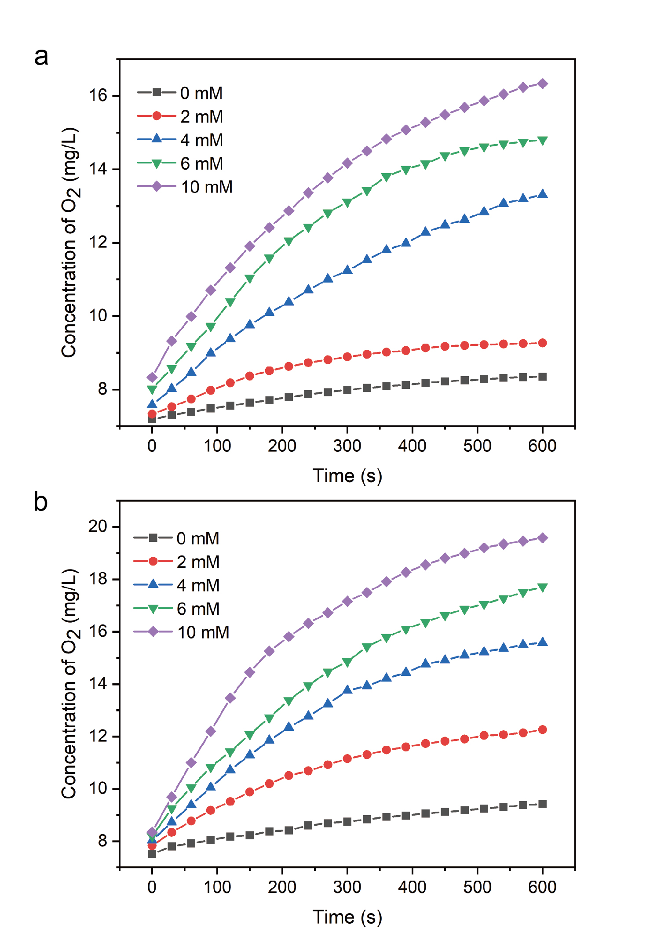
Fig. S17. O₂ generation upon the addition of 10 μg/mL Fe-SAzyme and H₂O₂ with varying concentrations (a) without or (b) with mild NIR-II laser treatments.

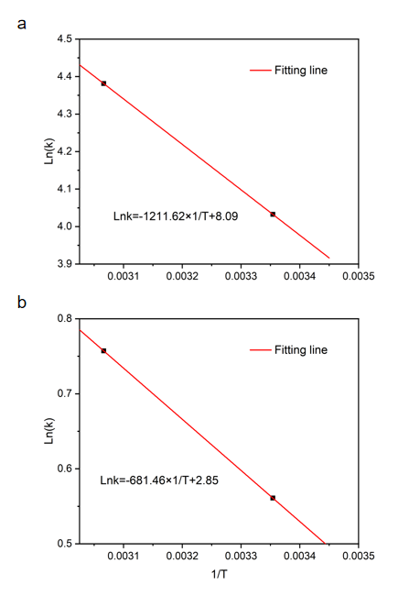
Fig. S18. Arrhenius plots for Fe-SAzyme's (a) POD-like catalytic activity and (b) CAT-like catalytic activity at room temperature and PTT temperature.

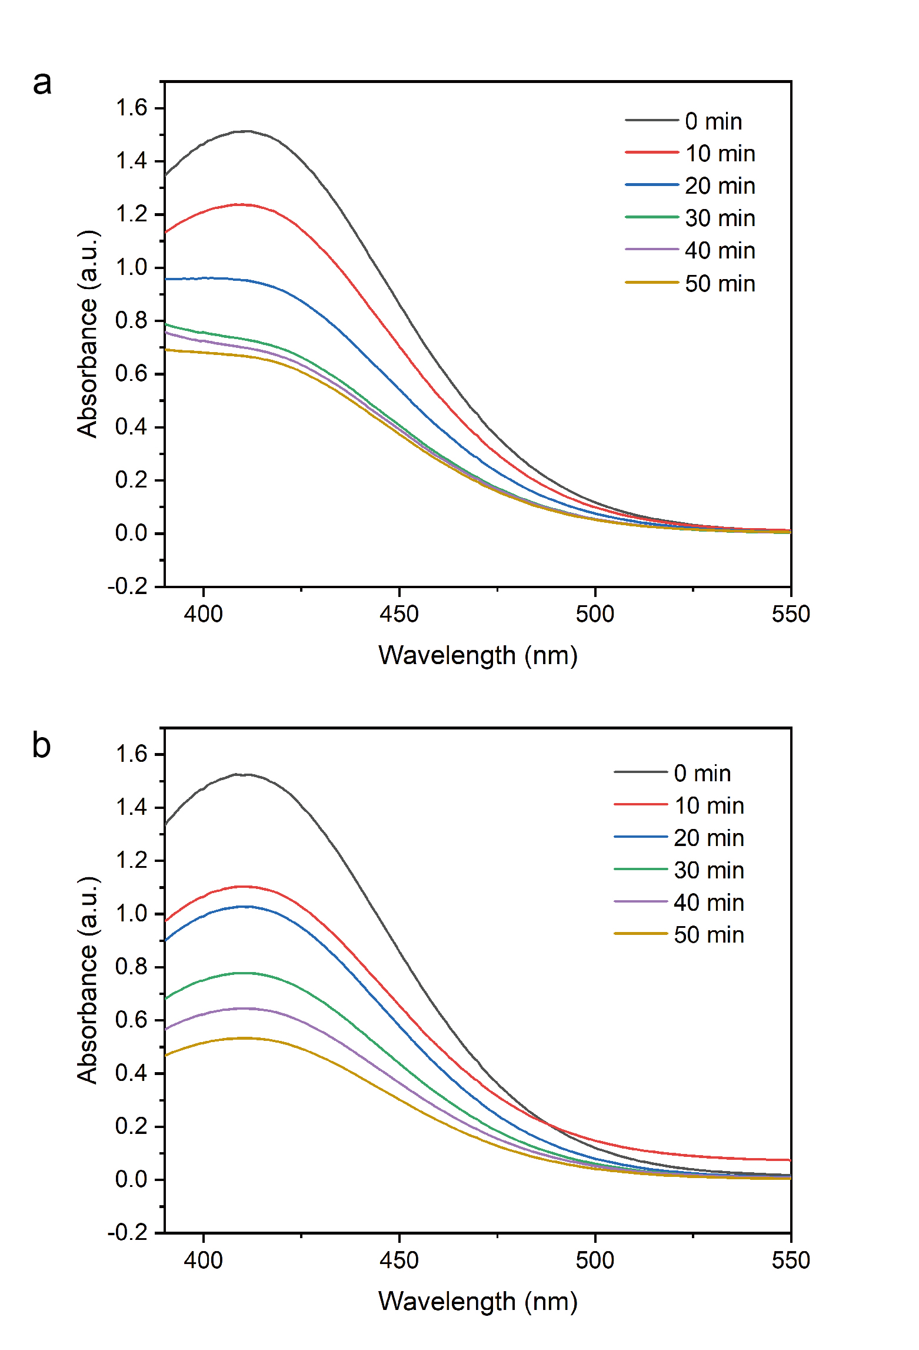
Fig. S19. The GSH depletion activity evaluation of Fe-SAzyme (a) without or (b) with mild NIR-II laser treatments.

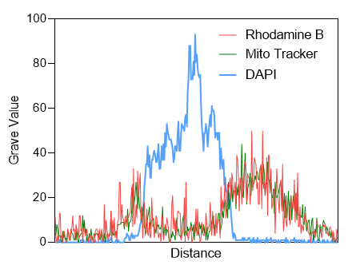
Fig. S20. Confocal fluorescence colocalization analysis of Fe-SAzyme-TPP stained with Rhodamine B, green-fluorescent mitochondria, and blue-fluorescent cells.

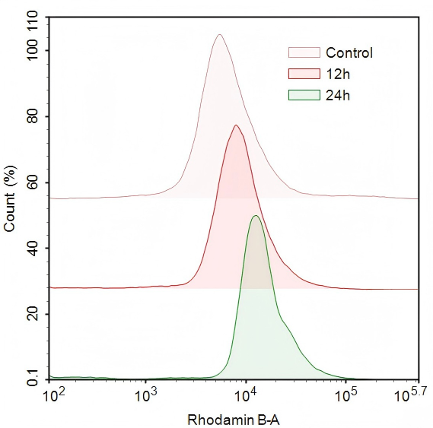
Fig. S21. Flow cytometry imaging of cellular uptake of Rhodamine B-labeled Fe-SAzyme-TPP over time.

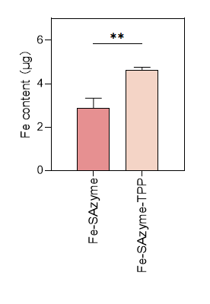
Fig. S22. ICP-OES quantification of intracellular Fe content.

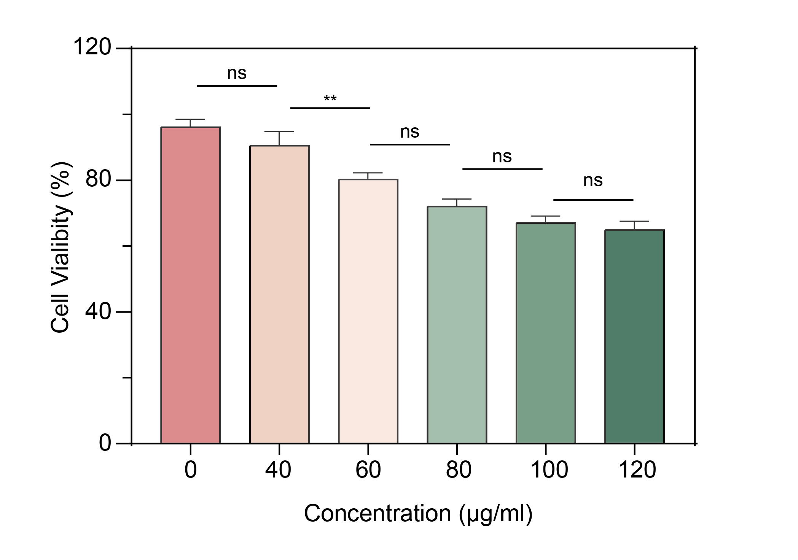
Fig. S23. Cell viability of HUVEC after treatment with different concentrations of Fe-SAzyme-TPP.

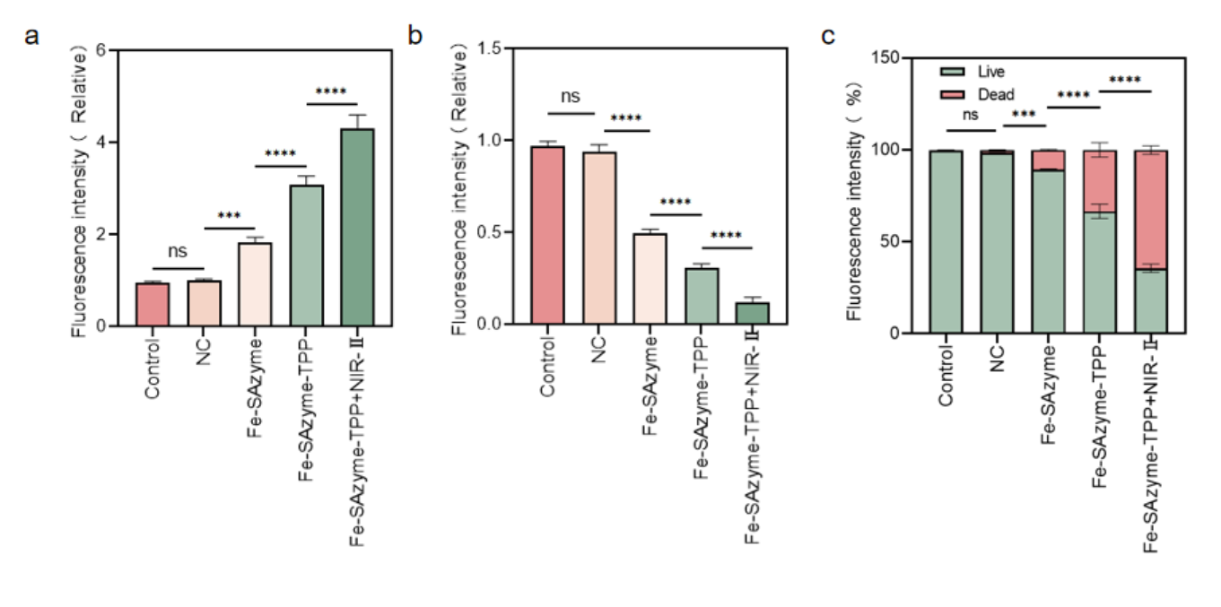
Fig. S24. Quantitative analysis of fluorescence intensity in cell (a) ROS, (b) O₂, and (c) Live/dead staining.

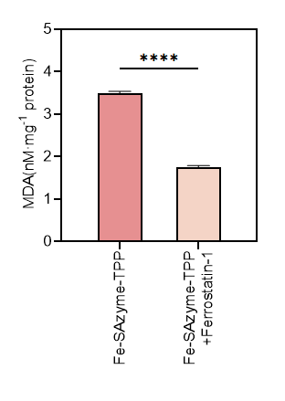
Fig. S25. MDA levels in cells treated with Fe-SAzyme-TPP and Fe-SAzyme-TPP+Ferrostatin-1 for 24 h.

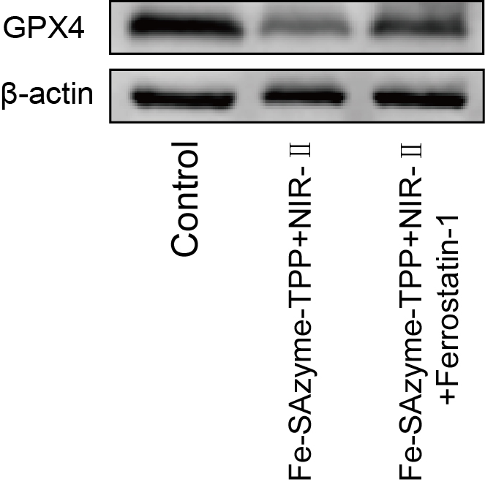
Fig. S26. GPX4 protein expression levels following treatment with Fe-SAzyme-TPP+NIR-Ⅱ and Fe-SAzyme-TPP+NIR-Ⅱ+Ferrostatin-1.

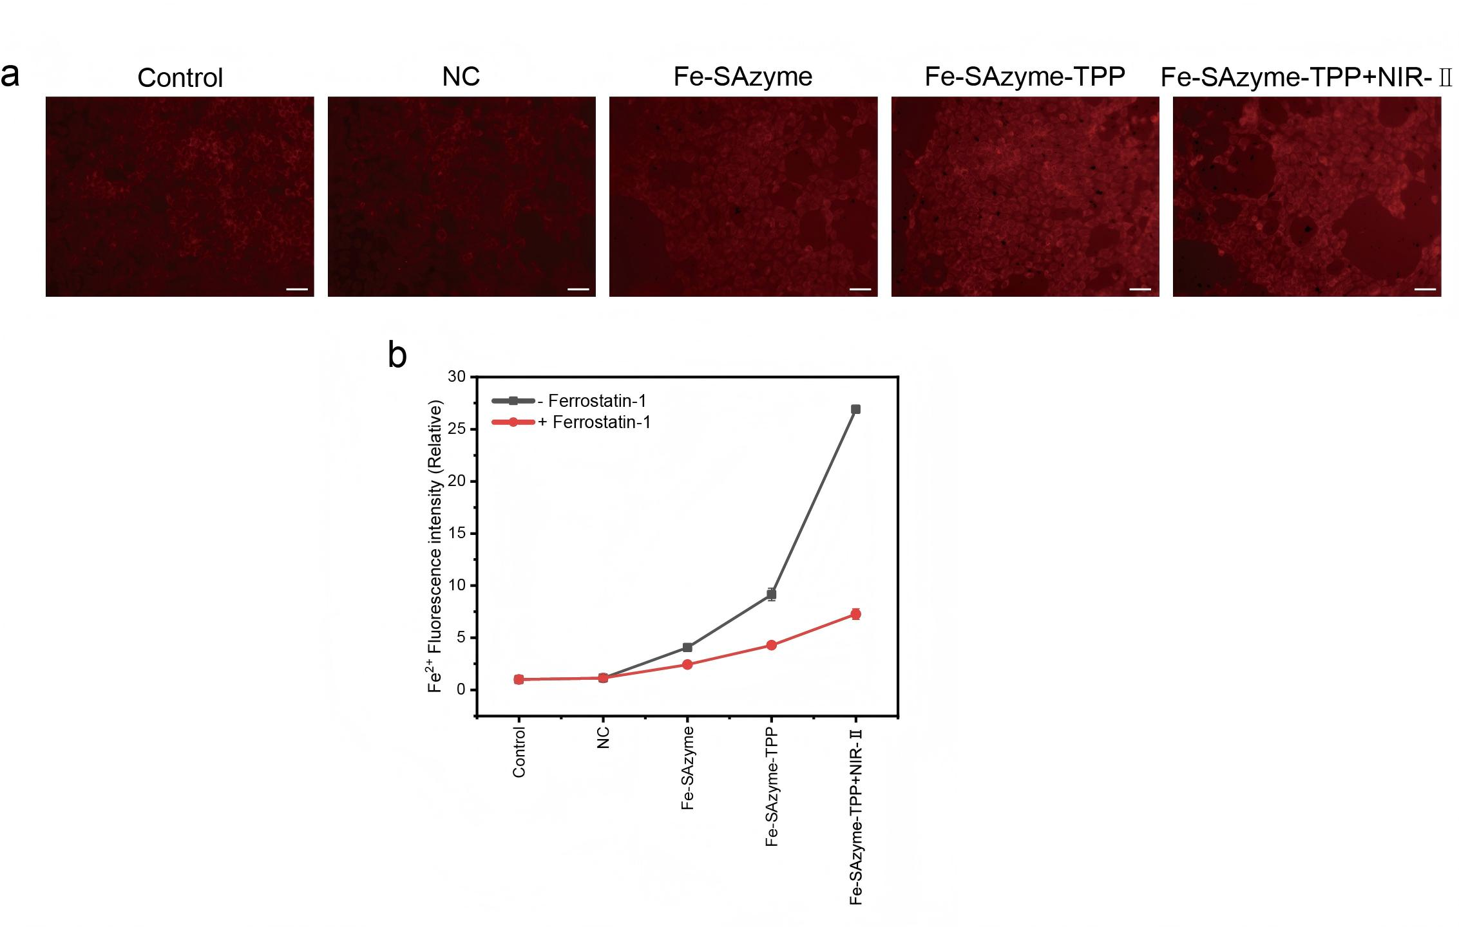
Fig. S27. Fluorescent staining (a) images and (b) quantitative analysis of intracellular Fe²⁺ in cells treated with Ferrostatin-1 (Scale bars: 50 μm).

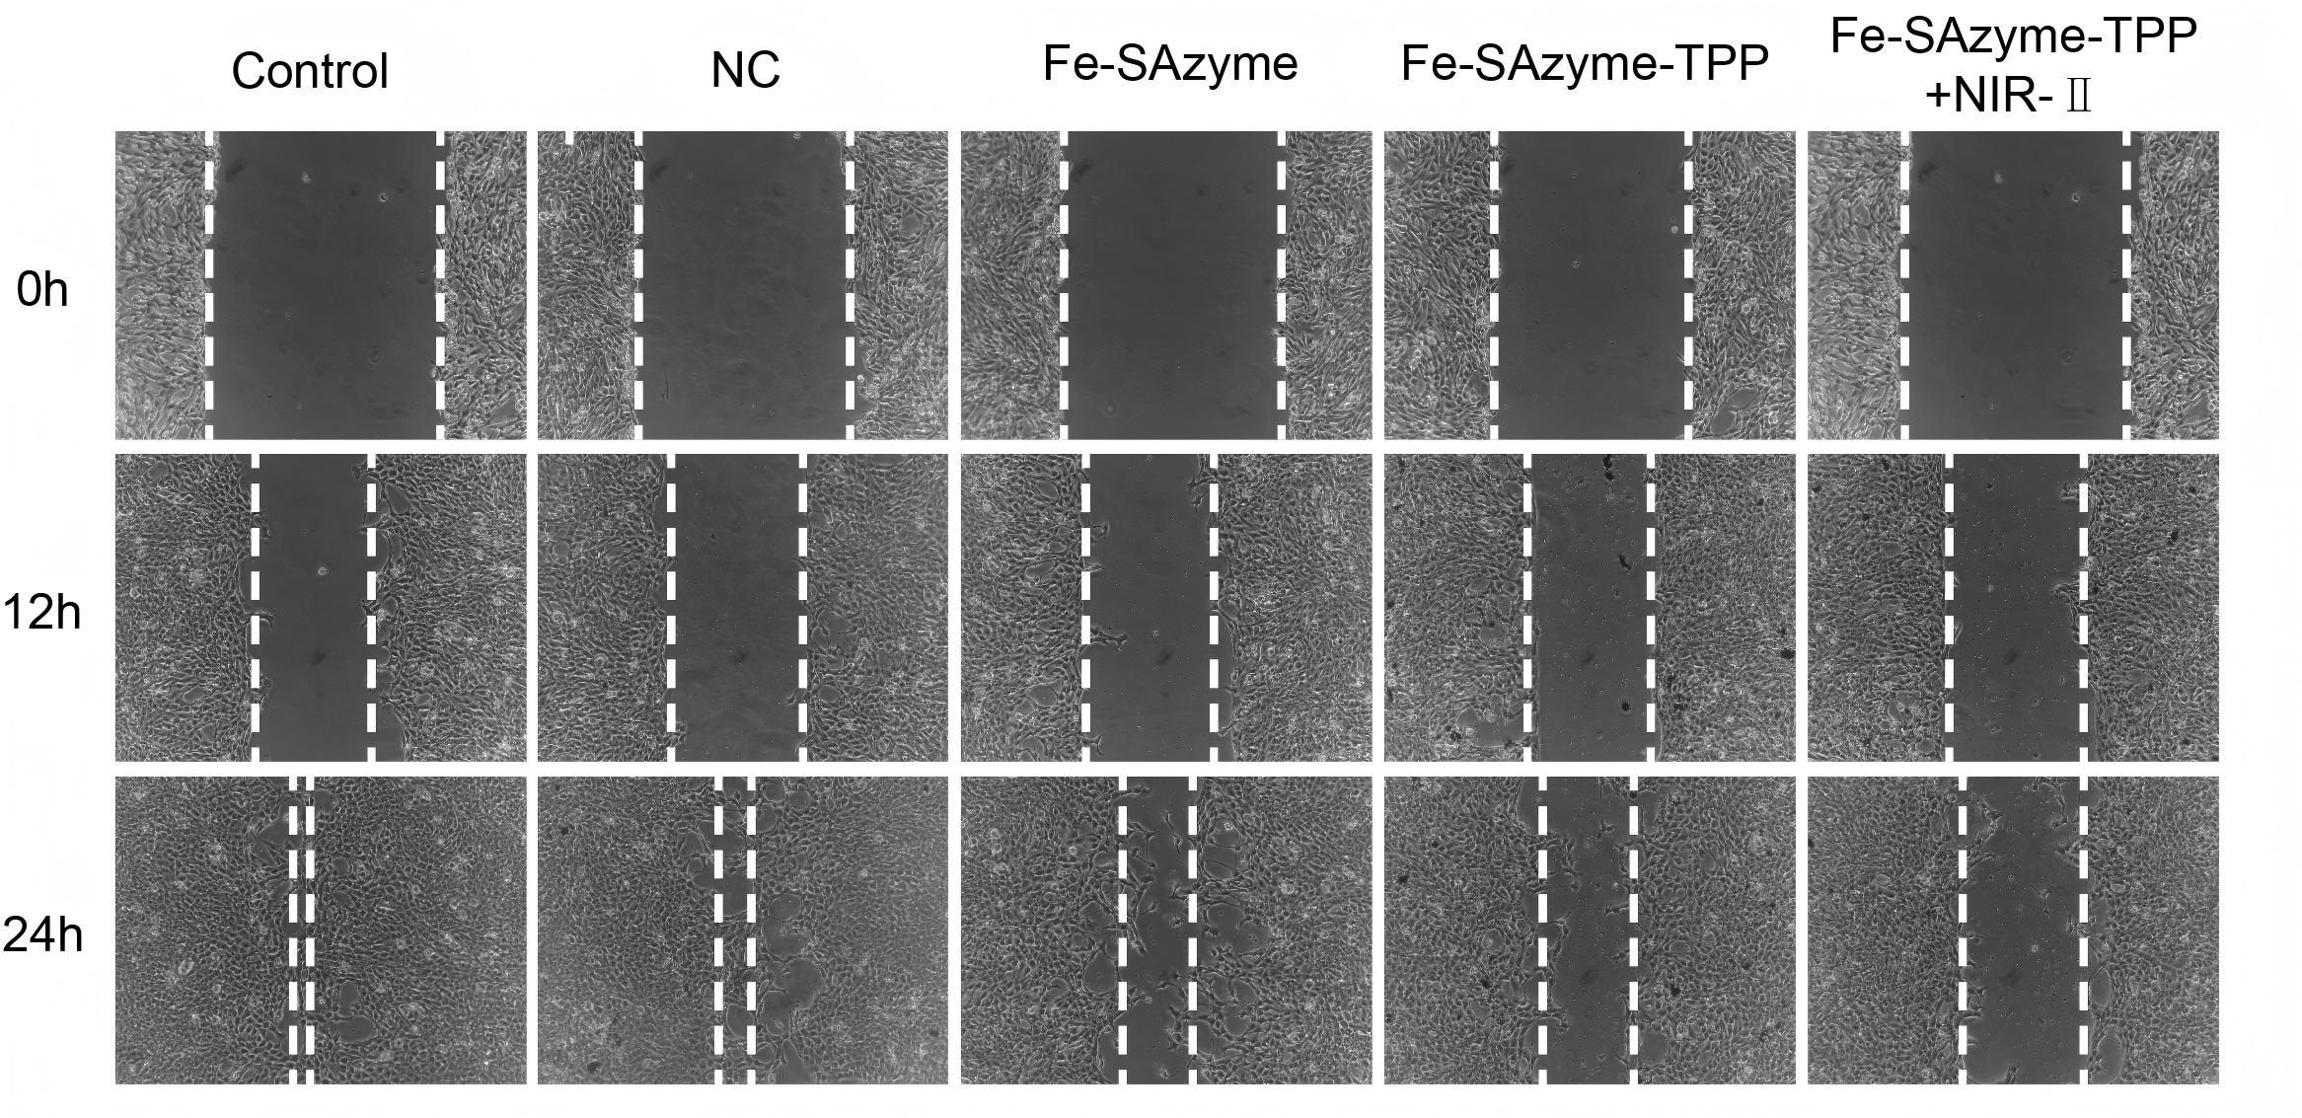
Fig. S28. Wound healing assays of 4T1 cells after treatment at the indicated time points.

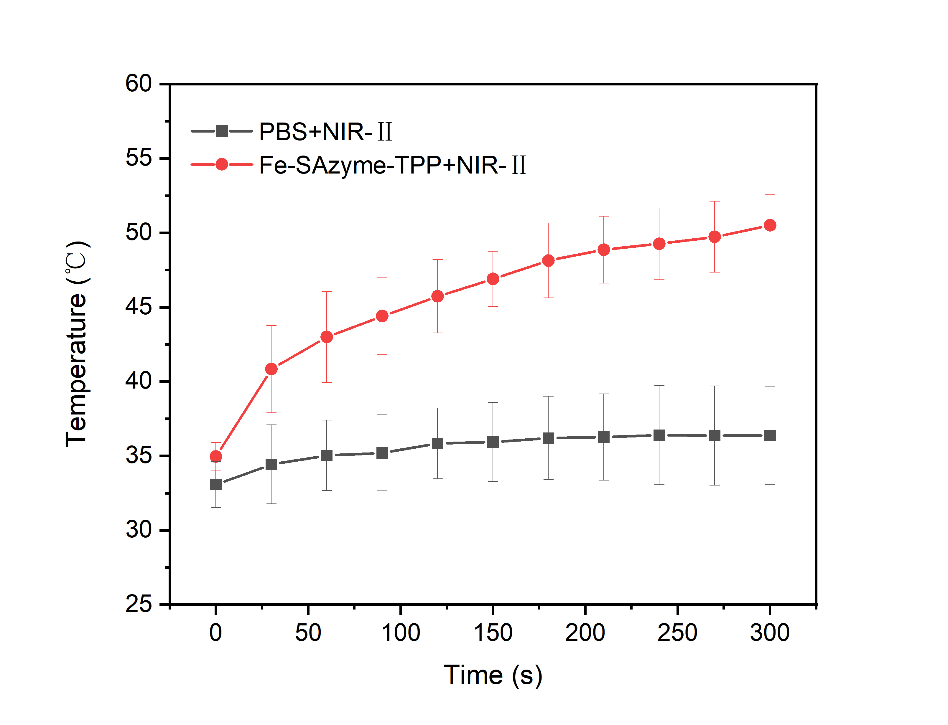
Fig. S29. Temperature changes of the tumors in mice under irradiation (1064 nm, 500mW/cm²) for 5 min after the administration of PBS and Fe-SAzyme-TPP.

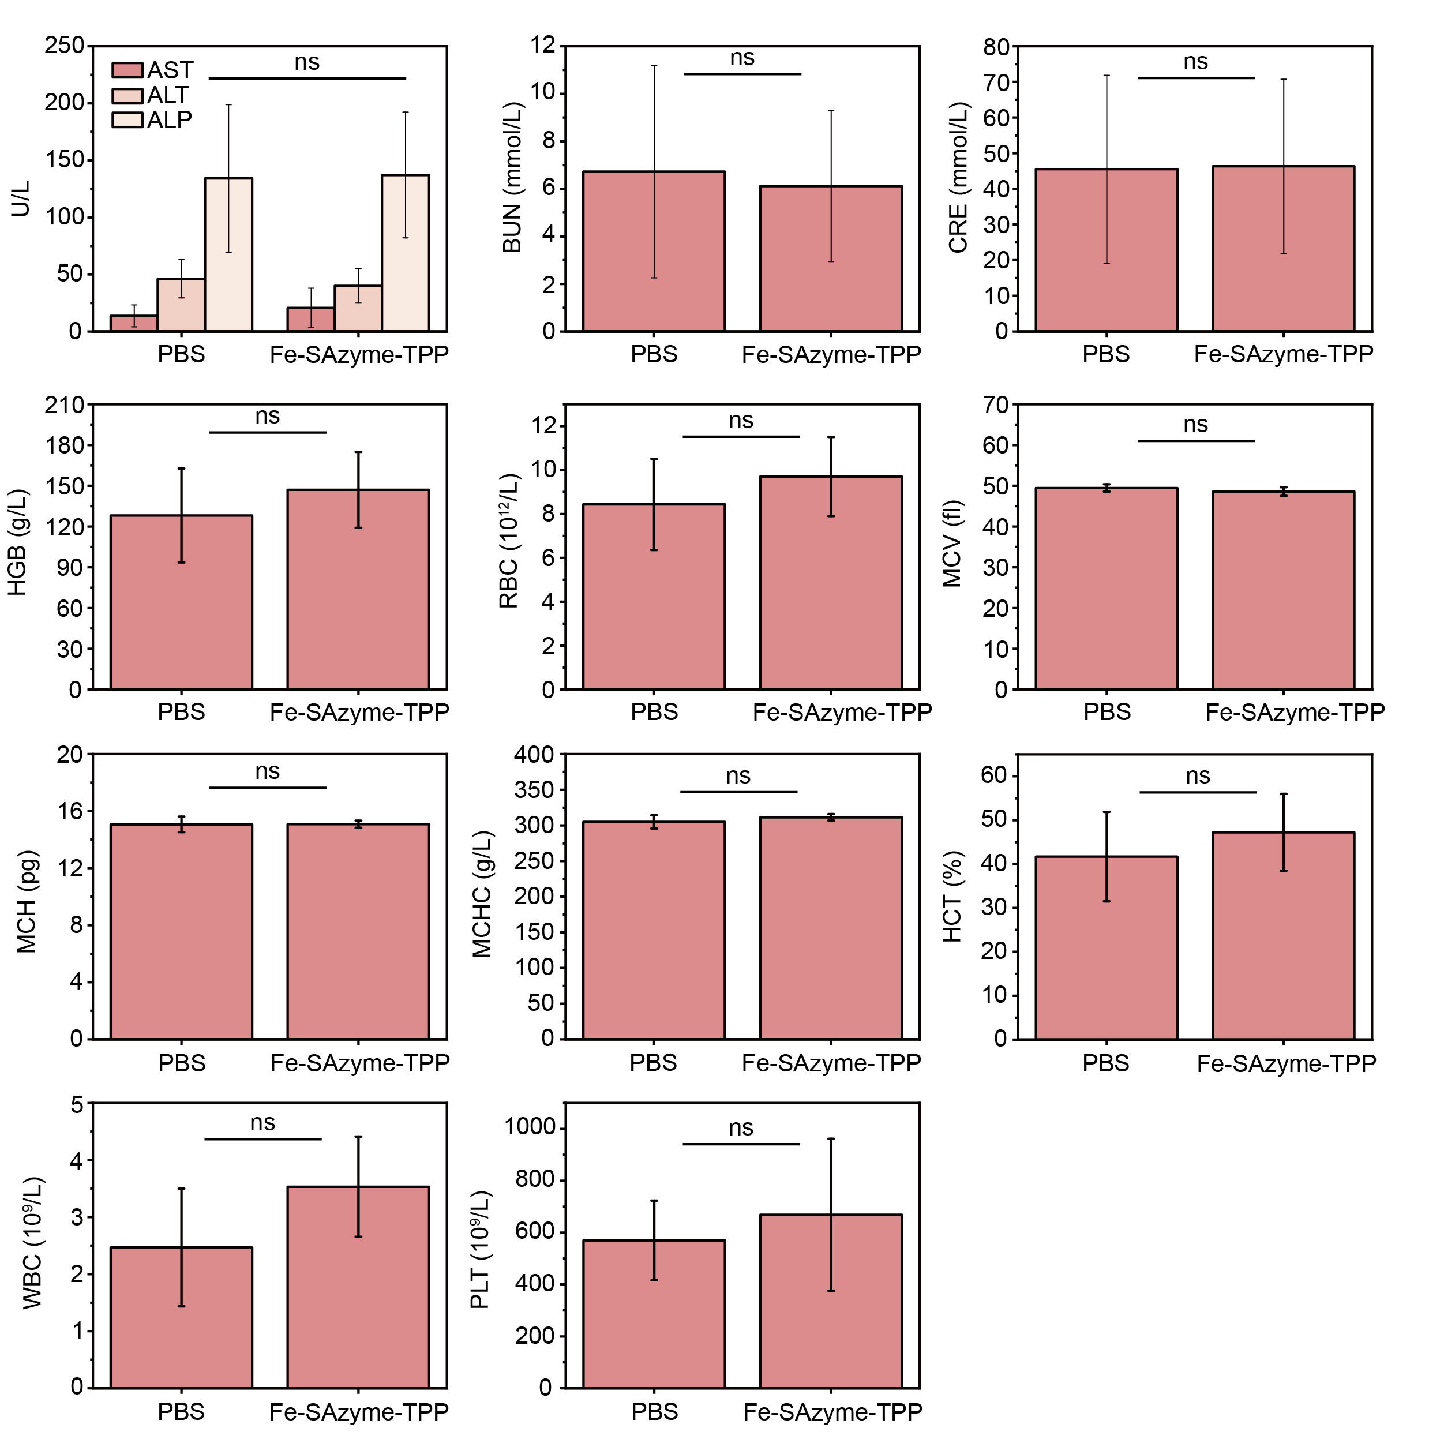
Fig. S30. Serum biochemical parameters of mice following treatment with PBS and Fe-SAzyme-TPP.

Table S1. Elemental quantification of Fe-SAzyme determined by XPS spectra.
Percentage | C (at%) | N (at%) | Fe (at%)
Fe-SAzyme | 95.86 | 3.71 | 0.43

Table S2. ICP-OES data for Fe-SAzyme.
Element | Element content in solution (μg/ml) | Element content in the sample (wt%)
Fe | 0.0228±0.0013 | 0.51±0.03
Data represent mean ± SD of at least three independent experiments (n=3)

Table S3. Comparison of K_{m} and V_{max} for Fe-SAzyme and other SAzymes with POD-like activity.
SAzymes | K_{m} (mM) | V_{max} (×10⁻⁷Ms⁻¹) | Reference
Fe-SAzyme | 1.56 | 1.03 | This method
Fe-SAzyme+NIR-Ⅱ | 1.25 | 1.46 | This method
FeN₅ | 11.2 | 2.96 | [1]
Fe-N-C | 4.84 | 1.18 | [2]
f-MNC | 2.5 | 0.495 | [3]
Fe-N-C | 12.2 | 3.56 | [4]
FeSA | 13.2 | 6.5 | [5]
CS@Fe/CDs | 0.156 | 1.0758 | [6]
Cu-NBC | 8.37 | 0.685 | [7]
PtsaN-C | 2.943 | 1.231×10⁴ | [8]
Mn/PSAE | 0.09 | 1.6 | [9]

Table S4. Comparison of K_{m} and V_{max} for Fe-SAzyme and other nanozymes exhibiting CAT-like activity.
Nanozymes | K_{m} (mM) |  | V_{max} (mgL⁻¹min⁻¹) |  | Reference
Fe-SAzyme |  | 21.93 |  | 5.13 | This method
Fe-SAzyme+NIR-Ⅱ |  | 13.49 |  | 6.23 | This method
Catalase |  | 54.3 |  | 31.104 | [10]
PtsaN-C | 19.33 |  | 5.343 |  | [8]
Fe-SAs/NC | 9.65 |  | 12.96 |  | [11]
Fe³⁺/AMP CPsd | 122.2 |  | 4.61 |  | [12]
Fe-SANzyme | 18.8 |  | 17.9 |  | [13]
FeN₄C | 55.57 |  | 1.915 |  | [13]
Co₃O₄ NPs | 34.3 |  | 21.5 |  | [10]
Co-SAs@NC | 40.5 |  | 156.7 |  | [14]
CM@Mn | 21.44 |  | 2.41 |  | [15]

Table S5. The O–O bond length in H₂O₂ before and after adsorption onto Fe-SAzyme.
 | Before adsorption (dO-O) | After adsorption (dO-O) | Δd (Å)
O–O bond length | 1.47 | 1.588 | 0.118

Table S6. The Bader charge transfer in H₂O₂ before and after adsorption onto Fe-SAzyme.
 | Before adsorption (qH₂O₂) | After adsorption (qH₂O₂) | Δq (e)
Bader charge | 0 | -0.111 | -0.111

References
1. Xu B, Li S, Zheng L, Liu Y, Han A, Zhang J, et al. A bioinspired five‐coordinated single‐atom iron nanozyme for tumor catalytic therapy. Advanced Materials. 2022;34:2107088.
2. Feng Y, Qin J, Zhou Y, Yue Q, Wei J. Spherical mesoporous Fe-N-C single-atom nanozyme for photothermal and catalytic synergistic antibacterial therapy. Journal of Colloid and Interface Science. 2022;606:826–36.
3. Zhang C, Chen C, Zhao D, Kang G, Liu F, Yang F, et al. Multienzyme cascades based on highly efficient metal–nitrogen–carbon nanozymes for construction of versatile bioassays. Anal Chem. 2022;94:3485–93.
4. Jiao L, Xu W, Yan H, Wu Y, Liu C, Du D, et al. Fe–N–C single-atom nanozymes for the intracellular hydrogen peroxide detection. Anal Chem. 2019;91:11994–9.
5. Chen Y, Jiao L, Yan H, Xu W, Wu Y, Zheng L, et al. Fe–N–C single-atom catalyst coupling with pt clusters boosts peroxidase-like activity for cascade-amplified colorimetric immunoassay. Anal Chem. 2021;93:12353–9.
6. Pan T, Chen H, Gao X, Wu Z, Ye Y, Shen Y. Engineering efficient artificial nanozyme based on chitosan grafted fe-doped-carbon dots for bacteria biofilm eradication. Journal of Hazardous Materials. 2022;435:128996.
7. Hamed EM, He L, Rai V, Hu S, Li SFY. Copper single‐atom nanozyme mimicking galactose oxidase with superior catalytic activity and selectivity. Small. 2024;20:2405986.
8. Ye T, Chen C, Wang D, Huang C, Yan Z, Chen Y, et al. Protective effects of pt-N-C single-atom nanozymes against myocardial ischemia-reperfusion injury. Nat Commun. 2024;15:1682.
9. Zhu Y, Wang W, Cheng J, Qu Y, Dai Y, Liu M, et al. Stimuli‐Responsive Manganese Single‐Atom Nanozyme for Tumor Therapy via Integrated Cascade Reactions. Angewandte Chemie. 2021;133:9566–74.
10. Mu J, Zhang L, Zhao M, Wang Y. Co3O4 nanoparticles as an efficient catalase mimic: Properties, mechanism and its electrocatalytic sensing application for hydrogen peroxide. Journal of Molecular Catalysis A: Chemical. 2013;378:30–7.
11. Ma W, Mao J, Yang X, Pan C, Chen W, Wang M, et al. A single-atom fe–N4 catalytic site mimicking bifunctional antioxidative enzymes for oxidative stress cytoprotection. Chem Commun. 2019;55:159–62.
12. Jiao M, Li Z, Li X, Zhang Z, Yuan Q, Vriesekoop F, et al. Solving the H2O2 by-product problem using a catalase-mimicking nanozyme cascade to enhance glycolic acid oxidase. Chemical Engineering Journal. 2020;388:124249.
13. Zhang R, Xue B, Tao Y, Zhao H, Zhang Z, Wang X, et al. Edge‐site engineering of defective fe–N4 nanozymes with boosted catalase‐like performance for retinal vasculopathies. Advanced Materials. 2022;34:2205324.
14. Cai S, Liu J, Ding J, Fu Z, Li H, Xiong Y, et al. Tumor‐Microenvironment‐Responsive Cascade Reactions by a Cobalt‐Single‐Atom Nanozyme for Synergistic Nanocatalytic Chemotherapy. Angew Chem Int Ed. 2022;61:e202204502.
15. Zhao Z, Dong S, Liu Y, Wang J, Ba L, Zhang C, et al. Tumor Microenvironment-Activable Manganese-Boosted Catalytic Immunotherapy Combined with PD-1 Checkpoint Blockade. ACS Nano. 2022;16:20400–18.

