Supporting Information
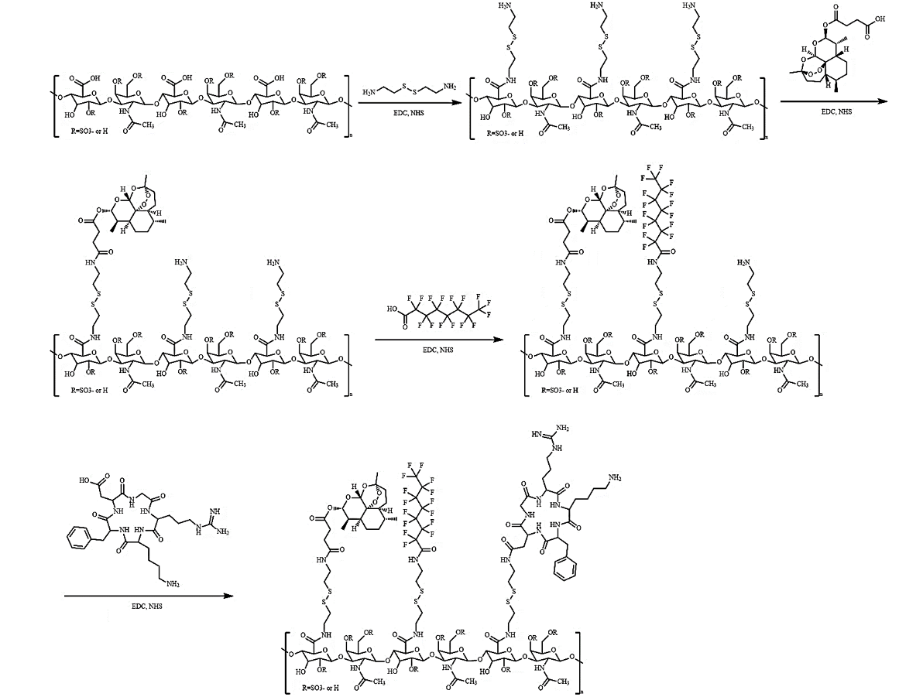
Figure S1. The chemical synthesis pathway of cRCAP.

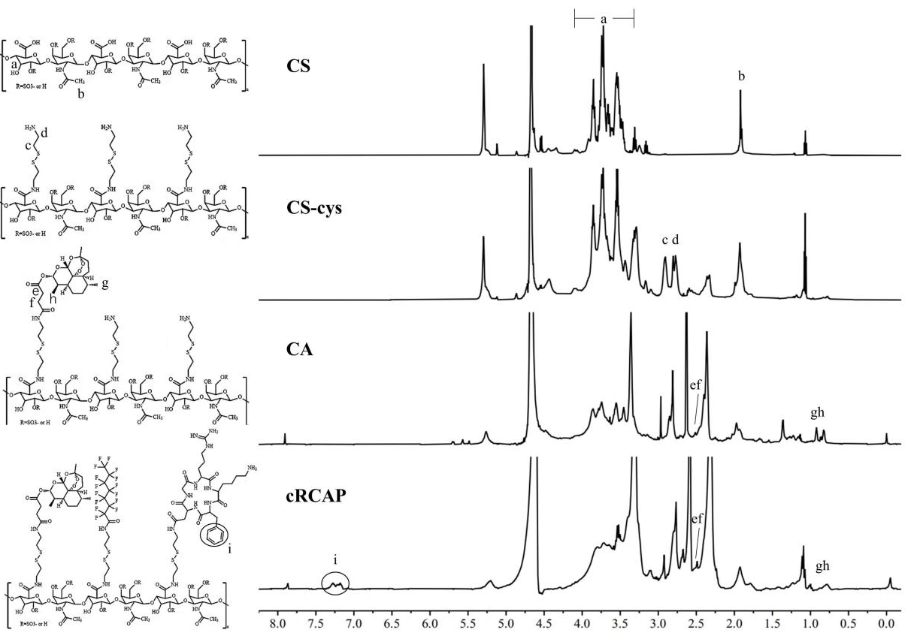
Figure S2. 1H NMR spectrum of CS, CS-cys, CA and cRCAP.

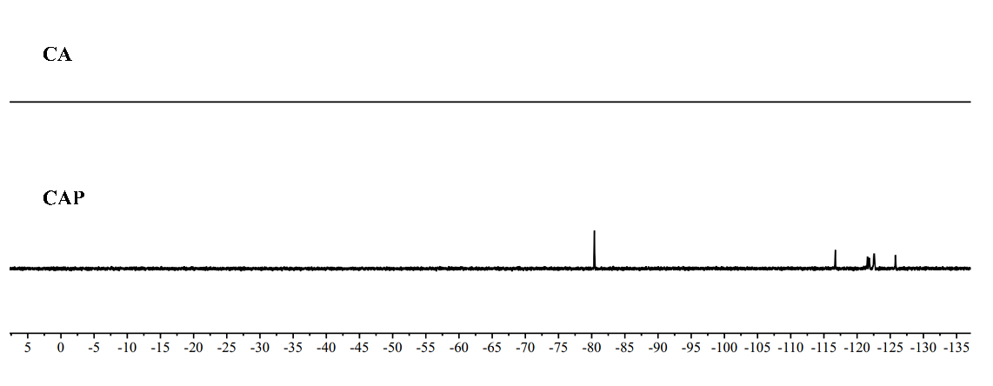
Figure S3. ¹⁹F NMR spectrum of CA and CAP.

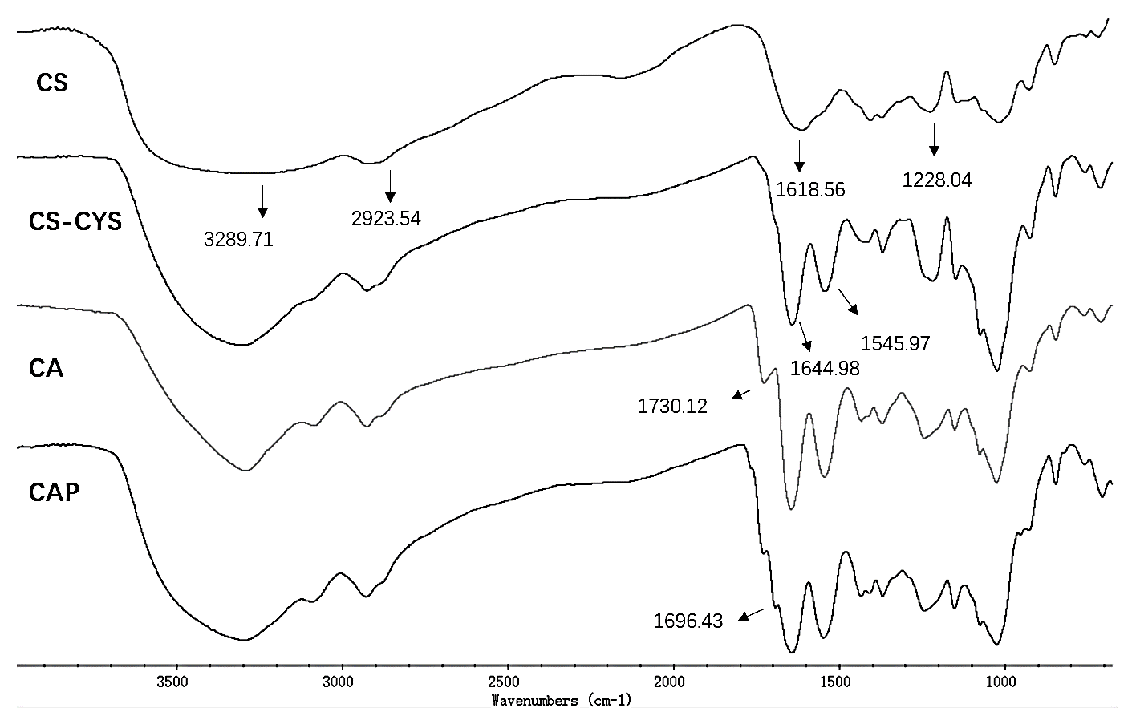
Figure S4. FT-IR spectra of CS, CS-cys, CA and CAP.

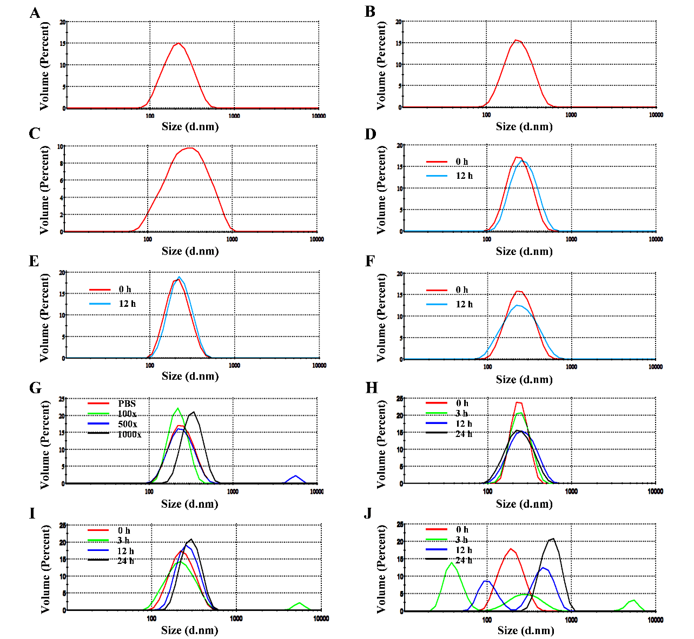
Figure S5. Stability and redox-sensitive size change of the micelles measured by DLS. (A-C) Size distribution of CAP micelle (A), cRCAP micelle (B) and cRCAPD micelle (C). Size distribution of cRCAP micelle after incubation with PBS (D), 0.9% NaCl (E) and 10 % FBS (F) for 12 h. (G)Size distribution of cRCAP micelle after 100, 500, and 1000-fold dilution. Size distribution of cRCAP micelle after incubation with PBS (pH=7.4) (H), 20 μM DTT in PBS (pH=7.4) (I) and 20 mM DTT in PBS (pH=7.4) (J) at different time points.
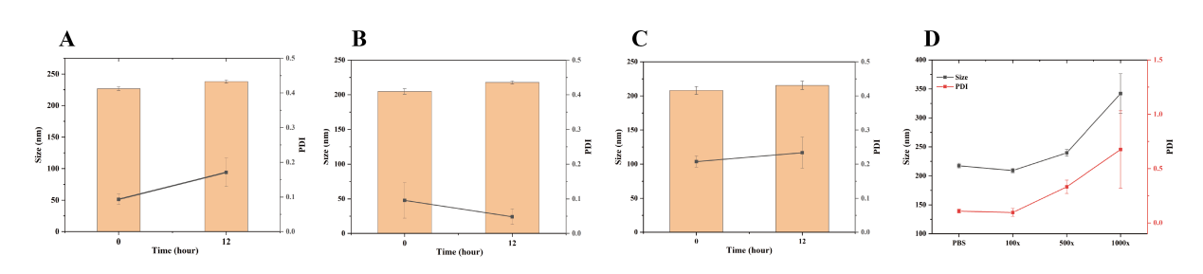
Figure S6. Size and PDI of cRCAP micelle after incubation with PBS (A), 0.9 % NaCl (B) and 10 % FBS (C) for 12 h. (D) Size distribution and PDI of cRCAP micelle after 100, 500, and 1000-fold dilution.

Figure S7. (A)TEM images of the cRCAPD on day 1, 3, 5, and 7 (scale bar: 200 μm).(B) The leakage rate of DTX from cRCAPD on days 1, 3, 5, and 7. (C) The peptide shedding rates of cRCAPD on days 1, 3, 5, and 7.

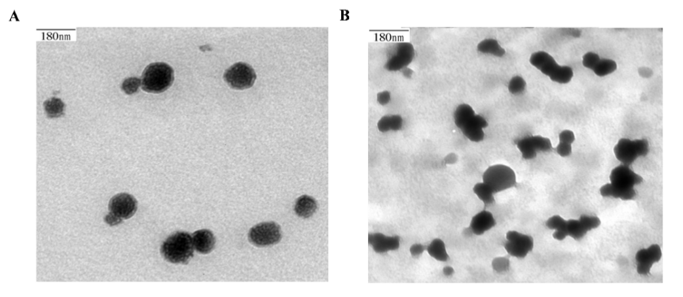
Figure S8. TEM images of cRCAP/DTX after incubation in PBS solution (A) and PBS solution containing 20 mM DTT (B).

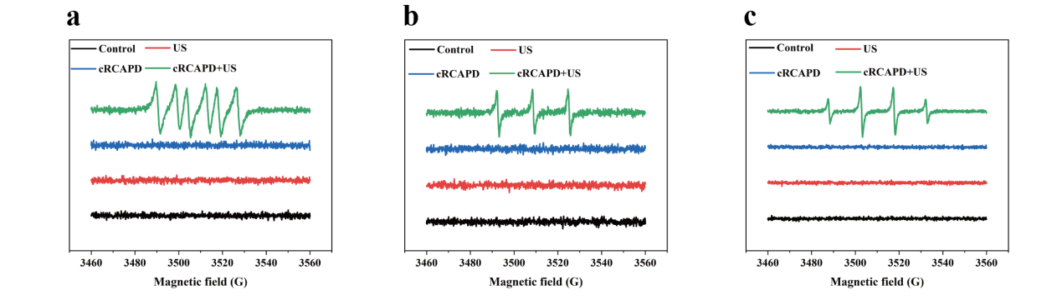
Figure S9. The types of ROS of (a) the superoxide radicals, (b) the singlet oxygen, and (c) the hydroxyl radicals produced by different preparations using the ESR detection method.
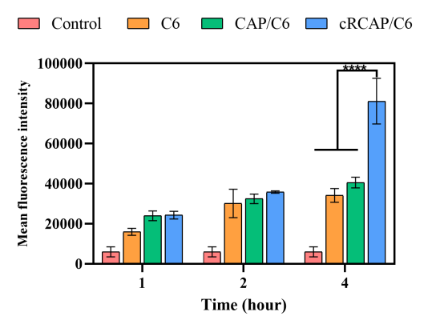
Figure S10. The fluorescent quantification plot of the cellular uptake in A549 cells.

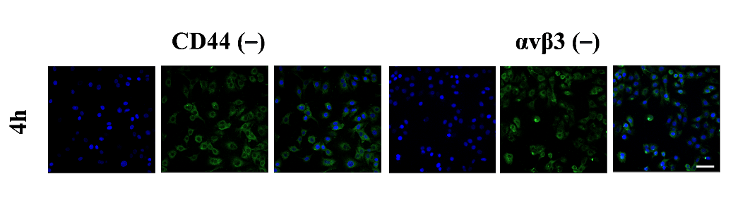
Figure S11. CLSM images of A549 cells incubated with cRCAP/C6 NPs after saturation with CD44 and αvβ3 receptors.

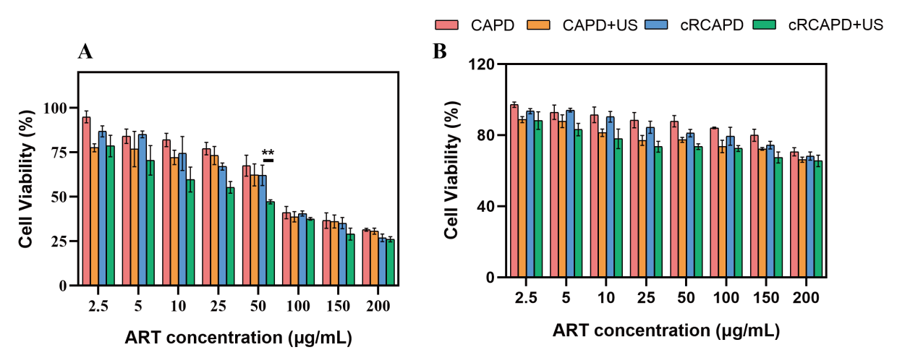
Figure S12. The cytotoxicity of LLC cells and MRC-5 cells after incubating with different formulations.
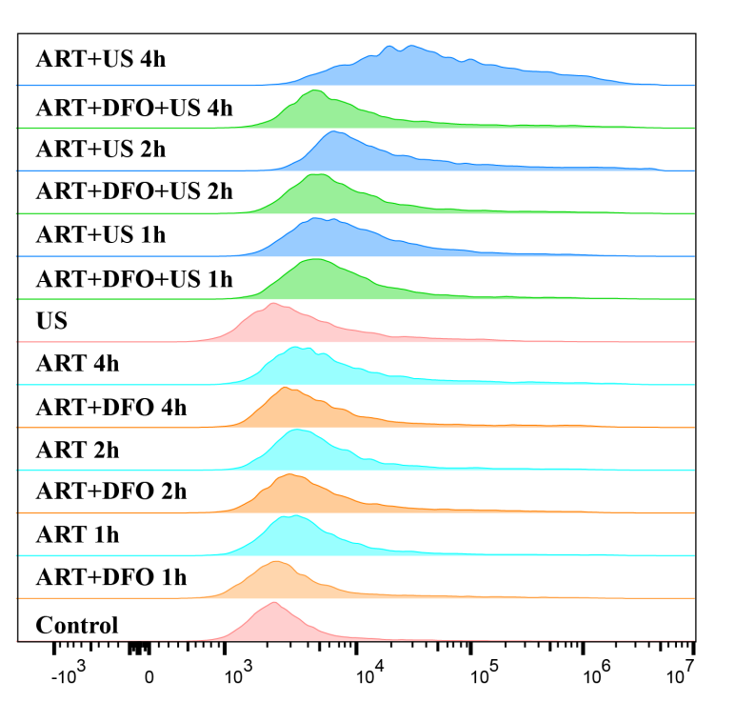
Figure S13. The production of ROS in different groups at different time points after incubating with A549 cells.
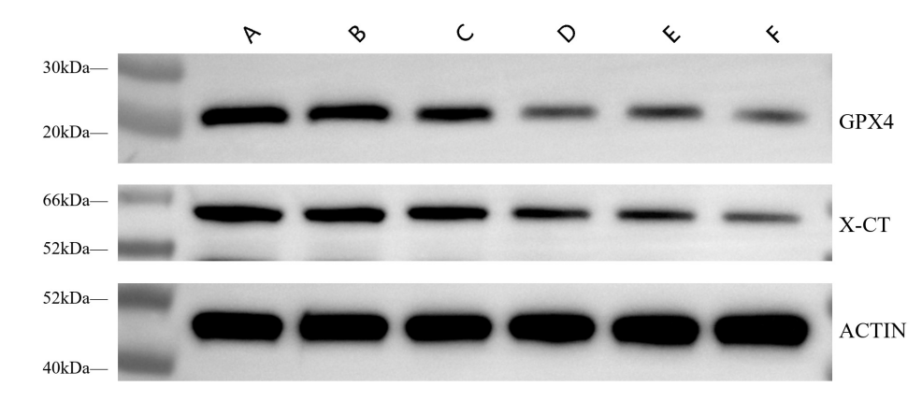
Figure S14. Western blot analysis of System X_{c}⁻ (X-CT) and GPX4 protein expression after different treatments.
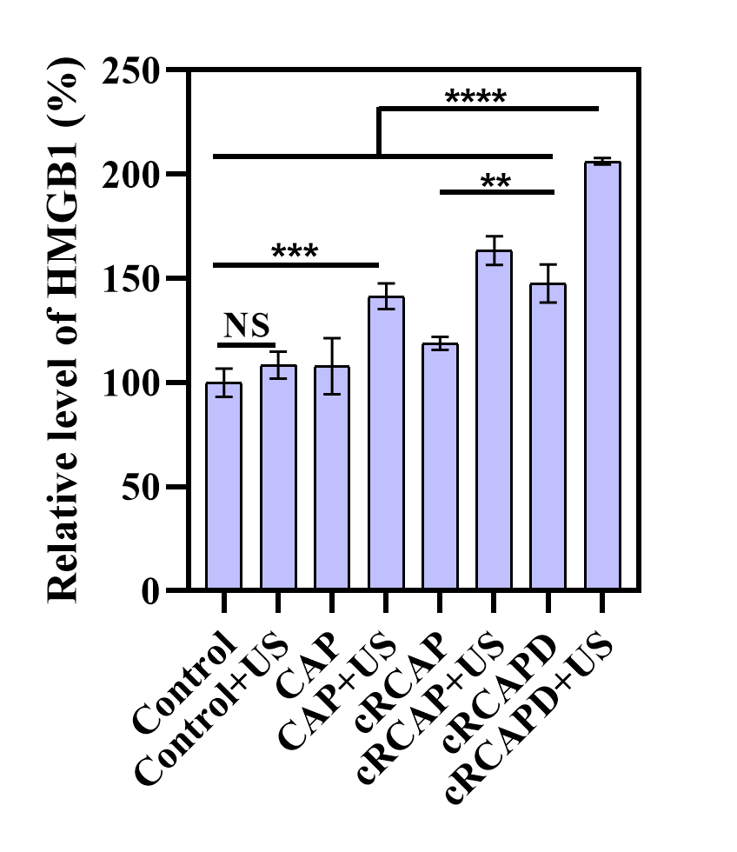
Figure S15. Relative level of HMGB1 in A549 cells subjected to distinct treatments (n = 3).
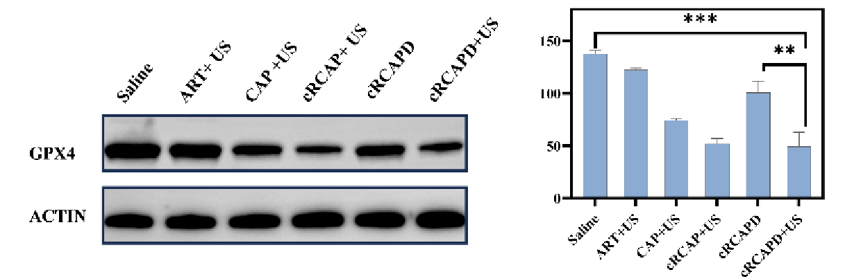
Figure S16. (A) Western blot analysis of GPX4 protein expression after different treatments in nude mice. (B) Quantitative analysis of GPX4 protein expression in nude mice (n = 3).

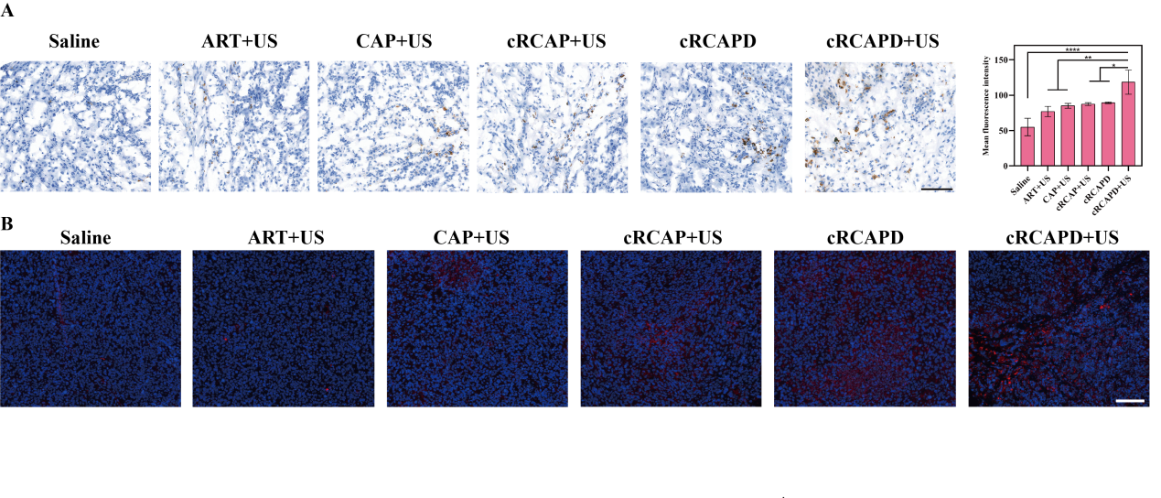
Figure S17. ( A)Immunofluorescence staining and semi-quantitative of ferrous ions in C57 tumor-bearing mice (scale: 100 μm). (B) Immunofluorescence staining result fo 4-HNE in C57 tumor-bearing mice (100 μm).

Table 1. Degree of substitution (DS), ART/CA ratios, particle size and PDI of CA NPs with different CS-CYS/ART feed ratios.
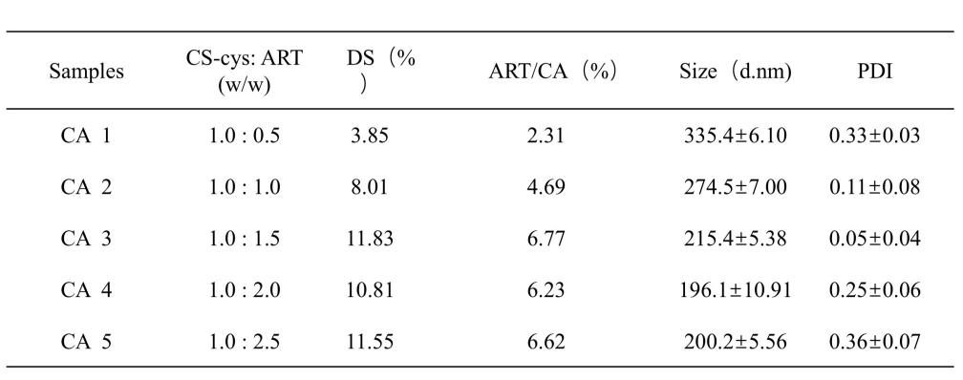
Table 2. Particle size and PDI of CAP NPs with different CA/PFCA feed ratios (n = 3).
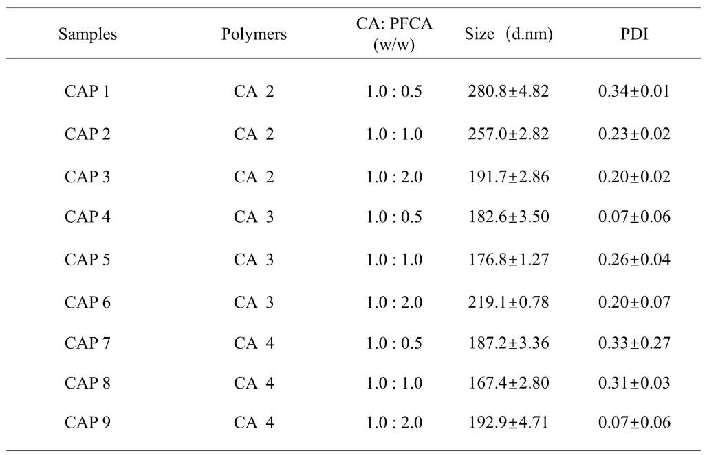
Table 3. Particle size, PDI, and Zeta potential of CAP NPs and cRCAP NPs (n = 3).
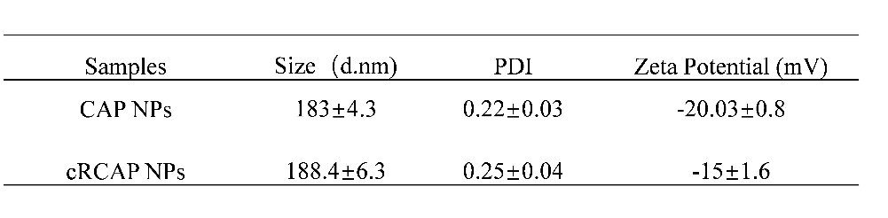
Table 4. Drug loading, encapsulation efficiency, particle size and zeta potential of cRCAPD nanoparticles with different drug-to-excipient ratios (n = 3).
