Supplementary Tables
Table.S1: List of specific antibodies
Primary antibodies | Manufacturer | Catalog No. | Application | Dilution
Anti-FAP antibody | Proteintech |  | Western blot | 1:1000
Anti-p-Smad3 antibody | Cell Signaling Technology | 9520 | Western blot | 1:1000
Anti-Smad3 antibody | Cell Signaling Technology | 9523 | Western blot | 1:1000
Anti-GAPDH antibody | Cell Signaling Technology | 97166 | Western blot | 1:1000
Actin-Tracker Red-Rhodamine | Beyotime | C2207S | Immunofluorescent staining | 1:200
Anti-Collagen I antibody | Proteintech |  | Immunofluorescent staining | 1:100
Anti-Collagen III antibody | Proteintech |  | Immunofluorescent staining | 1:100
Secondary antibodies | Manufacturer | Catalog No. | Application | Dilution
HRP-conjugated Goat Anti-Rabbit IgG Secondary Antibody | Proteintech | SA00001-2 | Western blot | 1:5000
HRP-conjugated Goat Anti-Mouse IgG Secondary Antibody | Proteintech | SA00001-1 | Western blot | 1:5000
Alexa Fluor 594 goat anti-rabbit Secondary Antibody | Invitrogen | A-11012 | Immunofluorescent staining | 1:200
Alexa Fluor 488 goat anti-mouse Secondary Antibody | Invitrogen | A-11001 | Immunofluorescent staining | 1:200

Sup Fig.1 Dynamic expression of FAP in the pathological cardiac fibrosis. A. Western blot analysis of FAP protein expression of AMI in heart tissue at different time points. B. Western blot analysis of FAP protein expression of TAC in heart tissue at different time points. *, p<0.05. **, p<0.01. ***, p<0.001. ****, p<0.0001. AMI, acute myocardial infarction; TAC, transverse aortic constriction.

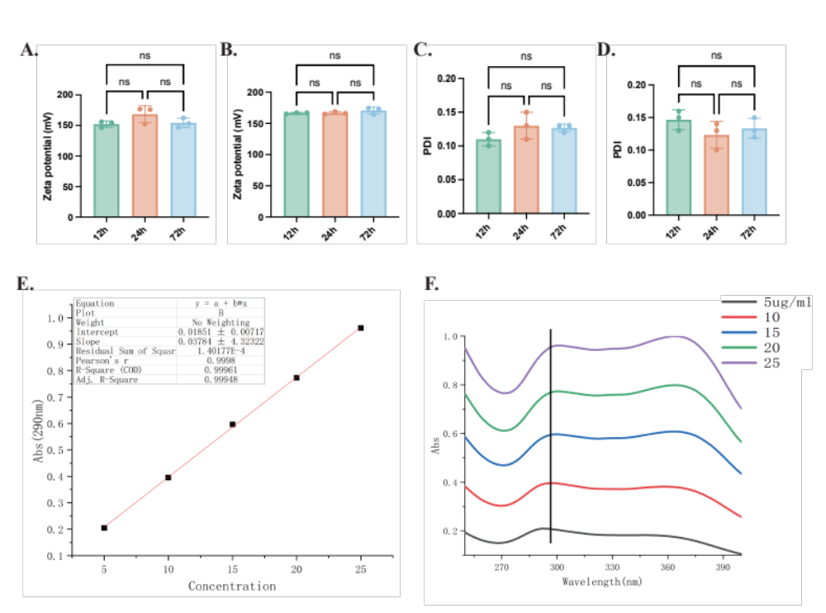
Sup Fig.2 Characteristic and stability of nanoparticles. A&B. ζ potential of NPs, NPs-SIS3 and NPs-SIS3-Ab after maintaining in PBS (pH 7.4, A) and 30% FBS (B) for 12h, 24h and 72h. C&D. The polydispersity index of NPs, NPs-SIS3 and NPs-SIS3-Ab after maintaining in PBS (pH 7.4, C) and 30% FBS (D) for 12h, 24h and 72h. E. Drug release study with absorption at 290 nm to measure the concentration of SIS3 in solution. F. Different concentration of SIS3 with absorption at 290nm.

Sup Fig.3 The NPs-SIS3-Ab could be efficiently taken up by fibroblasts with high safety.

Sup Fig.4 Inhibition of downstream of Smad3 in AMI mice treated with NPs-SIS3-Ab. A. The relative mRNA levels of fibrosis-related gene expression (Fn1, Col1a1, Col3a1 and TGFβ1) in cardiac tissue. B. Serum levels of TGFβ1. *, p<0.05. **, p<0.01. ***, p<0.001. ****, p<0.0001.

Sup Fig.5 Inhibition of downstream of Smad3 in TAC mice treated with NPs-SIS3-Ab. A. The relative mRNA levels of fibrosis-related gene expression (Fn1, Col1a1, Col3a1 and TGFβ1) in cardiac tissue. B. Serum levels of TGFβ1. *, p<0.05. **, p<0.01. ***, p<0.001. ****, p<0.0001.

