Supporting Information
for
NIR-Responsive Prussian Blue/Fer-1 Co-Loaded Nanozymes for Synergistic Therapy of Acute Lung Injury
Hanjing Lu ^{a, b#}, Min Li ^{c #}, Wenxuan Fan ª, Zhao Li ^{d}, Ji Cheng ª, Rui Liu ª, Pan Xu ª, Ding Luo ^{a,e*}, Jinghua Li ^{a*}, Xiaoran Liu ^{a*}
ª Department of Emergency Medicine, The First Affiliated Hospital, Key Laboratory of Emergency and Trauma of Ministry of Education, Key Laboratory of Hainan Trauma and Disaster Rescue, Hainan Medical University, Haikou 571199, China.
^{b} Department of Emergency Medicine, The First Affiliated Hospital of Gannan Medical University, Ganzhou 341000, China.
^{c} Emergency Department of Hainan General Hospital (Hainan Affiliated Hospital of Hainan Medical University), Haikou 570311, China.
^{d} Haikou Affiliated Hospital of Central South University Xiangya School of Medicine, Haikou 570311, China.
^{e} School of Nursing, Hainan Medical University, Haikou 571199，China.
#These authors contributed equally to this work.
*Corresponding author: Ding Luo, Jinghua Li, Xiaoran Liu.
Key Laboratory of Emergency and Trauma of Ministry of Education, Key Laboratory of Hainan Trauma and Disaster Rescue, Department of Emergency Medicine, The First Affiliated Hospital, Hainan Medical University，Haikou 570311, China.
E-mail addresses: 2925385109@qq.com (D. Luo), jinghuali@isl.ac.cn (J. Li), hy0203049@muhn.edu.cn (X. Liu).

Fig. S1. Relative viability of HBE cells treated with Fer-1 for different durations. Data are mean ± SD (n=3). Differences were assessed by one-way ANOVA followed by Tukey’s multiple comparison test. **P < 0.01, *P < 0.05 and ns, not significant.

Fig. S2. Relative viability of (A-C) HBE and (D-F) RAW 264.7 cells treated with PB for different durations. Data are mean ± SD (n=3). Differences were assessed by one-way ANOVA followed by Tukey’s multiple comparison test. ***P < 0.001, *P < 0.05 and ns, not significant , #P < 0.05 and ns, not significant.
Fig. S3. Relative viability of (A-D) HBE and (E-H) RAW 264.7 cells treated with LPS for different durations. Data are mean ± SD (n=3). Differences were assessed by one-way ANOVA followed by Tukey’s multiple comparison test. ***P < 0.001, *P < 0.05 and ns, not significant, ###P < 0.001, ##P < 0.01, #P < 0.05 and ns, not significant.
Fig. S4. Proliferation of HBE cells co-cultured with LPS under different treatments determined by CCK-8 assay. (A) 24 hours, (B) 48 hours, (C) 72 hours. Data are mean ± SD (n=3). Differences were assessed by one-way ANOVA followed by Tukey’s multiple comparison test. ***P < 0.001 and ns, not significant.

Fig. S5. Proliferation of RAW 264.7 cells co-cultured with LPS under different treatments determined by CCK-8 assay. (A) 24 hours, (B) 48 hours, (C) 72 hours. Data are mean ± SD (n=3). Differences were assessed by one-way ANOVA followed by Tukey’s multiple comparison test. ###P < 0.001, ##P < 0.01, #P < 0.05 and ns, not significant.

Fig. S6. Verification of ferroptosis pathway markers in RAW264.7 cells. (A) GPX4 and ACSL4 protein expression in RAW264.7 cells (Western blot, GAPDH as internal control). (B) Quantitative analysis of GPX4 and ACSL4 relative protein expression in RAW264.7 cells. (C) 4-HNE levels in RAW264.7 cells. (D) Intracellular Fe²⁺ levels in RAW264.7 cells. Data are mean ± SD (n=3). Differences were assessed by one-way ANOVA followed by Tukey’s multiple comparison test. ***P < 0.001, **P < 0.01, *P < 0.05 and ns, not significant.
Fig. S7. Pharmacokinetics and biodistribution of Fer‑1@PB after intratracheal administration in SD rats. (A) Blood clearance curve of Fe (tracking Fer‑1@PB) over time. (B) Lung tissue drug retention curve. (C) Multi‑organ distribution (Lung, Liver, Spleen, Kidney) of Fe at 0.5, 6, and 24 h post‑administration, presented as % injected dose per gram tissue (%ID/g). Data are mean ± SD (n = 5).
Fig. S8. Systemic biosafety assessment of Fer‑1@PB at different doses with or without NIR irradiation. (A-D) Hematological analysis of rats from control, Fer-1@PB (1/2/4 mg/kg) and Fer-1@PB + NIR groups at 7 days post nebulization; WBC, white blood cells; RBC, red blood cells; HGB, hemoglobin; PLT, platelets. (E, F) Coagulation tests (PT, prothrombin time; APTT, activated partial thromboplastin time), same groups, same time point. (G, H) Hepatic function (ALT, alanine aminotransferase; AST, aspartate aminotransferase) in serum, same groups, same time point. (I, J) Renal function (UREA, urea; CRE, creatinine) in serum, same groups, same time point. Data are mean ± SD (n = 5).

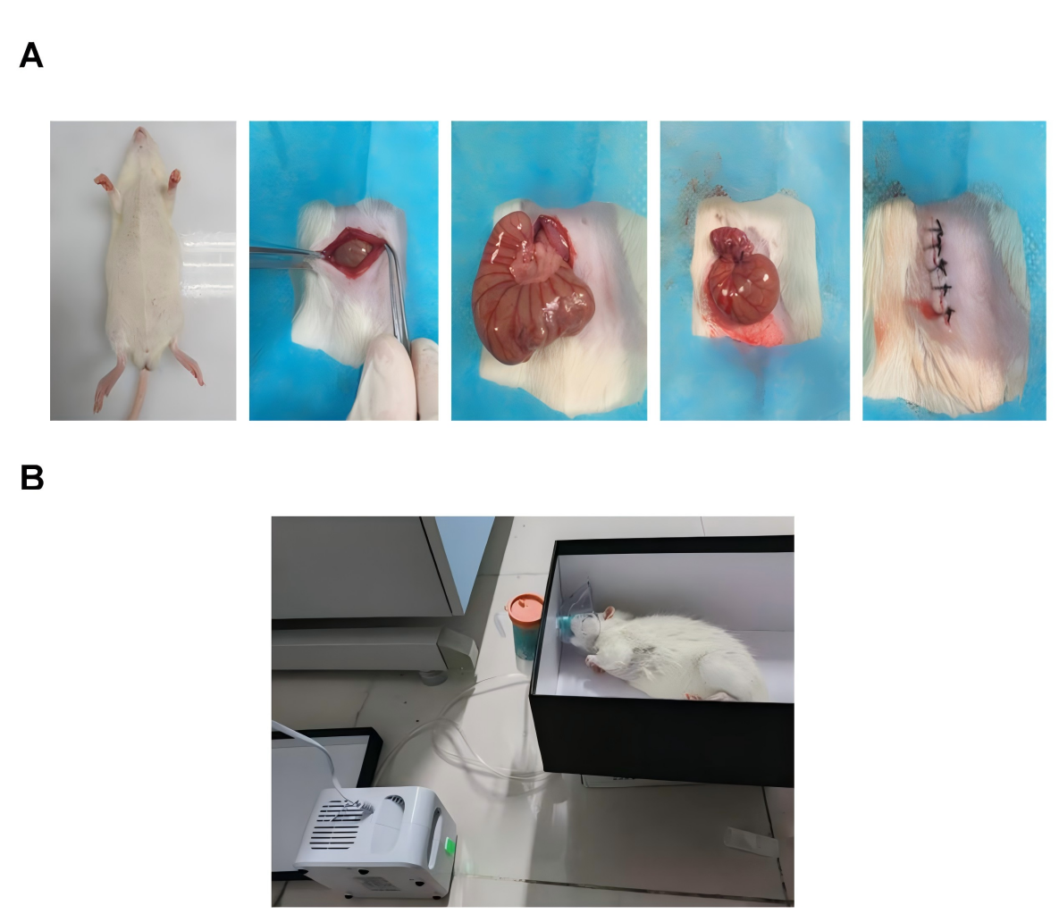
Fig. S9. Images of CLP modeling and aerosol-based treatment in SD rats. (A) Representative photographs of the surgical procedure for CLP modeling in SD rats. (B) Photographs of SD rats receiving nebulization therapy with Fer-1@PB.

Fig. S10. Hematological parameters of rats after administration of different treatment doses. Data are mean ± SD (n=5). Differences were assessed by one-way ANOVA followed by Tukey’s multiple comparison test. ***P < 0.001, **P < 0.01, *P < 0.05 and ns, not significant.

Fig. S11. Anti-inflammation capacity in vivo. Inflammation-related genes (A) TNF-α, (B) IL-6 and (C) IL-1β gene expression levels of treated rats by qRT-PCR. Data are mean ± SD (n=5). Differences were assessed by one-way ANOVA followed by Tukey’s multiple comparison test. ***P < 0.001, **P < 0.01.

Fig. S12. Anti-inflammation capacity in vivo. Quantification of the cytokine levels of (A) TNF-α, (B) IL-6, and (C) IL-1β in lung tissues with different treatments by ELISA analysis. Data are mean ± SD (n=5). Differences were assessed by one-way ANOVA followed by Tukey’s multiple comparison test. ***P < 0.001, **P < 0.01.

Fig. S13. Antioxidative stress properties in vivo. (A) SOD, (B) GSH, (C) CAT, and (D) MDA levels of lung homogenate of treated rats by the corresponding testing kits. Data are mean ± SD (n=5). Differences were assessed by one-way ANOVA followed by Tukey’s multiple comparison test. ***P < 0.001, **P < 0.01, and *P < 0.05.
Fig. S14. Verification of ferroptosis pathway markers in RAW264.7 cells. (A) GPX4 and ACSL4 protein expression in lung tissues (Western blot, GAPDH as internal control) (n=3). (B) Quantitative analysis of GPX4 and ACSL4 relative protein expression in lung tissues (n=3). (C) Immunofluorescence staining of 4‑HNE (red) in lung sections (scale bar: 20 μm; n=5). (D) Quantitative analysis of 4‑HNE content by ELISA (n=5). (E) Levels of labile Fe²⁺ in lung tissue homogenate (n=5). Data are presented as mean ± SD. Differences were assessed by one-way ANOVA followed by Tukey’s multiple comparison test. ***P < 0.001, *P < 0.05 and ns, not significant
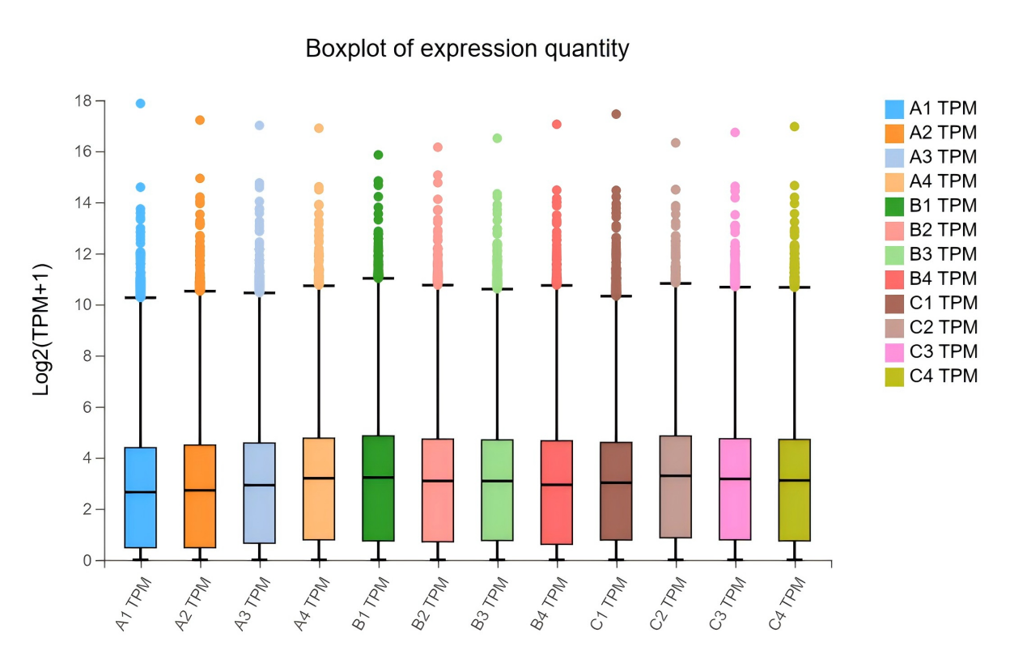
Fig. S15. Gene expression boxplots.

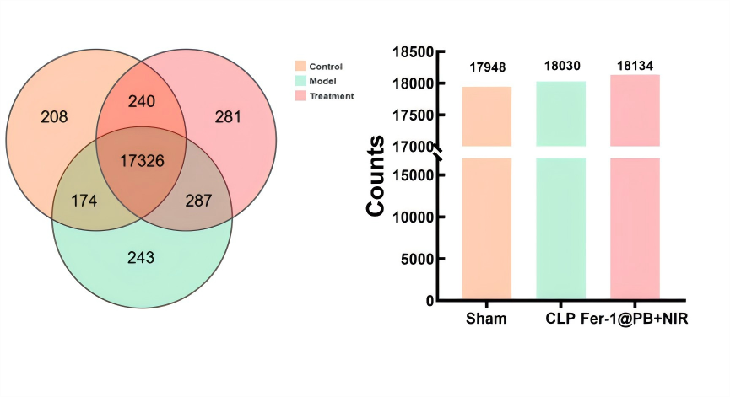
Fig. S16. Venn diagram of total gene expression in lung tissue RNA-seq sample among control, model, and treatment groups.

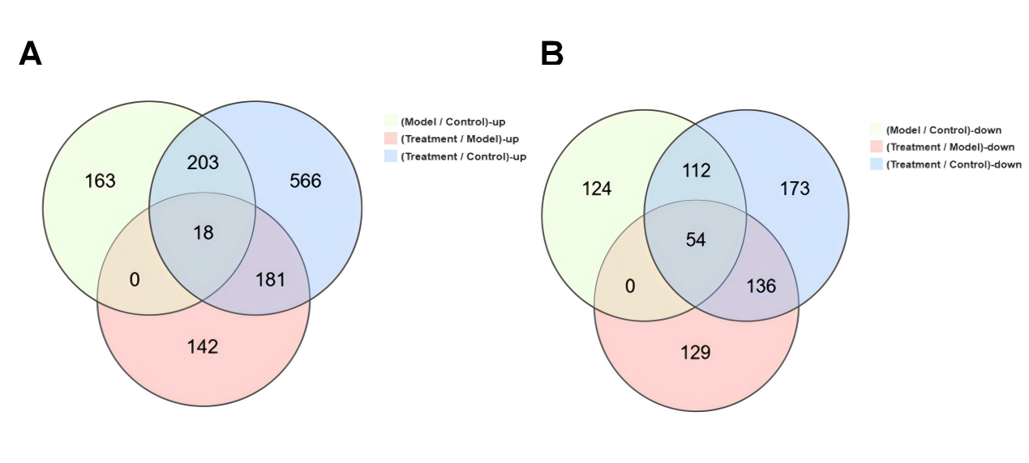
Fig. S17. (A) Venn diagram of upregulated DEGs among normal, model, and treatment groups. (B) Venn diagram of downregulated DEGs among normal, model, and treatment groups.

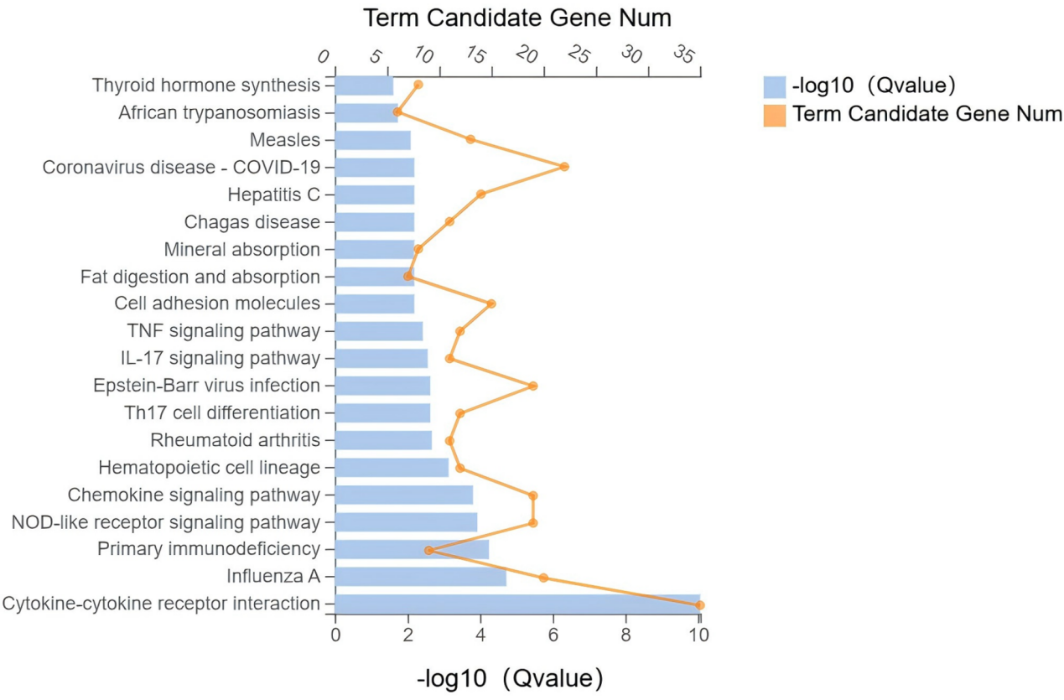
Fig. S18. KEGG pathway bar chart of DEGs between control and model groups.
Fig. S19. KEGG pathway bar chart of DEGs between model and treatment groups.

Fig. S20. qRT‑PCR validation of key DEGs (CXCL2, NCF1, ARF6) in lung tissues of ALI rats. (A) CXCL2 mRNA expression. (B) NCF1 mRNA expression. (C) ARF6 mRNA expression. Data are normalized to GAPDH. Data are mean ± SD (n=5). Differences were assessed by one-way ANOVA followed by Tukey’s multiple comparison test. ***P < 0.001, **P < 0.01, and *P < 0.05.

Fig. S21. ARF6 overexpression rescued SB225002-induced suppression of the ARF6/NCF1 pathway, shown by Western blot (WB) (A) and quantification (B) with GAPDH loading control. Data are mean ± SD (n=3).

Table S1. The primers used in quantitative Real-time PCR
Species | Name | Forward Primer | Reverse Primer
Rat | IL-1β | 5’- ATGGTCGGGACATAGTTGA -3’ | 5’- CTTGGCAGAGGACAAAGG -3’
Rat | TNF-α | 5’- CAGCCAGGAGGGAGAAC -3’ | 5’- GTATGAGAGGGACGGAACC -3’
Rat | IL-6 | 5’- CAGTTGCCTTCTTGGGACT -3’ | 5’- GGTCTGTTGTGGGTGGTATC -3’
Rat | CXCL2 | 5’-ACCATCAGGGTACAGGGGTT-3’ | 5’-CCTTCCCAGGTCAGTTAGCC-3’
Rat | NCF1 | 5’-ATGGGGGACACCTTCATTCG-3’ | 5’-GGGAGGTGAGGGATGACTCT-3’
Rat | ARF6 | 5’-CGATGGGGAAGGTGCTATCC-3’ | 5’-GGTGTAGTAATGCCGCCAGA-3’
Rat | GAPDH | 5’- ATGGCTACAGCAACAGGGT -3’ | 5’- TTATGGGGTCTGGGATGG -3’
Human | IL-1β | 5’- ATCAGCACCTCTCAAGCAG -3’ | 5’- AGTCCACATTCAGCACAGG -3’
Human | TNF-α | 5’- GCGTGGAGCTGAGAGATAA -3’ | 5’- TGATGGTGTGGGTGAGG -3’
Human | IL-6 | 5’- TGGCAGAAAACAACCTGA -3’ | 5’- GGCAAGTCTCCTCATTGAA -3’
Human | CXCL2 | 5’- AACCGAAGTCATAGCCACA -3’ | 5’- CAGGAACAGCCACCAATAA -3’
Human | NCF1 | 5’- CCCCACCTCCTCGACTT -3’ | 5’- CGCGGTACTCTTGCCAT -3’
Human | ARF6 | 5’- GGCTTCGTTTCGGTTTC-3’ | 5’- CGCATTTCCTTGTTCCC -3’
Human | GAPDH | 5’- ATCCCATCACCATCTTCCA -3’ | 5’- AATGAGCCCCAGCCTTC -3’

