Supplementary Materials

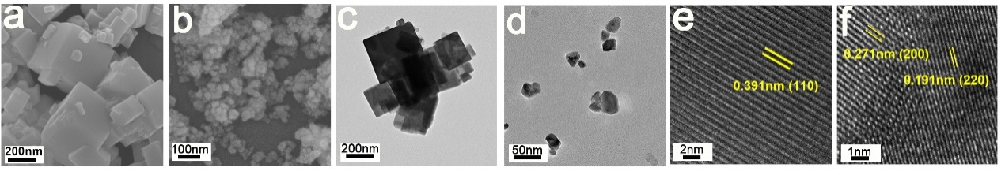
Fig. S1. Morphology and structure: (a, b) SEM, (c, d) TEM and (e, f) HRTEM images of NNO and CeO₂.

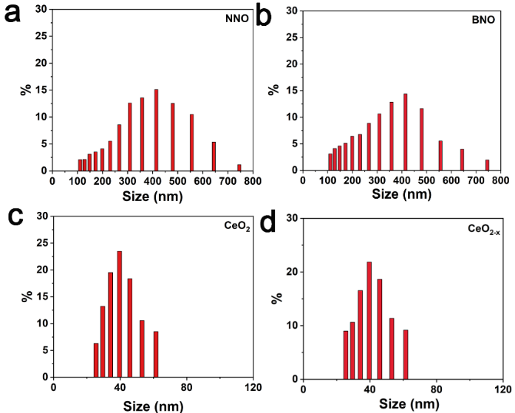
Fig. S2. Particle size: (a) DLS plot of NNO, (b) BNO and (c) CeO₂, (d) CeO_{2-x}.

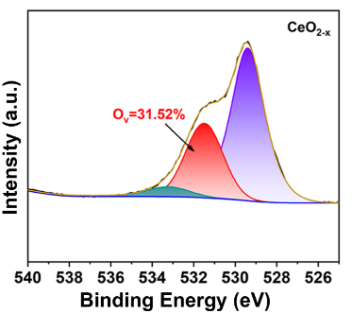
Fig. S3. High-resolution XPS of O 1s of CeO_{2-x}.

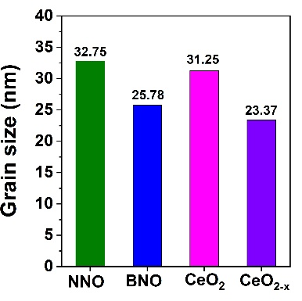
Fig. S4. Grain size of NNO, BNO, CeO₂, and CeO_{2-x}.

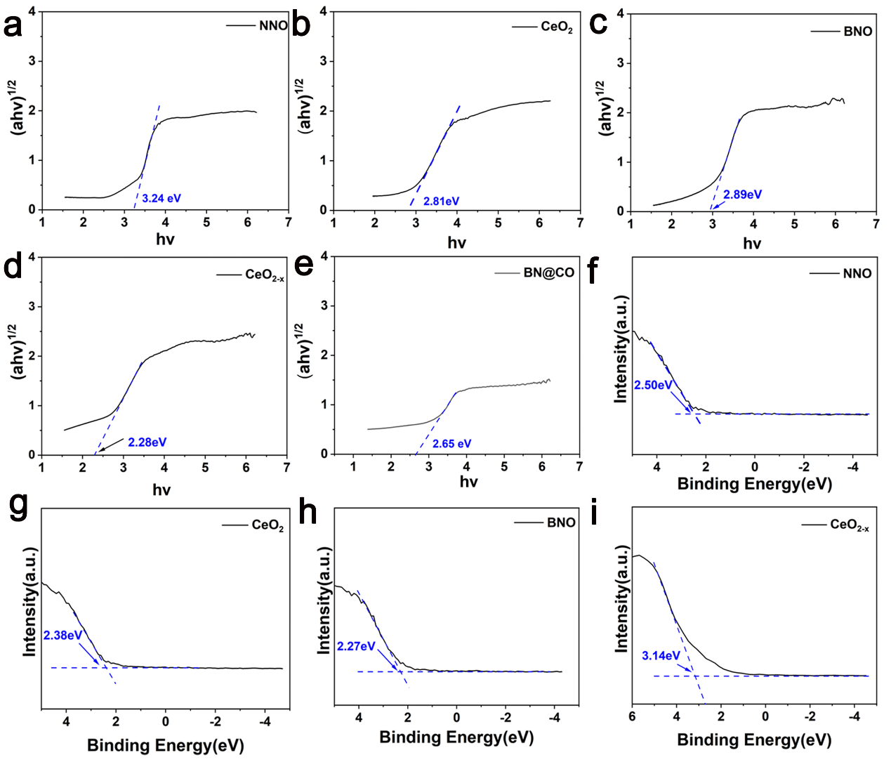
Fig. S5. Sonodynamic performance: Tauc plots of (a) NNO, (b) CeO₂, (c) BNO, (d) CeO_{2-x} and (e) BN@CO; VB-XPS spectra of (f) NNO, (g) CeO₂, (h) BNO, (i) CeO_{2-x}.
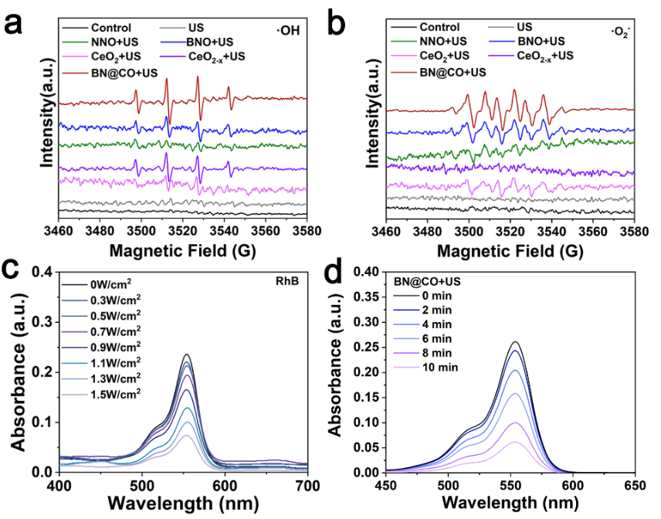
Fig. S6. Sonodynamic performance: ESR of (a) ·OH and (b) ·O₂⁻ for different groups; UV-vis-NIR absorption spectra of Rh B for BN@CO with different (c) intensity and (d) duration time of US. US parameters: 1.5W/cm², 1MHz, 50% duty cycle

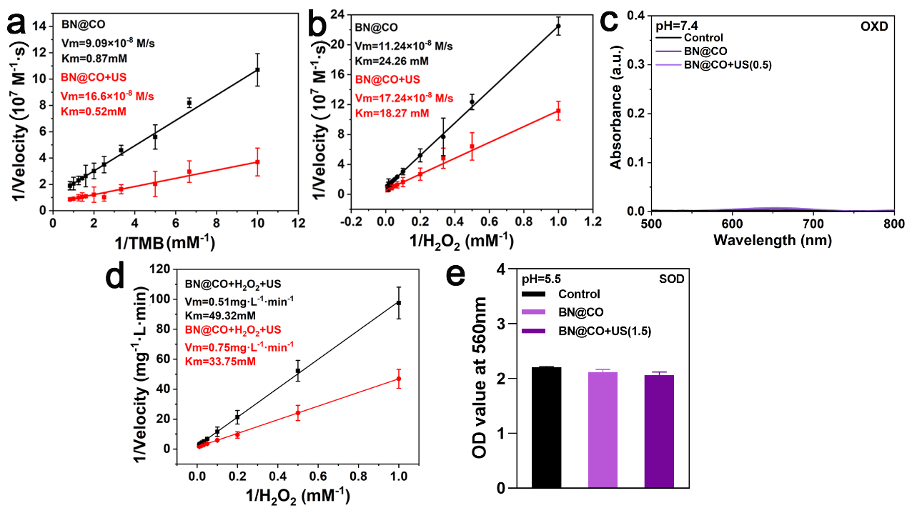
Fig. S7. Enzyme-like activities: Lineweaver-Burk plotting of BN@CO and BN@CO+US (1.5W/cm², 1MHz, 50% duty cycle) with (a) TMB and (b) H₂O₂ at pH=5.5; (c) UV-vis-NIR absorption spectra of TMB (without H₂O₂) at pH=7.4; (d) Lineweaver-Burk plotting of BN@CO and BN@CO+US (0.5W/cm², 1MHz, 50% duty cycle) with H₂O₂ at pH=7.4; (e) OD value of WST-8 formazan of different groups at pH=5.5. (f) UV-vis-NIR absorption spectra of DPBF for BN@CO+US at pH=7.4. n=3.

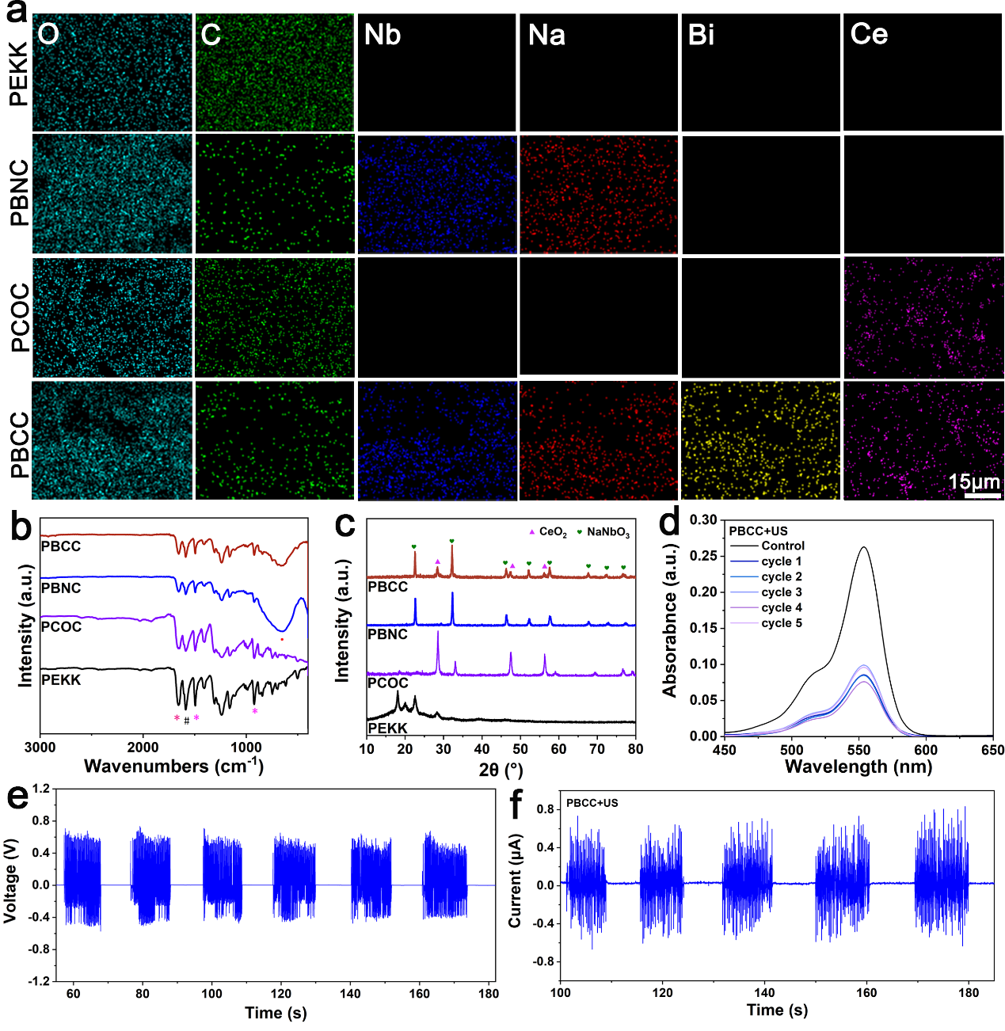
Fig. S8. Characterization: (a) EDS mapping of different elements for PEKK, PBNC, PCOC, and PBCC. (b) FTIR and (c) XRD for PEKK, PBNC, PCOC, and PBCC. (d)V-vis-NIR absorption spectra of Rh B for PBCC+US (1.5W/cm², 1MHz, 50% duty cycle) with 5 cycles. (e) open circuit voltage, (f) short circuit current of PBCC+US (0.5W/cm², 1MHz, 50% duty cycle) with 5 cycles.
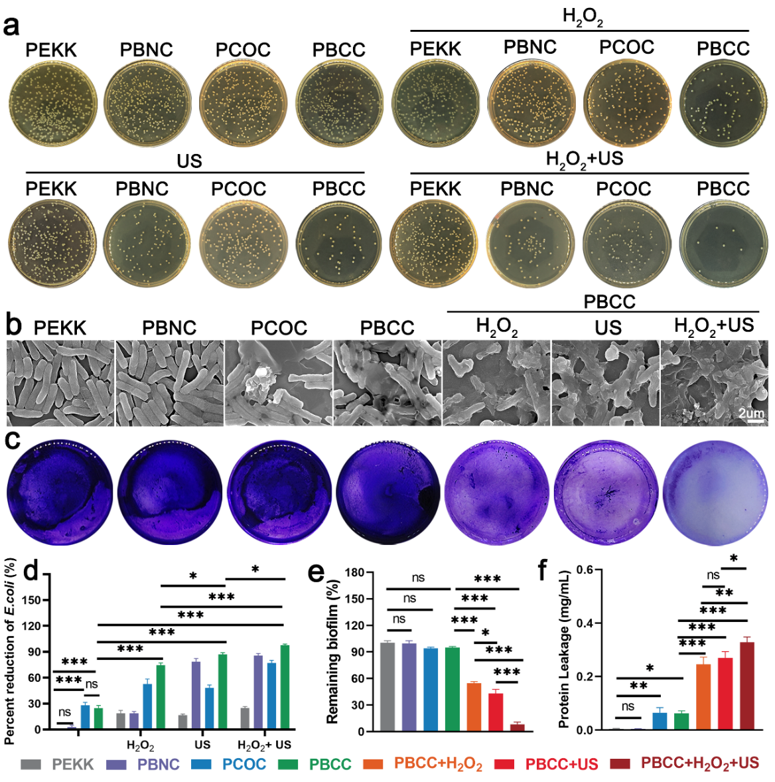
Fig. S9. Antibacterial properties: (a) Colony photos and (b) bacterial reduction rates, (c) SEM images, (e) protein leakage, (c) crystal violet staining images and (f) remaining biofilm rate of E. coli of different groups. n=3. US parameters: 1.5W/cm², 1MHz, 50% duty cycle.

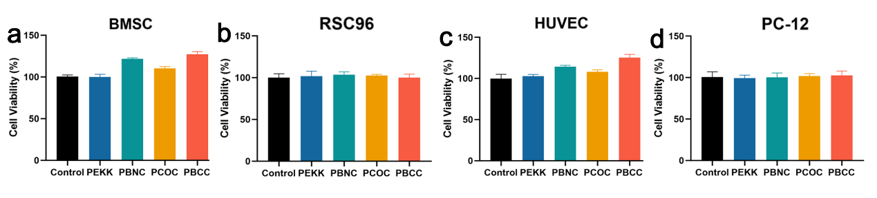
Fig. S10. Cytotoxicity: Cytotoxicity of PEKK, PBNC, PCOC and PBCC for (a) BMSC, (b) RSC96, (c) HUVEC, and (d) PC-12 cells at 24 h. n=3.

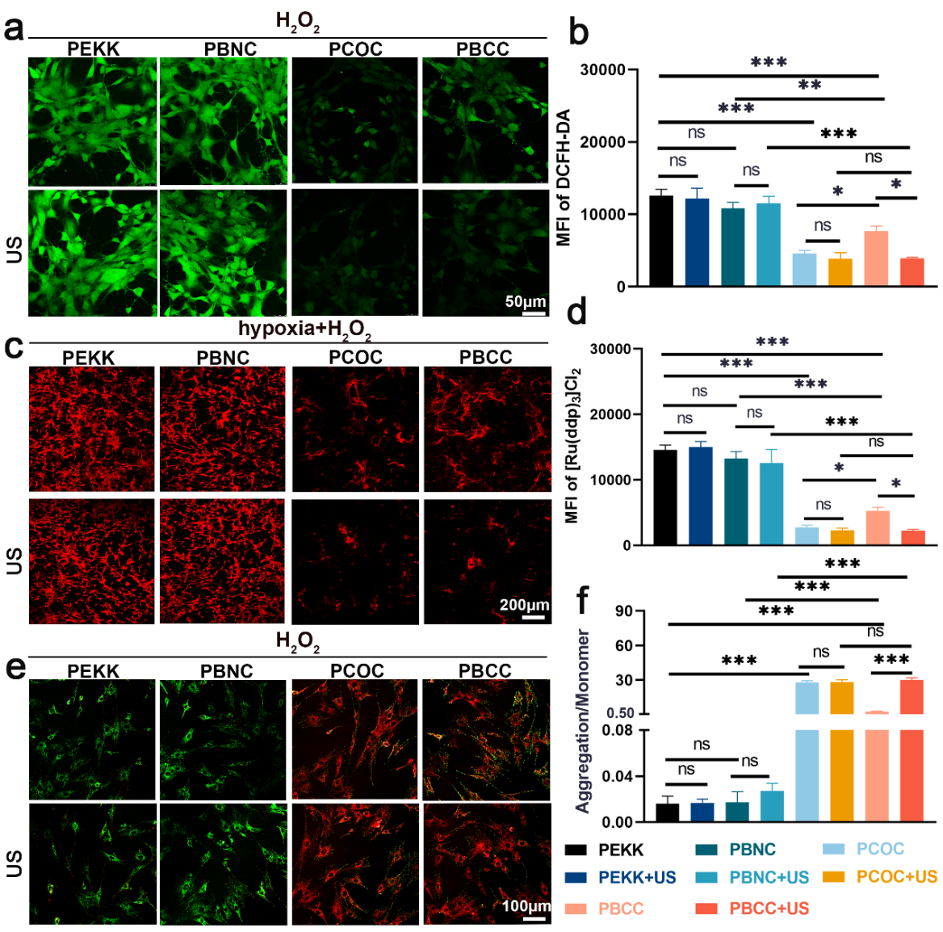
Fig. S11. Anti-oxidative performance: CLSM images of (a) DCFH-DA, (c) [Ru(ddp)₃]Cl₂, (e) JC-1 staining and (b, d, f) quantification of BMSC for different groups. n=3. US parameters: 0.5W/cm², 1MHz, 50% duty cycle.
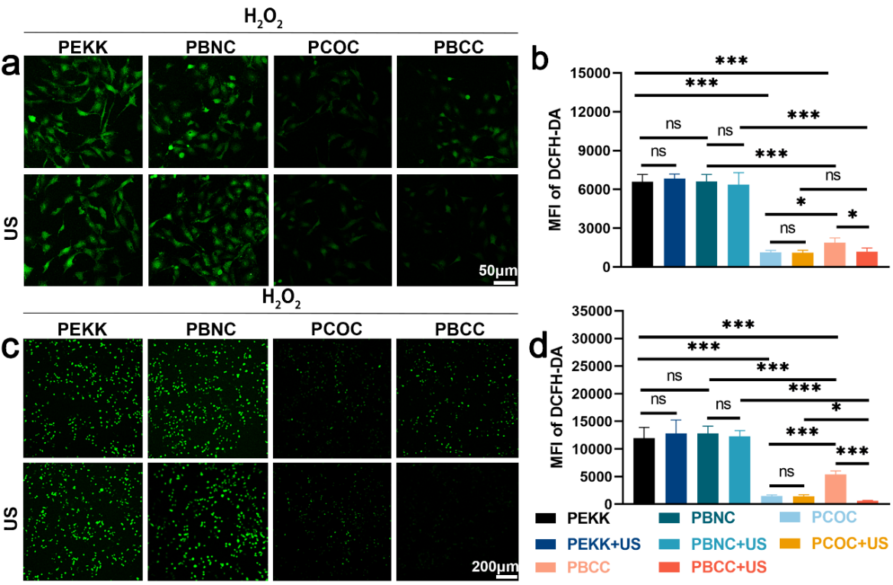
Fig. S12. Antioxidant properties: CLSM images of DCFH-DA staining and quantification for (a, b) HUVEC cells and (c, d) RSC96 cells for different groups. n=3. US parameters: 0.5 W/cm², 1MHz, 50% duty cycle.

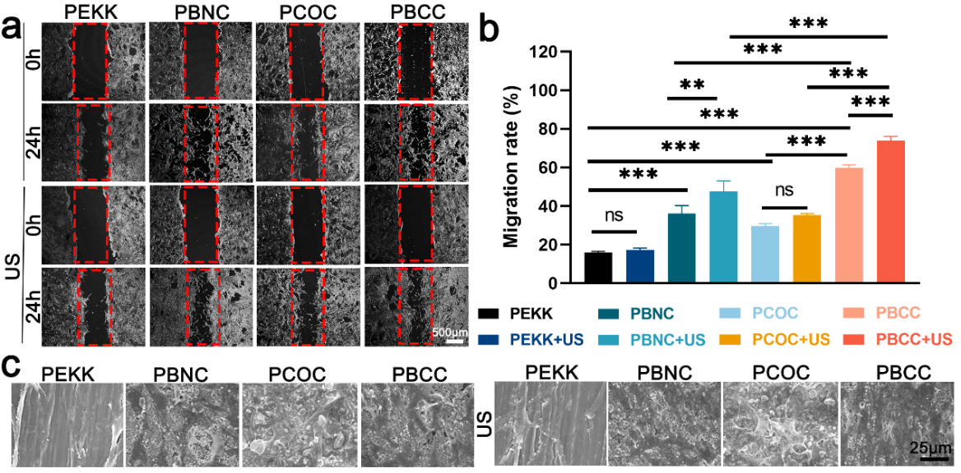
Fig. S13. Pro-osteogenesis by piezoelectric effect: (a) Migration images (b) and migration rate of BMSC for different groups; (c) SEM images of cell morphology on day 3. n=3. US parameters: 0.5 W/cm², 1MHz, 50% duty cycle.
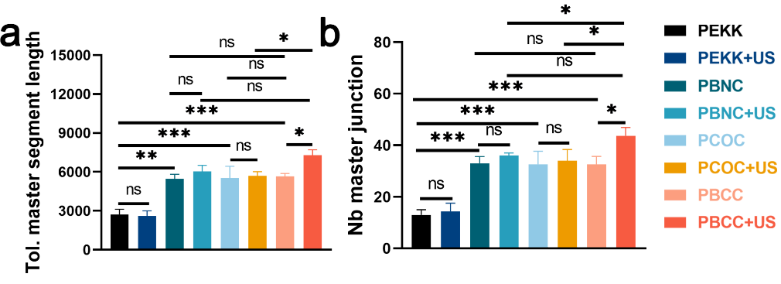
Fig. S14. Pro-angiogenesis by piezoelectric effect: (a) Length of total master segments (b) and number of master junction calculated by angiogenic maps at 4 h. n=3. US parameters: 0.5 W/cm², 1MHz, 50% duty cycle.

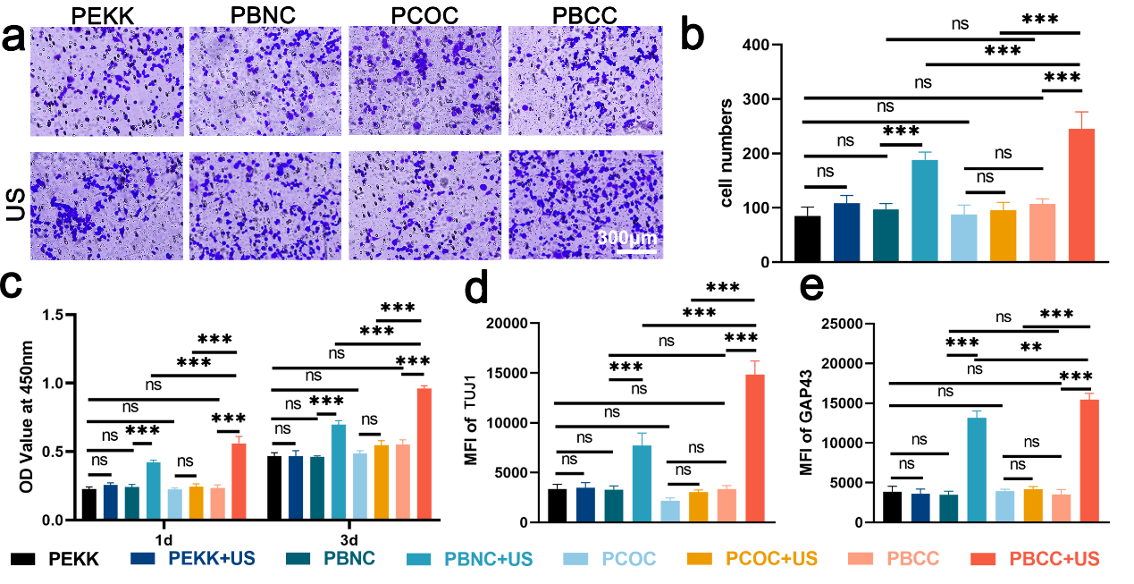
Fig. S15. Pro-neurogenesis by piezoelectric effect: (a) Migration images (b) and migration rate of RSC96 cells for different groups at 24 h; (c) Cell viability of RSC96 cells at 1 and 3 days after culturing; quantification of (d) TUJ1 and (e) GAP43 staining for different groups at 3 days. n=3. US parameters: 0.5 W/cm², 1 MHz, 50% duty cycle.

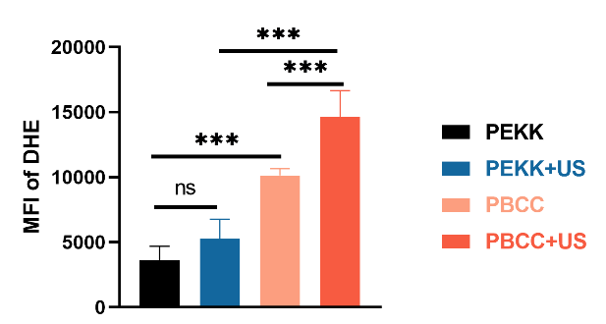
Fig. S16. Quantification of DHE staining for different groups at day 1. n=3. US parameters: 1.5 W/cm², 1MHz, 50% duty cycle.

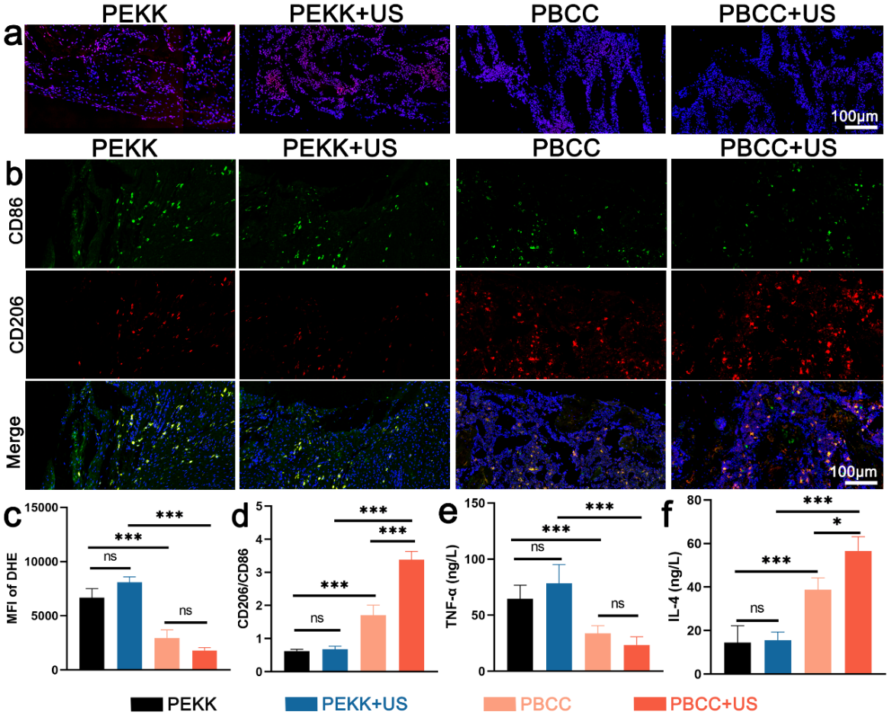
Fig. S17. Anti-inflammation in vivo: CLSM images of DHE (a) staining and (c) quantification, CLSM images of (b) CD206/CD86 staining and (d) quantification of bone tissue on day 21; Quantification of (e) TNF-αand (f) IL-4 in blood of mice on day 21. n=3. US parameters: 0.5 W/cm², 1MHz, 50% duty cycle.

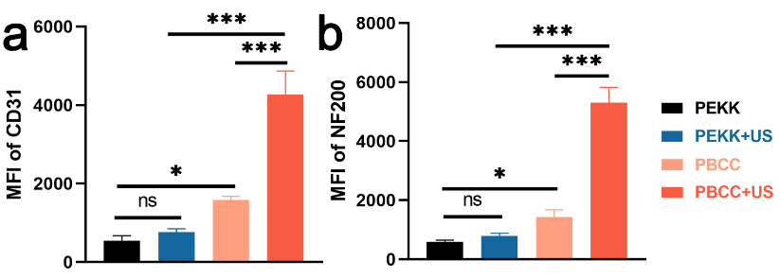
Fig. S18. Angiogenesis and neurogenesis in vivo: (a) Quantification of CD31 (b) and NF200 staining for different groups. n=3. US parameters: 0.5 W/cm², 1MHz, 50% duty cycle.

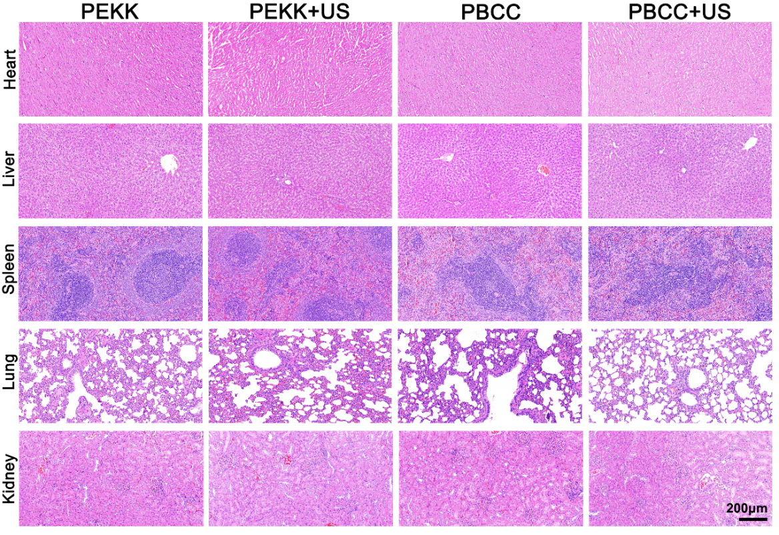
Fig. S19. H&E staining images of main organs (heart, liver, spleen, lungs and kidneys) for different groups at 8 w.

 | NNO | BNO
Na | 17.68% | 15.48%
Nb | 16.52% | 16.64%
O | 65.80% | 65.85%
Ce | 0 | 0
Bi | 0 | 2.03%
Table S1 Atomic percent of NNO and BNO.

Gene | Primer sequences
Gapdh | 5′-ACAGCAACAGGGTGGTGGAC-3′ (forward)
Gapdh | 5′- TTTGAGGGTGCAGCGAACTT-3′ (reverse)
Ocn | 5′-ACAAGTCCCACACAGCAACTC-3′(forward)
Ocn | 5′- CCAGGTCAGAGAGGCAGAAT-3′ (reverse)
Opn | 5′-GAGACCGTCTGAAACAGCGT-3′ (forward)
Opn | 5′-AACCACTGCCAGTCTCATGG-3′ (reverse)
Runx2 | 5′-CCTCTGACTTCTGCCTCTGGG-3′ (forward)
Runx2 | 5′-GATGAAATGCCTGGGAACTG-3′ (reverse)
Alp | 5′-CGGACAATGAGATGCGCCC-3′ (forward)
Alp | 5′-TGGGAGTGCTTGTGTCTAGG-3′ (reverse)
Tuj1 | 5′-CAAGTTCTGGGAGGTCATCAGT-3′ (forward)
Tuj1 | 5′-GAATGGCTCTGGGCACATAC-3′ (reverse)
Gap43 | 5′-GCACATCGGCTTGTTTAGGCT-3′ (forward)
Gap43 | 5′-GGAGGGAGATGGCTCTGCTACT-3′ (reverse)
Table S2 Primer sequences (Osteogenesis, neurogenesis).

Gene | Primer sequences
GAPDH | 5′-GGACTTCGAGCAAGAGATGG-3′ (forward)
GAPDH | 5′-CTGGAAGATGGTGATGG-3′ (reverse)
VEGF | 5′-CAGAAGGAGGAGGGCAGAAT-3′ (forward)
VEGF | 5′-TGCGATTGGATGGCAGTAGCA-3′ (reverse)
CD31 | 5′-CACATGCGAGTCCAATGTGA-3′ (forward)
CD31 | 5′-TGAGCCTTCCGATGGTCTTT-3′ (reverse)
Table S3 Primer sequences (vascularization).

