ROS-responsive Microneedle Patch Delivering NMN@Cu/CeO₂ Nanozyme for Restoring Immune Microenvironment and Mitochondrial Homeostasis to Potentiate Diabetic Wound Healing
Yanping Wang ^{a, 1}, Zhen Liang ^{a, 1, *}, Xianghao Xu ^{a, 1}, Yanan Gu ª, Yutao Li ª, Hongrui Sun ^{b}, Zhou Yu ª, Baolin Guo ^{b, c, e, *}, Xin Zhao ^{b, d *}, Baoqiang Song ^{a, *}
ª Department of Plastic Surgery, Xijing Hospital, Fourth Military Medical University, Xi'an 710032, China
^{b} State Key Laboratory for Mechanical Behavior of Materials, and Frontier Institute of Science and Technology, Xi'an Jiaotong University, Xi'an 710049, China
^{c} Department of Orthopaedics, The First Affiliated Hospital of Xi'an Jiaotong University, Xi'an 710061, China
^{d} State Key Laboratory of Oral & Maxillofacial Reconstruction and Regeneration, The Fourth Military Medical University, Xi'an, 710032, China
^{e} Key Laboratory of Shaanxi Province for Craniofacial Precision Medicine Research, College of Stomatology, Xi'an Jiaotong University, Xi'an 710049, China
¹ These authors contributed equally to the work.
*Corresponding author:
Dr. Zhen Liang, E-mail: lianglyzz@163.com; Prof. Baolin Guo, E-mail: baoling@mail.xjtu.edu.cn; Prof. Xin Zhao, E-mail: zhaoxinbio@mail.xjtu.edu.cn; Prof. Baoqiang Song, E-mail: songbq2012@163.com.
Experimental Section/Methods
1. Materials and Reagents
Cerium nitrate hexahydrate (CeN₃O₉·6H₂O), copper nitrate (Cu(NO₃)₂), epichlorohydrin (C₃H₅ClO), EPL, and 4-carboxyphenylboronic acid (C₇H₇BO₄) were purchased from Aladdin (Shanghai). Pig skin gelatin was obtained from Sigma-Aldrich, and rhodamine B from Solarbio. NMN was purchased from Bontai Biotech (Shenzhen), while DMEM and FBS were from Gibco. SIRT1 antibodies were obtained from ABclonal, GAPDH, Nrf2, HO-1, GPX4, and iNOS antibodies were from Proteintech (Wuhan), and fluorescence secondary antibodies were purchased from Thermo Fisher. Live/Dead Cell Staining Kit, BCA Protein Assay Kit, 2,7-dichlorofluorescin diacetate (DCFH-DA), EdU Kit, and Mitochondrial Membrane Potential (TMRE) Detection Kit were purchased from Beyotime, and Cell Counting Kit 8 (CCK8) was from Abbkine.
1,1-Diphenyl-2-picrylhydrazyl (DPPH), 3,3′,5,5′-Tetramethylbenzidine (TMB) were purchased from Aladdin (Shanghai). Methacrylic anhydride (MA), PVA, and PEI were purchased from Macklin. Lithium Phenyl (2,4,6-trimethylbenzoyl) phosphinate (LAP) was sourced from Engineering For Life (Suzhou), and ethylene glycol from FuYu Reagents (Tianjin). L-methionine, nitro blue tetrazolium chloride (NBT), and riboflavin were obtained from DiBai Chemical Technology Ltd. Calcium yellow-green (AM), propidium iodide (PI), and 4',6-diamidino-2-phenylindole (DAPI) were purchased from Beyotime. Dihydroethidium (DHE) was obtained from Sigma-Aldrich, and lipopolysaccharide (LPS) was purchased from Sigma-Aldrich. The NAD⁺ detection kit, ATP detection kit and MitoSO™ Red were purchased from Beyotime. Ru(dpp)₃Cl₂ was purchased from GLPBIO.
2. Synthesis of GelMA, EPL-PBA, PEI-Cu/CeO₂ NPs, and NMN@Cu/CeO₂-MN
First, 20 g of pig skin gelatin powder (Sigma-Aldrich) was dissolved in 180 mL PBS (Biosharp) and stirred at 60°C in an oil bath until fully dissolved. Once the solution cooled to 50°C, 16 mL of methacrylic anhydride (MA) was added, and the mixture was stirred for 1 hour. The reaction was terminated by adding 800 mL of PBS. The solution was dialyzed in deionized water for 5 days at 40°C in the dark and then freeze-dried at -80°C to obtain GelMA for further use. Besides, 2 g of MES was dissolved in 200 mL of deionized water. Sequentially, 10 g of EPL, 2.64 g of PBA, 20 mL of DMF, 6.1 g of EDC∙HCl, and 3.66 g of NHS were added to the solution and stirred overnight at 60°C. After the solution returned to room temperature, it was centrifuged at 7,000 rpm for 10 minutes. Finally, the supernatant is collected and dialyzed in deionized water for 5 days, followed by freeze-drying to obtain the purified product.
The synthesis of CeO₂ and Cu/CeO₂ was carried out as following: CeN₃O₉·6H₂O aqueous solution (0.5 M, 2 ml) was added to 60 ml of ethylene glycol, stirred vigorously for 40 minutes, and transferred to a high-pressure reactor, maintained at 180°C for 12 hours to obtain CeO₂ nanoparticles. Subsequently, 57.85 mg of (Cu(NO₃)₂) was added to the obtained CeO₂ product, stirred for 1 hour, and kept at 180°C for 4.5 hours in the reactor. The precipitate was centrifuged, washed alternately with anhydrous ethanol and deionized water, and freeze-dried to obtain copper-doped cerium oxide nanoparticles (Cu/CeO₂ NPs).
PEI coupling with Cu/CeO₂ nanoparticles was achieved through an SN₂ reaction between PEI and C₃H₅Cl. First, 50 mg of Cu/CeO₂ was suspended in NaOH solution (0.1 M, 10 ml) and stirred at room temperature for 10 minutes. Then, 10 ml of C₃H₅Cl and 0.5 ml of 2 M NaOH were added and stirred overnight at room temperature. The reaction product was centrifuged at 10,000 rpm for 5 minutes, washed several times with deionized water to reach a pH of around 7, and vacuum-dried for further use. The dried product was mixed with 40 mg PEI in 250 ml deionized water and stirred for 24 hours at room temperature. The product was washed several times at 4,000 rpm for 20 minutes, and the supernatant was discarded. The final product was dialyzed in deionized water for 24 hours using a 10 kDa MWCO dialysis membrane to remove unreacted solvents. The product was centrifuged at 4,000 rpm for 20 minutes and freeze-dried to obtain PEI-modified Cu/CeO₂ nanoparticles (PEI-Cu/CeO₂ NPs). To load NMN, PEI-Cu/CeO₂ was mixed with NMN in different ratios and stirred at 100 rpm for 24 hours at room temperature. After washing twice at 10,000 rpm for 20 minutes with deionized water, the supernatant was discarded, and the centrifugal products was resuspended and saved for further use (NMN@Cu/CeO₂ NPs).
Under light protection, 100 mg of GelMA (10 wt%) and 2.5 mg of LAP (0.25 wt%) were dissolved in 1 ml of deionized water to prepare the GelMA precursor solution. Different nanomaterials were added to this solution and mixed thoroughly to obtain micro-needle tip GelMA precursor solutions containing (or without) NMN@Cu/CeO₂. Similarly, 200 mg of PVA (20 wt%) and 50 mg (5 wt%) EPL-PBA were dissolved in 1 ml of deionized water and thoroughly mixed to obtain the micro-needle substrate PVA/EPL-PBA precursor solution. The needle tip GelMA precursor solution was injected into a PDMS mold, maintained under vacuum for 5 minutes, and excess liquid and bubbles were removed by scraping. This process was repeated three times, and the mixture was crosslinked with 405 nm blue light. The PVA/EPL-PBA precursor solution was injected into the mold and left at room temperature overnight before being dried at 35°C for 48 hours. After drying, the microneedle patches containing composite nanomaterials (NMN@Cu/CeO₂-MN) were obtained from the mold. Similarly, microneedle patches containing Cu/CeO₂ and NMN (Cu/CeO₂-MN and NMN-MN) were prepared. Each microneedle patch contained approximately 66.84 μg of NMN, 100 μg of Cu/CeO₂, and 100 μg of NMN@Cu/CeO₂ (approximately 27.53 μg of NMN).
3. Characterizations
The nanoparticles to be tested were dispersed in ethanol, diluted to an appropriate concentration, and sonicated. The mixture was then drop-cast onto silicon wafers and left to dry for 30 minutes. After uniformly spraying gold onto the surface, scanning electron microscopy (SEM, QUTAN FEG 250, FEI) was used to examine the morphology of the samples. Transmission electron microscopy (TEM, JEM-2100F, JEOL, Japan) was used to observe the morphology of Cu/CeO₂, PEI-Cu/CeO₂, and NMN@Cu/CeO₂ nanoparticles, and energy-dispersive X-ray spectroscopy (EDS) was used to detect the elemental composition. The particle size and ζ-potential of the samples were measured using a Malvern Zetasizer Nano ZS90 (UK). The ultraviolet-visible (UV-vis) absorption spectra were recorded using a Shimadzu UV-2660i spectrophotometer (Japan). X-ray photoelectron spectroscopy (XPS, Thermo K-alpha, US) was employed for full and high-resolution elemental analysis of the samples.
The macro and micromorphology of the MNs were characterized using SEM (QUTAN FEG 250, FEI), optical microscopy (Nikon), and an inverted microscope (Nikon E100, Japan). Fluorescence microscopy was used to observe the morphology of microneedles labeled with rhodamine B (RB) and FITC. MNs were applied to the dorsal skin of mice, and Ponceau S staining was performed. The skin was also processed for hematoxylin-eosin (H&E) staining. Fluorescently labeled materials (RB) encapsulated in nanoparticles were incorporated into the microneedles, and their skin penetration depth was observed using a laser confocal microscope (Leica TCS SP8, DE). The morphological changes of various MNs in a high-humidity environment were observed using an inverted microscope (Nikon E100, Japan). Randomly selected MN tips were placed onto supporting attachments, exposed to a 60% relative humidity environment at 25°C, and imaged at scheduled time points.
DFT calculations were performed with the DMol³ module in Materials Studio (MS) under the spin-unrestricted scheme. Exchange–correlation effects were modeled using the Perdew–Burke–Ernzerhof (PBE) functional within the generalized gradient approximation (GGA), together with a double numerical plus polarization (DNP) basis set. The convergence tolerances for energy change, maximum force, and maximum displacement were 2.0 × 10⁵ Ha, 0.004 Ha Å^-1, and 0.005 Å, respectively. A 3 × 3 × 1 Monkhorst-Pack grid was used for Brillouin zone integration. The interaction energy (E_{int}) between PEI and NMN on Cu/CeO₂ NPs was expressed as: E_{int} = E_{A}+B − E_{A} − E_{B}, where E_{A}+B, E_{A}, and E_{B} represent the energy of the PEI and NMN on Cu/CeO₂ NPs, PEI, and NMN isolated on Cu/CeO₂ NPs, respectively.
4. Swelling Behavior of Microneedle Patches
The swelling behavior of the samples was evaluated by recording changes in the microneedle mass during incubation. The initial mass (W₀) of the microneedles was measured, and then they were immersed in 0.01 M PBS buffer (pH 7.4) at 37°C. At designated time points, the microneedles were removed, surface water was removed with filter paper, and the mass (W_{t)} was measured again. The swelling ratio (E_{s}) was calculated using the formula: E_{s} = (W_{t} - W₀) / W₀ × 100%.
5. In Vitro Drug Release of NMN@Cu/CeO₂
NMN@Cu/CeO₂ were encapsulated in a dialysis bag (10 kDa MWCO) and placed in 30 mL of PBS (pH=5.5) at 37°C on a shaker set at 100 rpm. At specified time intervals, 1 mL of the release medium was withdrawn and analyzed for absorbance at 266 nm using a UV-vis spectrophotometer. The cumulative release of the drug was calculated using the standard curve method. The drug release percentage was calculated using the formula: W_{d} × 100% / W_{a}, where W_{d} is the released NMN amount and W_{a} is the initial amount of NMN.
6. DPPH• and ox-TMB Free Radical Scavenging Tests
The free radical scavenging capacity of the composite nanoenzymes was assessed using DPPH•. DPPH (10 mg) was mixed with ethanol (20 mL) and incubated at room temperature in the dark to obtain DPPH•. Different concentrations of NMN, Cu/CeO₂, Vitamin C, and NMN@Cu/CeO₂ nanoparticle solutions (100 μL) were added to the DPPH• solution, and absorbance was measured at 517 nm. Similarly, the antioxidant capacity of the composite nanoenzymes was evaluated using 3,3′,5,5′-Tetramethylbenzidine (TMB). The maximum absorbance of ox-TMB was measured at 652 nm using a UV-vis spectrophotometer.
7. Measurement of SOD and CAT Enzyme Activities
The SOD enzyme activity of the composite nanoenzymes was represented by the inhibition of NBT photoreduction. Briefly, different concentrations of nanomaterials (10, 20,40, 80, 100, 150, and 200 μg/mL) were mixed with L-methionine (0.1 mL, 125 mM), riboflavin (0.1 mL, 200 μM), and NBT (0.1 mL, 750 μM) in deionized water, and the final volume was adjusted to 1 mL. The reaction mixture was irradiated with UV light for 30 minutes, and absorbance was measured at 560 nm. The inhibition percentage was calculated using the formula: Inhibition (%) = [(A_{m} - A_{n}) / A_{m}] × 100%, where A_{n} is the absorbance of the samples and A_{m} is the absorbance of the control group.
CAT enzyme activity was evaluated by measuring H₂O₂ clearance. Different concentrations of nanomaterials (10, 20,40, 80, 100, 150, and 200 μg/mL) were mixed with H₂O₂ solution (50 μM) to form a 1 mL reaction mixture. The reaction was incubated at 37°C for 2 hours, and the absorbance at 240 nm was measured. CAT enzyme activity was calculated based on the rate of change in absorbance.
8. Oxygen Generation Release Test
The oxygen generation efficiency of the nanoparticles was measured by mixing a specific concentration of nanomaterials with H₂O₂ (200 mM) in Tris-HCl buffer (0.1 M, pH 7.2). The dissolved oxygen concentration was measured over 20 minutes using a dissolved oxygen meter (JPBJ-608) to simulate the oxygen generation efficiency of nanoenzymes in wound environments.
9. Drug Release Behavior in NMN@Cu/CeO₂-MN
To investigate the drug release behavior of the microneedles, rhodamine B (RB) was used as a model drug. RB was incubated with composite nanoenzymes to obtain fluorescently labeled nanoparticles, which were then loaded into the microneedles to prepare RB-loaded microneedle patches (1 mg/mL). The microneedles were immersed in 5 mL of PBS at 37°C, and at scheduled time points (0, 1, 3, 6, 12, 24, 48, 72, 96, and 144 hours), the fluorescence absorbance of the supernatant was measured. The cumulative release was calculated based on the standard fluorescence intensity-concentration curve.
10. In Vitro Hemolysis Test of Microneedle Patches
To evaluate the blood compatibility of microneedles, an in vitro hemolysis test was performed. Red blood cells collected from C57 mice were washed several times with PBS until the supernatant was clear, and then centrifuged at 1000 rpm for 5 minutes to obtain red blood cell pellets. Different microneedle patches were placed in a 12-well plate, and PBS and 0.1% Triton X-100 were used as negative and positive controls, respectively. 800 μL of 5% red blood cell suspension was added to each sample well and incubated at 37°C for 1 hour. The solution was centrifuged at 1000 rpm for 10 minutes, and 100 μL of the supernatant was transferred to a 96-well plate for absorbance measurement at 540 nm using a microplate reader (Tecan, Switzerland). The hemolysis percentage was calculated using the formula: [OD_{h} - OD_{b}] / [OD_{t} - OD_{b}] × 100%, where OD_{h}, OD_{b}, and OD_{t} represent the absorbance values of the microneedle sample, negative control (PBS), and positive control (Triton X-100), respectively.
11. In Vitro Biocompatibility and Cell Proliferation Assay
HUVEC and NFB cells were cultured in DMEM supplemented with 10% FBS at 37°C and 5% CO₂. Cell toxicity was assessed using CCK-8, EdU, and Live/Dead cell staining kits. Microneedle patches and their extracts were prepared for further experiments. HUVEC and NFB cells were seeded at 1 × 10⁴ cells per well in a 96-well plate and incubated for 24, 48, and 72 hours, followed by cell viability measurement using the CCK-8 kit. After co-culturing the cells with microneedles in a 6-well plate for 24 hours, the patch and culture medium were removed, and the Live/Dead cell staining kit was used according to the manufacturer's instructions, followed by fluorescence imaging (Nikon, DS-Ri2, Japan). For EdU proliferation assays, HUVEC cells were incubated with the patches for 24 hours, fixed with 4% PFA, and stained with EdU and DAPI. Images were captured using a fluorescence microscope. Each experiment was repeated three times.
12. In Vitro Wound Healing Assay
NFB and HUVEC scratch assays were performed in a 6-well plate. Briefly, cells were passaged at a density of 2 × 10⁵ cells per well. Once the cells were confluent, several scratches were made on the surface of the culture plate using a sterile pipette tip. Wound closure was monitored at 0 and 24 hours using a microscope, and the wound closure rate was calculated as the ratio of the closed area to the initial wound area.
13. In Vitro Endothelial Cell Tube Formation Assay
For tube formation assays, HUVECs were pre-treated by co-culturing with different microneedles for 24 hours. Subsequently, 1 × 10⁵ harvested cells were transferred to a 12-well plate coated with 600 μL precooled Matrigel (Corning) and incubated at 37°C for 4 hours. Tube formation was imaged using an optical microscope (Nikon, DS-Ri2).
14. In Vitro Antibacterial Assay
The antibacterial performance of the microneedles was evaluated by colony counting. Briefly, 10 μL of methicillin-resistant Staphylococcus aureus (MRSA) and Escherichia coli (E. coli) suspensions (approximately 10⁶ CFU/mL) were added to the microneedle surface and incubated at 37°C for 2 hours. 1 mL of PBS was added to each well to resuspend the bacteria. A 10 μL aliquot was evenly spread onto an agar plate and incubated at 37°C for 24 hours. Bacterial colony counts were recorded. the antibacterial ratio (%) was calculated using the formula: (control group bacterial count - surviving count on microneedles) / control group bacterial count × 100%. Bacterial survival rate (%) calculation formula: microneedle survival count/control group bacterial count × 100%.
15. In Vivo Hemostasis Evaluation
C57 male mice (50 g) were anesthetized and fixed on a surgical cork board (n = 5). An abdominal incision was made to expose the liver, and a filter paper was placed under the liver. A 1 mm deep bleeding wound was created on the liver, and a portion of the microneedle patch was immediately applied to the bleeding site. Similarly, a 3 cm segment of the tail was amputated, and a filter paper was placed at the amputated site, followed by immediate application of the microneedle. The control group treated with PBS was used for comparison. Blood loss was measured by weighing the filter paper.
16. Evaluation of ROS Clearance by Microneedle Patches
DCFH-DA probe was used to evaluate the ROS scavenging ability of the microneedles. Briefly, HUVECs were seeded in a 6-well plate and induced with ROS inducers (Rosup). The cells were then co-cultured with different samples for 24 hours. PBS was used as the negative control. After removing the microneedles, DCFH-DA reagent was added, and cells were incubated at 37°C for 20 minutes. Fluorescence images were taken using a fluorescence microscope. Each experiment was repeated three times.
17. Macrophage Polarization Study
RAW 264.7 cells (2 × 10⁴ cells per well) were seeded in a confocal dish and incubated overnight at 37°C with 5% CO₂. The cells were treated with LPS (0.1 μg/mL) in DMEM for 12 hours. The culture medium was replaced with DMEM extract from MN, Cu/CeO₂-MN, NMN-MN, and NMN@Cu/CeO₂-MN groups, and the cells were further incubated for 24 hours. Untreated cells were used as controls. The cells were fixed with 4% formaldehyde (Biosharp) for 10 minutes, permeabilized with 0.5% Triton X-100 (Solarbio) for 20 minutes, and blocked with 2% BSA (Servicebio) for 30 minutes. The cells were then incubated with primary antibodies for CD206 (1:150, ABclonal) and iNOS (1:150, Proteintech) overnight at 4°C. Fluorescent secondary antibodies (Alexa Fluor 488 and Alexa Fluor 594, ThermoFisher Scientific) were added, and cells were incubated at room temperature for 30 minutes in the dark. Finally, DAPI (Solarbio) was used for nuclear staining, and fluorescence images were captured using a fluorescence microscope (Nikon).
18. Detection of intracellular NAD⁺, ATP, mitochondrial superoxide and oxygen production
In brief, 1×10⁶ cells were seeded in a confocal dish and cultured adherently overnight. The cells were treated with high glucose medium for 12 hours, followed by co-culture with the corresponding components using micro needles for 24 hours. According to the instructions of the reagent suppliers, the cells were stained and incubated with ATP detection kit, NAD⁺ detection kit, MitoSO™ Red and Ru(dpp)₃Cl₂ respectively. After washing with PBS, images were taken using a fluorescence microscope.
19. Mitochondrial Membrane Potential (MMP) Detection in HUVECs
Mitochondrial membrane potential (MMP) in HUVECs was assessed using the TMRE staining kit. Briefly, 1 × 10⁶ HUVECs were seeded in a confocal dish and cultured overnight. The cells were pre-treated with the mitochondrial membrane potential inhibitor CCCP (10 μM) for 20 minutes, and then the culture medium was replaced with the DMEM extract from microneedles for 24 hours. The cells were incubated with TMRE staining solution (10 μM) and incubated for 20 minutes at 37°C. After washing twice with PBS, cells were analyzed using a fluorescence microscope.
20. In Vivo Evaluation of Diabetic Wound Healing
All animal experiments adhered to the guidelines for the care and use of laboratory animals issued by the National Institutes of Health, China. C57 wild-type mice (8 weeks old) were purchased from the Model Animal Research Center of the Fourth Military Medical University, and all surgical procedures and perioperative management were carried out following the guidelines approved by the Ethics Committee of Xijing Hospital, Fourth Military Medical University (Ethical approval number: 20241312).
Before the experiments, the mice were housed in a specific pathogen-free (SPF) environment at a temperature of 23 ± 2°C and humidity of 50-60%, with ad libitum access to water and food. After Feeding with high-fat and high-sugar foods, diabetes was induced by a single intraperitoneal injection of streptozotocin (STZ, Sigma-Aldrich) at 50 mg/kg in citrate buffer (pH = 4.5) for 5 consecutive days. One week after injection, mice with blood glucose levels above 16.7 mm were considered diabetic. The mice were randomly divided into 5 groups (n = 12) for treatment with control (Tegaderm Film, 3M, USA), MN, Cu/CeO₂-MN, NMN-MN, and NMN@Cu/CeO₂-MN. Full-thickness wounds were created on the dorsal skin of mice using a 9 mm biopsy punch. The microneedle patch or PBS (control) was applied to the wound site, and the wounds were covered with Tegaderm film (3M, USA). Wound areas were measured and photographed on days 0, 3, 7, and 14. At the specified time points, 3 mice from each group were randomly selected to collect wound tissues for further histological studies. Wound contraction was measured and calculated using ImageJ (version 1.53e). Wound contraction rate (%) = (A₀ - A_{n}) / A₀ × 100%, where A₀ and A_{n} represent the wound area on day 0 and day n.
21. Histological, ROS, and Immunofluorescence Staining of Wound Tissue
At the specified dates, full-thickness wound tissues were excised, including 2 mm of healthy tissue at the edges, and used for cryosectioning or fixed tissue immunofluorescence staining. H&E and Masson staining were performed to assess epithelial formation and collagen deposition (on days 7 and 14); DHE probe was used to assess in vivo ROS clearance (on day 3); CD86 and CD206 antibodies (Servicebio) were used to evaluate macrophage polarization (on day 7); CD31 antibody (Boster Bio) was used to assess angiogenesis, and TNF-α antibody (Abcam) was used to evaluate inflammation-related factor expression.
22. Western Blot Analysis
Proteins from animal wound tissues were extracted, and the protein concentrations of the supernatant were measured using the BCA assay kit (Beyotime). Protein separation was performed by SDS-PAGE (8-20% gels), followed by transfer to a 0.22 μm PVDF membrane (ISEQ00010, Millipore). The membrane was blocked for 1 hour and incubated overnight at 4°C with primary antibodies for Nrf2 (Proteintech), GAPDH (Proteintech), SIRT1 (Proteintech), HO-1 (Proteintech), and GPX4 (Proteintech). The membrane was washed six times for 30 minutes each with PBS containing 0.1% Tween 20 (TBST). After incubation with HRP-conjugated secondary antibodies for 1 h, enhanced chemiluminescence detection reagents were used to observe the immunoreactive bands. GAPDH was used as the loading control.
23. Statistical Analysis
All statistical analyses were performed using GraphPad Prism 8.0 software (La Jolla, California, USA) and Origin 2024 (version 9.8.0.200). Data are presented as mean ± SD from at least three independent experiments. The sample size (n) for each statistical analysis is detailed in the figure legends, and all experiments were repeated with at least three samples to ensure consistency. For statistical methods, comparisons between two groups were performed using Student’s t-test, and comparisons among multiple groups were analyzed using one-way ANOVA with Tukey post-hoc test to determine significant differences between specific means. Statistical significance was set at P < 0.05, and all tests were two-tailed unless otherwise specified. A P-value of <0.05 was considered statistically significant.
Results
Table S1. Loading ratios of NMN and PEI-Cu/CeO₂ in the composite NMN@Cu/CeO₂.
NMN (mM) | PEI-Cu/CeO₂ (mM) | Ratio of NMN and PEI-Cu/CeO₂ |  | Drug loading ratios
2.5 | 2.656 | 0.9413:1 |  | 4.40%
5 | 2.656 | 1.8825:1 |  | 12.95%
7.5 | 2.656 | 2.8238:1 |  | 27.53%
10 | 2.656 | 3.7651:1 |  | 25.66%

Figure S1. The energy-dispersive X-ray spectroscopy (EDS) analysis of NMN@Cu/CeO₂ nanoparticles.
Figure S2 (A) Particle size analysis of NMN@ Cu/CeO₂ at Day 3. (B) Particle size analysis of NMN@ Cu/CeO₂ at Day 7.
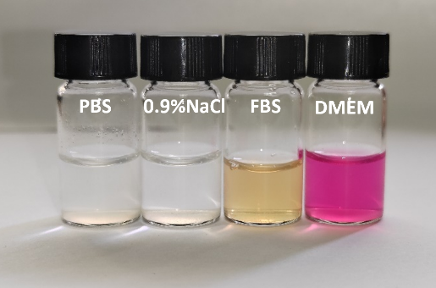
Figure S3. Dispersion stability of NMN@Cu/CeO₂ in PBS, 0.9% NaCl, FBS, and DMEM.
Figure S4. Standard calibration curve of NMN for determining its loading efficiency in PEI-Cu/CeO₂ nanoparticles (denoted as NMN@Cu/CeO₂).

Figure S5. UV-vis absorption spectra of initial NMN solutions (denoted as solid lines) and the corresponding supernatants (denoted as dotted lines) after incubation and centrifugation with PEI-Cu/CeO₂ at varying concentrations.
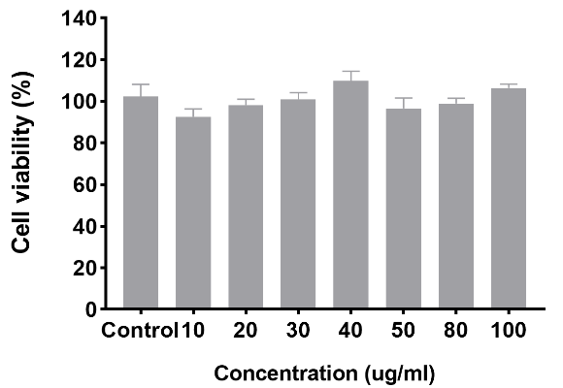
Figure S6. The cytotoxicity of the composite nanomaterial NMN@Cu/CeO₂ toward HUVECs.
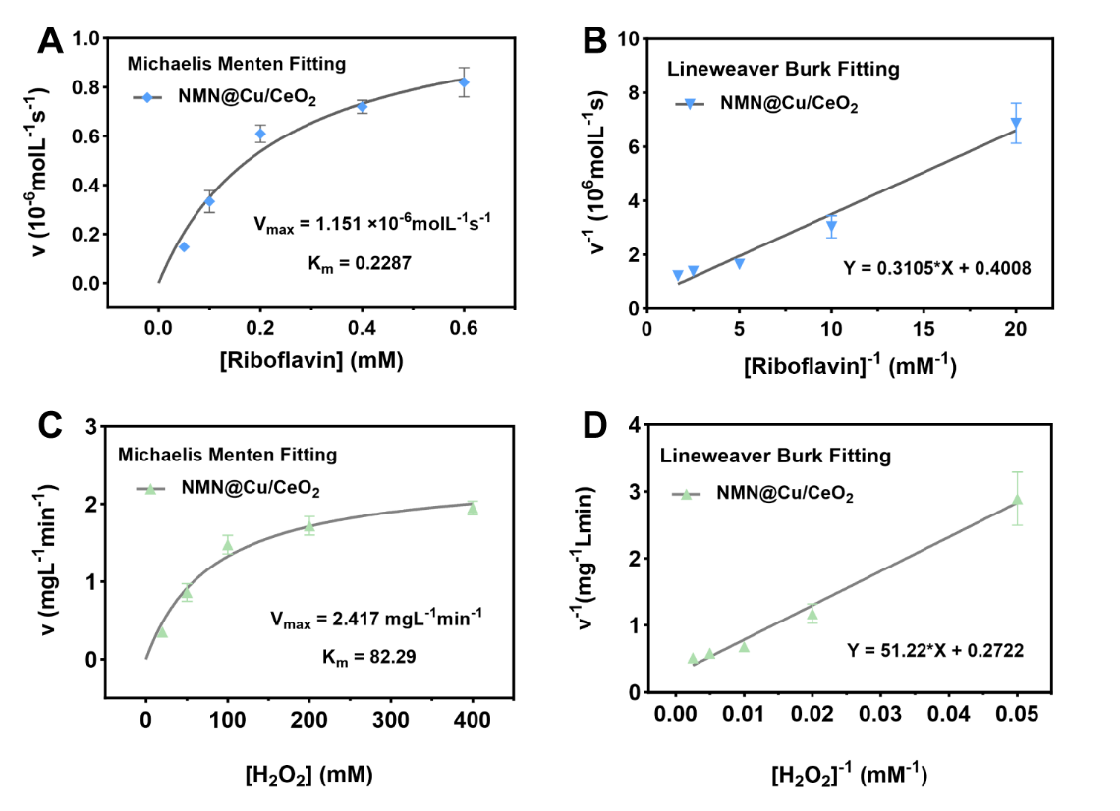
Figure S7. (A) Analysis of the Michaelis-Menten kinetics of SOD enzyme. (B) Lineweaver-Burk plotting to investigate the SOD-mimic activity of NMN@Cu/CeO₂ on the condition of using Riboflavin as the substrate. (C) Analysis of the Michaelis-Menten kinetics of CAT enzyme. (D) Lineweaver-Burk plotting to investigate the CAT-mimic activity of NMN@Cu/CeO₂ on the condition of using H₂O₂ as the substrate.
Figure S8. Color changes of NMN@Cu/CeO₂ solution after H₂O₂ treatment and over several weeks of storage.
Figure S9 ¹H NMR spectra of EPL-PBA (A) and GelMA (B).
Figure S10 Fluorescence images of MNs loaded with RhB (Left) and FITC (Right).
Figure S11. Swelling behavior of MN and NMN@Cu/CeO₂-MN.
Figure S12. Bright-field images of MN patches after moisture absorption at different time points.
Figure S13. H&E staining images of MNs applied to the mouse dorsal skin. The scale bars in 500 μm and 200 μm.
Figure S14. cumulative release percentage of Rhodamine B from MNs over 144 hours .
Figure S15 Co-culture of MNs with NFBs for 24 hours was followed by live/dead cell staining. The scale bars in 500 μm.
Figure S16 (A) Quantitative analysis of intracellular NAD⁺ levels in cells after co-culture with MNs and HUVECs. (B) Quantitative analysis of intracellular NAD⁺ levels in cells after co-culture with MNs and NFBs. *P < 0.05, **P < 0.01, ***P < 0.001, ****P < 0.0001.
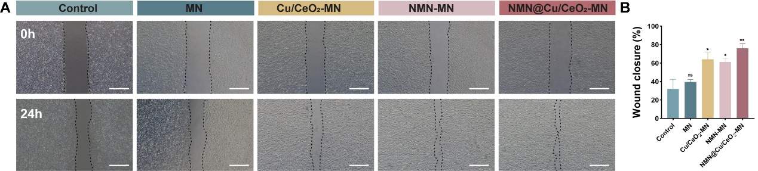
Figure S17 (A) Migration images of HUVECs after 24 hours of co-culture with MNs. (B) migration rate after 24 hours of co-culture with MNs (n = 3, data represented as mean ± SD). *P < 0.05, **P < 0.01, ***P < 0.001, ****P < 0.0001. The scale bars in 500 μm.
Figure S18 (A) NFBs Intracellular O₂ generation assay was validated by O₂ probe. (B) Statistics of NFBs intracellular O₂ production. P < 0.05, **P < 0.01, ***P < 0.001, ****P < 0.0001. The scale bars in 200 μm.
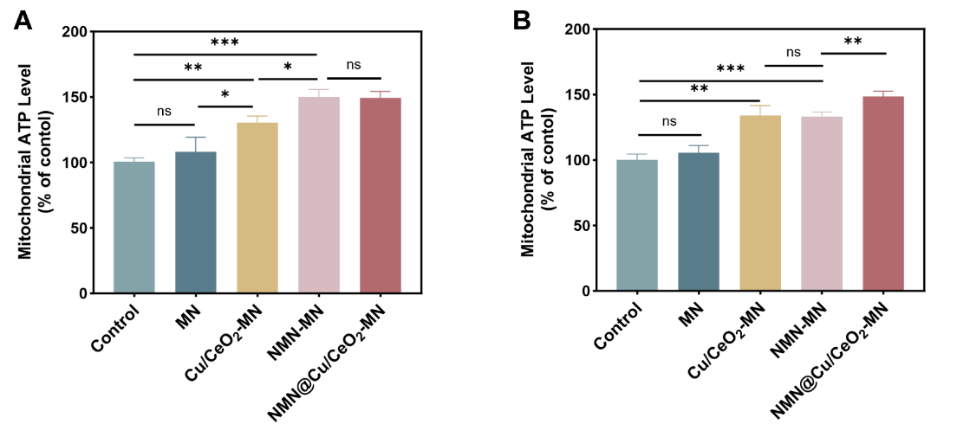
Figure S19 Quantitative analysis of ATP production in RAW264.7 (A) and HUVECs (B) after different treatments. (n = 3, data represented as mean ± SD). *P < 0.05, **P < 0.01, ***P < 0.001, ****P < 0.0001.
Figure S20 (A) Degradation curves of hydrogel samples in PBS. (B) Degradation curves of hydrogel samples in PBS containing 10 μg/mL Collagenase. ("GelMA" refers to the material that constitutes the tip of the MNs).

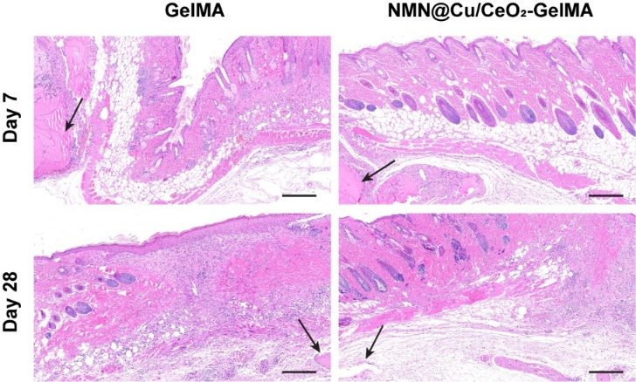
Figure S21 H&E staining results of hydrogels after 7 days and 28 days of subcutaneous implantation in mice (black arrow indicates hydrogel). Scale bar, 200 μm.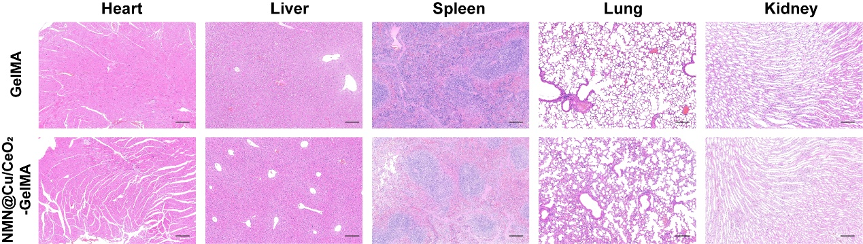
Figure S22 H&E staining images of heart, liver, spleen, lung, and kidney tissues from mice. Scale bar, 200 μm.
Figure S23 The MNs of each group were applied to the epidermal thickness statistics of the wound of diabetic mice on the 14th day. *P < 0.05, **P < 0.01, ***P < 0.001, ****P < 0.0001.

