Supporting information

Unlocking Caspase-8 Enables Pt(IV) to Trigger Robust Caspase-3/GSDME-Mediated Pyroptosis via Drug Co-delivery in Chemoresistant Bladder Cancer

Jintao Wen^{1,2}†, Baotong Zhou^{3,4}†, Hanchen Zhang⁵, Yongbo Tang^{1,2}, Haiwei Hu^{1,2}, Haihua Xiao⁵, Bo Ge^{1,2}*

Affiliations:
¹ Department of Urology, The Second Affiliated Hospital of Guilin Medical University, Guilin 541199, China
² Guangxi Key Laboratory of Metabolic Reprogramming and Intelligent Medical Engineering for Chronic Diseases, The Second Affiliated Hospital of Guilin Medical University, Guilin 541199, China
³ Guangzhou Institutes of Biomedicine and Health, Chinese Academy of Sciences, Guangzhou 510530, China
⁴ Department of Urology, Shenzhen Following Precision Medical Research Institute, The Third Affiliated Hospital of Shenzhen University, Shenzhen 518000, China
⁵ Beijing National Laboratory for Molecular Sciences, Laboratory of Polymer Physics and Chemistry, Institute of Chemistry, Chinese Academy of Sciences, Beijing 100190, China

Corresponding Authors:
*Bo Ge - Department of Urology, The Second Affiliated Hospital of Guilin Medical University, Guilin 541199, China; Email: ge1123@sina.com

Footnote:
† These authors contributed equally to this work.

Table of Contents
Supporting Materials and Methods 3
Figure S1 7
Figure S2 8
Figure S3 9
Figure S4 10
Figure S5 11
Figure S6 12
Figure S7 13
Figure S8 14
Figure S9 15
Figure S10 16
Figure S11 17
Figure S12 18
Table S1 19
Supporting Methods and Materials
Materials and Reagents
Cisplatin (CisPt) and gemcitabine were purchased from Shandong Boyuan Pharmaceutical Co., Ltd. (Shandong, China). 1,2,4,5-cyclohexanetetracarboxylic dianhydride (HPMDA) was obtained from Shanghai Aladdin Biochemical Technology Co., Ltd. (Shanghai, China). Methoxy poly(ethylene glycol) (mPEG5k-OH, molecular weight: 5000) was sourced from Alfa Aesar (USA). Anhydrous N,N-dimethylformamide (DMF), 3-(4,5-dimethylthiazol-2-yl)-2,5-diphenyltetrazolium bromide (MTT), and hydrogen peroxide (H₂O₂) were procured from Beijing Energy and Chemical Co., Ltd. RPMI-1640 medium, 0.25% trypsin-EDTA, fetal bovine serum (FBS), and penicillin-streptomycin (P/S) were supplied by Gibco (Grand Island, NY, USA). 2-(4-Amidinophenyl)-1H-indole-6-carboxamidine (DAPI) was purchased from Sigma-Aldrich (USA). Aloxistatin (E64d) was acquired from Shanghai Bide Pharmaceutical Technology Co., Ltd. (Shanghai, China).

Characterization Methods and Instruments
Chemical shifts (δ) were referenced to tetramethylsilane (TMS, δ 0.00 ppm) using residual proton solvent peaks as internal standards, with data reported in parts per million (ppm). Inductively coupled plasma mass spectrometry (ICP-MS) analysis was performed using an Agilent 7700 spectrometer (Agilent Technologies, USA). Transmission electron microscopy (TEM) images were acquired on an HT-7700 microscope (Hitachi, Japan). Dynamic light scattering (DLS) measurements were conducted with a Malvern Nano Zetasizer ZS90 (Malvern Instruments, UK). Flow cytometry (FCM) analysis was carried out on a CytoFLEX flow cytometer (Beckman Coulter, San Jose, CA, USA). Confocal laser scanning microscopy (CLSM) images were captured using an LSM-880 microscope (Carl Zeiss AG, Germany). Western blot analysis was performed with a multifunctional imaging system (Servicebio, Wuhan, China). In vivo fluorescence imaging of mice was conducted using an IVIS Lumina imaging system (PerkinElmer, USA).

Antibodies and Detection Reagents
Rabbit monoclonal antibodies against Vinculin, Caspase-3, Cleaved Caspase-3, GSDMD, and GSDME were purchased from Affinity Biosciences (USA). Polyclonal antibodies targeting Cathepsin H and Caspase-8 were obtained from Proteintech (Wuhan Sanying Biotechnology Co., Ltd., China). Anti-GSDME/GSDMD (N-terminal) antibodies were sourced from Abcam (Cambridge, UK). The Enhanced ATP Assay Kit, Phalloidin, and Annexin V-FITC Apoptosis Detection Kit were procured from Beyotime Biotechnology Co., Ltd. (Shanghai, China).

Flow Cytometry Antibodies and Cytokines
Cytokines (IL-4, GM-CSF) and fluorochrome-conjugated antibodies for flow cytometry, including PE-labeled anti-mouse CD11c, FITC-labeled anti-mouse CD80, APC-labeled anti-mouse CD86, PE-labeled anti-mouse F4/80, APC-labeled anti-mouse CD206, PE-labeled anti-mouse CD3, FITC-labeled anti-mouse CD8, APC-labeled anti-mouse CD4, APC-labeled anti-mouse CD62L, and PerCP/Cyanine5.5-labeled anti-mouse CD44, were purchased from BioLegend (San Diego, CA, USA).

Cell Culture and Animals
T24 and MB49 cells were cultured in RPMI-1640 and DMEM medium, respectively, supplemented with 10% fetal bovine serum (FBS) and 100 U/mL penicillin-streptomycin, under standard conditions (37°C, 5% CO₂). Four-week-old male C57BL/6 mice were purchased from Vital River Laboratory Animal Technology Co., Ltd. (Beijing, China).

Preparation of NP2@Cy5.5
PHHM (10 mg), Cy5.5 (0.25 mg), Pt(IV) (1 mg), and E64d (1 mg) were co-dissolved in 1 mL dimethyl sulfoxide (DMSO) and stirred at room temperature for 10 minutes. The mixture was transferred into a dialysis bag (MWCO: 3,500 Da) and dialyzed against deionized water for 24 hours to remove DMSO. The supernatant was collected to obtain NP2@Cy5.5.

NP@Pt(IV)-E64d-Induced Apoptosis in Resistant Cells
MB49-R cells (3×10⁵ cells/well) were seeded in 12-well plates and treated with CisPt, Pt(IV), NP@Pt(IV), or NP@Pt(IV)-E64d (5 μM Pt/E64d) for 72 hours. Cells were harvested, stained with Annexin V-FITC/PI (BD Biosciences) for 15 minutes in the dark, and analyzed by flow cytometry (CytoFLEX, Beckman Coulter). Apoptotic populations were quantified as follows: early apoptosis (Annexin V⁺/PI⁻), late apoptosis (Annexin V⁺/PI⁺), and necrosis (Annexin V⁻/PI⁺).

Detection of Calreticulin (CRT) Expression (Immunogenic Cell Death Biomarker)
MB49-R cells were seeded in 24-well (8×10⁴ cells/well, CLSM) or 12-well (4×10⁵ cells/well, flow cytometry) plates and treated with PBS, CisPt, Pt(IV), Pt(IV)+E64d, NP@Pt(IV), or NP@Pt(IV)-E64d (5 μM Pt/E64d) for 12 hours. CLSM Analysis: Cells were fixed with 4% paraformaldehyde, incubated with anti-CRT primary antibody (1:200, Abcam) for 2 hours (37°C), followed by Alexa Fluor 488-conjugated secondary antibody (1:500, 1 hour, dark). Nuclei were stained with DAPI. CRT surface exposure (green fluorescence) was imaged using an LSM-880 confocal microscope (Zeiss, Germany). Flow Cytometry: Cells were blocked with 1% BSA, stained with anti-CRT antibody (1:200, 1 hour) and Alexa Fluor 488 secondary antibody (1:500, 30 minutes, dark), and analyzed for mean fluorescence intensity (MFI) using a CytoFLEX flow cytometer.

HMGB1 Protein Expression (ICD Biomarker)
MB49-R cells (8×10⁴ cells/well) in 24-well plates with coverslips were treated with PBS, CisPt, Pt(IV), Pt(IV)+E64d, NP@Pt(IV), or NP@Pt(IV)-E64d (5 μM Pt/E64d) for 12 hours. Cells were fixed with 4% paraformaldehyde (15 minutes, room temperature), blocked with 1% BSA (30 minutes), and incubated with anti-HMGB1 primary antibody (1:200, Abcam) overnight at 4°C. After PBS washing, cells were stained with Alexa Fluor 555-conjugated secondary antibody (1:500, 1 hour, dark) and DAPI (nucleus, blue). HMGB1 subcellular localization (red) was visualized using an LSM-800 confocal microscope (Zeiss, Germany). Nuclear-to-cytoplasmic fluorescence intensity ratios were quantified using ImageJ software.

PD-L1 Expression Analysis
MB49-R cells (8×10⁴ cells/well) were treated as above. After fixation and blocking, cells were incubated with anti-PD-L1 primary antibody (1:200, Cell Signaling Technology) overnight at 4°C, followed by Alexa Fluor 555-conjugated secondary antibody (1:500, 1 hour, dark). PD-L1 membrane/cytoplasmic localization (red) and DAPI (blue) were imaged by CLSM. Red fluorescence intensity was quantified using ImageJ to assess PD-L1 expression.

In Vitro Polarization of Bone Marrow-Derived Macrophages (BMDMs)
Bone marrow cells were cultured in RPMI-1640 medium with 10% FBS and 20 ng/mL M-CSF (Beyotime) for 7 days to generate unpolarized BMDMs. Pretreated MB49-R cells were co-cultured with BMDMs at a 10:1 ratio (tumor cells:BMDMs) for 24 hours. BMDMs were stained with anti-F4/80-PE, anti-CD80-FITC, and anti-CD206-APC antibodies (30 minutes, 4°C, dark). M1 polarization (CD80⁺CD206⁻/F4/80⁺) was analyzed by flow cytometry.

Expansion of Chemoresistant Bladder Cancer Animal Models
Subcutaneous tumors from GP-R model mice were excised, minced into 2 mm³ fragments in cold PBS, and implanted into the right flank of 5-week-old male C57BL/6 mice (Vital River, Beijing, China). Tumor growth was monitored until volumes reached ~100 mm³ (volume = length × width² / 2), and these expanded models were used for subsequent efficacy and biodistribution studies.

Tumor Growth Inhibition in Chemoresistant Models
Thirty tumor-bearing mice (subcutaneous volume ~100 mm³) were randomized into six groups (n=5): PBS, CisPt (3 mg Pt/kg, i.p.), Pt(IV) (3 mg Pt/kg, i.p.), Pt(IV) + E64d (3 mg Pt/kg + 20 mg/kg, i.p.), NP@Pt(IV) (3 mg Pt/kg, i.v.), and NP@Pt(IV)-E64d (3 mg Pt/kg, i.v.). Tumor dimensions (length/width) and body weights were measured every 2 days. Tumor volume was calculated as (length × width²)/2. The study was terminated at day 22 or upon reaching ethical endpoint volumes.

Immunohistochemical (IHC) Analysis of CTSH in Resistant Bladder Tumors
Resistant tumor tissues were fixed in 4% neutral-buffered formalin (24–48 hours, 4°C), dehydrated through a graded ethanol series (70%→100%), paraffin-embedded, and sectioned (4 μm). After deparaffinization and rehydration, antigen retrieval was performed in citrate buffer (pH 6.0) via microwave heating (5 minutes high power, 15 minutes medium-low power). Endogenous peroxidase activity was blocked with 3% H₂O₂ (10 minutes), followed by 5% BSA blocking (30 minutes). Sections were incubated with anti-CTSH antibody (1:200, Proteintech) overnight at 4°C, then with HRP-conjugated secondary antibody (1:500, 1 hour, room temperature). DAB (0.05% DAB + 0.03% H₂O₂) was used for chromogenic detection, and nuclei were counterstained with Harris hematoxylin. CTSH expression was visualized under a light microscope (Olympus BX53, Japan).
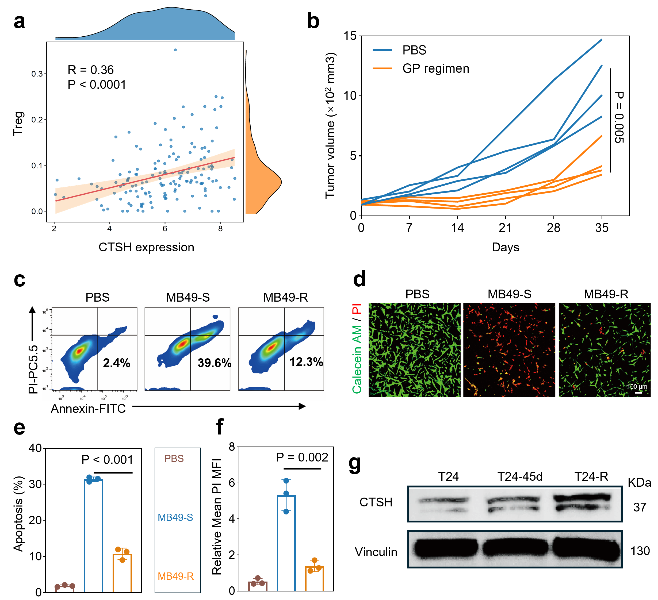
Figure S1. Validation of CTSH expression correlation with Treg infiltration and drug resistance in the GP-R model. (a) Scatter plot: CTSH expression association with Treg infiltration. (b) Tumor volume changes in mice across treatment groups (CisPt: 3 mg/kg; Gem: 50 mg/kg; n = 4). (c) Flow cytometry dot plots of apoptosis in MB49 subtype cells. (d) CLSM images of Calcein-AM (green, viable) and PI (red, dead) dual staining in MB49 subtype cells (scale bar: 100 μm). (e) Quantitative flow cytometry analysis of apoptosis in MB49 Subtype cells (n=3). (f) Quantitative analysis of propidium iodide (PI) MFI in MB49 Subtype cells by CLSM (n=3). (g) Western blot (WB) analysis of CTSH expression in T24 subtype cells (Vinculin as loading control). CisPt: cisplatin; Gem: gemcitabine. c-d: 5μM Cispt + 0.5μM Gem, 72h. Statistical significance was analyzed by unpaired two-tailed t-test.
Figure S2. Evaluation of the synergistic anticancer effects by Pt(IV) + E64d in vitro. (a) Semi-quantitative analysis of relative mean PI mean fluorescence intensity (MFI) and (b) apoptosis rate in MB49-R cells. Data are presented as mean ± SD (n = 3). Statistical significance was analyzed by unpaired two-tailed t-test.

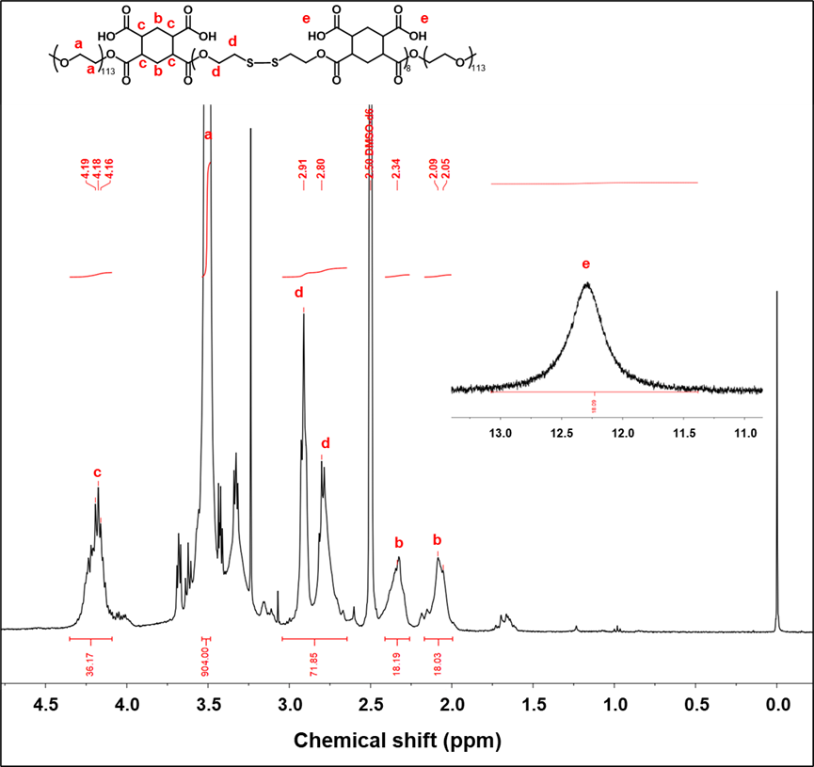
Figure S3. The 1H-NMR spectrum of PHHM.
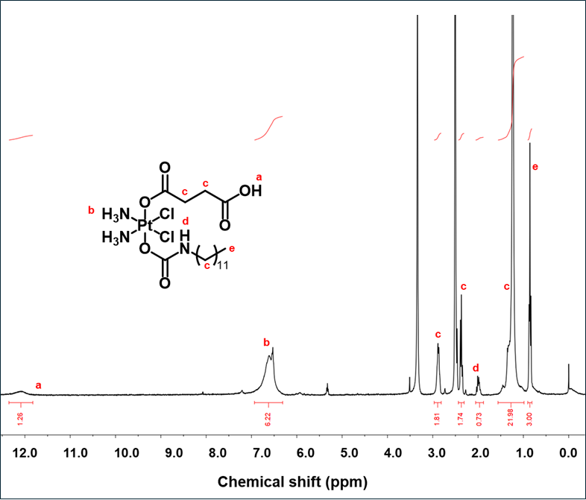
Figure S4. The ¹H-NMR spectrum of Pt(IV).
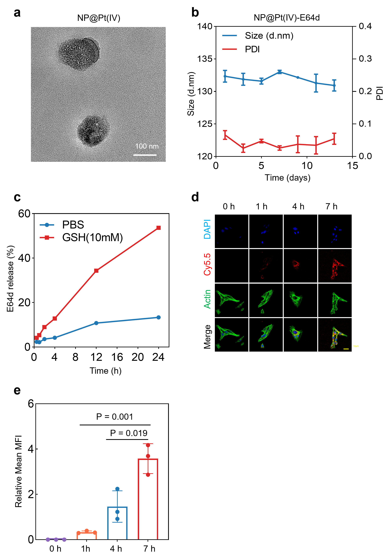
Figure S5. characterization of NP@Pt(IV) and NP@Pt(IV)-E64d nanoparticles. (a) Representative TEM image of NP@Pt(IV) (Scale bar: 100 nm). (b) Particle size and dispersion stability over 13 days in serum-containing medium. (c) E64d release kinetics in 10 mM GSH. (d) Representative CLSM images of MB49-R cells incubated with NP@Pt(IV)-E64d with Cy5.5 for 0, 1, 4, and 7 h (nuclei: DAPI, blue; cytoskeleton: Actin, green; scale bar: 10 μm). (e) semi-quantifying MFI for NP@Pt(IV)-E64d with Cy5.5 uptake at different time points (n=3). Statistical significance was analyzed by unpaired two-tailed t-test.
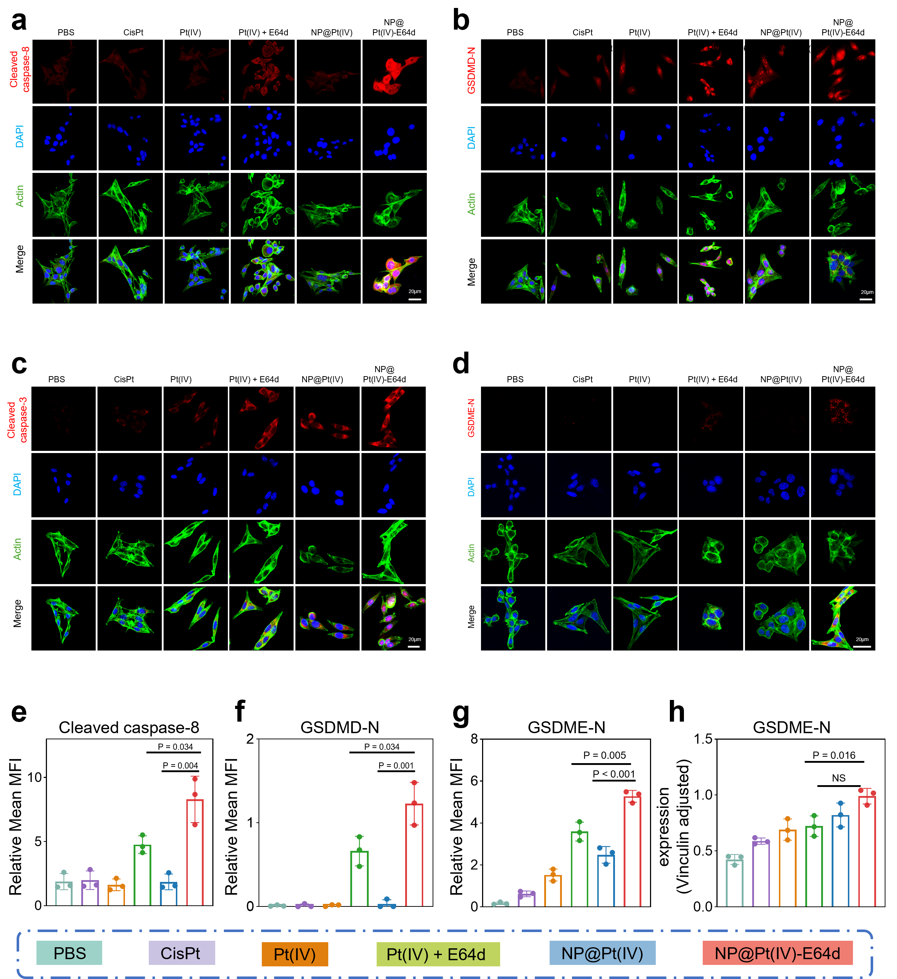
Figure S6. Representative CLSM images of pyroptosis-related protein expression in MB49-R cells under different drug treatments. (a) cleaved caspase-8. (b) GSDMD-N. (c) cleaved caspase-3. (d) GSDME-N. (e-g) Quantification of cleaved caspase-8 (e), GSDMD-N (f), and GSDME-N (g) expression based on MFI from CLSM images (n = 3). (h) Quantification of GSDME-N expression by Western blotting. Band intensities were normalized to vinculin. Data are presented as mean ± SD (n = 3). Statistical significance was analyzed by unpaired two-tailed t-test.
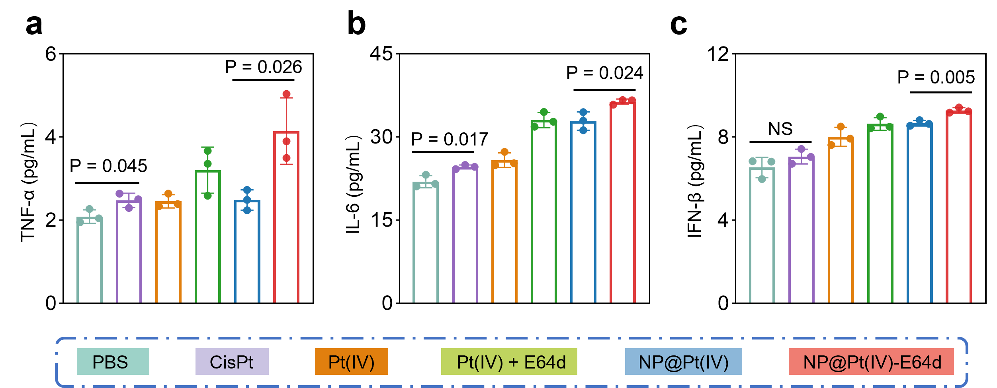
Figure S7. The release of cytokines from NP@Pt(IV)-E64d-triggered pyroptosis remodels the immune landscape. (a-c) Quantification of TNF-α (a), IL-6 (b), and IFN-β (c) in the culture supernatant of MB49-R cells after different treatments (n=3).
Figure S8. Characterization of DAMPs and PD-L1 expression combined with quantitative analysis of BMDCs and BMDMs. (a-b) CLSM images of CRT (a) and the corresponding quantification (b) in MB49-R cells after different treatments. (c-d) CLSM images of HMGB1 (c) and the corresponding quantification (d) in MB49-R cells after different treatments. (e-f) CLSM images of PD-L1 (e) and the corresponding quantification (f) in MB49-R cells after different treatments. (g-h) Quantification of (g) mature BMDCs and (h) the M1/M2 macrophage ratio by flow cytometry. Data are presented as mean ± SD (n = 3). Statistical significance was analyzed by unpaired two-tailed t-test.
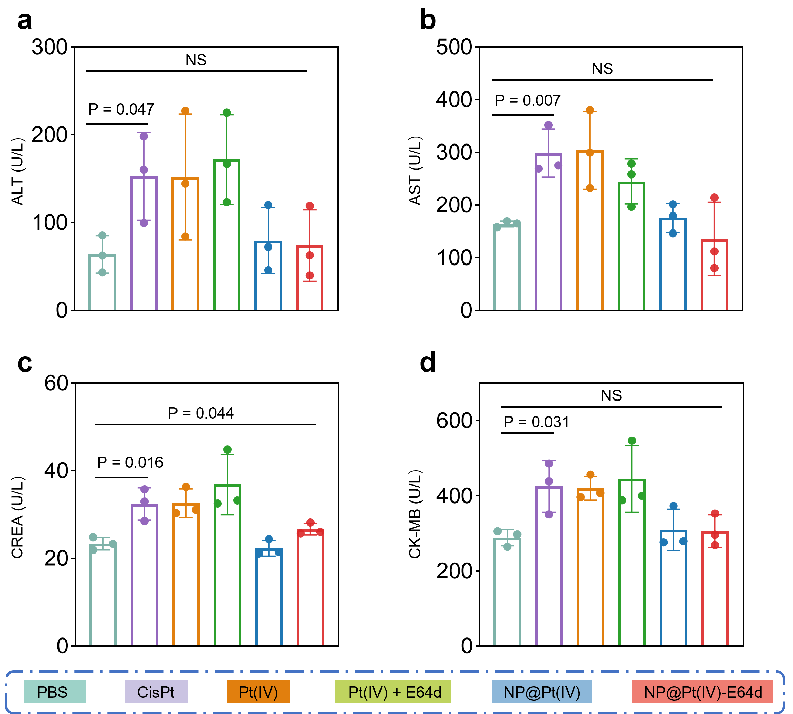
Figure S9. Serum biochemical analysis of mice after different treatments. The levels of alanine aminotransferase (ALT) (a), aspartate aminotransferase (AST) (b), creatinine (CRE) (c), and creatine kinase isoenzyme MB (CK-MB) (d) were measured to evaluate systemic toxicity. Data are presented as mean ± SD (n = 3). Statistical significance was analyzed by unpaired two-tailed t-test.
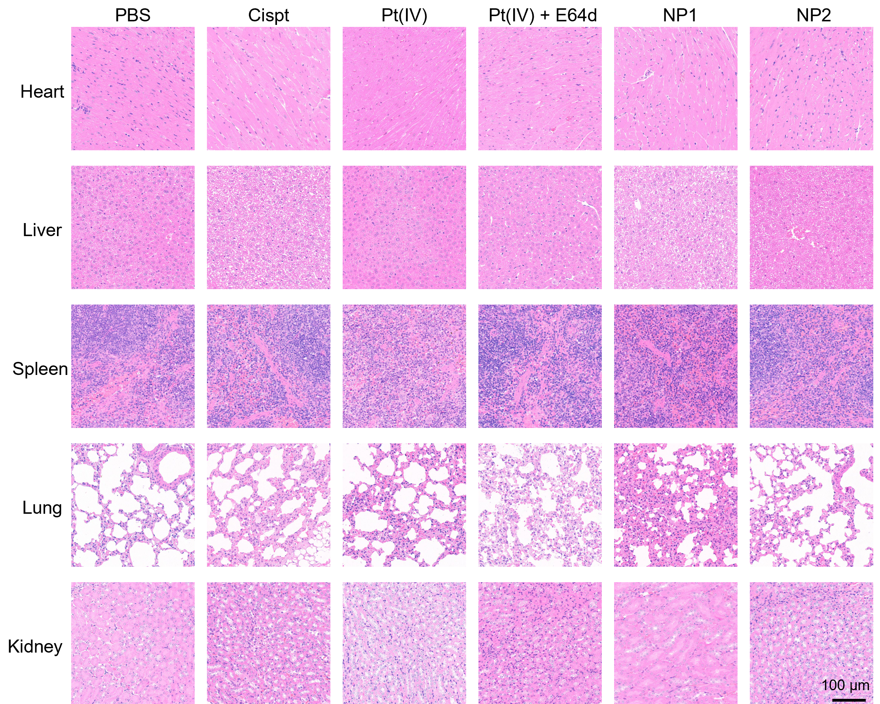
Figure S10. Histological evaluation of major organs after different treatments. Representative hematoxylin and eosin (H&E) staining images of heart, liver, spleen, lung, and kidney tissues from C57BL/6 treated with PBS, CisPt, Pt(IV), Pt(IV) + E64d, NP@Pt(IV), and NP@Pt(IV)-E64d. Scale bar: 100 μm.
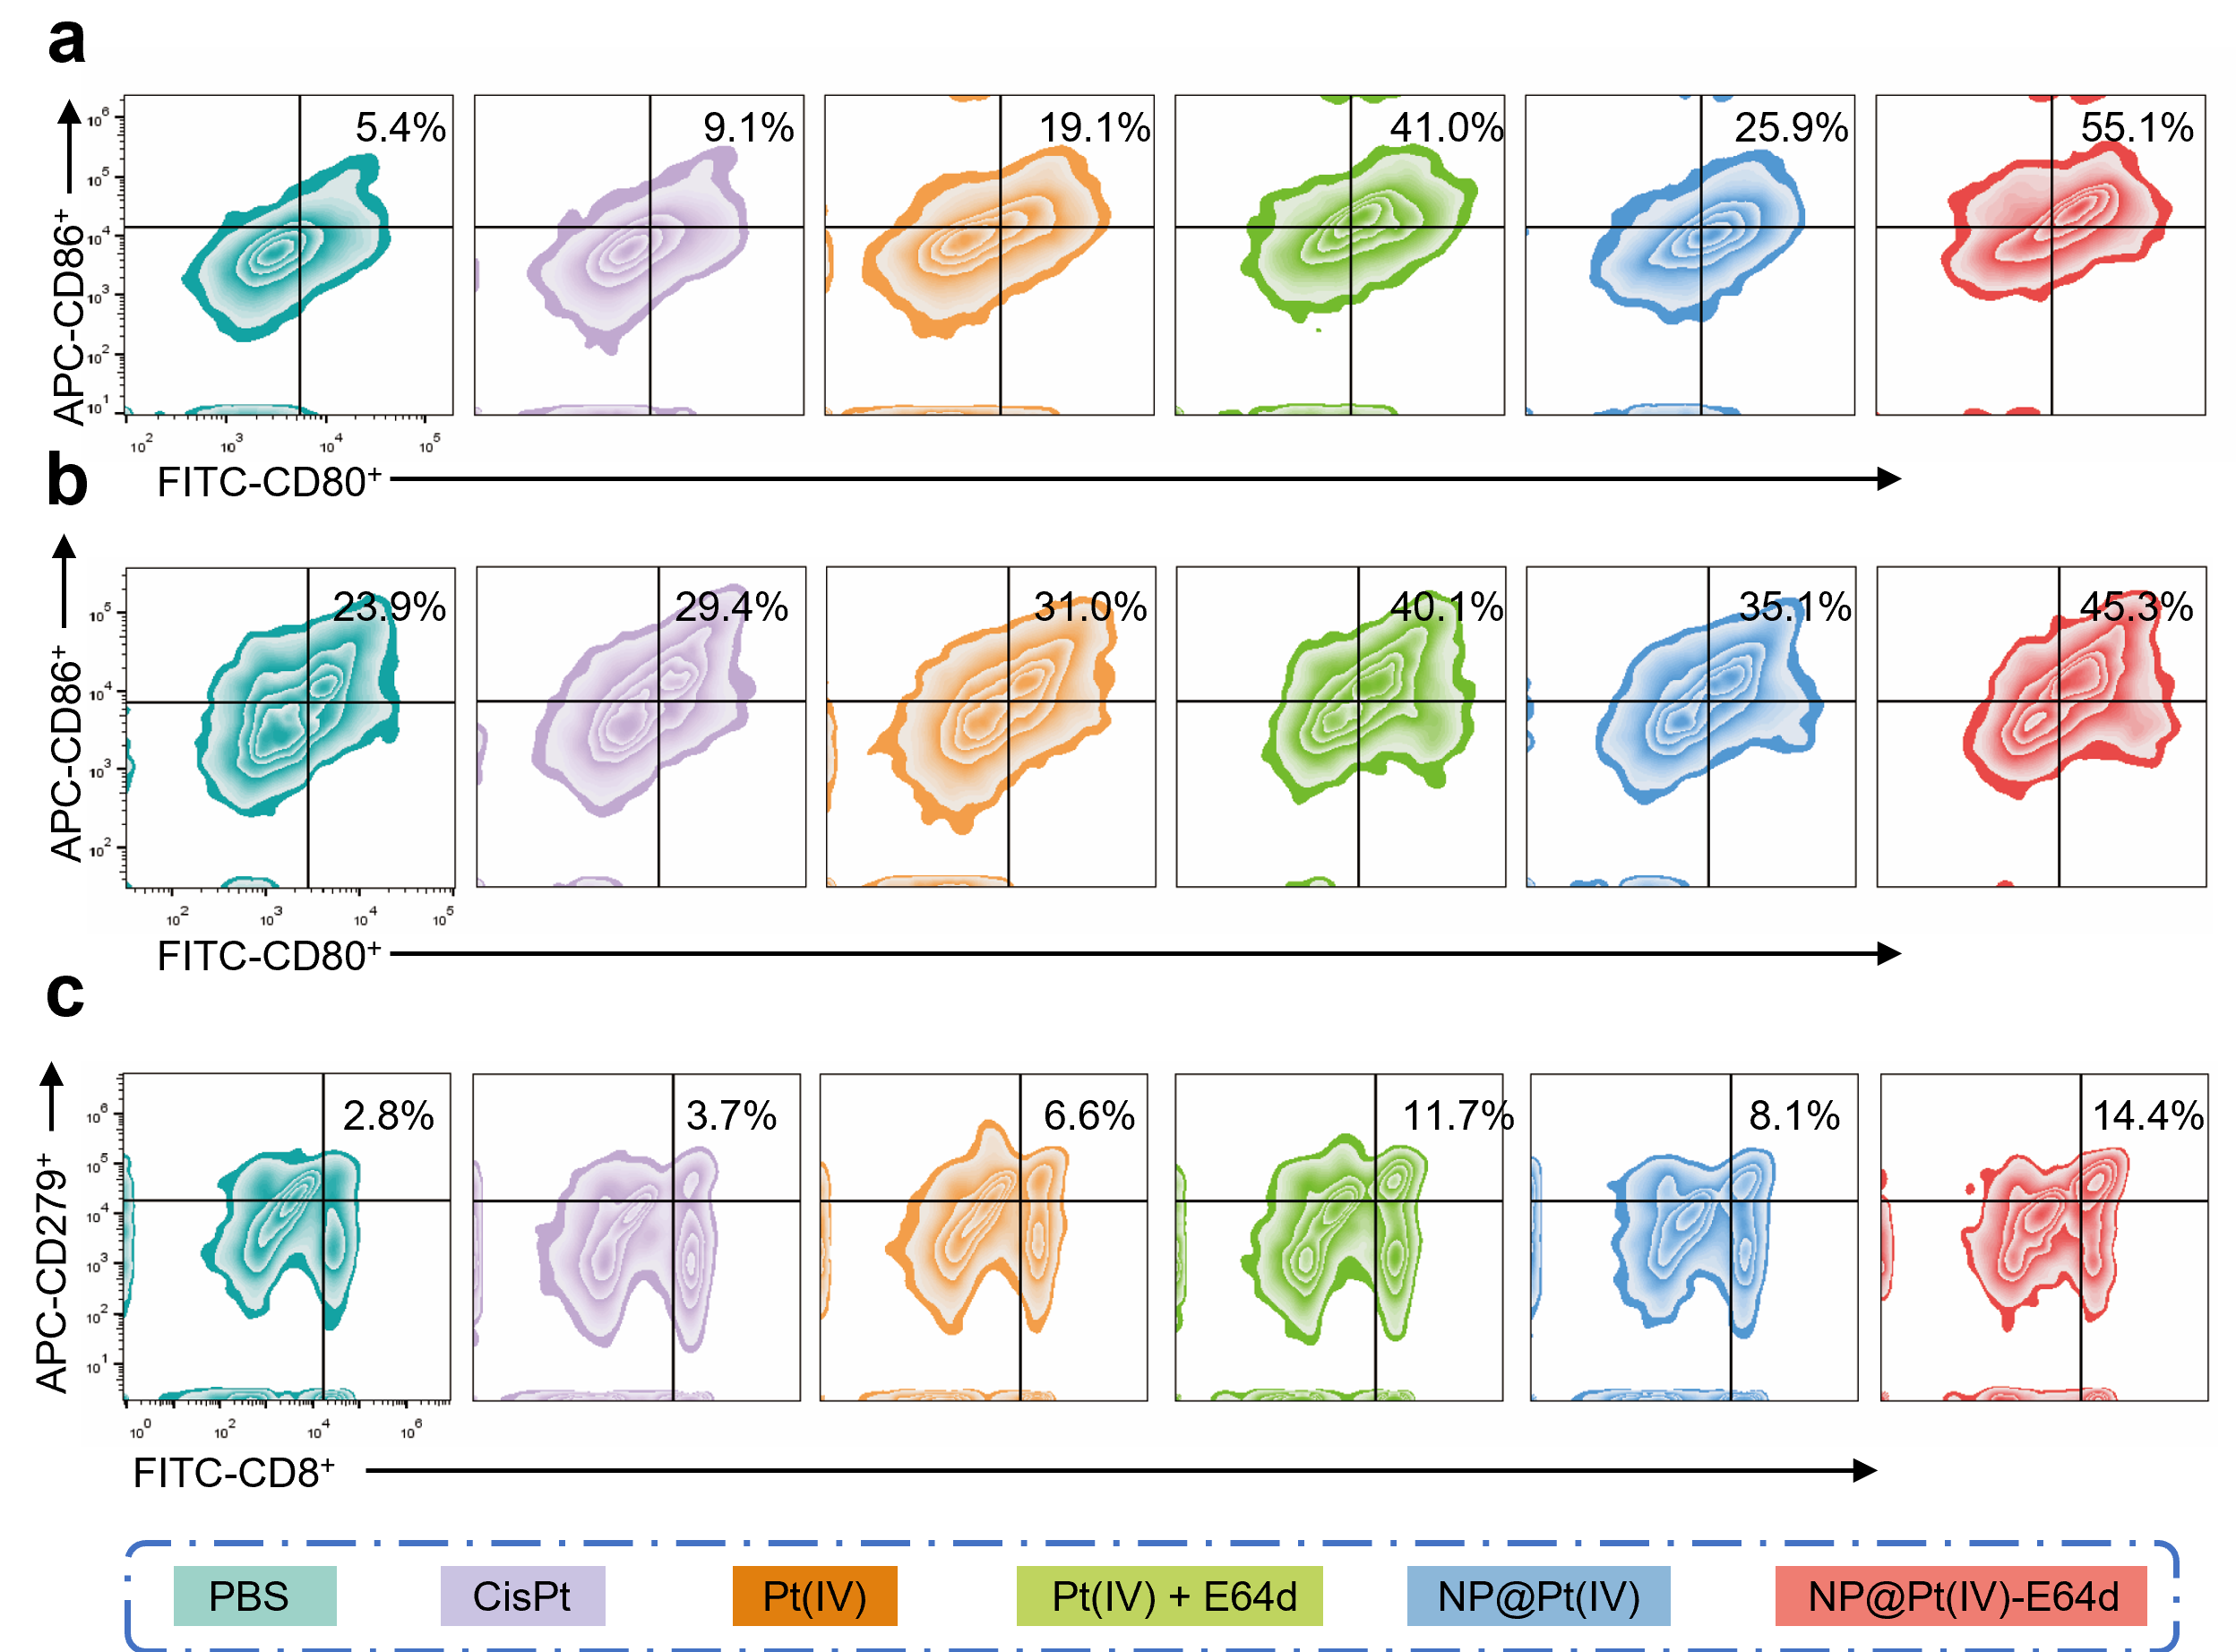
Figure S11. Flow cytometric analysis of immune cell populations in tumors and lymph nodes. (a-b) Flow cytometry analysis of mature dendritic cells (CD80⁺CD86⁺) among CD11c⁺ cells in the tumor (a) and draining lymph node (b). (c) Flow cytometry analysis of PD-1⁺ cells among CD8⁺ T cells in the tumor.

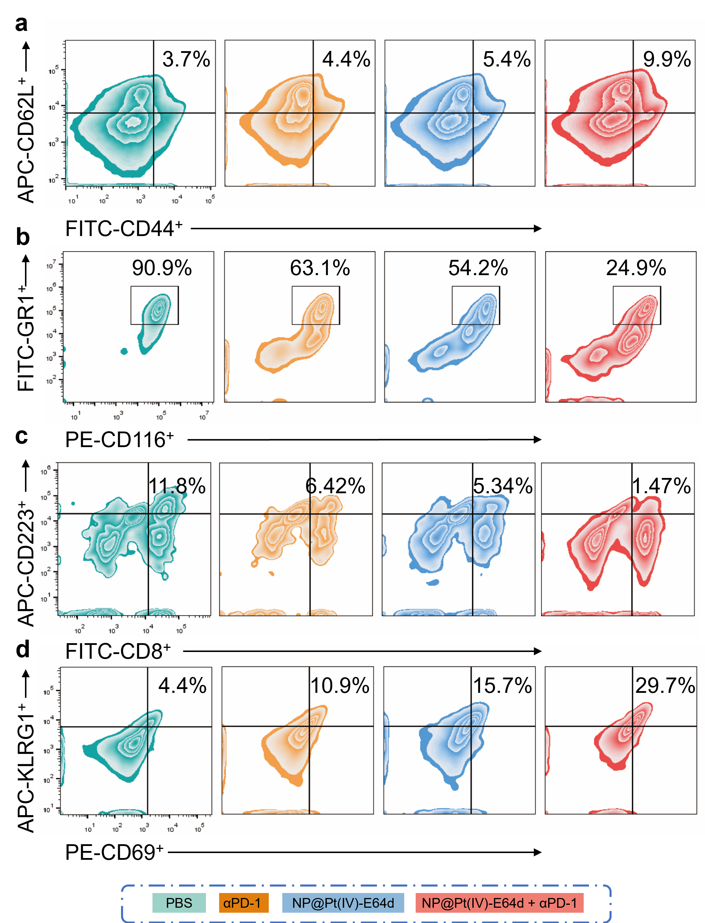
Figure S12. Flow cytometric analysis of immune cell populations in tumors and lymph nodes. (a) Flow cytometry analysis of TCM (CD44⁺CD62L⁺) in lymph nodes. (b) Flow cytometry analysis of MDSC (CD45⁺CD11b⁺GR1⁺) in tumor. (c) Flow cytometry analysis of LAG3⁺T cells (CD3⁺CD8⁺CD223⁺) in tumor. (d) Flow cytometry analysis of NK cells (NK1.1⁺CD69⁺KLGR1⁺) in tumor.
Cell line | Cisplatin  ( n=3, Mean ± SD ) | Gemcitabine  ( n=3, Mean ± SD )
MB49-R | 15.8 ± 0.9 | 3.1 ± 0.3
MB49-S | 4.2 ± 0.5 | 0.5 ± 0.1
T24-R | 17.8 ± 1.8 | 3.8 ± 0.2
T24-S | 10.5 ±1.7 | 1.1 ± 0.1
Table S1. IC₅₀ (μM) of Cisplatin and Gemcitabine in Various Cell Lines.

