Supporting Information For:

All-in-One: A CGRP- Encapsulated Rh-GelMA Supramolecular Dual-network Hydrogel Orchestrating Immune-Vascular Coupling for Diabetic Wound Healing

Xianglong Zhou^{1#}, Jianhui Xiang^{1#}, Hanhong Fang^{1#}, Yang Liu¹, Fulin Zhou¹, Jiheng Xiao¹, Weicheng Chen¹, Haoran Zhou¹, Guohui Liu¹, Xiao Lv^{1*}, Yiqiang Hu^{1*}, Liming Xiong^{1*}

¹Department of Orthopaedics, Union Hospital, Tongji Medical College, Huazhong University of Science and Technology, Wuhan, 430022, China.
# Xianglong Zhou, Jianhui Xiang, and Hanhong Fang contributed equally to this work.
* Correspondence
Xiao Lv
lvxiaotjmu@163.com
Yiqiang Hu
huyiqiang@hust.edu.cn
Liming Xiong
xiongliming@hust.edu.cn

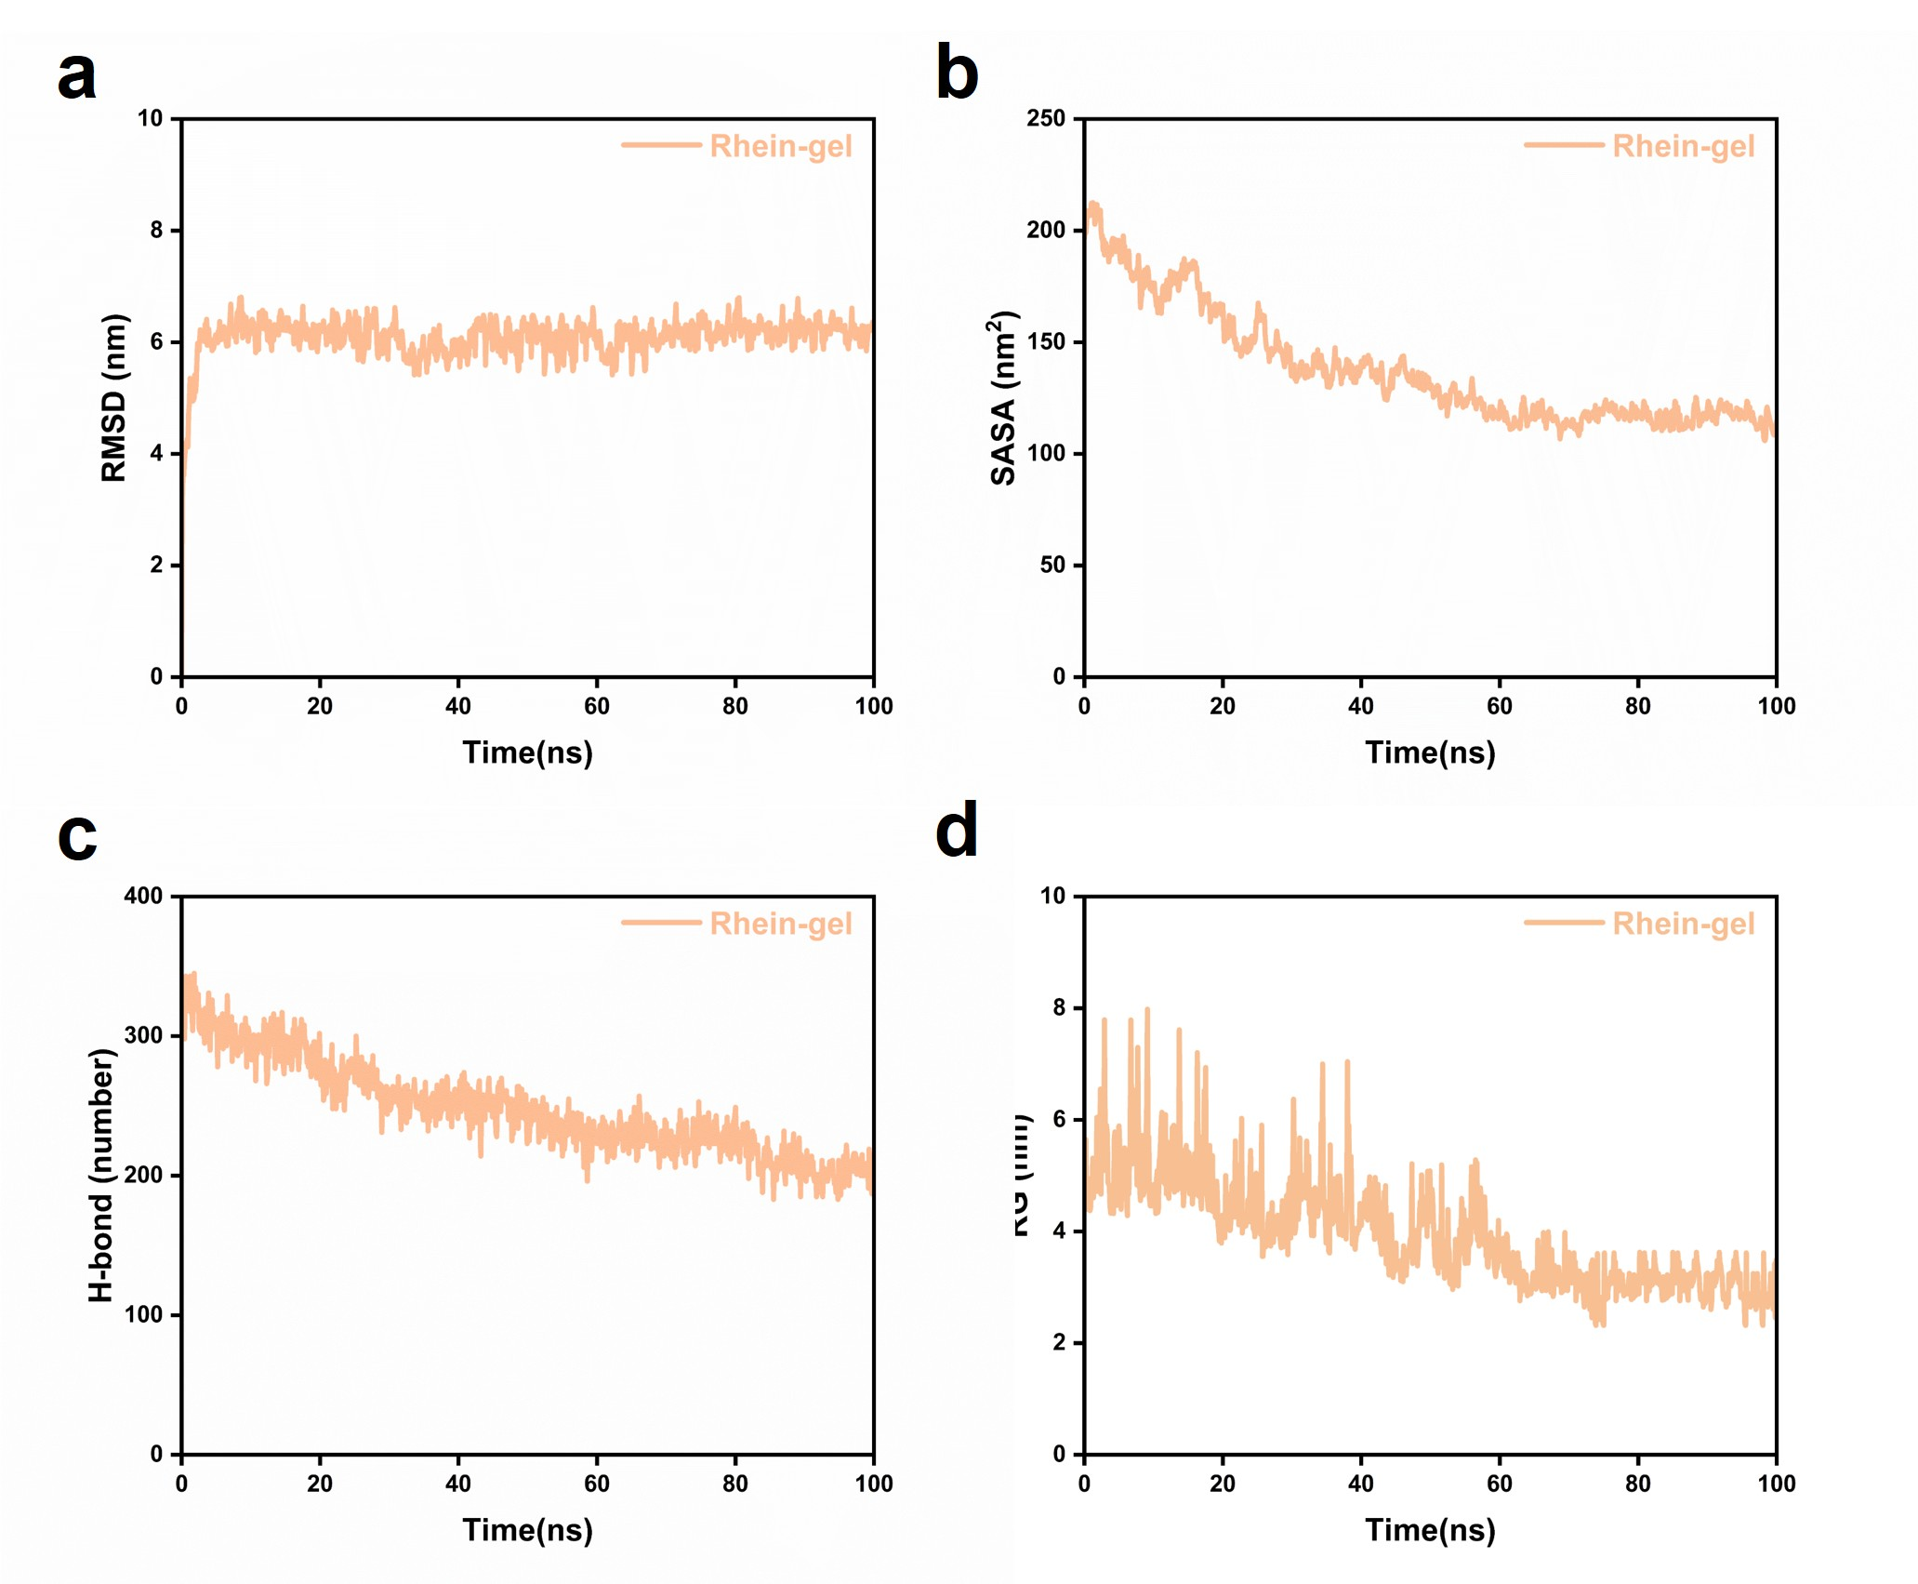
Figure S1. Molecular dynamics simulation data supporting the aggregation behavior of rhein molecules within 100 ns. (a) RMSD of the Rhein-gel system during the 100 ns simulation. (b) SASA of the Rhein-gel system during the 100 ns simulation. (c) Time-dependent hydrogen bond number of the Rhein-gel system during the 100 ns simulation. (d) Radius of gyration (RG) of the Rhein-gel system during the 100 ns simulation.

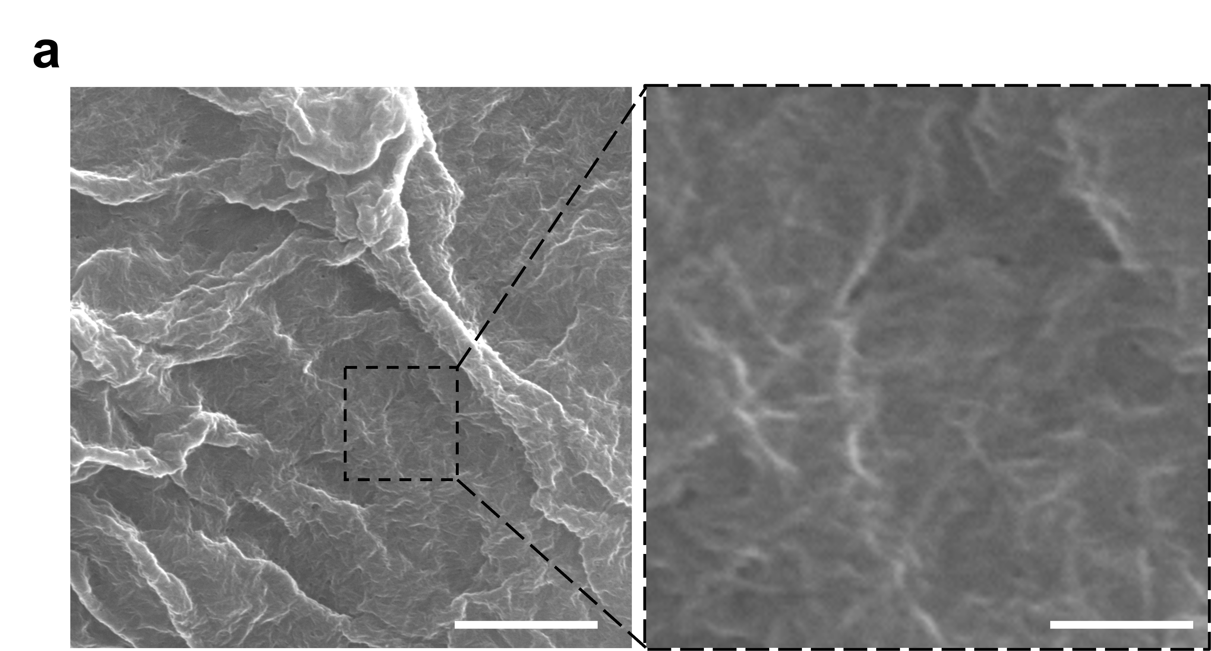
Figure S2. SEM morphology of the Rh/GelMA mixture before UV-induced photocrosslinking. (a) SEM image of the Rh/GelMA mixture prior to UV treatment and the corresponding magnified view. Scale bar: 10 μm (low-magnification image); 2 μm (magnified image).
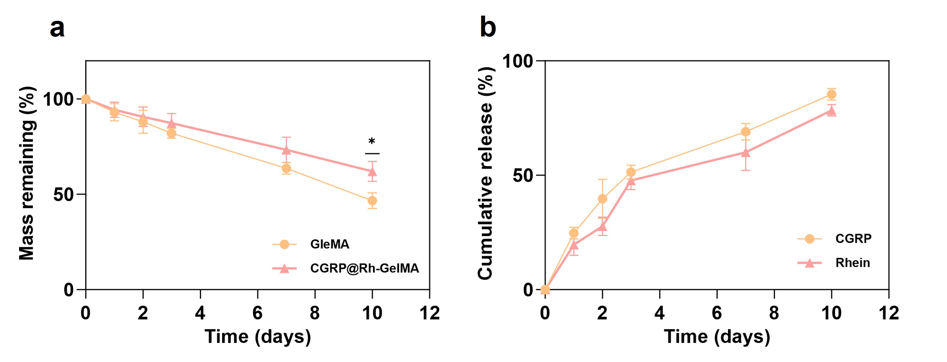
Figure S3. In vitro degradation and drug release behaviors of the CGRP@Rh-GelMA hydrogel. (a) In vitro degradation profiles of GelMA and CGRP@Rh-GelMA hydrogels over 10 days, expressed as the percentage of mass remaining relative to the initial weight. (b) In vitro cumulative release profiles of CGRP and rhein from the CGRP@Rh-GelMA hydrogel over 10 days. Data are presented as mean ± SD (n = 3). *P < 0.05.

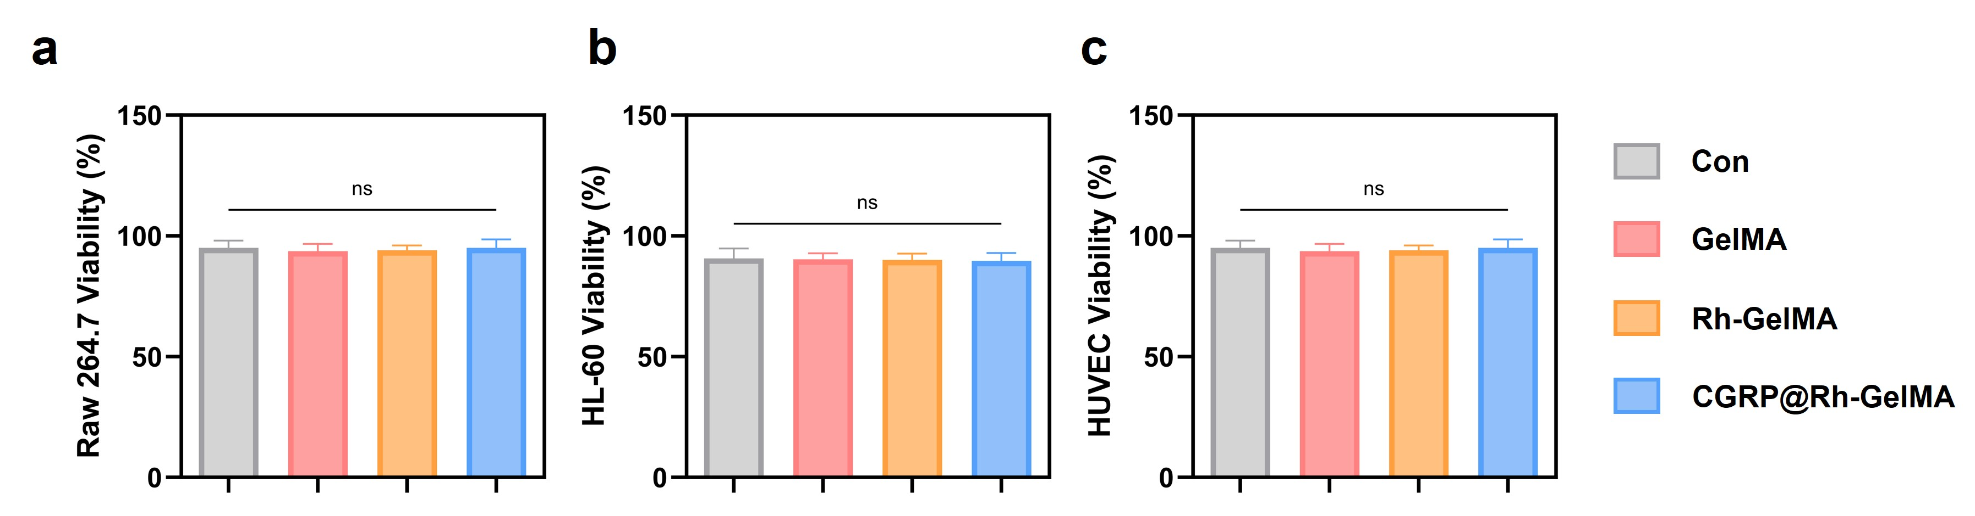
Figure S4. Quantitative analysis of cell viability based on live/dead staining. (a-c) Quantitative analysis of survival rates of RAW264.7 cells, HL-60 cells, and HUVECs after treatment with different hydrogels, corresponding to the live/dead staining results shown in Figure 2j. Data are presented as mean ± SD (n = 3); ns, p > 0.05.

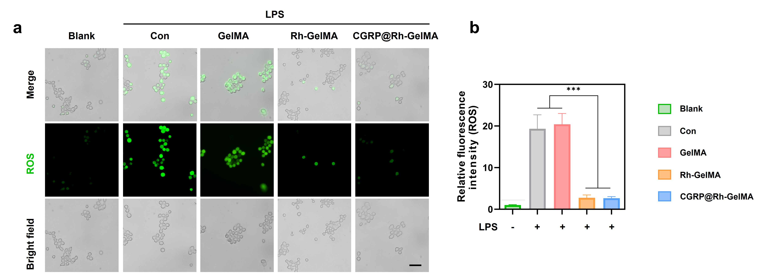
Figure S5. (a) Intracellular ROS scavenging assay and quantitative analysis in RAW264.7 cells under LPS stimulation; scale bar: 100 μm. (b) Quantitative analysis corresponding to (a). Data are reported as mean ± SD (n = 3); ***p < 0.001.

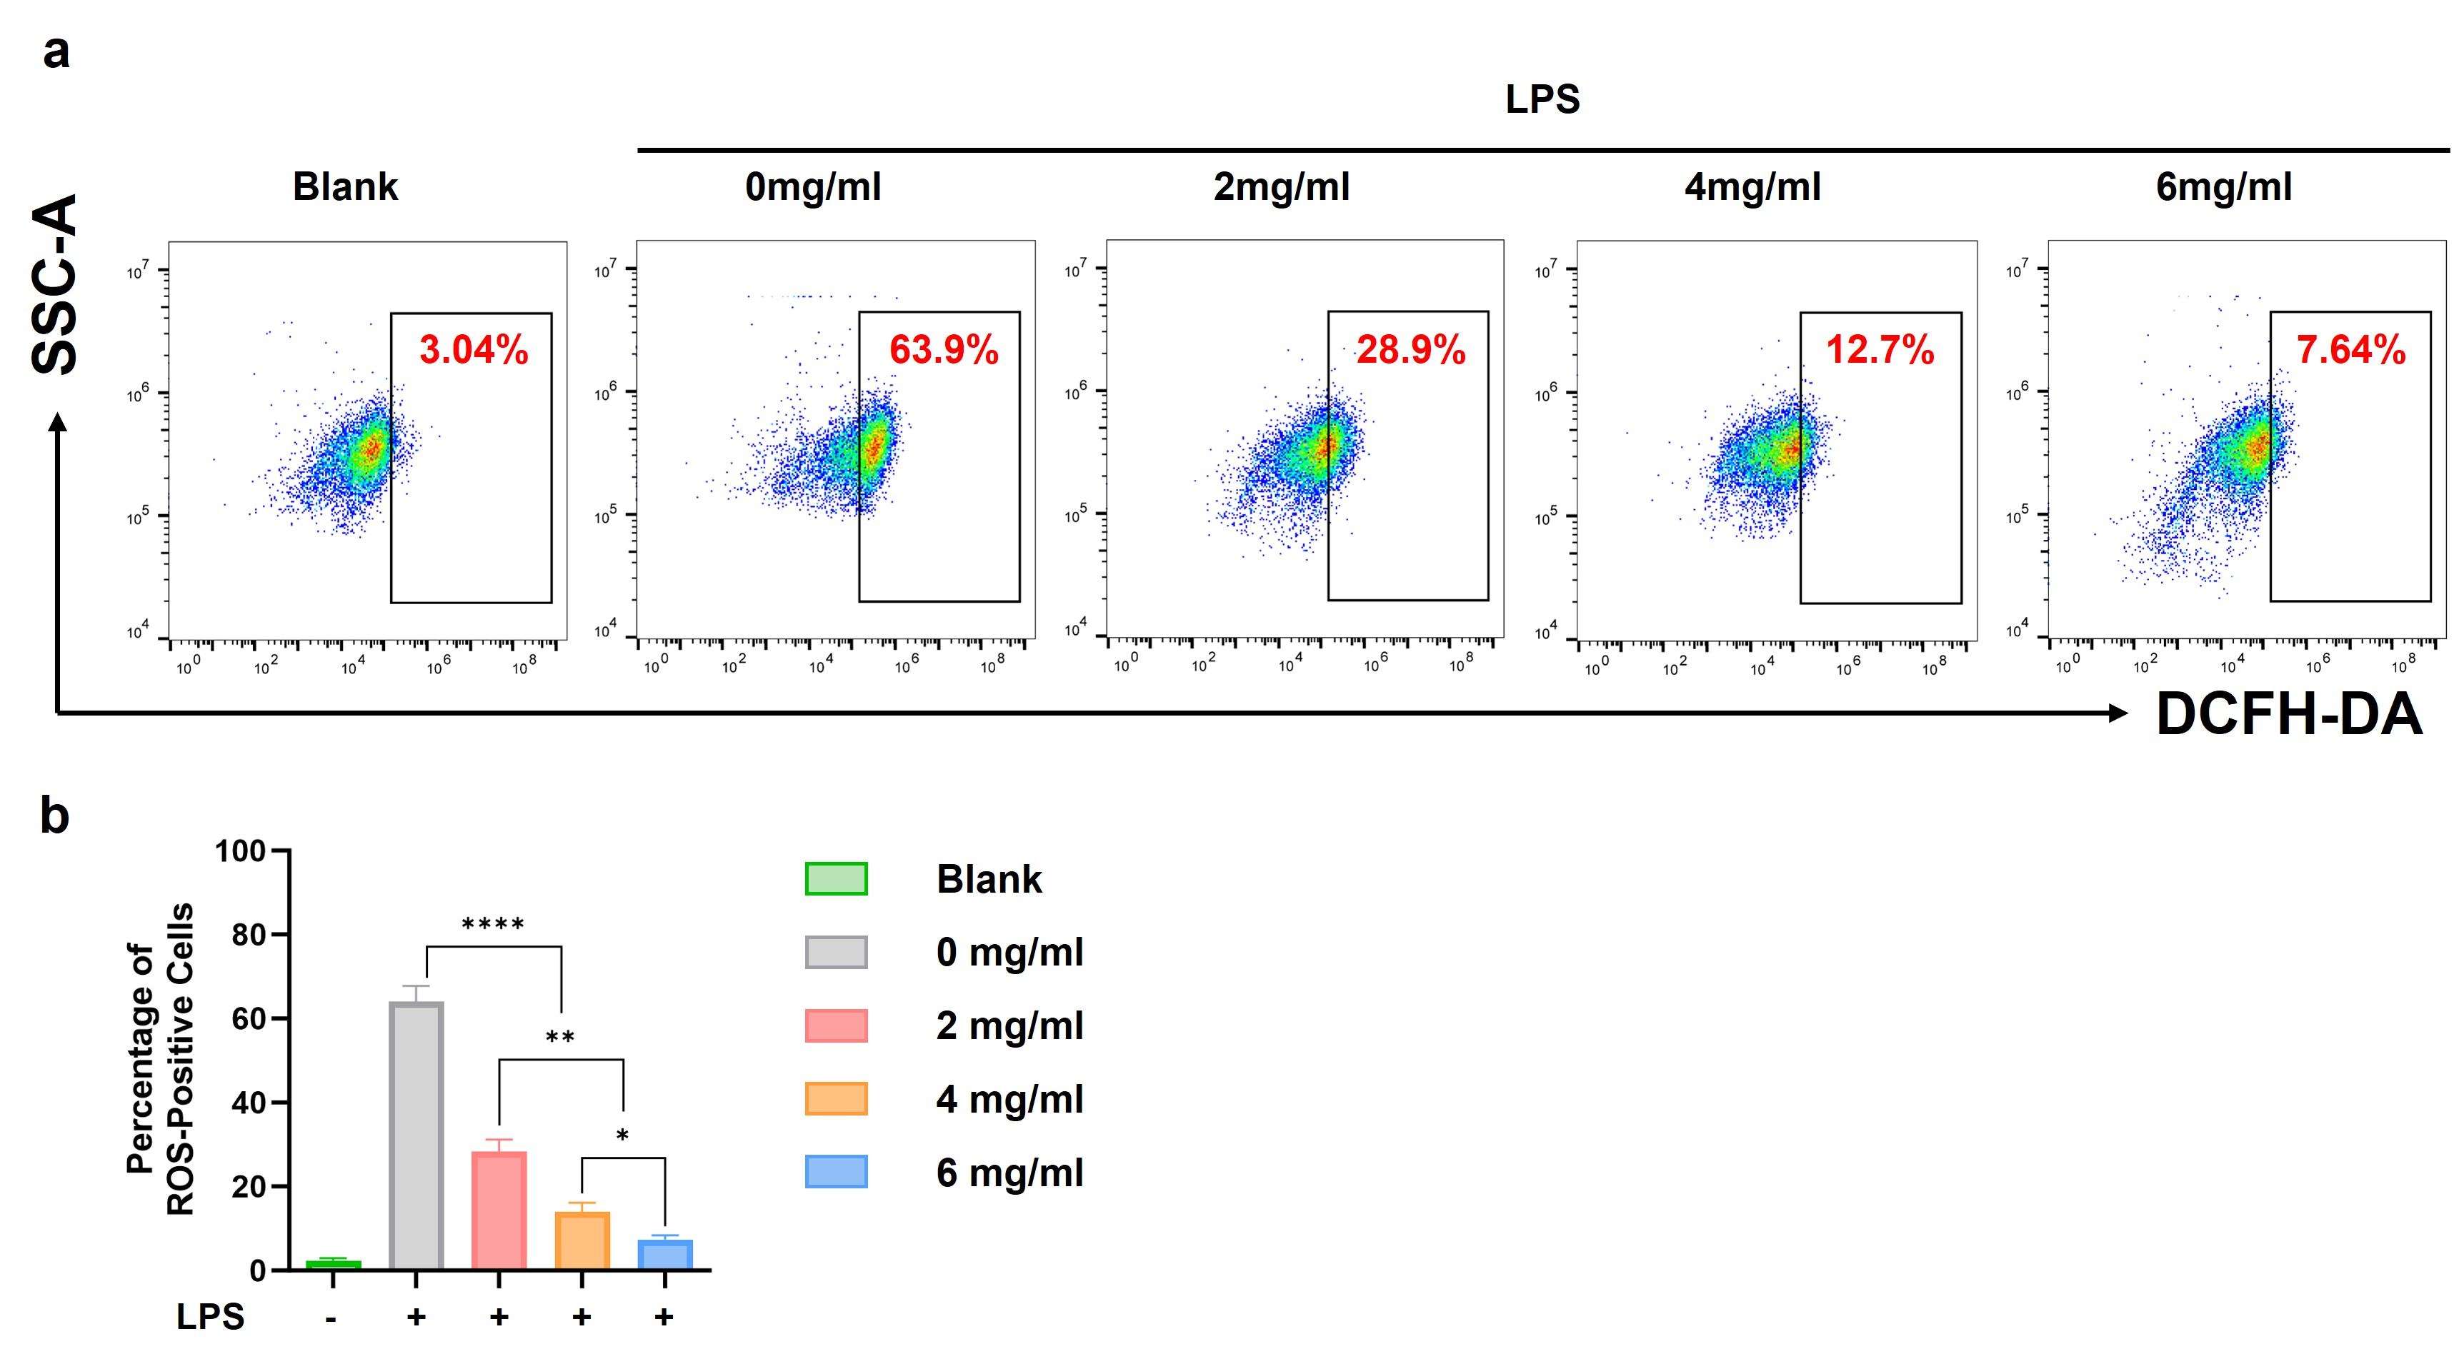
Figure S6. Concentration-dependent ROS scavenging effect of Rh-containing hydrogels in LPS-stimulated RAW264.7 macrophages. (a) Representative flow cytometry dot plots showing intracellular ROS levels in RAW264.7 cells stained with DCFH-DA after LPS stimulation. Cells were treated with containing increasing Rh concentrations (0, 2, 4, and 6 mg mL⁻¹). Data are reported as mean ± SD (n = 3); *p < 0.05; ***p < 0.001; ****p < 0.0001.

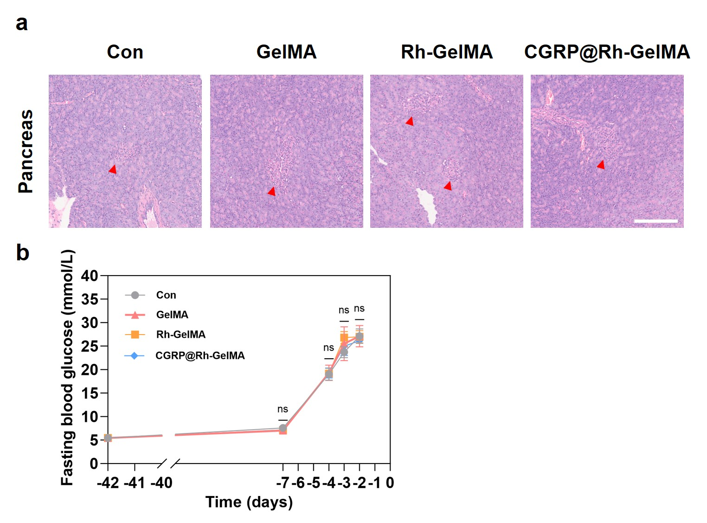
Figure S7. Verification of type 2 diabetic rat model establishment by pancreatic histology and fasting blood glucose monitoring. (a) Representative H&E staining images of pancreatic tissues from the Con, GelMA, Rh-GelMA, and CGRP@Rh-GelMA groups at the experimental endpoint. Red arrowheads indicate pancreatic islets. Scale bar = 200 μm. (b) Dynamic monitoring of fasting blood glucose (FBG) levels during diabetic model establishment. FBG was measured before high-fat diet feeding (day -42), after 5 weeks of high-fat diet feeding (day -7), and on 3 consecutive days starting at 72 h after STZ injection (days -4, -3, and -2). Rats with FBG ≥ 11.1 mmol/L for 3 consecutive days were considered successfully established as insulin-resistant type 2 diabetic models. Data are presented as mean ± SD (n = 3); ns, p ＞ 0.05.

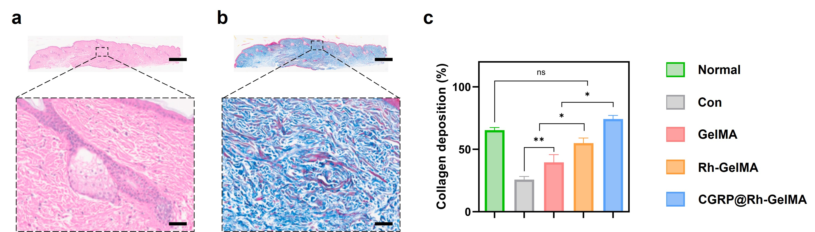
Figure S8. Histological comparison of normal skin tissue and healed wound tissue. (a) H&E staining of normal skin tissue. (b) Masson’s trichrome staining of normal skin tissue. (c) Quantitative analysis of collagen deposition in normal skin and different treatment groups. Scale bar: 1 mm (low-magnification images); 50 μm (magnified images). Data are presented as mean ± SD (n = 3); ns, p > 0.05; *p < 0.05; **p < 0.01.

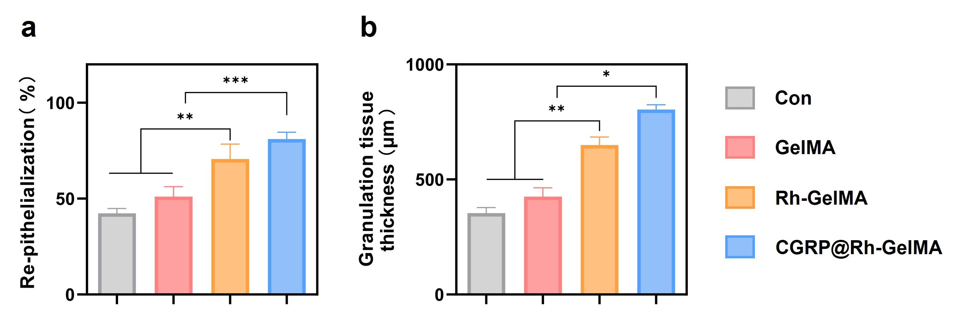
Figure S9. Quantitative analysis of re-epithelialization and granulation tissue thickness in healed wound tissues. (a) Quantitative analysis of re-epithelialization in wound tissues at day 10 after different treatments. (b) Quantitative analysis of granulation tissue thickness in wound tissues at day 10 after different treatments. Data are presented as mean ± SD (n = 3); *p < 0.05; **p < 0.01; ***p < 0.001.

