Support Information
A pH-inspired Hydrogel Enables Real-Time Monitoring and Precise Treatment of Diabetic Wounds
Yan Sun^{1a}, Xiangchen Su^{1a}, Xinrong Geng^{1a}, Mengdi Sun^{1a}, Ge Zhang¹, Mingzhu Song¹, Fang Li¹, Ruizhen Lv¹, Yuting Zhao¹, Yijie Shi^{1,2*}, Liang Zhao^{1,2,3*}
¹ School of Pharmacy, Jinzhou Medical University, Jinzhou 121000, P R China.
² Collaborative Innovation Center for Age-related Disease, Jinzhou Medical University, Jinzhou, Liaoning, China.
³ Liaoning Provincial Key Laboratory of Neurodegenerative Diseases, Jinzhou Medical University, Jinzhou, China.
*Corresponding author, email: shiyijie119@163.com (Yijie Shi), liangzhao79@163.com (Liang
Zhao)
ª These four authors contributed equally to the manuscript.

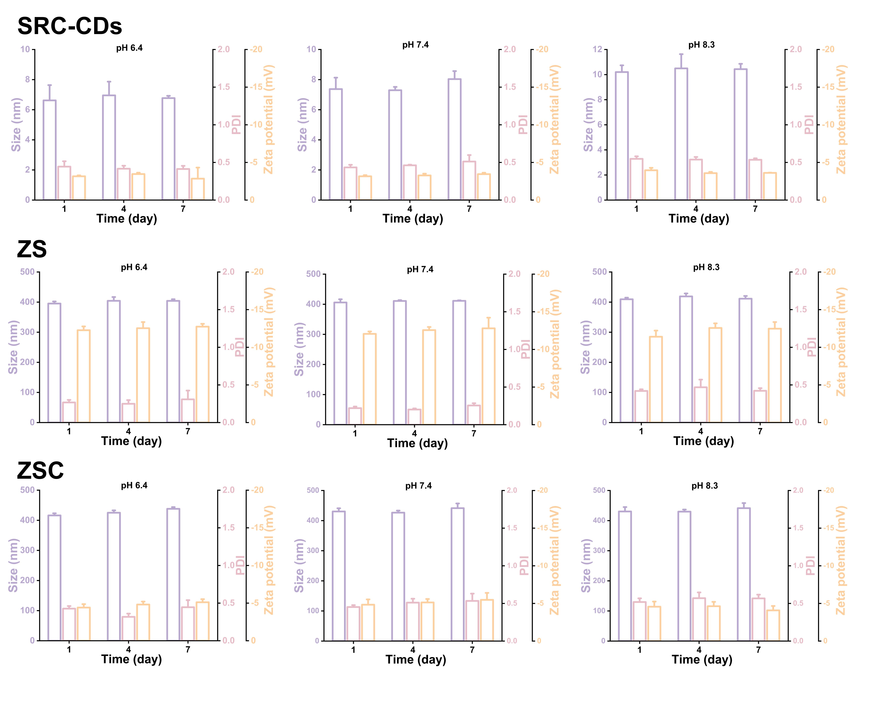
Figure S1. Stability analysis of SRC-CDs, ZS, and ZSC in PBS buffers of different pH values over 7 days. Data are presented as mean ± SD (n=3).

Figure S2. UV spectra of SRC-CDs, ZS, and ZSC.

Figure S3. High-resolution XPS spectrum of C 1s and N 1s of SRC-CDs, ZS, and ZSC.

Figure S4. Trajectories, mean square displacement (MSD), and translational speed of ZSC and SRC-CDs in the presence of 50 µM H₂O₂. Data are presented as mean ± SD (n=3), **p<0.01.

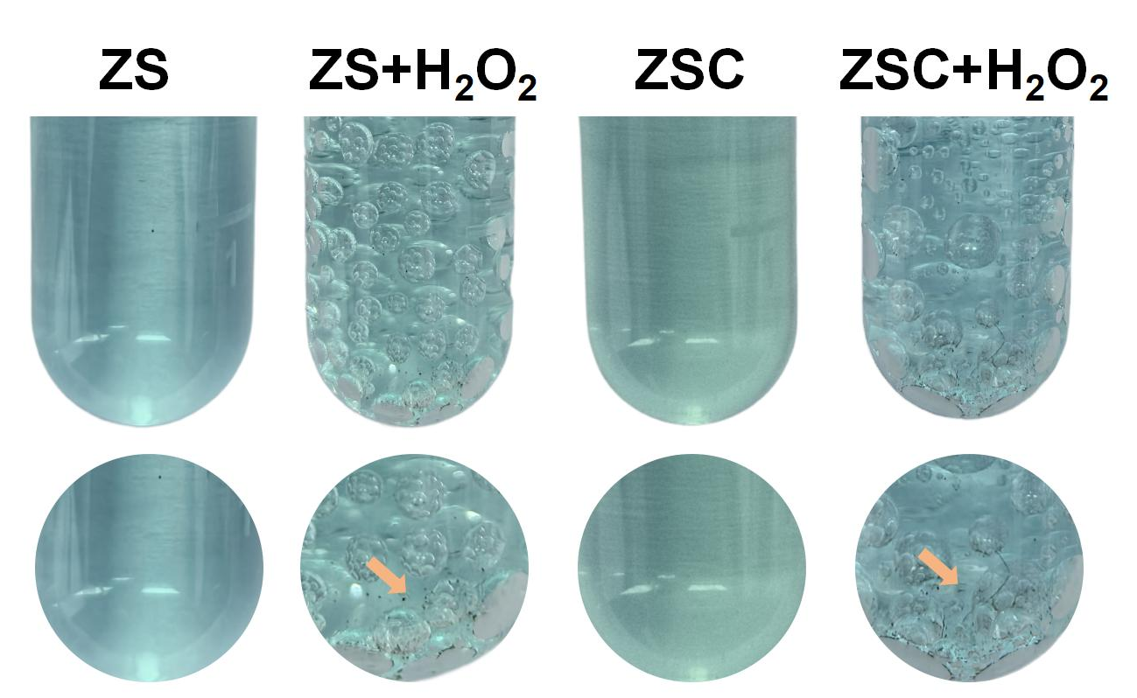
Figure S5. The precipitation images generated by the reaction of ZS and ZSC with copper sulfate solution in the medium containing 0 µM H₂O₂ and 50 µM H₂O₂ (n=3).

Figure S6. Images of SRC-CDs under natural light and 365 nm UV irradiation (n=3).

Figure S7. Fitting curve and equation between pH versus RGB values (n=3).

Figure S8. The storage modulus (G') and loss modulus (G") of SCHY and ZSC-SCHY in the temperature range of 25-45 ℃.

Figure S9. (A) XPS patterns of SA, CMCS, SA-CMCS, and SCHY. (B) High-resolution XPS spectrum of N 1s of SA-CMCS and SCHY.

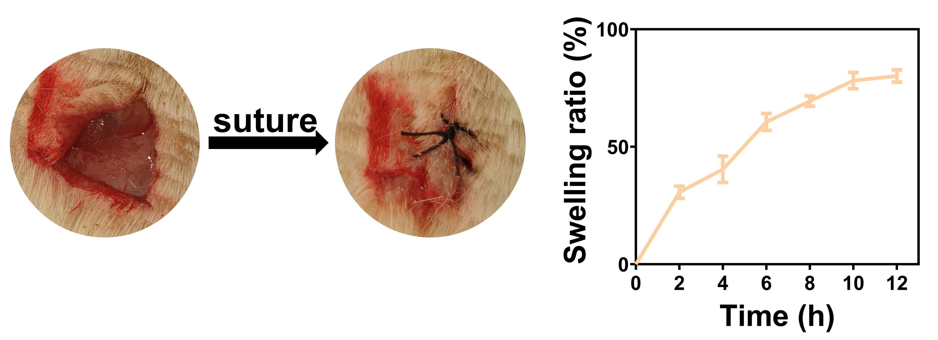
Figure S10. In vivo swelling of ZSC-SCHY and the in vivo swelling curve of ZSC-SCHY. The data are expressed as the mean ± SD (n=3).
Figure S11. Cumulative release rate of Zn²⁺ and H₂S in ZSC-SCHY over 48 h in PBS at pH=8.3. The data are expressed as the mean ± SD (n=3).

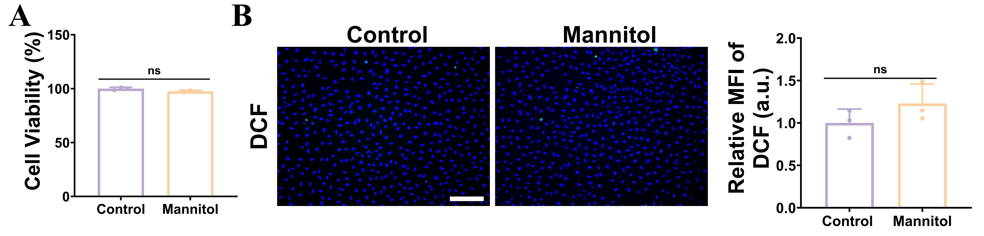
Figure S12. (A) The cell viability of HUVECs treated with mannitol (40 mM) or not. The data are expressed as the mean ± SD (n=3). (B) Fluorescence images and relative fluorescence intensity of DCF in HUVECs treated with mannitol or not. The data are expressed as the mean ± SD (n=3).. The scale bar is 200 µm.

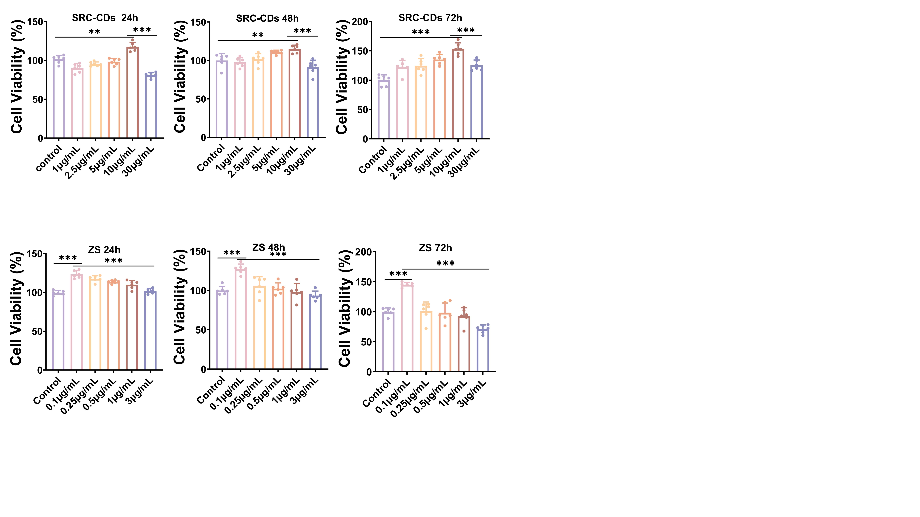
Figure S13. Cell viability of HUVECs after treatment with different concentrations of SRC-CDs for 24 h, 48 h, and 72 h.The data are expressed as the mean ± SD (n=6), **p<0.01, ***p<0.001.
Figure S14. Cell viability of HUVECs after treatment with different concentrations of ZS for 24 h, 48 h, and 72 h.The data are expressed as the mean ± SD (n=6), ***p<0.001.
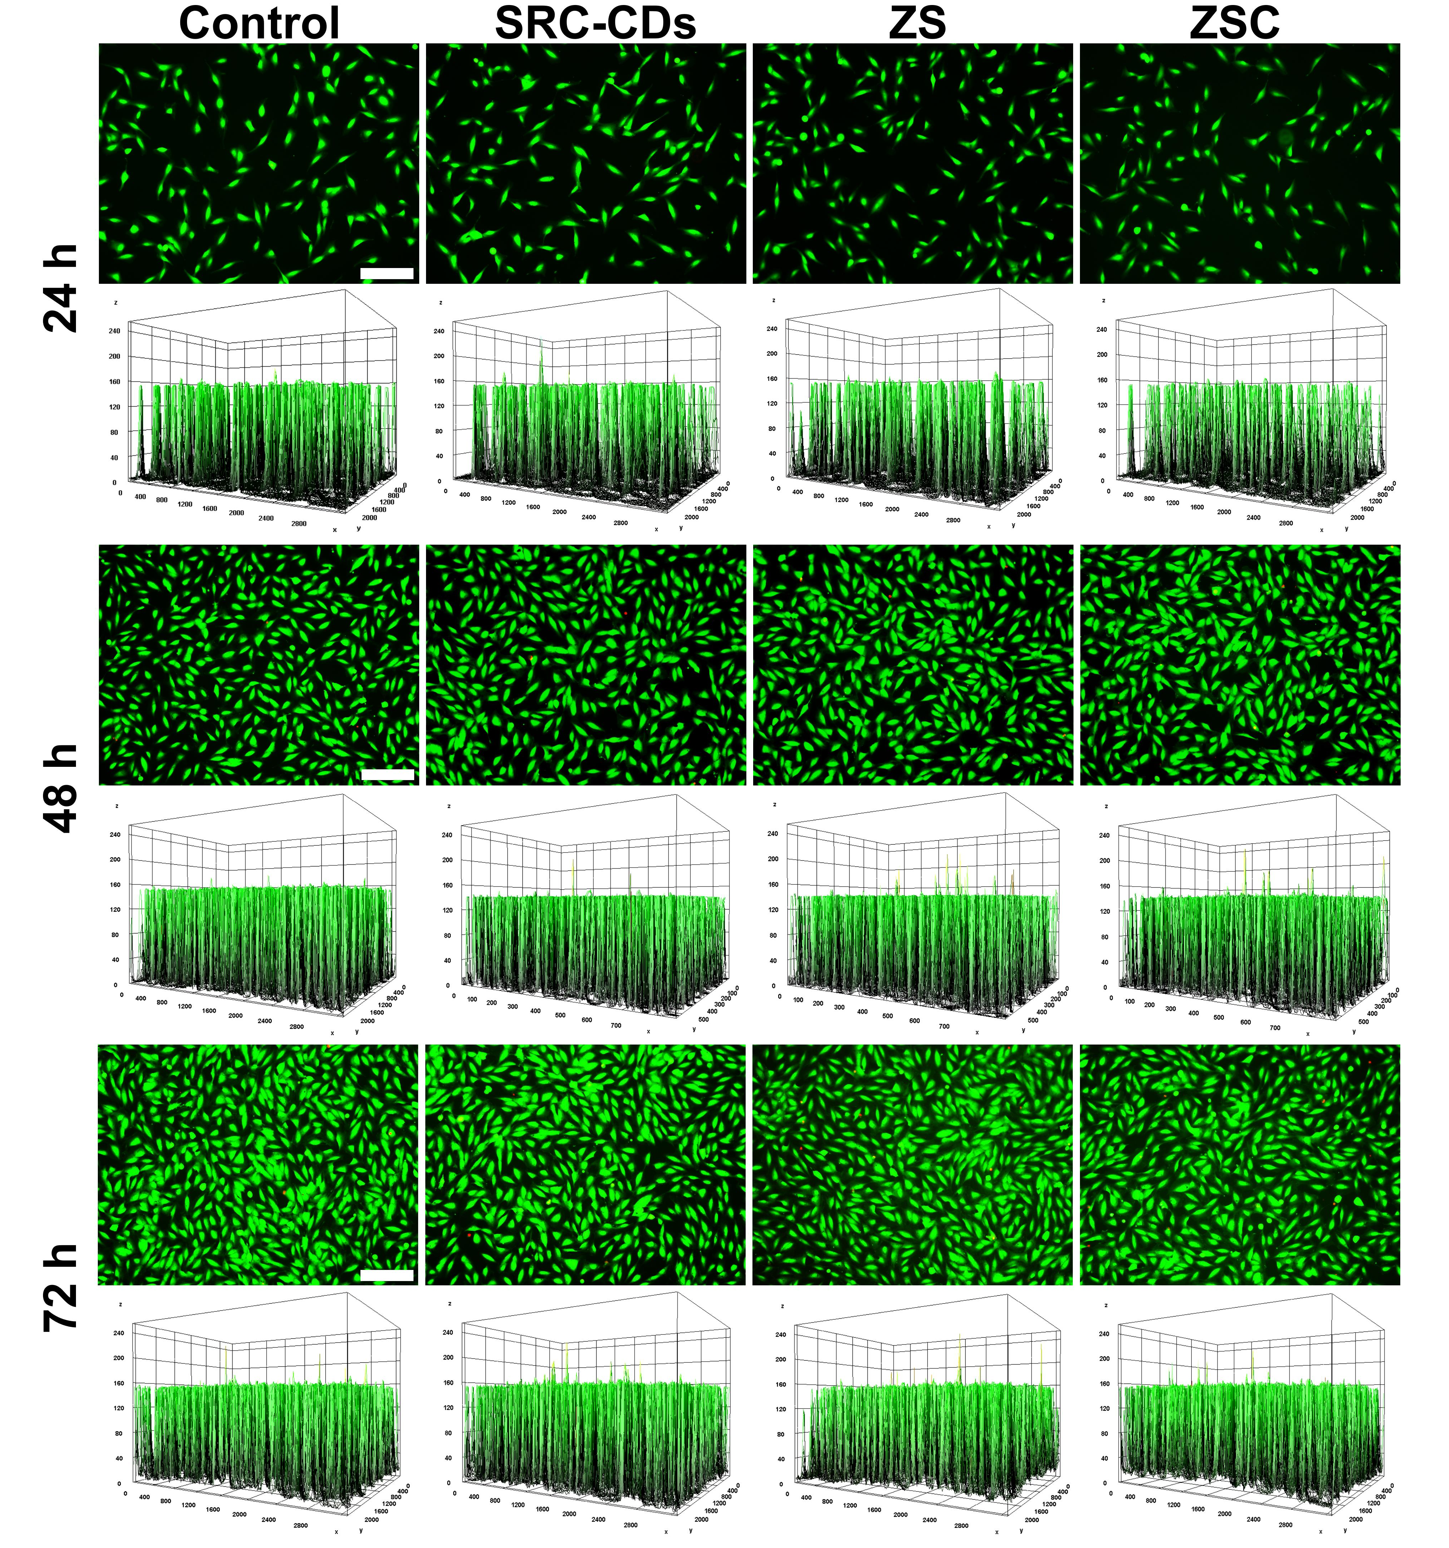
Figure S15. Calcein-AM/PI staining results of HUVECs after incubation with SRC-CDs, ZS, and ZSC for 24 h, 48 h, and 72 h (n=3). The scale bar is 200 µm.

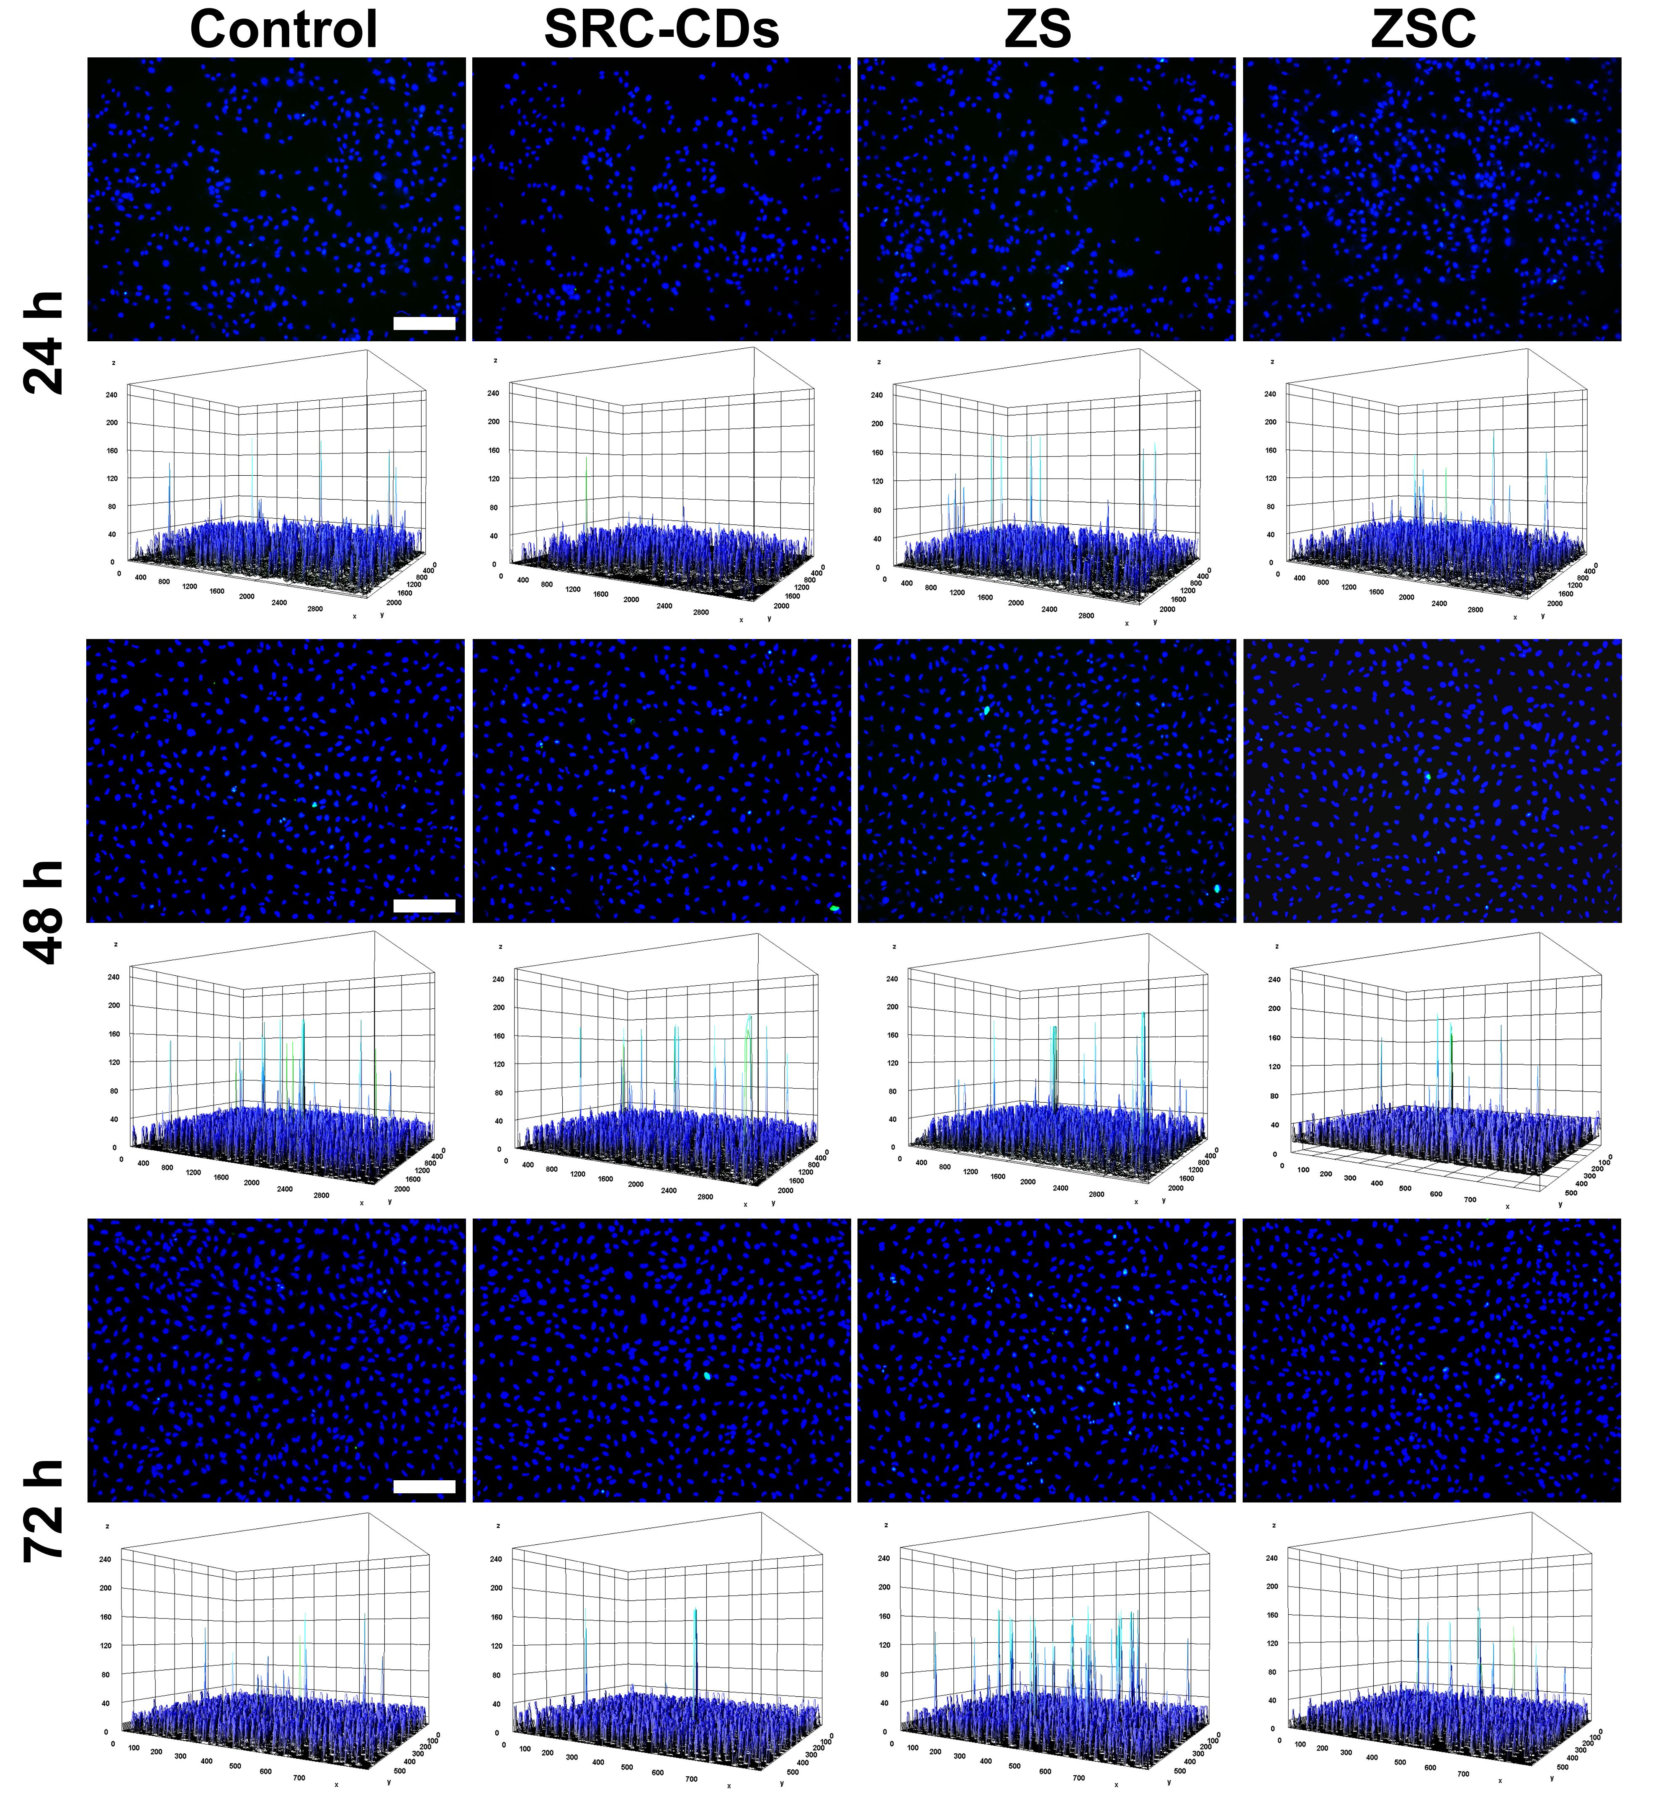
Figure S16. TUNEL results of HUVECs after incubation with SRC-CDs, ZS, and ZSC for 24 h, 48 h, and 72 h (n=3). The scale bar is 200 µm.
Figure S17. The cell viability of HG-HUVECs treated with SRC-CDs, ZS, and ZSC. The data are expressed as the mean ± SD (n=6), ***p<0.001.
Figure S18. Quantitative analysis of the expression levels of Nrf2 and VEGF in HG-HUVECs treated with SRC-CDs, ZS, and ZSC. The data are expressed as the mean ± SD (n=3), **p < 0.01, ***p < 0.001.

Figure S19. Quantitative analysis of the expression levels of NF-кB, HO-1, and STAT3 in LPS-RAW 264.7 cells treated with SRC-CDs, ZS, and ZSC. The data are expressed as the mean ± SD (n=3), *p<0.05, **p<0.01, ***p<0.001.

Figure S20. The cell viability of HG-SCs treated with SRC-CDs, ZS, and ZSC. The data are expressed as the mean ± SD (n=6), ***p<0.001.

Figure S21. Quantitative analysis of number of migratory SCs (control group) and HG-SCs treated with SRC-CDs, ZS, and ZSC. All data are expressed as the mean ± SD (n=3), ***p < 0.001.

Figure S22. Western blot images and quantitative analysis of c-Jun, MBP, and VEGF in SCs (control group) and HG-SCs treated with SRC-CDs, ZS, and ZSC. The data are expressed as the mean ± SD (n=3), **p<0.01, ***p<0.001.
Figure S23. Growth morphology of PC12 cells (control group) and HG-PC12 cells treated with SCM (HG) and SCM (HG+ZSC) (n=3). The scale bar is 200 µm.
Figure S24. Immunofluorescence images of VEGF in diabetic wounds on day 7 of SCHY and ZSC-SCHY treatment (n=3). The scale bar is 100 µm. Expression levels of NGF and BDNF measured by ELISA in diabetic wounds after different treatment. The data are expressed as the mean ± SD (n=3), ***p<0.001

Figure S25. Hemolysis test images and quantitative analysis. The data are expressed as the mean ± SD (n=3).
ddH₂O pbs CDs ZnS ZSC SCHY ZSC-SCHY

Figure S26. H&E staining of heart, liver, lung, spleen and kidney in diabetic rats treated with SCHY and ZSC-SCHY via daily covering on the wound surface for 14 days (n=3). The scale bar is 100 μm.
Figure S27. Body weight of diabetic rats treated with SCHY and ZSC-SCHY via daily covering on the wound surface for 14 days. The data are expressed as the mean ± SD (n=3).

