Galactosylated LNP-mediated hepatic Sam68 silencing improves glucose homeostasis in diabetes by suppressing gluconeogenesis
Ning Wang^{1, 2#}, Xiang Cao^{3#}, Jing Lai^{4#}, Yifan Gao³, Ao Yu³, Siyu An³, Yucheng Gao¹, Ebenezeri Erasto Ngowi^{1, 5}, Juan Yang^{1,4}, Chang Fu¹, Junyu Xu^{1, 5}, Li Tian⁶, Haozhe Piao², Shiyang Shen^{1, 3, 4, 5*}, Aijun Qiao^{1, 3, 4, 5, 7*}
Supplementary Information

Fig. S1. Construction and characterization of targeted LNPs.
(A) Representative gel electrophoresis image of LNP prepared with different N/P ratios.
(B) Representative gel electrophoresis image of LNP in which DMG-PEG was replaced by different ratio of DMG-PEG-Mal.
(C) Synthetic route of Gly-SH, Fa-SH, Man-SH, Gal-SH, Ca-SH, Ret-SH.
(D) Representative gel electrophoresis image of LNP, LNP-Gly, LNP-Fa, LNP-Man, LNP-Gal, LNP-Ca, LNP-Ret.
(E) Particle diameters of LNP, LNP-Gly, LNP-Fa, LNP-Man, LNP-Gal, LNP-Ca, LNP-Ret (n = 3).
(F) Particle diameter changes of LNP and targeted LNP over time (n = 3).
Data are presented as mean ± SD. “n” denotes biologically independent LNP samples

Fig. S2. Delivery efficiency and mechanistic evaluation of targeted LNP.
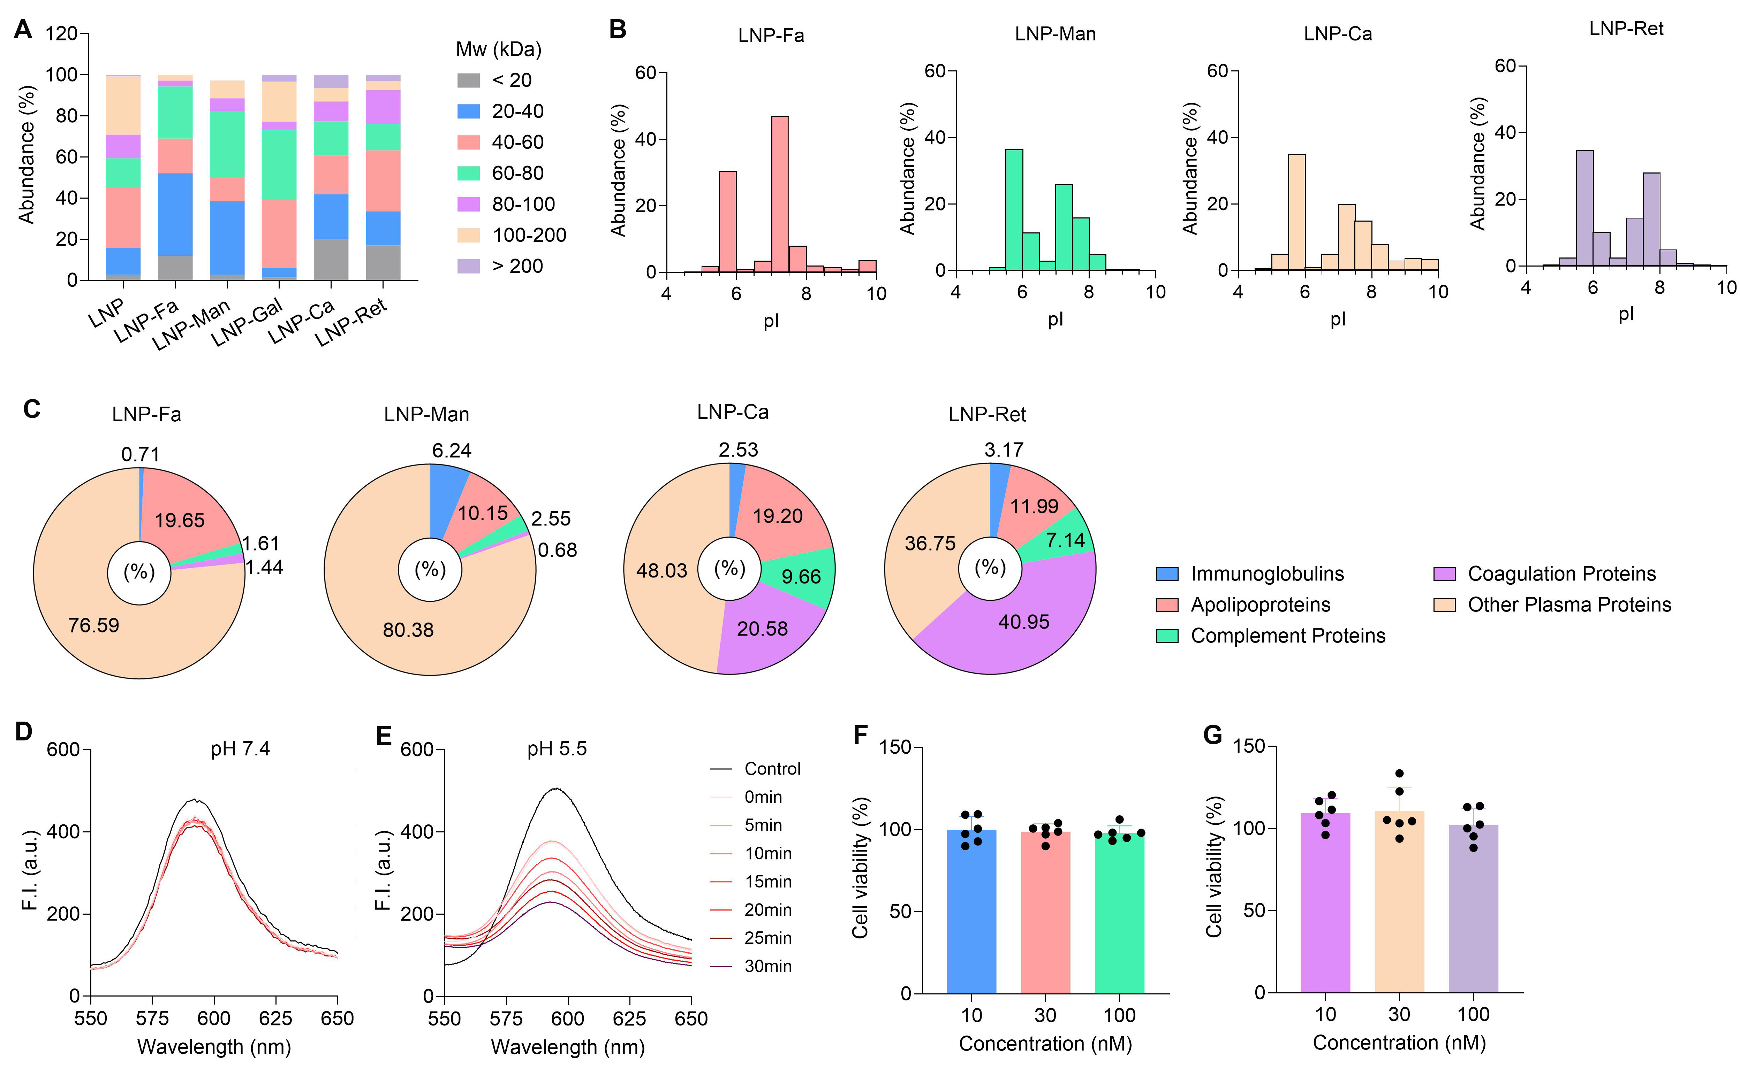
(A) Proteomic analysis of protein corona around LNPs and targeted LNPs with an abundance above 0.1% were categorized based on their molecular weight.
(B) Isoelectric point distributions of protein corona around LNP-Fa, LNP-Man, LNP-Ca or LNP-Ret with an abundance above 0.1%.
(C) Proteomic analysis of protein corona around LNP-Fa, LNP-Man, LNP-Ca or LNP-Ret with an abundance above 0.1% were categorized based on their biological functions.
(D-E) Fluorescence scanning spectrum of LNP-Gal incubated with vesicles loaded with NBD-PE and Rho-PE in pH7.4 (D) or pH5.5 (E) over time (Ex = 465 nm).
(F-G) Cell viability of AML12 cells after treatment with siSam68/LNP (F) and siSam68/LNP-Gal (G) for 24 h (n = 6).
Data are presented as mean ± SD. “n” denotes biologically independent AML12 cell samples.
Fig. S3. Validation of efficiency and selective Sam68 silencing by siSam68/LNP in liver, and safety in liver and kidney.
(A–C) WT mice received a single intravenous injection of siNC/LNP-Gal or siSam68/LNP-Gal (1 mg/kg). At day 6 post-injection, Sam68 mRNA (A) and protein (B) levels were measured by qRT-PCR (n = 3) and WB, respectively, in the liver, kidney, brain, islet, lung, spleen, heart, skeletal muscle, brown adipose tissue (BAT), and inguinal white adipose tissue (ingWAT). Sam68 mRNA levels in epiWAT (epididymal white adipose tissue) and retroWAT (‌retroperitoneal white adipose tissue) were additionally assessed by qRT-PCR (n = 3). Histological morphologies of liver and kidney tissues were analyzed by H&E staining (C, 200 μm, 10).
Data are presented as mean ± SD. Significance levels are indicated as **P < 0.01 (A: unpaired two-tailed Student’s t-tests). “n” denotes biologically independent tissues.

Fig. S4 siSam68/LNP-Gal treatment suppresses glucose production by inhibiting gluconeogenesis in primary hepatocytes.
(A–D) Mouse primary hepatocytes were treated with siNC/LNP-Gal (100 nM), siSam68/LNP-Gal (100 nM), or metformin (50 or 500 μM). mRNA levels of PGC-1α, PEPCK, and G6Pase were quantified by qRT-PCR 24 h post-treatment, following forskolin (A) or Bt2-cAMP (C) stimulation with 1, 2, 3 h (n = 3). Glucose production was measured after 24 h of treatment followed by stimulation with forskolin (B) or Bt2-cAMP (D) for 4 h (n = 3).
Data are presented as mean ± SD. Significance levels are indicated as *P < 0.05, **P < 0.01, ***P < 0.001, and ****P < 0.0001 (A and B: Two-way ANOVA followed by Tukey’s multiple comparisons test; C and D: One-way ANOVA with Tukey’s multiple comparisons test). “n” denotes biologically independent primary hepatocyte samples.
Fig. S5. siSam68/LNP-Gal administration in HFD/STZ diabetic mice enhances systemic and hepatic insulin sensitivity.
Diabetic mice were intravenously injected with siNC/LNP-Gal (1 mg/kg) or siSam68/LNP-Gal (1 mg/kg) every 6 days, or received metformin (50 or 150 mg/kg) via daily oral administration. All treatments lasted for 4 weeks.
(A) Blood glucose levels were measured before vehicle administration (n = 8).
(B) Hepatic mRNA expression of FOXO1 and HNF4α under fed or 16 h fasting conditions was quantified by qRT-PCR (n = 6).
(C) Blood glucose was measured at 0, 15, 30, 45, 60, 90, and 120 min after injection of insulin, AUC were analyzed from the corresponding curves (right, n = 8).
(D) Protein expression of p-AKT (Ser473 and Thr308) and total AKT were assessed by WB in liver tissue, which were collected 20 min after intraperitoneal injection of insulin (1 U/kg) or vehicle in mice administered with siNC/LNP-Gal or siSam68/LNP-Gal (left, image; right, quantification; n = 3) .
Data are presented as mean ± SD. Significance levels are indicated as *P < 0.05, **P < 0.01, ***P < 0.001, and ****P < 0.0001 (A, B and right panel of C: One-way ANOVA followed by Dunnett’s multiple comparisons test; D: One-way ANOVA with Tukey’s multiple comparisons test). “n” denotes biologically independent blood samples or liver tissues.

Fig. S6. siSam68/LNP-Gal administration enhances systemic and hepatic insulin sensitivity in db/db mice.
db/db diabetic mice were intravenously injected with siNC/LNP-Gal (1 mg/kg) or siSam68/LNP-Gal (1 mg/kg) once every 6 days, or received metformin (50 or 150 mg/kg) via daily oral administration. All treatments lasted for 4 weeks.
(A) Baseline blood glucose levels were measured among all treatment groups (n = 8).
(B) Sam68 mRNA levels in the heart, islet, spleen, skeletal muscle, lung, kidney, brain, BAT, ingWAT, epiWAT and retroWAT were quantified by qRT-PCR after 4-week treatment (n = 4).
(C) Hepatic mRNA expression of FOXO1 and HNF4α under fed or 16 h fasting conditions was quantified by qRT-PCR (n = 6).
(D) Insulin tolerance test (ITT, 6 h fasting). Blood glucose was measured at 0, 15, 30, 45, 60, 90, and 120 min after insulin injection (left), AUC were analyzed from the corresponding curves (right, n = 8).
(E) WB analysis and quantification of p-AKT (Ser473 and Thr308) and total AKT in liver tissues collected 20 min after intraperitoneal insulin administration (2 U/kg) or vehicle in siNC/LNP-Gal- or siSam68/LNP-Gal-treated mice (left, image; right, quantification; n = 3).
Data are presented as mean ± SD. Significance levels are indicated as *P < 0.05, **P < 0.01, ***P < 0.001, and ****P < 0.0001 (A, C and right panel of D: One-way ANOVA followed by Dunnett’s multiple comparisons test; B: Unpaired two-tailed Student’s t-tests; E: One-way ANOVA with Tukey’s multiple comparisons test). “n” denotes biologically independent blood samples or liver tissues.
Supplementary Table 1: List of antibodies
Name | Catalogue Number | Company Name | Dilution
Sam68 | ab76471 | Abcam | 1:5000
CRTC2 | 12497-1-AP | Proteintech | 1:1000
CREB | 9197 | Cell Signaling | 1:1000
p-CREB (Ser133) | 9196 | Cell Signaling | 1:1000
PGC-1α | ab72230 | Abcam | 1:1000
G6Pase | NBP1-80533 | Novus | 1:1000
PEPCK | 12940 | Cell Signaling | 1:1000
HNF4α | MA1199 | Thermo | 1:1000
FOXO1 | 2880 | Cell Signaling | 1:1000
AKT | 9272 | Cell Signaling | 1:1000
Phospho-AKT (Thr308) | 2965 | Cell Signaling | 1:1000
Phospho-AKT (Thr473) | 4060 | Cell Signaling | 1:1000
β-actin | 8457 | Cell Signaling | 1:1000
Anti-mouse IgG, HRP-linked antibody | 7076 | Cell Signaling | 1:5000
Anti-rabbit IgG, HRP-linked antibody | 7074 | Cell Signaling | 1:5000

Supplementary Table 2: List of primers
Name | Forward sequence | Reverse sequence
mCRTC2 | TTTGGGCATCAGTGGAGGTC | CCTGGAGGTTGGGATTGCTT
mPGC-1α | AGCCGTGACCACTGACAACGAG | GCTGCATGGTTCTGAGTGCTAAG
mG6pase | TGGGCAAAATGGCAAGGA | TCTGCCCCAGGAATCAAAAAT
mSam68 | GATATCTGTCAGGAGCAGTTTCT | CTCCTCGTCCTCTCACAGATA
mβ-actin | GTATGGAATCCTGTGGCATC | AAGCACTTGCGGTGCACGAT
mFOXO1 | CCCAGGCCGGAGTTTAACC | GTTGCTCATAAAGTCGGTGCT
mHNF4α | AAGGTGCCAACCTCAATTCATC | CACATTGTCGGCTAAACCTGC

