1. Experimental Section
1.1. Chemicals
PVP-K30，CuCl₂·2H₂O were acquired from Aladdin (Shanghai, China). Sodium hydroxide (NaOH) purchased from Sigma-Aldrich. Cell Counting Kit-8 (CCK-8), 2′,7′-dichlorodihydrofluorescein diacetate (DCFH-DA) and 3′-p-(hydroxyphenyl) fluorescein (HPF) were supplied from Sigma-Aldrich. H₂O₂ Assay Kit, Reduced Glutathione (GSH) Content Assay Kit, Cysteine (Cys) Content Assay Kit, Cu Content Assay Kit and trypan blue stain solution were obtained from Solarbio, China. The Alanine Transaminase (ALT) Content Assay kit, Aspartate Transaminase (AST) Content Assay kit, Blood Urea Nitrogen (BUN) Content Assay kit and Serum Creatinine (SCr) Content Assay kit were purchased in Nanjing JianCheng, China. JC-1 staining kit were purchased from Beyotime Inst. Biotech. (Haimen, China). C11-BODIPY lipid probes is purchased from Thermo Fisher Scientific (Shanghai, China). Singlet Oxygen Sensor Green (SOSG) was purchased from Beyotime Biotechnology (Shanghai, China). Acridine orange/ethidium bromide (AO/EB) double-staining kit was obtained from Maokang Bio (Shanghai, China). Mouse GPX4 ELISA kit was supplied by Shanghai FanTai Biotech. Human DLAT ELISA kit from Cusabio. All chemicals used here were of analytical grade and were used without further purification.
1.2. Characterization
Transmission electron microscopy (TEM) was carried out on a JEOL-2100F instrument with a field-emission gun operating at 200 kV. With a Thermo Fisher ESCALAB 250Xi spectrometer, chemical composition is examined using X-ray photoelectron spectroscopy (XPS). Powder X-ray Diffraction (XRD) patterns were recorded within the 2θ range of 5°–80° (8°/ min) with a Rigaku Model D/max-2500 diffraction using Cu Kα radiation. A 3D optoacoustic tomographic (Tomowave) imaging system was equipped. A TU-1901 dual-beam UV-vis spectrophotometer (PerkinElmer) were used record UV-Vis-NIR spectra. Dynamic light scattering (DLS) and zeta potential measurements were performed using a Nano-Zetasizer (Malvern Instruments Ltd).
1.3 Synthesis of CuO_{x}
CuCl₂·2H₂O (307 mg) and PVP (153.5 mg) were dissolved in 60 mL deionized water by sonication for 5 min. NaOH (300 mg) was dissolved in 30 mL deionized water. The CuCl₂–PVP solution was transferred into a 60 °C water bath and stirred vigorously with a magnetic bar. The NaOH solution was added dropwise while monitoring the pH in real time, titration was halted as soon as the pH reached 9. The mixture was kept at 60 °C for an additional 6 h under continuous stirring. The resulting CuO_{x} nanoparticles were collected by centrifugation, washed three times with deionized water, and finally lyophilized for one day to further use.
1.4 In vitro test
1.4.1 In vitro photothermal measurement
The CuO_{x} with different concentrations (0, 250, 500, 1000 and 2000 μg/mL) were irradiated with NIR-II light (980 nm, 0.25 W/cm²) for 5 min and the temperatures changes were recorded by an IR image camera (Guide sensmart, PS 400). The photostability of CuO_{x} was evaluated through five cycles between heating and cooling. The photothermal conversion efficiency (η) of CuO_{x} can be calculated according to the equation (1):
$\text{ɳ=}\frac{{\text{m}}_{\text{D}}{\text{c}}_{\text{D}}\text{(}\frac{{\text{△}\text{T}}_{\text{MaxCuO}\text{x}}}{{\text{τ}}_{\text{sCuO}\text{x}}}\text{-}\frac{{\text{△}\text{T}}_{\text{Max}\text{water}}}{{\text{τ}}_{\text{s}\text{water}}}\text{)}}{\text{I(1-}{\text{10}}^{\text{-A}}\text{)}}$ (1)
Where m_{D} and c_{D} represents the mass and heat capacity of the solvent. $∆$T_{max} represents the difference between the maximum equilibrium temperature and the ambient temperature. I is incident laser power (0.25 W/cm²) for the 980 nm laser, and A is the absorbance value of CuO_{x} at 980 nm. The value of $τ_{s}$was calculated based on equation (2):
${\text{τ}}_{\text{s}}\text{=}\frac{\text{t}}{\text{-}\text{lnθ}}\text{=}\frac{\text{t}}{\text{-ln}\frac{\text{T-}{\text{T}}_{\text{Sur}}}{{\text{T}}_{\text{Max}}\text{-}{\text{T}}_{\text{Sur}}}}$ (2)
The τ_{s} means the time constant, Tmax represents the highest equilibrium temperature, T_{Sur} is environment temperature, according to calculating, the η of the CuO_{x} is calculated to 41.18 %.
1.4.2. In vitro NIR-II PA measurement
CuO_{x} aqueous solutions at different concentrations (0, 125, 250, 500 and 1000 μg/mL) were sealed into polyethylene tubes, respectively. Then, a real-time multispectral optoacoustic tomographic (MSOT) imaging system was utilized to detect and quantify the PA signal for each sample at 980 nm.
1.4.3. Catalytic ability of CuO_{x}
To investigate the catalytic ability of CuO_{x}, GSH (10 mM) or Cys (0.1 mM) were incubated with CuO_{x}. The GSH and Cys consumption was measured by Glutathione (GSH) Content Assay Kit and Cysteine (Cys) Content Assay Kit. At different time points, 1mL solutions were collected to detect H₂O₂ generation according to the manufacturer’s protocols of H₂O₂ Assay Kit (Solarbio, Beijing, China).
H₂O₂ (1mM) were incubated with CuO_{x} (0.5 mg/mL) in the presence or absence of Cys atmosphere to investigate the catalase activity of CuO_{x}, the dissolved O₂ was detected using a portable dissolved oxygen meter every 1 min.
CuO_{x} (1 mL, 0.5 mg/mL) were added into DPBF solution (1 mg/ml) under acidic (pH 6.5) or neutral (pH 7.4) conditions, Normoxic/hypoxic environments and with or without Cys. Under 980nm laser irradiation (0.25 W/cm²), the generation of ¹O₂ was measured at different time points by UV-vis spectrophotometer at 425 nm.
CuO_{x} (1 mL, 0.5 mg/mL) and appropriate amount of H₂O₂ (1 mM) were added into TMB solution (10 mM) under acidic or neutral conditions and with or without Cys. The generation of •OH was measured at different time points by UV-vis spectrophotometer at 650 nm.
1.4.4. The Cu²⁺ release capacity of CuO_{x}
CuO_{x} was incubated in an acidic environment (pH 6.5). At different time points, 1 mL solution were taken out, centrifuged to remove particles, and the supernatant was analyzed for Cu²⁺ concentration using Cu Content Assay Kit (Solarbio, China).
1.5. Cell lines
1.5.1. Cell culture
4T1 cell lines were cultured in cell culture medium (RPMI-1640) supplemented with 10% fetal bovine serum and 1% Penicillin-Streptomycin solution. in a humidified incubator at 37°C with 5% CO₂. The medium was refreshed every 2–3 days based on cell growth and culture conditions, with cells being passaged once they reached 70–80% confluency
1.5.2. Cell live/dead assessment
In vitro cell viability assessment
To evaluate the cytotoxicity of CuO_{x}, HUVECs and 4T1 cells were seeded into 96-well plates and incubated overnight. The cells were then exposed to various concentrations of CuO_{x} for another 24 h. Cell viability was quantified using the CCK-8 assay, absorbance at 450 nm for each well was recorded on a microplate reader. Relative cell viability was calculated by normalizing the absorbance of treated groups to that of untreated controls. Based on these results, appropriate concentrations were selected for subsequent experiments. In the following assays, cells were subjected to different nanomaterials, selected groups were further treated with CuO_{x}, L, CuO_{x} +L, CuO_{x} +H⁺ and CuO_{x} +H⁺+L, followed by laser irradiation at 0.25 W cm⁻² for 5 min. Absorbance at 450 nm was re-measured and relative cell viability was recalculated accordingly.
Colony formation assay
Exponentially growing 4T1 cells were harvested, counted, and serially diluted in complete DMEM. A total of 500 cells per well were seeded into six-well plates. The medium was then replaced with fresh medium containing the designated treatments (PBS (control), CuO_{x}, CuO_{x} +L, CuO_{x} +H⁺ and CuO_{x} +H⁺+L (laser irradiation: 0.25 W cm⁻², 5 min)). After 24 h of exposure, the medium was changed to drug-free complete medium and the plates were incubated for an additional 10–12 days with medium renewal every 3 days. Colonies were fixed with 4 % paraformaldehyde for 15 min, washed twice with PBS, and stained with 0.5 % crystal violet in 20 % methanol for 20 min. Excess dye was removed by gentle rinsing with distilled water and the plates were air-dried. Colonies containing > 50 cells were counted under a stereomicroscope.
Trypan blue exclusion assay for cell viability
4T1 cells were collected by trypsinization after (PBS (control), CuO_{x}, CuO_{x} +L, CuO_{x} +H⁺ and CuO_{x} +H⁺+L (laser irradiation: 0.25 W cm⁻², 5 min) treatment, washed once with ice-cold PBS, and resuspended in complete DMEM. An aliquot of the cell suspension (50 µL) was mixed with an equal volume of 0.4 % trypan blue solution (Gibco) and incubated for 3 min at room temperature. A 10-µL aliquot of the stained mixture was then loaded onto a Neubauer hemocytometer, and viable (unstained) and non-viable (blue) cells were counted under an inverted microscope using a 10× objective. All experiments were performed in triplicate.
AO/EB dual-fluorescence staining
Cells were seeded on glass-bottom confocal dishes (1 × 10⁴ cells per dish) and allowed to attach overnight. After the designated treatments (PBS (control), CuO_{x}, CuO_{x} +L, CuO_{x} +H⁺ and CuO_{x} +H⁺+L (laser irradiation: 0.25 W cm⁻², 5 min)), the medium was removed and the cells were gently washed twice with PBS. A freshly prepared AO/EB working solution (100 µg mL⁻¹ AO + 100 µg mL⁻¹ EB in PBS) was added to each well and the dishes were incubated for 15 min at room temperature in the dark. Subsequently, the cells were rinsed twice with PBS to remove excess dye and immediately observed under an inverted fluorescence microscope using the FITC/TRITC filter sets (AO: Ex/Em 488/515 nm, EB: Ex/Em 518/605 nm). At least 200 cells were randomly counted per field, and the proportions of viable (green), early-apoptotic (green-yellow), late-apoptotic (orange-red) and necrotic (red) cells were calculated.
1.5.3 Cell photoacoustic uptake experiment
4T1 cells were seeded into glass-bottom confocal dishes (1 × 10⁴ cells per dish) and cultured overnight in complete DMEM. After discarding the medium, the cells were incubated with CuO_{x} nanoparticles (5 mg mL⁻¹) at 37 °C. At 20-min intervals, samples were gently rinsed three times with PBS to remove free nanoparticles, subjected to in vitro photoacoustic imaging using a multispectral optoacoustic tomographic (MSOT) system, and the resulting PA signals were converted into relative photoacoustic intensity (a.u.).
1.5.4. Detection of intracellular ROS levels
4T1 cells were seeded in confocal dishes and incubated overnight. The cells were then subjected to the following treatments: PBS (control), CuO_{x}, CuO_{x} +L, CuO_{x} +H⁺ and CuO_{x} +H⁺+L (laser irradiation: 0.25 W cm⁻², 5 min). After three gentle washes with PBS, the cells were incubated with DCFH-DA, HPF, or SOSG staining solution in the dark at 37 °C for 30 min. Following probe uptake, the cells were exposed to additional irradiation. Fluorescence images were acquired with a confocal microscope, and the fluorescence intensities were quantified using Image J.
1.5.5. Other staining experiments
C11-BODIPY: 4T1 cells were seeded in CLSM dishes and cultured overnight. The cells were then subjected to the following treatments: PBS (control), CuO_{x}, CuO_{x} +L, CuO_{x} +H⁺ and CuO_{x} +H⁺+L (laser irradiation: 0.25 W cm⁻², 5 min), followed by a 12 h incubation. After treatment, the cells were gently washed three times with PBS and incubated with 10 µM C11-BODIPY 581/591 (LPO probe) at 37 °C for 60 min. Nuclei were counterstained with Hoechst 33342 for 15 min. Fluorescence images were acquired on an inverted fluorescence microscope system.
JC-1: Cells were grown on 12-well plates or confocal dishes. After treatment (PBS (control), CuO_{x}, CuO_{x} +L, CuO_{x} +H⁺ and CuO_{x} +H⁺+L (laser irradiation: 0.25 W cm⁻², 5 min), the culture medium was removed and replaced with 1 mL of JC-1 working solution (5 µg mL⁻¹ in serum-free DMEM) and incubated at 37 °C for 20 min in the dark. The cells were then gently washed twice with pre-warmed JC-1 staining buffer (supplied with the kit) and once with PBS. For imaging, red fluorescence (J-aggregates, Ex/Em 560/595 nm) and green fluorescence (J-monomers, Ex/Em 485/535 nm) were acquired on an inverted fluorescence microscope. The ratio of red to green fluorescence intensity was calculated using Image J to quantify changes in mitochondrial membrane potential.
1.5.6. Western Blot Analysis
Western blot analysis: 4T1 cells were seeded into six-well plates cultured for 12 h, then exposed to the indicated treatments for 24 h. After incubation, cells were rinsed twice with ice-cold PBS, harvested, and lysed on ice for 30–60 min in RIPA buffe. Cell lysates were centrifuged at 12 000 rpm for 15 min at 4 °C, and the supernatants containing total protein were collected. Protein concentrations were determined with the Omni-Easy Instant BCA Protein Assay Kit (EpiZyme, China). Equal amounts of protein (30 µg per lane) were separated on 4–20 % gradient SDS–polyacrylamide gels (EpiZyme, China) and electro-transferred onto PVDF membranes (IPVH00010, Millipore, USA). The membrane was blocked for 2 h and then washed with Tris-buffered saline containing 0.1 % Tween 20 (TBS-T). After overnight incubation at 4 °C, the membrane was incubated with primary antibodies specifically targeting DLAT or GPX4. Following primary antibody incubation, the membrane was treated with the corresponding secondary antibody for 1 h at room temperature. Protein bands were then visualized using a Bio-Rad ChemiDoc Imaging System (Bio-Rad, China) and analyzed by grayscale quantification with Image J software. The experiment was repeated at least three times.
1.5.7. Immunofluorescence staining
GPX4/ DLAT: 4T1 cells were seeded on glass-bottom confocal dishes at 1 × 10⁵ cells per dish and cultured overnight. After the indicated treatments (PBS (control), CuO_{x}, CuO_{x} +L, CuO_{x} +H⁺ and CuO_{x} +H⁺+L (laser irradiation: 0.25 W cm⁻², 5 min), cells were fixed with 4 % paraformaldehyde for 15 min at room temperature and permeabilized with 0.2 % Triton X-100 for 10 min. Non-specific binding was blocked with 5 % BSA in PBS for 1 h. The dishes were then incubated overnight at 4 °C with a rabbit anti-GPX4/anti-DLAT primary antibody. Following three PBS washes, an Alexa Fluor 488-conjugated goat anti-rabbit secondary antibody (1:300, Invitrogen) was applied for 1 h at room temperature in the dark. Nuclei were counterstained with DAPI (1 µg mL⁻¹, 5 min). After a final wash, the samples were imaged on a confocal laser scanning microscope with 488 nm excitation and 500–550 nm emission filters。The fluorescence intensity was calculated using Image J to quantify changes.
1.5.8. Intracellular glutathione and cysteine depletion assay
4T1 cells were seeded into 6-well plates (2 × 10⁵ cells per well) and cultured overnight. After discarding the medium, fresh DMEM containing CuO_{x} at the indicated concentrations (0, 250, 500, 750, 1000 µg mL⁻¹) was added and the plates were incubated for 12 h at 37 °C. The cells were then washed twice with ice-cold PBS, scraped, and lysed by three freeze–thaw cycles in 200 µL of 0.1 % Triton X-100. Total GSH and Cys levels were quantified with commercially available kits (Solarbio, China, BC1175) following the manufacturer’s instructions. Since the detection principle of the GSH kit is to detect the content of sulfhydryl, and both GSH and Cys contain sulfhydryl, so the GSH kit is used to simultaneously detect the content of GSH and Cys. Briefly, 20 µL of cell lysate was mixed with 200 µL of working reagent and the absorbance at 412 nm was recorded on a microplate reader.
1.5.9. Intracellular copper-ion release assay
4T1 cells were seeded into 6-well plates (3 × 10⁵ cells per well) and cultured for 12 h. After removal of the medium, cells were exposed to CuO_{x} (0.5mg mL⁻¹) for the designated times (0, 0.5, 1, 2, 3, 4 h). At each time point, draw an equal amount of liquid and analyze the copper ion content in the solution using the copper ion content kit (Solarbio, China, BC5565) based on the manufacturer's knowledge. Briefly, 10 µL of sample solution was mixed with 200 µL of working reagent and the absorbance at 580 nm was recorded on a microplate reader.
1.6. Animal
1.6.1. Animal Model
To avoid unstable bone microenvironment caused by periodic sex hormone fluctuations in female mice, reduce experimental variability, and more stably simulate the process of breast cancer bone metastasis, we used male mice to establish the breast cancer bone metastasis model¹⁻³. Male BALB/c mice (6-8 weeks old, 17-20 g) were purchased from Weitong Lihua Experimental Animal Technology Co. Ltd (Beijing). The mice were acclimatized to the animal facility for at least 7 days, and then the bone metastases model was established by injecting the 4T1 cells (2×10⁴ 4T1 cells suspended in 20 µL PBS) on the right leg bone marrow cavity of the tibia under anesthesia using isoflurane. All animal experiments have been approved by the Animal Experiment Center of Shanxi Medical University Institutional Animal Care and Use Committee (No. 2016LL141, Taiyuan, China).
1.6.2. In vivo PA imaging and Photothermal imaging
The model mice were intravenous injected with CuO_{x} (200 µl, 5 mg/ml). Before injection and 1, 2, 4, 6, 12 and 24 h post-injection, they were anesthetized for NIR-II PA imaging. The in vivo PA properties were investigated by using PA equipment (LOIS 3D TomoWave Laboratories, USA) at the wavelength of 980 nm.
PA imaging demonstrated that CuO_{x} reached maximal accumulation in the tumor at 2 h post-injection. Therefore, the model mice were irradiated at the tumor site with a 980 nm laser (980 nm, 0.25 W/cm²) after intravenous injected CuO_{x} 2 h, while an IR image camera (Guide sensmart, PS 400) recorded the temperature changes images every minute.
1.6.3. Micro-CT measurement
After 15 days of treatment, micro-CT (SkyScan 1276, Bruker, German) was employed to further assess the bone destruction of CuO_{x} with the 90 kV tube voltage, 15.6 μm of resolution and the tube current was 88 μA. 3D tomograms were reconstructed through the standard CTAN software package. Relevant bone parameters including bone volume (BV), bone surface (BS), and bone mineral density (BMD) were also calculated.
1.6.4. In vivo anti-tumor performance and histological analysis
When the tumor size reached approximately 80-100 mm³, the tumor-bearing mice were randomly divided into three groups (n=3) for various treatments: Control, CuO_{x} and CuO_{x} +L. Laser irradiation was conducted at 2 h post-injection, with the 980 nm laser irradiation (0.25 W/cm²) for 5 min. During the process, the body weight, tumor volume were monitored every three days. The tumor volume was calculated by the following formula: volume= (horizontal×vertical²)/2. On the 16th day, the tumors were dissected and weighed to estimate the therapeutic efficacy. Tumor-bearing mice in different groups (n=3) were monitored for survival rate for 50 days.
After two weeks of treatment, the mice were sacrificed, tibial was collected and immersed in 10% neutral formalin buffer solution for 24 h. Subsequently, they were transferred to 10% EDTA solution (pH 7.2) for 7 days at 4°C in a constant temperature shaker and embedded in paraffin wax after dehydration with gradient ethanol. The specimens were subsequently cut transversely into sections of 15 μm thickness and stained with Hematein Eosin (H&E) and Masson's staining (Masson).
In addition, IHC staining for DLAT and GPX4 is also required, and IHC staining was performed according to the standard protocol.
1.6.5. Long-term Biosafety Assays
Histological Analysis of Major Organs (H&E Staining)
After 2 weeks of treatment, mice were sacrificed, and major organs including heart, liver, spleen, lung, and kidney were collected immediately. Tissues were fixed in 10% neutral buffered formalin, dehydrated through a graded ethanol series, and embedded in paraffin. Specimens were cut into 15 μm transverse sections and stained with H&E. Histological images were acquired and observed using a digital whole-slide scanner.
Routine Blood Test
After 2 weeks of treatment, whole blood was collected from mice and stored in EDTA anticoagulant tubes for routine blood analysis. RBC, WBC, and PLT counts were measured using standard clinical detection procedures.
Serum Biochemistry Analysis.
Blood samples were collected and centrifuged to obtain serum. Commercial assay kits were used to determine the levels of SCr, BUN, ALT, and AST. Absorbance was measured using a microplate reader, and corresponding concentrations were calculated according to the kit protocols.
1.6.6. Statistical analysis
All experimental data were presented as means ± standard, taken from at least three independent experiments. The statistical significance was considered significance as a value of *P < 0.05, **P < 0.01, ***P < 0.001, n.s. = not significant, respectively.
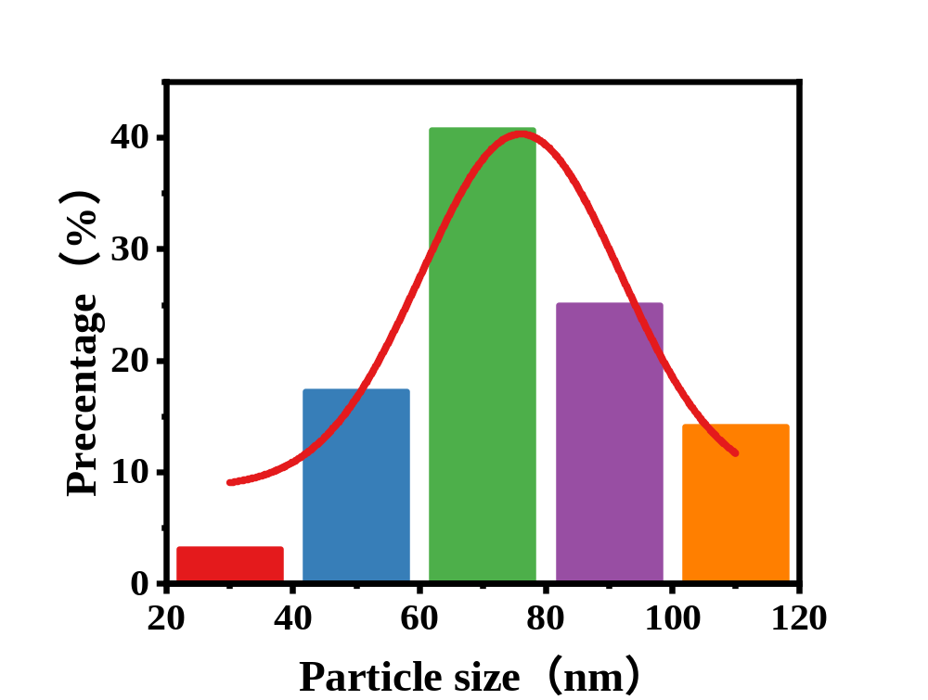
Figure S1. Particle-size distribution of CuO_{x} NPs obtained by ImageJ analysis of TEM micrographs.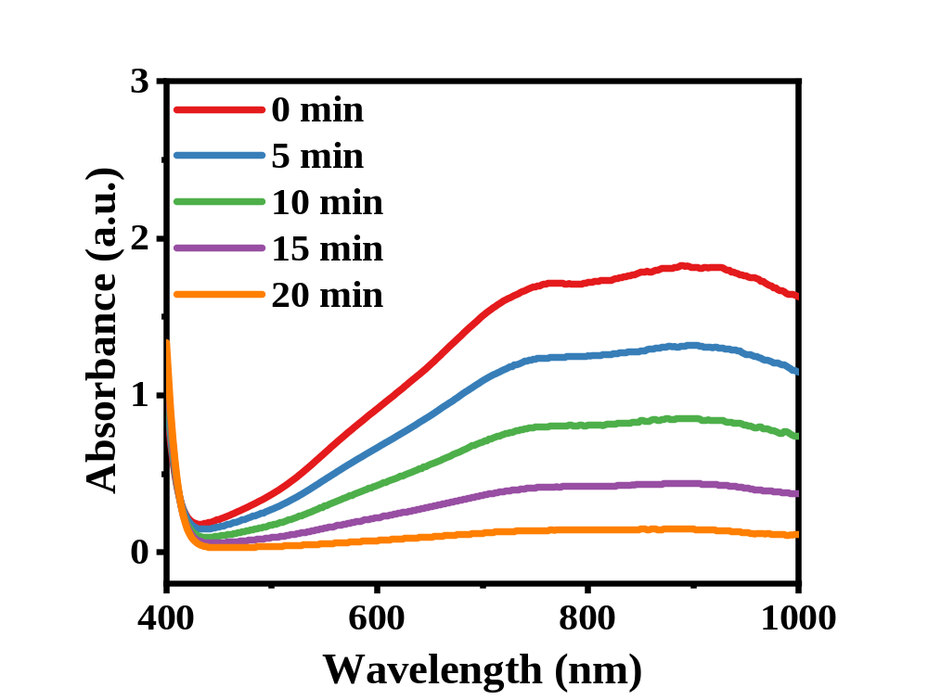
Figure S2. UV–vis absorption spectra demonstrating the time-dependent depletion of cysteine (Cys) after incubation with CuO_{x}. Samples were withdrawn at 0, 5, 10, 15 and 20 min and analyzed with a Cys content kit, the absorbance at 600 nm decreased progressively, confirming continuous Cys consumption.
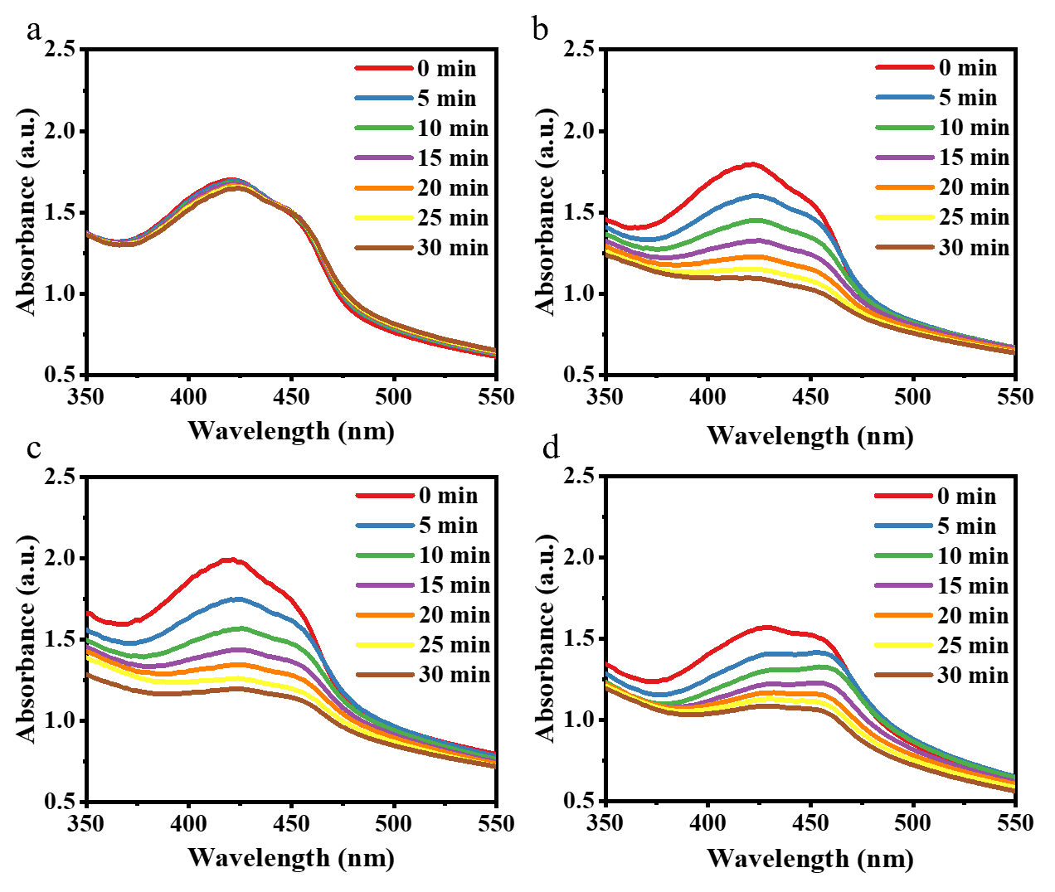
Figure S3. UV–vis absorption spectra of DPBF (1,3-diphenylisobenzofuran, 50 µM) recorded at 0, 5, 10, 15, 20, 25 and 30 min under different conditions. (a) CuO_{x} + N₂, (b) CuO_{x} + H₂O₂, (c) CuO_{x} + Cys + H₂O₂, (d) CuO_{x}. The progressive decrease in absorbance at 425 nm indicates singlet-oxygen-mediated DPBF degradation and thus confirms the photodynamic activity of CuO_{x}, which is markedly enhanced in the presence of both Cys and H₂O₂.
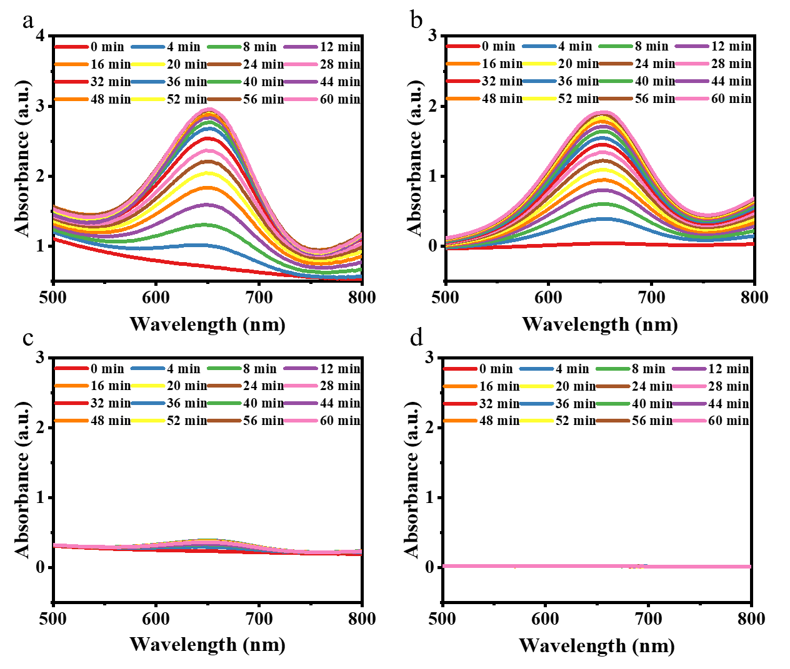
Figure S4. UV–vis absorption spectra of TMB (3,3′,5,5′-tetramethylbenzidine) recorded at 0–60 min to evaluate the peroxidase (POD)-like activity and fenton-like reaction of CuO_{x} under different conditions: (a) pH 6.5 + Cys, (b) pH 6.5, (c) pH 7.4, (d) Control. The continuous increase in absorbance at 650 nm indicates oxidation of TMB by •OH generated via the peroxidase (POD)-like activity and Cu²⁺-mediated Fenton-like reactions. Notably, acidic pH and the presence of Cys markedly enhance the catalytic activity. This indicates that both acidic environments and Cys can promote the production of •OH.
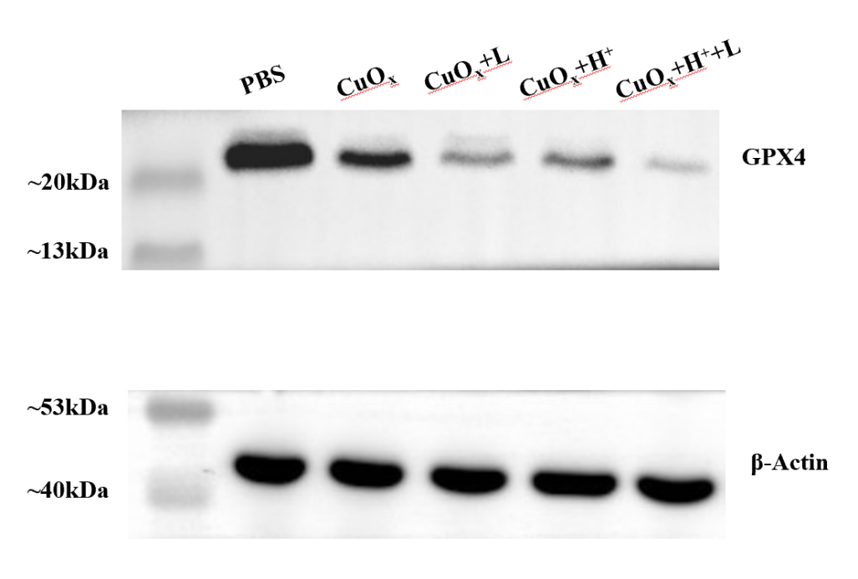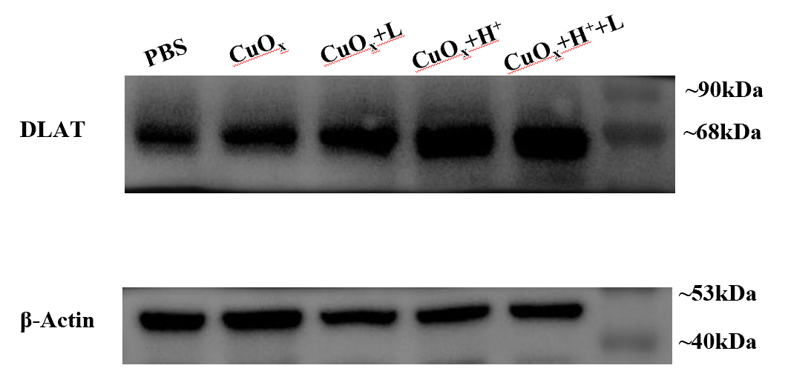
Figure S5. Full Western blot images with molecular weight markers.
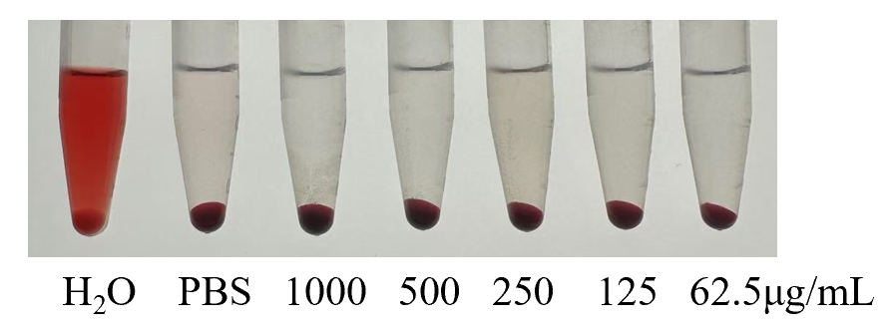
Figure S6. Hemolysis assay of CuO_{x} at different concentrations (62.5, 125, 250, 500 and 1000 µg mL⁻¹) after 2 h incubation with red-blood-cell suspensions at 37 °C. H₂O served as the positive control (100 % hemolysis) and PBS as the negative control (0 % hemolysis). Data are presented as mean ± SD (n = 3).

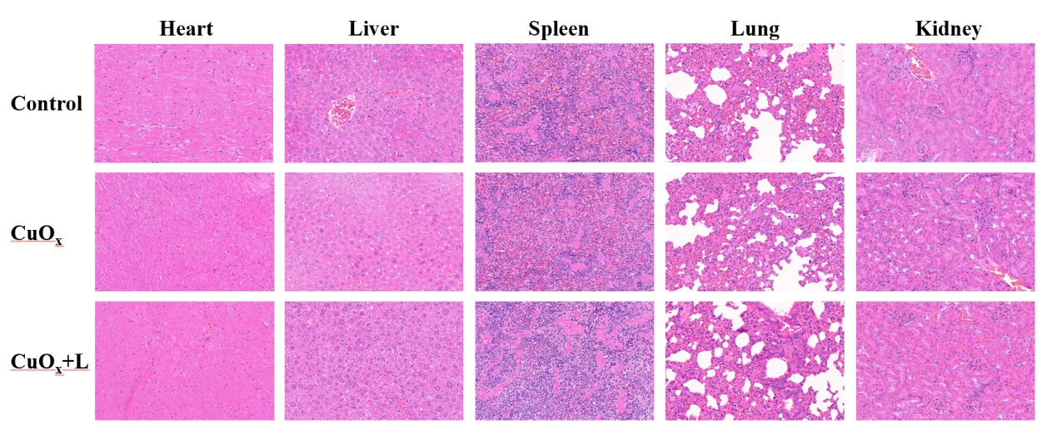
Figure S7. Histological H&E staining of major organs treated with Control, CuO_{x}, CuO_{x} +L.
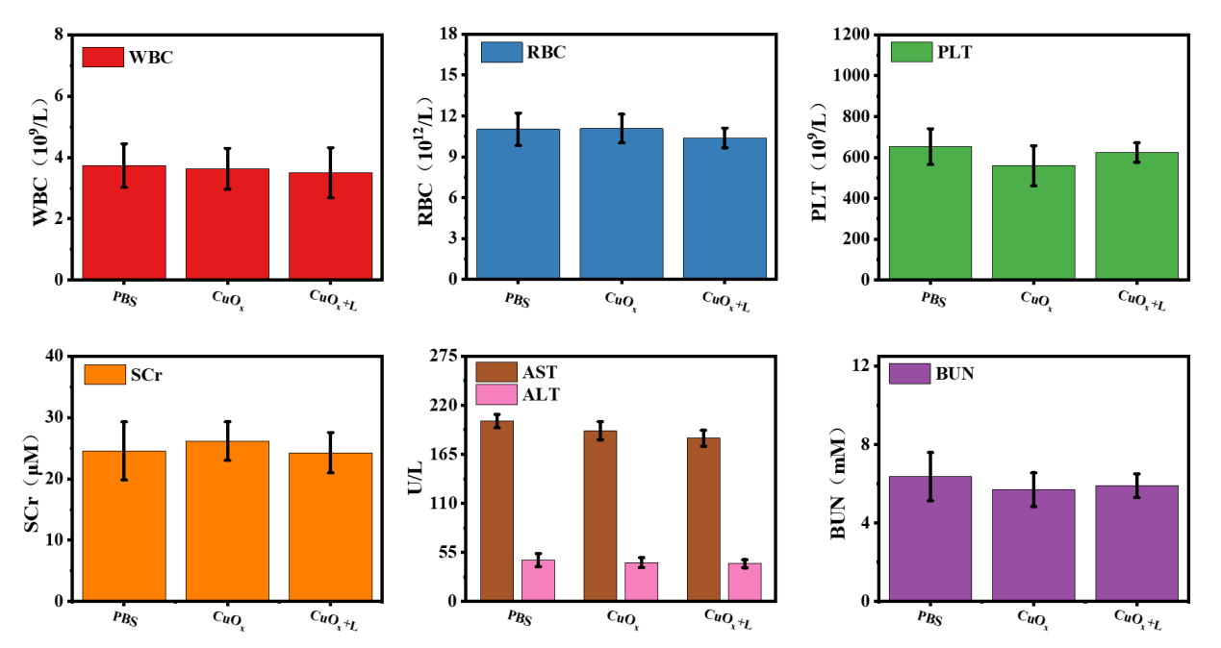
Figure S8. The hematologic and serum biochemical analysis in various groups.

References
[1] M. C. Farach-Carson, S.-H. Lin, T. Nalty, R. L. Satcher, Sex differences and bone metastases of breast, lung, and prostate cancers: Do bone homing cancers favor feminized bone marrow? Front. Oncol. 7 (2017) 163. https://doi.org/10.3389/fonc.2017.00163
[2] E. M. Albores-Mendez, R. G. Casanas-Pimentel, I. R. Reyes-Chacon, et al., Cancer progression is not different in mice of different gender inoculated with cells of the triple-negative 4T1 breast cancer model, World J. Oncol. 13 (2022) 249–258. https://doi.org/10.14740/wjon1517
[3] A. Ucci, L. Giacchi, N. Rucci, Primary bone tumors and breast cancer-induced bone metastases: In vivo animal models and new alternative approaches, Biomedicines 12 (2024) 2451. https://doi.org/10.3390/biomedicines12112451

