Supplementary Information
Hydrogel microneedle delivery of a palmitoylated peptide promotes hair regeneration via dual activation of Wnt/β-catenin and cAMP–PKA signaling

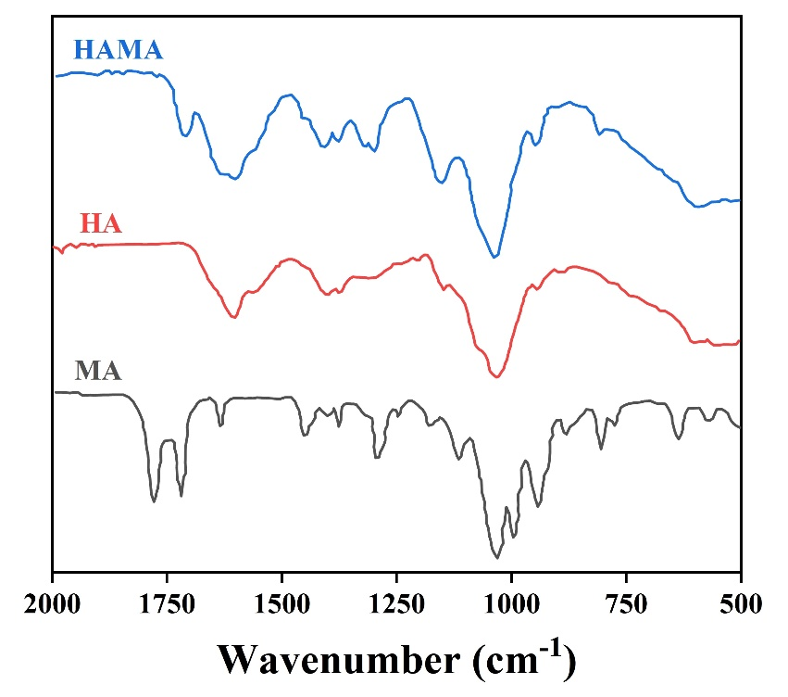
Fig. S1. FTIR spectra of the HA, MA, and HAMA.
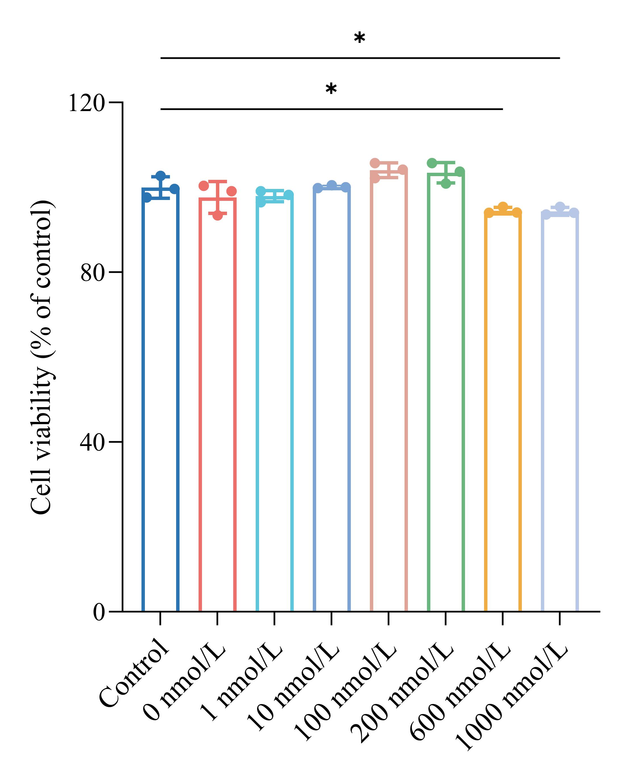
Fig. S2. DPCs were treated with Pal-MPAPO with different concentrations for 24 h. Cell proliferation was measured using the CCK-8 assay. Data points represent mean ± SD. *p < 0.05, **p < 0.01, ***p < 0.001, ****p < 0.0001.
Table S1 Human dermal papilla cell primers
Target Name | Primer
β-actin | Forward | TCCTCCTGAGCGCAAGTACTCC
β-actin | Reverse | CATACTCCTGCTTGCTGATCCAC
GSK3β | Forward | CTTATTCCTCCTCATGCTCGG
GSK3β | Reverse | GCAGAAGCAGCATTATTGGT
Wnt3a | Forward | CTTTGCAGTGACACGCTCAT
Wnt3a | Reverse | ACCATCCCACCAAACTCGAT
Wnt10b | Forward | TGCGAATCCACAACAACAGG
Wnt10b | Reverse | CTTGCATTTCCGCTTCAGGT
β-catenin | Forward | AGCTGGAATTCTTTCTAACCTC
β-catenin | Reverse | CGAAGGACAGTACGCACAA
Lef-1 | Forward | ATGATCCCCTTCAAGGACGAGG
Lef-1 | Reverse | CCGGGATGATTTCAGACTCGTTC
Cyclin D1 | Forward | CGCGTACCCCGATGCCAAC
Cyclin D1 | Reverse | CCAGGTGGCGACGATCTTCC
Bcl-2 | Forward | GAGGAGCTTTGTTTCAACCA
Bcl-2 | Reverse | AATACCATGAATTAAATGCGGAA
VIPR1/VPAC1 | Forward | CCATTCAAGGCCGCAATGTA
VIPR1/VPAC1 | Reverse | CGTAGAACATGGTCTGCTGC
VIPR2/VPAC2 | Forward | CTGTACGAGTGACGGATG
VIPR2/VPAC2 | Reverse | AGCAGCCAGAAGAAGTTG

Table S2. Information on primary antibodies
Primary antibodies | Supplier | Dilution | Source
β-actin | Affinity (AF7018) | 1:5000 | Rabbit
Bcl-2 | Proteintech (12789-1-AP) | 1:2000 | Rabbit
Cyclin D1 | Proteintech (26939-1-AP) | 1:3000 | Rabbit
GSK3β | Proteintech (22104-1-AP) | 1:2000 | Rabbit
Lef-1 | Proteintech (14972-1-AP) | 1:1000 | Rabbit
p-GSK3β | Proteintech (67558-1-Ig) | 1:1500 | Mouse
Wnt3a | Proteintech (26744-1-AP) | 1:800 | Rabbit
Wnt10b | Proteintech (67210-1-Ig) | 1:2000 | Mouse
β-catenin | Proteintech (51067-2-AP) | 1:2000 | Rabbit
PKA | Affinity (AF7746) | 1:1500 | Rabbit

Table S3. Information on secondary antibodies
Secondary antibodies | Supplier | Dilution
HRP- Goat Anti-Rabbit IgG | Abcam (ab214880) | 1:5000
HRP- Goat Anti-Mouse IgG | Abcam (ab6789) | 1:5000

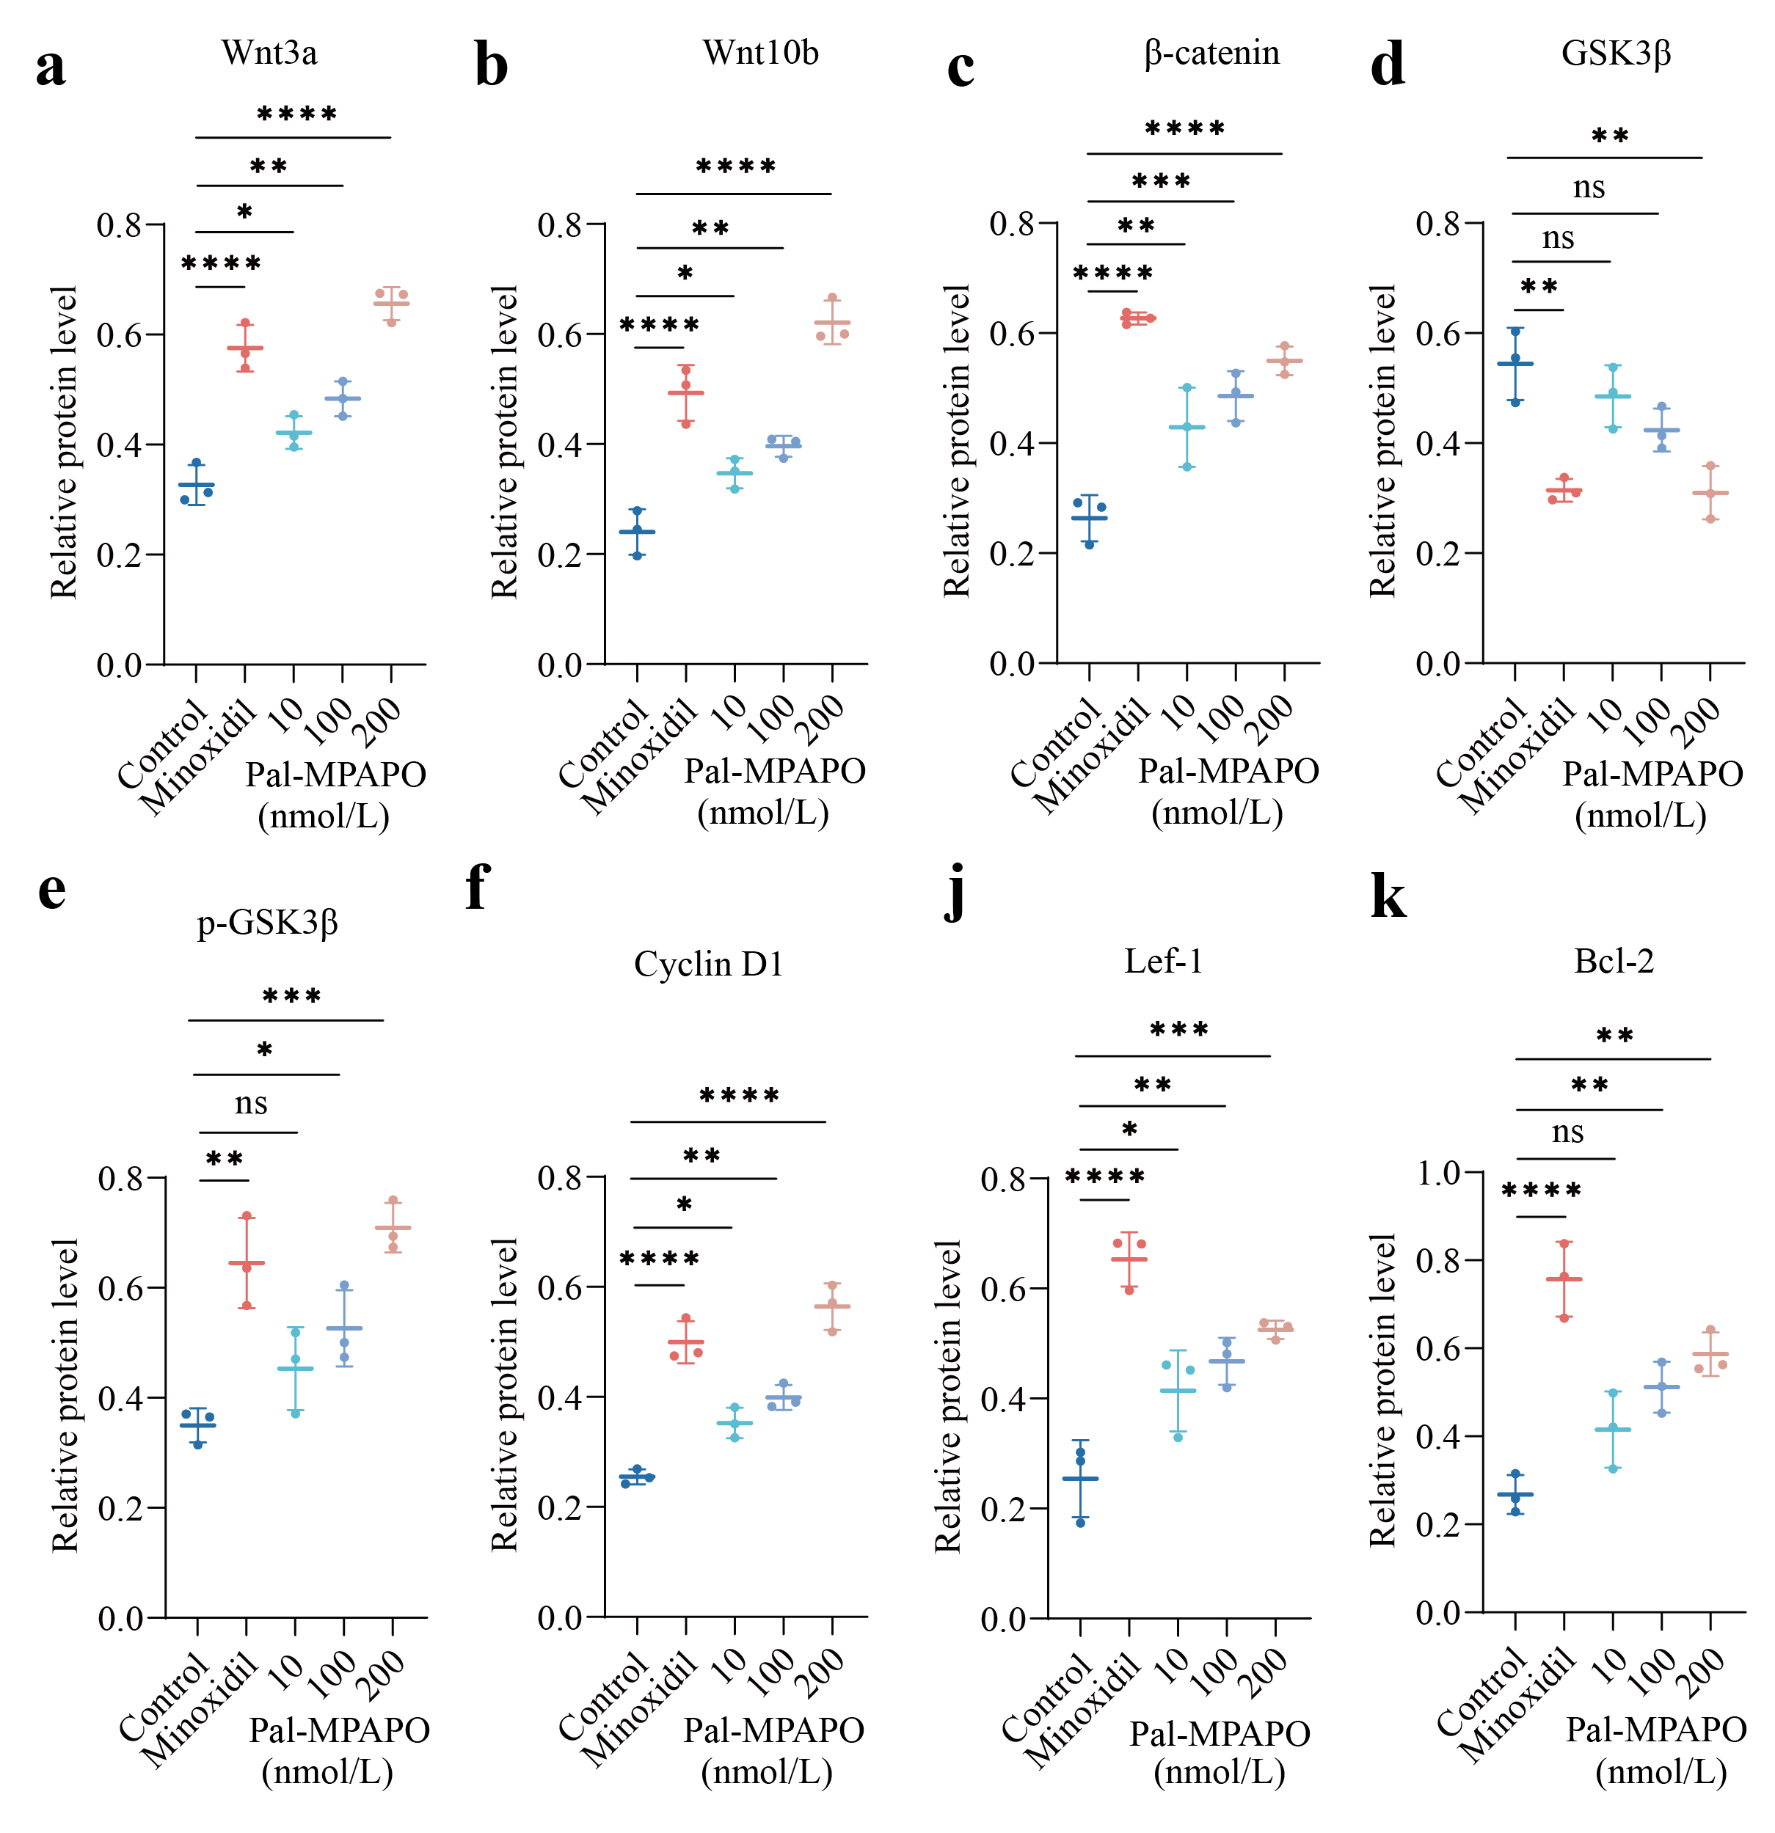
Fig. S3. Quantitative analysis of Wnt3a, Wnt10b, β-catenin, GSK3β, p-GSK3β, Cyclin D1, Lef-1 and Bcl-2 protein levels in the DPCs in different groups. Data points represent mean ± SD. *p < 0.05, **p < 0.01, ***p < 0.001, ****p < 0.0001.
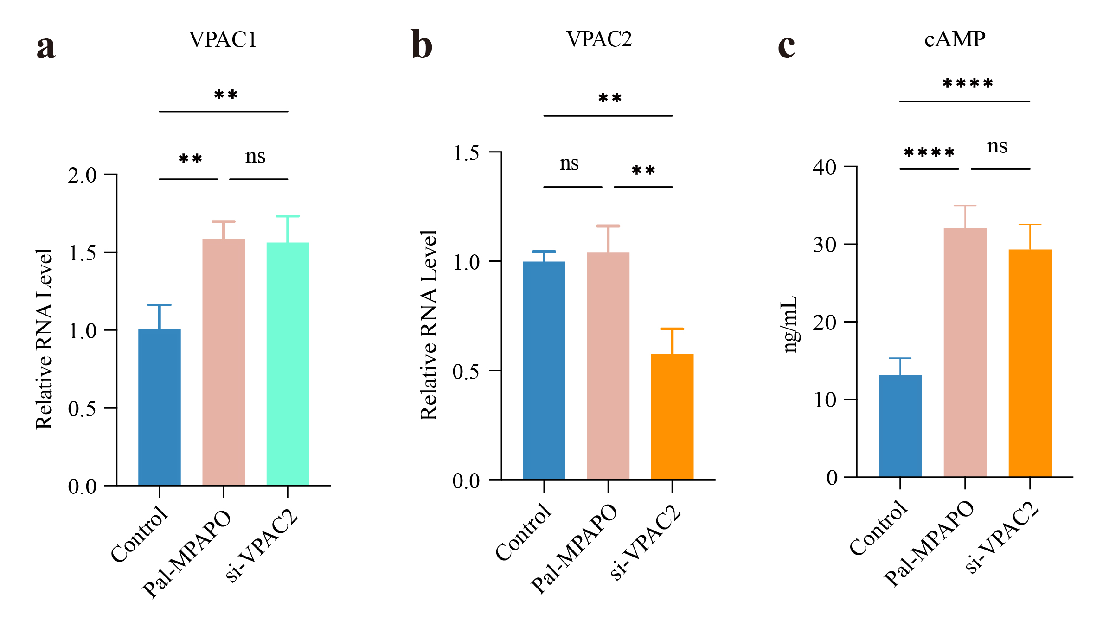
Fig. S4. Additional evaluation of VPAC2 involvement in Pal-MPAPO-induced signaling in DPCs. (a, b) Relative mRNA expression of VPAC1 and VPAC2 after Pal-MPAPO treatment or si-VPAC2 transfection. (c) Intracellular cAMP levels measured by ELISA in different groups. Data are presented as mean ± SD (n = 3). Statistical significance was analyzed by one-way ANOVA. *p < 0.05, **p < 0.01, ***p < 0.001, ****p < 0.0001.
Table S4 mouse tissue primers
Target Name | Primer
β-actin | Forward | CTCCTGAGCGCAAGTACTCT
β-actin | Reverse | TACTCCTGCTTGCTGATCCAC
GSK3β | Forward | TCCCTTGAGATTCTTCCGA
GSK3β | Reverse | TACTTTGTCAAGCTAACCCC
Wnt3a | Forward | GGGAGTCAGCCTTTGTCCAT
Wnt3a | Reverse | ACAGATAGCAGCTGATCCCTC
β-catenin | Forward | AAGAAACCAGCATAGATGACAG
β-catenin | Reverse | AAGGTAAGAGTCACGACCA
Lef-1 | Forward | TCATCTTTGGTTAACGAGTCCGA
Lef-1 | Reverse | TGCTTTCCTTCATCAGGGTGT
Cyclin D1 | Forward | TAAAGTTACTGTGCTGGGTCCTG
Cyclin D1 | Reverse | GGCTGTAGAATCCTATGTCCTC
Bcl-2 | Forward | ACTTCTCTCGTCGCTACCGTC
Bcl-2 | Reverse | CCCCATCCCTGAAGAGTTCCT

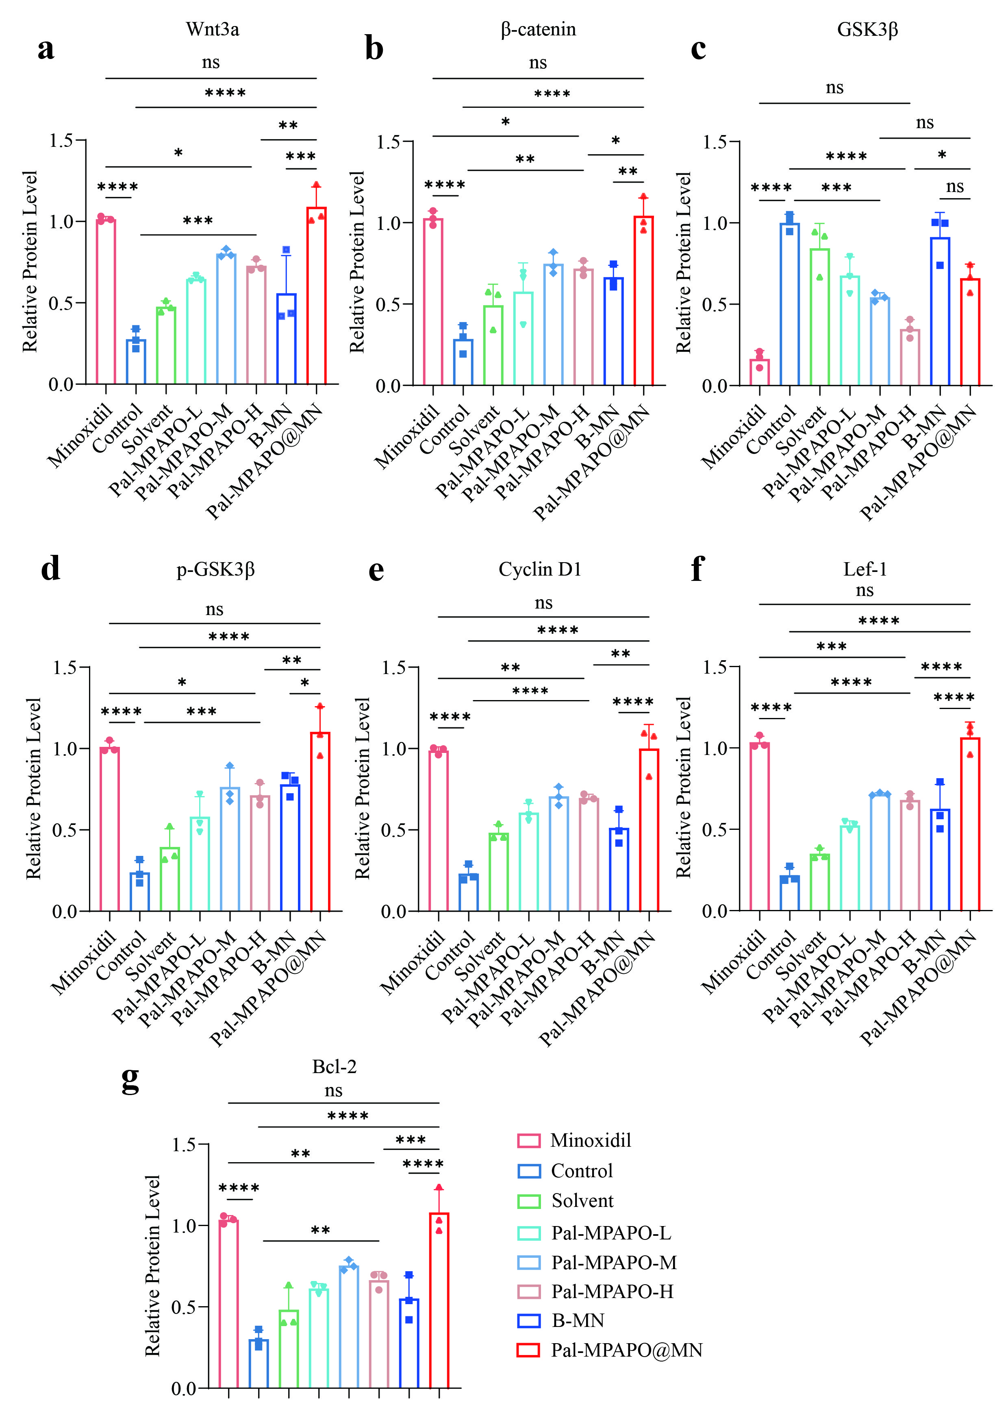
Fig. S5. Quantitative analysis of Wnt3a, β-catenin, GSK3β, p-GSK3β, Lef-1, Cyclin D1 and Bcl-2 protein levels from three independent mice skin tissues, detected by western blotting. Data points represent mean ± SD. *p < 0.05, **p < 0.01, ***p < 0.001, ****p < 0.0001.

