Supplementally materials
Ultrasound-Activated Piezoelectric Bi@Bi-MOF Enables STING-Mediated Immunotherapy for Implant-Associated Infections
Junkai Zeng^{1, 2, #}, Liang Chen^{1, 2, #}, Feihui Zeng^{3, #}, Qunya Zheng^{1, 2}, Songye Wu^{1, 2}, Shengcan Li^{1, 2}, Shanhong Fang^{1, 2}, Hongbin Luo^{1, 2, *}, Deqing Hu^{1, 2, *}, Peng Chen^{1, 2, *}
¹ Department of Sports Medicine, Binhai Campus of the First Affiliated Hospital, National Regional Medical Center, Fujian Medical University, Fuzhou, 350005, PR China.
² Department of Orthopedic Surgery, The First Affiliated Hospital of Fujian Medical University, Fuzhou, 350005, PR China.
³ Department of Endocrinology, Fujian Medical University Union Hospital, Fuzhou,350001, PR China.
*Corresponding authors. E-mail: Peng Chen (13506989645@163.com), Deqing Hu (hudeqing1987@126.com), Hongbin Luo (robin1752@fjmu.edu.cn)
Junkai Zeng#, Liang Chen#, and Feihui Zeng# contributed equally to this work.

Experimental Section
Characterization method
The synthesized materials were characterized using a suite of analytical techniques. Microstructural and morphological analyses were conducted using transmission electron microscopy (TEM; JEOL JEM-2100, 200 kV) and scanning electron microscopy (SEM; Hitachi Regulus 8100). Crystal structure was determined by X-ray diffraction (XRD; Rigaku Ultima IV). Surface chemical composition and bonding states were investigated by X-ray photoelectron spectroscopy (XPS; PHI Genesis 500) and Fourier transform infrared spectroscopy (FT-IR; Nicolet 6700). The particle size distribution in dispersion was measured by dynamic light scattering (DLS; Malvern Nano ZS90). Functional properties were assessed using piezoresponse force microscopy (PFM; Asylum Research MFP-3D, Oxford Instruments) and electron spin resonance spectroscopy (ESR; Bruker EMXplus-6/1).
Synthesis of Bi₂O₂Se ultrathin nanosheets
Following a previously reported procedure, Bi₂O₂Se ultrathin nanosheets were synthesized via a hydrothermal method. ^{[1]} Specifically, 1.48 g of Bi(NO₃)₃·5H₂O was dissolved in 30 mL of deionized water. After complete dissolution, 1.39 g of sodium citrate was added, and the mixture was stirred for 30 minutes to form Solution A. In a separate preparation, 2.664 g of PVP was dissolved in 30 mL of deionized water, followed by the successive addition of 0.60 g of NaOH and 0.148 g of selenourea. The mixture was stirred for 30 minutes to obtain Solution B. After stirring, Solution A was added dropwise into Solution B at a rate of 0.25 mL/min. The resulting mixture was transferred into a 100 mL Teflon-lined autoclave and reacted at 150 °C for 24 hours. The product was then collected and thoroughly washed with deionized water and ethanol to remove impurities. Finally, the Bi₂O₂Se ultrathin nanosheets were obtained after vacuum drying at 60 °C for 12 hours.
Synthesis of Bi-MOF
Bi-MOF was synthesized via a one-step hydrothermal method. In a typical procedure, 2.91 g of Bi(NO₃)₃·5H₂O was dissolved in 60 mL of deionized water under continuous stirring at room temperature. After complete dissolution, 1.87 g of H₂IDC and 0.52 g of piperazine were sequentially added to the solution. The mixture was stirred for 30 minutes and then transferred into a 100 mL Teflon-lined autoclave, where it underwent a hydrothermal reaction at 170 °C for 24 hours. The resulting product was collected and thoroughly washed with deionized water and ethanol to remove impurities. Finally, a pale gray Bi-MOF material was obtained after vacuum drying at 60 °C for 12 hours.
Density functional theory (DFT) calculations
Density functional theory (DFT) calculations were performed to investigate the electronic structure, interfacial charge transfer, and catalytic reaction energetics of Bi₂O₂Se, Bi-MOF, and the Bi@Bi-MOF heterostructure. All calculations were carried out using the Vienna ab initio simulation package (VASP). The projector augmented wave (PAW) method was employed to describe the ion–electron interactions, and the generalized gradient approximation with the Perdew–Burke–Ernzerhof (PBE) functional was used for exchange–correlation effects.
The plane-wave energy cutoff was set to 450 eV, and appropriate Monkhorst–Pack k-point meshes were applied for Brillouin zone sampling. Structural optimizations were performed until the forces on each atom were less than 0.02 eV Å⁻¹ and the total energy convergence threshold reached 10⁻⁵ eV. A vacuum layer of at least 15 Å was introduced to eliminate spurious interactions between periodic images.
Density of states (DOS) and band structure calculations were conducted based on the optimized structures. Charge density difference analyses were performed to evaluate interfacial charge redistribution, defined as
Δρ = ρ(Bi@Bi-MOF) − ρ(Bi₂O₂Se) − ρ(Bi-MOF).
The adsorption behavior of O₂ and reaction intermediates (*O₂, *OOH, *O, and *OH) was investigated by calculating adsorption energies and reaction free energies. Adsorption energies were obtained according to
E_ads = E_surface+adsorbate − E_surface − E_adsorbate.
Reaction free energy profiles were constructed using the computational hydrogen electrode (CHE) model, including zero-point energy and entropy corrections.
Preparation of Bi₂O₂Se@Bi-MOF Composite
The Bi₂O₂Se@Bi-MOF composite structure was obtained by uniformly coating as-prepared Bi-MOF onto Bi₂O₂Se ultrathin nanosheets via a hydrothermal process. Specifically, 400 mg of pre-synthesized Bi₂O₂Se nanomaterial was dispersed in 60 mL of deionized water, followed by the addition of 20 mg of the prepared Bi-MOF material. After ultrasonication for 30 minutes to achieve a homogeneous dispersion, the mixture was transferred into a 100 mL Teflon-lined autoclave and subjected to hydrothermal treatment at 100 °C for 2 hours. The resulting product was collected and thoroughly washed with deionized water and ethanol to remove impurities. Finally, the coated Bi₂O₂Se@Bi-MOF material, designated as Bi@Bi-MOF, was obtained after vacuum drying at 60 °C for 12 hours.
In vitro cytocompatibility
Cytocompatibility was evaluated by CCK-8 assay. For concentration-dependent cytotoxicity analysis, HUVECs were seeded in 96-well plates and incubated with Bi@Bi-MOF at different concentrations (0, 20, 50, 100, 200, and 500 μg/mL) in the presence or absence of ultrasound (US). After 24 h of treatment, CCK-8 reagent was added and incubated at 37 °C for 1–2 h, and the absorbance at 450 nm was measured using a microplate reader. To further evaluate longer-term cytocompatibility, RAW264.7 macrophages, HUVECs, and L929 fibroblasts were seeded in 96-well plates and divided into six groups: Ctrl, US, Bi₂O₂Se, Bi₂O₂Se+US, Bi@Bi-MOF, and Bi@Bi-MOF+US. After the corresponding treatments, the cells were further cultured for 1, 3, and 5 days. At each time point, cell viability was determined by CCK-8 assay following the same procedure described above.
Hemocompatibility was assessed by a hemolysis assay. Fresh red blood cells (RBCs) were collected, washed with PBS, and diluted to prepare a 2% RBC suspension. The suspension was then incubated with different treatments (Ctrl, US, Bi₂O₂Se, Bi₂O₂Se+US, Bi@Bi-MOF, and Bi@Bi-MOF+US). PBS and deionized water were used as the negative and positive controls, respectively. After incubation at 37 °C for 2 h, the samples were centrifuged, and the absorbance of the supernatant was measured at 540 nm. The hemolysis ratio was calculated using the standard formula.
Biofilm antigen release assay
Bacterial suspensions in the logarithmic growth phase (500 μL, 1 × 10⁷ CFU/mL) were seeded onto sterilized titanium discs placed in 24-well plates and incubated at 37 °C for 24 h to allow for mature biofilm formation. The resulting biofilms were then exposed for 24 h to different treatment regimens: phosphate-buffered saline (PBS, control), US (US), Bi₂O₂Se, Bi₂O₂Se + US, Bi@Bi-MOF, and Bi@Bi-MOF + US. The anti-biofilm efficacy was assessed using both live/dead bacterial staining and crystal violet (CV) staining. Viable and non-viable bacterial populations were visualized using the LIVE/DEAD BacLight Bacterial Viability Kit (Thermo Fisher), strictly following the manufacturer's instructions. For CV staining, biofilms were fixed with 1% crystal violet solution for 15 min, rinsed twice with deionized water, and subsequently decolorized with 96% ethanol. The absorbance at 595 nm was measured using a microplate reader to quantify residual biofilm biomass. In addition, the bacterial samples were gently collected, fixed with 2.5% glutaraldehyde at 4 °C overnight, and washed three times with PBS. The samples were then dehydrated through a graded ethanol series, dried, and sputter-coated with gold prior to observation. The bacterial morphology and structural integrity after different treatments were examined by SEM. For bacterial plating analysis, the treated bacterial suspensions were collected, serially diluted with sterile PBS, and spread onto agar plates. After incubation at 37 °C overnight, the colonies were counted and the results were expressed as log₁₀(CFUs/plate).
After washing the biofilm-coated titanium discs three times with sterile PBS, the adherent biofilms were resuspended in 1 mL of sterile normal saline containing Congo red dye (final concentration: 40 μg/mL). Samples were incubated on a shaking incubator at 37 °C and 200 rpm for 2 h. Following incubation, the absorbance of the supernatant was measured at 490 nm, with saline containing Congo red alone serving as a blank control. The Congo red binding efficiency (%) was calculated using the following formula: Binding efficiency (%) = 100 − [(Abs_{sample} × 100) / Abs_{control}]. To quantify extracellular DNA (eDNA), the biofilms after treatment were subjected to genomic DNA extraction using a commercial DNA purification kit (Analytik Jena AG, Jena, Germany), following the manufacturer’s protocol. The concentration of eDNA was determined using a NanoDrop OneC spectrophotometer (Thermo Fisher Scientific). All experiments were conducted in triplicate for each group.
The bacteriolytic activity of various treatments was assessed using an alkaline phosphatase (AKP) assay kit and a β-galactosidase substrate hydrolysis system based on o-nitrophenyl-β-D-galactopyranoside (ONPG). Briefly, biofilm-embedded bacterial cells were subjected to the designated treatments. The culture supernatants were then collected and analyzed using the AKP assay, with absorbance measured at 520 nm using a microplate reader. In parallel, treated biofilms were harvested and resuspended to an optical density of 0.1 at 600 nm to normalize bacterial content. The ONPG substrate was then added, and enzymatic hydrolysis was monitored by measuring absorbance at 420 nm to evaluate lytic kinetics. All experiments were performed in triplicate.
In vitro antimicrobial mechanisms
To delineate the underlying antibacterial mechanism of Bi@Bi-MOF+US, we first quantified intracellular reactive oxygen species (ROS) levels using the fluorescent probe 2′,7′-dichlorofluorescin diacetate (DCFH-DA). Bacterial suspensions post-treatment were incubated with 10 μM DCFH-DA in phosphate-buffered saline (PBS, pH 7.4) at 37 °C for 30 min under light-protected conditions. To eliminate residual extracellular dye, samples were subjected to three rounds of centrifugation (6,000×g, 4 °C, 5 min). Fluorescence intensities were subsequently quantified using both a BD FACSAria III flow cytometer (excitation/emission: 488/530 nm; 10,000 events/sample) and a BioTek Synergy H1 microplate reader (excitation/emission: 485/528 nm). All measurements were conducted under standardized instrument settings and normalized to untreated controls across three independent biological replicates. In addition, bacterial membrane integrity was evaluated by staining the samples with propidium iodide (PI) for 30 minutes. The fluorescence intensity of PI, indicative of compromised cell membranes, was recorded using both a flow cytometer and a microplate reader (excitation/emission: 535/615 nm).
Furthermore, bacterial transcriptome profiling was conducted following Bi@Bi-MOF + US exposure. Differential gene expression analysis was performed using the edgeR algorithm, with thresholds set at P < 0.05 and log₂(fold change) > 1. Gene ontology (GO) and Kyoto Encyclopedia of Genes and Genomes (KEGG) pathway analyses were used to annotate and interpret the transcriptomic changes. In addition, quantitative real-time PCR (qRT-PCR) was carried out to validate the expression of key biofilm-associated genes.
Dendritic cell stimulation and gene expression analysis
Bone marrow–derived dendritic cells (BMDCs) were generated from femurs and tibias of C57BL/6 mice following standard protocols and cultured in RPMI 1640 medium supplemented with 10% fetal bovine serum and GM-CSF. To prepare immunogenic bacterial stimuli, bacteria suspensions were incubated with Bi₂O₂Se or Bi@Bi-MOF nanoparticles, followed by US treatment where indicated. The treated bacterial suspensions were then co-cultured with immature BMDCs for 24 h. Total RNA was extracted from BMDCs using TRIzol reagent and reverse-transcribed into cDNA. Quantitative real-time PCR (qRT–PCR) was performed using SYBR Green Master Mix on a real-time PCR system. The expression levels of STING, TBK1, IRF3, IFN-β, Cxcl10, TNFα, as well as DC-associated genes (Cd40, Ciita, H2-Ab1, H2-D, Ccr7, and Timd4), were normalized to a housekeeping gene (e.g., Gapdh) and calculated using the 2^{⁻ΔΔCt} method.
Immunofluorescence staining of STING in BMDCs
Following co-culture with differently treated bacterial suspensions, BMDCs were fixed with 4% paraformaldehyde, permeabilized with 0.1% Triton X-100, and blocked with bovine serum albumin. Cells were then incubated with a primary antibody against STING, followed by an appropriate fluorescent secondary antibody. Nuclei were counterstained with DAPI. Fluorescence images were acquired using a confocal laser scanning microscope under identical acquisition settings for all groups.
Cytokine secretion analysis by ELISA
After 24 h of co-culture between BMDCs and treated bacterial suspensions, culture supernatants were collected and centrifuged to remove debris. The concentrations of IFN-β, IL-6, CXCL10, and TNF-α were quantified using commercial enzyme-linked immunosorbent assay (ELISA) kits according to the manufacturers’ instructions. Cytokine levels were calculated based on standard curves generated for each analyte.
Assessment of DCs maturation
To evaluate the immunomodulatory effects of various nanomaterials, MRSA suspensions were prepared at a concentration of 1×10⁶ CFU/mL and randomly assigned into six experimental groups: Control, US, Bi₂O₂Se, Bi₂O₂Se + US, Bi@Bi-MOF, and Bi@Bi-MOF + US. Each group was incubated with the corresponding nanomaterial at 37 °C for 2 hours. After this initial exposure, samples designated for sonodynamic treatment were subjected to US irradiation for 5 minutes and then incubated for an additional 2 hours. BMDCs were seeded into 24-well plates at a density of 1×10⁵ cells per well. The pre-treated bacterial suspensions were then added to the BMDC cultures and co-incubated for 24 hours to assess the impact on DC maturation.
Subsequently, flow cytometry analysis was performed to quantify surface expression of key maturation markers. Cells were stained with fluorochrome-conjugated monoclonal antibodies targeting CD45 (AF488; BioLegend, cat. no. 117333, clone N418), CD80 (APC; BioLegend, cat. no. 104713, clone 16-10A1), and CD86 (PerCP/Cy5.5; BioLegend, cat. no. 105012, clone GL-1) for 30 minutes at 4 °C in the dark. After washing, samples were analyzed using a BD Biosciences flow cytometer, and the resulting data were processed using FlowJo software (version 10).
Transcriptomic profiling of DCs
To investigate transcriptional changes in DCs induced by treated Staphylococcus aureus, bacterial suspensions (1×10⁶ CFU/mL in PBS) were divided into two groups: control and Bi@Bi-MOF + US. For the Bi@Bi-MOF + US group, Bi@Bi-MOF nanomaterials were added to the bacterial suspension, followed by 5 minutes of US stimulation. The control group received an equal volume of PBS. Both groups were incubated at 37 °C for 6 hours.
BMDCs were seeded in six-well plates at a density of 1×10⁶ cells per well and cultured under standard conditions (37 °C, 5% CO₂). After laser treatment, the prepared bacterial suspensions were added to the corresponding wells and co-incubated with DCs for 24 hours to mimic infection-mediated immune activation. Following incubation, culture media were removed and the cells were washed three times with sterile PBS. Total RNA was extracted using 1 mL of TRIzol reagent (Invitrogen, USA) according to the manufacturer's protocol. The purified RNA samples were submitted to Shanghai Majorbio Bio-pharm Technology Co., Ltd. for high-throughput RNA sequencing and bioinformatics analysis.
Macrophage culture, polarization, and functional assessment
The murine macrophage cell line RAW264.7 was obtained from the American Type Culture Collection (ATCC, Manassas, VA, USA) (RRID: CVCL_0493). This cell line was tested and certified by ATCC to be free of mycoplasma contamination. Cells were maintained in DMEM supplemented with 10% FBS under a humidified atmosphere of 5% CO₂ at 37 °C.
For in vitro assays, RAW264.7 cells were seeded into 24-well plates at a density of 1×10⁵ cells/well and allowed to adhere for 24 hours. The culture medium was then replaced with biofilm-conditioned media (BCMs), followed by another 24-hour incubation. Total RNA was extracted using TRIzol reagent (Invitrogen), and reverse transcription was performed with the PrimeScript RT Kit (Takara). Gene expression levels were normalized to β-actin and analyzed via quantitative PCR. The secretion of inflammatory cytokines, including tumor necrosis factor-α (TNF-α) and interleukin-6 (IL-6), was quantified from cell culture supernatants using ELISA kits according to the manufacturer’s instructions. For immunofluorescence staining, cells were fixed with 4% paraformaldehyde, permeabilized with 0.1% Triton X-100, and incubated overnight at 4 °C with anti-iNOS (ab210823, 1:200) and anti-CD206 (ab64693, 1:200) primary antibodies. After washing, cells were incubated with Alexa Fluor 488-conjugated secondary antibodies (1:500) and counterstained with DAPI (1 μg/mL, 1 h). Fluorescent images were acquired using a confocal laser scanning microscope (CLSM, Leica TCS SP8). Flow cytometry was performed to evaluate macrophage polarization using anti-CD86 (PerCP/Cy5.5; BioLegend, cat. no. 105012, clone GL-1) and anti-CD206 (AF647; BioLegend, cat. no. 141711, clone C068C2) antibodies.
Phagocytic capacity was assessed by co-incubating BCM-treated macrophages with CFDA-SE-labeled Staphylococcus aureus (multiplicity of infection, MOI = 10:1) for 2 hours at 37 °C. Extracellular bacteria were removed by treatment with vancomycin (50 μg/mL) for 1 hour. After washing and fixation, cells were stained with Dil (5 μM) and imaged by CLSM. Flow cytometry was also used to quantify bacterial internalization, using a similar protocol without cell membrane staining. For colony-forming unit (CFU) enumeration, infected macrophages were lysed with 0.1% Triton X-100, serially diluted, and plated on TSB agar. CFUs were counted after 24 hours of incubation.
Primary IAIs mice model
Titanium discs (6 mm in diameter, 0.5 mm in thickness) were sterilized and placed into 6-well plates. Each well was inoculated with 2 mL of methicillin-resistant Staphylococcus aureus (MRSA) suspension (1×10⁷ CFU/mL) and incubated for 48 hours at 37 °C in a 5% CO₂ atmosphere to promote mature biofilm formation. The biofilm-coated discs were then harvested and used to establish a subcutaneous biofilm-associated infection model in mice. All animal procedures were approved by the Animal Ethics and Welfare Committee of Fujian Medical University (approval no. IACUC FJMU 2024-Y-1735) and performed in accordance with institutional guidelines.
A total of 60 male C57BL/6J mice were randomly assigned into five groups (n = 10 per group): PBS (control), US, Bi₂O₂Se, Bi₂O₂Se + US, Bi@Bi-MOF, and Bi@Bi-MOF + US. Under aseptic conditions and anesthesia, a small incision was made on the dorsal skin of each mouse, and a biofilm-covered titanium disc was implanted subcutaneously to induce localized infection. On postoperative days 3 and 7, mice in the treatment groups received local injections of 100 μL Bi₂O₂Se or Bi@Bi-MOF (1 mg/mL), followed by US irradiation (5 min, 1.5 W/cm²). Mice in the control group were injected with an equal volume of PBS. On day 8, all animals were humanely euthanized by CO₂ overdose. The infected soft tissue surrounding the implant site was harvested, homogenized in 5 mL pre-chilled sterile PBS, and cultured on tryptic soy agar (TSA) plates at 37 °C for 24 hours to quantify bacterial load (CFUs). Residual biofilms on retrieved titanium discs were evaluated by scanning electron microscopy (SEM) and live/dead bacterial staining. Immunofluorescence staining was performed on the peri-implant tissue to assess iNOS and CD206 expression.
To further characterize immune cell infiltration, skin tissue surrounding the infection site was excised, minced, and enzymatically digested in a solution containing 1 mg/mL collagenase (Sigma), 1 mg/mL hyaluronidase (Sigma), and 0.1 mg/mL DNase I (Roche) at 37 °C for 1 hour under agitation. The resulting single-cell suspensions were stained with the following fluorophore-conjugated antibodies: CD45 (AF488; BioLegend, cat. no. 160305, clone S18009D), CD11b (PE-Cy7; BioLegend, cat. no. 101215, clone M1/70), F4/80 (BV421; BioLegend, cat. no. 123127, clone BM8), and CD206 (AF647; BioLegend, cat. no. 141711, clone C068C2), followed by flow cytometric analysis. To evaluate systemic biosafety, major organs—including heart, spleen, lung, liver, and kidney—were collected and subjected to histopathological examination after treatment with Bi@Bi-MOF + US.
In vivo biosafety evaluation
To evaluate the systemic biosafety of Bi@Bi-MOF + US treatment, a murine implant-associated infection (IAIs) model was employed. At the end of the treatment period, whole blood samples (approximately 200 μL per mouse) were collected from the retro-orbital sinus into tubes containing ethylenediaminetetraacetic acid (EDTA) anticoagulant and stored at 4 °C prior to analysis. Hematological parameters, including red blood cell count (RBC), white blood cell count (WBC), platelet count (PLT), granulocyte percentage (Gran%), and lymphocyte percentage (Lymph%), were measured using an automated hematology analyzer (e.g., Mindray BC-2800Vet, China). For serum biochemical analysis, an additional 200 μL of blood was collected without anticoagulant from the same mice. The samples were allowed to clot at room temperature for 2 h and then centrifuged to obtain serum. Liver and kidney function indicators, including alanine aminotransferase (ALT), aspartate aminotransferase (AST), urea, and serum creatinine (CREA), were quantified using commercial assay kits according to the manufacturers’ instructions. At the experimental endpoint, mice were euthanized under isoflurane anesthesia. Major organs, including the heart, liver, spleen, lungs, and kidneys, were harvested and fixed in 4% paraformaldehyde. After paraffin embedding, tissue sections (5 μm) were prepared and subjected to hematoxylin and eosin (H&E) staining. Histological morphology was examined using a light microscope to assess potential tissue damage or systemic toxicity.
Immune profiling of draining lymph nodes
To characterize the immune response elicited by the different treatments, immune cell infiltration in infection-associated draining lymph nodes (IDLNs) was comprehensively analyzed by flow cytometry. IDLNs were carefully dissected and gently dissociated into small fragments using the MACS™ tissue dissociation protocol. Samples were then enzymatically digested in a solution containing 0.1 mg/mL DNase I (Roche) and 1 mg/mL collagenase IV (Sigma-Aldrich) at 37 °C for 1 hour in a humidified incubator. Following digestion, the resulting cell suspension was filtered through a 70 μm cell strainer (BD Biosciences), centrifuged, washed with PBS, and resuspended for subsequent immunostaining.
Single-cell suspensions were incubated with fluorochrome-conjugated monoclonal antibodies against the following surface markers: CD45 (AF488; BioLegend, cat. no. 160305, clone S18009D), CD3 (PE; BioLegend, cat. no. 100205, clone 17A2), CD4 (BV605; BioLegend, cat. no. 100547, clone RM4-5), CD8a (PerCP/Cy5.5; BioLegend, cat. no. 100733, clone 53-6.7), CD11b (PE-Cy7; BioLegend, cat. no. 101215, clone M1/70), CD11c (BV605; BioLegend, cat. no. 117333, clone N418), CD80 (APC; BioLegend, cat. no. 104713, clone 16-10-A1), CD86 (PerCP/Cy5.5; BioLegend, cat. no. 105012, clone GL-1), Gr-1 (PE; BioLegend, cat. no. 108407, clone RB6-8C5), and NK1.1 (BV421; BioLegend, cat. no. 123131, clone BM8). Flow cytometric acquisition was performed using a CytoFLEX instrument (Beckman Coulter), and data were analyzed with FlowJo software (v10.8.1). Detailed gating strategies are provided in the Supplementary Figure S11–S15.
Recurrent IAIs mouse model
To evaluate the protective efficacy of various treatments against reinfection, a biofilm-associated infection model was established on day 1 using 60 male BALB/c mice by subcutaneous implantation of biofilm-covered titanium discs. On day 9 post-infection, mice were randomly divided into six groups (n = 10 per group): PBS (control), US, Bi₂O₂Se, Bi₂O₂Se + US, Bi@Bi-MOF, and Bi@Bi-MOF + US. All treatment groups received local administrations as previously described.
On day 10, under sterile conditions, infected implants were surgically explanted, and surrounding necrotic tissue was thoroughly debrided. Infected tissue was excised, and the wound was closed with sutures. The following day, a fresh biofilm-covered titanium disc was implanted into the same anatomical site to initiate a reinfection challenge. Wound healing and infection progression were monitored daily using caliper-based measurements until day 24. All surviving mice were humanely euthanized for endpoint analysis.
Bacterial burden at the infection site was quantified by standard colony-forming unit (CFU) enumeration. Retrieved implants were subjected to live/dead bacterial staining, and peri-implant tissue sections were processed for Gram staining to assess residual microbial activity. Spleens were harvested, and single-cell suspensions were prepared using the previously described enzymatic digestion protocol. Cells were stained on ice for 30 minutes with fluorophore-conjugated antibodies against CD45, CD3, CD4, CD8a, CD44, CD62L, CD19, and CD38 (BioLegend), followed by flow cytometric analysis using a CytoFLEX system (Beckman Coulter). Data were analyzed using FlowJo software (v10.8.1). Serum IgG antibody levels were quantified using a commercial ELISA kit according to the manufacturer’s instructions.
Statistical Analysis
Unless otherwise specified, all quantitative data are presented as mean ± standard deviation (s.d.). Statistical comparisons between two groups were performed using two-tailed Student’s t-tests. For multiple group comparisons, one-way analysis of variance (ANOVA) followed by Tukey’s post hoc test was employed, unless stated otherwise. All statistical analyses were conducted using Microsoft Excel 2016 and GraphPad Prism 9. A p-value < 0.05 was considered statistically significant.

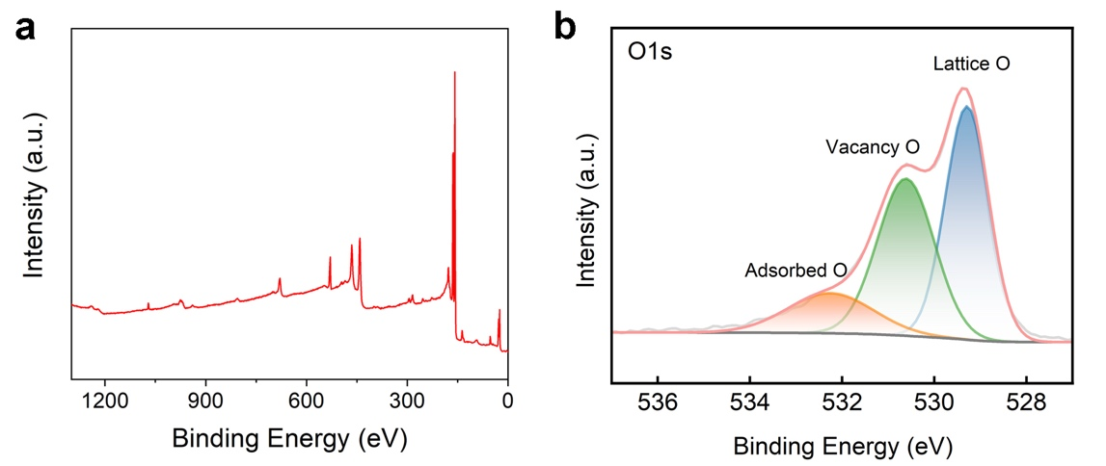
Figure S1. High-resolution XPS spectra.
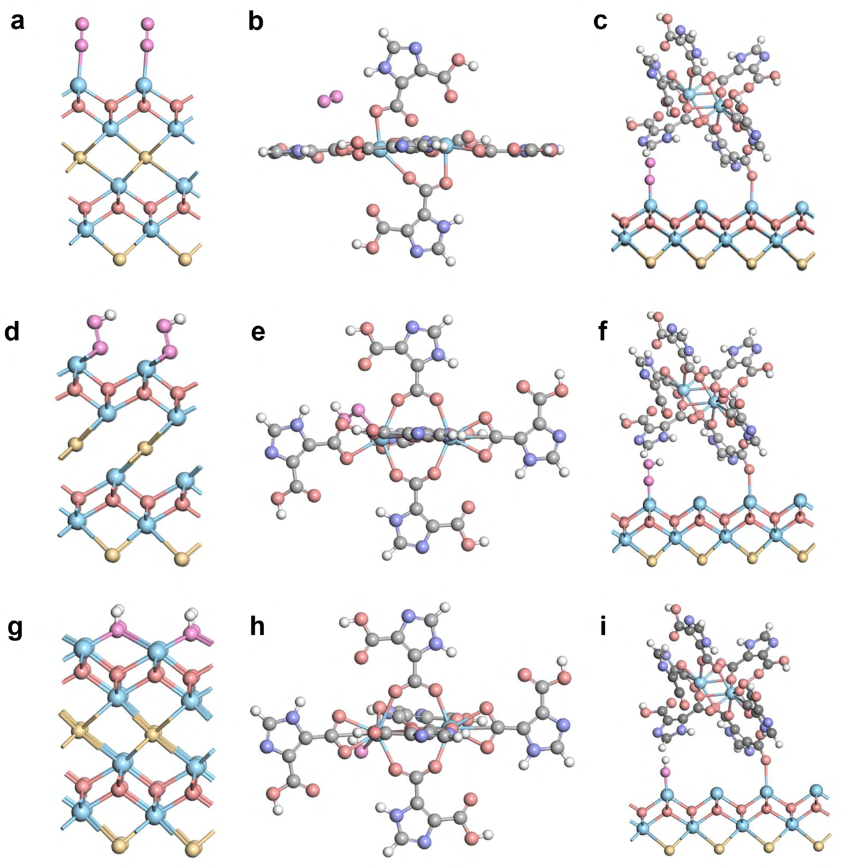
Figure S2. The models of O₂ adsorption in (a) Bi₂O₂Se, (b) Bi-MOF and (c) Bi@Bi-MOF. The models of OOH adsorption in (d) Bi₂O₂Se, (e) Bi-MOF and (f) Bi@Bi-MOF. The models of OH adsorption in (g) Bi₂O₂Se, (h) Bi-MOF and (i) Bi@Bi-MOF.
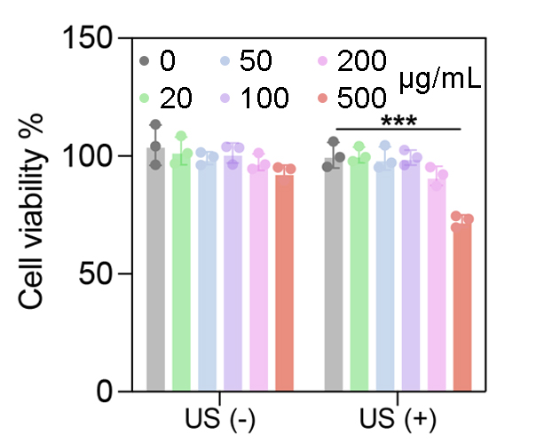
Figure S3. Cell viability after 24 h treatment with Bi@Bi-MOF at different concentrations with or without US. Data are shown as mean ± SD. *p < 0.05, **p < 0.01, ***p < 0.001, NS, not significant.
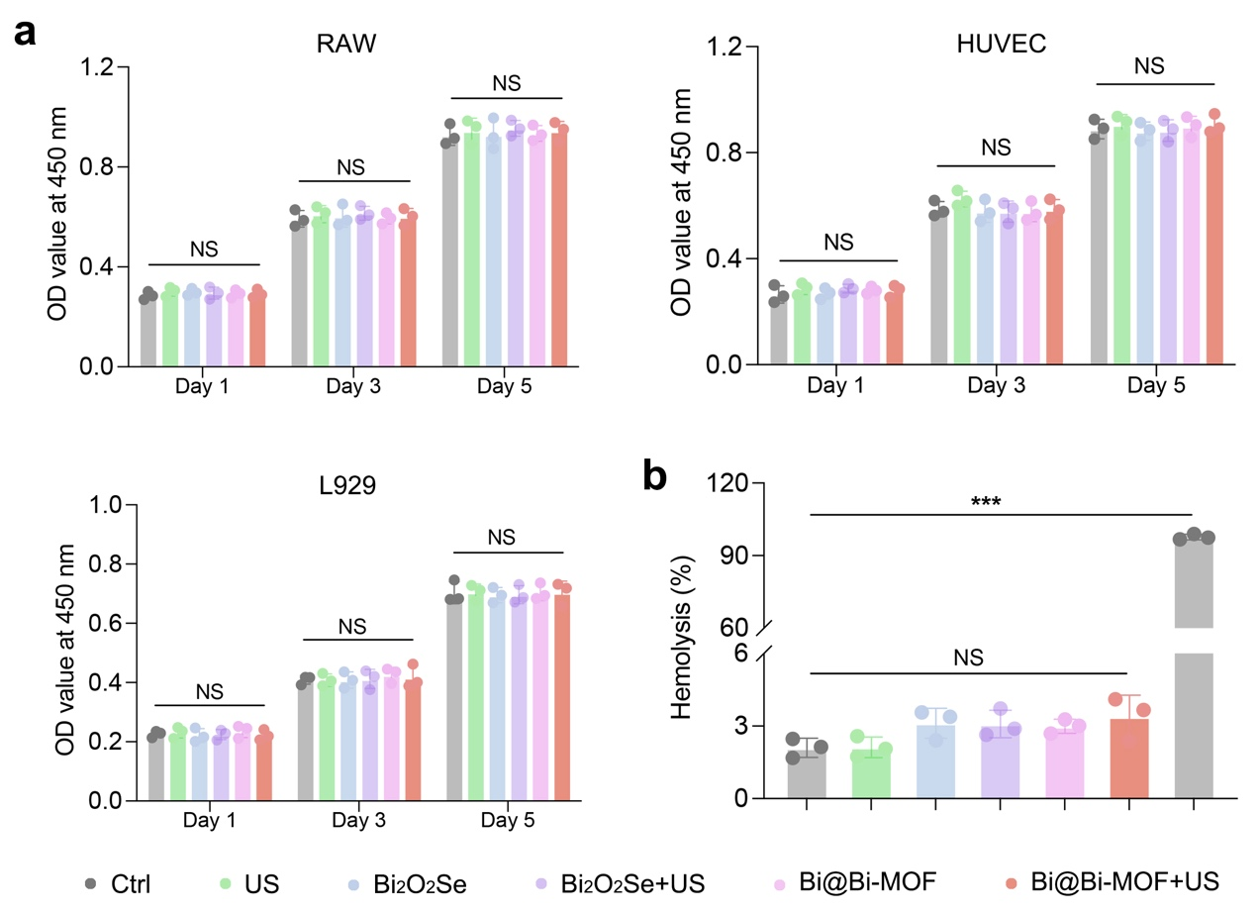
Figure S4. Evaluation of in vitro biosafety. (a) CCK-8 assay of RAW264.7, HUVEC, and L929 cells after different treatments for 1, 3, and 5 days. (b) Hemolysis assay after different treatments. Data are shown as mean ± SD. *p < 0.05, **p < 0.01, ***p < 0.001, NS, not significant.
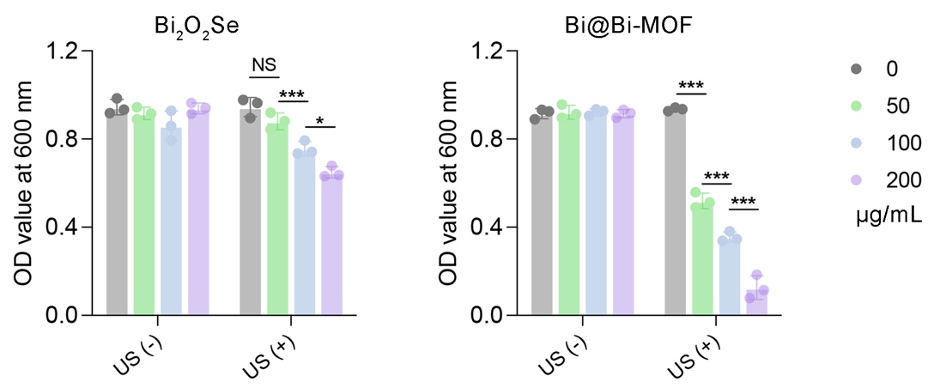
Figure S5. OD600 measurements of MRSA cultures after treatment with Bi₂O₂Se or Bi@Bi-MOF at different concentrations. Data are shown as mean ± SD. *p < 0.05, **p < 0.01, ***p < 0.001, NS, not significant.

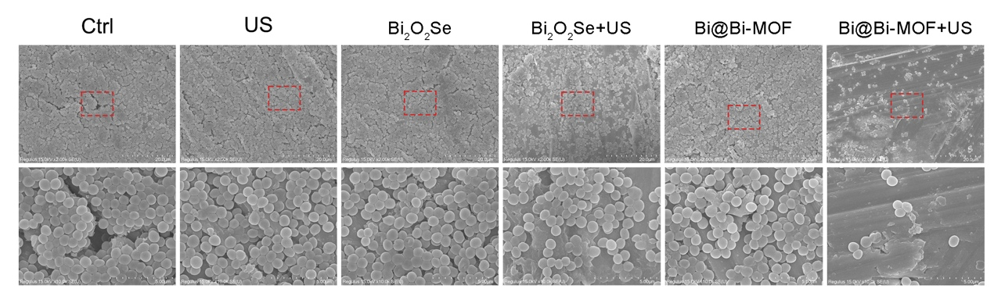
Figure S6. SEM images of biofilm after different treatments, including Ctrl, US, Bi₂O₂Se, Bi₂O₂Se+US, Bi@Bi-MOF, and Bi@Bi-MOF+US.

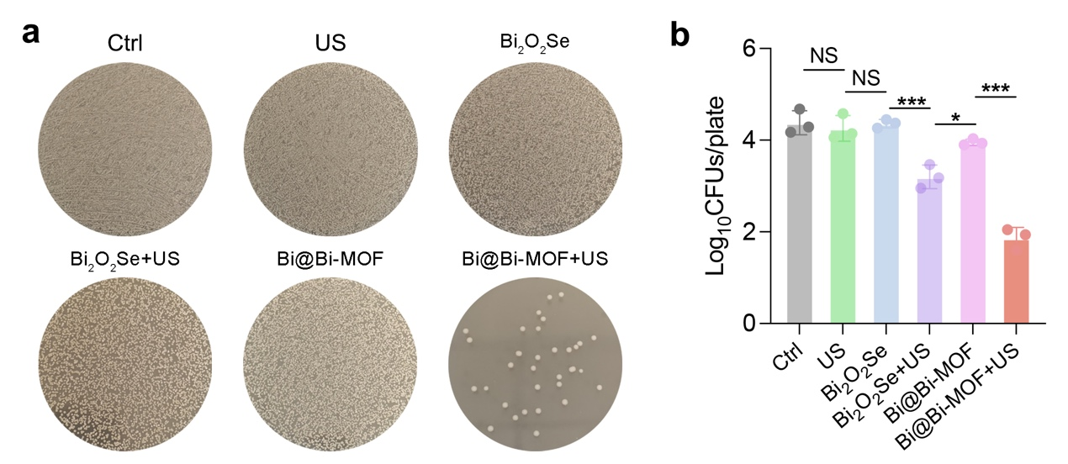
Figure S7. Bacterial plating assay of biofilm after different treatments.
(a) Representative images of bacterial colonies after treatment with Ctrl, US, Bi₂O₂Se, Bi₂O₂Se+US, Bi@Bi-MOF, and Bi@Bi-MOF+US. (b) Quantitative analysis of bacterial survival presented as log₁₀(CFUs/plate). Data are shown as mean ± SD. *p < 0.05, **p < 0.01, ***p < 0.001, NS, not significant.
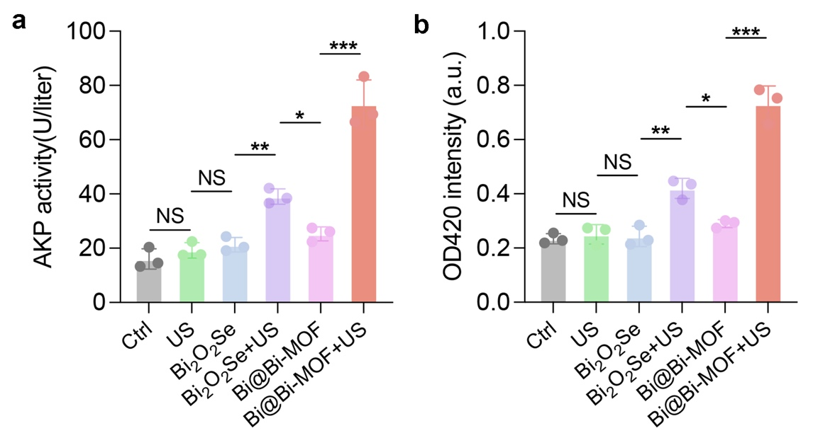
Figure S8. (a) Sensitivity of treated bacteria to alkaline phosphatase (AKP) activity, reflecting outer membrane integrity. (b) o-Nitrophenyl-β-D-galactopyranoside (ONPG) hydrolysis assay evaluating β-galactosidase leakage, indicative of inner membrane disruption. Data are shown as mean ± SD. *p < 0.05, **p < 0.01, ***p < 0.001, NS, not significant.
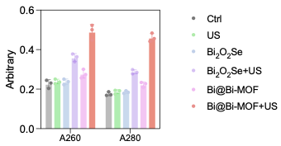
Figure S9. Leakage of cell contents after exposure to various treatments was investigated by monitoring the absorbance of extracellular material at 260 nm and 280 nm corresponding to nucleic acids and proteins, respectively.

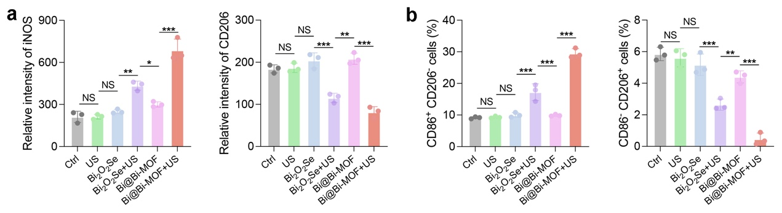
Figure S10. (a) Quantitative analysis of M1/M2 polarization from immunofluorescence images. (b) Statistical comparison of M1-type (CD86⁺CD206⁻) and M2-type (CD86⁻CD206⁺) macrophage populations across treatment groups. Data are shown as mean ± SD. *p < 0.05, **p < 0.01, ***p < 0.001, NS, not significant.

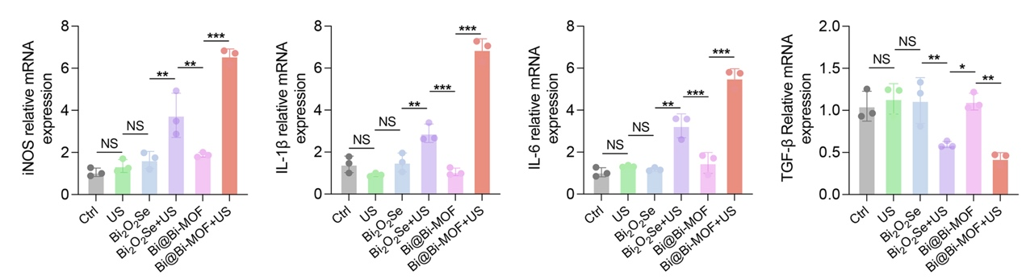
Figure S11. Quantitative real-time PCR (qPCR) analysis of M1-related (e.g., iNOS, IL-1-β, and IL-6) and M2-related (e.g., TGF-β) gene expression in macrophages. Data are shown as mean ± SD. *p < 0.05, **p < 0.01, ***p < 0.001, NS, not significant.

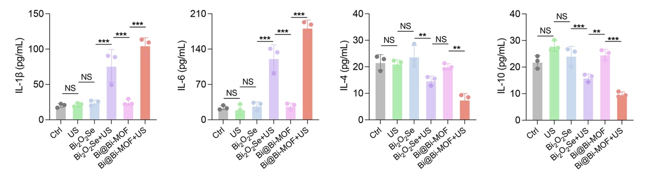
Figure S12. Enzyme-linked immunosorbent assay (ELISA) quantifying the secretion levels of pro-inflammatory cytokines (IL-1β, IL-6 ) and the anti-inflammatory cytokine (IL-4, IL-10). Data are shown as mean ± SD. *p < 0.05, **p < 0.01, ***p < 0.001, NS, not significant.
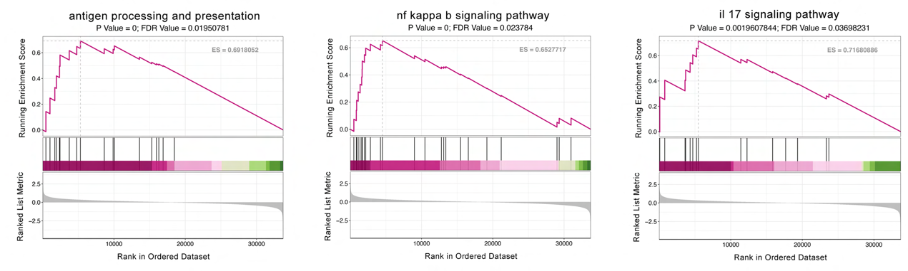
Figure S13. GSEA of representative immune signaling pathways in Bi@Bi-MOF + US-treated group.
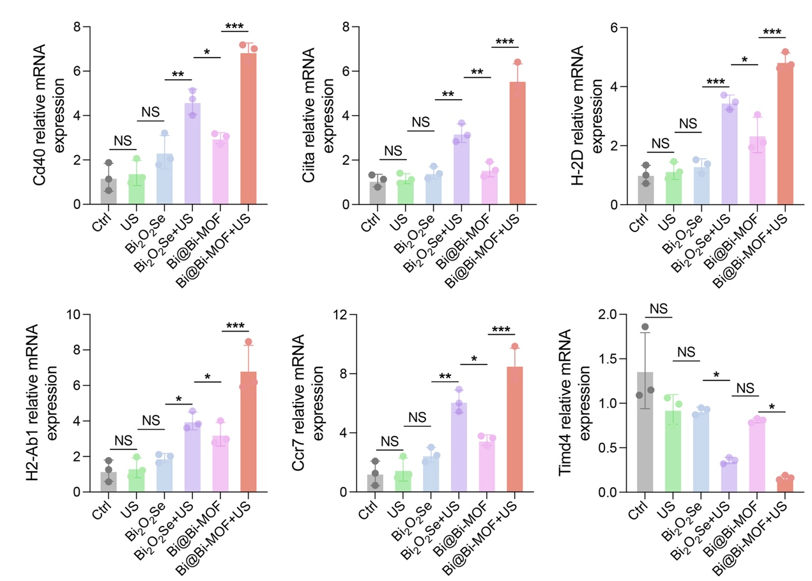
Figure S14. qPCR analysis of dendritic cell–related genes. Data are shown as mean ± SD. *p < 0.05, **p < 0.01, ***p < 0.001, NS, not significant.

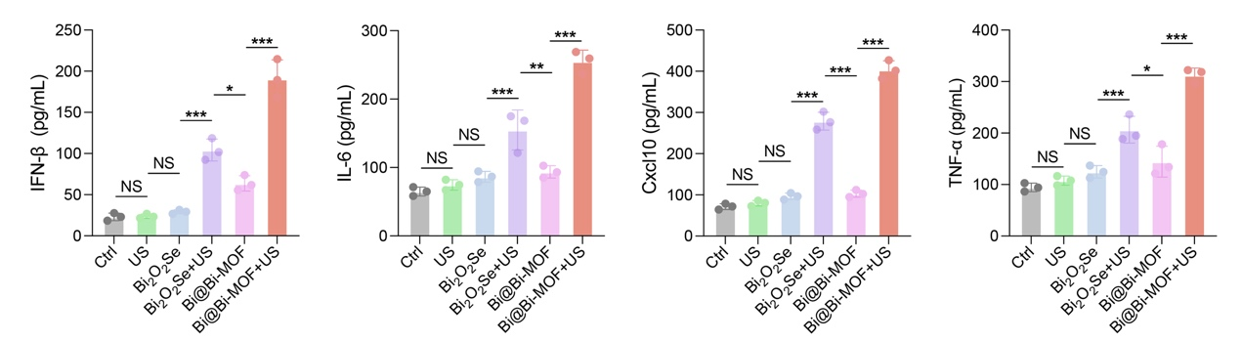
Figure S15. ELISA analysis of cytokine secretion by BMDCs. Data are shown as mean ± SD. *p < 0.05, **p < 0.01, ***p < 0.001, NS, not significant.

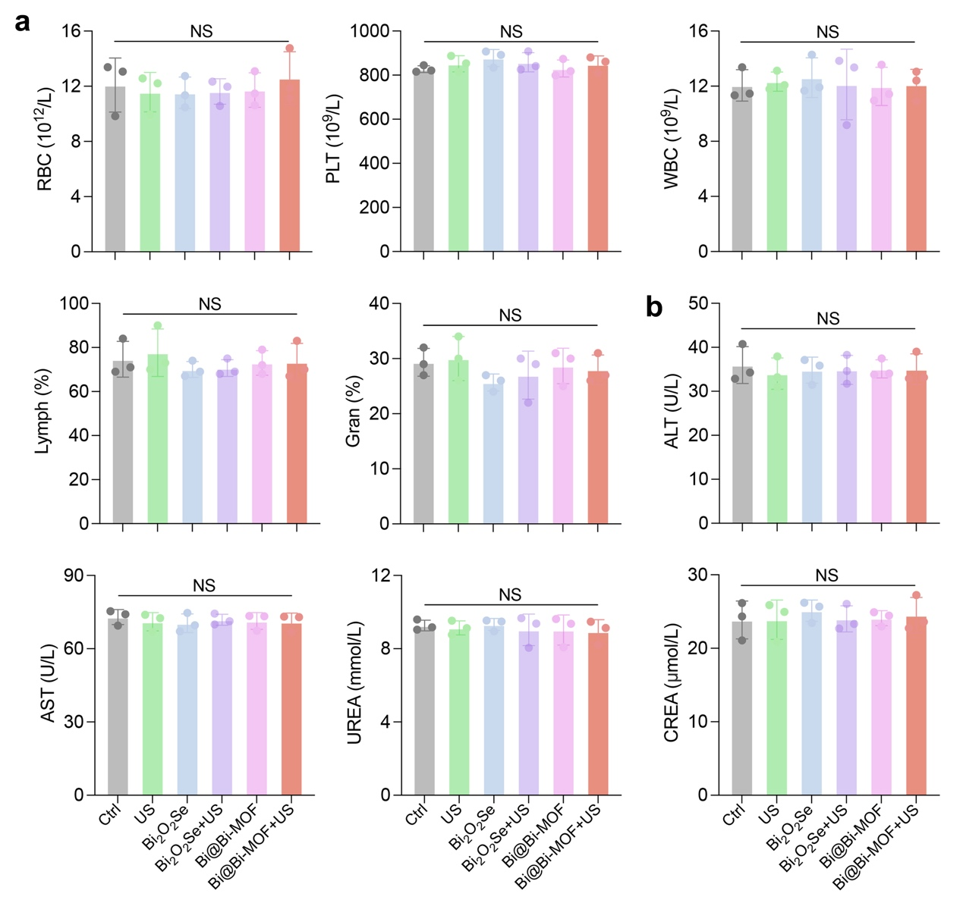
Figure S16. Hematological parameters included RBC, PLT, WBC, Lymph, and Gran. Serum biochemical indices included ALT, AST, urea, and CREA. Data are shown as mean ± SD. Data are shown as mean ± SD. *p < 0.05, **p < 0.01, ***p < 0.001, NS, not significant.
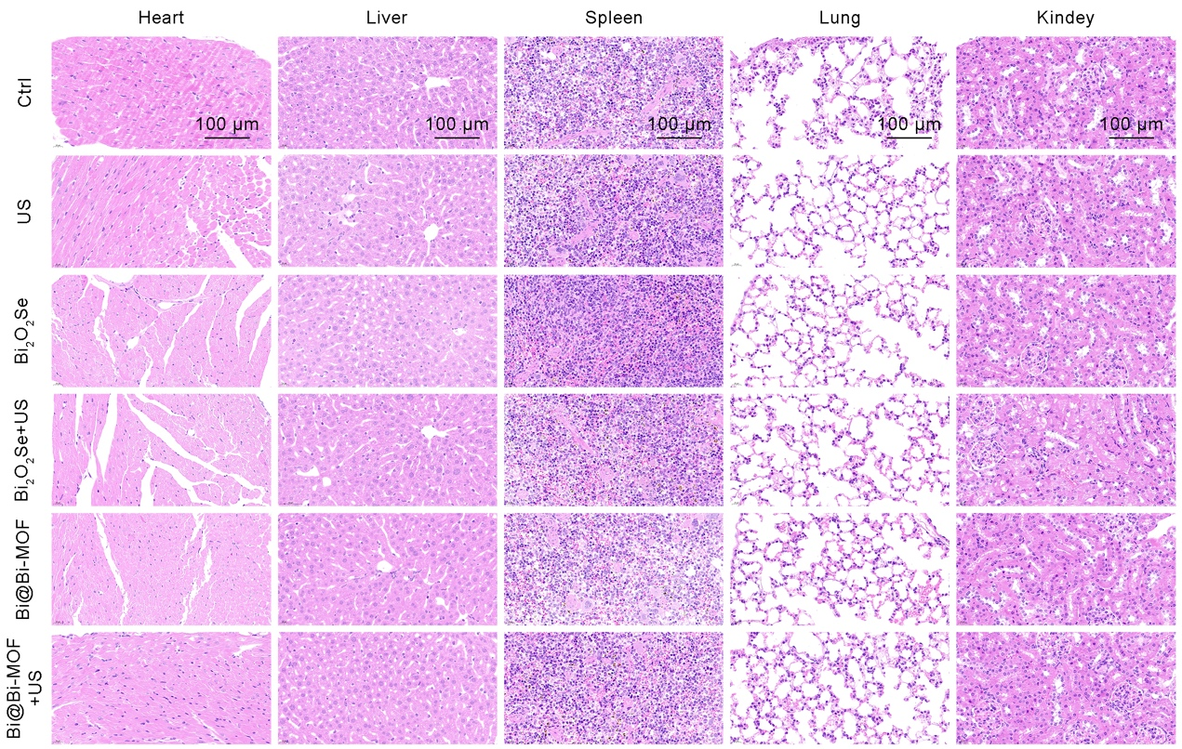
Figure S17. Representative hematoxylin and eosin (H&E) stained sections of heart, liver, spleen, lung, and kidney collected from mice after the therapeutic regimen.

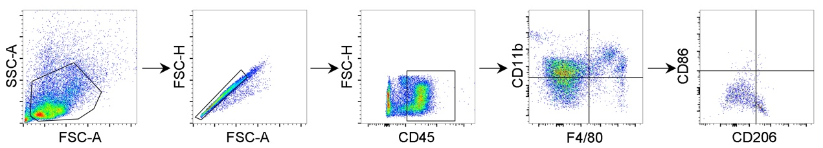
Figure S18. Representative gating strategy of macrophages in IDLN of the mice implant infection model.

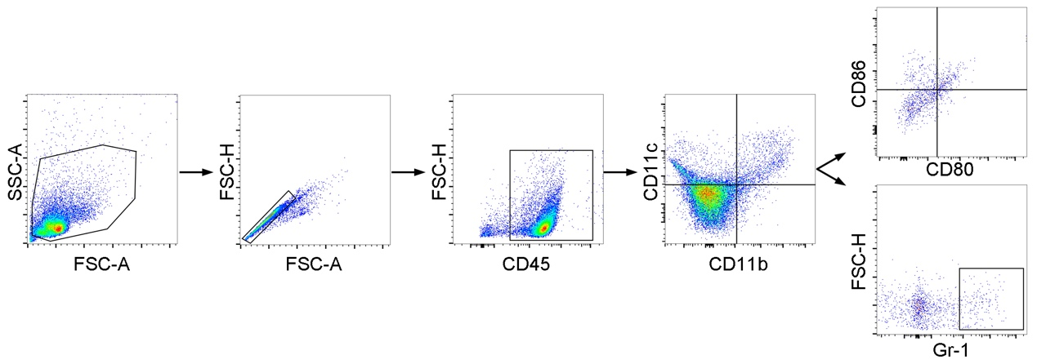
Figure S19. Representative gating strategy of DCs and MDSCs in IDLN of the mice implant infection model.

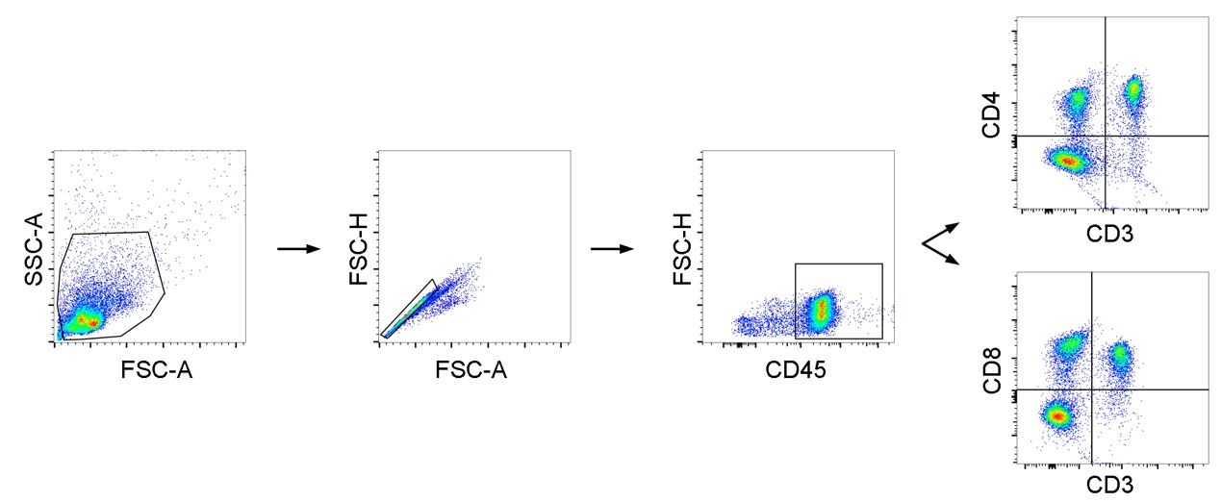
Figure S20. Representative gating strategy of CD4⁺ and CD8⁺ T cells in IDLN of the mice implant infection model.

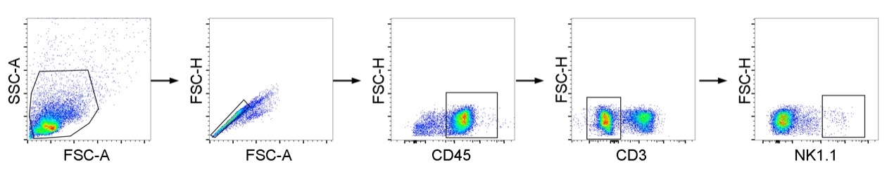
Figure S21. Representative gating strategy of NK cells in IDLN of the mice implant infection model.

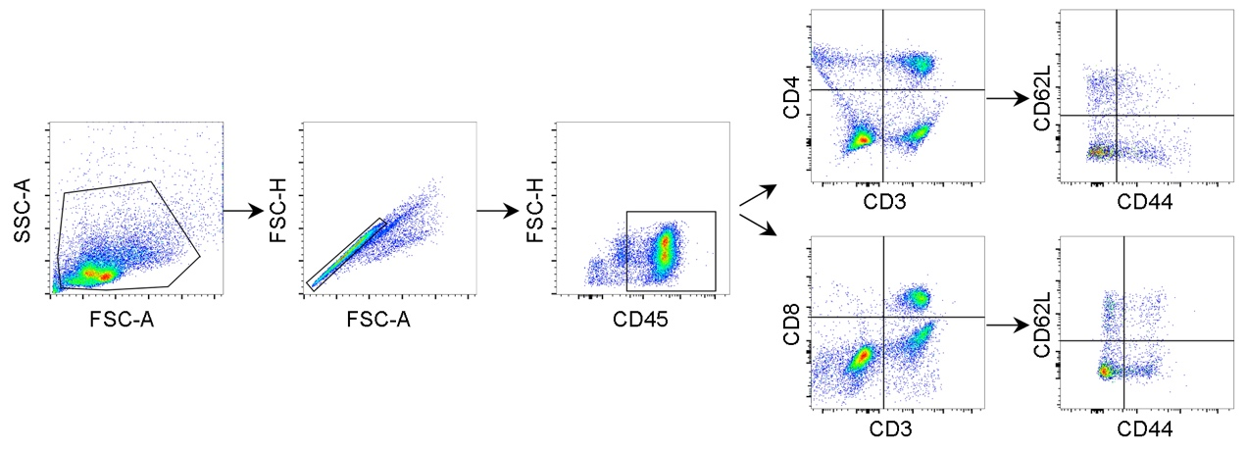
Figure S22. Representative gating strategy of memory T cells in spleen of the mice implant infection model.

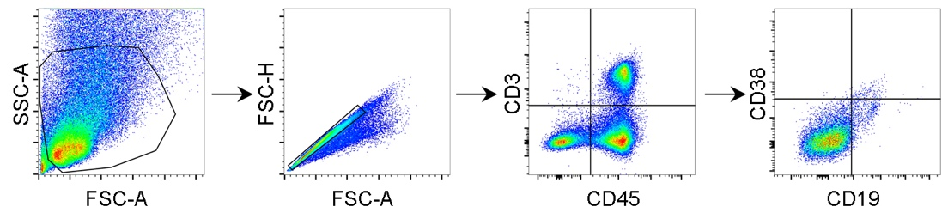
Figure S23. Representative gating strategy of mB cells in spleen of the mice implant infection model.
Reference
[1] X. Tian, H. Luo, R. Wei, C. Zhu, Q. Guo, D. Yang, F. Wang, J. Li, J. Qiu, Adv Mater 2018, 30, e1801021.

