Engineered Neuronal Exosomes Mediate α-Synuclein Clearance to Ameliorate Parkinson’s Disease

Lufei Chen^{1,2#}, Xiaoling Lin^{1,2#}, Mingzhi Fu², Shenglang Chen², Zhexiao Yan², Yuelin Diao², Genyu Chen^{1,2}, Zichen Huang², Yan Sun^{2,7}, Yaxin Lin², Zucheng Ye²*, Ying Zhou^{3,4}*, Qinyong Ye^{1,5,6}*

1. Department of Neurology, Fujian Medical University Union Hospital, Fuzhou, 350001, China.
2. Fujian Provincial Key Laboratory of Brain Aging and Neurodegenerative Diseases, School of Basic Medical Sciences, Fujian Medical University, Fuzhou, 350122, China.
3. College of Biological Science and Engineering, Fuzhou University, Fuzhou, 350108, China.
4. CAS Key Laboratory of Standardization and Measurement for Nanotechnology, CAS Key Laboratory for Biomedical Effects of Nanomaterials and Nanosafety, CAS Center for Excellence in Nanoscience, National Center for Nanoscience and Technology, Beijing 100190, China.
5. Fujian Key Laboratory of Molecular Neurology and Institute of Neuroscience, Fujian Medical University, Fuzhou, 350004, China.
6. Clinical Research Center for Precision Diagnosis and Treatment of Neurological Diseases of Fujian Province, Fuzhou, 350001, China.
7. School of Basic Medical Sciences, Ningxia Medical University, Yinchuan 750004, China.

#These authors contributed equally to this work.

* Corresponding authors: Email: zhouying@fzu.edu.cn; zcye@fjmu.edu.cn; unionqyye8@fjmu.edu.cn

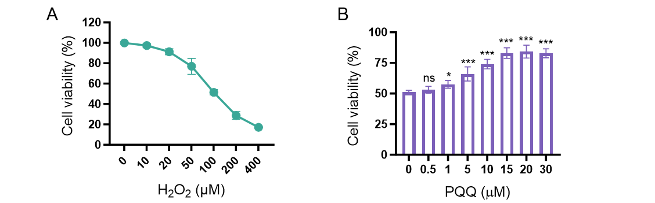
Fig. S1 PQQ reverses H₂O₂-induced oxidative stress. (A) Cell viability of SH-SY5Y treated with different concentrations of H₂O₂ for 24 hours, as determined by CCK-8 assay. The half-maximal inhibitory concentration (IC₅₀) of H₂O₂ was 100 μM. (B) Cell viability of SH-SY5Y treated with different concentrations of PQQ combined with 100 μM H₂O₂.

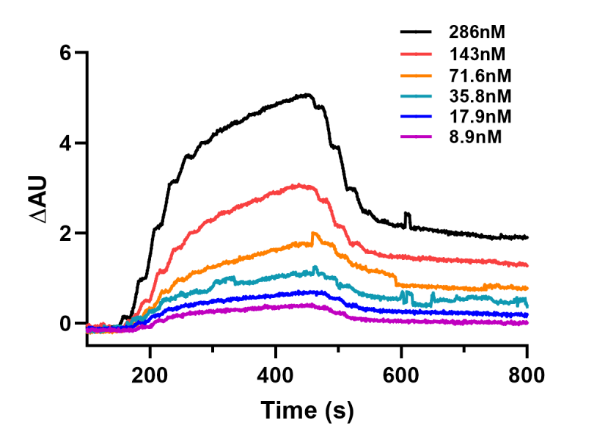
Fig. S2 SPRi measurement of the binding affinity of sPep toward αSyn at various protein concentrations.

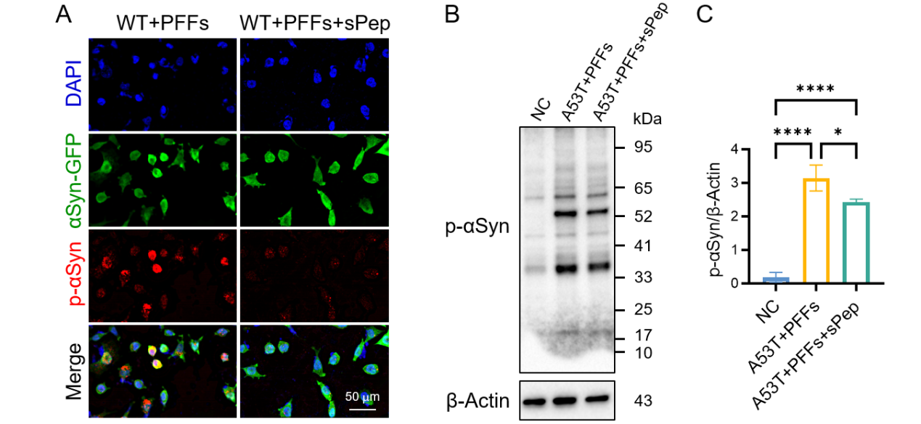
Fig. S3 The intervention effect of sPep on PD cell models. (A) Immunofluorescence staining shows the effect of sPep in SNCA-wild type cell models (another representative large-field image). (B, C) Western blot analysis detects the effect of sPep in SNCA-A53T mutant cell models, with corresponding quantitative statistical analysis.

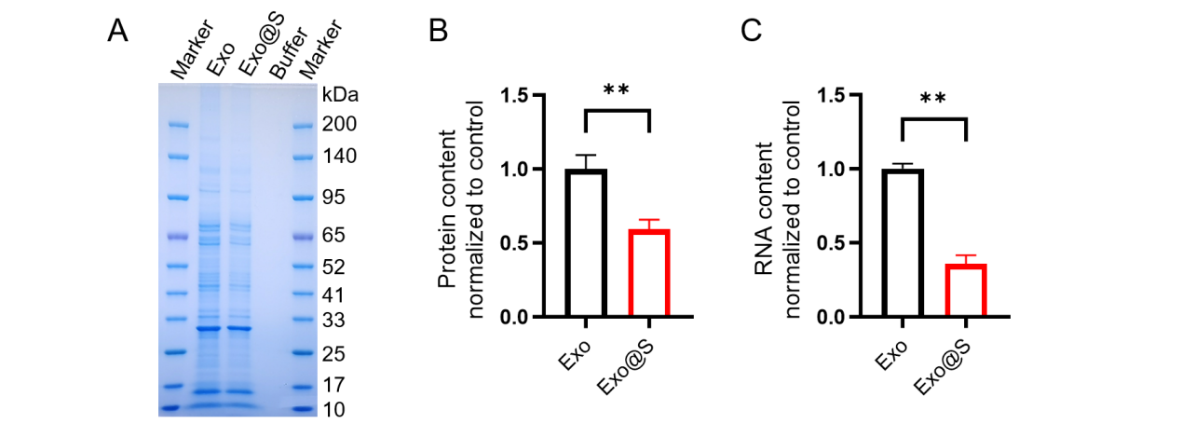
Fig. S4 Validation of the exosome content removal effect. (A) Coomassie brilliant blue staining results of proteins from the Exo and ultrasound-treated exosomes (Exo@S) after SDS-PAGE separation. (B, C) Quantification of total protein (detected by BCA assay) and total RNA (detected by Nanodrop) in the Exo and Exo@S groups.

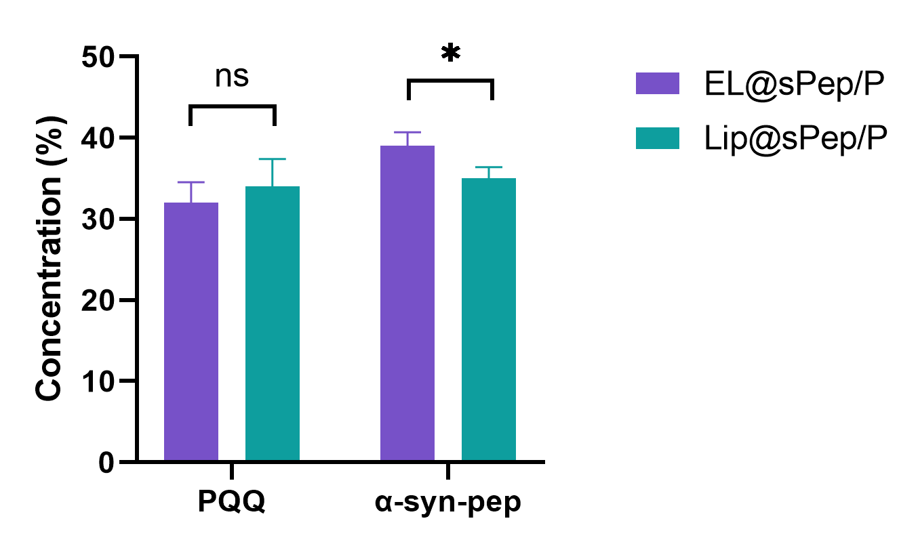
Fig. S5 The encapsulation efficiency of EL@sPep/P and Lip@sPep/P for sPep and PQQ.

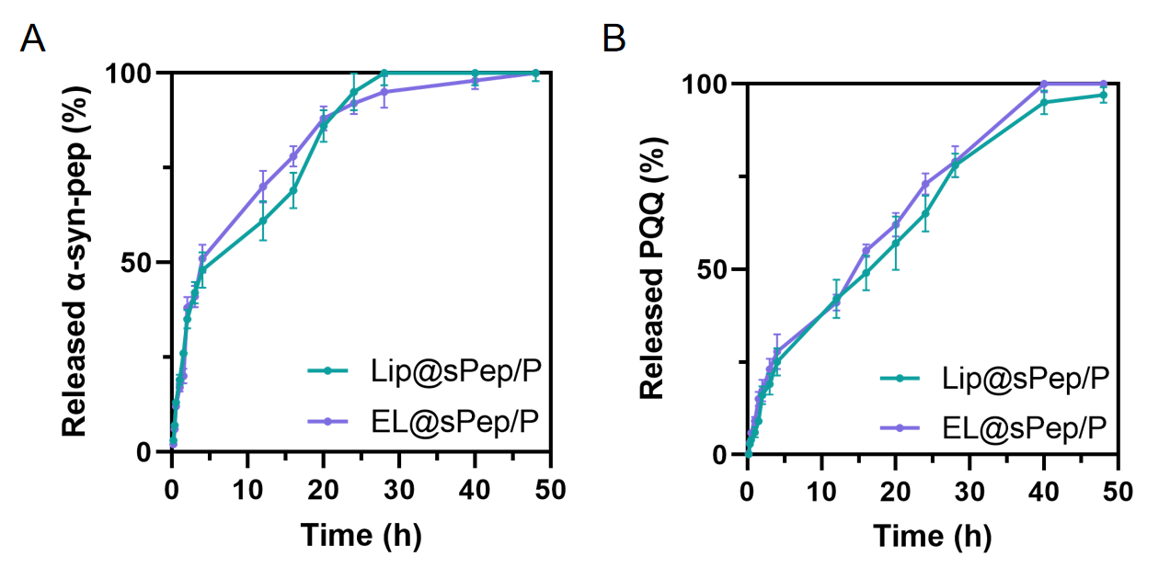
Fig. S6 Release profiles of sPep and PQQ from EL@sPep/P and Lip@sPep/P.

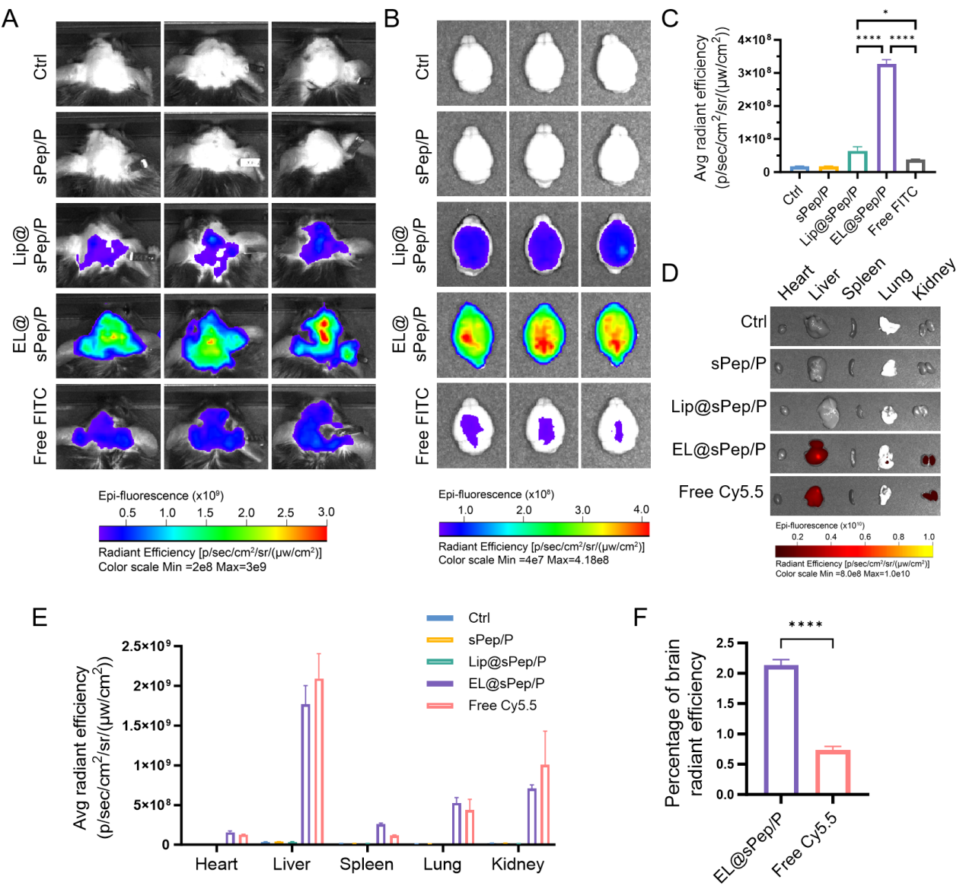
Fig. S7 Biodistribution of EL@sPep/P in major mouse organs. (A) In vivo fluorescence imaging of brains from PD model mice at 1 h after intravenous injection of FITC-labeled EL@sPep/P. (B, C) At 24 h after intravenous injection of FITC-labeled EL@sPep/P, ex vivo brain imaging and fluorescence quantification in the SN were performed in PD mouse models. (D, E) Fluorescence images and corresponding quantitative analysis of dissected organs (heart, liver, spleen, lung, kidney) were acquired at 24 h after intravenous injection of different Cy5.5-labeled EL@sPep/P formulations. (F) The percentage of radiant efficiency distributed in the brain relative to total major organs (brain, heart, liver, spleen, lung, kidney) was 2.14 ± 0.09% for the EL@sPep/P group and 0.73 ± 0.06% for the Free Cy5.5 group.

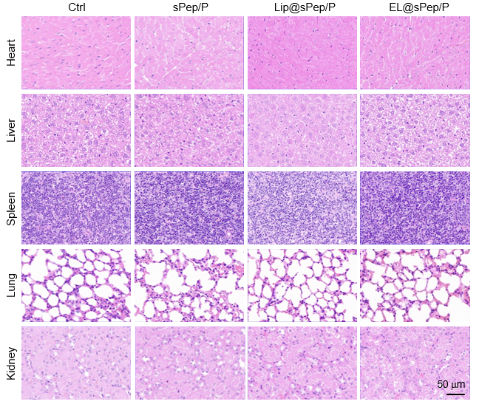
Fig. S8 Safety evaluation of different organs after different treatments. HE staining of heart, liver, spleen, lung, and kidney sections from animals treated with PBS (Ctrl), sPep/P, Lip@sPep/P, or EL@sPep/P.

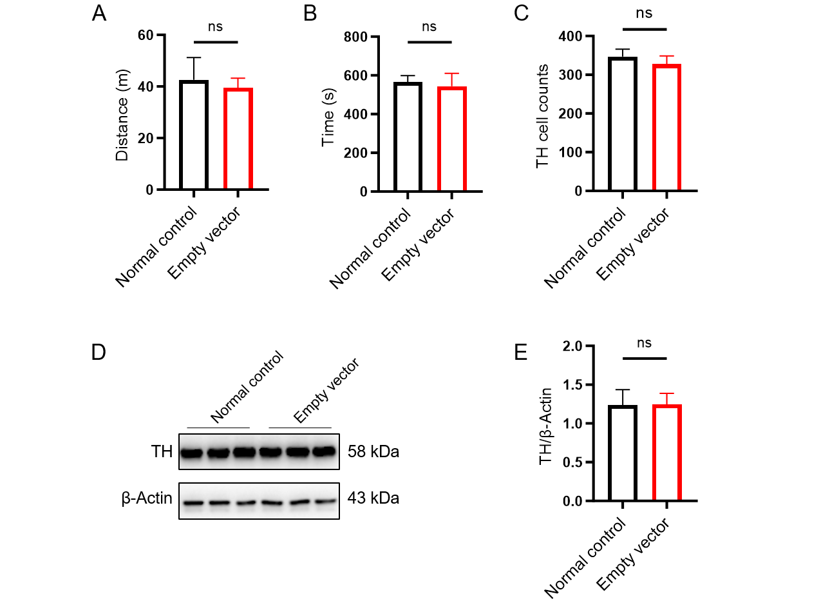
Fig. S9 Behavioral tests and TH neuron analysis in normal control and AAV9 empty vector groups. (A) Statistical analysis of total movement distance in the open field test. (B) Time taken to descend from the top to the base in the pole test. (C) Quantitative analysis of TH-positive neurons in the mouse SN via immunofluorescence staining. (D, E) Western blot analysis of TH protein expression in the mouse SN and corresponding statistical analysis.

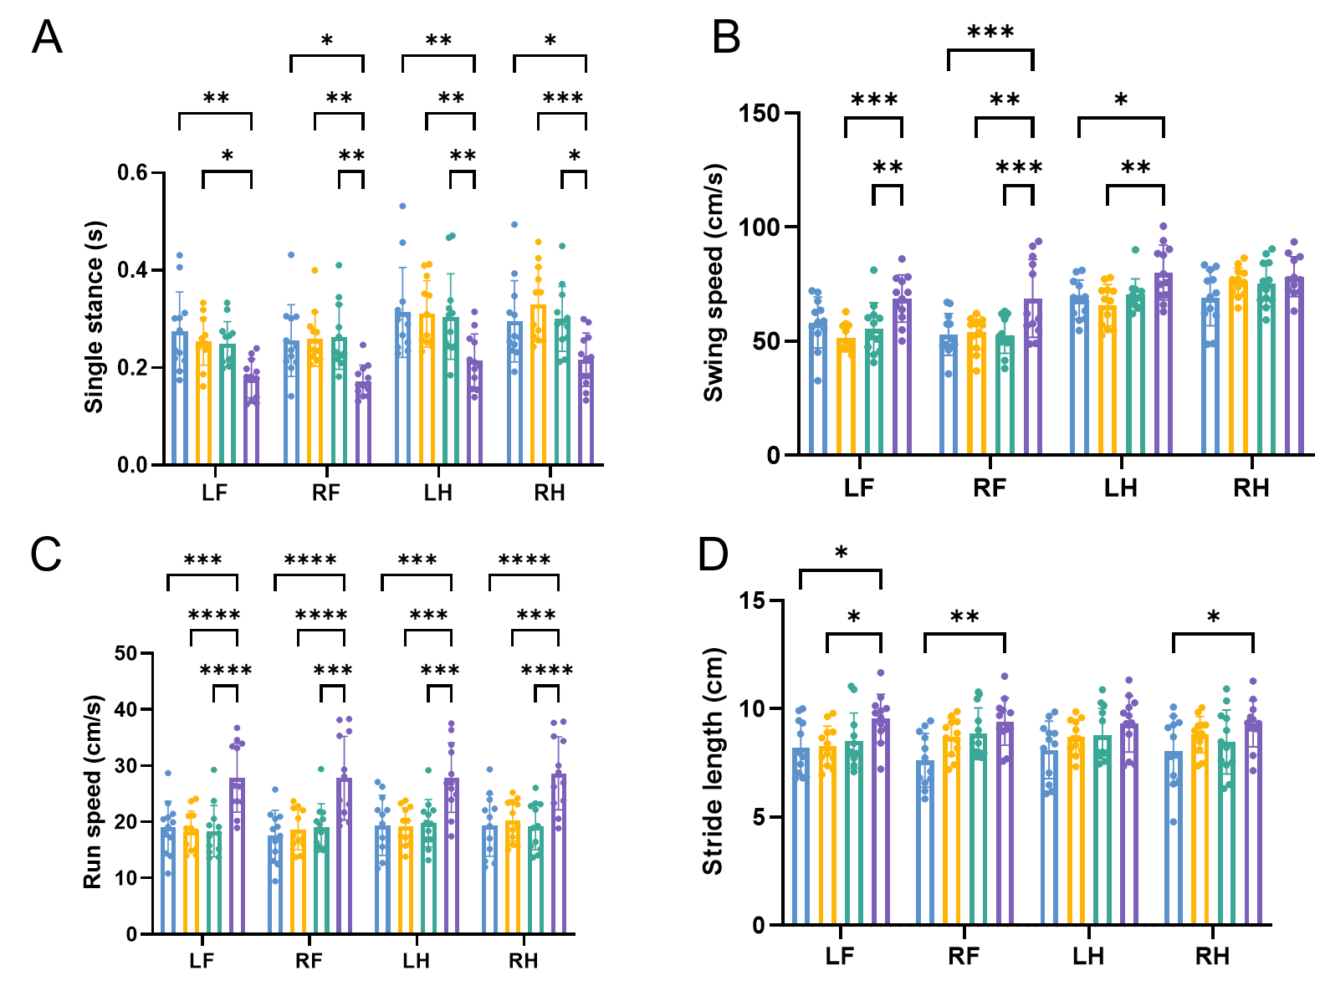
Fig. S10 Gait analysis of EL@sPep/P in PD model mice. Gait parameters analyzed by the gait system, including (A) single stance, (B) swing speed, (C) movement speed, and (D) stride length.

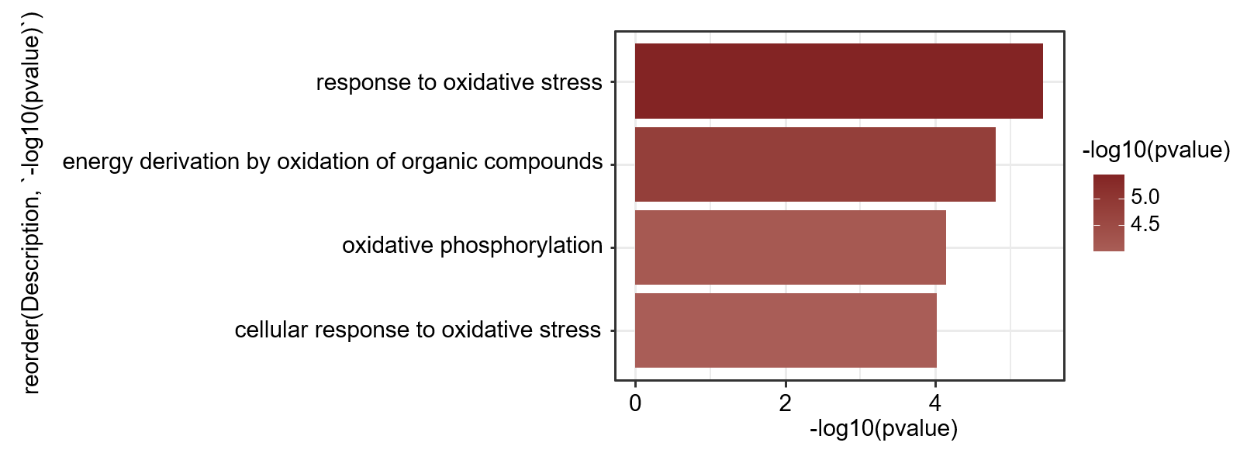
Fig. S11 GO enrichment analysis of oxidative stress response-related pathways.

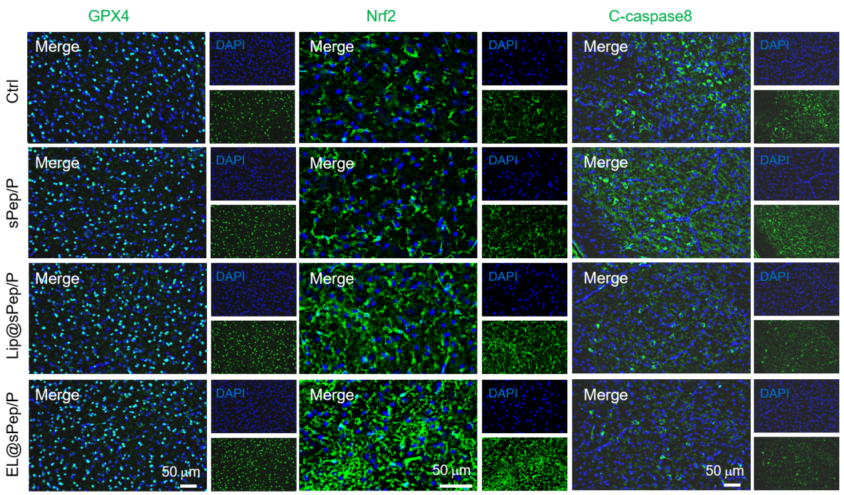
Fig. S12 Expression of oxidative stress and apoptosis-related proteins in the SN of PD mouse models. Immunofluorescence staining showed the expression of GPX4, Nrf2, and C-caspase8 in tissues.

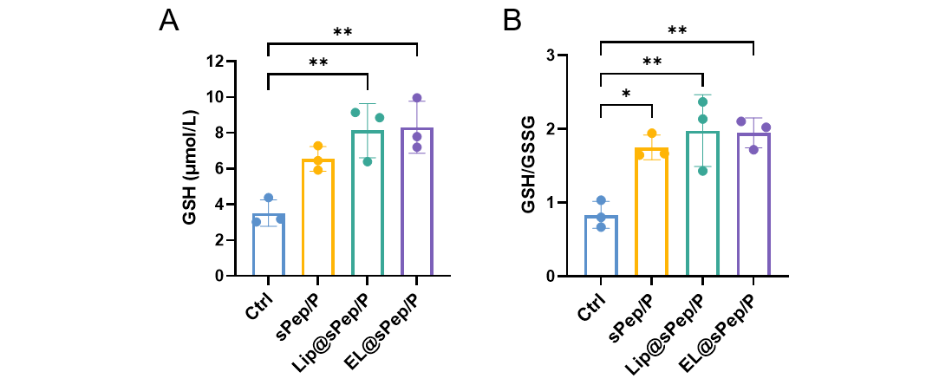
Fig. S13 Plasma GSH levels and GSH/GSSG ratio in PD mouse models under different treatments. Biochemical assays were performed to measure the levels of (A) glutathione (GSH) and (B) the ratio of reduced glutathione to oxidized glutathione (GSH/GSSG) in plasma samples from different groups. Data are presented as mean ± SD.
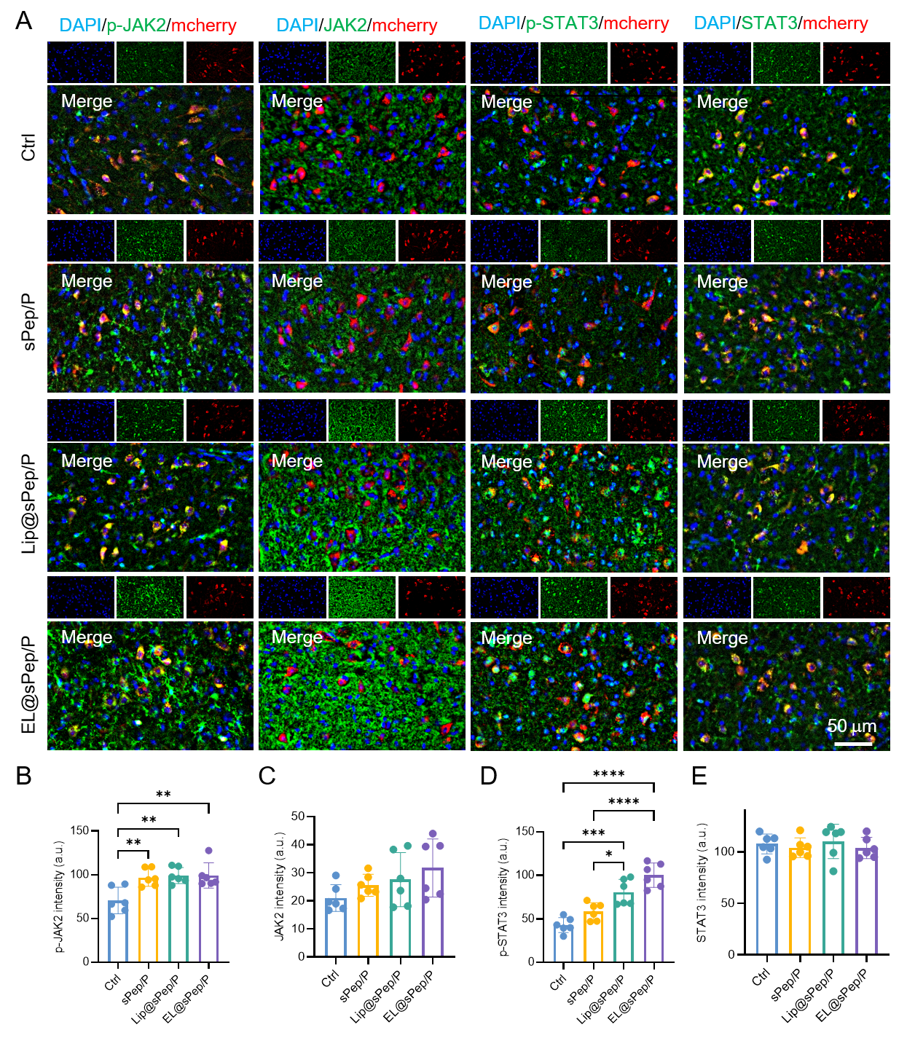
Fig. S14 Expression of JAK2/STAT3-related proteins in the SN of PD mouse models. Immunofluorescence staining showed (A) the expression of JAK2/STAT3 pathway-related proteins in tissue sections. (B-E) Corresponding quantitative analysis.
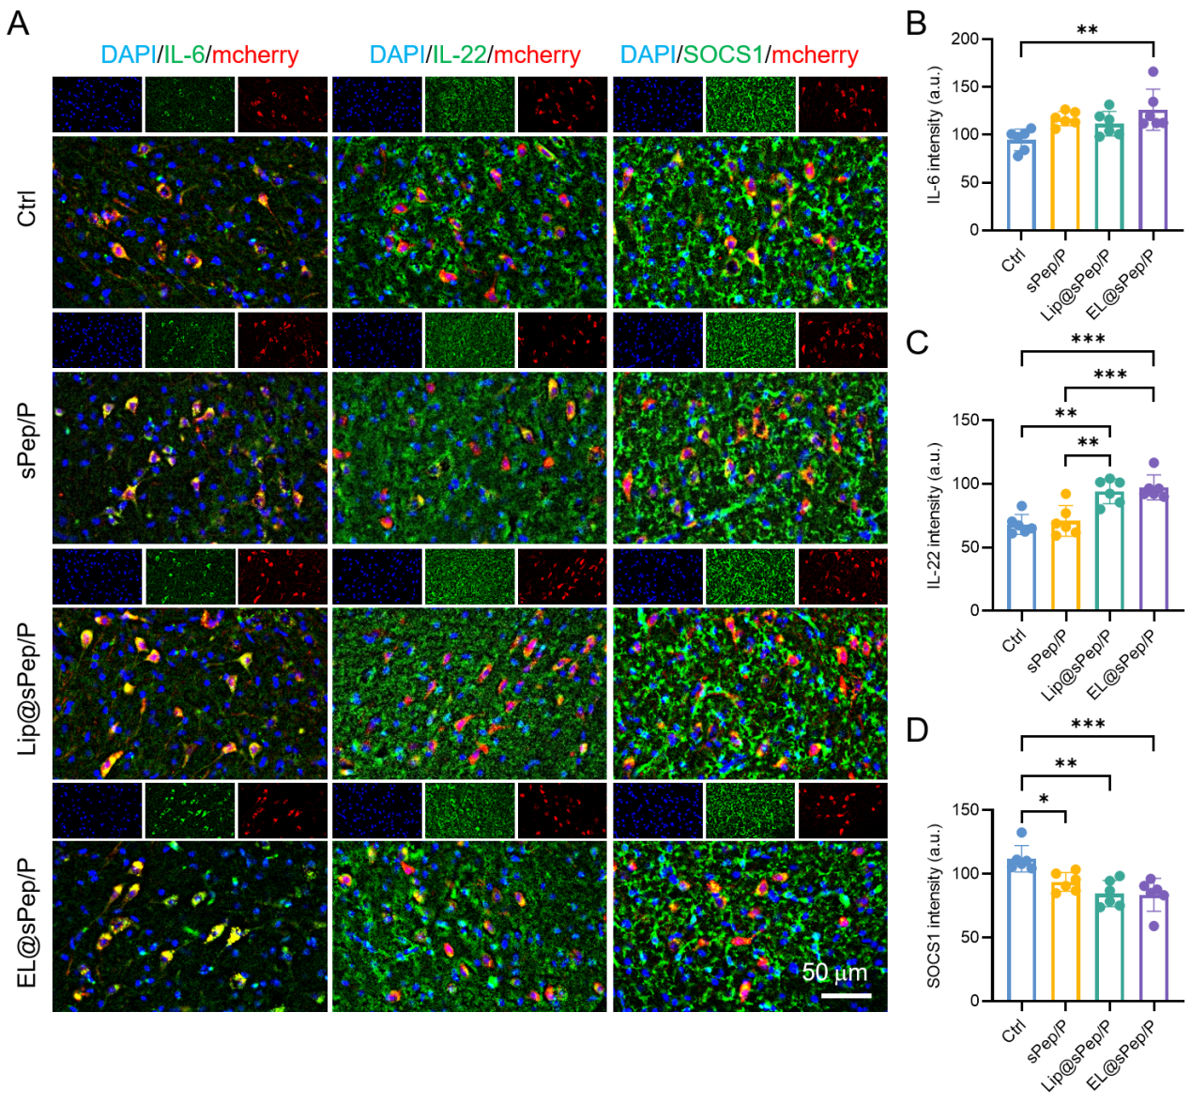
Fig. S15 Expression of IL-related and SOCS1 proteins in the SN of PD model mice. Immunofluorescence staining showed (A) the expression of IL-6, IL-22, and SOCS1 proteins in tissue sections. (B-D) Corresponding quantitative analysis.

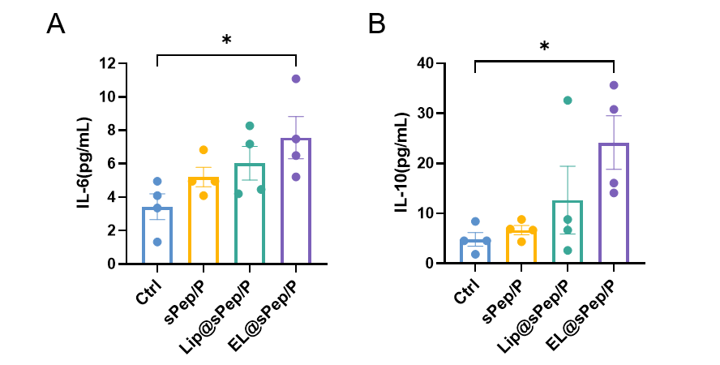
Fig. S16 Plasma IL-6 and IL-10 in PD model mice under different treatments. ELISA assays were performed to measure the levels of (A) IL-6 and (B) IL-10 in plasma samples from different groups. Data are presented as mean ± SEM.

