Supporting Information for
Rhein-Mn Coordination Nanomedicine for Peritoneal Metastatic Colorectal Cancer: Synergistic Mitochondrial Targeting, Immunogenic Cell Death, and Reverses Immunosuppression

Yingfei Wen ^{a,1}, Miaojuan Qiu ^{a,b,c,1}, Xinyi Deng ª, Yiran Wang ª, Xiaodie Zeng ^{d}, Binbin Li ^{b}, Shangbo Zhou ^{b}, Takeshi YAMAKAWA ^{a,b}, Peng Liu ^{b,} Shiqiang Zhang ª, Jingqi Chen ª, Yiye Chi ^{e}, Feng Chen ^{a,b*}, Zhiyong Wang ^{d*}, Jing Zhao^{a,b*}

ª Scientific Research Center, The Seventh Affiliated Hospital of Sun Yat-sen University, Shenzhen 518107, P. R. China
^{b} Gastrointestinal Surgery, Digestive Diseases Center, The Seventh Affiliated Hospital, Sun Yat-sen University, Shenzhen 518107, P. R. China.
^{c} School of Medicine, Sun Yat-Sen University, Shenzhen 518107, P. R. China
^{d} School of Materials Science and Engineering, Center for Functional Biomaterials, Key Laboratory for Polymeric Composite and Functional Materials of the Ministry of Education, Sun Yat-sen University, Guangzhou 510275, P.R. China
^{e} Bachelor Program of Bioinformatics, School of Medicine, The Chinese University of Hong Kong, Shenzhen, Shenzhen 518172, China

1 Yingfei Wen and Miaojuan Qiu have contributed equally to this work and share first authorship.

* Corresponding author:
E-mail: zhaoj265@mail.sysu.edu.cn (Zhao J)
E-mail: wangzhiy3@mail.sysu.edu.cn (Wang ZY)
E-mail: chenf293@mail.sysu.edu.cn (Chen F)

Experimental Section
Materials and methods
Materials. Rhein, manganese (II) chloride tetrahydrate (MnCl₂·4H₂O), and bovine serum albumin (BSA) were purchased from Shanghai Aladdin Bio-Chem Technology Co., LTD. (Shanghai, China). Cell culture medium, phosphate-buffered saline (PBS), and trypsin-EDTA were purchased from Pricella (Wuhan, China). Fetal bovine serum (FBS) and penicillin-streptomycin solution were provided by Gibco (Guangzhou, China). 4’,6-Diamidino-2-phenylindole, Dihydrochloride (DAPI), Rhodamine, 3,3’-Dioctadecyloxacarbocyanine Perchlorate (DIO), Fluorescein Isothiocyanate (FITC) FITC-labeled Goat Anti-Mouse IgG (H+L), Reactive oxygen species (ROS) Assay Kit, JC-1 Mitochondrial Membrane Potential Assay Kit, Annexin V-FITC/PI Apoptosis Detection Kit (FITC: Fluorescein Isothiocyanate; PI: Propidium Iodide), and Mitochondrial ATP Assay Kit (ATP: Adenosine Triphosphate) were purchased from Beyotime Biotechnology Co., Ltd. (Shanghai, China). D-Luciferin potassium salt D, DIR iodide, and Cell Counting kit-8 (CCK-8) assay kit were purchased from Yeasen Biotech Co., Ltd (Shanghai, China). Antibodies against Phospho-NF-κB p65 (Ser536) (p-NF-κB p65), NF-κB p65, Bcl-2, BAX, Caspase-1, Cleaved Caspase-3 (Asp175), Cytochrome c (CytC), and GAPDH were purchased from Cell Signaling Technology, Inc. (Shanghai, China). ELISA Kits (IL-6, IL-1β, TNF-α, CSF2, IFN-γ, and high mobility group box 1 (HMGB1)) were purchased from Ruixinbio (Quanzhou, China). The tumor tissue dissociation kit was procured from SeekGene (Beijing SeekGene Biotechnology Co., Ltd., China). Flow cytometry reagents were purchased from BioLegend, including: (1) Antibodies: Brilliant Violet 510™ anti-mouse CD45 (#103137), APC anti-mouse CD206 (#141707), APC/Fire™ 750 anti-mouse CD3 (#100247), Brilliant Violet 785™ anti-mouse F4/80 (#123141), Alexa Fluor® 700 anti-mouse CD4 (#100536), Brilliant Violet 650™ anti-mouse CD8a (#100741), Brilliant Violet 605™ anti-mouse CD80, PE/Cyanine7 anti-mouse CD86, FITC anti-mouse CD11c. (2) Other reagents: Fixation Buffer (#420801), Intracellular Staining Perm Wash Buffer (#421002), TruStain FcX™ (#101319), Cell Staining Buffer (#420201), Brefeldin A Solution (#420601), Compensation Beads (#424602). All reagents were used according to the manufacturer’s protocols.

Cell lines and animals. The murine colon adenocarcinoma cell line CT26 and luciferase-labeled CT26 cell line (CT26-Luc) were obtained from Procell Life Science & Technology Co., Ltd. The following cell lines were purchased from the American Type Culture Collection (ATCC): the colon adenocarcinoma cell lines MC38, HCT15, and HCT116; the human embryonic kidney cell line 293T; and the normal human colon epithelial cell line NCM460. All cell lines were tested for mycoplasma contamination using a commercial detection kit. Female BALB/c mice (5-6 weeks old, 16-18 g) were obtained from GemPharmatech Co., Ltd. and housed under specific pathogen-free (SPF) conditions. All animal experimental protocols were approved by the Animal Care and Use Committee (approval No. TOPGM-IACUC-2025-0181).

Synthesis and characterization of BRM nanomedicine
Synthesis: BRM nanomedicine was fabricated via a controlled two-step assembly protocol. 14.2 mg of Rhein was dissolved in 80 mL of double-distilled water (ddH₂O), and the pH was adjusted to 10 using NaOH to ensure complete solubilization. Separately, 39.4 mg MnCl₂ tetrahydrate was dissolved in 10 mL of deionized water. Then these two solutions were mixed, and the pH was tuned to 8.5 with NaOH under magnetic stirring, followed by a 10-minute incubation to facilitate coordination between Rhein and Mn²⁺ and form Rhein-Mn intermediate complexes. Subsequently, 20 mg of BSA pre-dissolved in 10 mL of distilled water was added to the RM solution. The mixture was incubated for 2 hours to drive BSA encapsulation via self-assembly and finally yield spherical BRM nanomedicine with a Rhein-Mn molar ratio of 2:1. To systematically evaluate the influence of Rhein-Mn stoichiometry on the physicochemical properties and biological functions of BRM nanomedicine, three additional formulations were prepared following the same two-step assembly procedure. The dosages of Rhein and MnCl₂ tetrahydrate were adjusted proportionally while keeping the total reaction volume and the amount of BSA unchanged. In total, four batches of BRM nanomedicine with Rhein-Mn molar ratios of 0.5:1, 1:1, 2:1, and 3:1 were successfully synthesized for subsequent characterization and in vitro/in vivo experiments. Characterization: Morphologies of BRM were observed using transmission electron microscopy (TEM) and scanning electron microscopy (SEM). Hydrodynamic diameter and zeta potential were measured via dynamic light scattering (DLS) using a Zetasizer Nano ZS90 (Malvern, UK). X-ray diffraction (XRD) patterns were recorded on a Rigaku Ultima IV diffractometer to analyze crystalline structure. Fourier transform infrared (FTIR) spectra were collected on a Nicolet 7000-C spectrometer in the range of 400-4000 cm⁻¹ to identify functional group interactions. For UV-visible (UV-vis) spectroscopy, BRM dispersions were analyzed using a UV-2600 spectrophotometer (Shimadzu, Japan) in the wavelength range of 200-800 nm. The encapsulation efficiency of Rhein in BRM was quantified using high-performance liquid chromatography (HPLC, Agilent 1260) equipped with a C18 column (250 × 4.6 mm, 5 μm). The mobile phase consisted of methanol:0.1% phosphoric acid (60:40, v/v) at a flow rate of 1 mL/min, with detection at 280 nm. In vitro degradation behavior was evaluated by dispersing 10 mg BRM in 10 mL ddH₂O, adjusting the pH to 3.0, 4.0, 5.0, 6.0, or 7.0 using dilute HCl/NaOH, and incubating at 37 °C for 24 h. Degradation was visualized via photography, and the release of Mn²⁺ was quantified using inductively coupled plasma mass spectrometry (ICP-MS, Thermo iCAP Qc) after centrifugation (12,000 × g, 10 min) to collect supernatants.

Drug loading and encapsulation efficiency. The drug loading content (LC) and encapsulation efficiency (EE) of both rhein and manganese in BRM nanoparticles were determined separately by high-performance liquid chromatography (HPLC) and inductively coupled plasma mass spectrometry (ICP-MS). LC was defined as the percentage of the mass of encapsulated component relative to the total mass of lyophilized BRM nanoparticles. EE was defined as the percentage of the mass of encapsulated component relative to the total mass of the corresponding component initially added during preparation. The calculations were performed using the following equations:
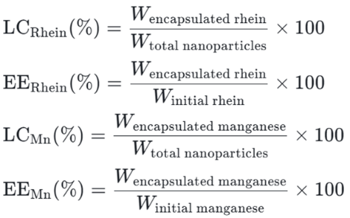

In vitro cellular uptake of BRM. BRM were labeled with DIO at 4 °C for 24 h. CT26 cells were seeded in confocal dishes and cultured to 60% confluency, then incubated with DIO-labeled BRM at 37 °C for 0, 1, 2, 4, 8, or 12 h. After incubation, cells were rinsed twice with PBS, fixed with 4% paraformaldehyde for 8 min, stained with DAPI (nuclei, blue) and Phalloidin (cytoskeleton, red). Images were acquired using a confocal laser scanning microscope (CLSM, Zeiss LSM880, Germany) to visualize nanoparticle localization (green, DIO). Fluorescence images were captured using an inverted fluorescence microscope to visualize the intracellular localization of BRM (green).

In vitro cellular uptake and BSA competition assay. Cellular uptake of BRM nanoparticles was evaluated using an inverted fluorescence microscope. CT26 cells were seeded in 6-well plates and cultured to 60% confluency. For the BSA competition assay, cells were pre-incubated with serum-free medium containing 1% (w/v) excess unlabeled BSA for 1 h at 37 °C, followed by incubation with DIO-labeled BRM for 8h at 37 °C. Control cells were incubated with DIO-labeled BRM without BSA pre-treatment. After incubation, cells were washed twice with PBS,

Lysosomal co-localization analysis. CT26 cells were seeded in confocal dishes and cultured to 60% confluency. Cells were incubated with DIO-labeled BRM for 8 h at 37 °C. After washing with pre-warmed PBS, cells were stained with LysoTracker Red at a dilution of 1:1000 for 30 min at 37 °C in the dark to label lysosomes. Cells were then fixed with 4% paraformaldehyde, counterstained with DAPI, and imaged using a confocal laser scanning microscope (CLSM, Zeiss LSM880, Germany). The co-localization coefficient was analyzed using ZEN 3.2 software.

Detection of intracellular ROS generation. CT26 cells were divided into four groups: control (CTL), free Rhein, Mn²⁺, and BRM (with Rhein concentration normalized to 15 μM in all treatment groups). The inhibitors and their working concentrations were as follows: N-acetylcysteine (NAC) at 5 μM and NF-κB inhibitor JSH-23 at 10 μM for 1 hour before subsequent stimulation or analysis. After 12 h of treatment, intracellular ROS levels were detected using a ROS assay kit following the manufacturer’s instructions. Fluorescence images were captured via fluorescence microscopy, and quantitative analysis was performed using flow cytometry.

JC-1 assay for mitochondrial membrane potential analysis. CT26 cells were treated with CTL, free Rhein, Mn²⁺, or BRM for 12 h. Mitochondrial membrane potential (ΔΨm) changes were evaluated using the JC-1 Mitochondrial Membrane Potential Assay Kit, following the manufacturer’s protocol. Quantitative analysis was performed via flow cytometry.

In vitro apoptosis analysis of CT26 cells. CT26 cells were divided into four groups: CTL, free Rhein, Mn²⁺, and BRM. After 12 h of treatment, apoptotic cell populations were quantified using an Annexin V-FITC/PI Apoptosis Detection Kit. Quantitative analysis of apoptosis was performed via flow cytometry, following the kit manufacturer’s protocol.

In vitro cytotoxicity study. The in vitro cytotoxicities of free rhein, RM, and BRM were tested using the CCK-8 cell proliferation assay kit. According to the manufacturer’s instructions, 5000 cells (CT26, MC38, HCT15, HT116, 293T, and NCM460) were seeded into 96-well plates and cultured overnight. Then, the cells were incubated with various concentrations of free rhein, RM, and BRM for 24 hours, respectively. Cells were pretreated with the NF-κB inhibitor JSH-23 at a concentration of 10 μM for 1 hour before subsequent stimulation or analysis. At each time point, 10 μL of CCK-8 reagent was added to each well and incubated for an additional 1 hour. Optical density (OD) at 450 nm was measured using a microplate reader (BioTek, SynergyH1, USA). Cell viability was calculated using the following formula: cell viability% = (OD_{sample} - OD_{blank}/OD_{control} - OD_{blank})×100%.

RNA sequencing. CT26 cells (1 × 10⁶) were seeded in 10 cm culture plates overnight, then treated with CTL (PBS), free Rhein, MnCl₂, or BRM for 24 h. Total RNA was extracted using the Qiagen RNeasy Mini Kit (Germany) following the manufacturer’s protocol. RNA concentration was quantified with a Qubit 2.0 Fluorometer, and quality was assessed using an Agilent Bioanalyzer 2100. mRNA-seq libraries were constructed per standard protocols and sequenced on an Illumina HiSeq 2500 platform (paired-end 150 bp). Raw reads were filtered using Trimmomatic to remove adaptors, low-quality sequences, and poly-N-containing reads, yielding high-quality clean reads for downstream analysis. Differential expression analysis between groups was performed with DESeq2; genes with a false discovery rate (FDR) < 0.05 and absolute fold change ≥ 2 were defined as differentially expressed genes (DEGs). Gene set enrichment analysis (GSEA) was conducted against Kyoto Encyclopedia of Genes and Genomes (KEGG) pathways.

Luciferase reporter assay for P65 transcriptional activity. The P65 luciferase reporter plasmid (containing the NF-κB P65 binding site upstream of the luciferase gene) and Renilla luciferase plasmid (as internal CTL) were co-transfected into CT26 cells using Lipofectamine 3000 (Invitrogen) according to the manufacturer’s protocol. After 24 h of transfection, cells were treated with CTL (PBS), free Rhein, Mn²⁺, BRM, or BRM+NAC for another 12 h. Luciferase activity was measured using the Dual-Luciferase Reporter Assay System (Promega) on a microplate reader (BioTek, SynergyH1, USA). Relative luciferase activity was calculated as the ratio of firefly luciferase activity to Renilla luciferase activity, reflecting P65 transcriptional activation level.

Immunofluorescence staining for P65 nuclear translocation. CT26 cells were seeded on confocal dishes and cultured to 60% confluency, then treated with CTL (PBS), free Rhein, Mn²⁺, or BRM for 12 h. After treatment, cells were rinsed twice with PBS, fixed with 4% paraformaldehyde for 15 min, and permeabilized with 0.1% Triton X-100 in PBS for 10 min at room temperature. Nonspecific binding was blocked with 5% BSA for 30 min, followed by incubation with anti-P65 primary antibody (1:200 dilution in 1% BSA) overnight at 4 °C. Cells were then washed three times with PBS and incubated with FITC-conjugated secondary antibody (1:500 dilution in 1% BSA) for 1 h at room temperature in the dark. Nuclei were stained with 5 mg/L DAPI for 5 min, and excess dye was removed by rinsing with PBS. Images were captured using a confocal laser scanning microscope (CLSM), with P65 visualized as green fluorescence (FITC) and nuclei as blue fluorescence (DAPI). The ratio of nuclear to cytoplasmic P65 fluorescence intensity was quantified to evaluate P65 nuclear translocation.

RT-qPCR analysis of NF-κB-regulated genes. CT26 cells were treated with CTL (PBS), free Rhein, Mn²⁺, or BRM for 6 h. Total RNA was extracted using FastPure® Cell/Tissue Total RNA Isolation Kit V2 (Vazyme, RC112) following the manufacturer’s protocol. Genomic DNA contamination was eliminated during the extraction process, and 1 μg of total RNA was reverse-transcribed into cDNA using Evo M-MLV RT Premix for qPCR (Accurate Biotechnology, AG11706) according to the kit’s instructions. RT-qPCR was performed on a real-time PCR system using SYBR Green Premix Pro Taq HS qPCR Kit (Accurate Biotechnology, AG11701). The 20 μL reaction system contained 10 μL 2× SYBR Green Premix, 0.4 μL each of forward and reverse primers (10 μM), 2 μL cDNA template, and 7.2 μL RNase-free water. Amplification conditions were: 95 °C for 30 s, followed by 40 cycles of 95 °C for 5 s and 60 °C for 30 s. A melting curve analysis (65-95 °C, 0.5 °C increments) was conducted to verify primer specificity. GAPDH was used as the internal reference gene, and relative mRNA expression levels of target genes (NF-κB, IL-6, TNF-α, IL-1β, IFN-β, CXCL10, NLRP3, STING, and cGAS) were calculated via the 2⁻^{ΔΔCt} method. The primer sequences for these genes were adopted from [Ref. 22] and synthesized by Sangon Biotech (China).

ELISA quantification of cytokines. CT26 cells were treated with CTL (PBS), free Rhein, Mn²⁺, or BRM for 12 h. Cell supernatants were collected and centrifuged at 12,000 × g for 10 min to remove cellular debris. Levels of IL-6, IL-1β, TNF-α, CSF2, IFN-γ, and HMGB1 in the supernatants were quantified using commercial ELISA kits (specify manufacturers and catalog numbers) following the respective manufacturer’s protocols. Briefly, standards and samples were added to antibody-precoated wells, followed by sequential incubation with biotinylated detection antibodies and horseradish peroxidase (HRP)-streptavidin conjugates. After washing, the TMB substrate was added to initiate color development, and the reaction was stopped with the stop solution. Absorbance was measured at 450 nm using a microplate reader (BioTek, SynergyH1, USA), and cytokine concentrations were calculated based on standard curves.

Western blot analysis. CT26 cells were treated with CTL (PBS), free Rhein, Mn²⁺, or BRM at 15 μm for 12h. Cells were lysed in RIPA buffer (with protease/phosphatase inhibitors) on ice for 30 min, centrifuged (12,000 × g, 15 min, 4 °C) to collect supernatants, and protein concentration was measured via BCA assay. Equal amounts of protein (30 μg) were separated by 10-12% SDS-PAGE, transferred to PVDF membranes, and blocked with 5% non-fat milk in TBST for 1 h. Membranes were incubated overnight at 4 °C with primary antibodies against phosphorylated NF-κB p65 (Ser536), total NF-κB p65, STING, phosphorylated STING (p-STING), IRF3, phosphorylated IRF3 (p-IRF3), TBK1, phosphorylated TBK1 (p-TBK1), Cleaved-Caspase3, Bax, Bcl2, Caspase1, cytochrome C, and GAPDH. After TBST washes, membranes were incubated with HRP-conjugated secondary antibodies (1:5000) for 1 h at room temperature. Protein bands were visualized by ECL, and intensities were quantified using ImageJ. Relative expression was normalized to GAPDH.

Detection of immunogenic cell death (ICD) induction in vitro. CT26 cells were seeded on confocal dishes and cultured to 60% confluency, then treated with CTL (PBS), free Rhein, Mn²⁺, or BRM for 12 h. ICD-related indicators were detected as follows: Calreticulin (CRT) translocation to the cell membrane. After treatment, cells were rinsed twice with PBS, fixed with 4% paraformaldehyde for 15 min, and permeabilized with 0.1% Triton X-100 in PBS for 10 min at room temperature. Nonspecific binding was blocked with 5% BSA for 30 min, followed by incubation with anti-CRT primary antibody (1:200 dilution in 1% BSA) overnight at 4 °C. Cells were washed three times with PBS and incubated with FITC-conjugated secondary antibody (1:500 dilution in 1% BSA) for 1 h at room temperature in the dark. Nuclei were stained with 5 mg/L DAPI for 5 min, and excess dye was removed by rinsing with PBS. Images were captured using a confocal laser scanning microscope (CLSM, Zeiss LSM880, Germany) with a scale bar of 50 µm; CRT was visualized as green fluorescence (FITC) and nuclei as blue fluorescence (DAPI). Magnified views of representative cells were marked with red boxes for clarity. HMGB1 secretion. Cell supernatants were collected and centrifuged at 12,000 × g for 10 min to remove debris. Extracellular HMGB1 levels were quantified using an HMGB1 ELISA kit following the manufacturer’s protocol. Intracellular and extracellular ATP levels. Intracellular ATP was detected in cell lysates, and extracellular ATP was detected in cell supernatants, using a chemiluminescence ATP assay kit according to standard protocols.

DCs stimulation in vitro. Bone marrow-derived cells (BMDCs) were collected from the femurs of BALB/c mice and cultured for 7 days to generate CD11c⁺ DCs. CT26 tumor cells were cultured and treated in different groups in the upper chamber of a 24-well transwell system with 0.4 μm polycarbonate porous membranes for 24 h. The treated tumor cells were then incubated with the BMDCs seeded in the bottom well at a 2:1 ratio for another 24 h. Subsequently, the BMDCs were collected and analyzed by flow cytometry after staining with FITC anti-CD11c antibody, APC anti-CD80 antibody, and PE anti-CD86 antibody, and the maturation rate of DCs was analyzed using FlowJo software.

In vivo biodistribution of BRM. CT26-Luc cells were harvested, resuspended in ice-cold PBS, and used for peritoneal tumor model establishment via intraperitoneal injection of 2.5 × 10⁶ cells per BALB/c mouse. After 10 days of tumor growth, mice were randomized into two groups. BRM was pre-labeled with DIR fluorescent dye via overnight incubation in alcohol at room temperature. For biodistribution assessment, tumor-bearing mice were intraperitoneally administered free DIR or BRM/DIR. Real-time in vivo imaging was performed using an IVIS system at 1, 4, 24, 48, and 72 h post-injection. At 72 h, mice were euthanized, and tumors along with major organs were harvested for ex vivo bioluminescence and fluorescence imaging. Fluorescence signal quantification was conducted using the Tanon system.

Pharmacokinetic studies were performed in male Sprague-Dawley rats. Rats were intraperitoneally administered BRM nanomedicine at a dose of 30 mg/kg (3 mg/mL, 10 mL/kg in normal saline) without fasting, and blood samples were collected at 0.5, 1, 2, 4, 6, 8, 12, 24, 48, and 72 h post-administration. Plasma was separated by centrifugation and stored at -80 °C until analysis. The concentrations of rhein and manganese in plasma were determined by high-performance liquid chromatography-tandem mass spectrometry (HPLC-MS/MS) and inductively coupled plasma mass spectrometry (ICP-MS), respectively.

In vivo antitumor efficacy, organ safety, and hemocompatibility of BRM. BALB/c mice were implanted with tumor cells, and 6 days post-implantation, they were randomly divided into four groups (n = 10 per group): the control group received intraperitoneal injections of 0.4 mL PBS every 5 days, while the three experimental groups received 0.4 mL PBS containing free Rhein (30 mg/kg), MnCl₂ (15 mg/kg), or BRM (30 mg/kg) via intraperitoneal injection every 5 days. During the experiment, mice were weighed, and their abdominal circumferences measured every 3 days to monitor general physiological status; changes in abdominal tumor size were tracked by intraperitoneal injection of D-luciferin potassium salt (150 mg/kg) followed by bioluminescence imaging using an IVIS system, with tumor burden quantified as total photon flux via Living Image software. At 16 days after the initial drug injection, 5 mice per group were euthanized under sterile conditions, and tumor tissues as well as major organs (heart, liver, spleen, lung, kidney) were collected; all tissues were fixed in 10% neutral buffered formalin for 24 h, embedded in paraffin, and sectioned into 5-μm slices—Hematoxylin-Eosin (H&E) staining was used to observe pathological changes in major organs for assessing in vivo safety of BRM, immunohistochemistry (IHC) was performed to detect infiltration of CD3⁺, CD4⁺, and CD8⁺ T cells (primary antibodies: anti-CD3, anti-CD4, anti-CD8; secondary antibody: HRP-conjugated IgG; visualized with DAB substrate), and immunofluorescence (IF) staining was conducted to assess NF-κB and CRT expression (primary antibodies: anti-NF-κB p65, anti-CRT; secondary antibody: FITC-labeled Goat Anti-Mouse IgG (H+L); nuclei counterstained with DAPI), with stained sections imaged using a Leica DM6B microscope and positive signals quantified via ImageJ software. For hemocompatibility assessment, the concentration-dependent hemolytic activity of BRM on murine erythrocytes was detected, using ddH₂O as the positive control (inducing complete hemolysis) and PBS as the negative control (inducing negligible hemolysis), with data presented as the mean ± SD from three independent experiments (n = 3).

Detection of DC maturation and T cell infiltration in tumor and ascites by flow cytometry. At the scheduled endpoint (16 days after initial drug injection), mice were euthanized via CO₂ inhalation. Part of the fresh tumor tissues were harvested and cut into small fragments, while ascites was collected by gently lavaging the abdominal cavity with 2-3 mL ice-cold Cell Staining Buffer (BioLegend, #420201) and transferred to sterile centrifuge tubes. Tumor tissue fragments were incubated with Tissue Dissociation Reagent A at 37 °C for 30 min; the resulting tumor cell suspension and collected ascites were both filtered through 40 μm mesh filters, washed with Cell Staining Buffer (BioLegend, #420201), and treated with red blood cell lysis buffer (0.83% NH₄Cl) on ice for 5 min. After centrifugation at 300 × g for 5 min at 4 °C, single cells were obtained and resuspended in Cell Staining Buffer to a final concentration of 1 × 10⁶ cells/mL. For flow cytometry staining, single cells from both tumor and ascites were first stained with Zombie UV™ Fixable Viability Kit to exclude dead cells, then blocked with TruStain FcX™ (BioLegend, #101319) for 15 min on ice to prevent non-specific Fc-mediated binding. For detecting DC maturation and T cell infiltration, cells were stained with the following BioLegend antibodies: Brilliant Violet 510™ anti-mouse CD45 (#103137), FITC anti-mouse CD11c, Brilliant Violet 605™ anti-mouse CD80, PE/Cyanine7 anti-mouse CD86, APC/Fire™ 750 anti-mouse CD3 (#100247), Alexa Fluor® 700 anti-mouse CD4 (#100536), and Brilliant Violet 650™ anti-mouse CD8a (#100741). Stained samples were detected using a flow cytometer (e.g., BD FACSCanto II) equipped with multi-wavelength lasers, with fluorescence compensation set using Compensation Beads (BioLegend, #424602); data were analyzed via FlowJo software (v10.8), where mature DCs were defined as CD45⁺CD11c⁺CD80⁺CD86⁺ cells, and T cell subsets were identified as CD45⁺CD3⁺CD4⁺ (CD4⁺ T cells) and CD45⁺CD3⁺CD8a⁺ (CD8⁺ T cells). All reagents were used according to the manufacturer’s protocols.

Statistical analysis. Data is presented as the mean ± standard deviation (SD) from at least three independent experiments. Statistical analyses were performed using GraphPad Prism 9.0 software. For comparisons between two groups, an unpaired Student’s t-test was applied. For comparisons among four groups, one-way analysis of variance (ANOVA) followed by Tukey’s post-hoc test was used. Statistical significance was denoted as P < 0.05 (*), P < 0.01 (**), and P < 0.001 (***), with increasing significance corresponding to higher numbers of asterisks.

Supporting data

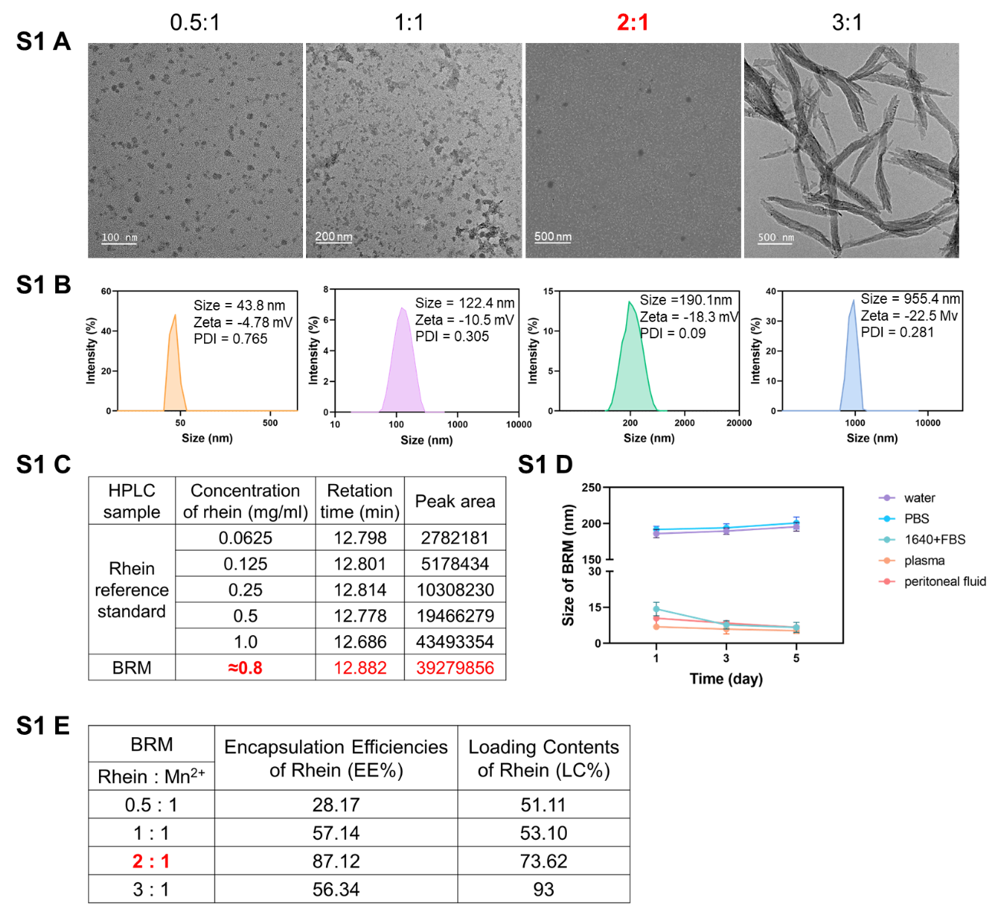
Figure S1. (A-B) TEM image and corresponding size distribution of BRM nanoparticles synthesized with varying Rhein: Mn²⁺ molar ratios. (C) HPLC calibration curve employed to quantify the concentration of rhein in BRM. (D) Temporal evolution of BRM nanoparticle size in various physiological media. (E) Encapsulation efficiency (EE%) and loading content (LC%) of Rhein of BRM nanoparticles at molar ratios of 0.5:1, 1:1, 2:1, and 3:1.

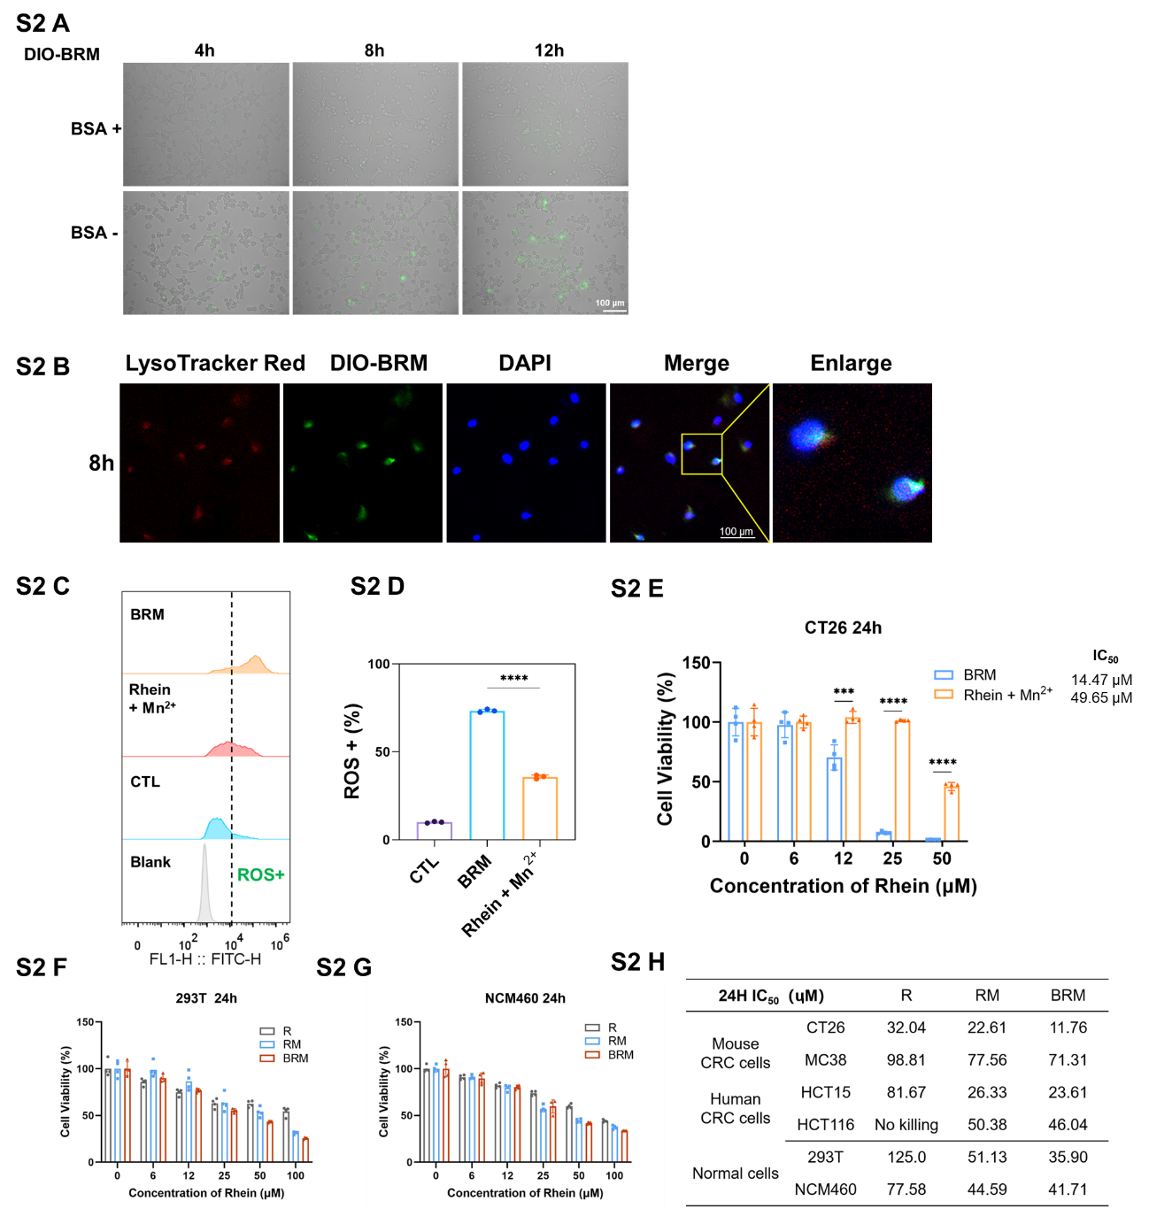
Figure S2. (A) BRM internalization via receptor-mediated endocytosis. Fluorescence images of CT26 cells showing the time-dependent internalization of Dio-labeled BRM (green). Pre-treatment with excess free BSA (BSA+) significantly attenuated cellular fluorescence compared to the control group (BSA-). Scale bar: 100 µm. (B) DIO-BRM co-localizes with lysosomes. Fluorescence images of CT26 cells showing the distribution of DIO-BRM (green) and lysosomes (LysoTracker Red, red) after 8 h incubation. The strong yellow signal in the merged view confirms lysosomal entrapment of DIO-BRM. Nuclei are stained with DAPI (blue). Scale bar: 20 μm. (C-D) Flow cytometry analysis of intracellular ROS levels (C) in CT26 cells treated with CTL, BRM, free Rhein + Mn²⁺, and quantitative analysis (D) (n = 3). (E) Cell viability of CT26, after 24 h treatment with CTL, BRM, free Rhein + Mn²⁺ at indicated concentrations, determined by CCK-8 assay. Data are presented as mean ± SD (n = 4). (F-G) Cell viability of 293T, NCM460 cells after 24 h treatment with free Rhein, RM, or BRM at indicated concentrations, determined by CCK-8 assay. Data are presented as mean ± SD (n = 4). (H) Summary table of the half-maximal inhibitory concentration (IC₅₀) values for different treatments across various cell lines, including mouse and human colorectal cancer cells as well as normal cells. (*, P < 0.05; **, P < 0.01; ***, P < 0.001; ****, P < 0.0001; ns, not significant; Ordinary one-way ANOVA).
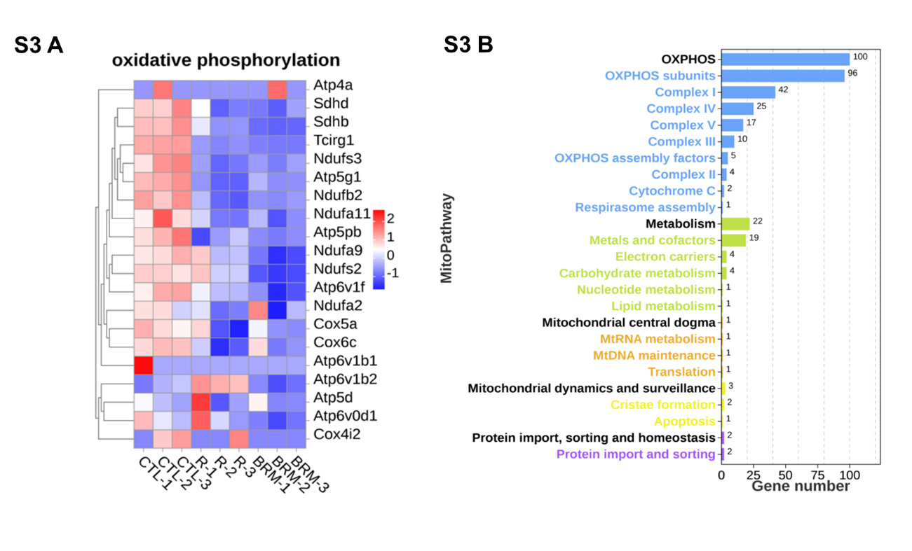
Figure S3. (A) Heatmap displaying expression patterns of genes associated with the oxidative phosphorylation pathway across different treatment groups. (B) Mitochondrial pathway enrichment analysis using the MitoCarta database.

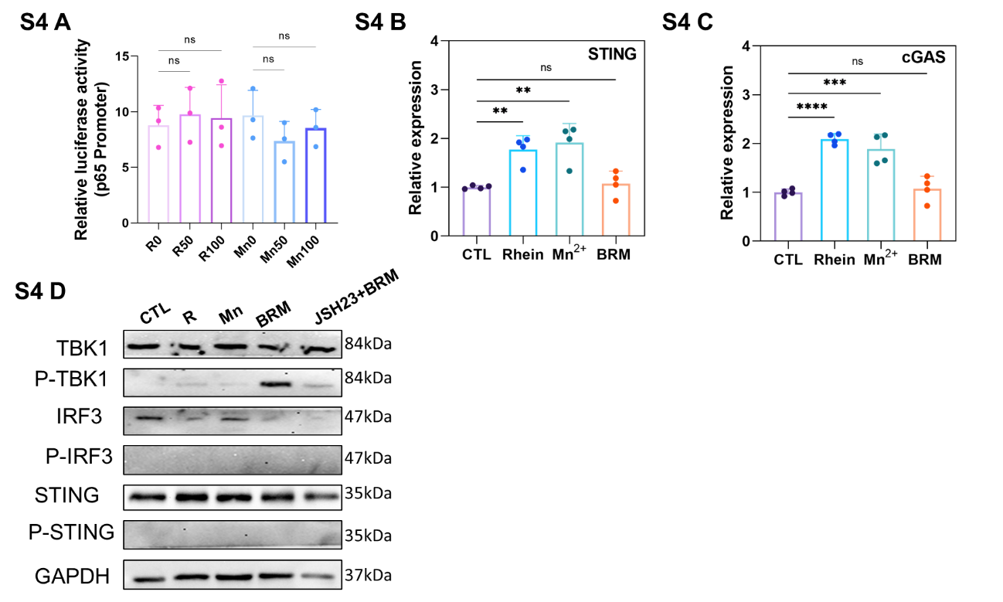
Figure S4. (A) Relative luciferase activity of NF-κB p65 promoter in CT26 cells treated with control, free Rhein, Mn²⁺ (50 and 100 μM, 12 h) (n = 3). (B-C) Relative mRNA expression levels of NF-κB-regulated genes in CT26 cells after various treatments (25 μM, 6 h), measured by RT‑qPCR: STING(B), cGAS(C) (n = 4). Data are presented as mean ± SD. (*, P < 0.05; **, P < 0.01; ***, P < 0.001; ****, P < 0.0001; ns, not significant; Ordinary one-way ANOVA). (D) Western blot analysis of the cGAS-STING signaling pathway in tumor cells.
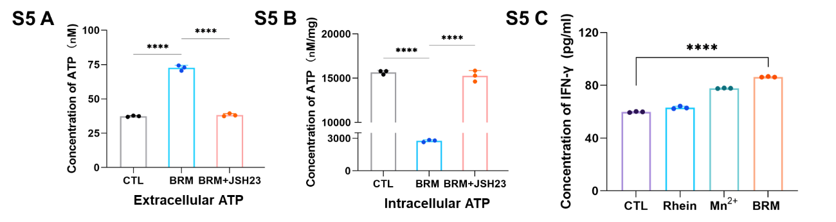
Figure S5. (A) Intracellular and (B) extracellular ATP levels in CT26 cells after BRM and JSH23 treatments (n = 3). (C) ELISA results of IFN-γ levels in the supernatant of bone marrow-derived DCs incubated with pretreated CT26 cells. (*, P < 0.05; **, P < 0.01; ***, P < 0.001; ****, P < 0.0001; ns, not significant; Ordinary one-way ANOVA).

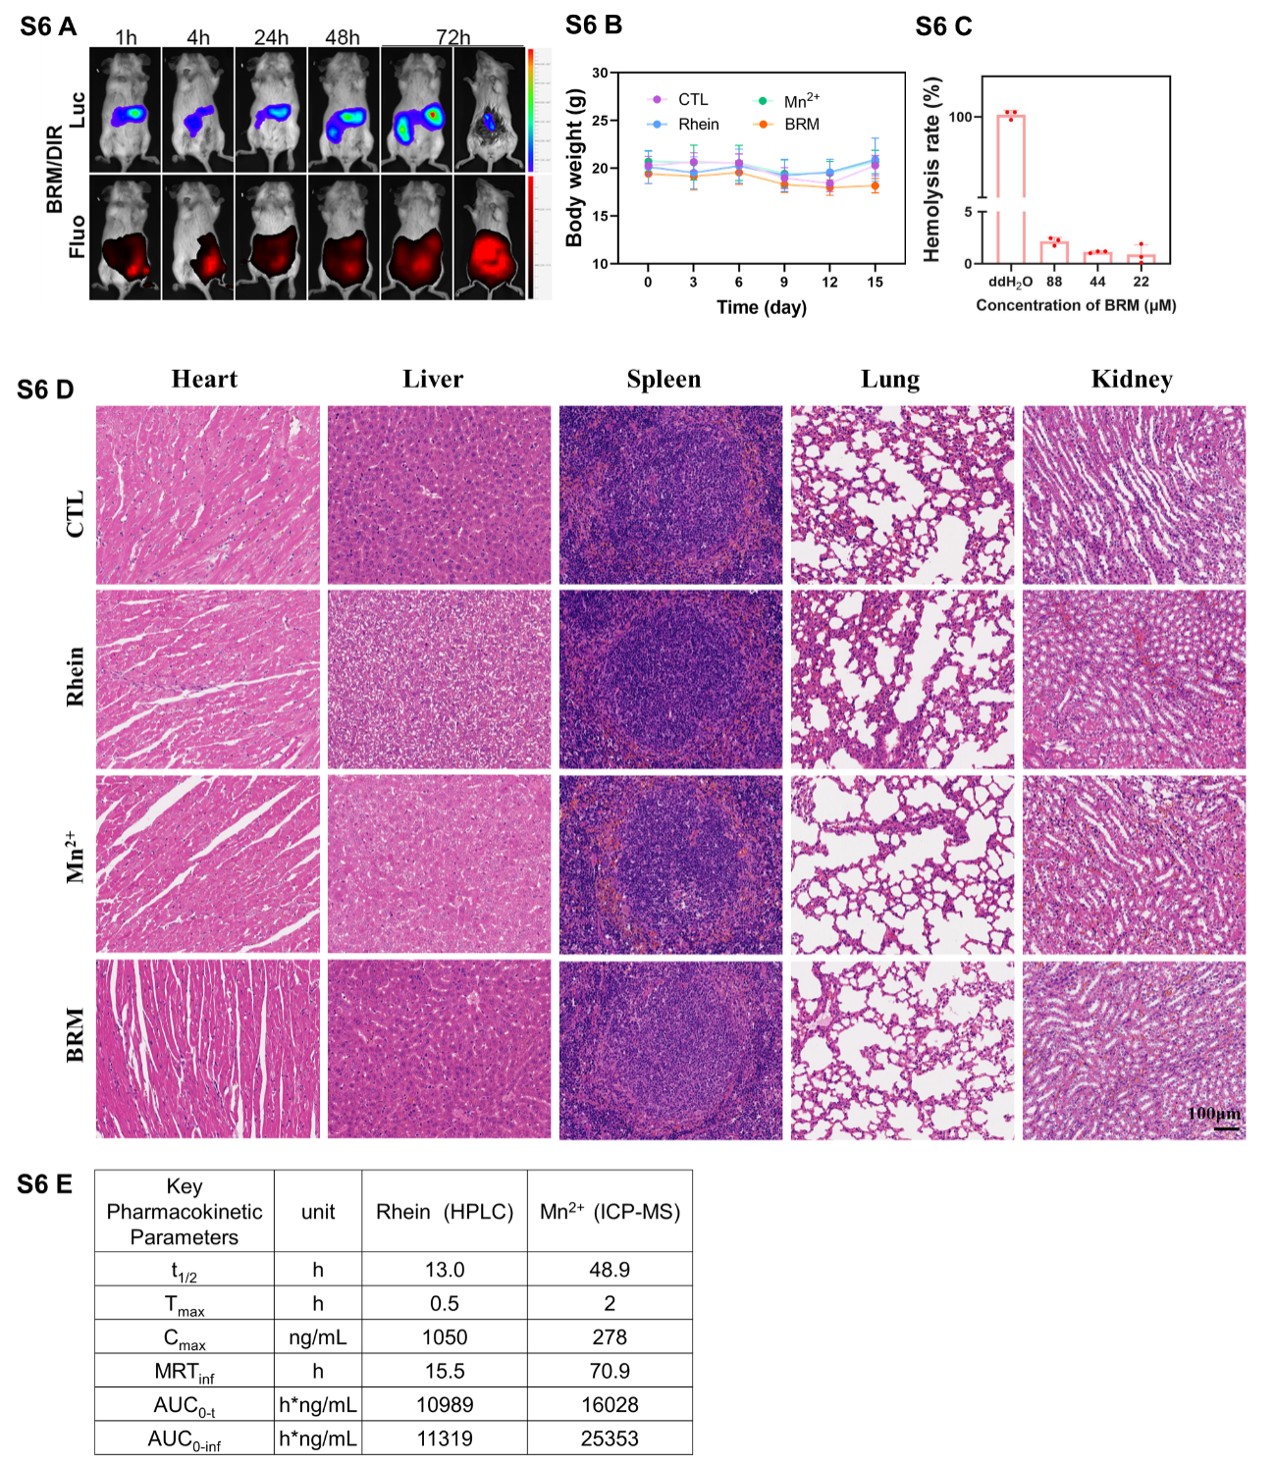
Figure S6. (A) Images of bioluminescence (Luc) for tumor and fluorescence (Fluo) for DiR in CT26-Luc tumor-bearing mice after intraperitoneal treatment with BRM nanoparticles -DiR at different time points. (B) Dynamic changes in body weight of mice during the treatment period. (C) Evaluation of the hemocompatibility of BRM nanoparticals. Concentration-dependent hemolytic activity of BRM nanoparticles on murine erythrocytes. The positive control (ddH₂O) induced complete hemolysis, whereas the negative control (PBS) resulted in negligible hemolysis. Values represent the mean ± SD from three independent experiments (n = 3). (D) H&E staining images of the main organs of mice with different treatments (scale bars = 100 µm). (E) Key pharmacokinetic parameters of Rhein and Mn²⁺ in SD rats after a single intraperitoneal injection of BRM nanoparticles at a dose of 30 mg/kg (n = 3, data are presented as mean values).
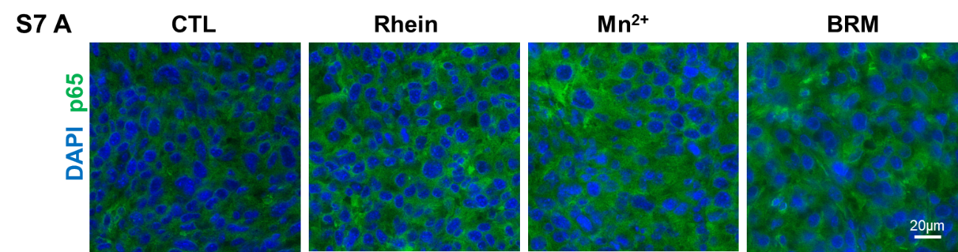
Figure S7. (A) Immunofluorescent images of tumor tissue stained with p65 (green) and DAPI (blue) (scale bar = 20 μm).

