Supporting Information

Self-fueling catalysis-driven membrane destabilization triggers CSC-enriched tumors ablation

Lin Huang^{1,2}, Basheng Hu³*, Guochao Wu², Wenjie Ma², Jiaoyang Qiu², Jiaoyang Zhu², Jing Yang², Haobin Cai², Qingdeng Fan², Bin Ren², Chunmei Chen², Zehui Wang^{2,4}, Jie Feng³, Yitong Li⁵, Sugeun Yang⁶, Chenggong Yan³, Xiangrong Yu⁴*, Zhigang Liu¹*, Zheyu Shen²*

¹ Cancer Center, Dongguan Key Laboratory of Precision Diagnosis and Treatment for Tumors, The Tenth Affiliated Hospital, Southern Medical University（Dongguan People's Hospital), Dongguan, Guangdong 523059, China
² School of Biomedical Engineering, Southern Medical University, 1023 Sha-Tai South Road, Guangzhou, Guangdong 510515, China
³ Medical Imaging Center, Nanfang Hospital, Southern Medical University, 1023 Sha-Tai South Road, Guangzhou, Guangdong 510515, China
⁴ Department of Radiology, Zhuhai People’s Hospital, Zhuhai Clinical Medical College of Jinan University, Zhuhai, 519000, China
⁵ Breast Surgery, Nanfang Hospital, Southern Medical University, 1023 Sha-Tai South Road, Guangzhou, Guangdong 510515, China
⁶ Department of Biomedical Science, BK21FOURProgram in Biomedical Science and Engineering, Inha University College of Medicine, Incheon 22212, South Korea

* Correspondence:
E-mail addresses: sz@smu.edu.cn (Z. Shen), zhigangliu1983@hotmail.com (Z. Liu), yuxiangrong@jnu.edu.cn (X. Yu), hubsh1@smu.edu.cn (B. Hu).

Experimental Section
Materials. Sodium hyaluronate (HA, Mw = 70 kDa), copper (II) chloride dihydrate (CuCl₂·2H₂O), zinc chloride (ZnCl₂), hydrazine (N₂H₄, 1.0 M in ethanol), sodium hydroxide (NaOH), hydrogen peroxide (H₂O₂, 30%), cariprazine, and tetrathiomolybdate (TTM) were purchased from Sigma-Aldrich (USA). Cholesterol oxidase (COD) was obtained from Aladdin Biochem Technology (Shanghai, China). Sodium sulfide nonahydrate (Na₂S·9H₂O, 99.9%), glutathione (GSH, 98.0%), 5,5’-dithiobis-2-(nitrobenzoicacid) (DTNB), 3,3’,5,5’-Tetramethylbenzidine (TMB), methylene blue (MB), rhodamine6G (R6G), [Ru(dpp)₃]Cl₂ (RuDPP, O₂ probe), and sulfo cyanine7 NHS ester (Cy7) were bought from Shanghai Macklin Biochemical Co., Ltd. H₂S probe (WSP-1) was purchased from Guangzhou Binpeng Biological Technology Co., Ltd. H₂S assay kit was bought from Beijing Solarbio Science & Technology Company (China). SiR-azide (Cu²⁺ selective fluorogenic probe), 2’,7’-dichlorofluorescein diacetate (DCFH-DA), Thiol Tracker Violet (GSH probe), and lipid peroxidation sensor (C11-BODIPY) were provided from Invitrogen Life Technologies (USA). Cholesterol detection Filipin III, and cholera toxin B subunit-FITC (CTB-FITC) probe were provided by TechTech (Guangzhou) Technology Service Co., Ltd. H₂O₂ assay kit, 4’,6-diamidino-2-phenylindole (DAPI), hydroxyphenyl fluorescein (HPF), 2,7-bis(2-carboxyethyl)-5,6-carboxyfluorescein acetoxymethyl ester (BCECF-AM), 5,5’,6,6’-tetrachloro-1,1’,3,3’-tetraethylbenzimidazolylcarbocyanine iodide (JC-1) assay kit, 3-(4,5-dimethylthiazol-2-yl)-2diphenyltetrazolium bromide (MTT), GSH assay kit, Glutathione Peroxidase (GPx) assay kit, lipid peroxidation MDA assay kit, dihydroethidium (DHE), Cell plasma membrane staining kit with DIO, DNA damage assay kit by γ-H2AX Immunofluorescence, Lyso-Tracker Green probe, Mito-Tracker Red probe, calcein acetoxymethyl ester (Calcein-AM)/propidium iodide (PI) assay kit, ATP assay kit, lactate dehydrogenase (LDH) assay kit, and Annexin V-FITC/propidium Iodide (PI) apoptosis detection kit were purchased from Beyotime Biotechnology Co., Ltd. (Shanghai, China). All other reagents were analytical grade and used as received.

Characterizations. The nanoparticle morphologies and corresponding energy dispersive X-ray spectroscopy (EDS) spectra were acquired from a transmission electron microscope (TEM) (JEM-2100F, JEOL). The X-ray diffraction (XRD) patterns of the nanoparticles were obtained using Cu Kα radiation at 40 mA and 40 kV. The size and zeta potential of nanoparticles were measured using an instrument of dynamic light scattering (DLS) (Nano-Brook 90PlusZata, Brookhaven). Nitrogen absorption-desorption isotherm and porosity were measured by a surface area analyzer (QuadraSorb SI 2000-08, Quantachrome Instruments). UV-vis spectra were measured using a spectrophotometer (Evolution 300, Thermo Fisher). Fourier transforms infrared (FT-IR) spectra were recorded using a Nicolet 6700 spectrometer (Thermo Electron Corporation, Madison, WI). X-ray photoelectron spectroscopy (XPS) spectra were obtained using a Thermo Scientific ESCALAB 250 XI. The Cu and Zn ions content were detected by inductively coupled plasma optical emission spectrometry (ICP-OES) (iCAP 6300Duo, Thermo Fisher Scientific, America).

Synthesis of Hollow Mesoporous Zinc-Copper Sulfide (HMZCS-HA) Nanocapsules. HMZCS-HA nanocapsules were synthesized via a one-pot strategy. Initially, 0.5 mL of HA stock solution (200 mg/mL) was mixed with 12 mL of metal precursor aqueous solution containing 2.0 mM of Cu²⁺ and 1.0 mM of Zn²⁺ under magnetic stirring. Subsequently, 12.5 mL of NaOH solution (pH 9.0) was added dropwise, followed by the addition of 100 μL of 1.0 M N₂H₄ solution. After stirring for 30 min, 100 μL of Na₂S aqueous solution (0.33-2.64 M) was injected. The reaction mixture was then heated at 60 °C for 3.0 h in an oil bath to yield HMZCS-HA1-4. The resulting nanocapsules were purified by dialysis (molecular weight cutoff: 100 kDa) against Milli-Q water for 24 h and harvested via centrifugation at 20,000 × g for 15 min. The concentrations of Zn and Cu in the synthesized HMZCS-HA nanocapsules were quantified using ICP-OES.

Synthesis of COD1-3@HMZCS-HA3. 1.0 mL of the prepared HMZCS-HA3 dispersion (10 mg/mL) was centrifuged at 20,000 × g for 10 min. The obtained precipitate was re-dispersed in 5.0 mL of COD solutions (0.2-1.0 mg/mL). After 10 min of ultrasonic treatment, the mixtures were incubated at room temperature for 12 h with gentle shaking. The resulting product, termed COD1-3@HMZCS-HA3, was then centrifuged again at 20,000 × g for 10 min, washed thrice with Milli-Q water, and subsequently re-dispersed in 5.0 mL of Milli-Q water. The supernatant was collected for the quantification of unloaded COD using the BCA protein assay kit (Sigma-Aldrich).

Assessment of Biodegradability Performance. 20 μL of COD2@HMZCS-HA3 (10 mg/mL) was added into 1.0 mL of acidic PBS buffer at pH 6.7. After incubation for 1.0, 4.0, 8.0, 12, or 24 h at 37 °C with shaking, 10 µL of the solution was used for TEM measurement to observe the degradation behavior of COD2@HMZCS-HA3.

In Vitro Drug Release. 2.0 mL of COD2@HMZCS-HA3 dispersion (4.0 mg/mL) was sealed in a 12 kDa cutoff dialysis bag and placed in 10 mL of PBS at pH 7.4, 6.7, or 5.5. Dialysis was performed at 37 °C with gentle shaking (100 rpm). At designated time points (0.25, 0.50, 1.0, 2.0, 4.0, 8.0, and 12 h), 0.5 mL of PBS was withdrawn and an equal volume of fresh PBS was supplemented. Released Zn and Cu ions were quantified by ICP-OES. The COD release was assessed using a BCA protein assay kit.
For H₂S release analysis, an additional batch of COD2@HMZCS-HA3 (2.0 mL, 5.0 mg/mL) was dispersed in 8.0 mL of PBS at varying pH values. After incubation with continuous stirring, 100 μL aliquots were collected at different time points (0.25, 0.50, 1.0, 2.0, 4.0, 8.0, and 12 h) and analyzed for H₂S content using the above-mentioned H₂S assay kit. These procedures were repeated three times for each group.

Detection of In Vitro •OH Production by TMB and MB Assays. The Fenton-like catalytic reaction for generating •OH by COD2@HMZCS-HA3 was conducted in PBS at pH 7.4, 6.7, or 5.5, using 0.5 mM TMB and 1.2 mM H₂O₂. Briefly, 1.0 mL of PBS at the desired pH containing 1.2 mM H₂O₂ was mixed with 50 μL of COD2@HMZCS-HA3 (2.0-8.0 mg/mL). The mixtures were stirred at room temperature for 0-8.0 h. Supernatants were obtained by centrifugation at 20,000 g for 10 min, followed by the addition of 0.10 mL of 5.0 mM TMB solution. After incubation for 30 min, the solutions were analyzed by UV-vis spectroscopy at 652 nm to quantify •OH generation. The concentration and time dependence of •OH generation were assessed at pH 6.7. Additionally, MB indicator (10 µg/mL) was used to further validate the extracellular •OH generation performance of COD2@HMZCS-HA3 using similar procedures.

Electron Spin Resonance (ESR) Measurements. To assess •OH generation via ESR, 200 μL of COD2@HMZCS-HA3 (4.0 mg/mL) was incubated with 4.0 mL of PBS at varying pH values (7.4,6.7, or 5.5) for 4.0 h. Subsequently, 100 μL of 5,5-dimethyl-1-pyrroline-N-oxide (DMPO) was added into the reaction mixture, and the ESR signal was recorded using an ESR spectrometer.

Assessment of GSH Depletion Performance. To evaluate the capability of GSH depletion, 200 µL of COD2@HMZCS-HA3 (0.625-10.0 mg/mL) was dispersed in 5.0 mL of GSH solution (1.0 mM). The pH of the mixture was then adjusted to 6.7, 6.0, or 5.5 using acetate buffers. The resulting solutions were maintained at 37 °C under magnetic stirring for 8.0 h. Subsequently, the mixtures were centrifuged at 20,000 × g for 10 min. The supernatants were then mixed with 50 µL of DTNB (10 mg/mL), and the mixture was incubated at 37 °C for 30 min. Finally, the absorbance of the solution was measured with a UV-vis spectrophotometer at a wavelength of 412 nm to assess the capacity for GSH consumption.

Cell Culture. Mouse breast carcinoma (4T1) cells and normal human umbilical vein endothelial cells (HUVECs) were cultured in Dulbecco's Modified Eagle's Medium (DMEM) supplemented with 10% fetal bovine serum (FBS), 100 U/mL penicillin G sodium, and 100 μg/mL streptomycin sulfate. Cultures were maintained in a HERAcell 150i incubator (Thermo Scientific) at 37 °C in a humidified atmosphere containing 5.0% CO₂.
4T1 cancer stem cells (CSC) were cultured in serum-free DMEM/F12 medium supplemented with B-27 (20.0 ng/mL), epidermal growth factor (EGF, 20.0 ng/mL), basic fibroblast growth factor (bFGF, 20.0 ng/mL), insulin (5.0 μg/mL), and penicillin/streptomycin (100 U/mL). Sorted CSC were seeded into ultralow-adherence culture plates (Corning) and incubated in a Tri-gas incubator (MCO-5M, Panasonic Healthcare) under hypoxic conditions (1.0% O₂, 5.0% CO₂) at 37 °C. Under these serum-free suspension culture conditions, CSC formed three-dimensional tumor spheroids with typical morphological features. Tumor spheroids were collected after 7-10 days for downstream experimental analyses.

R6G Labeling of Nanoparticles. 1.0 mL of freshly prepared R6G solution (4.0 mg/mL) was added into 10 mL of COD2@HMZCS-HA3 dispersion (1.0 mg/mL). The mixture was stirred for 24 h in the dark. The R6G-labeled COD2@HMZCS-HA3 (R6G-COD2@HMZCS-HA3) was then collected by centrifugation (15,000 × g, 10 min) and washed with Milli-Q water for further use.
In Vitro Cell Uptake. HUVECs or 4T1 cells were seeded in confocal dishes (5.0 × 10⁴ cells/dish) or 6-well plates (3.0 × 10⁵ cells/well) and incubated overnight to allow adherence. The growth medium was then replaced with 1.0 mL of DMEM containing R6G-COD2@HMZCS-HA3 (C_{Cu} = 5.0 μg/mL), and the cells were incubated for an additional 4.0 h. Subsequently, the cells were washed with PBS, fixed in 4.0% paraformaldehyde for 30 min, permeabilized with 0.10% Triton X-100 for 5.0 min, blocked with 1.0% BSA for 30 min, and stained with DAPI and Phalloidin-FITC for 30 min at room temperature. After rinsing with PBS, the cells were imaged using a laser scanning confocal microscope (LSCM, Nikon ECLIPSE Ti2). Additionally, cells treated with R6G-COD2@HMZCS-HA3 were collected for flow cytometry analysis (BD FASCVerse, USA) to evaluate intracellular R6G fluorescence intensity.
Furthermore, loss-of-function studies were conducted to provide additional evidence through blocking experiments using 200 times concentration of free HA.

Visualization of Cu²⁺ Delivery. 4T1 cells were seeded in confocal dishes (5.0 × 10⁴ cells/dish) and incubated overnight to achieve adherence. The growth medium was replaced with 1.0 mL of DMEM containing COD2@HMZCS-HA3 (C_{Cu} = 5.0 μg/mL), followed by 4.0 h of incubation. Subsequently, the cells were washed thrice with cold PBS, and stained with SiR-azide (Cu²⁺ probe, 5.0 μg/mL) for 30 min. After washing with PBS, the cells were fixed in 4.0% paraformaldehyde for 30 min, permeabilized with 0.10% Triton X-100 for 5.0 min, and blocked with 1.0% BSA for 30 min. Finally, they were stained with a DAPI and Actin-Tracker Green-488 solution (Phalloidin-FITC) for 30 min at room temperature before observation using the LSCM.
Observation of Lysosomal Escape. 4T1 cells were seeded into confocal dishes at a density of 1.0 × 10⁵ cells per dish, and incubated overnight for adherence. The medium was then replaced with 500 μL of culture medium containing R6G-COD2@HMZCS-HA3 (C_{Cu} = 5.0 μg/mL). After 6.0 h of incubation, the cells were washed with PBS, fixed in 4.0% paraformaldehyde for 30 min, permeabilized with 0.10% Triton X-100 for 5.0 min, and blocked with 1.0% BSA for 30 min. Subsequently, the cells were stained with Lyso-Tracker Green solution for 1.0 h and DAPI for 30 min. Finally, the cells were rinsed with PBS and observed using the LSCM.

Cytotoxicity Assay. HUVECs or 4T1 cells were seeded into 96-well plates at a density of 5.0 × 10³ cells per well and incubated overnight at 37 °C. After PBS washing, the cells were treated with COD2@HMZCS-HA3 nanoparticles at varying concentrations (C_{nanoparticles} = 1.6-50.0 μg/mL) for 24 h. Subsequently, 10 μL of MTT (5.0 mg/mL) was added into each well. After an additional 4.0 h of incubation, the culture media were removed, and 100 μL of DMSO was added into each well. Absorbance was measured at 570 nm using a microplate reader (Biotek Synergy H1).
Meanwhile, the cytotoxicity of various formulations was assessed using the MTT assay. Briefly, 4T1 cells were seeded in 96-well plates at a density of 5.0 × 10³ cells per well and incubated overnight at 37 °C. The cells were then treated with different cultivation solutions: (I) PBS, (II) NaHS (50.0 μg/mL), (III) COD (equivalent COD concentrations, i.e., 8.4 μg/mL), (IV) HMZCS-HA3 (41.6 μg/mL), or (V) COD2@HMZCS-HA3 (50.0 μg/mL). After co-incubation for 6.0-24 h, relative cell viability was measured following the previously described procedure.
To verify the effects of ferroptosis inhibitors on the cytotoxicity of COD2@HMZCS-HA3, 4T1 cells were incubated with COD2@HMZCS-HA3 (50.0 µg/mL) together with 5.0 mM of GSH, 50 μM of TTM, or 10 μM of cariprazine, respectively. After 24 h of incubation, the MTT assay was performed.
To discriminate ferroptosis from apoptosis and necroptosis, inhibitor co-treatment studies were conducted. 4T1 cells were exposed to the 50.0 µg/mL of COD2@HMZCS-HA3 (V) alongside specific inhibitors: the apoptosis inhibitor Z-VAD-FMK (Z-VAD, 10 μM), the necroptosis inhibitor Necrostatin-1 (Nec-1, 10 μM), and the ferroptosis inhibitor Ferrostatin-1 (Fer-1, 10 μM). Cell viability was assessed via MTT assay after 24 h.

Live/Dead Staining Assay. 4T1 cells were seeded into confocal dishes at a density of 5.0 × 10⁴ cells per dish and incubated for 24 h to achieve adherence. The cells were then treated with (I) PBS, (II) NaHS (50.0 μg/mL), (III) COD (8.4 μg/mL), (IV) HMZCS-HA3 (41.6 μg/mL), or (V) COD2@HMZCS-HA3 (50.0 μg/mL) for additional 24 h. After that, the cells were co-stained with calcein-AM (5.0 μg/mL) and propidium iodide (PI, 10.0 μg/mL) for 30 min. The cells were rinsed with PBS and observed using the LSCM.

Flow Cytometry Analysis of the Cell Apoptosis. 4T1 cells were seeded into 6-well plates at a density of 3.0 × 10⁵ cells per well and cultured for 24 h to achieve adherence. The cells were then treated with (I) PBS, (II) NaHS (50.0 μg/mL), (III) COD (8.4 μg/mL), (IV) HMZCS-HA3 (41.6 μg/mL), or (V) COD2@HMZCS-HA3 (50.0 μg/mL) for 12 h. After treatment, the cells were washed twice with PBS, harvested by centrifugation (2,000 ×g, 3.0 min), and resuspended in 185 μL of cold PBS. Subsequently, 5.0 μL of Annexin V-FITC and 10 μL of PI were added into the cell suspensions, which were incubated in the dark for 15 min prior to flow cytometry analysis.

Edu Cell Proliferation Assay. 4T1 cells were seeded into confocal dishes at a density of 1.0 × 10⁵ cells per dish and incubated overnight to achieve adherence. The cells were subsequently treated with (I) PBS, (II) NaHS (50.0 μg/mL), (III) COD (8.4 μg/mL), (IV) HMZCS-HA3 (41.6 μg/mL), or (V) COD2@HMZCS-HA3 (50.0 μg/mL) for 12 h. After that, the cells were washed with PBS and incubated with culture media containing EdU (10.0 mM) for an additional 2.0 h. The samples were then washed with PBS, fixed with 4.0% paraformaldehyde for 30 min, permeabilized with 0.10% Triton X-100 for 5.0 min, and blocked with 1.0% BSA for 30 min. The cells were then stained with DAPI for 10 min and treated with a click additive solution containing Azide 488 for 30 min, following the instructions of the BeyoClick™ Edu-488 proliferation kit. Finally, the cells were rinsed with PBS and observed using the LSCM.

Intracellular H₂S Content Detection. 4T1 cells were inoculated in 6-well plates at a density of 3.0 × 10⁵ cells per well and cultured for 24 h. The culture medium was then replaced with 1.0 mL of fresh complete DMEM containing different concentrations of COD2@HMZCS-HA3 (0-25.0 μg/mL) at pH 7.4 or 6.7, and the cells were incubated for an additional 24 h. Subsequently, the cells were washed with PBS and collected after trypsin digestion. The intracellular H₂S content was determined using the above-mentioned H₂S detection kit.
For the evaluation of intracellular H₂S generation from various formulations, 4T1 cells were seeded into confocal dishes at a density of 5.0 × 10⁴ cells per dish and cultured overnight. The cells were then treated with (I) PBS, (II) NaHS (25.0 μg/mL), (III) COD (4.2 μg/mL), (IV) HMZCS-HA3 (20.8 μg/mL), or (V) COD2@HMZCS-HA3 (25.0 μg/mL) for 12 h. After that, the cells were stained with WSP-1 (10.0 μg/mL) for 30 min at 37 °C in the dark. After washing thric with PBS, the cells were observed using the LSCM.

Monitoring of Intracellular Acidity Changes. 4T1 cells were seeded into confocal dishes (5.0 × 10⁴ cells /dish) or 6-well plates (3.0 × 10⁵ cells/well) and incubated overnight. Subsequently, the cells were treated with (I) PBS, (II) NaHS (25.0 μg/mL), (III) COD (4.2 μg/mL), (IV) HMZCS-HA3 (20.8 μg/mL), or (V) COD2@HMZCS-HA3 (25.0 μg/mL) for 12 h. The treated cells were then stained with BCECF-AM (2.5 μM, Ex = 488 nm, Em = 530 nm) for 30 min at 37 °C. After washing thrice with PBS, the cells were observed by the LSCM, or analyzed by flow cytometry.

Evaluation of Cell Respiration. For the detection of mitochondrial respiratory chain proteins, 4T1 cells were seeded into confocal dishes at a density of 5.0 × 10⁴ cells per dish and cultured overnight. The cells were then treated for 12 h with (I) PBS, (II) NaHS (25.0 μg/mL), (III) COD (4.2 μg/mL), (IV) HMZCS-HA3 (20.8 μg/mL), or (V) COD2@HMZCS-HA3 (25.0 μg/mL). After treatment, the cells were fixed with 4.0% paraformaldehyde, incubated overnight at 4.0 °C with an anti-cytochrome c oxidase (COX IV) rabbit antibody, and then treated with an Alexa Fluor 555-labeled anti-rabbit secondary antibody at room temperature for 2.0 h. The cells were then washed thrice with PBS, and then stained with DAPI for 15 min. Finally, fluorescence images were captured using the above-mentioned LSCM. Additionally, mitochondrial respiratory capacity was assessed using the XF Cell Mito Stress Test Kit (Agilent Technologies, 103015-100), following the instructions provided in the manual.

Detection of Intracellular O₂ Level. 4T1 cells were seeded in confocal dishes at a density of 5.0 × 10⁴ cells per dish and incubated overnight under hypoxic conditions (5.0% CO₂, 1.0% O₂). The cells were then treated for 12 h with (I) PBS, (II) NaHS (25.0 μg/mL), (III) COD (4.2 μg/mL), (IV) HMZCS-HA3 (20.8 μg/mL), or (V) COD2@HMZCS-HA3 (25.0 μg/mL). After that, the cells were incubated with RUDDP dye solution (1:200 dilution) for 25 min and then stained with DAPI for 15 min. Fluorescence images were captured using the LSCM. Dissolved oxygen levels in the medium were real-time monitored during the 12 h of treatment using a dissolved oxygen analyzer (JPB-607A).

Detection of ROS in Cells. 4T1 cells were seeded into confocal dishes (5.0 × 10⁴ cells/dish) or 6-well plates (3.0 × 10⁵ cells/well), and incubated for 24 h. Thereafter, the cells were treated with (I) PBS, (II) NaHS (25.0 μg/mL), (III) COD (4.2 μg/mL), (IV) HMZCS-HA3 (20.8 μg/mL), or (V) COD2@HMZCS-HA3 (25.0 μg/mL) for 12 h. The treated cells were then stained with DCFH-DA (10.0 μM) for 30 min at 37 °C in the dark. After washing thrice with PBS, the cells were observed by the LSCM or analyzed by the flow cytometry.

Evaluation of Intracellular Superoxide (•O₂⁻). First, 4T1 cells were seeded into confocal dishes at a density of 5.0 × 10⁴ cells per dish and incubated overnight. The culture medium was then replaced with 1.0 mL of fresh complete DMEM containing different concentrations of Zn²⁺ (0, 2.5, 5.0, or 10.0 μg/mL). After an additional 12 h of incubation, the cells were washed with PBS and incubated in the culture medium containing DHE (10 μM) for 30 min. Finally, the cells were rinsed with PBS and observed using the LSCM.
In addition, the •O₂⁻ levels in 4T1 cells treated with (I) PBS, (II) NaHS (25.0 μg/mL), (III) COD (4.2 μg/mL), (IV) HMZCS-HA3 (20.8 μg/mL), or (V) COD2@HMZCS-HA3 (25.0 μg/mL) for 12 h were evaluated using similar procedures.

Monitoring the COD-Induced Changes of Intracellular H₂O₂. 4T1 cells were seeded into 6-well plates (2.0 × 10⁵ cells per well) and incubated overnight. Then the culture medium was replaced with 1.0 mL of fresh complete DMEM medium containing different concentrations of COD (0, 2.5, 5.0, 10, or 20 μg/mL). After further 6.0 h of incubation, the cells were collected for the measurement of the intracellular H₂O₂ level via the standard H₂O₂ assay kit.
In addition, the H₂O₂ levels in 4T1 cells treated with (I) PBS, (II) NaHS (50.0 μg/mL), (III) COD (8.4 μg/mL), (IV) HMZCS-HA3 (41.6 μg/mL), or (V) COD2@HMZCS-HA3 (50.0 μg/mL) for 6.0 h were also evaluated using the similar procedures.

Depletion of Cholesterol. 4T1 cells were seeded into confocal dishes at a density of 5.0 × 10⁴ cells per dish or 6-well plates at a density of 3.0 × 10⁵ cells per well, and incubated for 24 h. Thereafter, the cells were treated with (I) PBS, (II) NaHS (25.0 μg/mL), (III) COD (4.2 μg/mL), (IV) HMZCS-HA3 (20.8 μg/mL), or (V) COD2@HMZCS-HA3 (25.0 μg/mL) for 12 h. The cells were then fixed with 4.0 % paraformaldehyde at room temperature for 20 min. Subsequently, the treated 4T1 cells were incubated with Filipin III solution (100 μg/mL) and analyzed using the LSCM or flow cytometry to validate cholesterol depletion.

Detection of Lipid Raft Integrity. The cholera toxin B subunit-FITC (CTB-FITC) probe (Absin) was utilized to investigate ganglioside GM1 expression in cancer cells, which is a critical marker of lipid raft integrity. Briefly, 4T1 cells were seeded into confocal dishes at a density of 5.0 × 10⁴ cells per dish or 6-well plates at a density of 3.0 × 10⁵ cells per well, and incubated for 24 h. Thereafter, the cells were treated with (I) PBS, (II) NaHS (25.0 μg/mL), (III) COD (4.2 μg/mL), (IV) HMZCS-HA3 (20.8 μg/mL), or (V) COD2@HMZCS-HA3 (25.0 μg/mL) for 12 h. The treated 4T1 cells were then incubated with CTB-FITC (10.0 μg/mL) for 30 min, and analyzed using the LSCM or flow cytometry.

Detection of Fluidity Membrane. 4T1 cells were seeded in 6-well plates at a density of 3.0 × 10⁵ cells per well and incubated for 24 h. Subsequently, the cells were treated with (I) PBS, (II) NaHS (25.0 μg/mL), (III) COD (4.2 μg/mL), (IV) HMZCS-HA3 (20.8 μg/mL), or (V) COD2@HMZCS-HA3 (25.0 μg/mL) for 12 h. After treatment, cells were trypsinized and stained with 1-pyrenedodecanoic acid for 5.0 min in the dark. Fluorescence spectra were then recorded using the fluorescence spectrophotometer (F-7100, Hitachi) with an excitation wavelength of 380 nm and emission scanning from 380 to 580 nm. Membrane fluidity was evaluated by calculating the ratio of excimer emission (475 nm) to pyrene monomer emission (397 nm) for each group.

Measurement of Intracellular Lipid Peroxide (LPO). 4T1 cells were seeded into confocal dishes at a density of 5.0 × 10⁴ cells per dish or 6-well plates at a density of 3.0 × 10⁵ cells per well, and incubated for 24 h. Thereafter, the cells were treated with (I) PBS, (II) NaHS (25.0 μg/mL), (III) COD (4.2 μg/mL), (IV) HMZCS-HA3 (20.8 μg/mL), (V) COD2@HMZCS-HA3 (25.0 μg/mL), or (VI) COD2@HMZCS-HA3 (25.0 μg/mL) together with 10 μM of cariprazine. After 12 h of incubation, the cells were then stained with C11-BODIPY (5.0 μM) for 30 min. The cells were further rinsed thrice by PBS and the nuclei were stained by DAPI for 15 min. Finally, the fluorescence images were monitored by the LSCM. Besides, the cells stained with C11-BODIPY were also analyzed by the flow cytometry.

Evaluation of Intracellular MDA Levels. 4T1 cells were seeded into 6-well plates (3.0 × 10⁵ cells/well) and incubated for 24 h. Thereafter, the cells were treated with (I) PBS, (II) NaHS (25.0 μg/mL), (III) COD (4.2 μg/mL), (IV) HMZCS-HA3 (20.8 μg/mL), (V) COD2@HMZCS-HA3 (25.0 μg/mL), and COD2@HMZCS-HA3 (25.0 μg/mL) together with (VI) 10 μM of cariprazine, (VII) 50 μM of ammonium tetrathiomolybdate (TTM, copper chelator), (VIII) 50 μM of tetrakis-(2-pyridylmethyl)ethylenediamine (TPEN, zinc chelator), or (IX) 100 μM of hypotaurine (HTAU, H₂S scavenger) for 12 h. The intracellular MDA contents were detected by the MDA assay kit according to the manufacturer’s protocol.

Inhibitor Rescue Assay. 4T1 cells were seeded into confocal dishes (5.0×10⁴ cells/dish) and incubated overnight under hypoxic conditions (5.0% CO₂, 1.0% O₂). Subsequently, the cells were treated with COD2@HMZCS-HA3 (V) alone or in combination with HTAU, TTM, TPEN, cariprazine, HTAU + TTM, HTAU + TPEN, or HTAU + TTM + TPEN for 12 h. The treated cells were then separately stained with WSP-1, RuDPP, DHE, Filipin III, HPF, or C11-BODIPY probes. After washing three times with PBS, the cells were imaged using the LSCM.

Assay of Intracellular GSH and GPX4. 4T1 cells were seeded into confocal dishes at a density of 5.0 × 10⁴ cells per dish or 6-well plates at a density of 3.0 × 10⁵ cells per well, and incubated for 24 h. Thereafter, the cells were treated with (I) PBS, (II) NaHS (25.0 μg/mL), (III) COD (4.2 μg/mL), (IV) HMZCS-HA3 (20.8 μg/mL), or (V) COD2@HMZCS-HA3 (25.0 μg/mL) for 12 h. The GSH level and GPX4 activity were measured using the GSH assay kit and the GPx assay kit, respectively, according to the manufacturer’s instructions. Additionally, 4T1 cells treated with different formulations were stained with Thiol Tracker Violet (10.0 μM) for 30 min. The nuclei were then stained with DAPI for 15 min and subsequently observed using the LSCM.
For immunofluorescence staining analysis of GPX4 protein, the treated cells were fixed with 4.0% paraformaldehyde, permeabilized with 1.0% Triton X-100, and then incubated overnight with anti-GPX4 rabbit antibody (dilution 1:1000). The cells were subsequently washed with PBS and incubated with Alexa Fluor 555-labeled anti-rabbit secondary antibody (Beyotime Biotechnology) for 30 min. The nuclei were stained with DAPI for 15 min. Finally, the samples were observed using the LSCM.

Detection of Mitochondrial Membrane Potential. 4T1 cells were seeded into culture dishes and incubated for 24 h to achieve adherence. The cells were then treated with one of the following formulations for 12 h: (I) PBS, (II) NaHS (25.0 µg/mL), (III) COD (4.2 µg/mL), (IV) HMZCS-HA3 (20.8 µg/mL), or (V) COD2@HMZCS-HA3 (25.0 µg/mL). After treatment, the cells were stained with the JC-1 probe (10.0 µg/mL) for 30 min. Subsequently, the cells were rinsed thrice with PBS at 4.0 °C and collected by centrifugation (2,000 × g, 3.0 min) for further analysis using the flow cytometry. Confocal microscopy was also used to capture fluorescence images of the different treatment groups.

Mitochondrial Integrity Assay. 4T1 cells were seeded into confocal dishes (5.0 × 10⁴ cells/dish) and incubated for 24 h to achieve adherence. The cells were treated with (I) PBS, (II) NaHS (25.0 µg/mL), (III) COD (4.2 µg/mL), (IV) HMZCS-HA3 (20.8 µg/mL), or (V) COD2@HMZCS-HA3 (25.0 µg/mL) for 12 h. After treatment, the cells were stained with Mito-Tracker Red solution (5.0 µM) for 30 min. The cells were subsequently rinsed thrice with PBS, and the nuclei were stained with DAPI for 15 min. Finally, fluorescence images were acquired using the LSCM.

Bio-TEM Observation of Mitochondrial Morphology. 4T1 cells were seeded into 6-well plates (2.0 × 10⁵ cells/well) and incubated for 24 h. Thereafter, the cells were treated with COD2@HMZCS-HA3 (25.0 μg/mL). After 12 h of incubation, the cells were collected and fixed with 3.0% glutaraldehyde, and the mitochondrial morphology was observed by the TEM.

Intracellular ATP Level Detection. 4T1 cells were seeded into 6-well plates at a density of 3.0 × 10⁵ cells per well and incubated for 24 h. Subsequently, the cells were treated with (I) PBS, (II) NaHS (25.0 µg/mL), (III) COD (4.2 µg/mL), (IV) HMZCS-HA3 (20.8 µg/mL), or (V) COD2@HMZCS-HA3 (25.0 µg/mL) for 12 h. The cells were then harvested by centrifugation at 2,000 × g for 3.0 min, and the intracellular ATP content was measured using an ATP assay kit according to the manufacturer's protocol.

Observation of Cell Membrane Morphology. 4T1 cells were pre-seeded into confocal dishes (5.0 × 10⁴ cells/dish) and incubated for 24 h. Thereafter, the cells were treated with (I) PBS, (II) NaHS (25.0 µg/mL), (III) COD (4.2 µg/mL), (IV) HMZCS-HA3 (20.8 µg/mL), or (V) COD2@HMZCS-HA3 (25.0 µg/mL). After 12 h of incubation, the cells were cultured with DIO solution (10.0 μg/mL) for 30 min. The cells were further rinsed thrice by PBS and the nuclei were stained by DAPI for 15 min. Finally, the fluorescence images were observed by the LSCM.

Released LDH measurement. 4T1 cells were seeded into 6-well plates at a density of 3.0 × 10⁵ cells per well and incubated for 24 h. Subsequently, the cells were treated with (I) PBS, (II) NaHS (25.0 µg/mL), (III) COD (4.2 µg/mL), (IV) HMZCS-HA3 (20.8 µg/mL), or (V) COD2@HMZCS-HA3 (25.0 µg/mL) for 12 h. The cell culture supernatant was collected by centrifugation at 2,000 × g for 3.0 min, and LDH release in the culture medium was quantified using an LDH assay kit, following the manufacturer's protocol.

Detection of DNA Damage: γ-H2AX immunofluorescence analysis was used for the detection of DNA damage. Typically, 4T1 cells were seeded into confocal dishes and incubated for 24 h to achieve adherence. The cells were then treated with (I) PBS, (II) NaHS (25.0 µg/mL), (III) COD (4.2 µg/mL), (IV) HMZCS-HA3 (20.8 µg/mL), or (V) COD2@HMZCS-HA3 (25.0 µg/mL) for 12 h. The cells were washed with PBS, fixed with 4.0% paraformaldehyde, permeabilized with 0.1% Triton X-100, and blocked with 1.0% BSA in sequence. The obtained cells were incubated with anti-phospho-histone γ-H2AX rabbit primary antibody (dilution 1: 1000) overnight at 4.0 ºC, and further stained with FITC-conjugated anti-rabbit secondary antibody for 1.0 h. After washing thrice with PBS, the cell nuclei were stained with DAPI for 15 min. Finally, the fluorescence images were taken by the LSCM.

Detection of Invasive Lamellipodia Around Cells. 4T1 cells were pre-seeded in confocal dishes at a density of 5.0 × 10⁴ cells per dish and incubated for 24 h. Subsequently, the cells were treated with (I) PBS, (II) NaHS (25.0 µg/mL), (III) COD (4.2 µg/mL), (IV) HMZCS-HA3 (20.8 µg/mL), or (V) COD2@HMZCS-HA3 (25.0 µg/mL). After 12 h of incubation, the cells were washed with PBS, fixed in 4.0% paraformaldehyde for 30 min, permeabilized with 0.10% Triton X-100 for 5 min, and blocked with 1.0% BSA for 30 min. The cells were then stained with Phalloidin-iFluor 647 (Abcam) and DAPI for 30 min at room temperature. Following rinsing with PBS, the cells were imaged using the LSCM.

Cell Migration Assay. Cell migration was assessed using a scratch wound assay. 4T1 cells were seeded in 6-well plates at a density of 3.0 × 10⁵ cells per well and cultured until nearly confluent. A scratch wound was created using a 200 μL of pipette tip, and images were captured with a microscope to mark the initial time point (0 h). The cells were then treated with (I) PBS, (II) NaHS (12.5 µg/mL), (III) COD (2.1 µg/mL), (IV) HMZCS-HA3 (10.4 µg/mL), or (V) COD2@HMZCS-HA3 (12.5 µg/mL) for 12 h. After removal of the culture medium, random photographs were taken, and the percentage of wound closure was calculated.

Transwell Invasion Assay. Matrigel® Matrix was diluted to 5.0 mg/mL in serum-free DMEM, and 50 μL of the diluted matrix was added to each Transwell chamber. The chambers were then incubated at 37 °C for 1.0 h. Subsequently, 1.0 × 10⁵ cells were resuspended in 200 μL of serum-free DMEM and added to the upper chambers of the Transwell plates. The Transwell inserts were placed in a 24-well plate containing 500 μL of complete DMEM containing (I) PBS, (II) NaHS (25.0 µg/mL), (III) COD (4.2 µg/mL), (IV) HMZCS-HA3 (20.8 µg/mL), or (V) COD2@HMZCS-HA3 (25.0 µg/mL). After incubation for 24 h, the cells were fixed with 4.0% paraformaldehyde for 20 min and stained with crystal violet (10 µg/mL) for 10 min. The cells were then washed with PBS, and those adhering to the inner wall were gently removed with a cotton swab before imaging under a microscope.

Identification of 4T1 CSC Proportions and Stemness Disruption via ROS Surge and Hypoxia Alleviation. The CSC were sorted from 4T1 cells and cultured as guided by the previous report [Li Z, Yang J, Ren B, et al. Double-layered hollow mesoporous cuprous oxide nanoparticles for double drug sequential therapy of tumors. Adv. Mater., 2024, 36(28), 2313212]. Quantitative real-time polymerase chain reaction (qPCR) was adopted to analyze the expression level of stemness-related genes (NANOG, CD133, and SOX2) in 4T1 cells or 4T1 CSC.
To investigate the differentiation-inducing effects of nanomedicines, sorted 4T1 CSC were seeded into 6-well plates at a density of 2.0 × 10⁵ cells per well, and incubated for 24 h. The culture medium was then replaced with 1.0 mL of fresh CSC medium containing (I) PBS, (II) NaHS (25.0 µg/mL), (III) COD (4.2 µg/mL), (IV) HMZCS-HA3 (20.8 µg/mL), or (V) COD2@HMZCS-HA3 (25.0 µg/mL). After an additional 24 h incubation, total RNA from the treated CSC was extracted using TRIzol (Servicebio) according to the manufacturer’s protocols, and RNA concentrations were quantified with a Nanodrop 2000. qPCR was performed to assess the expression levels of stemness-related genes (NANOG, CD133, and SOX2).

Penetration Analysis of 4T1 CSC Spheroids. The obtained 4T1 CSC spheroids (diameter > 100 μm) were transferred to confocal dishes, followed by the addition of fresh CSC medium (1.0 mL) containing R6G-COD2@HMZCS-HA3 (C_{Cu} = 5.0 μg/mL). After 6.0 h of incubation, the treated 4T1 CSC spheroids were washed carefully thrice with PBS and observed by LSCM.

In Vitro Tumor Spheroids Formation and Destruction. 1.0 × 10⁴ 4T1 CSC were seeded into a 96-well ultralow attachment plate and cultured in CSC tumor spheroid DMEM/F12 medium. After one week, half of the old culture medium was removed and replaced with an equal volume of fresh CSC medium containing (I) PBS, (II) NaHS (25.0 µg/mL), (III) COD (4.2 µg/mL), (IV) HMZCS-HA3 (20.8 µg/mL), or (V) COD2@HMZCS-HA3 (25.0 µg/mL). Tumor spheroids in each group were observed using an optical microscope, and both the number and size of the spheroids were recorded over a 7-day observation period.

Detection of ROS in 4T1 CSC Spheroids. 4T1 CSC spheroids were initially seeded into confocal dishes and incubated. Subsequently, the mammospheres were treated with CSC medium containing (I) PBS, (II) NaHS (25.0 µg/mL), (III) COD (4.2 µg/mL), (IV) HMZCS-HA3 (20.8 µg/mL), or (V) COD2@HMZCS-HA3 (25.0 µg/mL) for 12 h. The treated samples were then stained with DCFH-DA (10.0 μM) for 30 min at 37 °C in the dark. After washing thrice with PBS, the mammospheres were observed using the LSCM.

Calcein-AM/PI Staining of 4T1 CSC Spheroids. 4T1 CSC spheroids were initially seeded into confocal dishes and incubated. Subsequently, the mammospheres were treated with CSC medium containing (I) PBS, (II) NaHS (50.0 µg/mL), (III) COD (8.4 µg/mL), (IV) HMZCS-HA3 (41.6 µg/mL), or (V) COD2@HMZCS-HA3 (50.0 µg/mL) for 24 h. The treated CSC tumor spheroid were then co-stained with calcein-AM (5.0 μg/mL) and PI (10.0 μg/mL) for 30 min. After washing thrice with PBS, the mammospheres were observed using the LSCM.

Evaluation of Cytotoxicity in 4T1 CSC. 4T1 CSC were seeded into 96-well plates (5.0 × 10³ cells per well) and incubated overnight at 37 °C. After washing with PBS, the cells were treated with CSC medium containing NaHS (0-50.0 µg/mL), (III) COD (0-8.4 µg/mL), (IV) HMZCS-HA3 (0-41.6 µg/mL), or (V) COD2@HMZCS-HA3 (0-50.0 µg/mL) for 24 h. Subsequently, 10 μL of MTT (5.0 mg/mL) was added to each well. After an additional 4.0 h of incubation, the culture media were removed, and 100 μL of DMSO was added to the cells. Absorbance was measured at 570 nm using a microplate reader.

Tumor Model. All animal procedures were performed in accordance with the Guidelines for Care and Use of Laboratory Animals of Southern Medical University, and approved by the Animal Ethics Committee of Southern Medical University. The assigned approval/accreditation number is SCXK(YUE)2021-0167.
4-5 weeks old male BALB/c mice were purchased from the Animal Biosafety Lab (Level III) of Southern Medical University. 4T1 tumor-bearing and 4T1 CSC tumor-bearing BALB/c mice were established by subcutaneous injection of 4T1 tumor cells or 4T1 CSC (4.0 × 10⁶ cells in 100 μL of PBS) into the right flank of each mouse. The sizes of tumors were measured using a vernier caliper, and the tumor volumes were calculated as follows: tumor volume (mm³) = width² × length / 2.

Pharmacokinetic Analysis. 100 µL of COD2@HMZCS-HA3 (Cu dosage = 5.0 mg/kg) was intravenously injected into 4T1 tumor-bearing mice with ~ 150 mm³ of tumors (n = 3). 20 µL of venous blood in the orbit of mice was collected at certain time points (0.25, 0.50, 1.0, 2.0, 3.0, 6.0, 12, 24 and 48 h). The Cu level in the obtained blood was measured by ICP-OES after a series of pretreatments.

In Vivo Fluorescence Imaging. Cy7-labeled COD2@HMZCS-HA3 was used for the in vivo imaging in this study (n = 3). Briefly, 1.0 mL of Cy7 solution (0.50 mg/mL) was mixed with 4.0 mL of COD2@HMZCS-HA3 dispersion (2.0 mg/mL), and the mixture was stirred vigorously in the dark overnight. The resulting products were centrifuged (10,000 × g, 10 min) and washed thrice with PBS to eliminate unloaded Cy7. Subsequently, 100 μL of the Cy7-labeled COD2@HMZCS-HA3 solution (1.0 mg/mL) was intravenously injected into 4T1 tumor-bearing mice. Imaging was conducted at predetermined time points (0, 3.0, 6.0, 12, 24, and 36 h) using the IVIS Spectrum small animal imaging system.

Biodistribution Analysis. 100 µL of COD2@HMZCS-HA3 (Cu dosage = 5.0 mg/kg) was intravenously injected into 4T1 tumor-bearing mice (n = 3). At 3.0, 6.0, 12, or 24 h post-injection, the mice were sacrificed, and their major organs (heart, liver, spleen, lung, and kidney) and tumors were collected for biodistribution analysis of Cu and Zn using the ICP-OES.

In Vivo Antitumor Effects on 4T1 Tumor-Bearing Mouse Model. When the tumor volume reached approximately 100 mm³, 4T1 tumor-bearing mice were randomly assigned to five groups (n = 5). Mice in each group received intravenous (i.v.) injections of (I) PBS, (II) NaHS, (III) COD, (IV) HMZCS-HA3, or (V) COD2@HMZCS-HA3 (Cu dosage of 2.5 mg/kg, or an equivalent COD dosage of 1.2 mg/kg). The administration was conducted on the day 1 and 4. The tumor volume and body weight were recorded every other day. In this process, these treated mice were euthanized when tumor volume reached 1500 mm³.
In another parallel groups, on the third day of treatments, mice were euthanized, and the major organs (heart, liver, spleen, lung, and kidney) and tumors were collected, fixed in 4.0 % paraformaldehyde, and stained with hematoxylin and eosin (H&E). Additionally, terminal deoxynucleotidyl transferase (TdT)-mediated dUTP-biotin nick-end labeling (TUNEL), LPO, and anti-CD133 staining assays were performed on the collected tumor specimens to further assess the therapeutic effects of the different formulations. Cholesterol levels in the tumor tissues were measured using the cholesterol assay kit (Abcam) according to the manufacturer’s protocol.

In Vivo Antitumor Effects and Antimetastatic Activity of CSC-Derived 4T1 Tumors. When the tumor volume reached approximately 100 mm³, 4T1 CSC tumor-bearing mice were randomly assigned to five groups (n = 5). Lung metastatic models were then established by injection of 4T1 CSC (2.0 × 10⁵ cells in 100 μL of saline) via the caudal vein. Mice in each group received i.v. injections of (I) PBS, (II) NaHS, (III) COD, (IV) HMZCS-HA3, or (V) COD2@HMZCS-HA3 (Cu dosage of 2.5 mg/kg, or an equivalent COD dosage of 1.2 mg/kg). The administration was conducted on the day 1 and 4. Tumor volumes were measured every other day over a treatment period of 22 days. At the end of the treatment cycle, tumor tissues from each group were collected for H&E, TUNEL, and LPO staining assays to evaluate histopathological changes and apoptotic levels. The efficacy of ferroptosis in CSC-derived 4T1 tumors after various treatments was assessed using the MDA and GPx assay kits, following the manufacturer's instructions. Additionally, lungs from each group were harvested, and metastatic nodules on the pulmonary tissues were counted. Lung sections were subsequently stained with H&E.

In Vivo Biocompatibility and Biosafety. Hemolysis experiment (n = 3) was conducted to assess the hemocompatibility of COD2@HMZCS-HA3. Briefly, 1.5 mL of blood collected from the inner canthus vein plexus of mice was diluted with 3.5 mL of saline. The pure red blood cells (RBCs) were obtained after centrifugation (20000 × g, 5.0 min) and three times of washing, and finally suspended in 5.0 mL of saline. Subsequently, 100 μL of the RBC suspension was mixed with 900 μL of saline (negative control), H₂O (positive control), or varying concentrations of COD2@HMZCS-HA3 in saline (25.0-400 μg/mL). After incubation for 4.0 h at 37 °C, the samples were centrifuged at 2,000 × g for 5.0 min. Photographs of the samples were taken, and the absorbance of the supernatants was measured at 540 nm using the UV-vis spectrophotometer. The hemolysis rate was calculated according to the following formula: Hemolysis Rate (%) = (A_{(sample, 540 nm)} - A_{(negative, 540 nm)})/(A_{(positive, 540 nm)} - A_{(negative, 540 nm)}) × 100%.
Besides, 100 µL of COD2@HMZCS-HA3 (Cu dosage = 5.0 or 10 mg/kg) was intravenously injected into healthy Balb/c mice. At day 3.0 post-injection, mice were euthanized, and the corresponding blood samples were collected and centrifuged at 3,000 × g for 15 min. 300 μL of the upper serum was then obtained for the analysis of blood routine indicators and biochemical markers (n = 3). The blood routine indicators assessed included red blood cell count (RBC), white blood cell count (WBC), hemoglobin concentration (HGB), mean corpuscular hemoglobin (MCH), hematocrit (HCT), mean corpuscular hemoglobin concentration (MCHC), mean corpuscular volume (MCV), lymphocyte count (LYM), and platelet count (PLT). Additionally, biochemical markers were measured to evaluate organ function: creatine kinase isoenzyme (CK-MB) for cardiac function, blood urea nitrogen (BUN) for kidney function, and alanine aminotransferase (ALT) and aspartate aminotransferase (AST) for liver function.

Statistical Analysis. The experimental data are presented as mean ± S.D. The experiments were performed at least in triplicate, and data were analyzed with the SPSS software using one-way ANOVA followed by a post hoc Tukey’s test. The significance level was fixed as * P < 0.05, ** P < 0.01, *** P < 0.001, or **** P < 0.0001.

Table S1 Synthesis conditions and characterization results of HMZCS-HA1-4.
Formula | HA ª  (mg/mL) | N₂H₄ ^{b}  (μL) | Na₂S solution ^{c}  (M) | pH  value | Average particle size ^{d} (nm)
HMZCS-HA1 | 200 | 100 | 0.33 | 9.0 | 97.8
HMZCS-HA2 | 200 | 100 | 0.66 | 9.0 | 101.3
HMZCS-HA3 | 200 | 100 | 1.32 | 9.0 | 104.6
HMZCS-HA4 | 200 | 100 | 2.64 | 9.0 | 117.1
ª The feeding volume of HA solution is 0.5 mL.
^{b} The feeding concentration of N₂H₄ is 1.0 M.
^{c} The feeding volume of Na₂S solution is 100 μL.
^{d} Obtained from the TEM images.

Table S2 Synthesis conditions and characterization results of COD1-3@HMZCS-HA3.
Formula | HMCZS-HA3 ª (mg/mL) | COD ª (mg/mL) | COD Loading Content ^{b} (%) | COD Loading Efficiency ^{c} (%)
COD1@HMZCS-HA3 | 10 | 0.2 | 9.4 | 93.6
COD2@HMZCS-HA3 | 10 | 0.5 | 20.3 | 81.1
COD3@HMZCS-HA3 | 10 | 1.0 | 21.5 | 42.9
ª The feeding volume of HMCZS-HA3 dispersion and COD solution is respectively 1.0 and 5.0 mL.
^{b} Calculated from the mass percentage of the loaded COD to HMZCS-HA3 nanoparticles.
^{c} Calculated from the mass percentage of the loaded COD to the feeding COD.

Fig. S1 FT-IR spectra of HA and HMZCS-HA3.

Fig. S2 (a): Standard curve of COD determined by UV-vis spectrophotometry using a BCA protein assay kit. (b): UV-vis absorption spectra of HMZCS-HA3, COD and COD2@HMZCS-HA3.

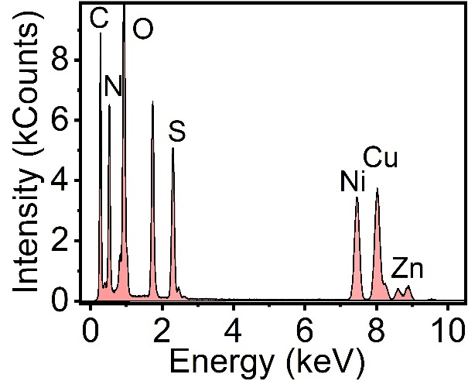
Fig. S3 Energy-dispersive X-ray (EDX) spectrum of COD2@HMZCS-HA3.

Fig. S4 High-resolution XPS spectra of Zn 2p (a), O 1s (b), S 2p (c), C 1s (d), and N 1s (e) for COD2@HMZCS-HA3.

Fig. S5 Zeta potential measurements of HMZCS-HA3 (average = -28.6 mV) and COD2@HMZCS-HA3 (average = -22.3 mV).

Fig. S6 Hydrodynamic particle size of COD2@HMZCS-HA3 after incubation in H₂O (a), PBS (b), or DMEM containing 10% FBS (c) over a period of 10 days (n = 3).

Fig. S7 Cumulative release curves of H₂S from COD2@HMZCS-HA3 in PBS at different pH conditions (pH 7.4, 6.7 or 5.5) (n = 3).

Fig. S8 LSCM images of 4T1 cells after treatment with R6G-COD2@HMZCS-HA3 (nanoparticles: red) for 6.0 h, followed by staining with Lyso-Tracker (lysosomes: green) and DAPI (nuclei: blue).

Fig. S9 Time-dependent cytotoxicity of 4T1 cells after incubation with PBS, NaHS, COD, HMZCS-HA3, or COD2@HMZCS-HA3 (n = 5).

Fig. S10 LSCM images of 4T1 cells after treatment with PBS, NaHS, COD, HMZCS-HA3, or COD2@HMZCS-HA3, followed by staining with Calcein-AM (live cells) and PI (dead cells).

Fig. S11 (a): H₂S content in 4T1 cells after incubation with various concentrations of COD2@HMZCS-HA3 at pH 7.4 for 24 h, measured by the H₂S detection kit (n = 5). (b): H₂S level in 4T1 cells after treatment with COD2@HMZCS-HA3 (C_{COD} = 5.1 μg/mL) at pH 7.4 or 6.7 for varying durations (n = 3).

Fig. S12 LSCM images of 4T1 cells after treatments with PBS, NaHS, COD, HMZCS-HA3, or COD2@HMZCS-HA3, followed by staining with Rabbit Anti-COX IV Primary Antibody, Alexa Fluor 555-Labeled Donkey Anti-Rabbit Secondary Antibody (COX IV: red) and DAPI (nuclei: blue).

Fig. S13 (a): OCR of 4T1 cells after incubation with PBS (control) or COD2@HMZCS-HA3. (b): Dissolved O₂ levels in the culture medium of 4T1 cells treated with PBS or COD2@HMZCS-HA3 (n = 3).

Fig. S14 LSCM images of 4T1 cells after treatment with different concentrations of Zn²⁺, and staining with DHE, showing the levels of intracellular •O₂⁻.
Fig. S15 (a-c): LSCM images of 4T1 cells incubated with COD2@HMZCS-HA3 (V) or COD2@HMZCS-HA3 (V) combined with HTAU, TTM, TPEN or cariprazine, followed by staining with WSP-1, RuDPP or DHE probes to visualize intracellular H₂S (a), O₂ (b) and •O₂⁻ (c) levels. (d): Cell membrane fluidity of 4T1 cells treated with PBS (I), NaHS (II), COD (III), HMZCS-HA3 (IV), or COD2@HMZCS-HA3(V), measured by the excimer (475 nm)/monomer (397 nm) ratio (n = 5).

Fig. S16 (a-c): LSCM images of 4T1 cells incubated with COD2@HMZCS-HA3 (V) or COD2@HMZCS-HA3 (V) combined with HTAU, TTM, TPEN, cariprazine, HTAU + TTM, HTAU + TPEN or HTAU + TTM + TPEN, followed by staining with Filipin III, HPF or C11-BODIPY to visualize intracellular cholesterol (a), •OH (b) and LPO (c) levels. (d): Intracellular MDA levels in 4T1 cells treated with PBS (I), NaHS (II), COD (III), HMZCS-HA3 (IV), COD2@HMZCS-HA3 (V), and COD2@HMZCS-HA3 supplemented with cariprazine (VI), TTM (VII), TPEN (VIII) or HTAU (IX) (n = 5).

Fig. S17 LSCM images of 4T1 cells after treatment with PBS, NaHS, COD, HMZCS-HA3, or COD2@HMZCS-HA3, followed by staining with Thiol Tracker Violet (GSH: green) and DAPI (nuclei: blue).

Fig. S18 LSCM images of 4T1 cells after treatments with PBS, NaHS, COD, HMZCS-HA3, or COD2@HMZCS-HA3, followed by staining with Rabbit Anti-GPX4 Primary Antibody, Alexa Fluor 555-Labeled Donkey Anti-Rabbit Secondary Antibody (GPX4: red) and DAPI (nuclei: blue).

Fig. S19 LSCM images of 4T1 cells after treatment with PBS, NaHS, COD, HMZCS-HA3, or COD2@HMZCS-HA3, followed by staining with Mito-Tracker Red (mitochondria: red) and DAPI (nuclei: blue).

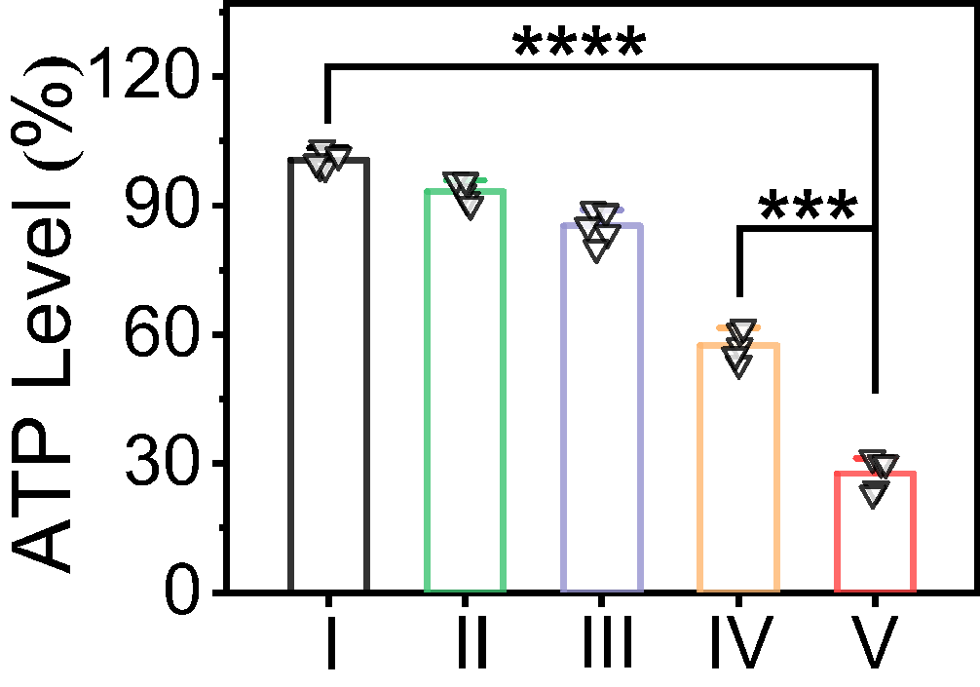
Fig. S20 Intracellular ATP levels in 4T1 cells after treatment with PBS (I), NaHS (II), COD (III), HMZCS-HA3 (IV), or COD2@HMZCS-HA3(V) (n = 5).

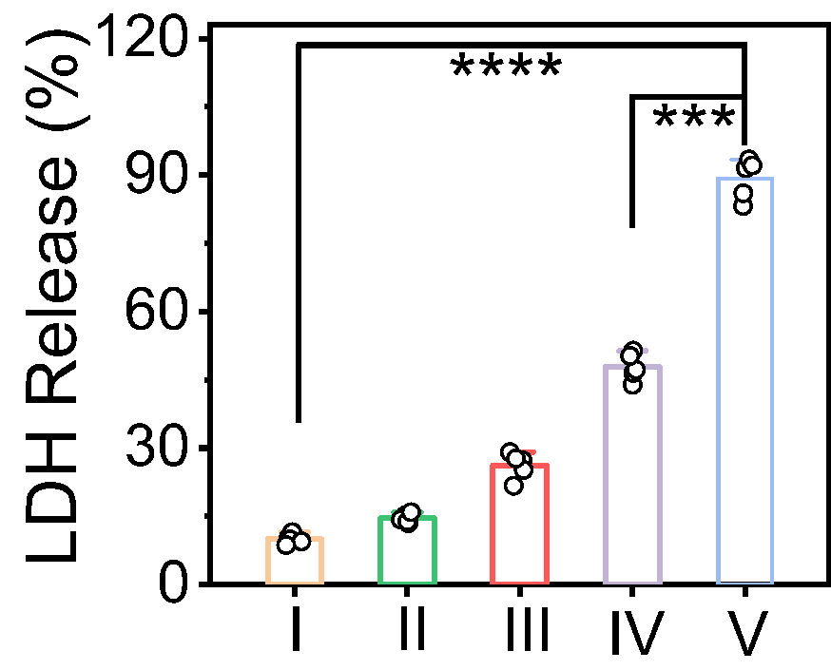
Fig. S21 LDH levels in the culture medium released from 4T1 cells after treatment with PBS (I), NaHS (II), COD (III), HMZCS-HA3 (IV), or COD2@HMZCS-HA3(V) (n = 5).

Fig. S22 LSCM images of 4T1 cells after treatment with PBS, NaHS, COD, HMZCS-HA3, or COD2@HMZCS-HA3, followed by staining with γ-H2AX (damaged DNA: green) and DAPI (nuclei: blue).

Fig. S23 Cell viability of 4T1 cells after incubation with COD2@HMZCS-HA3 in the absence or presence of GSH (antioxidant), TTM (specific copper chelator), or cariprazine (7-DHC inducer) (n = 5).

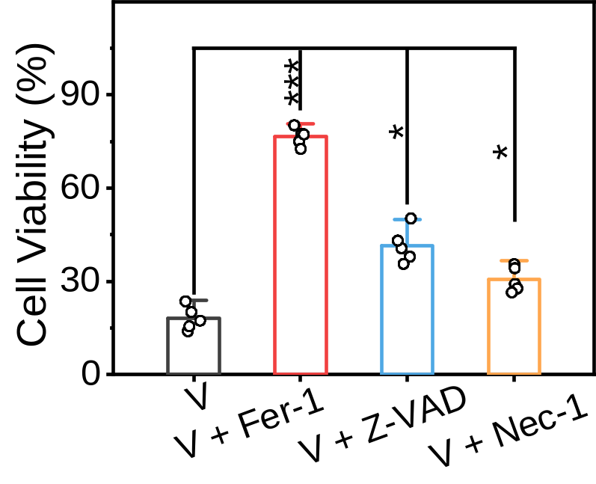
Fig. S24 Cell viability of 4T1 cells after incubation with COD2@HMZCS-HA3 (V) in the absence or presence of Fer-1 (ferroptosis inhibitor), Z-VAD (apoptosis inhibitor), or Nec-1 (necroptosis inhibitor) (n = 5).

Fig. S25 LSCM images of 4T1 CSC spheroids after treatment with PBS (I), NaHS (II), COD (III), HMZCS-HA3 (IV), or COD2@HMZCS-HA3(V), followed by staining with Calcein-AM (live cells) and PI (dead cells).

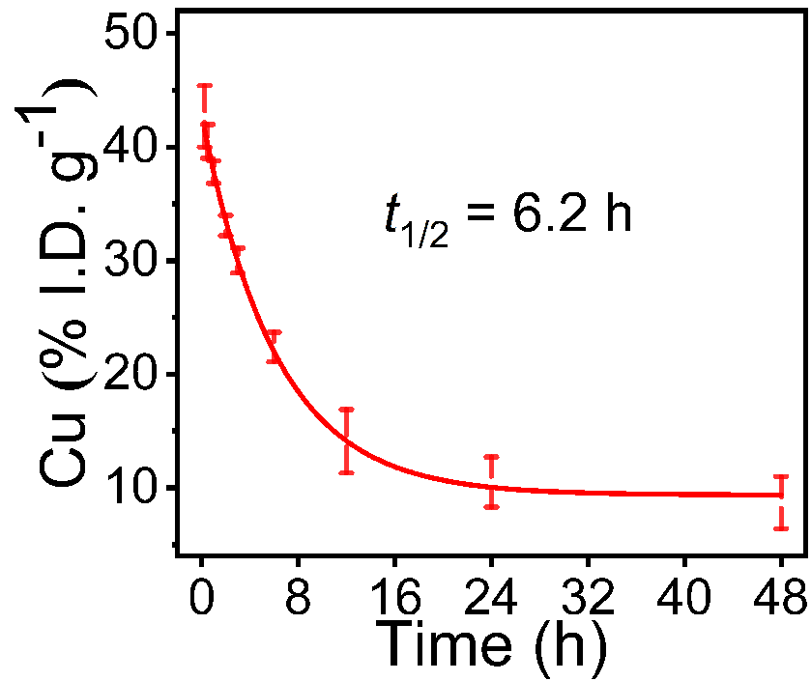
Fig. S26 Pharmacokinetics profile of COD2@HMZCS-HA3 in 4T1 tumor-bearing mice by tracking the Cu concentrations in blood measured by ICP-OES at different time intervals after i.v. injection (n = 3).

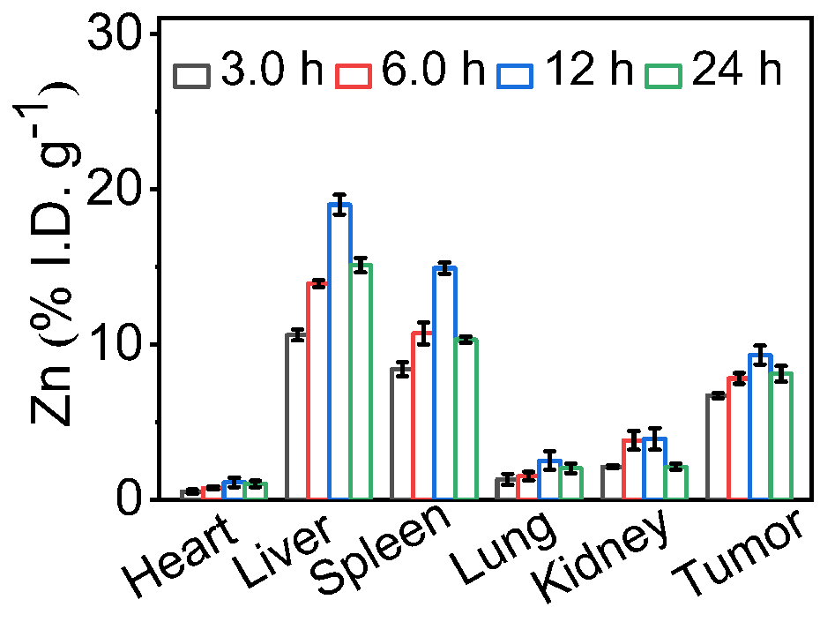
Fig. S27 Biodistribution analysis of Zn in the main organs and tumor tissues at 3.0, 6.0, 12, and 24 h post-injection (i.v.) of COD2@HMZCS-HA3 (n = 3).

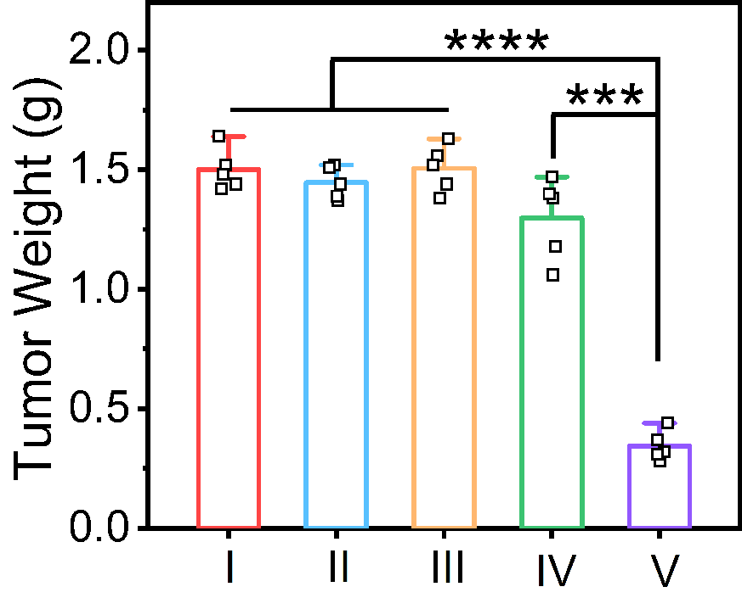
Fig. S28 Weights of tumors from 4T1 tumor-bearing mice at the therapeutic endpoint (i.e., when tumor volume exceeded 1500 mm³ or on day 36) after i.v. injection of PBS (I), NaHS (II), COD (III), HMZCS-HA3 (IV), or COD2@HMZCS-HA3 (V) (n = 5).

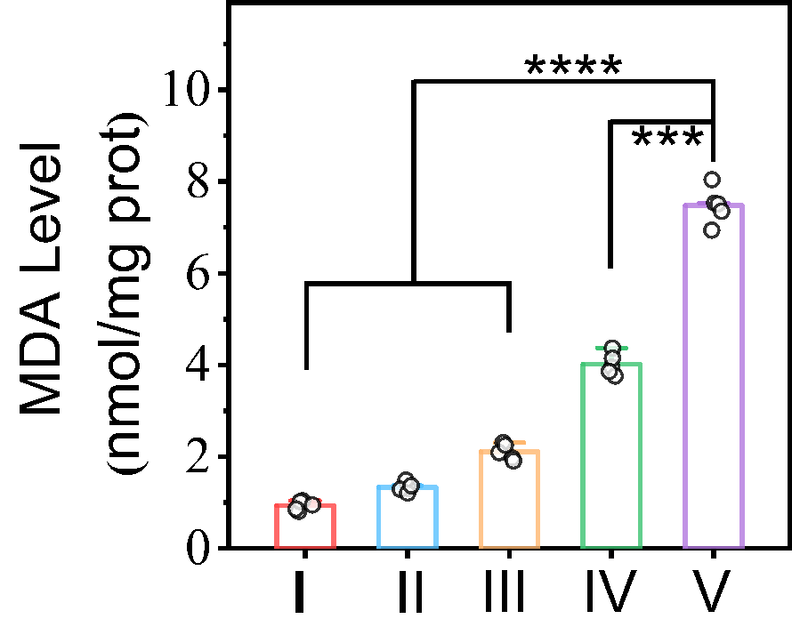
Fig. S29 MDA levels in tumors from 4T1 tumor-bearing mice at day 3 after i.v. injection of PBS (I), NaHS (II), COD (III), HMZCS-HA3 (IV), or COD2@HMZCS-HA3 (V) (n = 5).
Fig. S30 Relative body weights of 4T1 tumor-bearing mice after treatment with PBS (I), NaHS (II), COD (III), HMZCS-HA3 (IV), or COD2@HMZCS-HA3 (V) (n = 5).

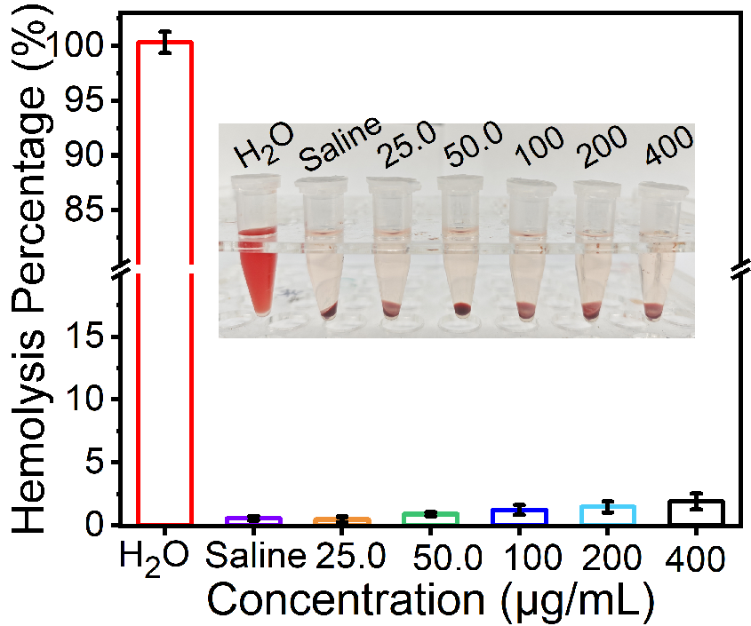
Fig. S31 Hemolysis percentage of mouse RBCs treated with pure H₂O, saline, or COD2@HMZCS-HA3 at various concentrations for 4.0 h at 37.0 °C (n = 3). The inset image shows the corresponding RBC samples after centrifugation (n = 3).

Fig. S32 Hematological index measurements of mice serum on day 3 after i.v. injection of COD2@HMZCS-HA3 with a Cu dosage of 5.0 or 10 mg/kg (n = 3). (a): RBC. (b): WBC. (c): HGB. (d): MCH. (e): HCT. (f): MCHC. (g): MCV. (h): LYM. (i): PLT.

Fig. S33 Biochemical analysis of mice serum on day 3 after i.v. injection of COD2@HMZCS-HA3 with a Cu dosage of 5.0 or 10 mg/kg (n = 3). (a): CK-MB. (b): BUN. (c): ALT. (d): AST.

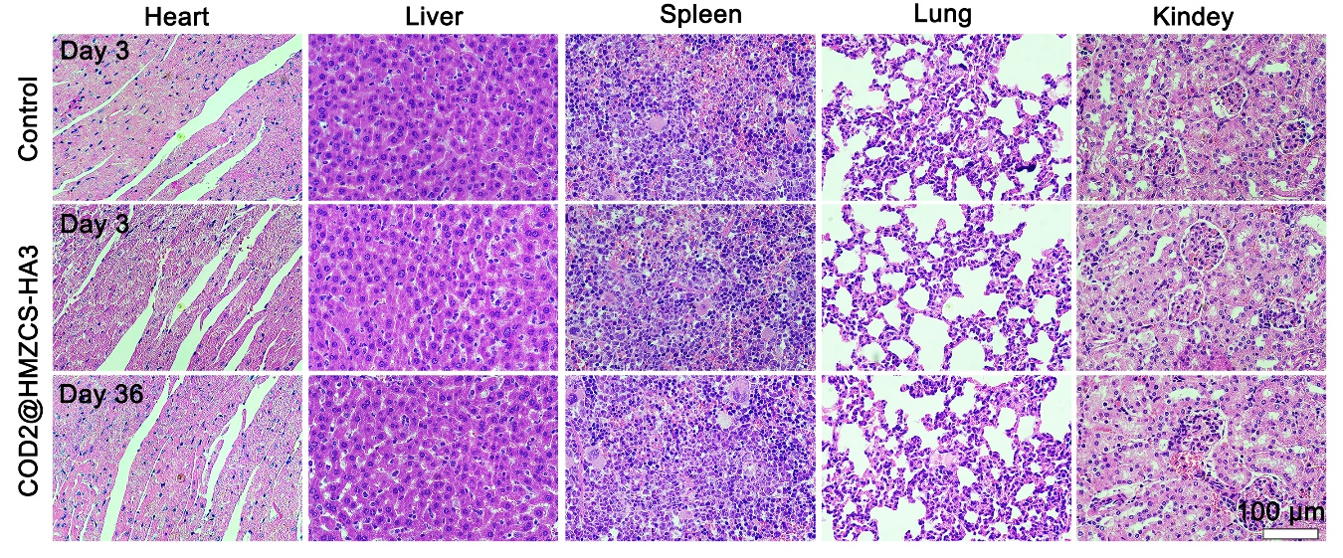
Fig. S34 Representative optical microscopic images of H&E-stained major organs (heart, liver, spleen, lung, and kidney) from 4T1 tumor-bearing mice after treatment with PBS (control) or COD2@HMZCS-HA3 at a Cu dosage of 5.0 mg/kg for 3.0 or 36 days.
Fig. S35 Representative immunofluorescence staining for pimonidazole (green) and DAPI (blue) in tumor slices from 4T1 CSC-bearing mice treated with PBS (I), NaHS (II), COD (III), HMZCS-HA3 (IV), or COD2@HMZCS-HA3 (V), showing the intratumoral hypoxia levels.

