Materials and methods
Data sources and analysis
scRNA-seq data corresponding to accession number GSE165722 were retrieved from the GEO database (https://www.ncbi.nlm.nih.gov/geo/). All subsequent analyses were conducted using the Seurat package in R. In the initial quality control step, cells were filtered according to the following criteria: RNA molecule counts ranging from 2,000 to 25,000; detected genes between 500 and 5,000; mitochondrial gene percentage below 15%; and ribosomal gene percentage below 100%. To reduce dimensionality, the 2,000 most variable genes were identified using the FindVariableFeatures function (with the "vst" method) and subsequently subjected to principal component analysis (PCA). The first six principal components, selected based on evaluation using the DimHeatmap and ElbowPlot functions, were retained for downstream analysis. Major cell subpopulations were then identified via the FindClusters function at a resolution of 0.2, and the UMAP algorithm was employed for nonlinear dimensionality reduction and visualization. Marker genes characteristic of each subpopulation were identified using the Seurat package, manually curated, and annotated. Finally, enrichment analysis was performed utilizing the clusterProfiler package.
Histopathology and immunohistochemistry(IHC)
Tissues were fixed, embedded, sectioned (4 μm), and stained with Safranin O-Fast Green or hematoxylin-eosin (HE) for histological evaluation. IHC was performed using primary antibodies (overnight, 4°C), secondary antibodies (1 h, RT), DAB visualization, and hematoxylin counterstaining. All images were acquired on an Olympus BX53 microscope.
Western blotting
Cells were lysed in RIPA buffer containing 1 mM PMSF. Protein concentrations were determined using a BCA assay. Equal amounts of protein were resolved by SDS‑PAGE, transferred onto PVDF membranes, blocked with 5% skim milk, and probed with primary antibodies overnight at 4 °C. After incubation with HRP‑conjugated secondary antibodies for 2 h at room temperature, protein bands were visualized using a ChemiDoc XRS+ system. GAPDH served as the loading control. The following primary antibodies were used: anti‑TMEM2 (CUSABIO, CSB‑PA23279A0Rb, 1:400), anti‑NLRP3 (Proteintech, 19771‑1‑AP, 1:500), anti‑ASC (Proteintech, 10500‑1‑AP, 1:5000), anti‑Caspase‑1 (CST, 3866T, 1:1000), anti‑GSDMD (Affinity, AF4012, 1:500), anti‑STING (Proteintech, 19851‑1‑AP, 1:20000), anti‑TBK1 (Proteintech, 67211‑1‑Ig, 1:500), anti‑p‑TBK1 (Abcam, ab109272, 1:1000), anti‑p65 (Proteintech, 10745‑1‑AP, 1:1000), anti‑p‑p65 (Proteintech, 82335‑1‑RR, 1:2000), anti‑BAX (Proteintech, 50599‑2‑Ig, 1:5000), anti‑VDAC (Proteintech, 81538‑1‑RR, 1:2000), anti‑HK2 (Proteintech, 22029‑1‑AP, 1:1000), anti‑ANT (Proteintech, 30631‑1‑AP, 1:500), anti‑PiC (Proteintech, 10420‑1‑AP, 1:500), anti‑CypD (Proteintech, 18466‑1‑AP, 1:1000), anti‑ATPase (Proteintech, 14418‑1‑AP, 1:20000), anti‑CK (Proteintech, 11360‑1‑AP, 1:500), and anti‑GAPDH (Proteintech, 60004‑1‑Ig, 1:5000).
RT-qPCR
Total RNA was extracted using the RNAprep FastPure Kit. cDNA was synthesized with SynScript Ⅲ RT SuperMix. RT-qPCR was performed using ArtiCanATM SYBR qPCR Mix. Relative gene expression was calculated by the 2⁻ΔΔCt method and normalized to GAPDH. Primer sequences were:
GAPDH (human): forward TCAAGAAGGTGGTGAAGCAGG, reverse TCAAAGGTGGAGGAGTGGGT.
TMEM2 (human): forward TACAGAAAGCCGTCAGTGGT, reverse TCCACAACAAGGAGGAGGAC.
Measurement of cytosolic mtDNA
Following TBHP treatment, NPCs were harvested and processed as previously described [37]. Briefly, cells were lysed in 0.1% NP‑40 lysis buffer on ice for 5 min. The lysate was centrifuged at 1,000×g, 4 °C for 5 min to pellet nuclei. The supernatant was further centrifuged at 14,000×g, 4 °C for 10 min to remove mitochondria, and the final supernatant (cytoplasmic fraction) was collected. DNA was extracted using the TIANamp Genomic DNA Kit (Tiangen, China). qPCR was performed with ND1 primers (Forward: 5′-CTCTTCGTCTGATCCGTCCT-3′; Reverse: 5′-TGAGGTTGAGGTCTGTTAGT-3′) to quantify mtDNA. Relative ND1 levels were normalized to the control group using the 2⁻ΔΔCt method.
Immunofluorescence
Cells were fixed, permeabilized, blocked, and then incubated overnight at 4°C with primary antibodies: anti‑TMEM2 (CUSABIO, Q9UHN6, 1:50), anti‑CASP1 (HUABIO, ET1608‑69, 1:50), anti‑NLRP3 (HUABIO, ET1610‑93, 1:50), anti‑GSDMD (Proteintech, 66387‑1‑Ig, 1:50), anti‑COL II (Proteintech, 28459‑1‑AP, 1:50), and anti‑MMP3 (Proteintech, 17873‑1‑AP, 1:200). After washing, cells were incubated with appropriate fluorescent secondary antibodies for 1 h at room temperature. Fluorescence images were acquired on an Olympus CKX53 microscope.
siRNA transfection
For transient knockdown, human NPCs were transfected with 50 nM of siRNA targeting TMEM2 (sense: 5′-UGGAAGAACUGCAAAGAAATT-3′; antisense: 5′-UUUCUUUGCAGUUCUUCCATT-3′) using jetPRIME reagent. A non‑targeting siRNA (sense: 5′-UUCUCCGAACGUGUCACGUTT-3′; antisense: 5′-ACGUGACACGUUCGGAGAATT-3′) was used as negative control.
shRNA transduction
For stable knockdown, rat NPCs were transduced with lentivirus expressing shRNA targeting rat TMEM2 (target sequence: 5′-GCTATTGCTGTTGGAGATTCA-3′) cloned into pLKO.1‑puro vector. Stable clones were selected with puromycin (2.5 μg/mL).
Flow cytometry
Apoptosis was assessed using an Annexin V-FITC/PI kit (Yeasen). Cells were suspended in 100 μL binding buffer, stained with 5 μL Annexin V-FITC and 10 μL PI, and incubated for 15 min at room temperature in the dark. Samples were then analyzed on a flow cytometer (Beckman Coulter).
TUNEL assay
Cells were fixed, permeabilized, and stained using a TUNEL kit (Beyotime). DAPI was used for nuclear counterstaining. Fluorescence images were captured on an Olympus CKX53.
Transmission electron microscopy (TEM)
NPCs were washed with 0.1 M phosphate buffer, fixed with 1% osmium tetroxide for 2 h in the dark, and dehydrated. After embedding and polymerization, 80‑nm ultrathin sections were cut and examined under a transmission electron microscope (HITACHI HT7800, Japan).
Hoechst‑PI staining
Cells were double‑stained with Hoechst 33342 and PI (Yeasen) for 30 min at 4°C and imaged under an Olympus CKX53.
mPTP opening assay
mPTP opening was detected using a commercial kit (Beyotime). Cells were incubated with Calcein-AM and Co²⁺ quencher at 37°C for 30 min, washed with PBS, and imaged under an Olympus CKX53 microscope.
Confocal microscopy
Cells were fixed, permeabilized, blocked, and stained with anti-TFAM (1:100) and anti-TOM20 (1:400) overnight at 4°C, then with secondary antibodies for 1 h at RT. Imaging was performed on a Nikon ECLIPSE Ti confocal microscope.
Co-immunoprecipitation (co-ip)
Cells were lysed in RIPA buffer (Beyotime, P0013) containing 1 mM PMSF. Protein concentration was determined using a BCA assay kit (Shanghai Sangon Biotech, C510004). Antibodies (0.5–3 μg) or control rabbit IgG were incubated with 50–100 μL of Protein A+G agarose beads (Beyotime, P2078‑1) at 4 °C for 1 h under rotation. After centrifugation, the supernatant was discarded, and the beads were incubated with lysates containing 0.5–1 mg of total protein overnight at 4 °C under rotation. The beads were then washed three to four times with PBS. Bound proteins were eluted by boiling the beads in 1.5× SDS loading buffer for 5 min and analyzed by Western blotting.
Molecular docking
BAX (PDB:1F16) and TMEM2 (PDB:8C6I) were docked using HDOCKlite v1.1. Binding free energy was calculated via MM/GBSA on HawkDock.
Synthesis of Lipo/shTMEM2@MS
Alginate (Alg, 2.0 g, Aladdin, Shanghai, China) and 3-aminophenylboronic acid (PBA, 0.78 g, Merck, Darmstadt, Germany) were dissolved in 200 mL of deionized water. EDC·HCl (1.96 g, Aladdin, Shanghai, China) was added, and the mixture was stirred at 25 °C overnight. The solution was dialyzed against deionized water for 3 days using a dialysis bag (MWCO 8–14 kDa, Thermo Fisher Scientific, USA), and the product was lyophilized to obtain Alg-PBA. Subsequently, Alg-PBA (500 mg) was dissolved in 50 mL of MES buffer (pH 6.0), and EDC (25 mg) and Sulfo‑NHS (15 mg) were added to activate the carboxyl groups for 30 min. RGD peptide (50 mg) was then added, and the reaction proceeded at room temperature for 24 h. The resulting mixture was dialyzed against deionized water and lyophilized to yield Alg-PBA-RGD. Cationic liposomes (DOTAP/cholesterol/DSPE-PEG2000 = 50:40:10) were prepared by rotary evaporation: lipids dissolved in chloroform were dried to a thin film, hydrated with DEPC-PBS, and sonicated to reduce vesicle size. The liposome suspension was then passed through a 0.22 μm filter for sterilization. The liposomes were mixed with shTMEM2 (N/P = 5:1) to form Lipo/shTMEM2. The aqueous phase consisted of 2% (w/v) Alg-PBA-RGD, 2% (w/v) dextran, and Lipo/shTMEM2 (equivalent to 100 nM shRNA) dissolved in DEPC-PBS. The oil phase was mineral oil containing 2% Span 80. The two phases were injected into a microfluidic chip (aqueous 0.5 mL/h, oil 1.0 mL/h). The generated droplets were allowed to stand at room temperature for 30 min to enable boronate ester crosslinking. After washing, the resulting ROS-responsive microspheres were designated as Lipo/shTMEM2@MS
Encapsulation efficiency and loading capacity
Lipo/shTMEM2 nanoparticles were prepared as described above with a theoretical shTMEM2 loading of 100 μg. To determine encapsulation efficiency (EE%), 200 μL of the nanoparticle suspension was transferred to an ultrafiltration tube (MWCO 100 kDa) and centrifuged at 12,000×g for 15 min at 4 °C. The filtrate containing free shTMEM2 was collected. An equal volume of the nanoparticle suspension was lysed with 2% Triton X-100 to measure total shTMEM2. RiboGreen working solution (Ex/Em 485/528 nm) was added to both the filtrate and the lysed samples, followed by incubation for 5–10 min in the dark. Fluorescence was measured using a microplate reader, and the shTMEM2 concentration was calculated from a standard curve. EE% was calculated as (total shRNA – free shRNA) / total shRNA × 100%. For loading capacity (LC%), an equal volume of the nanoparticle suspension was lyophilized and weighed. LC% (w/w) was calculated as (encapsulated shRNA mass) / (dry nanoparticle mass) × 100%.
Characterization of Lipo/shTMEM2@MS
¹H NMR (Bruker 400 MHz, DMSO-d₆) confirmed the synthesis of Alg-PBA-RGD. Liposome size and zeta potential before and after shTMEM2 loading were measured by dynamic light scattering (Malvern Zetasizer Nano ZS). Liposome morphology was visualized by transmission electron microscopy (TEM, Hitachi HT7800) after negative staining. Microsphere morphology was examined by optical microscopy (Olympus CKX53) and scanning electron microscopy (SEM, Zeiss Sigma 300). Loading of shTMEM2 into microspheres was verified by fluorescence microscopy using DiI-labeled liposomes. For degradation studies, microspheres were incubated in PBS with or without 1 mM H₂O₂ at 37 °C. At designated time points, microspheres were lyophilized and weighed to determine remaining mass. Release of DiI-labeled liposomes from microspheres was evaluated by collecting supernatants on days 2, 4, 6, 8, 10, and 12, followed by measuring fluorescence intensity using a microplate reader (excitation 549 nm, emission 565 nm). Encapsulation of shTMEM2 in microspheres was confirmed by agarose gel electrophoresis (2.5% gel, SYBR Gold staining) using free shTMEM2 as a positive control and intact Lipo/shTMEM2@MS as the test sample. Separately, to determine the optimal N/P ratio for complexation, Lipo/shTMEM2 complexes at N/P ratios of 3:1, 5:1, and 7:1 were analyzed under the same gel conditions.To assess cellular uptake, NPCs were incubated with DiI-labeled liposomes. After fixation, nuclei were stained with DAPI, and cells were imaged by confocal microscopy (Nikon ECLIPSE Ti). Internalization of DiI-labeled liposomes into NPCs was observed.
Cytocompatibility and in vivo imaging of Lipo/shTMEM2@MS
NPCs were seeded onto Lipo/shTMEM2@MS microspheres (1 mg/well) in 24‑well plates and cultured for 3 or 5 days. Live/dead staining was performed using a Calcein‑AM/PI kit (Beyotime, China) and visualized under a confocal microscope (Nikon ECLIPSE Ti). For cytoskeleton and nuclear staining, cells were fixed, permeabilized, and stained with Actin‑Tracker Red‑555 and DAPI (Beyotime, China), then imaged by the same confocal microscope. For co‑culture experiments, NPCs were seeded in 96‑well plates overnight, after which the medium was replaced with fresh medium containing Lipo/shTMEM2@MS microspheres (total volume 100 μL). On days 1, 3, and 5, live/dead staining was performed as described above (50 μL staining solution, 30 min incubation) and observed under a fluorescence microscope (Olympus BX53). CCK‑8 assay was conducted by adding 10 μL CCK‑8 solution (Beyotime, China) per well, incubating at 37 °C for 2 h, and measuring the absorbance. For scratch wound healing assay, NPCs were seeded in 6‑well plates, treated with TBHP for 24 h, scratched with a 200 μL pipette tip, washed with PBS, and incubated in serum‑free medium. Wound closure was photographed at 0, 12, and 24 h using a microscope (Olympus BX53), and the healing rate was calculated using ImageJ: healing rate (%) = (area at 0 h – area at t h) / area at 0 h × 100%. For in vivo tracking, male SD rats received an intradiscal injection of DiR‑labeled Lipo/shTMEM2@MS suspension (10 μL, 1 mg/mL) into the caudal intervertebral disc. Fluorescence signals at the tail discs were detected using an IVIS imaging system on days 1, 7, and 14.
Imaging evaluation
MRI was performed at 4 weeks post-surgery under pentobarbital anesthesia (40 mg/kg, i.p.). Disc degeneration was graded by the Pfirrmann system.
Supplementary Table 1. Information of participants
Case  Number | Gender | Age  (Years) | Diagnosis | Segment | MRI  Grade
Case 1 | Male | 22 | Lumbar disc herniation | L4-L5 | II
Case 2 | Female | 36 | Lumbar disc herniation | L3-L5 | IV
Case 3 | Male | 42 | Lumbar disc herniation | L3-L4 | V
Case 4 | Female | 24 | Lumbar disc herniation | L4-L5 | II
Case 5 | Male | 56 | Lumbar disc herniation | L4-S1 | IV
Case 6 | Female | 61 | Lumbar disc herniation | L4-L5 | V
Case 7 | Male | 55 | Lumbar disc herniation | L3-L5 | V
Case 8 | Female | 18 | Idiopathic scoliosis | T12-L1 | II
Case 9 | Male | 35 | Lumbar disc herniation | L5-S1 | III
Case 10 | Male | 44 | Lumbar disc herniation | L5-S1 | IV
Case 11 | Male | 38 | Lumbar disc herniation | L4-L5 | III
Case 12 | Female | 29 | Lumbar disc herniation | L3-L4 | III

Supplementary Fig. S1.
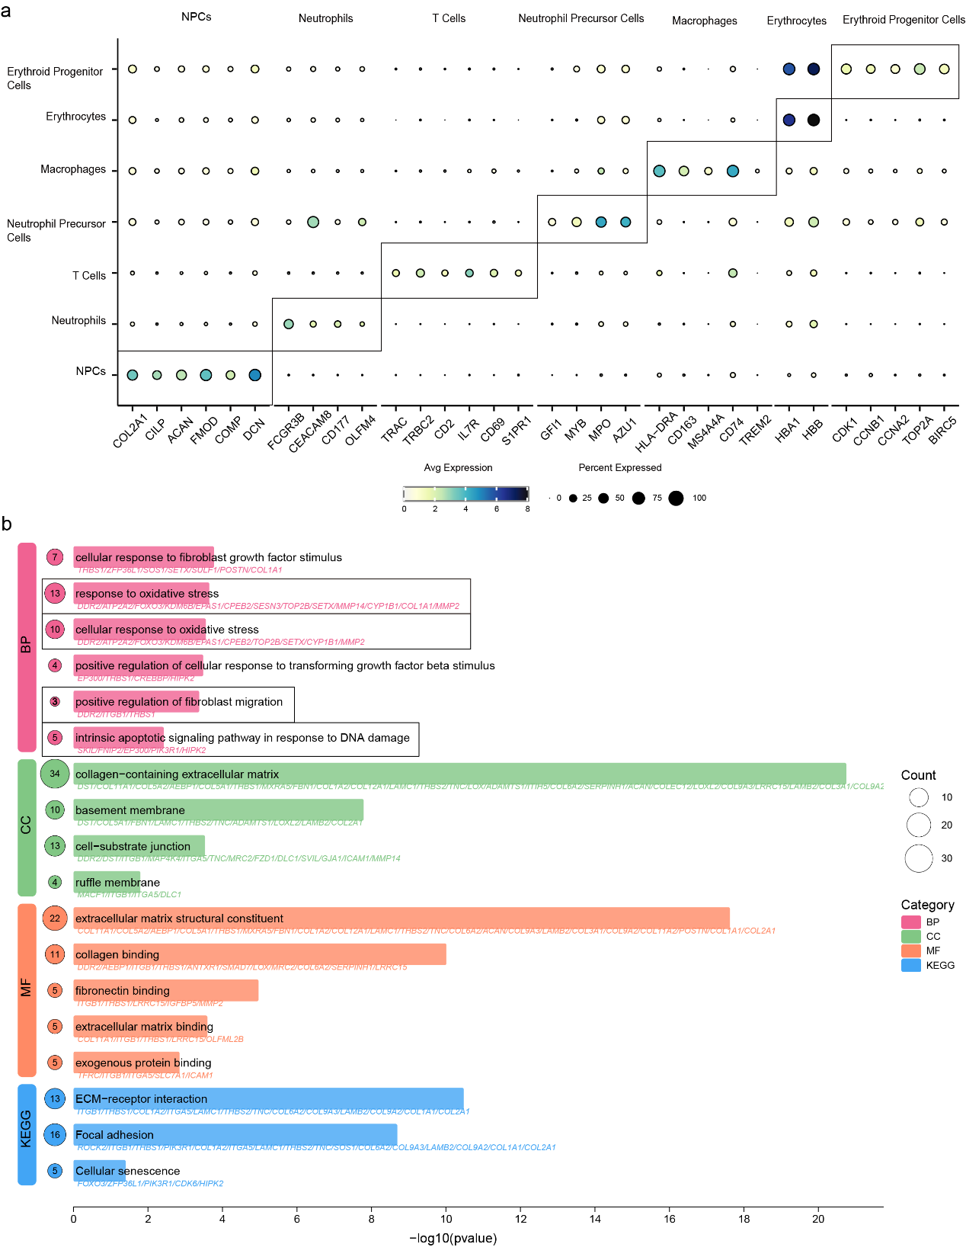
Supplementary Fig. S1.a, Heatmap of marker genes for the distinct subclusters identified in the scRNA_seq data from human NP tissues. b, GO and KEGG enrichment analysis for the TMEM2_high expression signature.

Supplementary Fig. S2 . GSDMD IHC in human NP tissues.
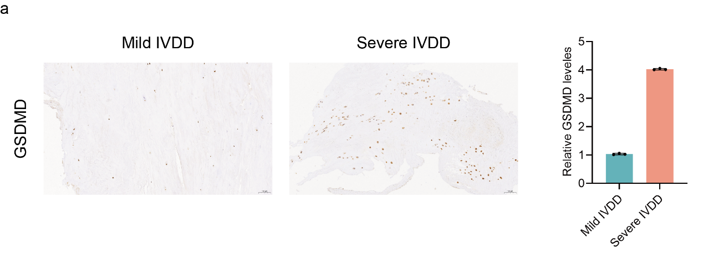
a.Representative IHC images (left) and quantitative analysis of GSDMD‑positive cells (right) in mild (Pfirrmann II‑III) vs. severe (IV‑V) degeneration.

Supplementary Fig. S3 . MMP3 and COL II expression in TBHP‑treated NPCs.
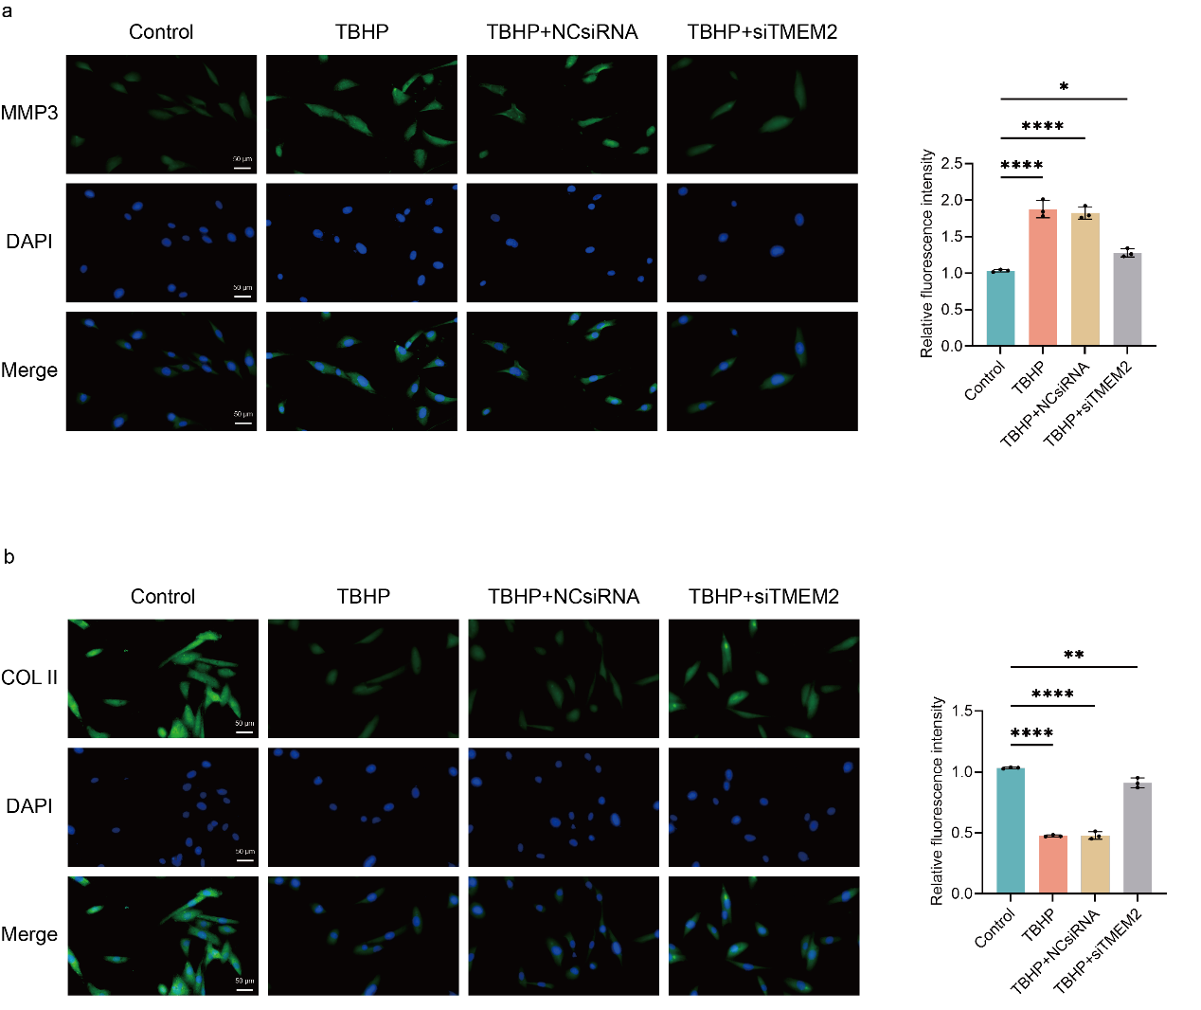
Supplementary Fig. S3.a, Representative immunofluorescence images and quantitative analysis of MMP3 in TBHP-treated NPCs.b, Representative immunofluorescence images and quantitative analysis of COL II in TBHP-treated NPCs. Data are presented as mean ± SD from at least three independent experiments. n.s., not significant; *p < 0.05; **p < 0.01; ****p < 0.0001.

Supplementary Fig. S4 . Direct quantification of cytosolic mtDNA.
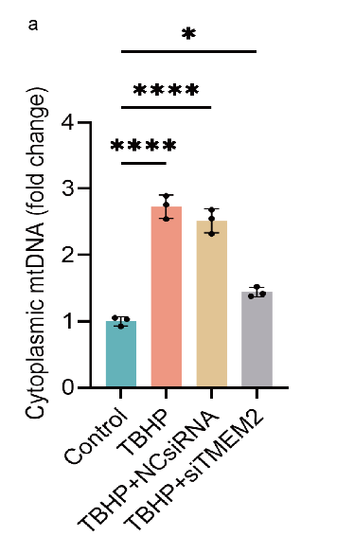
Supplementary Fig. S4.a, qPCR analysis of ND1 (mtDNA) in cytoplasmic fractions.Data are presented as mean ± SD from at least three independent experiments. n.s., not significant; *p < 0.05;****p < 0.0001.

Supplementary Fig. S5 . Size distribution of Lipo/shTMEM2@MS microspheres.
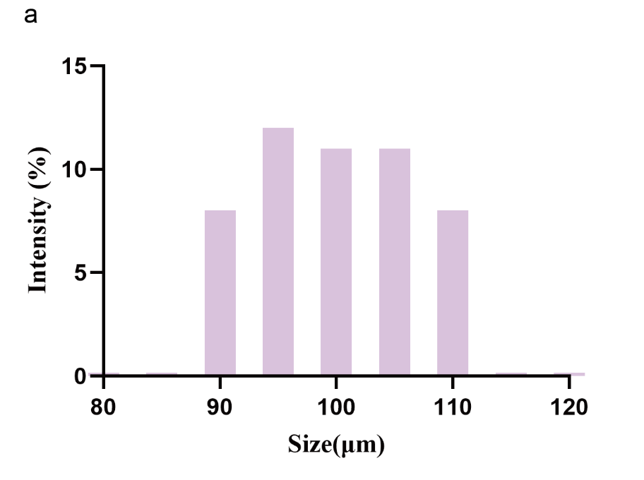
Supplementary Fig.S5. Histogram of microsphere diameters.

Supplementary Fig. S6 . Encapsulation efficiency and loading capacity.
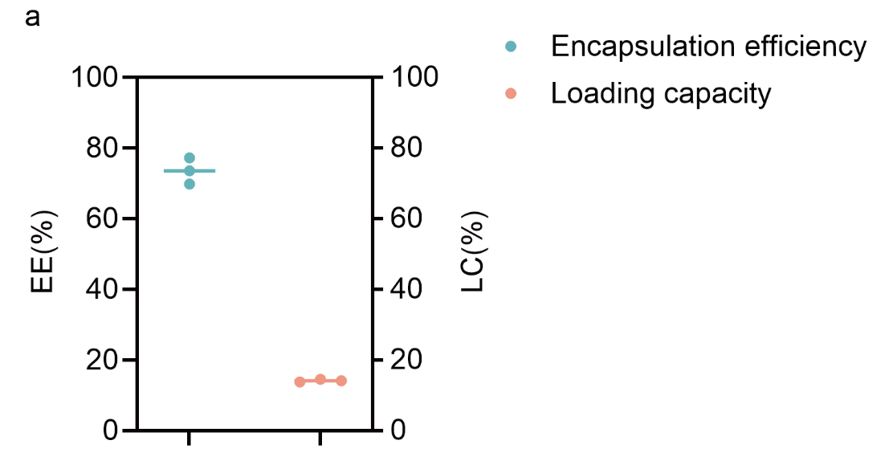
Supplementary Fig.S6. Encapsulation efficiency and loading capacity of Lipo/shTMEM2. Data are mean ± SD (n = 3). EE% = 73.5 ± 3.7%, LC% = 14.1 ± 0.4% (w/w).

Supplementary Fig. S7 . Optimization of N/P ratio for Lipo/shTMEM2 complexation.
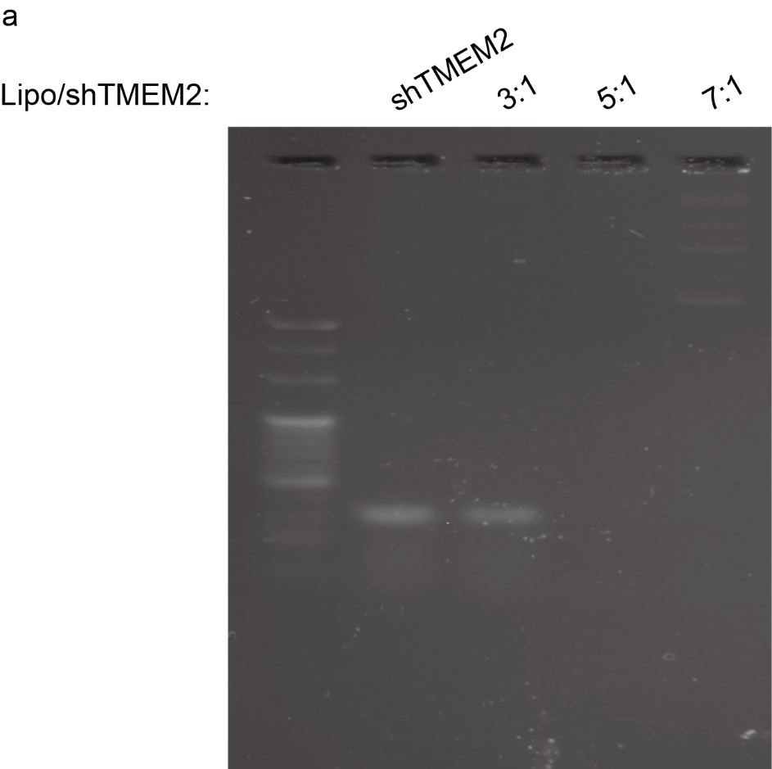
Supplementary Fig. S7 a. Agarose gel retardation assay of Lipo/shTMEM2 complexes at N/P ratios of 3:1, 5:1, and 7:1. Free shTMEM2 was used as a positive control.

