Supplementary figures

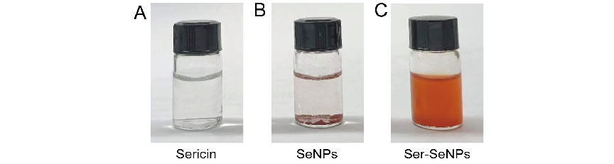Figure S1. Characterization of Ser-SeNPs. (A) Photograph of sericin. (B) Photograph of SeNPs. (C) Photograph of Ser-SeNPs.

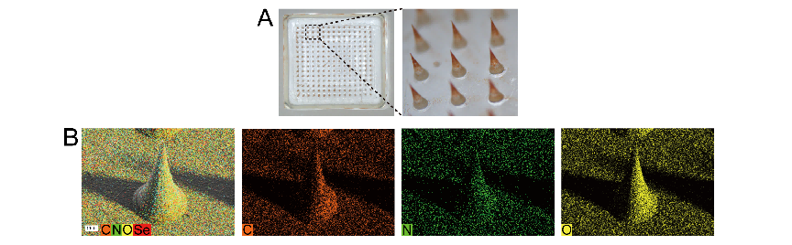
Figure S2. Characterization of Ser-SeNPs@MN. (A) Photograph of the Ser-SeNPs@MN. (B) Representative EDS elemental mapping image of Ser-SeNPs@MN.

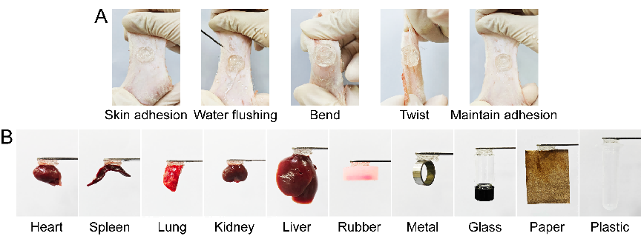
Figure S3. The adhesive properties of Ser-SeNPs@MN. (A) Adhesion of Ser-SeNPs@MN to rat skin under both dry and wet conditions. (B) Adhesion of Ser-SeNPs@MN to biological and non-biological substrates under dry conditions.

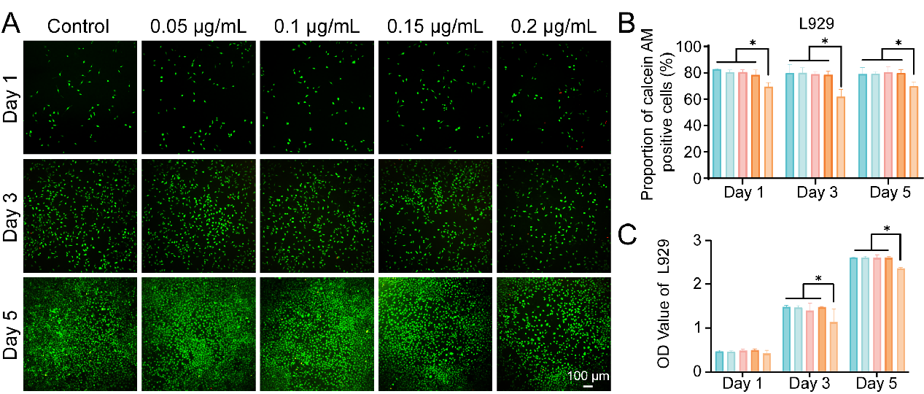
Figure S4. Biocompatibility evaluation of Ser-SeNPs in L929 cells. (A) Representative live/dead staining images of L929 cells after treatment with Ser-SeNPs for 1, 3, and 5 days. (B) Quantitative analysis of live and dead cells in L929 cultures. (C) Cell viability of L929 cells after treatment with Ser-SeNPs for 1, 3, and 5 days, as determined by CCK-8 assay.

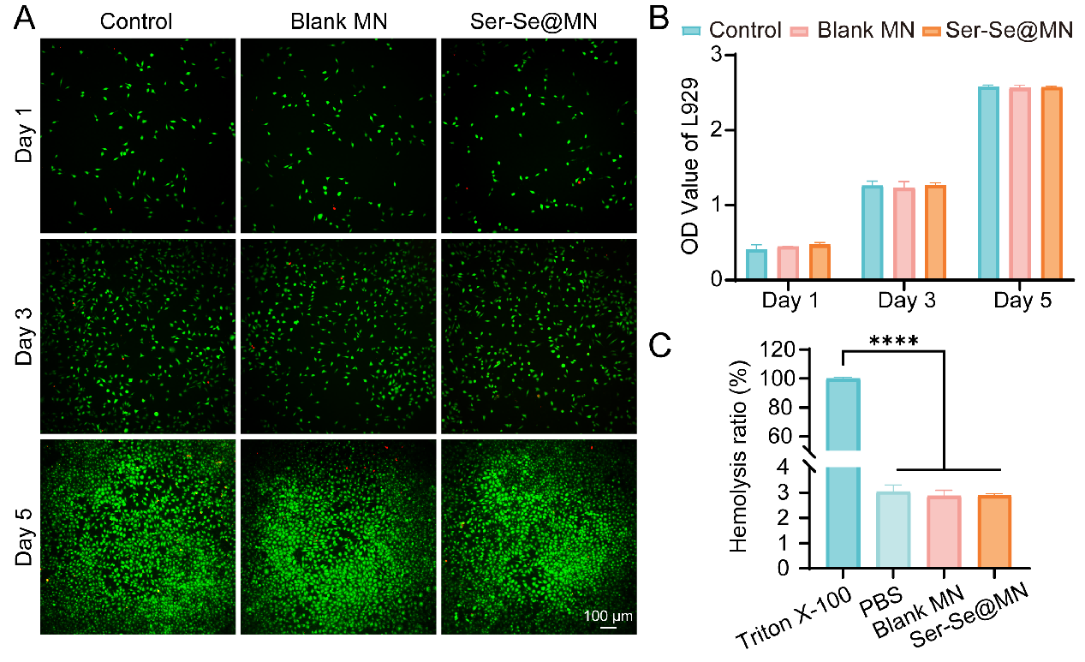
Figure S5. Biocompatibility evaluation of Ser-SeNPs@MN in L929 cells. (A) Representative live/dead staining images of L929 cells after incubation with different MN for 1, 3, and 5 days. (B) CCK-8 analysis of L929 cells after treatment with different MN for 1, 3, and 5 days. (C) Hemolysis rates after incubation with different MN.

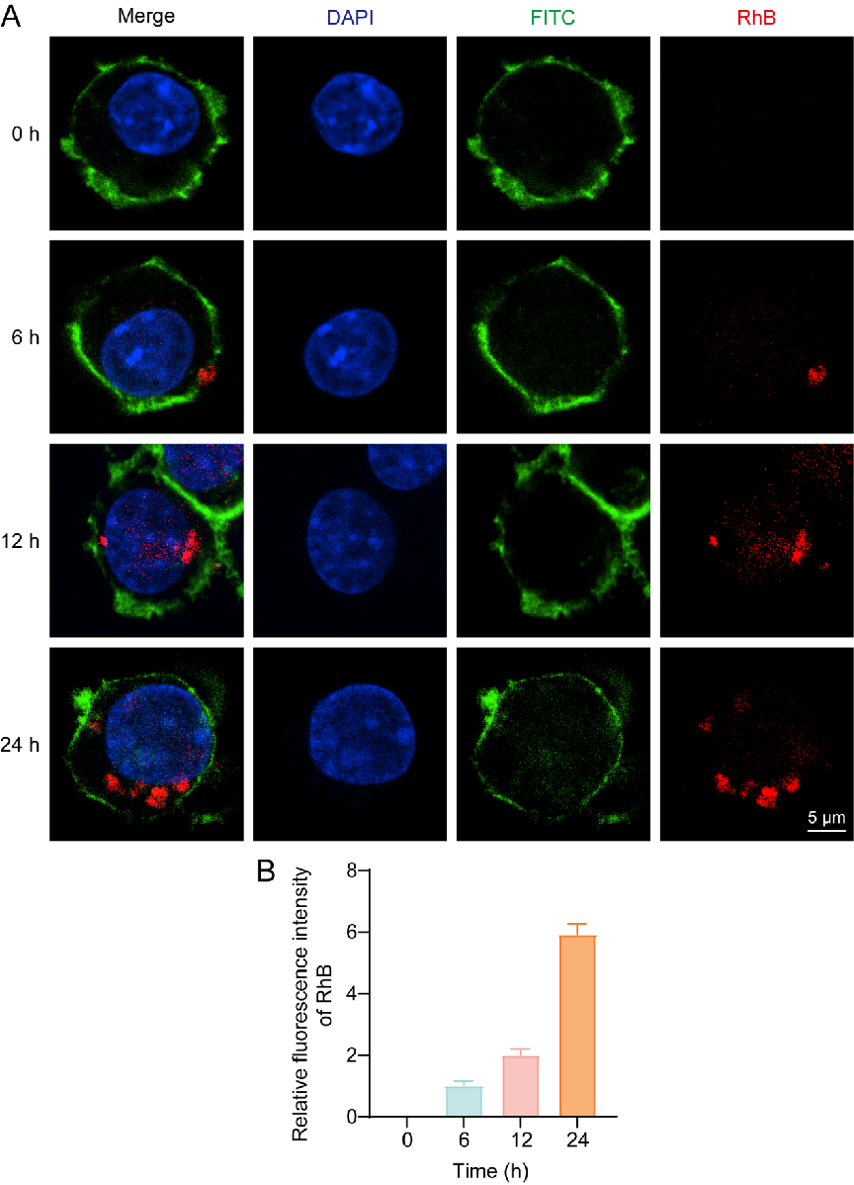
Figure S6. Cellular uptake of ‌RhB-labeled Ser-SeNPs. (A) Fluorescence images of ‌RhB-labeled Ser-SeNPs taken up by cells at 0, 6, 12, and 24 h. (B) Quantitative analysis of intracellular ‌RhB fluorescence intensity.
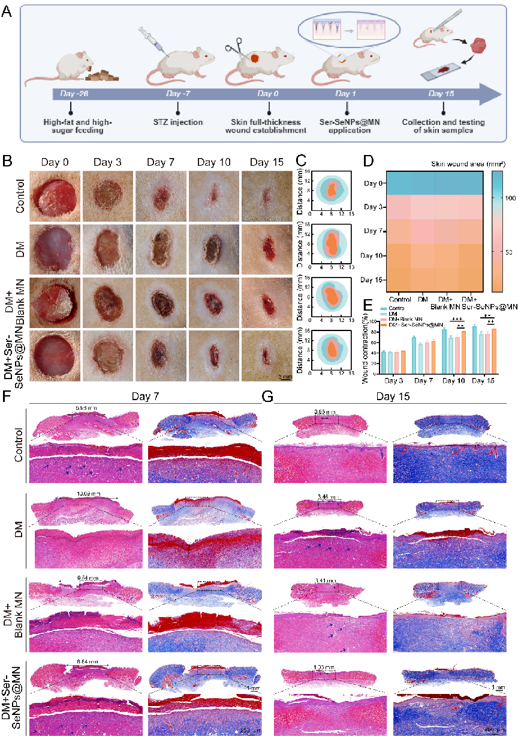
Figure S7. Ser-SeNPs@MN promotes the healing of skin wounds in diabetic rats. (A) Schematic diagram of skin wound modeling in diabetic rats. (B) Representative images of skin wounds in diabetic rats at different time points. (C) Schematic diagram of skin wound healing patterns. (D) Heatmap analysis of skin wound areas. (E) Quantitative analysis of skin wound healing rates. (F) H&E staining and Masson’s staining of skin tissues on day 7. (G) H&E staining and Masson’s staining of skin tissues on day 15. Blue arrows indicate neovascularization and red arrows indicate skin appendage.
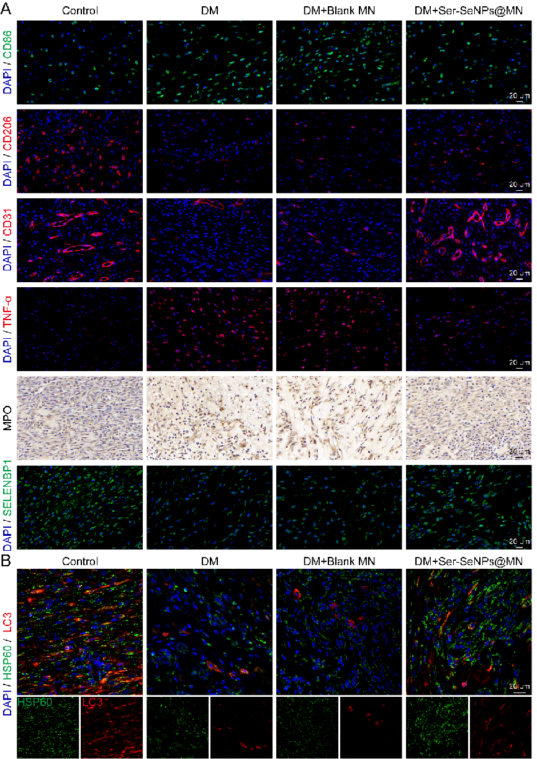
Figure S8. Ser-SeNPs@MN upregulates SELENBP1 to promote mitophagy, thereby inhibiting inflammation and accelerating diabetic skin wound healing in rats. (A) IF staining of CD86, CD206, CD31, SELENBP1, and TNF-α, and IHC staining of MPO in skin tissues. (B) IF co-staining of LC3 and HSP60 in skin tissues.

