Supplementary Information
Heat Shock Protein 60-Targeted Peptide-Conjugated Platinum Nanozyme: Redox Regulation by Multi-enzyme Activities Induces Mitochondrial Reprogramming and Acute Leukemia Cells Fate Switch
Jing Yao, Yanyan Li, Yiling Meng, Tao Wang, Jie Meng, Jian Liu, Tao Wen*, Haiyan Xu*
Institute of Basic Medical Sciences & School of Basic Medicine, Chinese Academy of Medical Sciences & Peking Union Medical College, Beijing 100005, China

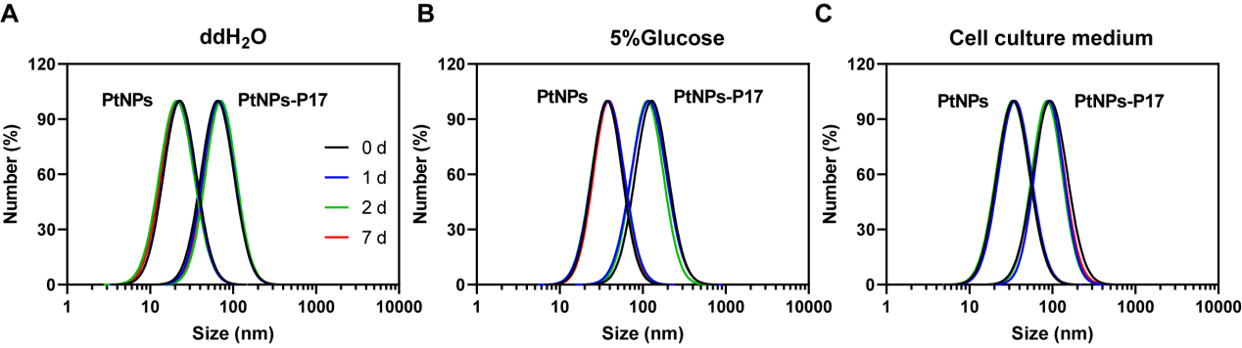
Fig. S1. Characterizations of NPs. The size distributions of PtNPs-P17 in (A) ddH₂O, (B) 5% of glucose and (C) cell culture medium.

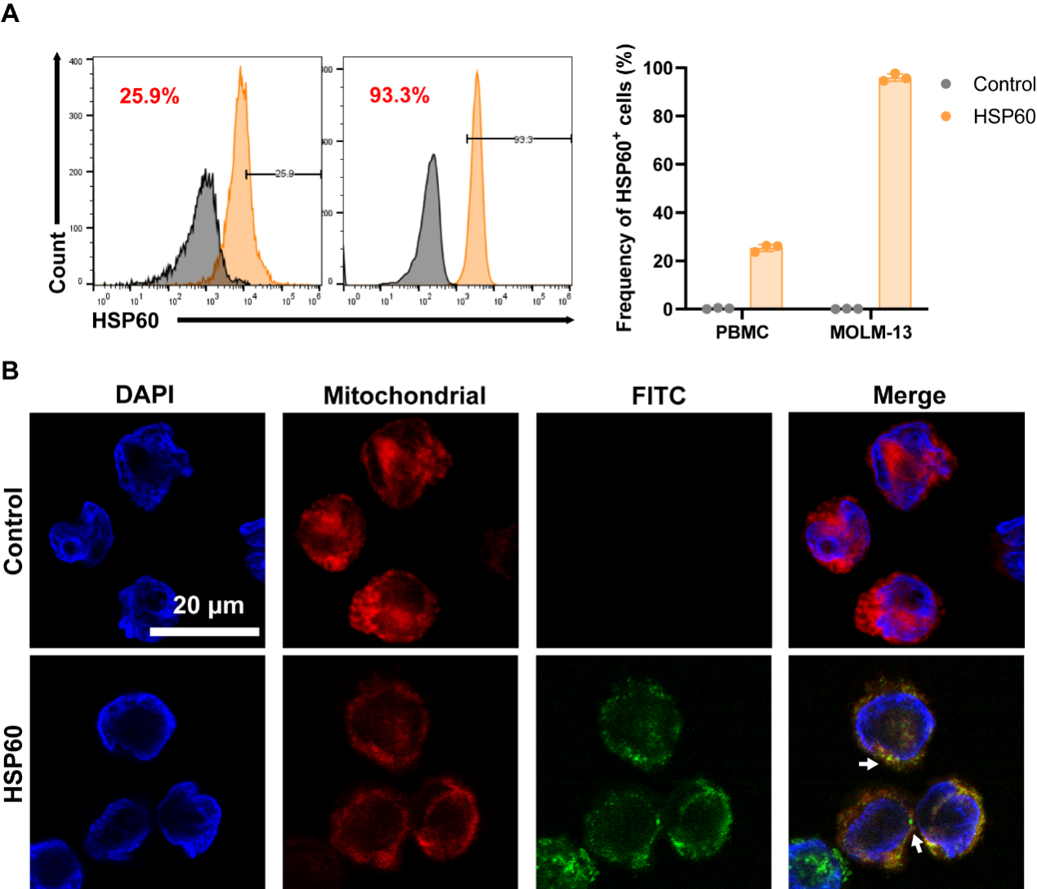
Fig. S2. Expression and distribution of HSP60 in cells (A) Representative plots distribution and quantification of HSP60 expressions in PBMCs from healthy human and MOLM-13 cell. (B) Confocal images of MOLM-13 cells co-stained with DAPI (blue, nucleus), MitoTracker (red, mitochondria), and HSP60-specific fluorescent antibody (green, HSP60). Scale bar = 20 μm.
Fig. S3. ROS levels in MOLM-13 cells. Intracellular ROS levels measured by DCFH-DA assay after 24 h incubation with P17 peptide at various concentrations.

Fig. S4. Intracellular singlet oxygen levels in AML cells. Singlet oxygen levels detected by Si-DMA staining in OCI-AML3 and U937 cells after 72 h treatment with NPs.

Fig. S5. Relative activity of phosphofructokinase (PFK). Changes in PFK enzyme activity in MOLM-13 cells after 24 h treatment with NPs by Elisa kit. (mean ± SD, n = 3; ***p, ###p < 0.001)

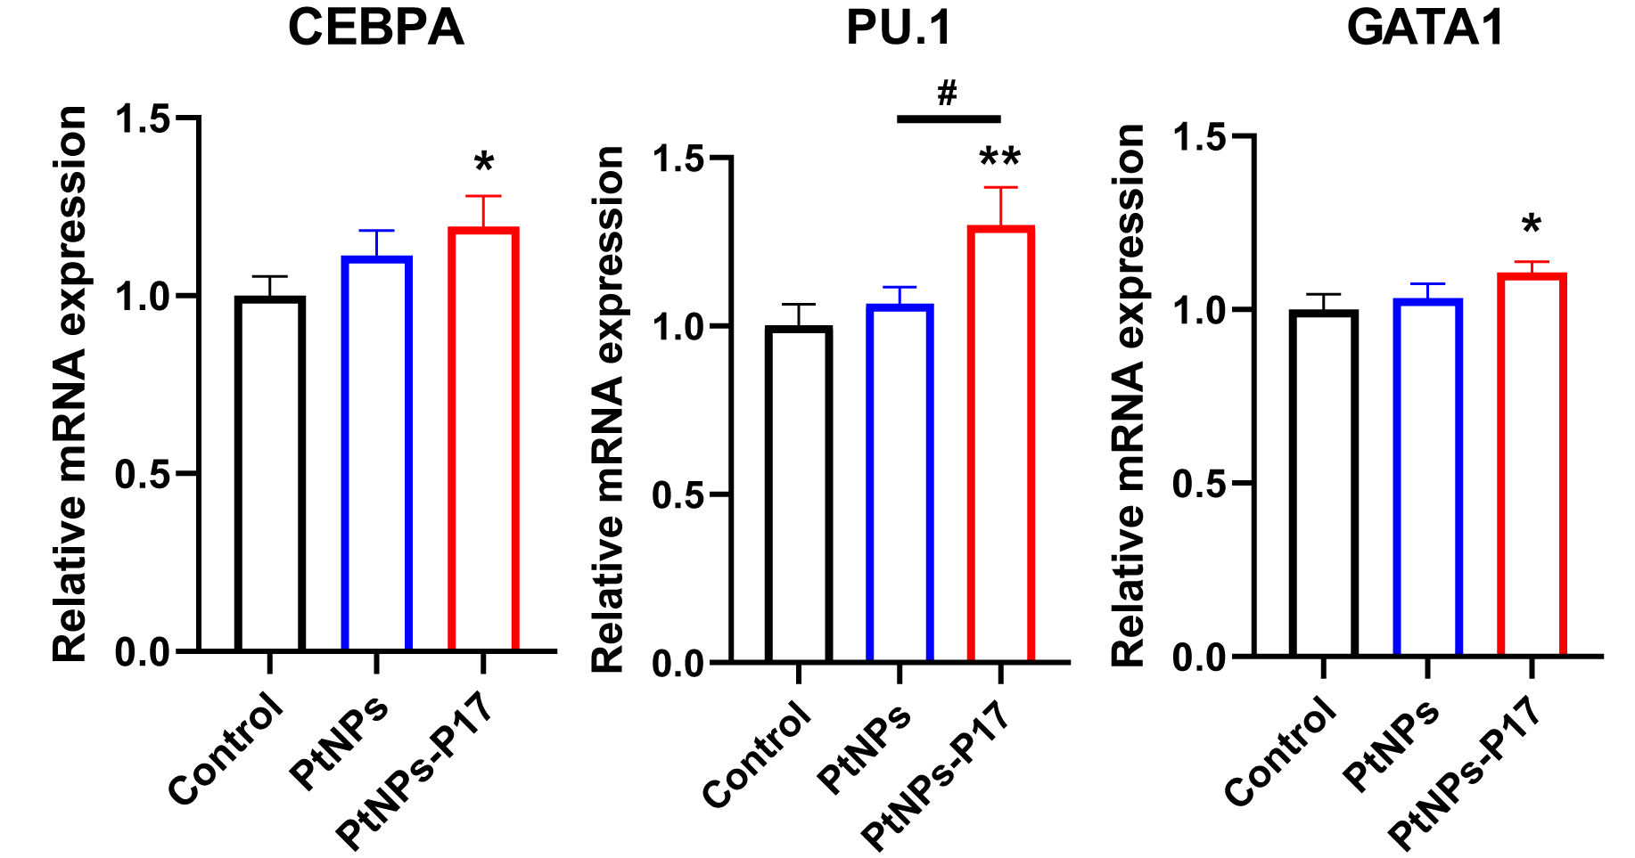
Fig. S6. Relative mRNA expression levels of myeloid differentiation-related transcription factors. mRNA levels of CEBPA, PU.1, and GATA1 in MOLM-13 cells incubated with 4 nM NPs for 12 h. (mean ± SD, n = 3; *p, #p < 0.05, **p < 0.01)

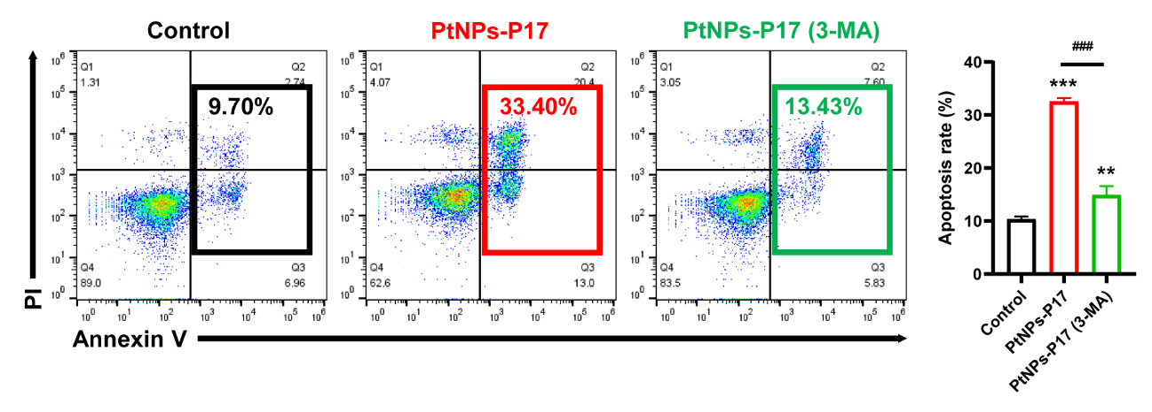
Fig. S7. Apoptosis rate of MOLM-13 cells with or without autophagy inhibition. Representative flow cytometry plots and quantification of apoptosis in MOLM-13 cells incubated with 32 nM PtNPs-P17 for 24 h in the absence or presence of 3-MA, stained with PI and Annexin V. (mean ± SD, n = 3; **p < 0.01, ***p, ###p < 0.001)
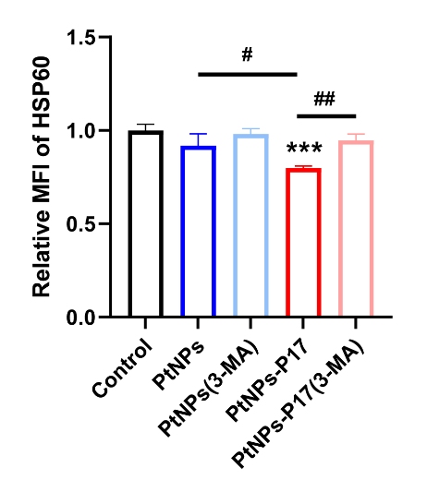
Fig. S8. HSP60 protein levels in MOLM-13 cells with autophagy inhibition. The related mean fluorescence intensity changes of HSP60 in MOLM-13 cells treated with PtNPs or PtNPs-P17, in the absence or presence of the autophagy inhibitor 3-MA. (mean ± SD, n = 3; #p < 0.05, ##p < 0.01, ***p < 0.001)

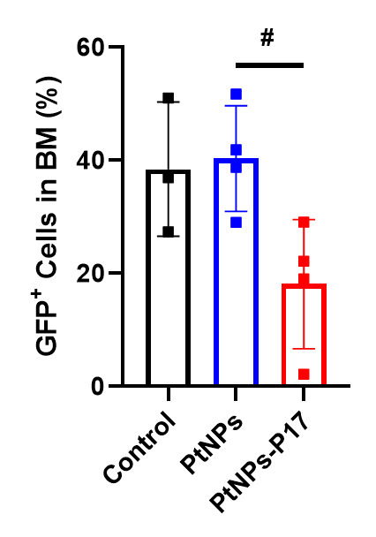
Fig. S9. Proportion of GFP-positive AML cells in mouse bone marrow. Percentage of GFP-labeled AML cells in mouse bone marrow after different treatments, analyzed by flow cytometry. (mean ± SD, #p < 0.05)

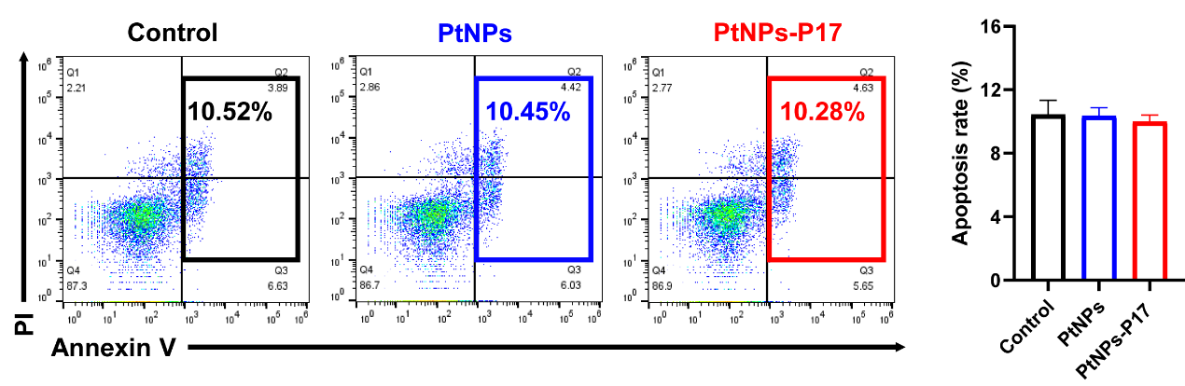
Fig. S10. Apoptosis rate of BMMNCs from healthy mouse treated with NPs. Representative flow cytometry plots and quantification of apoptosis in BMMNCs incubated with 16 nM nNPs for 24 h, stained with PI and Annexin V.

