Supplemental Figure Section

Supplemental Figure 1: Timeline of Research Trends in microplastic neurotoxic effects using Citespace. The horizontal axis represents years (from 2019 to 2025), showing how research topics have developed over time, and the numbered horizontal lines represent distinct major research areas or clusters.

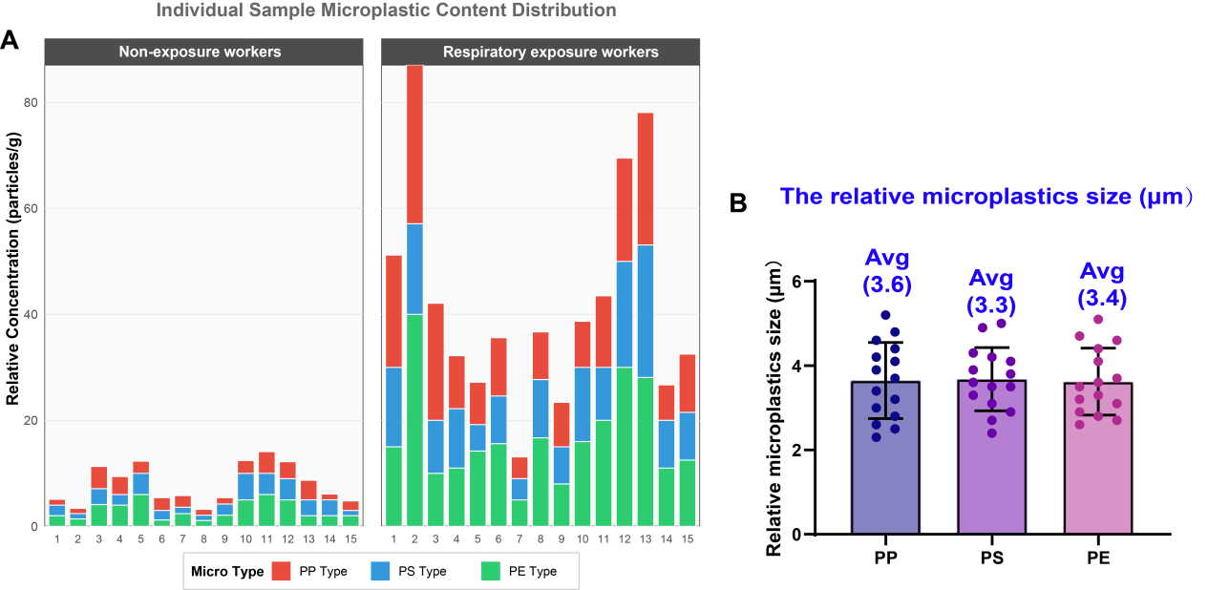
Supplemental Figure 2: Characterization of microplastic accumulation and particle size distribution in the blood of respiratory exposure workers.

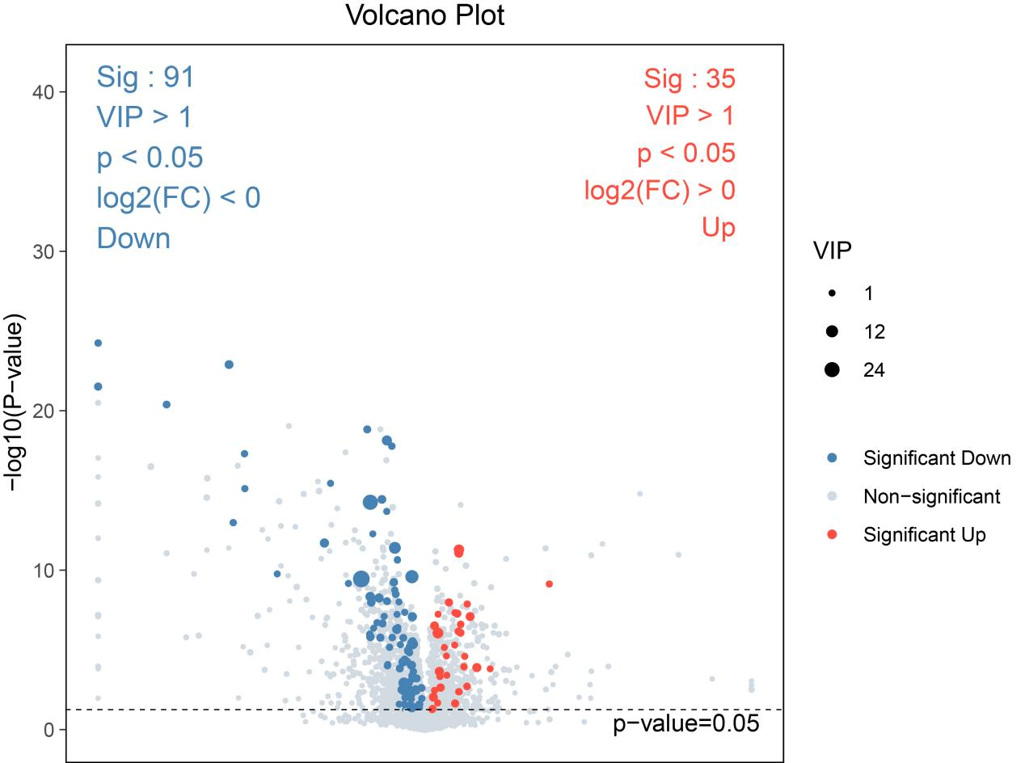
Supplemental Figure 3: Volcano plot of differential metabolites

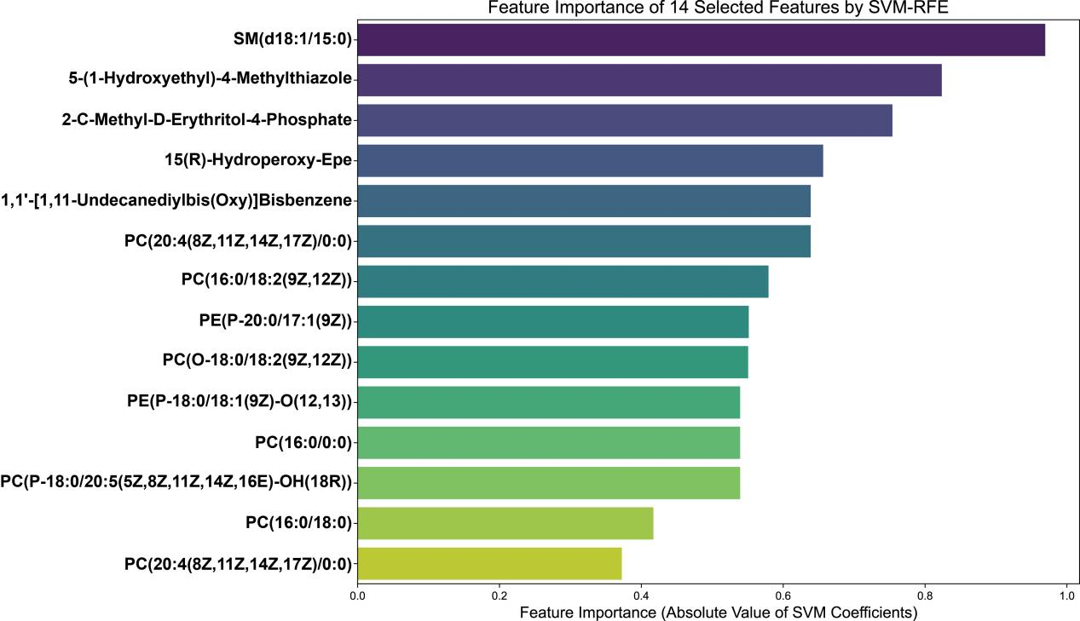
Supplemental Figure 4: Features Selected by SVM-RFE Method (TOP 14)
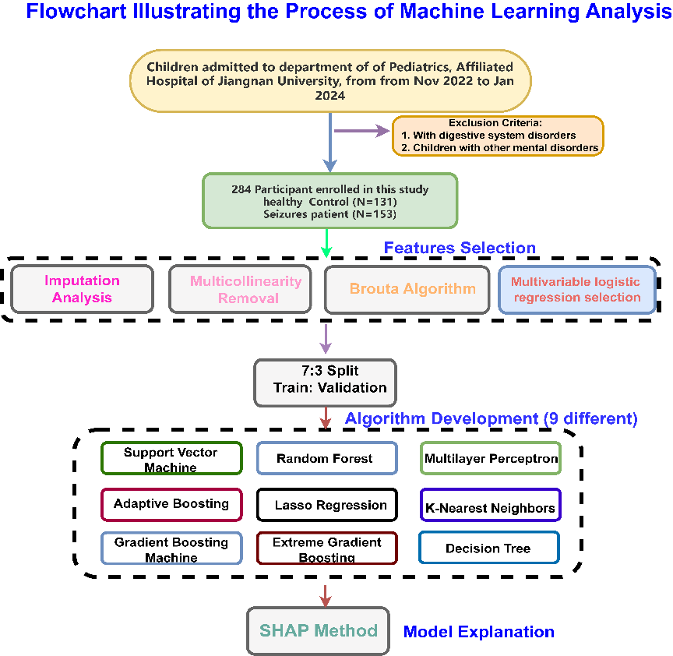
Supplemental Figure 5: Detailed Flowchart of Machine Learning Analyses to Identify Potential Independent Variables and Construct Predictive Models 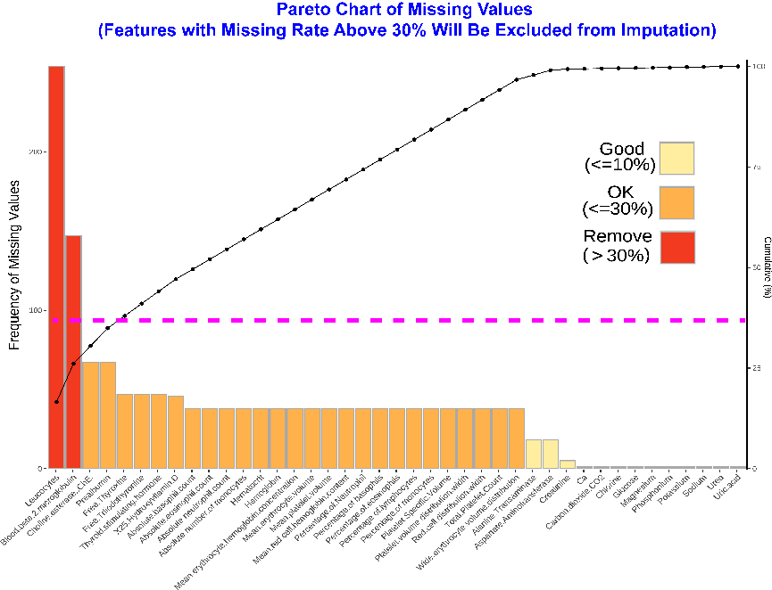Supplementary Figure 6: Missing Data Rate Analysis for All Study Variables Prior to Imputation. Features with >30% missing data were excluded from subsequent imputation procedures.

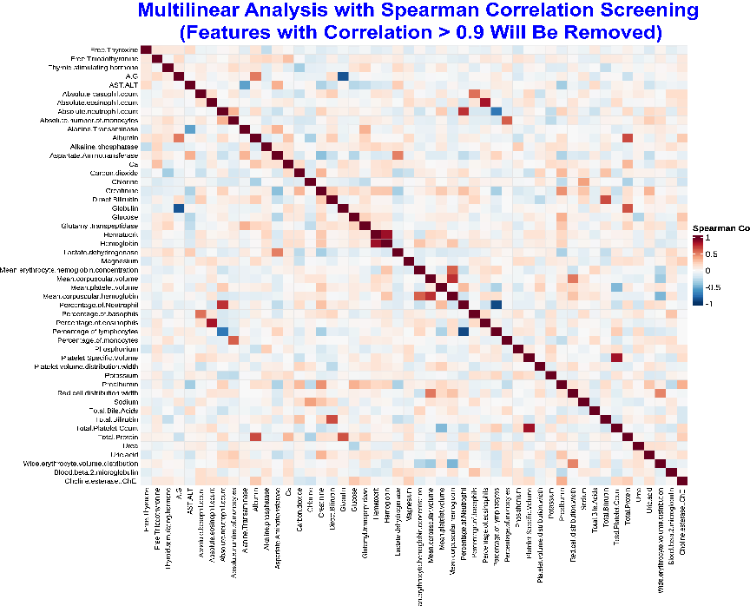Supplementary Figure 7: Spearman Correlation Analysis for Multicollinearity Assessment. Variables with correlation >0.9 were excluded from subsequent analysis.

Supplementary Figure 8: Multivariate logistic regression analysis of the Cohort 2
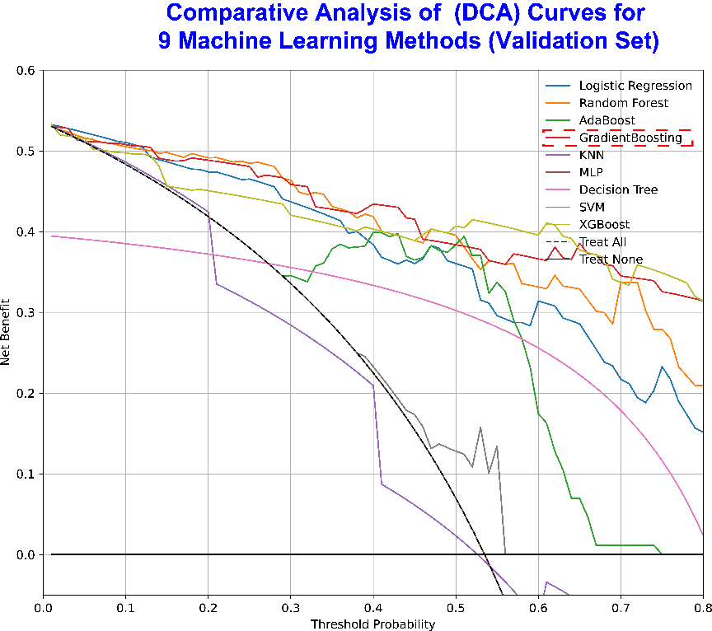

Supplementary Figure 9: Comparative Analysis of Decision Curve Analysis (DCA) Curves for 9 Machine Learning Methods
Supplementary Figure 10: Comparative Performance of 9 Machine Learning Models on the Validation Set

Supplementary Figure 11: Data Quality Control Before and After Filtering in scRNA-seq Analysis

Supplementary Figure 12: Clustering Tree for scRNA-seq Analysis

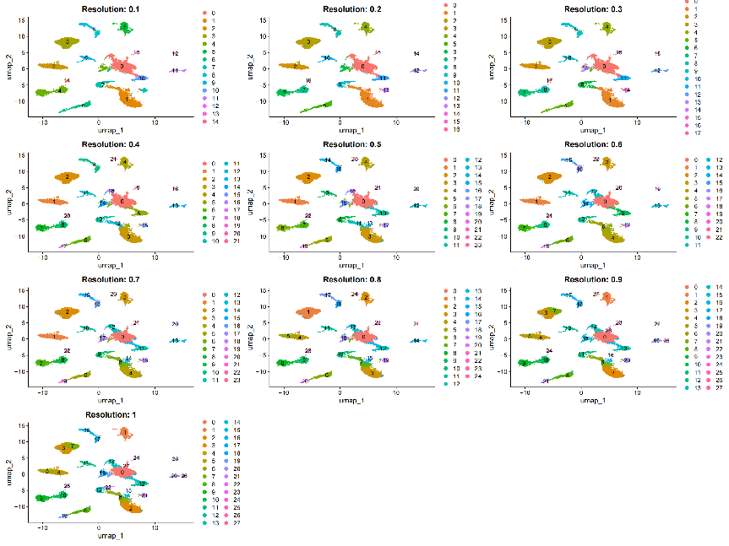
Supplementary Figure 13: UMAP Clustering at Different Resolutions

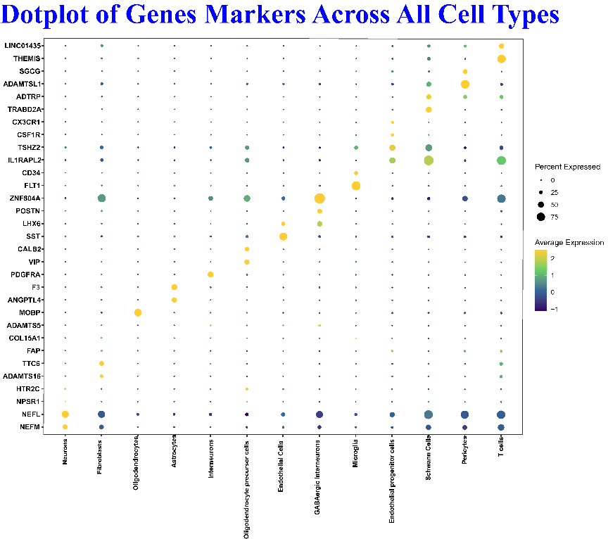
Supplementary Figure 14: Dotplot of Genes Markers Across All Cell Types

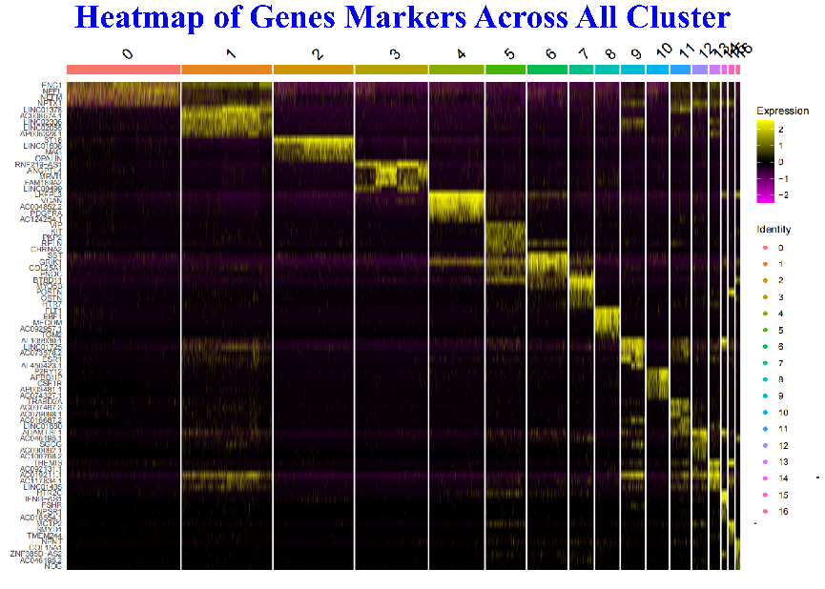
Supplementary Figure 15: Heatmap of genes Markers Across All Cluster

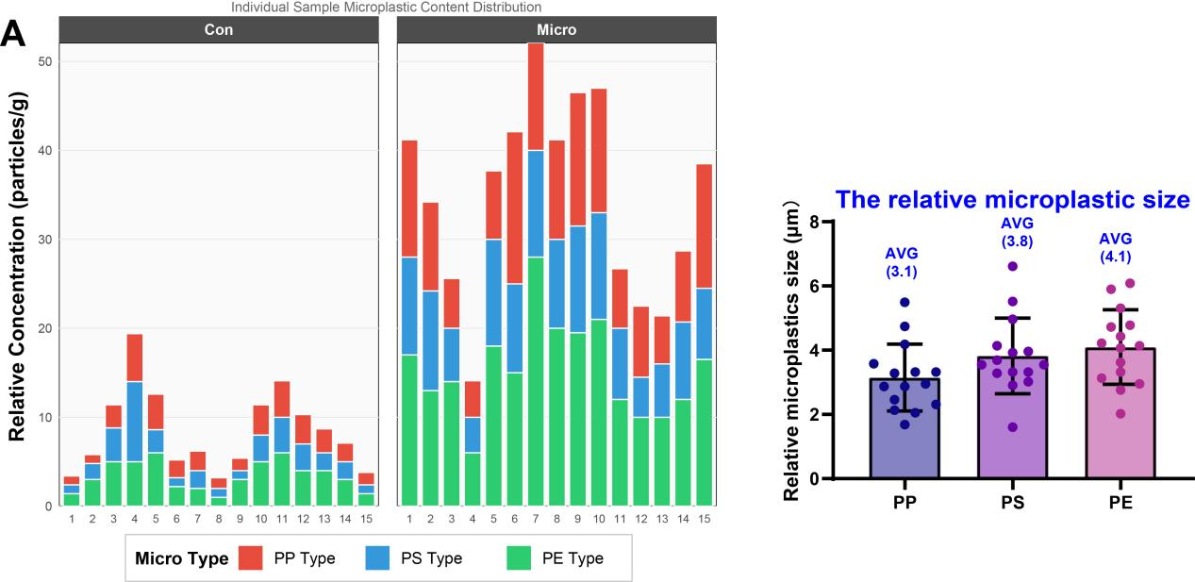
Supplemental Figure 16: Characterization of microplastic accumulation and particle size distribution in the blood of children with seizures.
Supplementary Figure 17: Flowchart of animal experiments

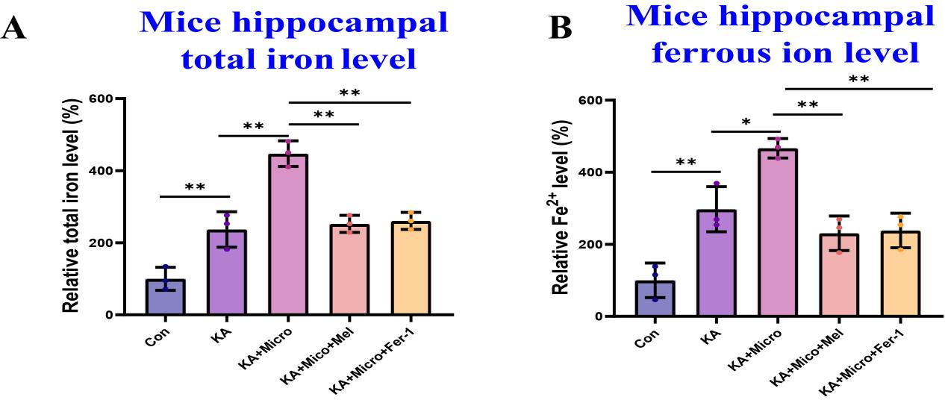
Supplementary Figure 18: Mice hippocampal iron level among different groups

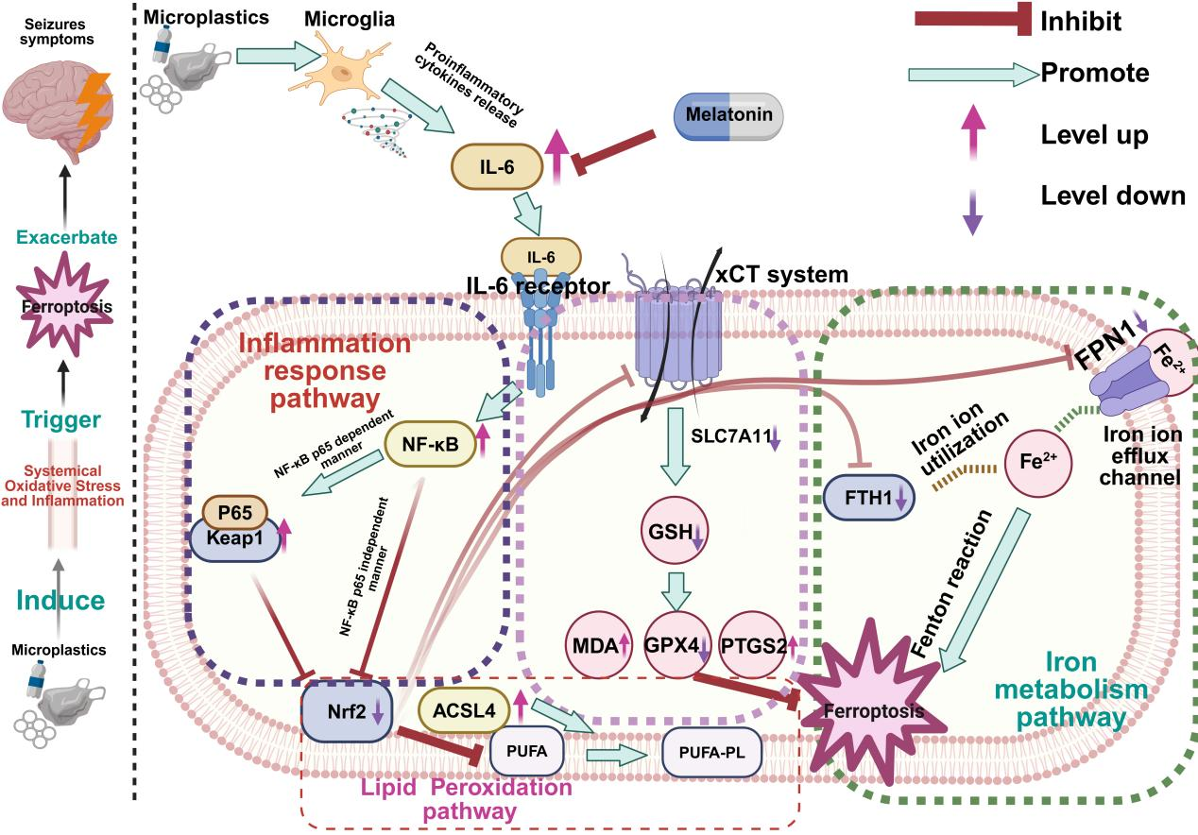
Supplementary Figure 19: Schematic illustration of the proposed molecular mechanism by which respiratory microplastic exposure exacerbates seizure symptoms via ferroptosis

Supplemental Information Section

Supplementary Information 1
Detailed Exclusion Criteria for Cohort1- Cohort 3
In this study, volunteer plastics manufacturing workers or volunteer children with seizures were carefully screened based on a set of exclusion criteria to ensure the homogeneity of the sample population and to minimize the influence of confounding factors on the results. The following exclusion criteria were applied:
- Diagnosed with diabetes, ulcerative colitis, Crohn's disease, or infectious diseases: Participants with pre-existing medical conditions such as diabetes, inflammatory bowel diseases (ulcerative colitis and Crohn's disease), or infectious diseases were excluded from the study. These conditions can independently affect the inflammatory markers, and neurological disorders including seizures, potentially confounding the results of the study.
- Received chemotherapy, radiotherapy, or surgery within 3–6 months before sampling: Participants who had undergone chemotherapy, radiotherapy, or surgery within 3–6 months prior to the sampling were excluded. These treatments can significantly alter the inflammatory responses, which may affect the study results.
- Exhibited abnormal bowel movements in the week before sampling: Participants who reported abnormal bowel movements, such as diarrhea or constipation, in the week before sampling were excluded. Abnormal bowel movements can be indicative of underlying gastrointestinal disorders or transient disturbances in the iron and lipid metabolism, which may affect the study results.
- Iron Supplementation: Those who had taken iron supplements prior to the study were excluded. Iron supplementation can disrupt iron metabolism, affecting the study's outcomes.
- Diagnosed with mental illness: Participants with a pre-existing diagnosis of mental illness were excluded from the study. The presence of mental health disorders such as major depressive disorder, generalized anxiety disorder, or other psychiatric conditions can influence the assessment of anxiety-like behaviors and may confound the evaluation of the effects of microplastics exposure on seizures symptoms.

Supplementary Information 2
Generalized Anxiety Disorder 7-item (GAD-7) questionnaire
Instructions
Over the last 2 weeks, how often have you been bothered by the following problems?
1. Feeling nervous, anxious, or on edge 0 1 2 3
2. Not being able to stop or control worrying 0 1 2 3
3. Worrying too much about different things 0 1 2 3
4. Trouble relaxing 0 1 2 3
5. Being so restless that it's hard to sit still 0 1 2 3
6. Becoming easily annoyed or irritable 0 1 2 3
7. Feeling afraid as if something awful might happen 0 1 2 3
Scores:
0 Not At all
1 Several Days
2 Over Half The Days
3 Nearly Everyday

Supplementary Information 3
Montreal Cognitive Assessment (MoCA) questionnaire


Supplementary Information 4
SHAP methods and SHAP values
SHAP (SHapley Additive exPlanations) is a powerful tool for interpreting the outputs of machine learning models by quantifying the contribution of each feature to individual predictions. Rooted in cooperative game theory, SHAP values provide a fair allocation of the prediction difference to each feature, enabling a transparent understanding of model decisions.
At its core, a SHAP value measures the impact of a single feature on a specific prediction. It represents the average change in the model’s output when that feature is included, computed over all possible permutations of feature inclusion orders. This approach captures complex feature interactions and ensures consistent and reliable explanations.
Key properties of SHAP values include:
- Magnitude
The absolute value of a SHAP value indicates the strength of the feature’s influence on the prediction. Larger absolute values correspond to greater impact.
- Sign
The sign of a SHAP value reveals the direction of the feature’s effect: A positive SHAP value means the feature pushes the prediction higher. While A negative SHAP value means the feature pushes the prediction lower.
- Additivity
For a given prediction, the sum of all feature SHAP values equals the difference between the model’s output for that prediction and the base value (the average model output over the entire dataset). This additive property ensures that the total contribution of all features accounts exactly for the deviation from the baseline prediction.
Beyond local explanations for individual predictions, SHAP values can be aggregated across samples to assess global feature importance and reveal complex relationships between features and model outputs. Visualization tools such as SHAP summary plots and dependence plots provide intuitive insights into feature effects and interactions, enhancing model transparency and interpretability.
In summary, SHAP offers a unified and theoretically grounded framework for explaining machine learning models, widely applied across fields such as medicine, finance, and environmental science. It helps researchers and practitioners gain deeper insights into model behavior, thereby promoting trustworthy and informed decision-making.

Supplementary Methods Section
- Bibliometric analysis
This study employed VOSviewer and CiteSpace software to perform visualized bibliometric analyses of the existing literature. Data were retrieved from the Web of Science (WOS) Core Collection database, which is widely recognized for its comprehensive coverage and rigorous indexing process, making it a reliable source for bibliometric studies. A systematic literature search was conducted using the following search strategy: "Microplastics" AND "neurotoxicity" in the topic field. The search was limited to articles published between 2019 and 2025. This temporal window was strategically selected to capture the most recent advances in this rapidly evolving research field while ensuring sufficient data volume for meaningful analysis. Document types were restricted to original research articles and reviews, which represent primary sources of scientific evidence. Conference abstracts, editorial materials, letters, meeting abstracts, and corrections were excluded to maintain data quality and analytical rigor. The retrieved records were exported in plain text format, including full bibliographic information and cited references, for subsequent analysis. To ensure the accuracy and reliability of the dataset, two independent researchers screened and evaluated the retrieved articles according to predefined inclusion and exclusion criteria. Any discrepancies were resolved through discussion until consensus was reached. Duplicate records were identified and removed prior to final analysis. The curated dataset was then imported into VOSviewer and CiteSpace for network visualization and trend analysis, including co-authorship networks, keyword co-occurrence, citation burst detection, and temporal evolution patterns.
- Quality assurance and quality control (QA/QC) description for human blood microplastics:
To ensure quality control in the laboratory and prevent contamination from airborne particles, containers, or potential human sources during experimental procedures, several measures were implemented. Clean and dry glassware or metalware were used throughout all experiments, and personnel wore cotton lab coats and nitrile gloves during all procedures. Sample containers and filter papers were covered with lids or tightly wrapped with aluminum foil to prevent sample contamination. Additionally, procedural blanks were included to monitor and eliminate background contamination.
- Detection and quantitative analysis of human blood microplastics using the Micro Raman system
In this study, we utilized a Micro Raman system (Thermo Scientific, DXR3, USA), a crucial analytical tool for microplastic identification and quantification, to detect and quantify microplastics in human blood samples. The methodology largely followed protocols established in previous research^{[1]}. As illustrated in Fig. 1D, the analysis comprised several key steps: Step 1: Whole blood samples were collected from subjects under strictly controlled, contamination-free conditions to minimize the risk of external microplastic contamination. Step 2: Nitric acid was added to the blood samples, and the mixtures were heated to facilitate the digestion of the biological matrix. This process breaks down organic components, resulting in a clear or slightly yellowish solution containing acid-resistant particles, including potential microplastics. Step 3: The digested solution was then subjected to vacuum filtration through a membrane filter, which effectively traps microplastic particles and other acid-resistant residues.Step 4: The filter membrane containing the retained particles was carefully placed on the stage of the Raman spectrometer for analysis. Raman spectra were acquired for each particle and compared against reference spectra from a comprehensive Raman polymer spectral library^{[2]}. In this study, we focused on polyethylene (PE), polypropylene (PP), and polystyrene (PS) as they are the most commonly used plastics for plastic package^{[3]}.
- Human Blood Collection
To assess the potential impacts of microplastics on metabolite profiles, oxidative stress markers, pro-inflammatory cytokine levels, and gene expression in peripheral blood, venous blood samples were collected from volunteers as previously described^{[4-6]}. Following overnight fasting, blood was drawn into EDTA anticoagulant tubes and processed within 30 min to minimize ex vivo alterations. For plasma isolation, whole blood was centrifuged at 3,000 × g for 10 min at 4°C. The separated plasma was immediately aliquoted and stored at −80°C until analysis by untargeted metabolomics and targeted lipidomics. Peripheral blood mononuclear cells (PBMCs) were isolated from the cellular fraction using Ficoll-Paque density gradient centrifugation according to the manufacturer's protocol. Isolated PBMCs were washed twice with phosphate-buffered saline (PBS) and immediately preserved in RNAlater solution for subsequent RT-qPCR analysis of inflammatory and immune-related gene expression. All samples were handled under standardized conditions to ensure reproducibility and minimize technical variability.
- Commercial Inflammatory Cytokine Measurement
To evaluate the systemic inflammatory response associated with microplastic exposure, we quantified key pro-inflammatory cytokines using commercially available enzyme-linked immunosorbent assay (ELISA) kits. ELISA is a well-established method for the precise quantification of specific proteins in biological fluids, widely utilized in immunological research ^{[4, 7, 8]}. For the clinical cohort, cytokine levels in human plasma were measured using highly sensitive ELISA kits from mLbio (Shanghai, China), following the manufacturer’s instructions and protocols adapted from our previous studies ^{[4, 7, 8]}. The following analytes were assessed: Interleukin-6 (IL-6) (Catalog No: ml058097); Interleukin-1β (IL-1β) (Catalog No: ml058059); Tumor Necrosis Factor-alpha (TNF-α) (Catalog No: ml077385). For the murine experimental model, blood samples were collected via the retro-orbital sinus plexus under anesthesia. Serum (or plasma, specify based on your method) was separated by centrifugation, and systemic IL-6 levels were determined using a specific ELISA kit (Catalog No: ml098430, mLbio, Shanghai, China).
- Assessment of Oxidative Stress Markers in Human Plasma
Oxidative stress markers in human plasma were quantified using commercial assay kits from Solarbio (Beijing, China) to evaluate systemic redox status in microplastic-exposed individuals based on our previous study^{[9]}. Three key biomarkers were measured: malondialdehyde (MDA, Cat. No. BC0025) as an indicator of lipid peroxidation, reduced glutathione (GSH, Cat. No. BC1175) for antioxidant capacity, and superoxide dismutase (SOD, Cat. No. BC0165) for enzymatic antioxidant activity. All assays were performed according to the manufacturer's instructions. Plasma samples were thawed on ice, appropriately diluted, and analyzed in duplicate to ensure technical reproducibility. Mean values from duplicate measurements were used for subsequent statistical analysis.
- Human plamsa untargeted metabolomic analysis
To assess the potential impact of long-term respiratory microplastic exposure on human metabolism, untargeted metabolomic analysis was performed on plasma samples following previously established methodologies. Briefly, 100 μL of each sample was mixed with 400 μL of 50% ice-cold methanol solution. After centrifugation at 12,000 rpm and 4 °C for 10 minutes, the supernatant was transferred to a new 2 mL centrifuge tube and concentrated to dryness under vacuum. The dried residues were redissolved in 150 μL of 2-chlorophenylalanine in 80% methanol solution. The supernatant was then filtered through a 0.22 μm membrane prior to liquid chromatography–mass spectrometry (LC–MS) analysis. Samples were subsequently sent to Shanghai OE Biotech Co. for comprehensive metabolomic profiling. A quality control (QC) sample was prepared by pooling equal volumes (20 μL) of supernatants from all samples to assess analytical variability. Differential metabolites were identified based on variable importance in projection (VIP) scores and relative expression levels. Metabolites with VIP values greater than 1, fold changes greater than 2 or less than 0.5, and P-values less than 0.05 were considered statistically significant. Further functional enrichment analysis was conducted using the Kyoto Encyclopedia of Genes and Genomes (KEGG) database to elucidate potential metabolic pathways affected by these differential metabolites.
- Identification of hub metabolic biomakers influced by respiator microplatisc exposure
To identify potential hub biomarkers and elucidate metabolic patterns associated with respiratory microplastic exposure, we employed two complementary supervised machine learning algorithms:Support Vector Machine-Recursive Feature Elimination (SVM-RFE) and Multi-Layer Perceptron Artificial Neural Network (MLP-ANN) algorithms^{[10-12]} .These models were used to classify samples and rank the importance of differentially abundant metabolites identified from the untargeted metabolomic analysis. Prior to modeling, a systematic exclusion process was applied to remove exogenous compounds, such as anticoagulants (e.g., EDTA), which could confound biological interpretation. The curated dataset of differentially abundant metabolites then underwent Z-score normalization to standardize scale disparities between variables and ensure equal weighting during model training. To ensure model robustness and prevent overfitting, samples were randomly partitioned into a training set (70%) and an independent test set (30%) using stratified sampling to preserve the proportion of exposure groups in both subsets. Model performance was rigorously evaluated on the test set using accuracy and error rate. Feature importance scores were extracted from both MLP and SVM models. Metabolites that consistently ranked in the top features across both algorithms were identified as key drivers of the metabolic response to microplastic exposure
- Mendelian Randomization analysis
Mendelian Randomization (MR) analysis is a powerful technique that leverages genome-wide association studies (GWAS) data by using genetic variants as instrumental variables (IVs) to explore potential relationships between risk factors and health outcomes^{[13]}. MR analysis has been widely employed to assess the effects of environmental exposures, such as air pollution, on disease risk^{[14]}. In this study, we applied MR analysis to identify risk factors highly associated with seizure symptoms and to establish potential causal associations between microplastic exposure–induced alterations in gene expression and lipid metabolism with seizure severity. We systematically extracted GWAS summary statistics for potential independent risk factors, gene expression profiles, lipidome data, and focal epilepsy (the predominant form of epilepsy in pediatric populations) from the comprehensive IEU OpenGWAS repository (https://gwas.mrcieu.ac.uk/). Genetic variants were selected as IVs based on the following criteria: (1) genome-wide significance threshold of P < 1.0 × 10⁻⁵ for association with the exposure, which has been validated in previous MR studies for identifying robust genetic predictors; (2) independence from linkage disequilibrium (LD), with variants clumped at r² < 0.001 within a 10,000 kb window; and (3) exclusion of variants directly associated with the outcome (focal epilepsy) at P < 5.0 × 10⁻⁸ to minimize pleiotropic effects.The inverse variance weighted (IVW) method was employed as the primary analytical approach to estimate causal effects, which provides the most precise estimates when all IVs are valid. For exposures with only a single SNP available as an IV, the Wald ratio method was applied to calculate the causal estimate. All MR analyses were conducted using the TwoSampleMR package in R software . A P-value < 0.05 was considered statistically significant.
- Targeted Lipidomic Analysis of Human Plasma
Targeted lipidomic profiling was performed on human plasma samples using liquid chromatography-tandem mass spectrometry (LC-MS/MS) to quantify 141 predefined oxidized lipid species (MetWare Biotechnology, Wuhan, China), which are critically involved in membrane integrity, inflammatory signaling, and energy homeostasis. Plasma samples (100 μL) were subjected to lipid extraction using a methyl tert-butyl ether (MTBE)/methanol/water (10:3:2.5, v/v/v) solvent system with isotope-labeled internal standards to ensure quantification accuracy. Extracts were dried under nitrogen, reconstituted in isopropanol/acetonitrile (1:1, v/v), and analyzed by ultra-performance liquid chromatography (UPLC) coupled to a triple quadrupole (QQQ) mass spectrometer in both positive and negative electrospray ionization (ESI) modes. Chromatographic separation was achieved using a C18 reversed-phase column (Acquity UPLC BEH C18, 1.7 μm, 2.1 × 100 mm) with gradient elution. Lipid species were identified based on accurate mass, retention time, and MS/MS fragmentation patterns. Quantification was performed using multiple reaction monitoring (MRM) with calibration curves generated from authentic lipid standards. Data were processed using LipidSearch software (Thermo Fisher Scientific). Lipid abundances were normalized to internal standards and log-transformed for statistical analysis. Differential lipids between microplastic-exposed and control groups were identified using partial least squares discriminant analysis (PLS-DA) and univariate testing (t-test or Mann-Whitney U test as appropriate), with false discovery rate (FDR) correction applied (P < 0.05).
- Machine learning model construction and evaluation
In this study, we combined the Boruta algorithm with unvariable analysis to select relevant features, effectively to mitigate overfitting. Consequently, a total of 12 features were identified for the development of machine learning analyses. In this study, we employed 9 distinct ML techniques to predict the risk probability of seizure symptoms using the selected 12 features:: 1. Adaptive Boosting (AdaBoost), 2. Lasso Regression (Lasso), 3. Random Forest (RF), 4. Gradient Boosting Machine (GBM), 5. Extreme Gradient Boosting (XGBoost), 6. Support Vector Machine (SVM), 7. K-Nearest Neighbors (KNN), 8. Multilayer Perceptron (MLP), and 9. Decision Tree (DT). The use of multiple models facilitated a comparison of their performance and the identification of the most effective technique for predicting the risk of seizures symptoms. We implemented a 7:3 train-test split, where 70% of the data was used for model training and the remaining 30% was reserved for testing and evaluation. This methodology ensured a clear separation between the data used for model development and the data used for performance assessment. Model reliability was assessed using two primary metrics: Receiver Operating Characteristic (ROC) and Precision-Recall Curve (PRC)^{[15]}. Additionally, specificity, sensitivity, accuracy and F1-score were presented using a radar chart. .
- Model interpretation
Interpreting machine learning models has consistently been a challenge. To further elucidate how each feature influences and contributes to the final model, we employed the SHapley Additive exPlanation (SHAP) technique to interpret the highest-performing black-box model, as established in prior studies. In this study, we evaluated the importance of each feature by computing the mean absolute SHAP values. Additionally, we utilized the SHAP dependency plots to assess the influence of selected features, primarily focusing on how individual features affect the predicted risk probability of seizure symptoms. These relationships were visualized through scatter plots enhanced with LOESS (Locally Estimated Scatterplot Smoothing) fitting, which effectively revealed potential non-linear relationships between feature values and model predictions. This approach provided valuable insights into the complex mechanisms underlying our predictive model.
- Quantitative real-time reverse transcription PCR (qRT-PCR)
To examine the effects of microplastic exposure on gene expression, particularly within the Nrf2-dependent ferroptosis pathway, we conducted qRT-PCR following the protocols established in our previous studies^{[4-6, 16]}. Detailed primer sequences employed for amplification are provided in Supplementary File 1.
- Human brain single cell analysis
To investigate cellular and molecular alterations in seizure-affected brain tissue, we performed single-cell RNA sequencing (scRNA-seq) analysis on surgically resected specimens from pediatric patients with focal epilepsy. Brain tissue samples were collected from patients undergoing therapeutic resection surgery (n = 3 per group: seizure-affected hippocampal tissue and control tissue from non-epileptic hippocampal ). The raw sequencing data were obtained from the DISCO database, generously shared by Nationwide Children's Hospital (Columbus, OH, USA). Rigorous quality control was performed to ensure high-quality cells for downstream analysis. Specifically, cells were retained only if they met the following criteria: (1) at least 200 detected genes per cell, (2) unique molecular identifier (UMI) counts > 1,000, (3) mitochondrial gene UMI ratio < 20% to exclude damaged or dying cells, and (4) red blood cell gene expression ratio < 5% to remove potential contamination from erythrocytes. Low-quality cells and potential doublets were excluded from further analysis. Following quality control, the filtered gene expression matrices from all samples (n = 3 per group) were integrated using the Harmony algorithm implemented in the R package "Seurat" to correct for batch effects and technical variation across samples while preserving biological heterogeneity. The integrated dataset was then normalized using the LogNormalize method, and the top 2,000 highly variable genes were identified for principal component analysis (PCA). Dimensionality reduction was performed using Uniform Manifold Approximation and Projection (UMAP) based on the first 30 principal components, followed by graph-based clustering using the Louvain algorithm with a resolution parameter of 0.2. Unsupervised clustering analysis identified 16 distinct cell clusters. Cell type annotation was performed by identifying cluster-specific marker genes using the FindAllMarkers function in Seurat (Wilcoxon rank-sum test, log₂ fold change > 0.25, adjusted P < 0.05) and comparing them with known cell type markers from published brain cell atlases. Major cell types identified included neurons, astrocytes, oligodendrocytes, microglia, and endothelial cells. Differential gene expression analysis between seizure-affected and control tissues was conducted within each cell type to identify cell-type-specific molecular signatures associated with seizure pathology. All scRNA-seq analyses were performed using R software with the Seurat package.
- Human Blood RNA-Seq Analysis
To further investigate the role of ferroptosis in epilepsy pathogenesis, we conducted a comprehensive transcriptomic analysis using an independent public cohort. The gene expression dataset GSE143272 was retrieved from the Gene Expression Omnibus (GEO) database (https://www.ncbi.nlm.nih.gov/geo/). This dataset comprises RNA sequencing data from peripheral blood samples of 91 patients diagnosed with epilepsy and 50 healthy control subjects. Gene expression levels were quantified as transcripts per million (TPM) and log₂-transformed for statistical analysis. We specifically focused on the expression patterns of ferroptosis-related genes, Differential expression analysis between epilepsy patients and healthy controls was performed using Student's t-test (for normally distributed data) or Mann-Whitney U test (for non-normally distributed data) after assessing normality with the Shapiro-Wilk test. Statistical significance was set at P < 0.05, with Benjamini-Hochberg false discovery rate (FDR) correction applied for multiple testing. Results were visualized using box plots generated with the ggplot2 package in R software, and individual data points for each ferroptosis-related gene across both groups.
- Magnetic resonance imaging (MRI)
To investigate the impact of microplastics exposure on iron metabolism within the brain of epileptic mice, we employed T2-weighted MRI, a noninvasive technique frequently utilized to evaluate brain iron content, as detailed elaborated in our prior study. In brief, T2-weighted MRI scans, iron accumulation manifests as hypointense signals—areas that appear darker on the images. Notably, a lower T2 MRI value indicates higher iron content within the brain tissue, providing a quantitative measure of iron levels ^{[21]}.
- 1H-Magnetic Resonance Spectroscopy (MRS)
To assess the effects of microplastics exposure on the metabolism of unsaturated fats in the brains of epileptic mice, we employed Magnetic Resonance Spectroscopy (MRS). This non-invasive technique is pivotal for the comprehensive analysis of tissue metabolic composition, as demonstrated in our previous studies ^{[6]}. Specifically, MRS facilitated the identification and quantification of several key metabolites, including choline (Cho), creatine (Cr), myo-inositol (mI), N-acetyl aspartate (NAA), and lipids (Lip). Each metabolic resonance offers valuable insights into various aspects of brain metabolism, with a particular emphasis on alterations in lipid profiles resulting from microplastics exposure.
- Chemicals and reagents
The 50nm polystyrene microplastics (PS-MPs) were acquired from Hugebio Technology Co., Ltd. (DS50, Shanghai, China), with their dynamic light scattering images illustrated in Figure 11B. Melatonin and Ferrostatin-1 were obtained from MedChemExpress (Shanghai, China). Antibodies targeting IL-6, NF-κB, Phospho-NF-κB p65, SLC40A1/FPN1, GPX4, β-Actin, KEAP1, and NFE2L2/Nrf2 were sourced from Proteintech Group, Inc. (Shanghai, China). Additionally, antibodies against SLC7A11/xCT and FTH1 were purchased from Cell Signaling Technology (Danvers, MA, USA).
- Relative Seizures symptoms scoring
To investigate and confirm the potential effects of microplastics exposure on the severity of seizures, we employed video monitoring and Racine scale assessments to quantitatively evaluate seizure intensity in epileptic mice, building upon our previous research ^{[4-6, 16]}. Specifically, during the 4 hour observation window following KA injection, two trained observers who were blinded to the experimental conditions meticulously recorded the corresponding Racine scores, as well as the frequency and duration of each seizure event.
- Novel object recognition (NOR) test
To investigate and confirm the potential effects of microplastics exposure on short-term recognition memory in mice, we utilized the NOR test, as detailed in our previous studies ^{[4-6, 16]}. Specifically, we meticulously recorded the duration each mouse spent exploring the familiar object (F) compared to the novel object (N). The discrimination index (DI) was then calculated using the formula: (N − F)/(N + F) × 100%. This metric enabled us to assess the mice's ability to differentiate between familiar and novel objects, thereby evaluating their recognition memory performance.
- Morris water maze (MWM) test
To investigate and validate the potential effects of microplastics exposure on spatial memory in mice, we conducted the MWM test following our established protocol ^{[4-6, 16]}. . The apparatus consisted of a circular pool filled with opaque water containing a hidden platform (8 cm diameter) submerged 1 cm below the surface. Mice underwent spatial navigation training over five consecutive days. Each mouse performed four trials per day with randomized start positions. Mice were allowed 60 seconds to locate the hidden platform; if unsuccessful, they were gently guided to it. Upon reaching the platform, mice remained there for 15 seconds to consolidate spatial cues. The inter-trial interval was 15–20 minutes. Escape latency (time to reach the platform) was recorded as the primary measure of spatial learning. Twenty-four hours after the final training session, the platform was removed, and mice were released from the quadrant opposite to the former platform location. Mice swam freely for 60 seconds while the WMT-100S system recorded: (1) swimming trajectory, (2) time spent in the target quadrant, and (3) number of platform crossings, These parameters assessed spatial memory retention.
- Marble burying test
The marble burying test is commonly used to assess anxiety-like behavior in rodents ^{[17]}. In this study, we conducted the marble burying test to explore the effects of microplastics on anxiety-like behaviors, in alignment with the methodology of our previous study ^{[6]}. In brief, the mice were placed in a standard laboratory cage containing a 5 cm-thick layer of bedding material. Before the experiment, twelve colored glass marbles were laid out on the surface of the bedding in a grid pattern ^{[18]}. During the 30-minute test, the mice were allowed to move freely within the cage. Only those marbles that were covered by at least two-thirds with sawdust were considered "buried." A higher number of buried marbles may indicate increased anxiety-like behaviors or obsessive-compulsive tendencies ^{[18, 19]}.
- Open field test (OFT)
The OFT is a widely used method to assess anxiety-like behaviors in rodents, including mice ^{[20]}. In this study, we conducted the open field test to explore the effects of microplastics on anxiety-like behaviors, in alignment with the methodology of a prior study ^{[19]}. Briefly, mice were placed individually in the center of an open field arena (50 × 50 × 40 cm) and allowed to freely explore the apparatus for 5 minutes. A camera was used to monitor movement, and the total distance traveled, the number of entries into the central zone, and the time spent in the central zone were measured to assess anxiety-like behaviors in mice ^{[20]}. After each test, the arena was cleaned with a 70% alcohol solution.
- Nissl staining
To assess the neurotoxic impacts resulting from microplastic exposure, we employed Nissl staining techniques as detailed in our previous studies ^{[4, 5, 8]}.
- RNA sequencing analysis
RNA sequencing analysis was conducted following the procedures described in our previous report. In brief, total RNA was extracted from the hippocampus of mice using TRIzol reagent (Takara, Shiga, Japan) according to the manufacturer’s instructions. The isolated RNA samples were then sent to Shanghai OE Biotech Co., Ltd. for high-throughput RNA sequencing. Differentially expressed genes (DEGs) were identified based on the criteria of fold change ≥ 1.5 and adjusted P-values (corrected for multiple testing) less than 0.05. To visualize the expression patterns, heatmaps and volcano plots were generated using OECloud tools available at https://cloud.oebiotech.cn. For functional interpretation, Gene Ontology (GO) enrichment analysis and Kyoto Encyclopedia of Genes and Genomes (KEGG) pathway analysis were performed on the DEGs. These analyses provided insights into the biological processes, molecular functions, cellular components, and signaling pathways significantly associated with the observed gene expression changes.
- Transmission electron microscopy (TEM)
As outlined in our earlier studies ^{[4, 5, 8]}, we employed transmission electron microscopy (TEM) to assess the potential impact of microplastic exposure on the morphological alterations of mitochondria within the hippocampal region. The TEM images were obtained using a Hitachi transmission electron microscope (Model H-7650, Hitachi, Tokyo, Japan).
- Quantification of Phosphatidylcholine PUFA and 8-iso-PGF2α
To assess metabolic alterations in lipids, we utilized commercial enzyme-linked immunosorbent assay (ELISA) kits to measure the concentrations of phosphatidylcholines (PC), polyunsaturated fatty acids (PUFA), and 8-iso-prostaglandin F2α (8-iso-PGF2α) in murine serum. The specific kits employed were: PC (Cat: CB11816-Mu), PUFA (Cat: CB13245-Mu), and 8-iso-PGF2α (Cat: CB10015-Mu), all sourced from COIBIO (Shanghai, China).
- Malondialdehyde (MDA), glutathione levels (GSH) and 4HNE level
To assess oxidative stress and lipid peroxidation in the mice hippocampus following microplastic exposure, we measured malondialdehyde (MDA, Cat. No. BC0025), reduced glutathione (GSH, Cat. No. BC1175), and 4-hydroxynonenal (4-HNE, Cat. No. SEKSM-0044) levels using commercial assay kits from Solarbio (Beijing, China). All measurements were performed in triplicate according to the manufacturer's instructions and our previously published protocols^{[4, 5, 8]}.
- Iron concentration analyse
To investigate the impact of microplastic exposure on iron concentration in the hippocampus, we employed two commercially available kits: the Tissue Iron Content Assay Kit (Solarbio, BC4350) and the Ferrous Ion Content Assay Kit (Solarbio, BC5415), as outlined in our previous research.
- Western blot analyses
To quantify protein alterations in the hippocampus, Western blot analyses were conducted following the methodology detailed in our previous study ^{[9]}.

References
1. Zhu M, Li X, Lin W, Zeng D, Yang P, Ni W, et al. Microplastic Particles Detected in Fetal Cord Blood, Placenta, and Meconium: A Pilot Study of Nine Mother-Infant Pairs in South China. Toxics 2024, 12(12).
2. Prata JC, da Costa JP, Fernandes AJS, da Costa FM, Duarte AC, Rocha-Santos T. Selection of microplastics by Nile Red staining increases environmental sample throughput by micro-Raman spectroscopy. Sci Total Environ 2021, 783: 146979.
3. Zheng X, Feng Q, Chen J, Yan J, Li X, Guo L. Quantification analysis of microplastics released from disposable polystyrene tableware with fluorescent polymer staining. Sci Total Environ 2023, 864: 161155.
4. Mei H, Wu D, Yong Z, Cao Y, Chang Y, Liang J, et al. PM(2.5) exposure exacerbates seizure symptoms and cognitive dysfunction by disrupting iron metabolism and the Nrf2-mediated ferroptosis pathway. Sci Total Environ 2024, 910: 168578.
5. Cao Y, Zhao W, Zhong Y, Jiang X, Mei H, Chang Y, et al. Effects of chronic low-level lead (Pb) exposure on cognitive function and hippocampal neuronal ferroptosis: An integrative approach using bioinformatics analysis, machine learning, and experimental validation. Sci Total Environ 2024, 917: 170317.
6. Chang Y, Jiang X, Dou J, Xie R, Zhao W, Cao Y, et al. Investigating the potential risk of cadmium exposure on seizure severity and anxiety-like behaviors through the ferroptosis pathway in epileptic mice: An integrated multi-omics approach. J Hazard Mater 2024, 480: 135814.
7. Xie Q, Hu B. Effects of gut microbiota on prostatic cancer: a two-sample Mendelian randomization study. Front Microbiol 2023, 14: 1250369.
8. Xie R, Zhao W, Lowe S, Bentley R, Hu G, Mei H, et al. Quercetin alleviates kainic acid-induced seizure by inhibiting the Nrf2-mediated ferroptosis pathway. Free Radic Biol Med 2022, 191: 212–226.
9. Xie R, Li T, Qiao X, Mei H, Hu G, Li L, et al. The Protective Role of E-64d in Hippocampal Excitotoxic Neuronal Injury Induced by Glutamate in HT22 Hippocampal Neuronal Cells. Neural Plast 2021, 2021: 7174287.
10. Zhang X, Xiao X, Luo Y, Xiao W, Cao Y, Chang Y, et al. Machine Learning Based Early Diagnosis of ADHD with SHAP Value Interpretation: A Retrospective Observational Study. Neuropsychiatr Dis Treat 2025, 21: 1075–1090.
11. Li A, Liu Y, Luo Y, Xiao X, Xiao W, Xie R, et al. Machine learning based predictive model of the risk of Tourette syndrome with SHAP value interpretation: a retrospective observational study. Sci Rep 2025, 15(1): 18336.
12. Alabi RO, Elmusrati M, Leivo I, Almangush A, Mäkitie AA. Machine learning explainability in nasopharyngeal cancer survival using LIME and SHAP. Sci Rep 2023, 13(1): 8984.
13. Sanderson E, Glymour MM, Holmes MV, Kang H, Morrison J, Munafò MR, et al. Mendelian randomization. Nat Rev Methods Primers 2022, 2.
14. Lin L, Zhang R, Huang H, Zhu Y, Li Y, Dong X, et al. Mendelian Randomization With Refined Instrumental Variables From Genetic Score Improves Accuracy and Reduces Bias. Front Genet 2021, 12: 618829.
15. Hu J, Xu J, Li M, Jiang Z, Mao J, Feng L, et al. Identification and validation of an explainable prediction model of acute kidney injury with prognostic implications in critically ill children: a prospective multicenter cohort study. EClinicalMedicine 2024, 68: 102409.
16. Wang Y, Quan F, Cao Q, Lin Y, Yue C, Bi R, et al. Quercetin alleviates acute kidney injury by inhibiting ferroptosis. J Adv Res 2021, 28: 231–243.
17. Singh S, Botvinnik A, Shahar O, Wolf G, Yakobi C, Saban M, et al. Effect of psilocybin on marble burying in ICR mice: role of 5-HT1A receptors and implications for the treatment of obsessive-compulsive disorder. Transl Psychiatry 2023, 13(1): 164.
18. Horii-Hayashi N, Masuda K, Kato T, Kobayashi K, Inutsuka A, Nambu MF, et al. Entrance-sealing behavior in the home cage: a defensive response to potential threats linked to the serotonergic system and manifestation of repetitive/stereotypic behavior in mice. Front Behav Neurosci 2023, 17: 1289520.
19. Samra AI, Kamel AS, Abdallah DM, El Fattah MAA, Ahmed KA, El-Abhar HS. Preclinical Evidence for the Role of the Yin/Yang Angiotensin System Components in Autism Spectrum Disorder: A Therapeutic Target of Astaxanthin. Biomedicines 2023, 11(12).
20. Dang R, Wang M, Li X, Wang H, Liu L, Wu Q, et al. Edaravone ameliorates depressive and anxiety-like behaviors via Sirt1/Nrf2/HO-1/Gpx4 pathway. J Neuroinflammation 2022, 19(1): 41.
21. Lee JH, Yun JY, Gregory A, Hogarth P, Hayflick SJ. Brain MRI Pattern Recognition in Neurodegeneration With Brain Iron Accumulation. Front Neurol 2020, 11: 1024.
22. Võsa U, Claringbould A, Westra HJ, Bonder MJ, Deelen P, Zeng B, et al. Large-scale cis- and trans-eQTL analyses identify thousands of genetic loci and polygenic scores that regulate blood gene expression. Nat Genet 2021, 53(9): 1300–1310.

Supplemental table section

Supplemental Table 1 microplastic level in the blood of respiratory exposure workers*
Microplastic types | Control | Respiratory Microplastic workers
Total | 7.76±3.39 | 42.24±21.04
PE | 2.64±1.60 | 16.87±9.30
PP | 2.44±1.19 | 13.88±7.70
PS | 2.87±1.50 | 11.75±5.64
*Level concentration:(particles/g)

Supplemental table 2: Detailed information of GWAS data used in the study
GWAS ID | Years | Trait | Sample Size | Population | Database/PMID*
finn-b-FE_STRICT | 2021 | Focal epilepsy | 213,143 | European | IEU OPEN GWAS  PMID:NA
eqtl-a-ENSG00000167468 | 2017 | GPX4 | 31,470 | European | IEU OPEN GWAS  PMID:34475573
eqtl-a-ENSG00000116044 | 2017 | NFE2L2 | 31,470 | European | IEU OPEN GWAS  PMID:34475573
eqtl-a-ENSG00000151012 | 2017 | SLC7A11 | 31,470 | European | IEU OPEN GWAS  PMID:34475573
eqtl-a-ENSG00000167996 | 2017 | FTH1 | 31,470 | European | IEU OPEN GWAS  PMID:34475573
eqtl-a-ENSG00000138449 | 2017 | FPN1 | 31,470 | European | IEU OPEN GWAS  PMID:34475573
GCST90277268 | 2023 | level of Phosphatidylcholine (20:4/0:0) | 6,235 | European | GWAS Catalog  PMID:37907536
GCST90277347 | 2023 | level of Phosphatidylethanolamine (18:0/18:2) | 6,235 | European | GWAS Catalog  PMID:37907536
GCST90277345 | 2023 | level of Phosphatidylcholine (16:0/18:2) | 6,235 | European | GWAS Catalog  PMID:37907536
*IEU OPEN GWAS (https://gwas.mrcieu.ac.uk/) ^{[22]}
GWAS Catalog (https://www.ebi.ac.uk/) ^{[22]}

Supplemental Table 3 Detailed Information for Human plasma lipidomics
Compounds | Abbreviation | CAS No
(±)14,15-epoxy-5Z,8Z,11Z-eicosatrienoic acid | 14,15-EET | 81276-03-1
(±)11,12-epoxy-5Z,8Z,14Z-eicosatrienoic acid | 11,12-EET | 81276-02-0
(±)8,9-epoxy-5Z,11Z,14Z-eicosatrienoic acid | 8,9-EET | 81246-85-7
(±)5,6-epoxy-8Z,11Z,14Z-eicosatrienoic acid | 5,6-EET | 81246-84-6
9-oxo-10E,12Z-octadecadienoic acid | 9-oxoODE | 54232-59-6
13-oxo-9Z,11E-octadecadienoic acid | 13-oxoODE | 54739-30-9
(±)-18-hydroxy-5Z,8Z,11Z,14Z,16E-eicosapentaenoic acid | (±)18-HEPE | 141110-17-0
(±)-15-hydroxy-5Z,8Z,11Z,13E,17Z-eicosapentaenoic acid | (±)15-HEPE | 88852-33-9
(±)-12-hydroxy-5Z,8Z,10E,14Z,17Z-eicosapentaenoic acid | (±)12-HEPE | 81187-21-5
(±)-5-hydroxy-6E,8Z,11Z,14Z,17Z-eicosapentaenoic acid | (±)5-HEPE | 83952-40-3
20-hydroxy-5Z,8Z,11Z,14Z-eicosatetraenoic acid | 20-HETE | 79551-86-3
(±)5-hydroxy-6E,8Z,11Z,14Z-eicosatetraenoic acid | (±)5-HETE | 70608-72-9
8-hydroxy-5Z,9E,11Z,14Z-eicosatetraenoic acid | 8-HETE | 98462-03-4
8S-hydroxy-4Z,6E,10Z-hexadecatrienoic acid | tetranor-12(S)-HETE | 121842-79-3
19S-hydroxy-5Z,8Z,11Z,14Z-eicosatetraenoic acid | 19(S)-HETE | 79551-85-2
(±)18-hydroxy-5Z,8Z,11Z,14Z-eicosatetraenoic acid | (±)18-HETE | 133268-58-3
(±)17-hydroxy-5Z,8Z,11Z,14Z-eicosatetraenoic acid | (±)17-HETE | 128914-47-6
(±)16-hydroxy-5Z,8Z,11Z,14Z-eicosatetraenoic acid | (±)16-HETE | 128914-46-5
(±)15-hydroxy-5Z,8Z,11Z,13E-eicosatetraenoic acid | (±)15-HETE | 71030-36-9
(±)12-hydroxy-5Z,8Z,10E,14Z-eicosatetraenoic acid | (±)12-HETE | 71030-37-0
11S-hydroxy-5Z,8Z,12E,14Z-eicosatetraenoic acid | 11(S)-HETE | 54886-50-9
(±)-9-hydroxy-5Z,7E,11Z,14Z-eicosatetraenoic acid | (±)9-HETE | 79495-85-5
Eicosapentaenoic Acid | EPA | 10417-94-4
Arachidonic Acid | ARA | 506-32-1
Docosahexaenoic Acid | DHA | 6217-54-5
Dihomo-γ-Linolenic Acid | DGLA | 1783-84-2
Linoleic Acid | LA | 60-33-3
α-Linolenic Acid | ALA | 463-40-1
γ-Linolenic Acid | GLA | 506-26-3
20-Carboxyarachidonic Acid | 20-COOH-AA | 79551-84-1
(±)4-hydroxy-5E,7Z,10Z,13Z,16Z,19Z-docosahexaenoic acid | (±)4-HDHA/HDoHE | 90906-40-4
(+/-)20-Hydroxy-4Z,7Z,10Z,13Z,16Z,18E-Docosahexaenoic Acid | (±)20-HDHA/HDoHE | 90906-41-5
(±)7-hydroxy-4Z,8E,10Z,13Z,16Z,19Z-docosahexaenoic acid | (±)7-HDHA/HDoHE | 90780-55-5
14S-hydroxy-4Z,7Z,10Z,12E,16Z,19Z-docosahexaenoic acid | (±)14-HDHA/HDoHE | 87042-40-8
(±)17-hydroxy-4Z,7Z,10Z,13Z,15E,19Z-docosahexaenoic acid | (±)17-HDHA/HDoHE | 90780-52-2
(+/-)-13-hydroxy-4Z,7Z,10Z,14E,16Z,19Z-docosahexaenoic acid | (±)13-HDHA/HDoHE | 90780-53-3
(+/-)-10-Hydroxy-4Z,7Z,11E,13Z,16Z,19Z-Docosahexaenoic Acid | (±)10-HDHA/HDoHE | 90780-50-0
(+/-)-8-Hydroxy-4Z,6E,10Z,13Z,16Z,19Z-Docosahexaenoic Acid | (±)8-HDHA/HDoHE | 90780-54-4
(+/-)-11-Hydroxy-4Z,7Z,9E,13Z,16Z,19Z-Docosahexaenoic Acid | (±)11-HDHA/HDoHE | 87018-59-5
(+/-)-16-Hydroxy-4Z,7Z,10Z,13Z,17E,19Z-Docosahexaenoic Acid | (±)16-HDHA/HDoHE | 90780-51-1
4S,11R,17S-trihydroxy-5Z,7E,9E,13Z,15E,19Z-docosahexaenoic acid | RvD3 | 916888-47-6
7S,16R,17S-trihydroxy-4Z,8E,10Z,12E,14E,19Z-docosahexaenoic acid | RvD2 | 810668-37-2
7S,8R,17S-trihydroxy-4Z,9E,11E,13Z,15E,19Z-docosahexaenoic acid | RvD1 | 872993-05-0
7S,17S-dihydroxy-4Z,8E,10Z,13Z,15E,19Z-docosahexaenoic acid | RvD5 | 578008-43-2
9-oxo-11α,15S-dihydroxy-prost-13E-en-1-oic acid | PGE1 | 745-65-3
9α,15S-dihydroxy-11-oxo-prost-13E-en-1-oic acid | PGD1 | 17968-82-0
9-oxo-11α,15S-dihydroxy-prosta-5Z,13E-dien-1-oic acid | PGE2 | 363-24-6
9α,15S-dihydroxy-11-oxo-prosta-5Z,13E-dien-1-oic acid | PGD2 | 41598-07-6
9α,11α,15S-trihydroxy-prosta-5Z,13E,17Z-trien-1-oic acid | PGF3α | 745-64-2
9-oxo-15S-hydroxy-5Z,10Z,13E-prostatrienoic acid | PGA2 | 13345-50-1
15S-hydroxy-9-oxo-5Z,8(12),13E-prostatrienoic acid | PGB2 | 13367-85-6
9S,15S-dihydroxy-11-oxo-5Z,13E,17Z-prostatrienoic acid | PGD3 | 71902-47-1
9S,11R-dihydroxy-15-oxo-13E-prostaenoic acid | 15-keto-PGF1α | 21562-58-3
9S,11R-dihydroxy-15-oxo-5Z,13E-prostadienoic acid | 15-keto-PGF2α | 35850-13-6
9,15-dioxo-11R-hydroxy-5Z,13E-prostadienoic acid | 15-keto-PGE2 | 26441-05-4
11,15-dioxo-9S-hydroxy-5Z-prostenoic acid | 13,14-dihydro-15-keto PGD2 | 59894-07-4
9,15-dioxo-11R-hydroxy-5Z-prostenoic acid | 13,14-dihydro-15-keto PGE2 | 363-23-5
8-iso 9α,11α,15S-trihydroxy-prosta-5Z,13E-dien-1-oic acid | 8-iso-PGF2α | 27415-26-5
2,3-Dinor-8-Epi-Prostaglandin F2alpha | 2,3-dinor-8-iso-PGF2α | 221664-05-7
6 keto-PGF1α | 6-keto-PGF1α | 58962-34-8
12-Hydroxy-5,8,10-heptadecatrienoic acid | 12-HHT | 54397-84-1
tetranor-PGFM | tetranor-PGFM | 23109-94-6
9α,11α,15S-trihydroxy-prosta-5Z,13E-dien-1-oic acid | PGF2α | 551-11-1
9α,11α,15S-trihydroxy-prost-13E-en-1-oic acid | PGF1α | 745-62-0
9,11-dioxo-15S-hydroxy-prost-13E-en-1-oic acid | PGK1 | 69413-73-6
11-oxo-15S-hydroxy-prosta-5Z,9,13E-trien-1-oic acid | PGJ2 | 60203-57-8
9-oxo-15S-hydroxy-prost-13E-en-1-oic acid | 11-deoxy PGE1 | 37786-00-8
9-oxo-11S,15S-dihydroxy-5Z,13E-prostadienoic acid | 11β-PGE2 | 38310-90-6
9S,11S,15S-trihydroxy-5Z,13E-prostadienoic acid | 11β-PGF2α | 38432-87-0
5S,12R,18R-trihydroxy-6Z,8E,10E,14Z,16E-eicosapentaenoic acid | RvE1 | 552830-51-0
5S-hydroxy-6R-(S-cysteinyl)-7E,9E,11Z,14Z-eicosatetraenoic acid | LTE4 | 75715-89-8
5S,12R-dihydroxy-6Z,8E,10E,14Z-eicosatetraenoic acid | LTB4 | 71160-24-2
9S,15S-Dihydroxy-11-Oxo-Thromboxa-5Z,13E-Dien-1-Oic Acid | 11-keto-TXB2 | 67910-12-7
9S,11,15S-trihydroxy-thrombox-13E-enoic acid | TXB1 | 64626-32-0
5S,12R,20-trihydroxy-6Z,8E,10E,14Z-eicosatetraenoic acid | 20-OH-LTB4 | 79516-82-8
5S,12R-dihydroxy-6Z,8E,10E,14Z-eicosatetraene-1,20-dioic acid | 20-COOH-LTB4 | 80434-82-8
5S,12R-dihydroxy-6E,8E,10E,14Z-eicosatetraenoic acid | 6-trans-LTB4 | 71652-82-9
5S-hydroxy-6R-(S-cysteinyl)-7E,9E,11E14Z-eicosatetraenoic acid | 11-trans-LTE4 | 75715-88-7
15S-hydroxy,14R-(S-cysteinyl)-5Z,8Z,10E,12E-eicosatetraenoic acid | 14,15-LTE4 | 1000852-57-2
9α,11,15S-trihydroxythromba-5Z,13E-dien-1-oic acid | TXB2 | 54397-85-2
9α,11,15S-trihydroxythromba-5Z,13E,17Z-trien-1-oic acid | TxB3 | 71953-80-5
5S-hydroxy-6R-(S-cysteinylglycinyl)-7E,9E,11Z,14Z-eicosatetraenoic acid | LTD4 | 73836-78-9
5S,6R,15S-trihydroxy-7E,9E,11Z,13E,17Z-eicosapentaenoic acid | LXA5 | 110657-98-2
5S,6R,15S-trihydroxy-7E,9E,11Z,13E-eicosatetraenoic acid | LXA4 | 89663-86-5
5S,14R,15S-trihydroxy-6E,8Z,10E,12E-eicosatetraenoic acid | LXB4 | 98049-69-5
7R,14S-dihydroxy-4Z,8E,10E,12Z,16Z,19Z-docosahexaenoic acid | 1-Mar | 1268720-28-0
10(S),17(S)-dihydroxy-4Z,7Z,11E,13Z,15E,19Z-docosahexaenoic acid | PDX | 871826-47-0
(±)9,10-dihydroxy-12Z-octadecenoic acid | 9,10-DiHOME | 263399-34-4
(±)17,18-epoxy-5Z,8Z,11Z,14Z-eicosatetraenoic acid | 17(18)-EpETE | 131339-23-6
(±)16,17-epoxy-4Z,7Z,10Z,13Z,19Z-docosapentaenoic acid | 16(17)-EpDPE | 155073-46-4
5S-hydroxy-6E,8Z,11Z-eicosatrienoic acid | 5-HETrE | 195061-94-0
(±)5,6-dihydroxy-8Z,11Z,14Z,17Z-eicosatetraenoic acid | (±)5,6-DIHETE | 845673-97-4
5S,15S-dihydroxy-6E,8Z,10Z,13E-eicosatetraenoic acid | 5(S),15(S)-DiHETE | 82200-87-1
(+/-)-8,9-dihydroxy-5Z,11Z,14Z,17Z-eicosatetraenoic acid | (±)8(9)-DiHETE | 867350-87-6
(+/-)-11,12-dihydroxy-5Z,8Z,14Z,17Z-eicosatetraenoic acid | (±)11(12)-DiHETE | 867350-92-3
(+/-)-14,15-dihydroxy-5Z,8Z,11Z,17Z-eicosatetraenoic acid | (±)14(15)-DiHETE | -
(+/-)-17,18-dihydroxy-5Z,8Z,11Z,14Z-eicosatetraenoic acid | (±)17(18)-DiHETE | -
(+/-)14,15-dihydroxy-5Z,8Z,11Z-eicosatrienoic acid | (±)14(15)-DiHET | 77667-09-5
5-oxo-6E,8Z,11Z,14Z-eicosatetraenoic acid | 5-oxoETE | 106154-18-1
8S-hydroxy-9E,11Z,14Z-eicosatrienoic acid | 8(S)-HETrE | 889573-69-7
15S-hydroxy-8Z,11Z,13E-eicosatrienoic acid | 15(S)-HETrE | 13-16-1
(+/-)-19(20)-Epoxy-4Z,7Z,10Z,13Z,16Z-Docosapentaenoic Acid | (±)19(20)-EpDPE(A) | -
(+/-)-7(8)-dihydroxy-4Z,10Z,13Z,16Z,19Z-Docosapentaenoic Acid | (±)7(8)-DiHDPE(A) | -
(+/-)-13(14)-dihydroxy-4Z,7Z,10Z,16Z,19Z-Docosapentaenoic Acid | (±)13(14)-DiHDPE(A) | 1345275-24-2
(+/-)-19(20)-dihydroxy-4Z,7Z,10Z,13Z,16Z-Docosapentaenoic Acid | (±)19(20)-DiHDPE(A) | -
8,9-dihydroxy-5Z,11Z,14Z-eicosatrienoic acid | (±)8(9)-DiHET | 192461-96-4
11,12-dihydroxy-5Z,8Z,14Z-eicosatrienoic acid | (±)11(12)-DiHET | 192461-95-3
9（S）,10(S),13(S)-Trihydroxy-11-Octadecenoic Acid | 9(S),10(S),13(S)-TriHOME | 29907-57-1
9S,12S,13S-Trihydroxy-10E-Octadecenoic Acid | 9(S),12(S),13(S)-TriHOME | 97134-11-7
15-oxo-5Z,8Z,11Z,13E-eicosatetraenoic acid | 15-oxoETE | 81416-72-0
(+/-)-14(15)-Epoxy-5Z,8Z,11Z,17Z-Eicosatetraenoic Acid | (±)14(15)-EpETE | 131339-24-7
(+/-)11-Hydroxy-12E,14Z-Eicosadienoic Acid | 11-HEDE | 5598-37-8
(+/-)-15-Hydroxy-11Z,13E-Eicosadienoic Acid | 15-HEDE | 77159-57-0
(±)5,6-dihydroxy-8Z,11Z,14Z-eicosatrienoic acid | 5,6-DiHETrE | 213382-49-1
(±)9,10-epoxy-12Z-octadecenoic acid | 9,10-EpOME | 16833-56-0
(±)12(13)epoxy-9Z-octadecenoic acid | 12,13-EpOME | -
(8β)-5,9α,11α-trihydroxy-prosta-6E,14Z-dien-1-oic acid | 5-isoPGF2VI | -
9S-hydroxy-10E,12Z,15Z-octadecatrienoic acid | 9-HOTrE | 89886-42-0
13S-hydroxy-9Z,11E,15Z-octadecatrienoic acid | 13-HOTrE | 87984-82-5
9-oxo-10E,12Z,15Z-octadecatrienoic acid | 9-OxoOTrE | 125559-74-2
13S-hydroxy-6Z,9Z,11E-octadecatrienoic acid | 13(S)-HOTrE(γ) | 74784-20-6
13S-hydroxy-9Z,11E-octadecadienoic acid | 13(S)-HODE | 29623-28-7
(±)-9-hydroxy-10E,12Z-octadecadienoic acid | (±)9-HODE | 98524-19-7
9S-hydroperoxy-10E,12Z,15Z-octadecatrienoic acid | 9(S)-HpOTrE | 111004-08-1
9-oxo-11-(3-pentyl-2-oxiranyl)-10E-undecenoic acid | trans-EKODE-(E)-Ib | 478931-82-7
13S-hydroperoxy-9Z,11E-octadecadienoic acid | 13(S)-HpODE | 33964-75-9
12,13-dihydroxy-9Z-octadecenoic acid | (±)12(13)-DiHOME | 263399-35-5
9-oxo-prosta-5Z,10,12Z,14E-tetraen-1-oic acid | 15-deoxy-Δ12,14-PGA2 | 112839-31-3
(±)-11-hydroxy-5Z,8Z,12E,14Z,17Z-eicosapentaenoic acid | (±)11-HEPE | 99217-78-4
12-oxo-5Z,8Z,10E,14Z-eicosatetraenoic acid | 12-OxoETE | 108437-64-5
(±)-8-hydroxy-5Z,9E,11Z,14Z,17Z-eicosapentaenoic acid | (±)8-HEPE | 99217-77-3
(±)-9-hydroxy-5Z,7E,11Z,14Z,17Z-eicosapentaenoic acid | (±)9-HEPE | 286390-03-2
5S,12S-dihydroxy-6Z,8E,10E,14Z-eicosatetraenoic acid | 12-epi LTB4 | 83709-73-3
5S,12S-dihydroxy-6E,8Z,10E,14Z-eicosatetraenoic acid | 5(S),12(S)-DiHETE | 79056-01-2
5S,12S-dihydroxy-6E,8E,10E,14Z-eicosatetraenoic acid | 6-trans-12-epi LTB4 | 71548-19-1
8S,15S-dihydroxy-5Z,9E,11Z,13E-eicosatetraenoic acid | 8(S),15(S)-DiHETE | 80234-65-7
(±)7(8)-epoxy-4Z,10Z,13Z,16Z,19Z-docosapentaenoic acid | (±)7,8-EpDPE | 895127-66-9
9α,11α-dihydroxy-15-oxo-prost-5Z-en-1-oic acid | 13,14-dihydro-15-keto PGF2α | 27376-76-7
9α,11α,15S-trihydroxy-prost-5Z-en-1-oic acid | 13,14-dihydro PGF2α | 27376-74-5
9α,11α,15S,19R-tetrahydroxy-prosta-5Z,13E-dien-1-oic acid | 19(R)-hydroxy PGF2α | 64625-53-2
9α,11α,15S,20-tetrahydroxy-prosta-5Z,13E-dien-1-oic acid | 20-hydroxy PGF2α | 57930-92-4

Supplemental table 4
Detailed information of basic clinical characteristics of cohort 2
Characteristics | Control  N = 131¹ | Seizures  N = 153¹ | P-value²
Gender |  |  | 0.025
Male | 74 (56.5%) | 65 (42.5%)
Female | 57 (43.5%) | 88 (57.5%)
Years | 9.96 ± 2.32 | 9.31 ± 2.27 | 0.017
Education |  |  | 0.013
Kingdergarden | 7 (5.3%) | 4 (2.6%)
Primary school | 79 (60.3%) | 117 (76.5%)
High school | 45 (34.4%) | 32 (20.9%)
A/G | 1.73 ± 0.21 | 1.87 ± 0.27 | <0.001
AST/ALT | 2.00 ± 0.62 | 1.98 ± 0.58 | 0.736
Absolute basophil count | 0.01 ± 0.02 | 0.02 ± 0.04 | <0.001
Absolute eosinophil count | 0.16 ± 0.12 | 0.26 ± 0.18 | <0.001
Absolute neutrophil count | 3.86 ± 1.54 | 3.18 ± 1.08 | <0.001
Absolute number of monocytes | 0.44 ± 0.16 | 0.42 ± 0.12 | 0.373
Alanine Transaminase | 14.02 ± 4.56 | 13.89 ± 7.29 | 0.850
Albumin | 44.77 ± 2.11 | 45.93 ± 2.30 | <0.001
Alkaline phosphatase | 298.49 ± 79.71 | 256.65 ± 84.73 | <0.001
Aspartate Aminotransferase | 25.92 ± 5.35 | 23.95 ± 5.64 | 0.003
Ca | 2.52 ± 0.07 | 2.49 ± 0.07 | <0.001
Carbon dioxide | 25.68 ± 1.50 | 25.14 ± 2.09 | 0.012
Chlorine | 105.03 ± 1.25 | 104.81 ± 1.82 | 0.237
Creatinine | 43.75 ± 10.49 | 47.12 ± 8.16 | 0.003
Direct Bilirubin | 1.99 ± 0.65 | 2.44 ± 1.15 | <0.001
Free Thyroxine | 1.20 ± 0.28 | 1.20 ± 0.15 | 0.922
Free Triiodothyronine | 3.56 ± 0.41 | 3.58 ± 0.37 | 0.766
Globulin | 26.29 ± 2.76 | 25.01 ± 2.96 | <0.001
Glucose | 5.03 ± 0.31 | 5.01 ± 0.35 | 0.567
Glutamyl transpeptidase | 12.39 ± 2.33 | 12.59 ± 3.48 | 0.572
Hematocrit | 41.92 ± 3.86 | 39.63 ± 2.38 | <0.001
Hemoglobin | 139.18 ± 11.15 | 133.64 ± 8.52 | <0.001
Lactate.dehydrogenase | 214.05 ± 27.03 | 217.53 ± 40.73 | 0.391
Magnesium | 0.85 ± 0.04 | 0.87 ± 0.05 | <0.001
Mean Corpuscular Hemoglobin Concentration | 337.53 ± 6.95 | 337.23 ± 7.74 | 0.732
Mean Corpuscular Volume | 80.87 ± 8.71 | 83.55 ± 4.02 | 0.001
Mean.platelet.volume | 8.59 ± 1.21 | 9.11 ± 0.82 | <0.001
Mean.red.cell.hemoglobin.content | 29.39 ± 1.65 | 28.18 ± 1.56 | <0.001
Percentage.of.Neutrophil | 49.10 ± 8.74 | 46.40 ± 9.05 | 0.011
Percentage.of.basophils | 0.50 ± 0.29 | 0.49 ± 0.31 | 0.729
Percentage.of.eosinophils | 3.11 ± 1.82 | 3.86 ± 2.58 | 0.004
Percentage.of.lymphocytes | 41.76 ± 8.51 | 42.88 ± 8.63 | 0.272
Percentage.of.monocytes | 5.53 ± 1.25 | 6.36 ± 1.58 | <0.001
Phosphonium | 1.77 ± 0.15 | 1.65 ± 0.15 | <0.001
Platelet Specific Volume | 0.22 ± 0.06 | 0.26 ± 0.05 | <0.001
Platelet volume distribution.width | 14.00 ± 2.80 | 13.45 ± 2.88 | 0.101
Potassium | 4.40 ± 0.21 | 4.44 ± 0.27 | 0.101
Prealbumin | 248.15 ± 36.34 | 214.12 ± 30.26 | <0.001
Red.cell.distribution.width (SD) | 38.46 ± 3.24 | 38.49 ± 1.82 | 0.920
Sodium | 139.19 ± 1.14 | 139.01 ± 1.40 | 0.219
Thyroid.stimulating.hormone | 2.34 ± 0.84 | 2.52 ± 0.99 | 0.093
Total.Bile.Acids | 3.76 ± 1.56 | 4.06 ± 2.38 | 0.196
Total.Bilirubin | 10.36 ± 3.48 | 8.96 ± 3.35 | <0.001
Total.Platelet.Count | 321.03 ± 91.46 | 290.69 ± 58.07 | 0.001
Total.Protein | 71.05 ± 3.53 | 70.94 ± 3.49 | 0.796
Urea | 4.66 ± 0.93 | 4.64 ± 1.00 | 0.914
Uric.acid | 302.97 ± 64.08 | 293.96 ± 65.22 | 0.243
Red cell distribution.width (SV) | 13.51 ± 1.05 | 12.68 ± 0.70 | <0.001
Choline esterase | 8,728.14 ± 1,616.91 | 8,269.86 ± 1,235.53 | 0.009
¹n (%); Mean ± SD
²Pearson's Chi-squared test; Welch Two Sample t-test

Supplemental Table 5 microplastic level in the blood of children with seizures*
Microplastic types | Control | Seizures
Total | 8.53±4.61 | 34.63±10.98
PE | 2.44±1.19 | 13.88±7.70
PP | 2.52±1.31 | 10.14±3.98
PS | 2.54±2.05 | 9.02±2.83
*Level concentration:(particles/g)

Supplemental table 6
Detailed information of primer sequences utilized in this study
Name | Sequence
Human
h-FPN1 forward | 5′-CTACTTGGGGAGATCGGATGT-3′
h-FPN1 reverse | 5′-CTGGGCCACTTTAAGTCTAGC-3′
h-FTH1 forward | 5′-TGAAGCTGCAGAACCAACGAGG-3′
h-FTH1 reverse | 5′-GCACACTCCATTGCATTCAGCC-3′
h-GPX4 forward: | 5′-GAGGCAAGACCGAAGTAAACTAC-3′
h-GPX4 reverse: | 5′-CCGAACTGGTTACACGGGAA-3′
h-SLC7A11 forward: | 5′-TCTCCAAAGGAGGTTACCTGC-3′
h-SLC7A11 reverse: | 5′-AGACTCCCCTCAGTAAAGTGAC-3′
h-NRF2 forward | 5′-TCAGCGACGGAAAGAGTATGA-3′
h-NRF2 reverse | 5′- CCACTGGTTTCTGACTGGATGT -3′
h-ACSL4 forward | 5′- CATCCCTGGAGCAGATACTCT-3′
h-ACSL4 reverse | 5′-TCACTTAGGATTTCCCTGGTCC-3′
h-GAPDH forward: | 5′- GGAGCGAGATCCCTCCAAAAT -3′
h-GAPDH reverse: | 5′- GGCTGTTGTCATACTTCTCATGG -3′
Mouse
m-Ptgs2 forward: | 5′-TTCCAATCCATGTCAAAACCGT-3′
m-Ptgs2 reverse: | 5′-AGTCCGGGTACAGTCACACTT-3′
m-Gapdh forward: | 5′- AGGTCGGTGTGAACGGATTTG -3′
m-Gapdh reverse: | 5′- GGGGTCGTTGATGGCAACA -3′

