Supporting

Table S1. Raw ICP–MS Data for In Vivo Biodistribution of hybrid membrane vesicles coated with gold nanoparticles (A) vesicles coated with gold nanoparticles derived from 4T1 tumor cell membranes (4T1m), red blood cell membranes (RBCm), macrophage membranes (MΦm), and neutrophil membranes (NEm) were intravenously injected. At 6 h post-injection, gold concentrations in the liver, spleen, and tumor tissues were quantified by ICP–MS.
gold concentration in Liver
Group | 4T1m(μg/g) | RBCm(μg/g) | MΦm(μg/g) | NEm(μg/g)
1 | 11.0273 | 12.8548 | 13.0194 | 10.2927
2 | 10.8235 | 11.5911 | 11.6417 | 10.6334
3 | 12.1560 | 10.9972 | 13.0644 | 9.2331

gold concentration in Spleen
Group | 4T1m(μg/g) | RBCm(μg/g) | MΦm(μg/g) | NEm(μg/g)
1 | 2.9772 | 8.4675 | 3.5556 | 2.2212
2 | 2.6353 | 8.2716 | 3.6901 | 2.0662
3 | 2.6518 | 8.1580 | 3.1578 | 2.7184

gold concentration in Tumor
Group | 4T1m(μg/g) | RBCm(μg/g) | MΦm(μg/g) | NEm(μg/g)
1 | 0.1534 | 0.1079 | 0.0586 | 0.0509
2 | 0.1412 | 0.1246 | 0.0607 | 0.0506
3 | 0.1217 | 0.1251 | 0.0599 | 0.0505

(B) hybrid membrane vesicles coated with gold nanoparticles with different 4T1m:RBCm fusion ratios (1:0, 20:1, 10:1, 1:1, 1:10, and 1:20) were intravenously administered, followed by ICP–MS quantification of gold accumulation in major organs at 6 h.
gold concentration in Liver
Group | 1:0(μg/g) | 20:1(μg/g) | 10:1(μg/g) | 1:1(μg/g) | 1:10(μg/g) | 1:20(μg/g)
1 | 17.4510 | 16.3862 | 12.9058 | 12.9139 | 12.0390 | 10.7748
2 | 17.0151 | 16.1601 | 13.0494 | 12.6299 | 11.8167 | 10.8656
3 | 17.1702 | 16.3099 | 12.9691 | 12.6380 | 11.9582 | 10.9705

gold concentration in Spleen
Group | 1:0(μg/g) | 20:1(μg/g) | 10:1(μg/g) | 1:1(μg/g) | 1:10(μg/g) | 1:20(μg/g)
1 | 2.1757 | 4.1567 | 5.4722 | 5.6610 | 5.8648 | 6.5783
2 | 2.2228 | 4.1732 | 5.4174 | 5.7528 | 5.8137 | 6.6041
3 | 2.2971 | 4.1410 | 5.4100 | 5.9486 | 5.7693 | 6.3548

gold concentration in Tumor
Group | 1:0(μg/g) | 20:1(μg/g) | 10:1(μg/g) | 1:1(μg/g) | 1:10(μg/g) | 1:20(μg/g)
1 | 0.1601 | 0.1586 | 0.1536 | 0.0768 | 0.0491 | 0.0362
2 | 0.1764 | 0.1502 | 0.1627 | 0.0739 | 0.0523 | 0.0353
3 | 0.1815 | 0.1800 | 0.1628 | 0.0766 | 0.0489 | 0.0342
Data are presented as mean ± SD (n = 3). Gold concentrations are expressed as μg/g tissue.

Figure S1. In Vivo Fluorescence Imaging of DIR-Labeled Membrane Vesicles

In vivo fluorescence imaging of DIR-labeled membrane vesicles in 4T1 tumor-bearing mice at different time points following intravenous administration. Representative whole-body fluorescence images were acquired to monitor temporal biodistribution. The spleen region is indicated, and 6 h post-injection was identified as the time point exhibiting prominent splenic signal enrichment.

Figure S2. Organ-to-liver distribution ratios of nanoparticles with different membrane compositions
(A) Spleen-to-liver ratio of nanoparticle accumulation for different membrane fusion ratios (4T1m: RBCm = 1:0, 20:1, 10:1, 1:1, 1:10, 1:20), calculated based on ICP-MS quantification. (B) Tumor-to-liver ratio of nanoparticle accumulation across the same groups. Data are presented as mean ± SD (n = 3). Statistical significance was analyzed using unpaired two-tailed Student’s t-test. ns, not significant; **p < 0.01; ****p < 0.0001.

Figure S3. Western blot analysis on densitometric quantification of membrane proteins and inflammasome-related markers.
(A) Densitometric analysis of CD47 and Band 3 expression levels in hybrid membranes prepared at different fusion ratios (20:1, 10:1, and 1:1).
(B) Densitometric analysis of inflammasome-related proteins, including NLRP3, GSDMD, and cleaved caspase-1, under different treatment conditions.
Band intensities were quantified by densitometric analysis and normalized to GAPDH. Data are presented as relative grey intensity values.

Figure S4. Single-particle nanoscale flow cytometry analysis of CD47 and Band 3 on hybrid membrane-coated nanoparticles.
(A) Representative scatter plot of single-particle CD47 and Band 3 signals. (B) Quantification of CD47-positive, Band 3-positive, double-positive, and Band 3-only particle populations. (C) Median fluorescence intensity (MFI) of CD47 and Band 3.

Figure S5. Effect of DIDS Treatment on the In Vivo Biodistribution of TRM@ZIF-8 at post-injection of 6h
(A, B) Representative whole-body fluorescence images of 4T1 tumor-bearing mice at 6 h post-injection after intravenous administration of DiR-labeled TRM@ZIF-8 or DIDS-treated TRM@ZIF-8. (C, D) Quantification of fluorescence intensities in the liver and spleen. (E) The spleen-to-liver fluorescence ratio was calculated to evaluate the relative spleen-biased distribution. Data are shown as the mean ± SD (n = 3). *p < 0.05, **p < 0.01.

Figure S6. Quantitative Biodistribution Analysis of ZIF-8 and TRM@ZIF-8
Quantification of ZIF-8 accumulation in tumor, spleen, and liver tissues of 4T1 tumor-bearing mice following intravenous administration of ZIF-8 and TRM@ZIF-8. The ZIF-8 content, determined by the concentration of Zn²⁺ measured by ICP-MS at 6 hours post-injection, is expressed as µg of Zn per gram of tissue. The spleen-to-liver ratio of Zn²⁺ was calculated to evaluate the relative splenic enrichment. Data are shown as the mean ± SD (n = 3).

Figure S7. Colloidal Stability of TRM@ZIF-8 in PBS

Figure S8. Cell viability of macrophages following treatment with increasing concentrations of TRM@ZIF-8
Cells were incubated with TRM@ZIF-8 at the indicated concentrations (μg/mL) for the specified duration, and viability was assessed using a standard cell viability assay. Data are presented as mean ± SD (n = 3).

Figure S9. Cellular Uptake, Intracellular Zn²⁺ Accumulation, and Tumor Cell Membrane Damage Induced by ZIF-8–Based Nanoplatforms
Cellular interactions of ZIF-8-based formulations with 4T1 tumor cells. Cells were incubated with ZIF-8 or TRM@ZIF-8 under the indicated conditions. (A) Intracellular Zn²⁺ levels were visualized using the Zn²⁺-responsive fluorescent probe TSQ, which selectively emits blue fluorescence upon binding to labile Zn²⁺, thereby reflecting intracellular Zn²⁺ accumulation resulting from cellular uptake and intracellular processing of ZIF-8. Representative fluorescence images and corresponding quantitative analyses of TSQ signal intensity are shown. (B) In parallel, tumor cell membrane integrity was evaluated by measuring lactate dehydrogenase (LDH) release into the culture medium, serving as an indicator of cell damage following treatment. Data are presented as mean ± SD (n = 3). Scale bars: 100μm.

Figure S10. Maturation and Polarization of Macrophages Induced by TRM@ZIF-8
Flow cytometric analysis of macrophage maturation and polarization following exposure to TRM@ZIF-8 (100 μg/mL). Surface markers associated with macrophage maturation and M1/M2 polarization were analyzed. Representative flow cytometry plots and quantitative results are shown. (A) CD80 and CD206 showed the M1/M2 polarization. (B) CD80 and CD86 showed the macrophage maturation.

Figure S11. Immunomodulatory effects of hybrid membrane-coated gold nanoparticles in vitro
(A) Flow cytometry analysis of DC2.4 cells following treatment with hybrid membrane-coated gold nanoparticles at the indicated concentrations. Representative contour plots of CD80 and CD86 expression are shown, together with quantification of the CD80⁺CD86⁺ population. (B) Flow cytometry analysis of RAW264.7 macrophages following treatment with hybrid membrane-coated gold nanoparticles at the indicated concentrations. Representative contour plots of CD80 and CD86 expression are shown, together with quantification of the CD80⁺CD86⁺ population. (C) Flow cytometry analysis of RAW264.7 macrophage polarization following treatment with hybrid membrane-coated gold nanoparticles at the indicated concentrations. Representative contour plots of CD80 and CD206 expression are shown, together with quantification of the CD80/CD206 ratio.
Data are presented as mean ± SD (n = 3). *P < 0.05, **P < 0.01.
Figure S12. Kaplan–Meier survival analysis of 4T1 tumor-bearing mice treated with different membrane-coated ZIF-8 formulations.
Kaplan–Meier survival curves of 4T1 tumor-bearing mice after treatment with PBS, ZIF-8, TM@ZIF-8, RM@ZIF-8, TRM@ZIF-8 with splenectomy, or TRM@ZIF-8. Survival differences were analyzed using the log-rank (Mantel–Cox) test.

Figure S13. Serum Biochemical Analysis of Liver and Kidney Function
Serum biochemical analysis of liver and kidney function following systemic administration. Levels of alanine aminotransferase (ALT) and aspartate aminotransferase (AST) were measured to assess liver function, while serum urea (UREA) and creatinine (CREA) were quantified as indicators of renal function. Data are presented as mean ± SD (n = 5).

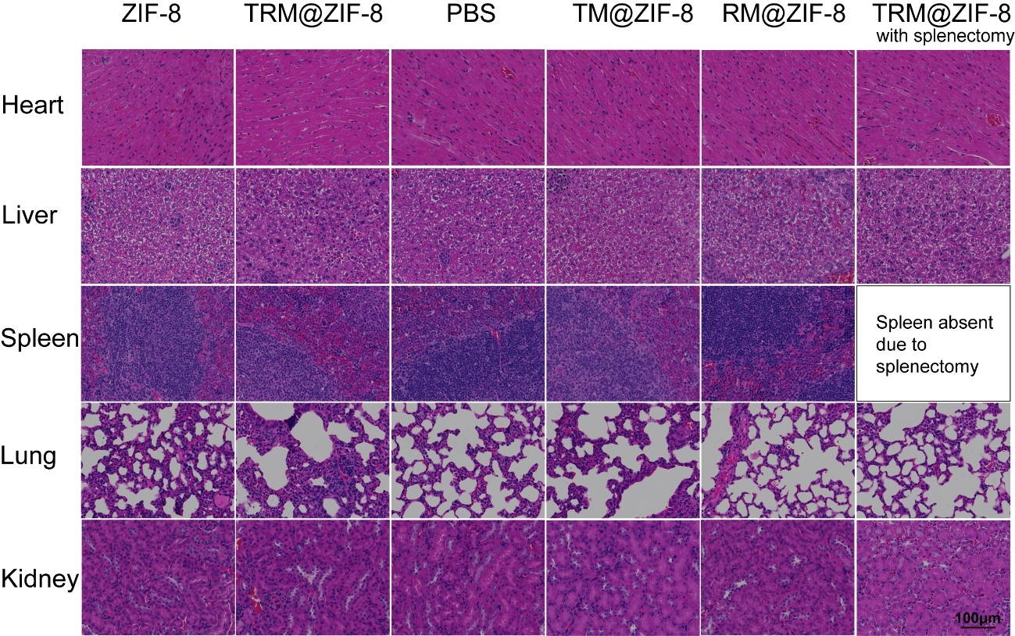
Figure S14. Histological Analysis of Major Organs
Major organs from mice in each group were subjected to hematoxylin and eosin (H&E) staining. Representative histological images of the heart, liver, spleen, lungs, and kidneys are shown to evaluate tissue morphology and potential pathological changes. For the splenectomy group, spleen tissue was absent due to surgical removal and is therefore not shown. Scale bar: 100 μm.

Figure S15. Hematological evaluation of systemic biosafety in treated mice
Whole blood samples collected from mice in each group were subjected to complete blood count (CBC) analysis to evaluate hematological safety after treatment. Hematological parameters, including white blood cell count (WBC), lymphocyte count (Lymph#), monocyte count (Mon#), granulocyte count (Gran#), lymphocyte percentage (Lymph%), monocyte percentage (Mon%), granulocyte percentage (Gran%), red blood cell count (RBC), hemoglobin (HGB), hematocrit (HCT), mean corpuscular volume (MCV), mean corpuscular hemoglobin (MCH), mean corpuscular hemoglobin concentration (MCHC), red cell distribution width (RDW), platelet count (PLT), mean platelet volume (MPV), platelet distribution width (PDW), and plateletcrit (PCT), are shown. Data are presented as mean ± SD, n=5. *P < 0.05; ns, not significant.

Figure S16. Quantification of M2 Macrophages in the Spleen
Quantitative analysis of M2 macrophages in spleen tissues following treatment. Macrophages were defined as F4/80⁺ cells, and M2-polarized macrophages were identified based on CD206 expression (F4/80⁺CD206⁺). G1 (PBS), G2 (ZIF-8), G4 (TM@ZIF-8), G5 (RM@ZIF-8), and G6 (TRM@ZIF-8). Data are presented as mean ± SD (n = 6). Statistical significance was determined using appropriate statistical tests (*p < 0.05, **p < 0.01, ***p < 0.001, ****p < 0.0001; ns, not significant). The corresponding flow cytometric gating strategy and representative plots are shown in the main text.

Figure S17. Flow Cytometric Analysis and Quantification of MDSCs and T Cells in Tumor Tissue
Flow cytometric analysis of immune cell populations in tumor tissues following different treatments. G1 (PBS), G2 (ZIF-8), G3 (TRM@ZIF-8 with splenectomy), G4 (TM@ZIF-8), G5 (RM@ZIF-8), and G6 (TRM@ZIF-8). (A) Representative flow cytometry density plots showing tumor-infiltrating myeloid-derived suppressor cells (MDSCs), defined as CD11b⁺Gr-1⁺ cells. (B) Quantitative analysis of the percentage of CD11b⁺Gr-1⁺ MDSCs among total tumor-infiltrating cells. (C) Quantitative analysis of the CD8⁺/CD4⁺ T cell ratio in tumor tissues. The corresponding flow cytometric gating strategy and representative plots for CD8⁺ and CD4⁺ T cells are shown in the main text. Data are presented as mean ± SD (n = 6). Statistical significance was determined using appropriate statistical tests (*p < 0.05, **p < 0.01, ***p < 0.001, ****p < 0.0001; ns, not significant).

Figure S18. TRM@ZIF-8 Activates NLRP3 Inflammasome-Associated Signaling in Tumor Tissues
Western blot analysis of cleaved caspase-1, NLRP3, GSDMD, and IL-1β in tumor tissues collected from the PBS, ZIF-8, and TRM@ZIF-8 groups, with GAPDH as the loading control. Compared with the PBS group, TRM@ZIF-8 moderately increased the expression of these proteins, consistent with activation of inflammasome-associated and inflammasome-related signaling in tumor tissues.

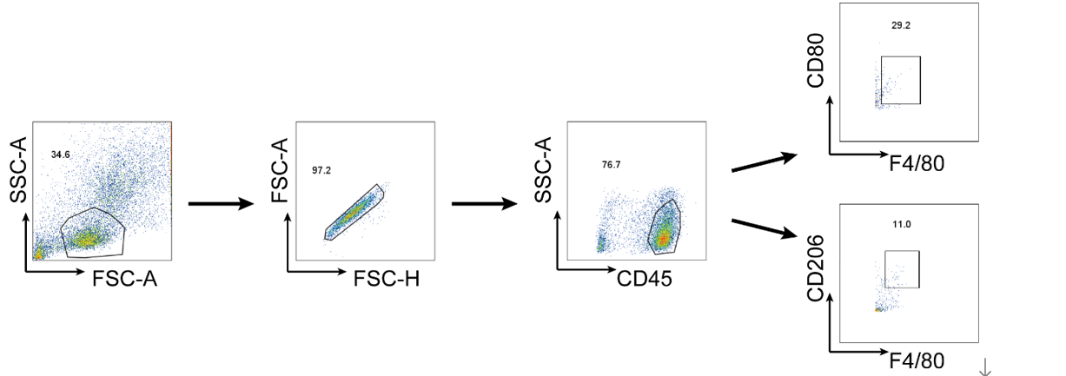
Figure S19. Flow cytometry gating strategy for immune cell population analysis
Cells were first gated based on forward scatter (FSC-A) and side scatter (SSC-A) to exclude debris. Singlet cells were then selected using FSC-A versus FSC-H. CD45⁺ immune cells were subsequently gated, followed by identification of macrophage populations (F4/80⁺). Further gating was performed to distinguish macrophage polarization states based on CD80 and CD206 expression.

