Supplementary material
Acid-Enhanced Drinkable Hydrogel Co-Delivering Riboflavin-Loaded Nanozymes for Orchestrated Inflammation-Immune Modulation and Redox Homeostasis in Colitis Therapy
Wenting Pan^{a#}, Ying Song^{b#}, Yuchen Wang^{d#}, SAKANDAR ABBAS^{b}, YiChao Jingª, Haibin Huang^{b}, Yuanzhe Li^{e}, Wang Ma^{b*}, Jianguo Feng^{c*}, Huan Zhao^{b*}
ªDepartment of Stomatology, The First Affiliated Hospital of Zhengzhou University, No.1 Jianshe East Road, Zhengzhou 450052, Henan, China.
^{b}Oncology department, The First Affiliated Hospital of Zhengzhou University, No.1 Jianshe East Road, Zhengzhou 450052, Henan, China.
^{c}Anesthesiology and Critical Care Medicine Key Laboratory of Luzhou, The Affiliated Hospital, Southwest Medical University, Luzhou, Sichuan 646000, China
^{d}School of Basic Medical Sciences, Zhengzhou University, Zhengzhou, 450001, China.
^{e}Department of Pediatrics, Children’s Hospital Affiliated of Zhengzhou University, Zhengzhou 450052, Henan, China

*Correspondence: doctormawang@126.com (Wang Ma); fengjianguo@swmu.edu.cn (Jianguo Feng); zhaohuan1988@zzu.edu.cn (Huan Zhao).
# These authors contributed equally to this work and should be considered as co-first authors.

Materials and Methods
Materials
The materials used in this study included zinc nitrate hexahydrate (Zn(NO3)2·6H2O, ≥99%, Sinopharm Chemical Reagent Co., Ltd.), platinum(III) chloride (PtCl3, ≥99.9%, Sigma-Aldrich), cetyltrimethylammonium bromide (CTAB, ≥99%, Alfa Aesar), 2-methylimidazole (C4H6N2, 98%, Shanghai Macklin Biochemical Co., Ltd.), sodium borohydride (NaBH4, ≥98%, Shanghai Aladdin Biochemical Technology Co., Ltd.), riboflavin (C17H20N4O6, 98%, Shanghai Yuanye Bio-Technology Co., Ltd.), hydrogen peroxide (H2O2, 30% w/w, Sinopharm), xanthine (≥99%, Sigma-Aldrich), cytochrome C (from bovine heart, Sigma-Aldrich), xanthine oxidase (from bovine milk, 0.1–0.5 U/mg protein, Sigma-Aldrich), 2,2′-azino-bis(3-ethylbenzothiazoline-6-sulfonic acid) diammonium salt (ABTS, ≥98%, Shanghai Ruji Biotechnology Development Co., Ltd.), potassium persulfate (K2S2O8, ≥99.5%, Sinopharm), 1,1-diphenyl-2-picrylhydrazyl (DPPH, ≥95%, Shanghai Ruji Biotechnology Development Co., Ltd.), phosphate-buffered saline (PBS, powder, BioSharp), anhydrous methanol (CH3OH, HPLC grade, Sinopharm), and ethanol (C2H5OH, analytical grade, Sinopharm); all aqueous solutions were prepared using ultrapure water (resistivity ≥18.2 MΩ·cm). All other chemical agents and solvents were analytical grade or above. The main instruments comprised a precision electronic balance (MS105DU, Mettler Toledo), a thermostatic magnetic stirrer (DF-101S, Yuhua Instrument), a high-speed refrigerated centrifuge (ST16R, Thermo Fisher Scientific), a vacuum drying oven (DZF-6020, Jinghong Experimental Equipment), Enzyme labeled instrument (PerkinElmer), a portable dissolved oxygen meter (SevenExcellenceTM S9, Mettler Toledo), an ultrasonic cleaner (KQ-500DE, Kunshan Ultrasonic Instruments Co., Ltd.), an agate mortar and pestle, and 96-well transparent polystyrene microplates (Corning Incorporated).
Catalase (CAT)-like Activity Assay
The CAT-like activity was evaluated by monitoring the generation rate of dissolved oxygen (DO) during the catalytic decomposition of H₂O₂ by the materials. Briefly, 10 mL of PBS (50 mM) was added to a reaction vial, followed by the addition of 200 μL of the material dispersion (1 mg/mL). The reaction was initiated by rapidly injecting 200 μL of H₂O₂ solution (0.03%, v/v, prepared in the same PBS). The change in DO concentration within the initial 10 min at room temperature was immediately monitored and recorded using a portable dissolved oxygen meter (METTLER TOLEDO). A control experiment using an equal volume of PBS without the material served as the blank.
Superoxide Dismutase (SOD)-like Activity Assay
The SOD-like activity was determined using the classic cytochrome C reduction assay. The working solution was freshly prepared by mixing equal volumes of 0.3 mM xanthine solution, 0.45 mg/mL cytochrome C solution (both prepared in 50 mM PBS), and PBS buffer. Xanthine oxidase was diluted with PBS to an appropriate activity unit prior to use. A 300 μL reaction system was constructed in a 96-well plate, consisting of 150 μL of the working solution, 120 μL of the sample solution (composed of material dispersions at various concentrations and ultrapure water), and 30 μL of the diluted xanthine oxidase solution. Before measurement, the reaction system without the material (using ultrapure water instead of the sample) was used to 0.0225 the absorbance at 550 nm. The volumes of ultrapure water and enzyme solution were finely adjusted so that the absorbance change (ΔA550/min) between the 0 and 1st minute of the reaction stabilized at approximately 0.0225, which was defined as the standard reaction rate. The material was tested at concentrations of 0.833, 0.417, 0.083, 0.042, 0.0083, and 0.00083 mg/mL. Immediately after initiating the reaction, the absorbance at 550 nm was monitored over time using a microplate reader. The SOD-like activity was expressed as the material concentration required to inhibit the superoxide-mediated cytochrome C reduction by 50% (IC₅₀), calculated via nonlinear fitting.
ABTS^{+•} Radical Scavenging Capacity Assay
The ABTS⁺• radical scavenging capacity was measured according to a literature method with slight modifications. An ABTS⁺• radical stock solution was generated by mixing equal volumes of 7 mM ABTS aqueous solution and 2.45 mM potassium persulfate aqueous solution, followed by incubation at room temperature in the dark for 12-16 h. Prior to use, the stock solution was diluted with anhydrous ethanol until its absorbance at 735 nm reached 0.70 ± 0.02, serving as the working solution. The materials (Pt-ZIF and RAF@Pt-ZIF) were diluted with an appropriate solvent to five concentrations: 3.125, 6.25, 12.5, 25, and 50 μg/mL. In a 96-well plate, the test group consisted of a mixture of 20 μL sample and 180 μL ABTS^{+•} working solution; the control group contained 20 μL sample and 180 μL anhydrous ethanol; and the blank group contained 20 μL solvent and 180 μL working solution. All measurements were performed in triplicate. After adding the reagents, the plate was incubated at room temperature in the dark for 6 minutes, and the absorbance (A) at 735 nm was immediately measured. The radical scavenging activity (SA) was calculated using the following formula:
SA (%) = [1 − (Asample − Acontrol) / Ablank] × 100%
where Asample, Acontrol, and Ablank represent the average absorbance of the test group, control group, and blank group, respectively.
DPPH• Radical Scavenging Capacity Assay
The DPPH• radical scavenging capacity was determined using a standard method. A working solution was prepared by accurately weighing 4 mg of DPPH, dissolving it in anhydrous ethanol, and diluting to a final volume of 50 mL. This solution was stored protected from light. The materials (Pt-ZIF and RAF@Pt-ZIF) were diluted to five concentrations: 1.5625, 3.125, 6.25, 12.5, and 25 μg/mL. In a 96-well plate, the test group consisted of a mixture of 20 μL sample and 180 μL DPPH working solution; the control group contained 20 μL sample and 180 μL anhydrous ethanol; and the blank group contained 20 μL solvent and 180 μL working solution. Each concentration was tested in triplicate. After adding the reagents, the 96-well plate was incubated in the dark at 37 ℃ for 30 minutes, after which the absorbance at 517 nm was immediately measured. The DPPH• radical scavenging rate was calculated using the formula described in the previous section.
Colonic Histopathology Analysis
To make blocks, pieces of the distal colon that were about 0.5 to 1 cm long were preserved in 4% paraformaldehyde, dried out, and then put in paraffin. Paraffin-embedded sections were stained with HE for histological scoring. Mucin and goblet cells were found in colonic tissue using AB/PAS staining. The thickness of the mucus layer was analyzed by Alcian Blue staining. As directed by the In Situ Cell Death Detection Kit, POD (Roche, USA), TUNEL staining was used to analyze the apoptosis of colonic cells.
Immunofluorescence staining
Paraffin-embedded colon sections were cut into 4–5 μm sections. After deparaffinization and rehydration, antigen retrieval was performed using citrate buffer (pH 6.0). Sections were blocked with 5% BSA for 1 h at room temperature and then incubated overnight at 4 °C with primary antibodies against Muc2, AGR2, Claudin-1, Occludin, ZO-1, CD68, CD86, CD4, RORγt, FOXP3, KEAP-1, and Nrf2. After washing with PBS, sections were incubated with appropriate fluorophore-conjugated secondary antibodies for 1 h at room temperature. Nuclei were counterstained with DAPI, and images were captured using a confocal microscope. Representative images were analyzed to assess protein expression and localization.
Immunohistochemistry Staining
Paraffin-embedded colon sections (4–5 μm) were deparaffinized, rehydrated, and subjected to antigen retrieval in citrate buffer (pH 6.0). Endogenous peroxidase activity was blocked, and the sections were then incubated with 5% BSA to prevent nonspecific binding. The sections were probed overnight at 4 °C with primary antibodies against cleaved caspase-3, Ki67, and iNOS. After washing, HRP-conjugated secondary antibodies were applied for 1 h at room temperature. Specific staining was visualized with DAB substrate, and the sections were counterstained with hematoxylin. Images were acquired under a light microscope, and representative fields were analyzed to evaluate protein expression and localization.
Western Blot Analysis
Proteins were extracted from colon tissues using RIPA lysis buffer (Solarbio, Beijing, China) supplemented with protease and phosphatase inhibitors. The protein concentration was determined using a BCA protein assay kit (Solarbio, Beijing, China). Loading buffer was added to the protein samples, and the mixture was boiled for 5 min. The mixture containing 30 μg of protein was loaded onto 10% SDS‒PAGE gels to separate the proteins before being transferred onto polyvinylidene difluoride (PVDF) membranes. The membranes were incubated with 5% skim milk at room temperature for 2 h and then subsequently incubated overnight at 4°C with diluted primary antibodies (all from Proteintech) diluted in blocking buffer: anti-Bcl-2, anti-Bax, anti-SCAD, anti-DJ-1, anti-β-actin, and anti-Tubulin. After being washed three times with Tris-buffered saline with Tween 20 (TBST), the membranes were incubated with horseradish peroxidase (HRP)-conjugated secondary antibodies for 1 h at room temperature. Protein bands were visualized using an enhanced chemiluminescence (ECL) substrate and quantified with ImageJ software (National Institutes of Health).
Enzyme-linked immunosorbent assay (ELISA)
Using a cryogenic grinder, colonic tissues were finely ground and homogenized in phosphate-buffered saline that had been chilled and contained phenylmethylsulfonyl fluoride (PMSF). The homogenate was centrifuged at 12,000 × g for 15 min to collect the supernatant, which served as the colonic tissue lysate. Protein concentrations were determined using a BCA protein assay kit. The levels of inflammatory cytokines in the colonic tissue and serum were measured using the appropriate ELISA kits in accordance with the manufacturer's instructions. Using a microplate reader, absorbance was determined at 450 nm.
Transcriptional Level Analysis of Genes
Total RNA from colon tissues was extracted using TRIzol reagent (Invitrogen, Carlsbad, CA, USA) and reverse transcribed into cDNA using HiScript III RT SuperMix (Vazyme, China). Quantitative real-time PCR (qRT-PCR) was performed to measure mRNA expression of muc2, klf4 and spdef. Relative expression levels were calculated using the 2^-ΔΔCt method with GAPDH as an internal control. The list of genes and their corresponding primers used in this study is detailed in Table S1.
Oxidative Stress Assessment
Colon tissues were homogenized in ice-cold lysis buffer and centrifuged at 12,000 × g for 15 min at 4 °C, and the resulting supernatants were used for biochemical assays. ROS levels were quantified using a commercial fluorometric ROS assay kit according to the manufacturer’s instructions. Antioxidant enzyme activities, including SOD and GPX4, were measured using corresponding colorimetric assay kits. All measurements were normalized to total protein concentration, which was determined using a BCA protein assay.
Fecal 16S rDNA Sequencing
Fecal samples were collected from mice at the end of the experiment and immediately stored at −80 °C. Microbial genomic DNA was extracted using a commercial stool DNA extraction kit following the manufacturer’s protocol. The V3–V4 hypervariable regions of the bacterial 16S rRNA gene were amplified and subjected to high-throughput sequencing on the NovaSeq 6000 platform (OE Biotech Co., Ltd., Shanghai, China). Quality control, chimera removal, and sequence denoising were performed to obtain high-quality amplicon sequence variants (ASVs). Taxonomic annotation was conducted against a curated reference database. Alpha- and beta-diversity indices, principal coordinate analysis (PCoA), and taxonomic composition analyses were performed to evaluate microbiota structure and intergroup differences.
Statistical Analysis
Data were analyzed using GraphPad Prism and are presented as mean ± SEM. Differences between the two groups were assessed using unpaired two-tailed t-tests, and multiple-group comparisons were performed using one-way ANOVA with Tukey’s post hoc test. Histology and immunostaining data were analyzed using nested ANOVA. A P value < 0.05 was considered statistically significant.

Table S1. The sequence of Primers used in this study
Target genes | Forward | Reverse
Muc2 | CTTCTGTGCCACCCTCGT | TTCGGGATCTGGCTTCTT
Spdef | AAGGCAGCATCAGGAGCAATG | CTGTCAATGACGGGACACTG
klf4 | GTGCCCCGACTAACCGTTG | GTCGTTGAACTCCTCGGTCT
GAPDH | AGGTCGGTGTGAACGGATTTG | TGTAGACCATGTAGTTGAGGTCA

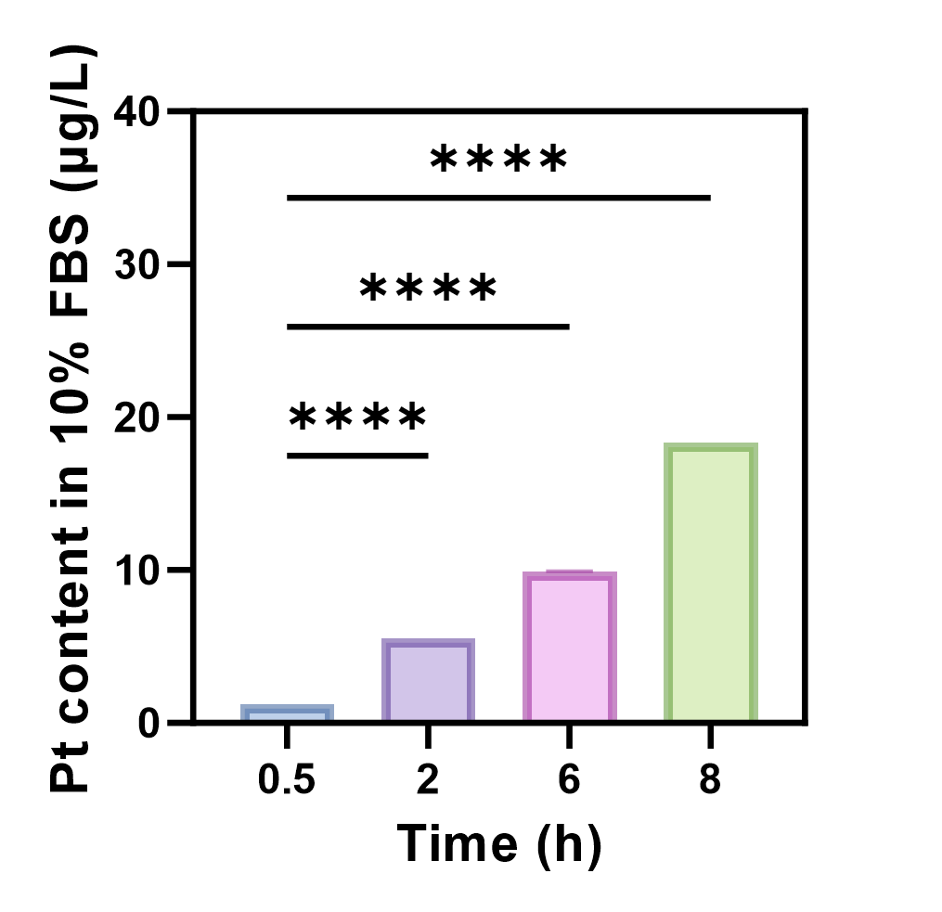
Figure S1. Pt release profile of RPZCS in PBS containing 10% FBS (n = 3).

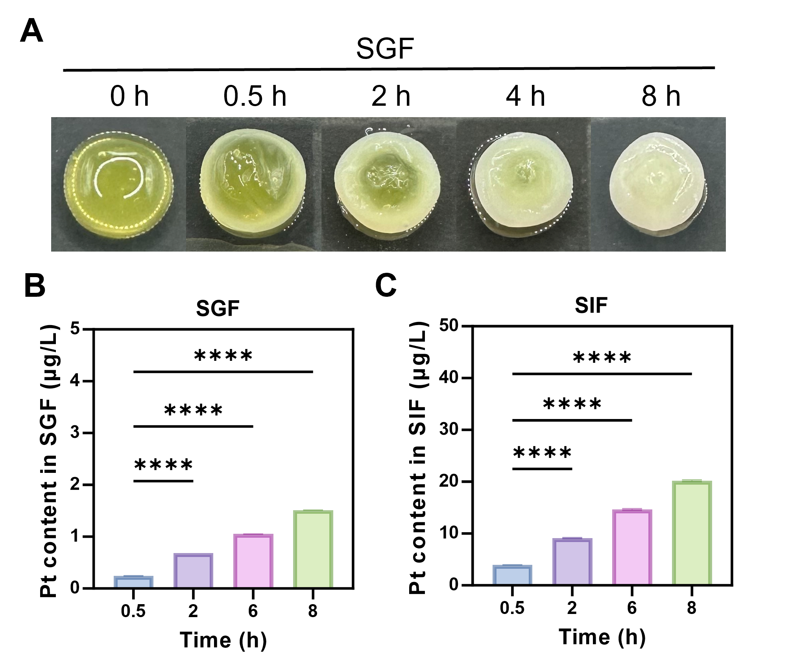
Figure S2. Environmental responsiveness and in vitro release behavior of RPZCS. (A) Time-dependent gelation behavior of RPZCS in simulated gastric fluid (SGF), indicating in situ reconstruction of the hydrogel network. (B) In vitro Pt release profile of RPZCS in SGF, showing limited release under acidic conditions (n = 3). (C) In vitro Pt release profile of RPZCS in simulated intestinal fluid (SIF), exhibiting sustained and time-dependent release behavior (n = 3).

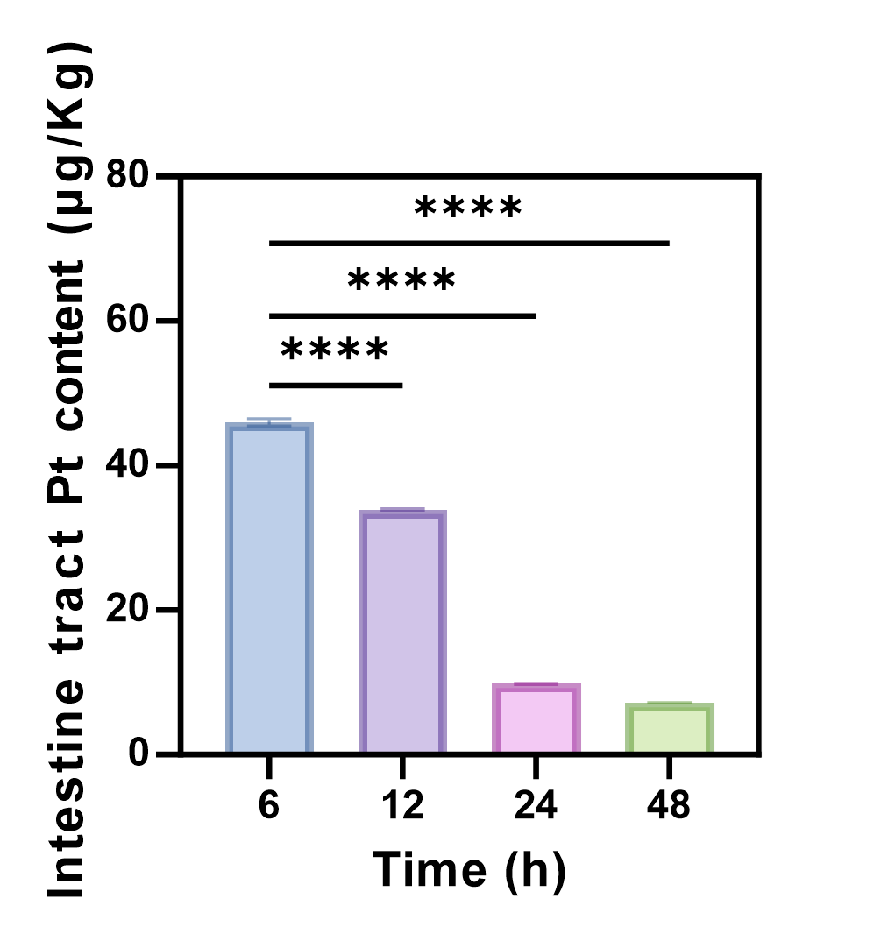
Figure S3. Pt levels in intestinal tissues at 6, 12, 24, and 48 h post-administration measured by ICP-MS, indicating sustained gastrointestinal retention and release of RPZCS (n = 3).

