Cel-LDH Dual-Functional Nanotherapy Simultaneously Promotes Microglial Efferocytosis and Alleviates Neuronal Apoptosis
for Spinal Cord Injury Recovery

Nuo Chen^{1, 3, 4#}, Lufeng Yao^{2#}, Le Zou^{3, 4#}, Qiuchen Wang^{3, 4}, Yaning Li^{3, 4}, Junjun Luo^{3, 4}, Mengting Zhan^{3, 4}, Kailiang Zhou⁵, Jian Xiao^{3, 4}, Songlin Tong^{1*}, Hongyu Zhang^{3, 4*}, Liangliang Yang^{1, 3, 4*}, Lu Ge^{3, 4*}

¹ Affiliated Cixi Hospital, Wenzhou Medical University, Cixi, 315300, China;
² Department of Foot and Ankle Surgery, Ningbo No.6 Hospital, Ningbo, 315040, China;
³ School of Pharmaceutical Sciences, Wenzhou Medical University, Wenzhou, 325035, China;
⁴ Department of Neurosurgery, Ningbo No.2 Hospital, Cixi Biomedical Research Institute, Wenzhou Medical University, Ningbo, 315302, China;
⁵ Zhejiang Provincial Key Laboratory of Orthopaedics, Wenzhou, 325027, China

#These authors contributed equally.
*Corresponding author:
Songlin Tong, E-mail: 13806646388@163.com;
Hongyu Zhang, E-mail: st_hyz@126.com;
Liangliang Yang, E-mail: liangliangyangLLL@126.com;
Lu Ge, E-mail: gelu100466@126.com

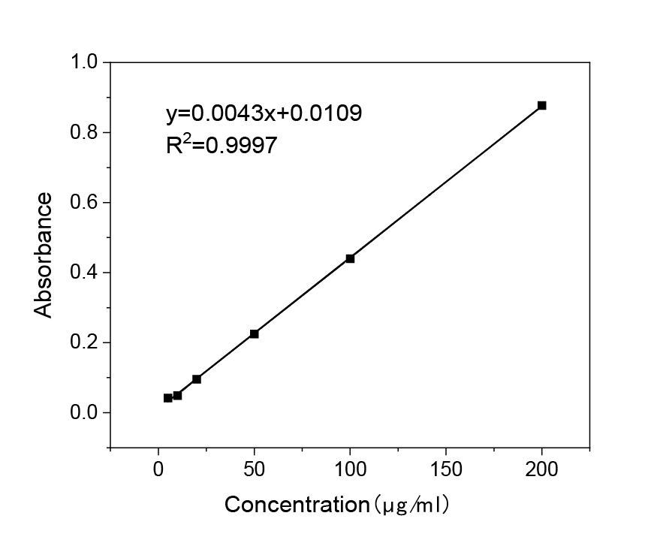
Figure S1. The standard curve image of Cel concentration-absorbance values (λ =
424 nm).

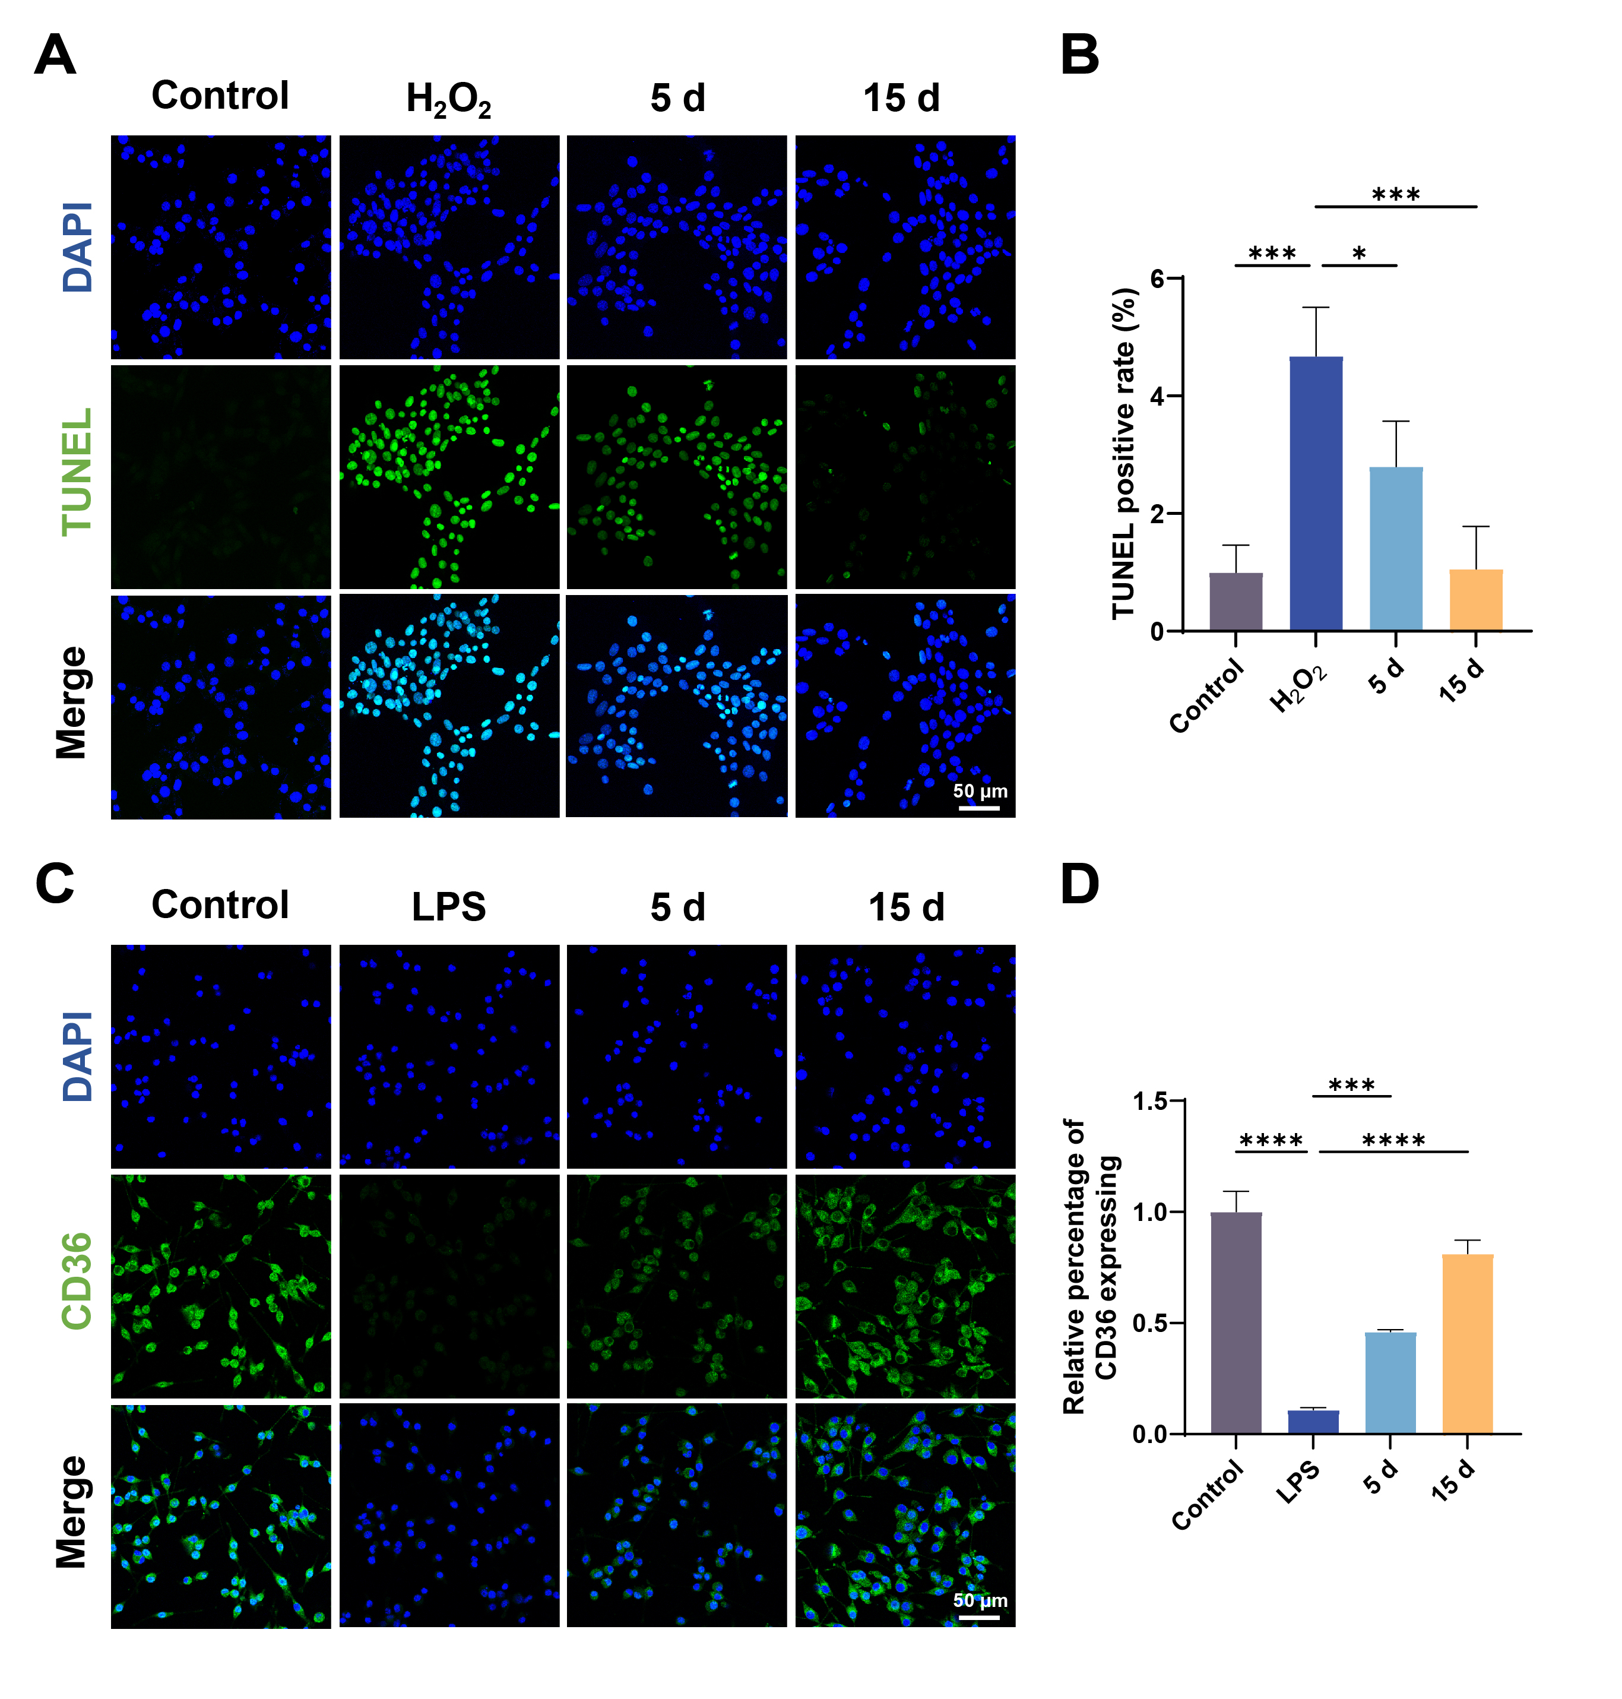
Figure S2. Biological activity of drug released from Cel-LDH at different time points. A) TUNEL staining images of HT22 cells treated with Cel-LDH release supernatants at 5 and 15 days (scale bar: 50 µm). B) Relative quantification of TUNEL fluorescence intensity. C) CD36 staining images of HT22 cells treated with Cel-LDH release supernatants at 5 and 15 days (scale bar: 50 µm). D) Relative quantification of CD36 fluorescence intensity. All the data are presented as the mean ± SD; n = 3; *p < 0.05, **p < 0.01, ***p < 0.001, ****p < 0.0001.

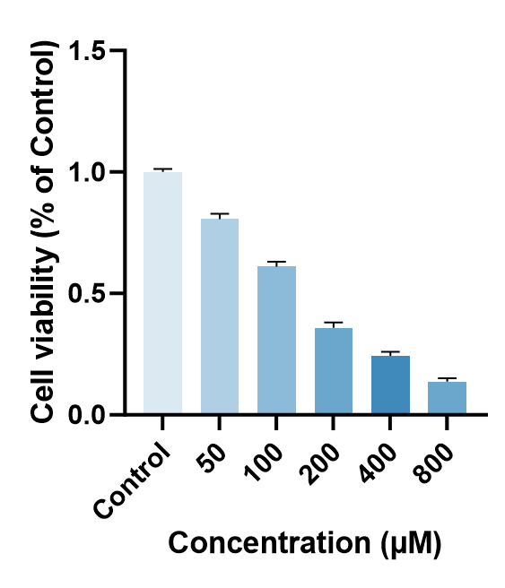
Figure S3. Cell viability of HT22 cells under different TBHP concentrations.
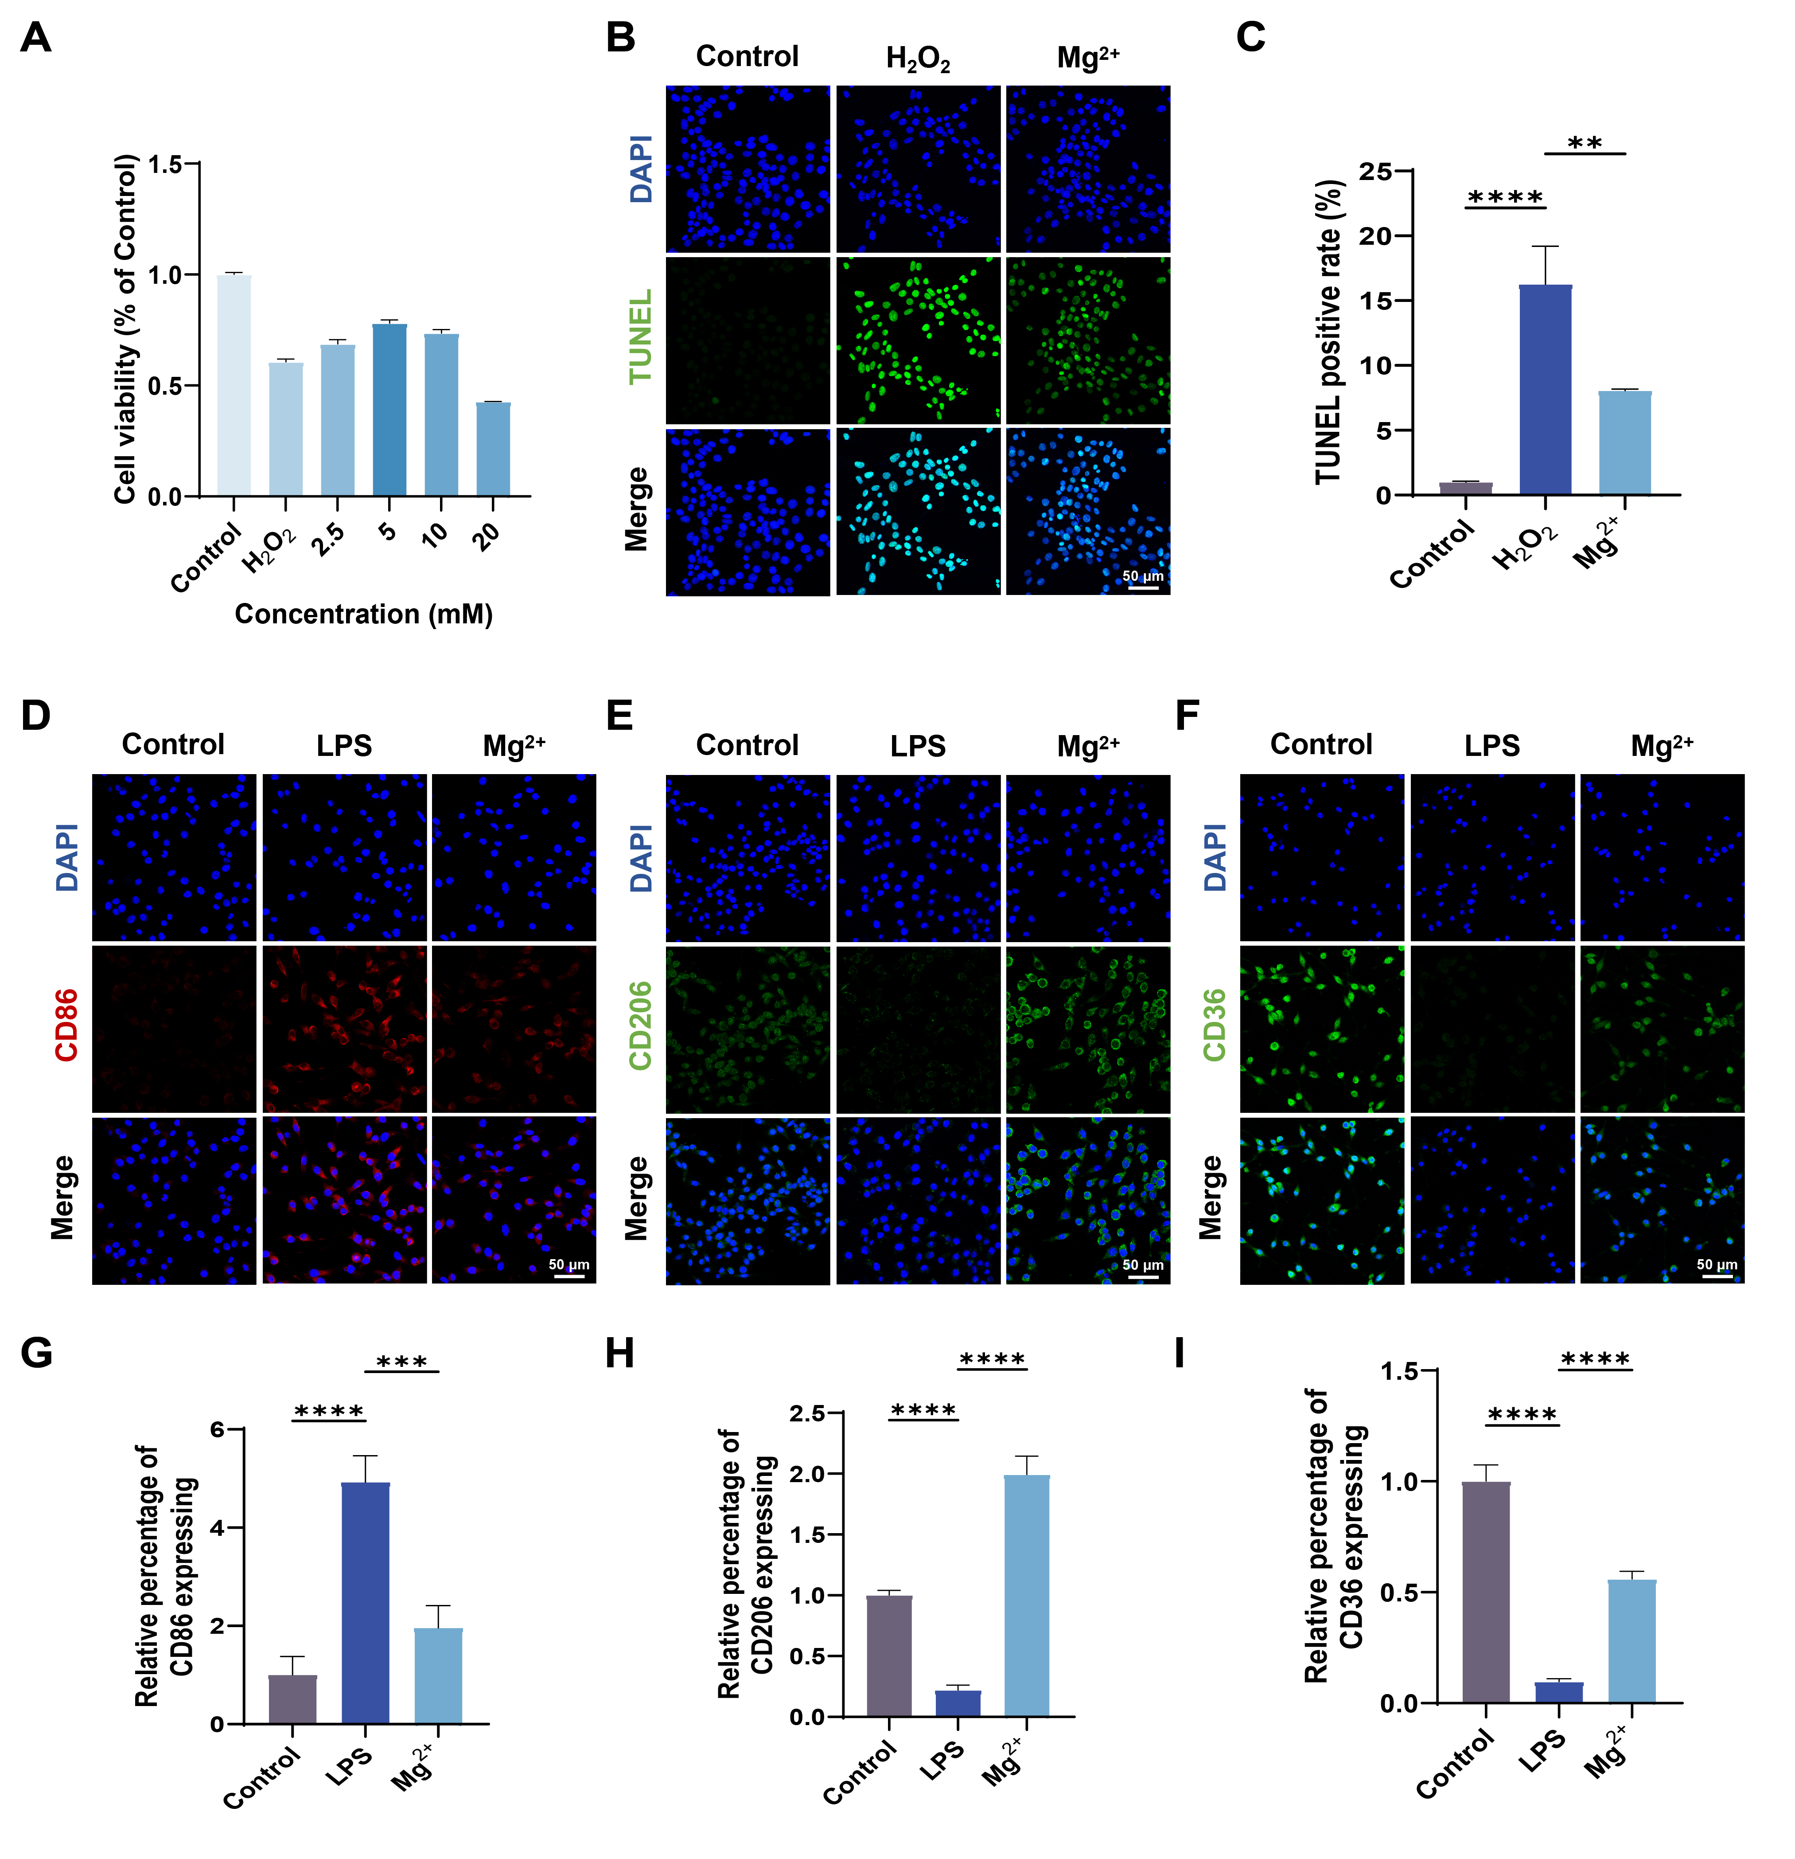
Figure S4. Effects of Mg²⁺ on neuronal cells survival and microglial function. A) CCK-8 assay showing cell viability of H₂O₂-stimulated HT22 neurons treated with different concentrations of Mg²⁺. B) Representative TUNEL staining images of H₂O₂-stimulated HT22 neurons treated with or without Mg²⁺ (scale bar: 50 μm). C) Relative quantification of TUNEL fluorescence intensity. D) Representative immunofluorescence images of CD86 in LPS-stimulated BV2 cells treated with or without Mg²⁺ (scale bar: 50 µm). E) Representative immunofluorescence images of CD206 in LPS-stimulated BV2 cells treated with or without Mg²⁺ (scale bar: 50 µm). F) Representative immunofluorescence images of CD36 in LPS-stimulated BV2 cells treated with or without Mg²⁺ (scale bar: 50 µm). G) Relative quantification of CD86 fluorescence intensity. H) Relative quantification of CD206 fluorescence intensity. I) Relative quantification of CD36 fluorescence intensity. All the data are presented as the mean ± SD; n = 3; *p < 0.05, **p < 0.01, ***p < 0.001, ****p < 0.0001.

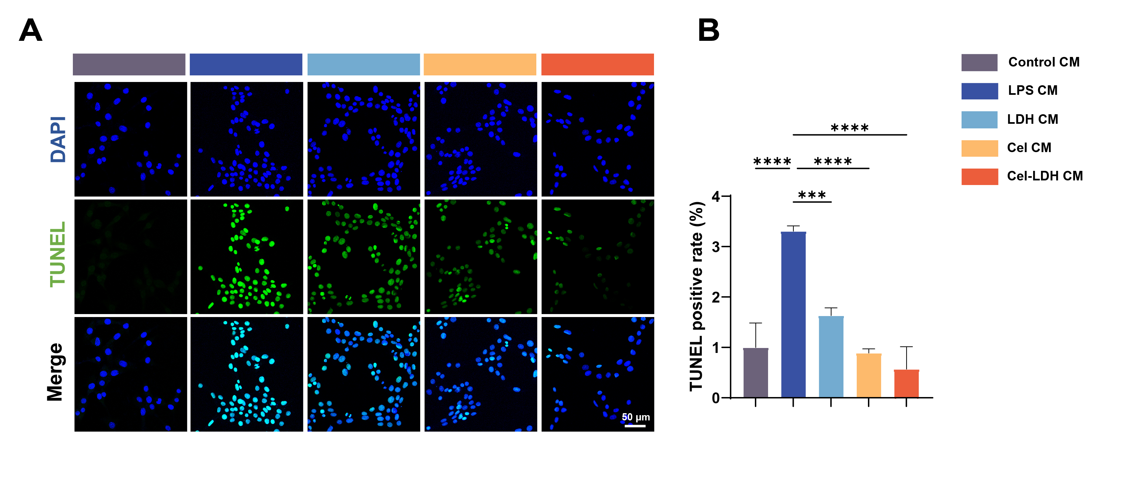
Figure S5. Conditioned medium from Cel-LDH-treated BV2 microglia protects HT22 neurons against apoptosis. BV2 cells were treated with control, LPS alone, LPS+LDH, LPS+Cel, or LPS+Cel-LDH. Conditioned media were collected and applied to H₂O₂-injured HT22 neurons. A) TUNEL staining images of HT22 neurons treated with conditioned media from BV2 cells under different conditions (scale bar: 50 µm). B) Relative quantification of TUNEL fluorescence intensity. All the data are presented as the mean ± SD; n = 3; *p < 0.05, **p < 0.01, ***p < 0.001, ****p < 0.0001.

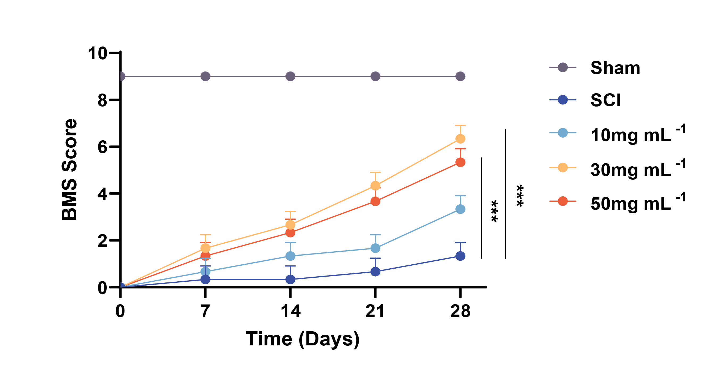
Figure S6. BMS scores of hindlimb motor function in mice treated with different concentrations of Cel-LDH (10, 30, and 50 mg mL⁻¹) at various time points post-injury.

Table S1. Target gene primer sequences.
Gene | Forward Primers | Revers Primers
IL-1β | CAACCAACAAGTGATATTCTCCATG | GATCCACACTCTCCAGCTGCA
TNF-α | GGAACACGTCGTGGGATAATG | GGCAGACTTTGGATGCTTCTT
IL-10 | GCTCTTACTGACTGGCATGAG | CGCAGCTCTAGGAGCATGTG
TGF-β | TCCAACCGCAGCTACTCTG | CCGTACAGGAAGCAGTTATTT
β-actin | GTGACGTTGACATCCGTAAAGA | GCCGGACTCATCGTACTCC

