Supplementary Material

pH-Responsive CDs-based Nanoplatform for Chemo-Resistant Esophageal Cancer Treatment via Downregulation of HIF-1α Related Pathway
Xuewei Wang^{1,2,†}, Yue Zhang^{1,†}, Hao Wu^{1,†}, Zelei Yang¹, Sufang Ma^{1,2}, Lihong Li^{1,2,3},
Lixia Guo^{1,2}, Lili Yan^{1,2}, Boye Zhang^{1,2}, Jianfei Liu^{1,2}, Haipeng Diao^{1,2},
Guodong Ren^{1,2}*, Chengwu Zhang^{1,2}*, Wen Liu^{1,2,3}*

Fig.S1-Fig.S10
Fig. S1. Absorbance spectrum of Fe-CDs.

Fig. S2. The fluorescence of (A) RDPP and (B) the mixture of RDPP and H₂O_{2.}

Fig. S3. Standard curves of (A) Fe-CDs and (B) DOX. The X-axis represents the concentration of Fe-CDs or DOX, and the Y-axis represents corresponding absorbance of the mixture solution.

Fig. S4. Quantitative analysis of (A) colony formation, (B) wound healing, (C) invasion and (D) migration results of KYSE-30 cells subjected to different treatments. Statistical significance was defined as **p < 0.01, and ***p < 0.001.

Fig. S5. Quantitative analysis of related proteins (HIF-1α and SLC2A1) in KYSE-30 cells before and after incubation with CDG@PEG. Statistical significance was defined as **p < 0.01, and ***p < 0.001.

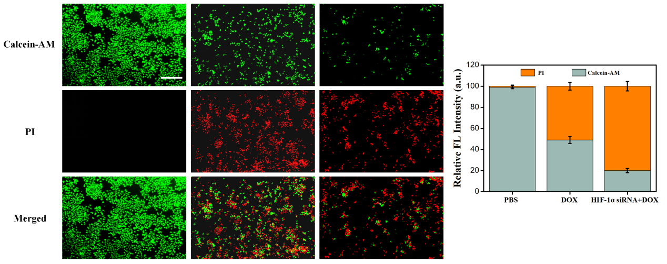
Fig. S6. Calcein-AM/PI staining and quantitative analysis of KYSE-30 cells following different treatments (Scale bar = 200.00 μm).

Fig. S7. Quantitative analysis of fluorescence imaging in vivo.

Fig. S8. In vivo pharmacokinetics of DOX and CDG@PEG in mice.
Fig. S9. The routine blood analysis of mice after treatment with CDG@PEG for 30 days (n = 3, WBC: White Blood Cell Count, RBC: Red Blood Cell Count, HGB: Hemoglobin, MCV: Mean Corpuscular Volume, MCH: Mean Corpuscular Hemoglobin, MCHC: Mean Corpuscular Hemoglobin Concentration, MPV: Mean Platelet Volume, Lym#: Absolute Lymphocyte Count, Mid#: Mid-range Absolute Count, GR#: Absolute Granulocyte Count, PCT: Plateletcrit, PLT: Platelet Count).

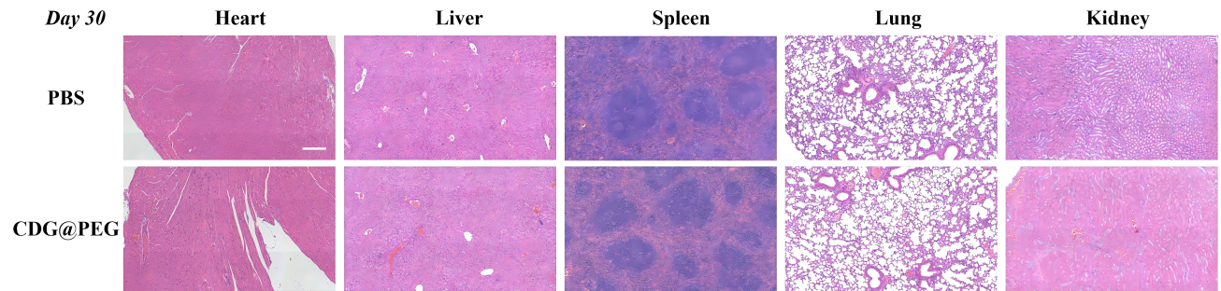
Fig. S10. Representative H&E-stained sections of major organs (heart, liver, spleen, lung and kidney) from the PBS and CDG@PEG groups following 30 days of treatment. (scale bar = 200.00 µm)

